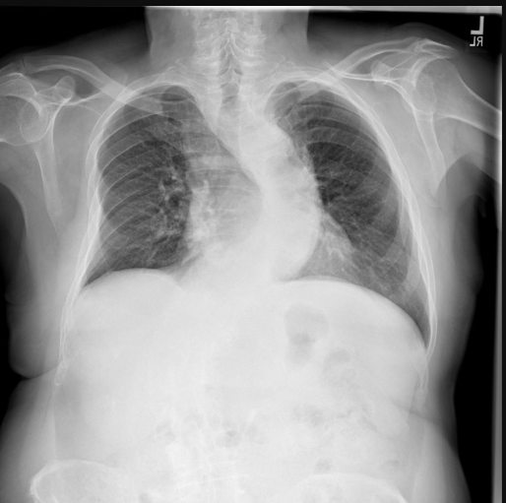
gpt-4.1-mini
CLINICAL HISTORY:
No specific clinical history provided.

TECHNIQUE:
Single-view chest radiograph (AP projection) with mild rotation. Adequate inspiration and penetration. No motion artifact noted.

FINDINGS:
- The cardiac silhouette demonstrates moderate cardiomegaly (definite confidence).
- Mild atelectasis is present in the right lower lung zone, consistent with partial volume loss (probable confidence).
- No acute pulmonary infiltrates or consolidations are identified.
- No post-surgical changes are present.
- No spinal abnormalities are identified.

IMPRESSION:
Moderate cardiomegaly with mild atelectasis in the right lower lung zone. No evidence of acute pulmonary pathology. No post-surgical or spinal abnormalities identified.

DIFFERENTIAL (RANKED):
1. Cardiomegaly likely secondary to underlying cardiac conditions such as hypertensive heart disease, valvular disease, or cardiomyopathy. (Supported by RAG chunk #7 describing cardiomegaly and its radiographic features)
2. Mild right lower lobe atelectasis possibly due to hypoventilation, mucus plugging, or early volume loss. (Supported by RAG chunk #5 discussing atelectasis and its management)
3. Less likely acute infectious or inflammatory process given absence of consolidation or air bronchograms.

RECOMMENDATIONS:
- Clinical correlation with cardiac history and symptoms is advised.
- Consider echocardiography to evaluate cardiac function and etiology of cardiomegaly.
- If clinically indicated, follow-up chest imaging or CT may be warranted to further evaluate atelectasis if symptoms persist or worsen.
- Supportive measures such as incentive spirometry and chest physiotherapy may be beneficial for atelectasis.

LIMITATIONS:
- Single AP chest radiograph limits full assessment of cardiac size compared to PA view.
- Mild rotation may slightly affect silhouette evaluation.
- No lateral view available for further characterization of lung zones or cardiac contours.
- Clinical history and symptoms were not provided, limiting correlation.

Gpt-5-mini
CLINICAL HISTORY:
No history provided.

TECHNIQUE:
PA chest radiograph. Mild rotation. Inspiration adequate. Penetration adequate. No motion artifact.

FINDINGS:
- Cardiomediastinal silhouette within expected size limits without mediastinal widening.
- No focal air‑space consolidation to suggest pneumonia.
- No pleural effusion identified.
- No pneumothorax.
- No acute cardiogenic pulmonary edema identified.
- Subsegmental linear subpleural opacities at the bilateral lower lobes, greater on the right, consistent with atelectasis or scar.
- No acute hilar enlargement or focal hilar mass identified.
- No lines or tubes visualized (no endotracheal tube, central lines, or pacing wires).
- No radiopaque foreign body visualized in the chest/upper abdomen.
- No acute post‑surgical changes identified (no sternotomy wires or surgical clips).
- No acute rib fracture or destructive osseous lesion identified on this limited survey.
- Thoracic spine: mild dextroscoliosis with multilevel degenerative endplate osteophytes.

IMPRESSION:
1) No acute cardiopulmonary disease identified on this PA chest radiograph — specifically, no focal air‑space consolidation to suggest pneumonia, no pleural effusion, no pneumothorax, and no acute cardiogenic pulmonary edema.
2) Mild subsegmental linear subpleural opacities in the bilateral lower lobes, greater on the right, most consistent with subsegmental atelectasis or scar.
3) Thoracic spine: mild dextroscoliosis with multilevel degenerative endplate osteophytes.
4) No acute post‑surgical changes identified.

DIFFERENTIAL (RANKED):
1) Subsegmental atelectasis (most likely) — dependent linear subpleural opacities in the lower lungs commonly reflect subsegmental collapse from shallow breathing or hypoventilation (e.g., post‑operative or immobility-related). (Supported by typical radiographic patterns.)
2) Pulmonary scar/fibrosis from prior infection or inflammation — chronic peripheral scarring can appear as linear subpleural opacities and may be indistinguishable from chronic atelectasis on a single frontal radiograph.
3) Peripheral/early consolidation (less likely) — focal peripheral pneumonia can mimic peripheral linear opacity but would more likely demonstrate progressive change or air‑bronchograms and correlate with clinical signs.
4) Other less likely causes: pleural‑based scar or small subpleural neoplasm — uncommon on a single PA view; consider further evaluation if persistent or progressive.

RECOMMENDATIONS:
- Correlate with clinical symptoms and prior chest imaging, if available, to determine chronicity.
- If the lower‑lobe opacities are new, progressive, or there is clinical concern for infection or an obstructing process, consider follow‑up chest radiograph in 4–6 weeks and/or chest CT for further evaluation.
- If related to postoperative status or immobility, conservative measures (incentive spirometry, chest physiotherapy, early mobilization) are reasonable and often result in improvement.

LIMITATIONS:
- Single frontal (PA) view with mild rotation; no lateral view for improved localization or characterization.
- Plain radiography is insensitive for small pleural effusions, early air‑space disease, and subtle mediastinal/hilar pathology. Osseous assessment is limited on this exam.

