**Name:** Shubham Chemate

**Roll Number:** 21118

**TITLE:** **SWOC Analysis**

**PROBLEM DEFINITION:**

Draw SWOC table showing your Strength, Weakness, Opportunity and Challenges.

**OBJECTIVE:**

* Inculcating habit of objective analysis for finding out strengths & weakness of individual & associated opportunities and challenges thereof.
* To get first-hand information about the individuals background, technical skills, other skills, achievements, future goals, hobbies.
* To identify key internal & external factors seen as important to achieving an objective.

**THEORY:**

Ask the following questions to self for analysis:

Strengths:

* What advantages do I have that others don't have?
* What do I do better than anyone else?
* What personal resources can I access?
* What do other peoples see as my strength?

Weaknesses:

* What tasks do I usually avoid because you don't feel confident doing them?
* What will the people around me see as my weaknesses?
* Am I completely confident in my educational skills?
* What are my negative work habits?

Opportunities:

* What new technologies can help me?
* What are the trends in my institute that synchronize with solutions of my problems?
* What are the new projects that forces me to work on my weaknesses?
* Can I take advantage of weakness of my competitor (In positive way)?

Challenges:

* What are the challenges currently I am facing at the work?
* Is anyone is competing with me for project/role?
* Can changing technology threatens my position?
* What are my weaknesses that leads to threat?

SWOC Matrix:

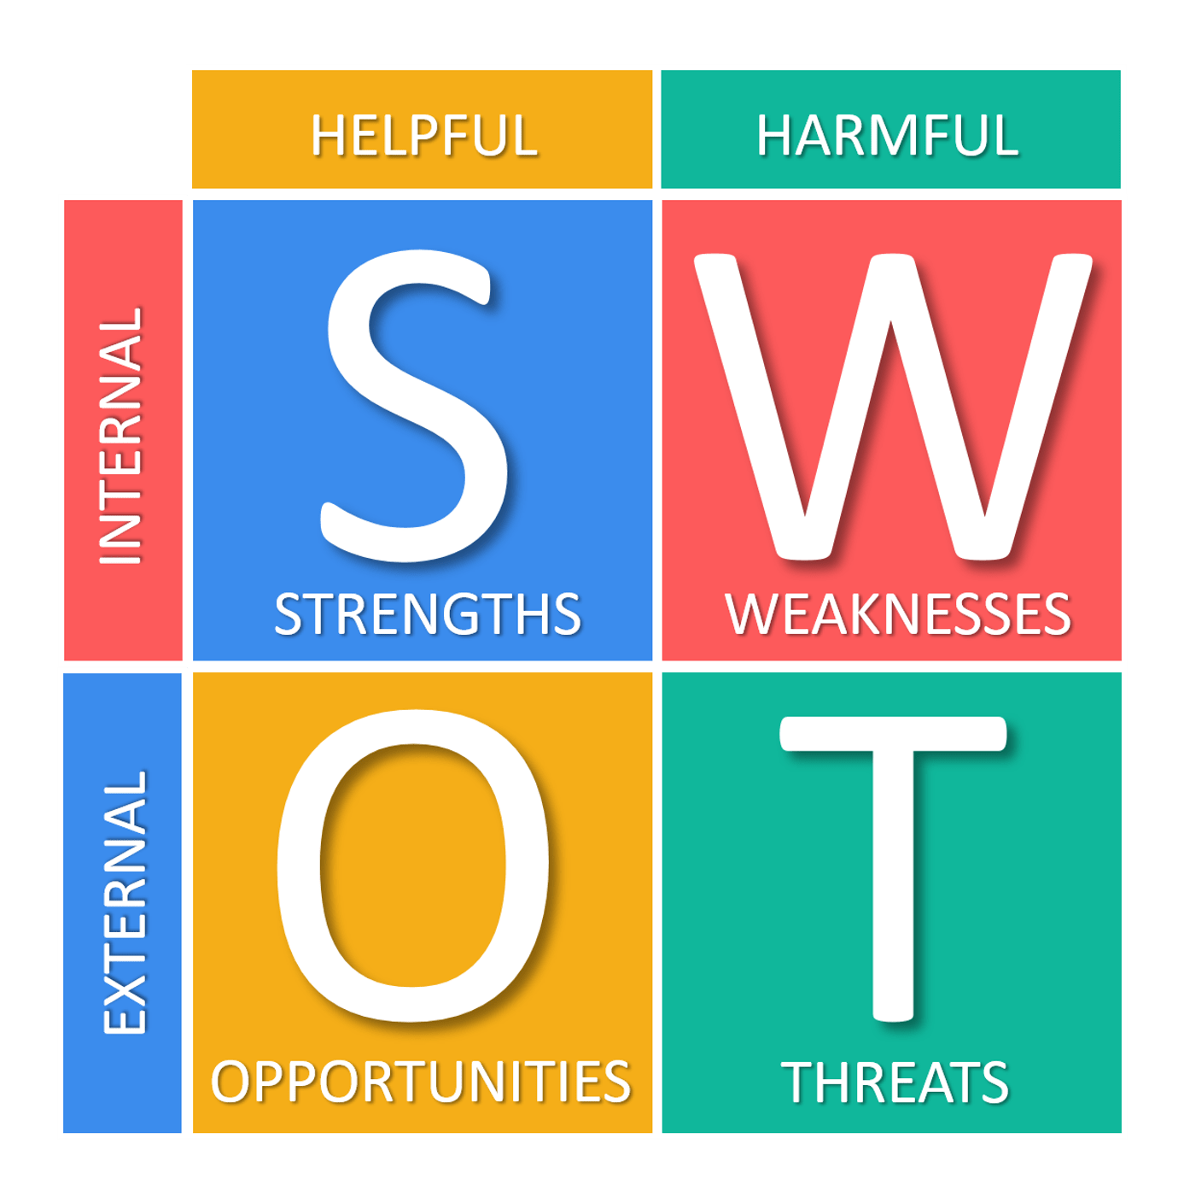

* S–O strategies: pursue opportunities that are a good fit to the strengths.
* W–O strategies: overcome weaknesses to pursue opportunities.
* S–T strategies: identify ways that the firm can use its strengths to reduce its vulnerability to external threats.
* W–T strategies: establish a defensive plan to prevent the firm's weaknesses from making it highly susceptible to external threats.

The Johari Window:

* Open Area: what is known by the person about him/herself and is also known by others
* Blind Area: what is unknown by the person about him/herself but which others know
* Hidden Area: what the person knows about him/herself that others do not know
* Unknown Area: what is unknown by the person about him/herself and is also unknown by others

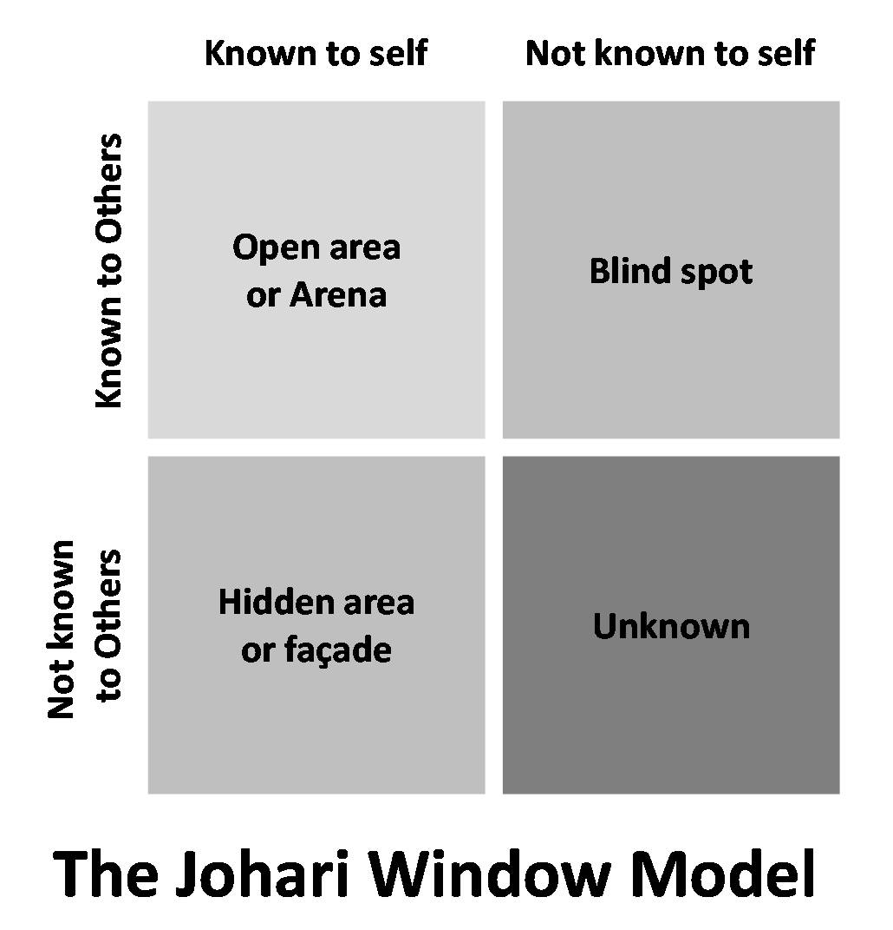

**STEPS:**

* Evaluate oneself for strengths and weakness of individual and associated opportunities in the future.
* Evaluate oneself for weakness and use it to eliminate threat and associated impact

**SELF-ASSESSMENT:**

**Strengths:**

* Positive Thinking: I am very calm person and I look at the things positively in almost any situation. This is one of my biggest strength and always help me to overcome from my bad times.
* Consistency: I am pretty much consistent in almost everything which I do. It may be personal goals or my career goals. I try my best to achieve anything in any situation. But sometimes I have to compromise on some things to stay consistent but at end till now it’s always worth it.
* Learning New Things: I really love to learn new things. It may be some technical skill, some new sport or some non-technical skills. This is some kind of medicine for me to do different from normal life things. But on the hand, it creates a weakness for me which is mentioned in the weakness part.

I think, above two things are sufficient for me to achieve anything and stay happy in my life.

**Weaknesses:**

* English: I think my English is poor. I’m not able to express my thoughts properly or communicate professionally in English. Till now it didn’t cause any problem but personally I think it is always good to have English speaking skills for good professional life.
* Not able to socialize myself: I am some kind of introvert person who loves to stay alone or with only loved ones. This thing of mine restricts me to enjoy social gatherings and related things. I found it difficult to socialize myself and share my personal thoughts/things with others.
* Stage Fear: I think this weakness of mine inherits from above mentioned weakness. I am comfortable to speak in front of my class/batch but in front large crowd I am unable to manage things properly.
* Doing Multiple Things at Same Time: I sometimes try to do lot of things at the same time which make difficult for me to manage things. Also, sometimes I’m in the hurry of completing the things and finally I get messed up everything. So I try to do multiple things at a time and finally end up doing nothing.

**Opportunities:**

* Try to include English in everyday life: To get better with English speaking skills I should include English in my everyday life and should switch to English content like movies and web series.
* Take part in social gatherings: Social gatherings teach us lot of things about other persons and also about our behaviour in social meets. I think I shouldn’t restrict myself and there is an opportunity I should take that and socialize myself. This is only way to improve my social sense.
* Start with smaller groups: To remove stage fear I think I should express my thoughts to small groups and increase the count with time. This way I will cope up with increasing crowd and also able to remove my stage fear.
* Focus on single thing: Rather than doing multiple things I should do one thing at a time and get better in that. I should control my mind and do the things.

**Challenges:**

* Mindset: I think mindset is one of the greatest thing that I should tackle before going to external challenges. I should make my mind to remove my weaknesses in mind first which is the greatest challenge.
* External Crowd: The next challenge for my two weaknesses is external crowd. It is very essential for me to have a positive and true feedback from others. My growth and confidence to work on my weaknesses is dependent on external crowd to a great extent.
* My Background: I am not completely clear but sometimes I think my background has some share in developing my weaknesses and this is the only thing on which I cannot work at current stage.

The Johari Window:

**CONCLUSION:**

The SWOC analysis gives me opportunity to know myself more. I have spend several days thinking about my skills and I clearly say that it was worth it. I know my strengths and now I can use them to excel in particular fields. Analysis of weaknesses gives me insights of my weak areas and I am able to work on them now. I think, knowing is not enough we must know how to apply it. These things get covered in opportunity section of SWOC analysis. Also challenges section help me to analyse futuristic things of my weaknesses and opportunities. Johari Window was also really help me to analyse myself. I talked with my friend about Open and Hidden are and this gives me idea about many things.

Overall, I learned a lot about myself during the SWOC analysis and it will definitely help me set my future goals and to work on my weak areas.

Thank You.