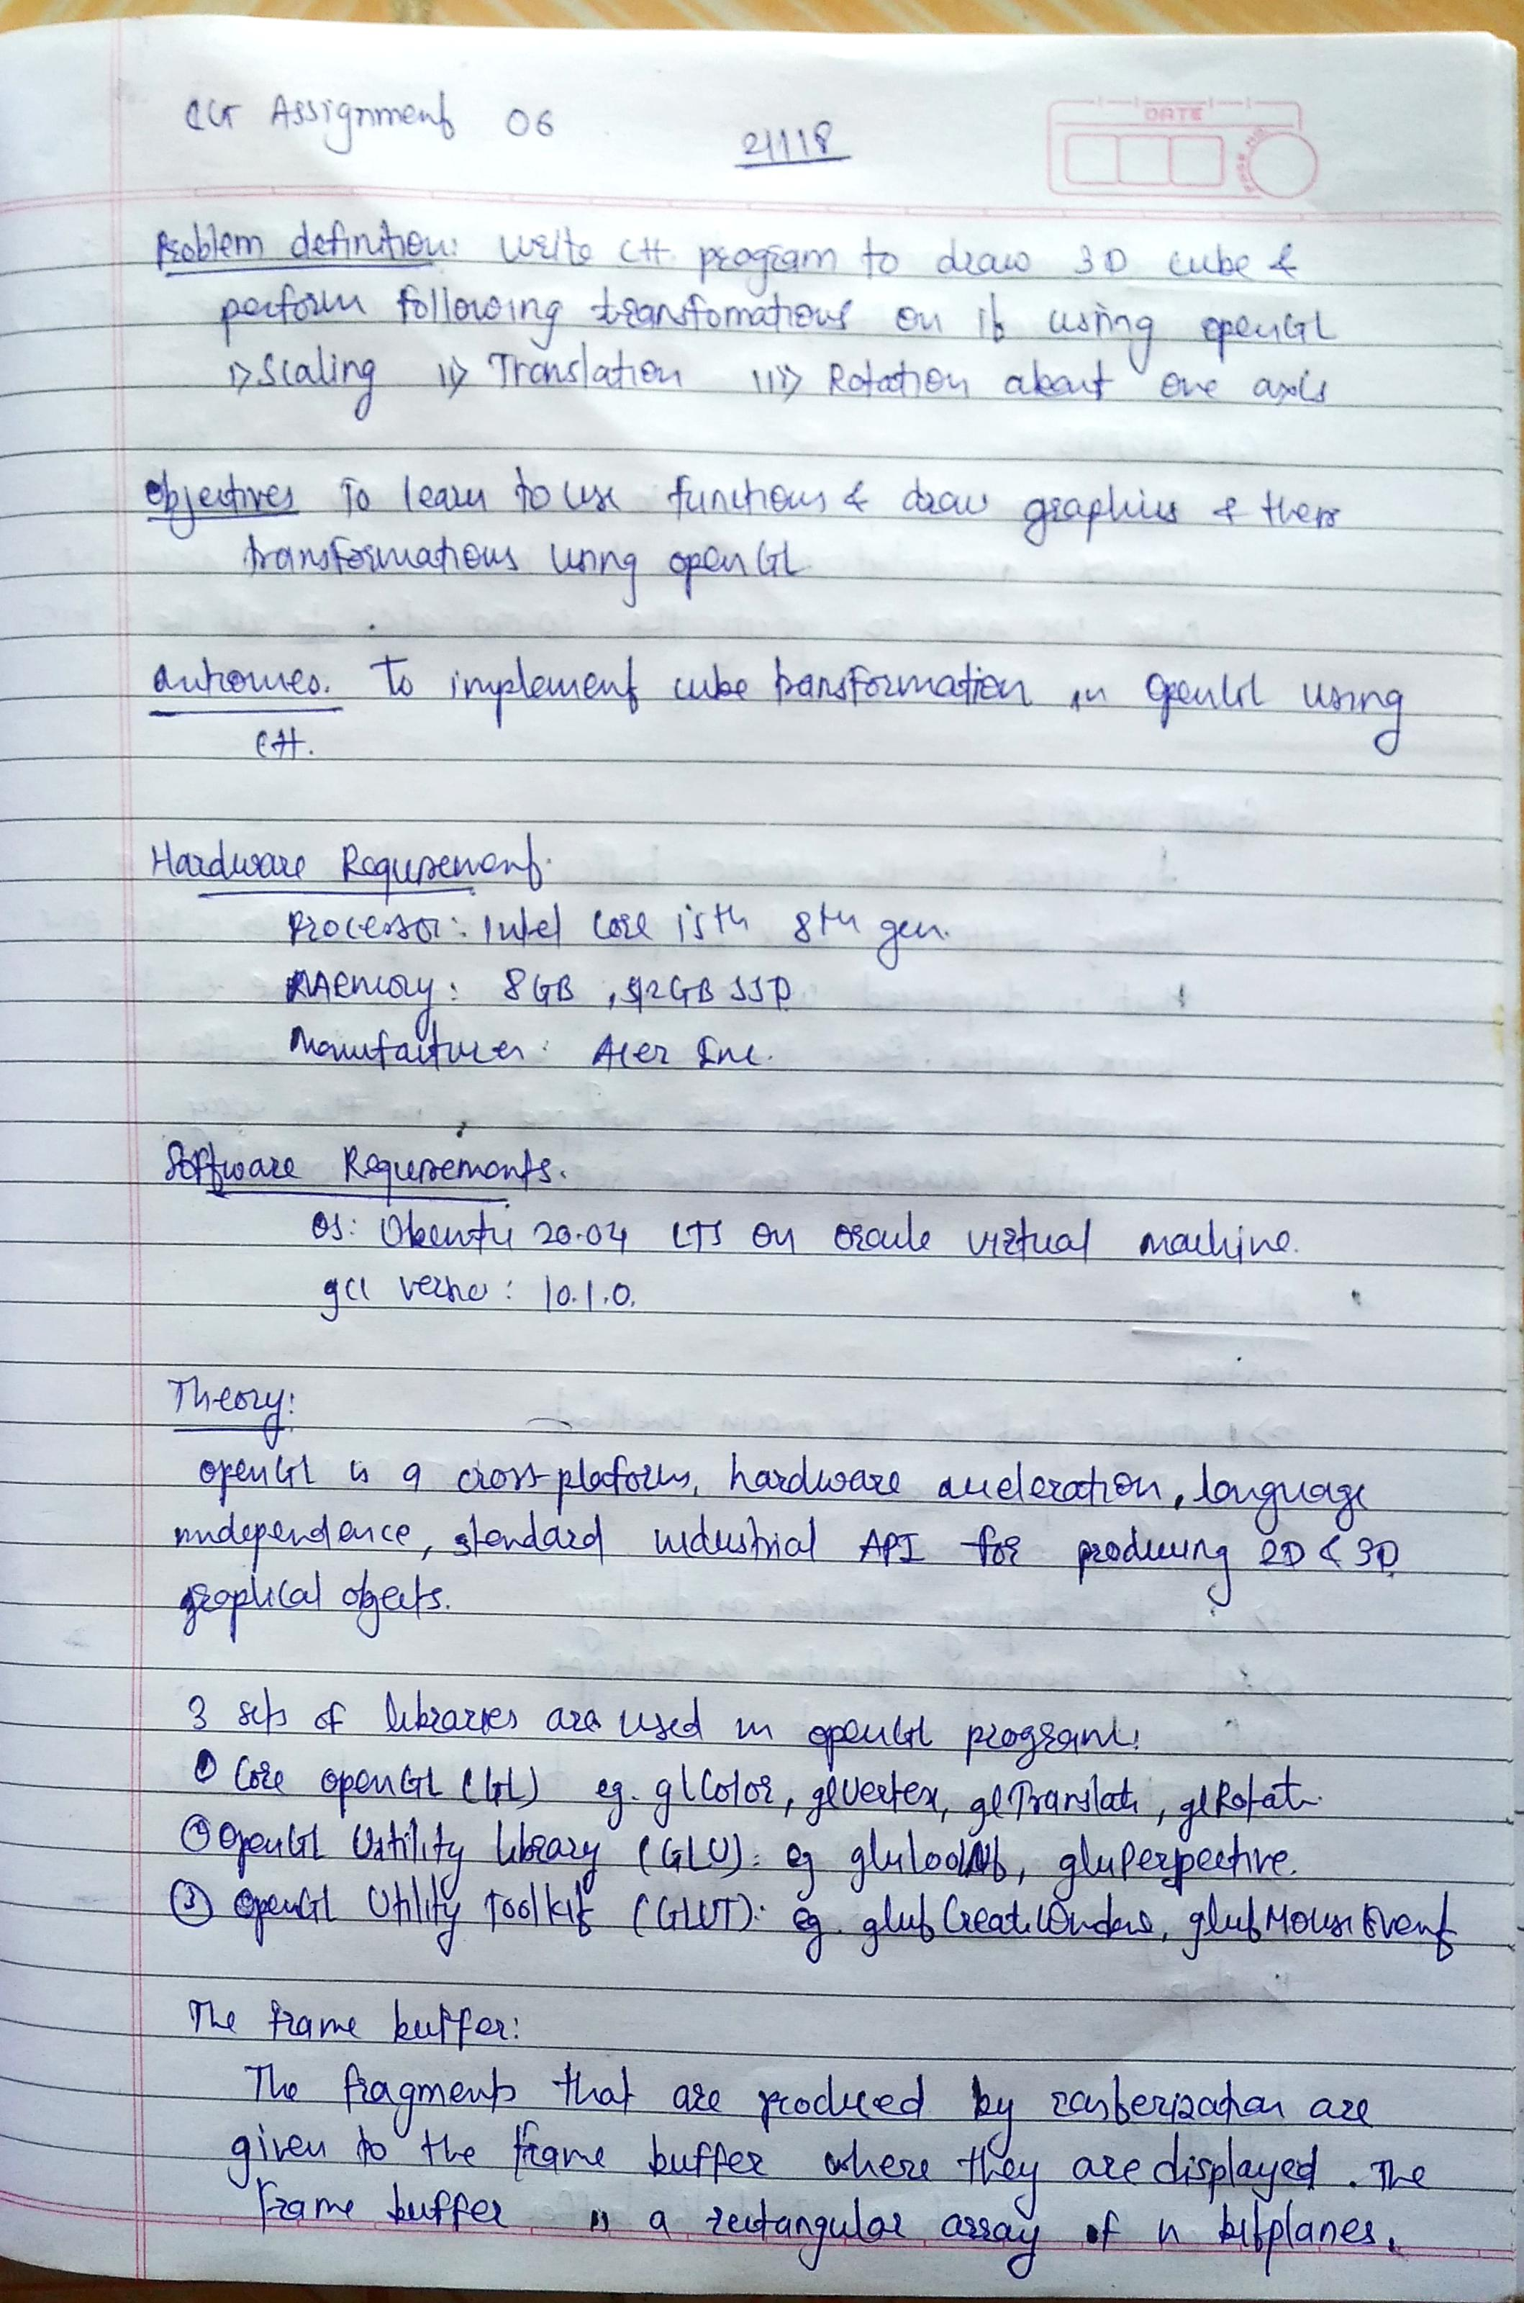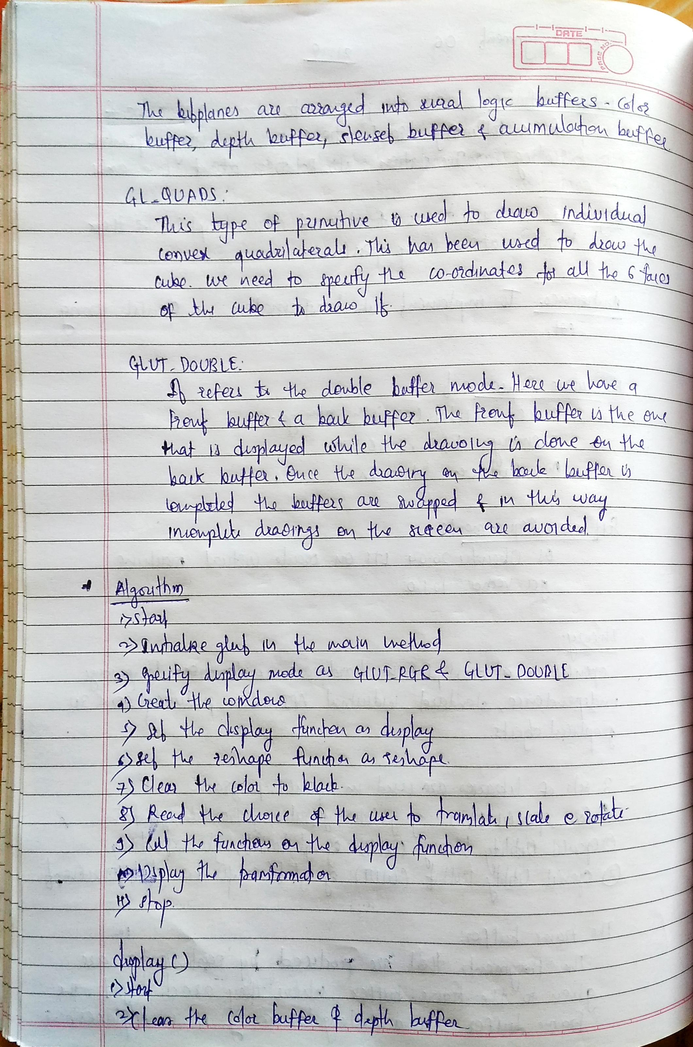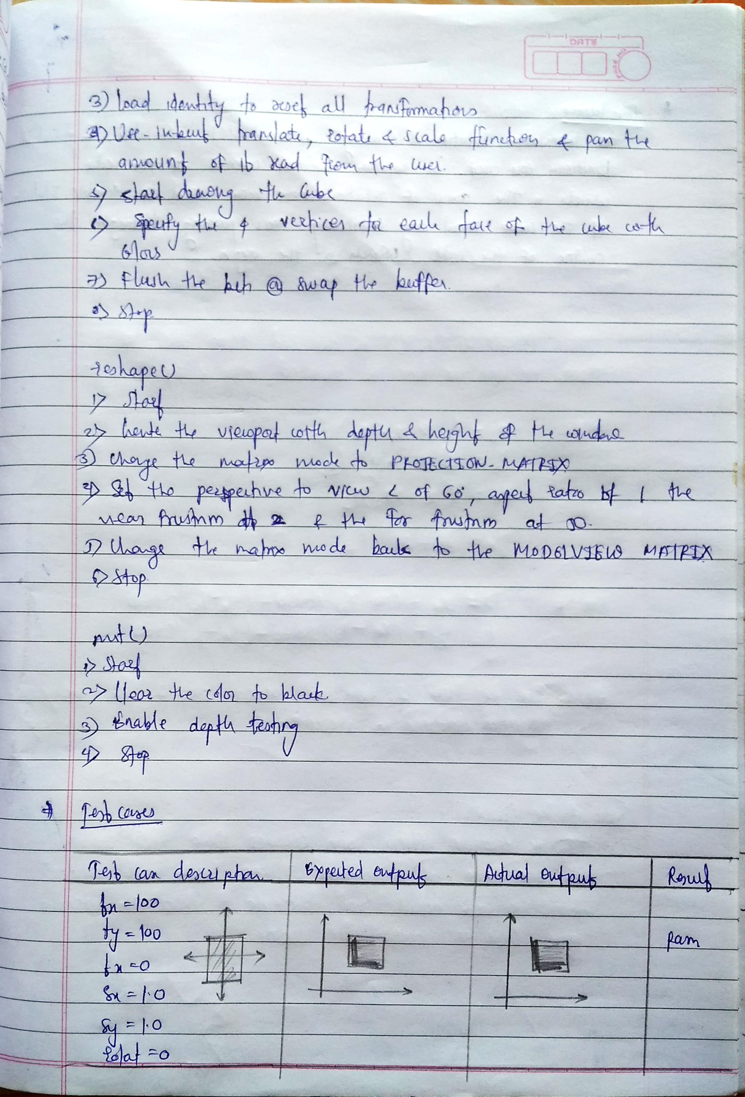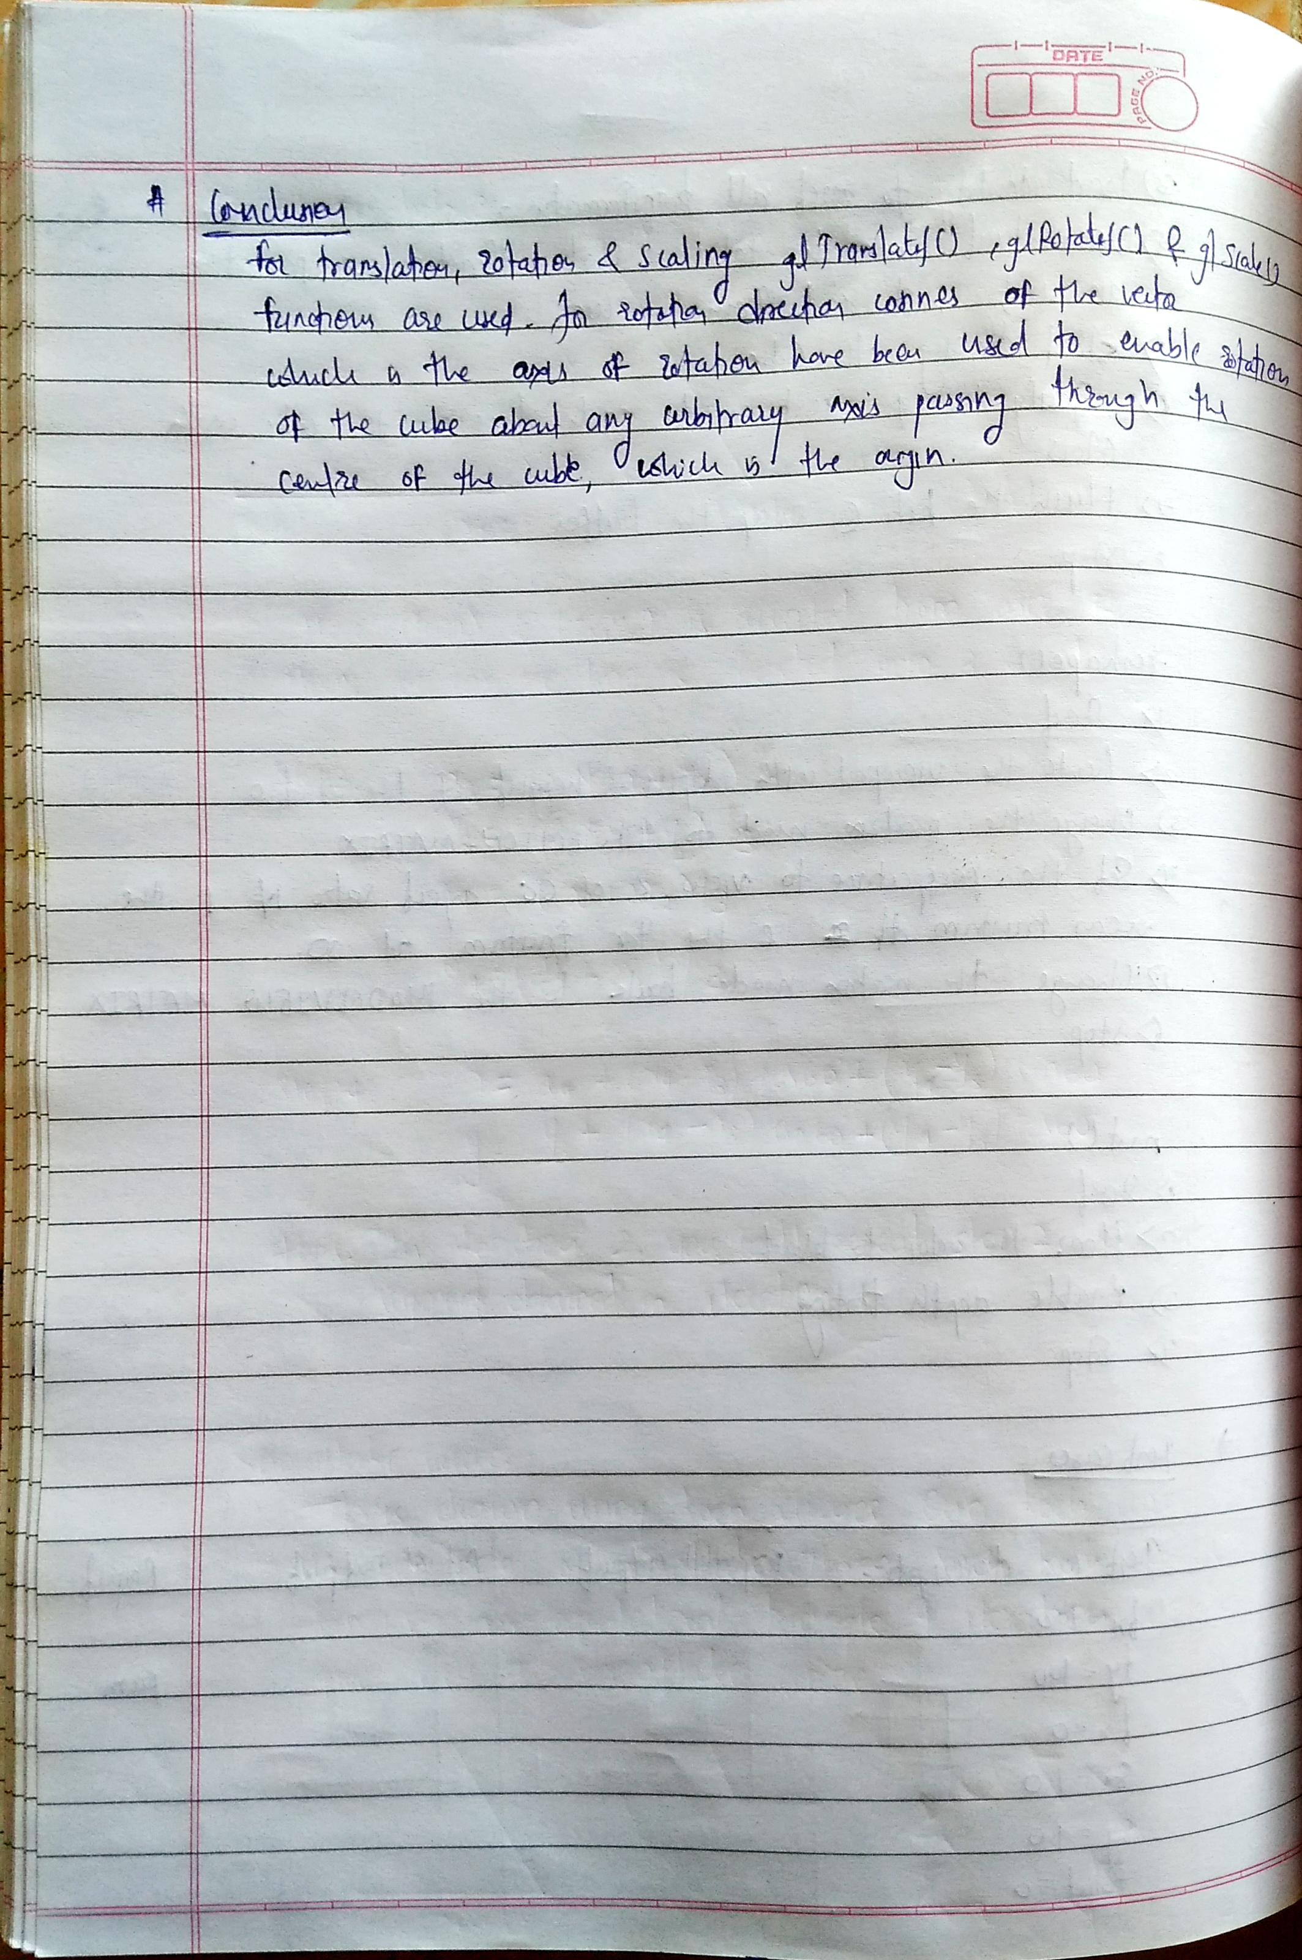

**Testcases and Outputs Description:**

**Translation:** The cube is translated by 100 units along +x axis and 0 units in y and z axis respectively. 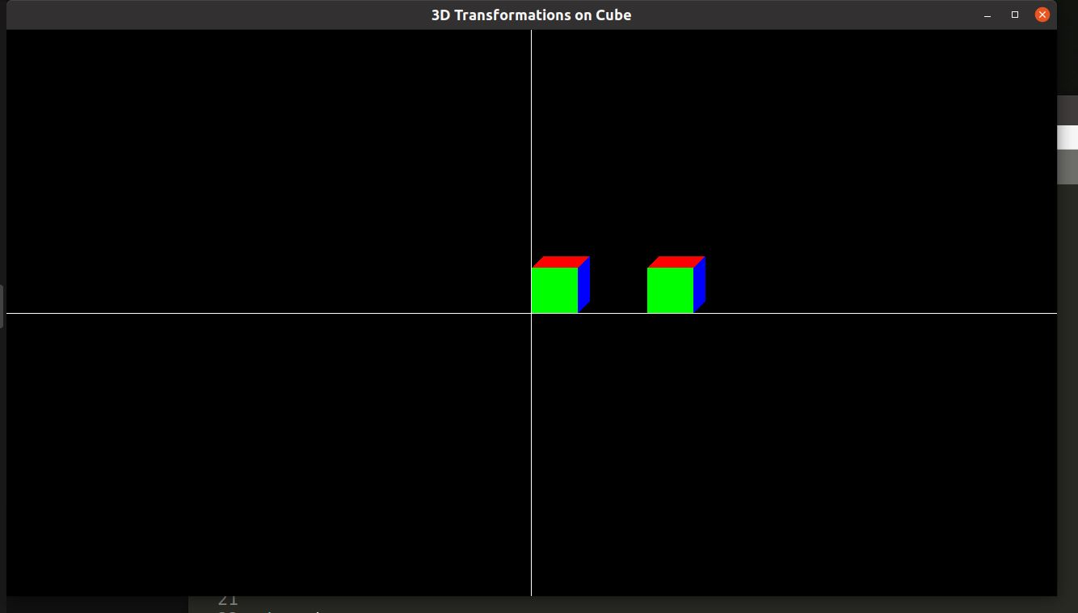

**Scaling**: The cube is scaled by 5 units in all directions that is x, y and z.

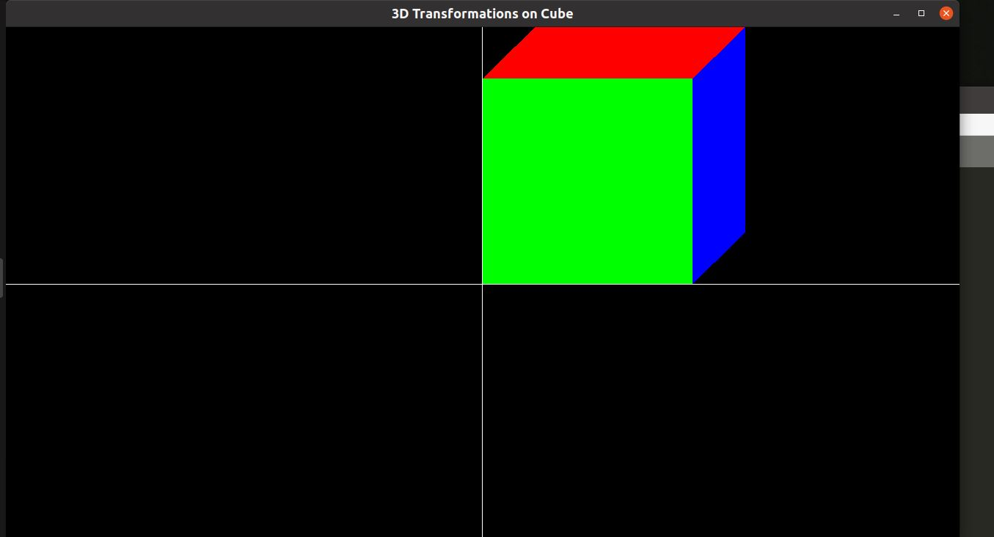

**Rotation:** The cube is rotated by 180 degree along the z axis due to which the rotated cube is in the opposite quadrant of that original cube.