**Name:** Shubham Chemate

**Roll Number:** 21118

**Subject:** Colour CRT Monitor

**Introduction and history:**

**“It's still magic even if you know how it's done.”** - Terry Pratchett

This quote is completely suit in the case of Display Devices. It’s a magic.

A display device is an output device used to represent information in visual form. Types of display devices are Electroluminescent (ELD) Display, Liquid Crystal Display (LCD), Light-Emitting Diode (LED) Display, Plasma Display and Quantum Dot Display.

Cathode Ray Tube (also known as CRT) is a vacuum tube that contains one or more electron guns and phosphorescent screen. CRT is used to display images. It modulates, deflects, accelerates electron beam to display images. Images may be electrical waveform, pictures, radar targets or any other.

The next step in the evolution of display devices after Cathode Ray Tube was the colour CRT display. Colour CRT display is the starting point of evolution of colour television. Colour Television is considered an improvement on the earliest television technology, monochrome or black and white television, in which the image is displayed in shades of grey (grayscale). Television broadcasting stations and networks in most parts of the world upgraded from black and white to colour transmission in the 1960s to the 1980s. The invention of colour television standards is an important part of the history of television, and it is described in the technology of television article.

In my view, the Colour CRT display is the actual start of colour display world.

**Colour CRT Monitor:**

The CRT monitor display can be made colour using combination of phosphorous. The phosphors are different colours. Three different phosphors which emit red, green, and blue light respectively. Colour CRTs have three electron guns, one for each primary colour, arranged either in a straight line or in an equilateral triangular configuration There are two methods for producing colour displays with a CRT:

* Beam Penetration Method
* Shadow-Mask Method

**Beam Penetration Method:**

* The Beam-Penetration method has been used with random-scan monitors.
* In this method, the CRT screen is coated with two layers of phosphor, red and green and the displayed colour depends on how far the electron beam penetrates the phosphor layers.
* This method produces four colours only, red, green, orange and yellow.
* A beam of slow electrons excites the outer red layer only; hence screen shows red colour only.
* A beam of high-speed electrons excites the inner green layer. Thus screen shows a green colour.

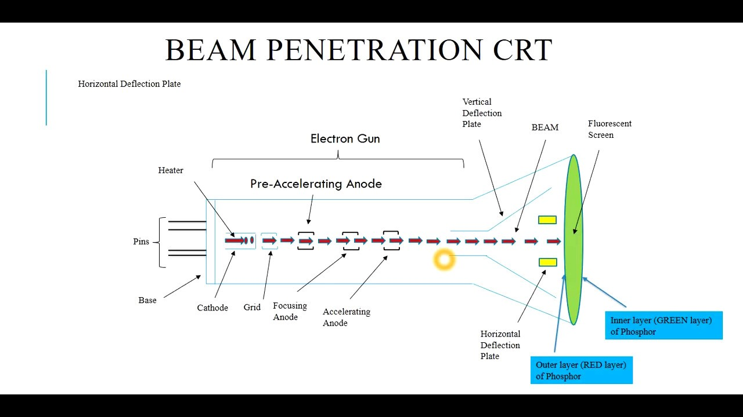

* This method is inexpensive for producing colour displays.
* But on the other hand very few (only four) colours are possible due to which low quality images are produced.

**Shadow-Mask Method:**

* Shadow Mask Method is commonly used in Raster-Scan System because they produce a much wider range of colours than the beam-penetration method.
* It is used in the majority of colour TV sets and monitors.

Construction:

A shadow mask CRT has 3 phosphor colour dots at each pixel position.

1. One phosphor dot emits: red light
2. Second phosphor dot emits: green light
3. Third phosphor dot emits: blue light

This type of CRT has 3 electron guns, one for each colour dot and a shadow mask grid just behind the phosphor coated screen. Shadow mask grid is pierced with small round holes in a triangular pattern.

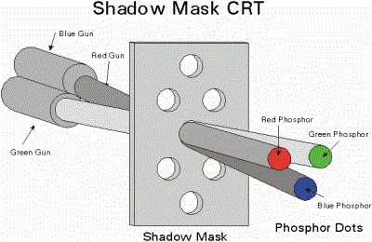

Working:

* Triad arrangement of red, green, and blue guns.
  + The deflection system of the CRT operates on all 3 electron beams simultaneously; the 3 electron beams are deflected and focused as a group onto the shadow mask, which contains a sequence of holes aligned with the phosphor- dot patterns.
  + When the three beams pass through a hole in the shadow mask, they activate a dotted triangle, which occurs as a small colour spot on the screen.
  + The phosphor dots in the triangles are organized so that each electron beam can activate only its corresponding colour dot when it passes through the shadow mask.
* Inline arrangement:
  + It is the 3 electron guns and the corresponding red-green-blue colour dots on the screen, are aligned along one scan line rather of in a triangular pattern.
  + This inline arrangement of electron guns in easier to keep in alignment and is commonly used in high-resolution colour CRT's.

The advantage of this method is that it produces realistic image, also it has millions of colours compared to beam penetration method. Also shadow scenes are possible in this method. On the other side, it is expensive method, it has poor resolution also it has convergence problem.

**Conclusion:**

According to me Colour CRT’s are the beginning of colour displays. All the magic of display devices starts from CRT and it was big revolution while switching to colour CRT. These colour CRT displays are used widely for a long time till LED displays arrived. Also we should not forget display colouring starts from them only.

Thank You.