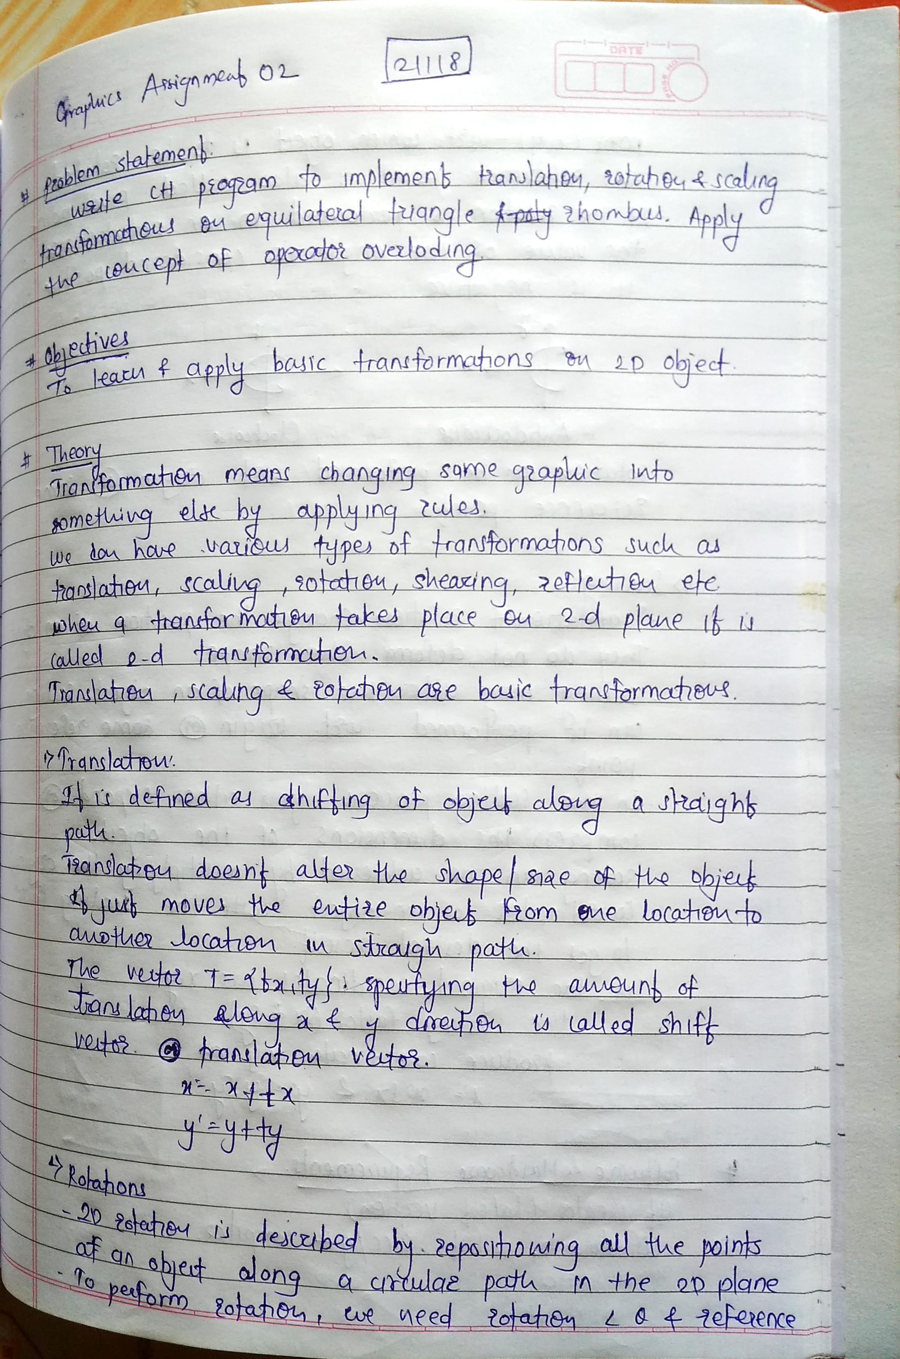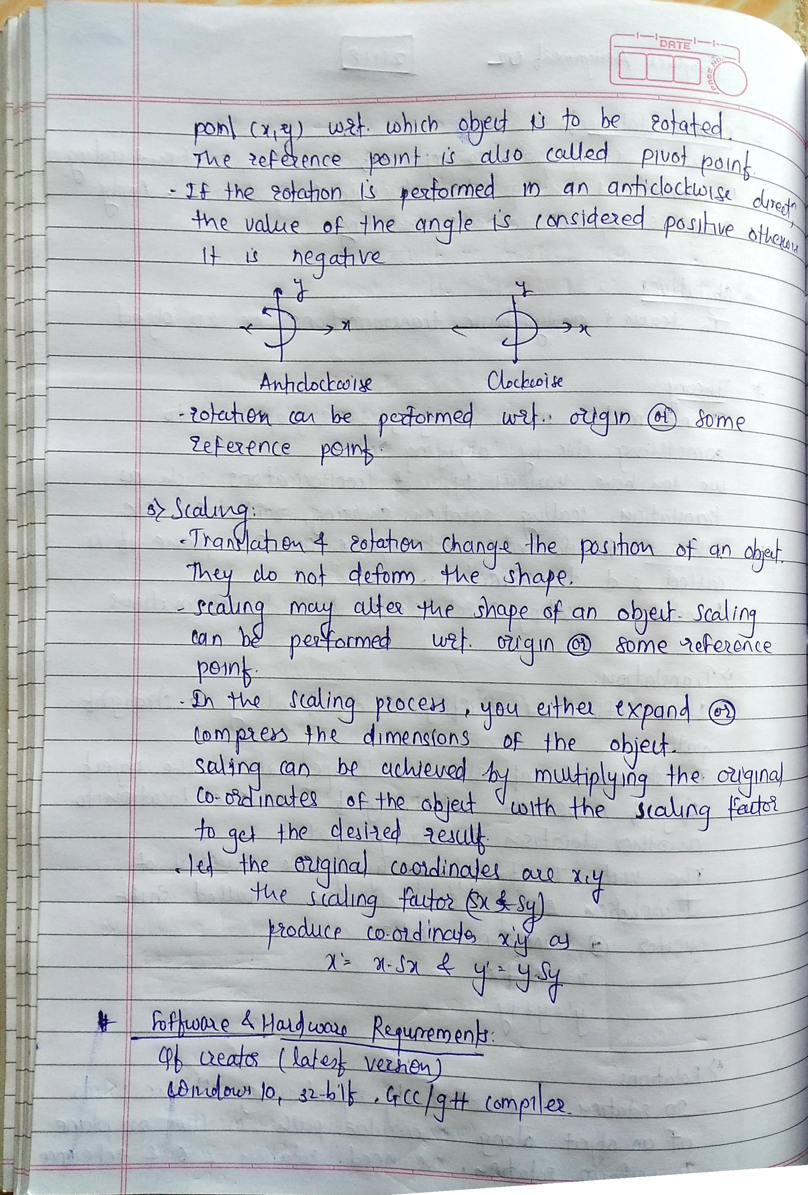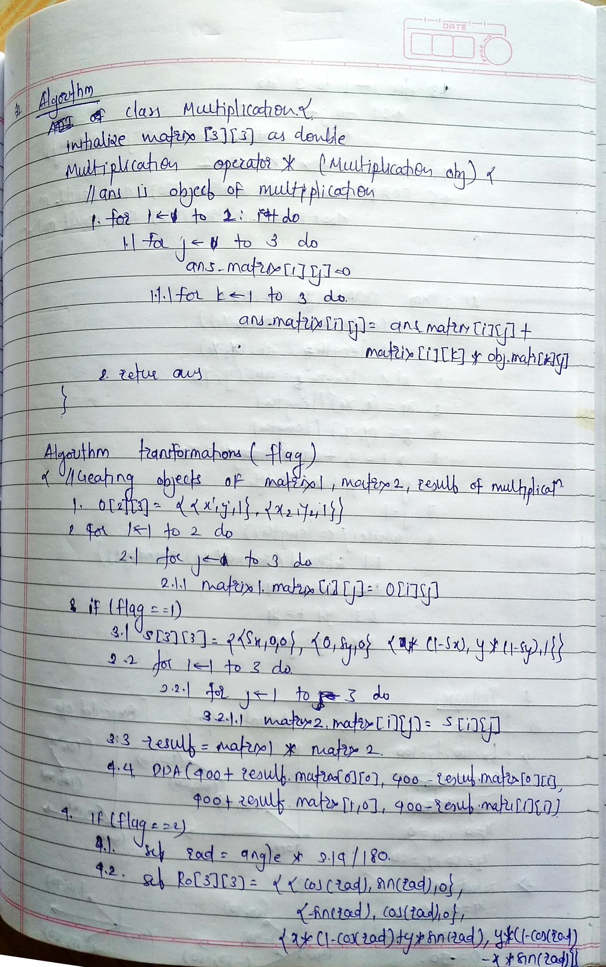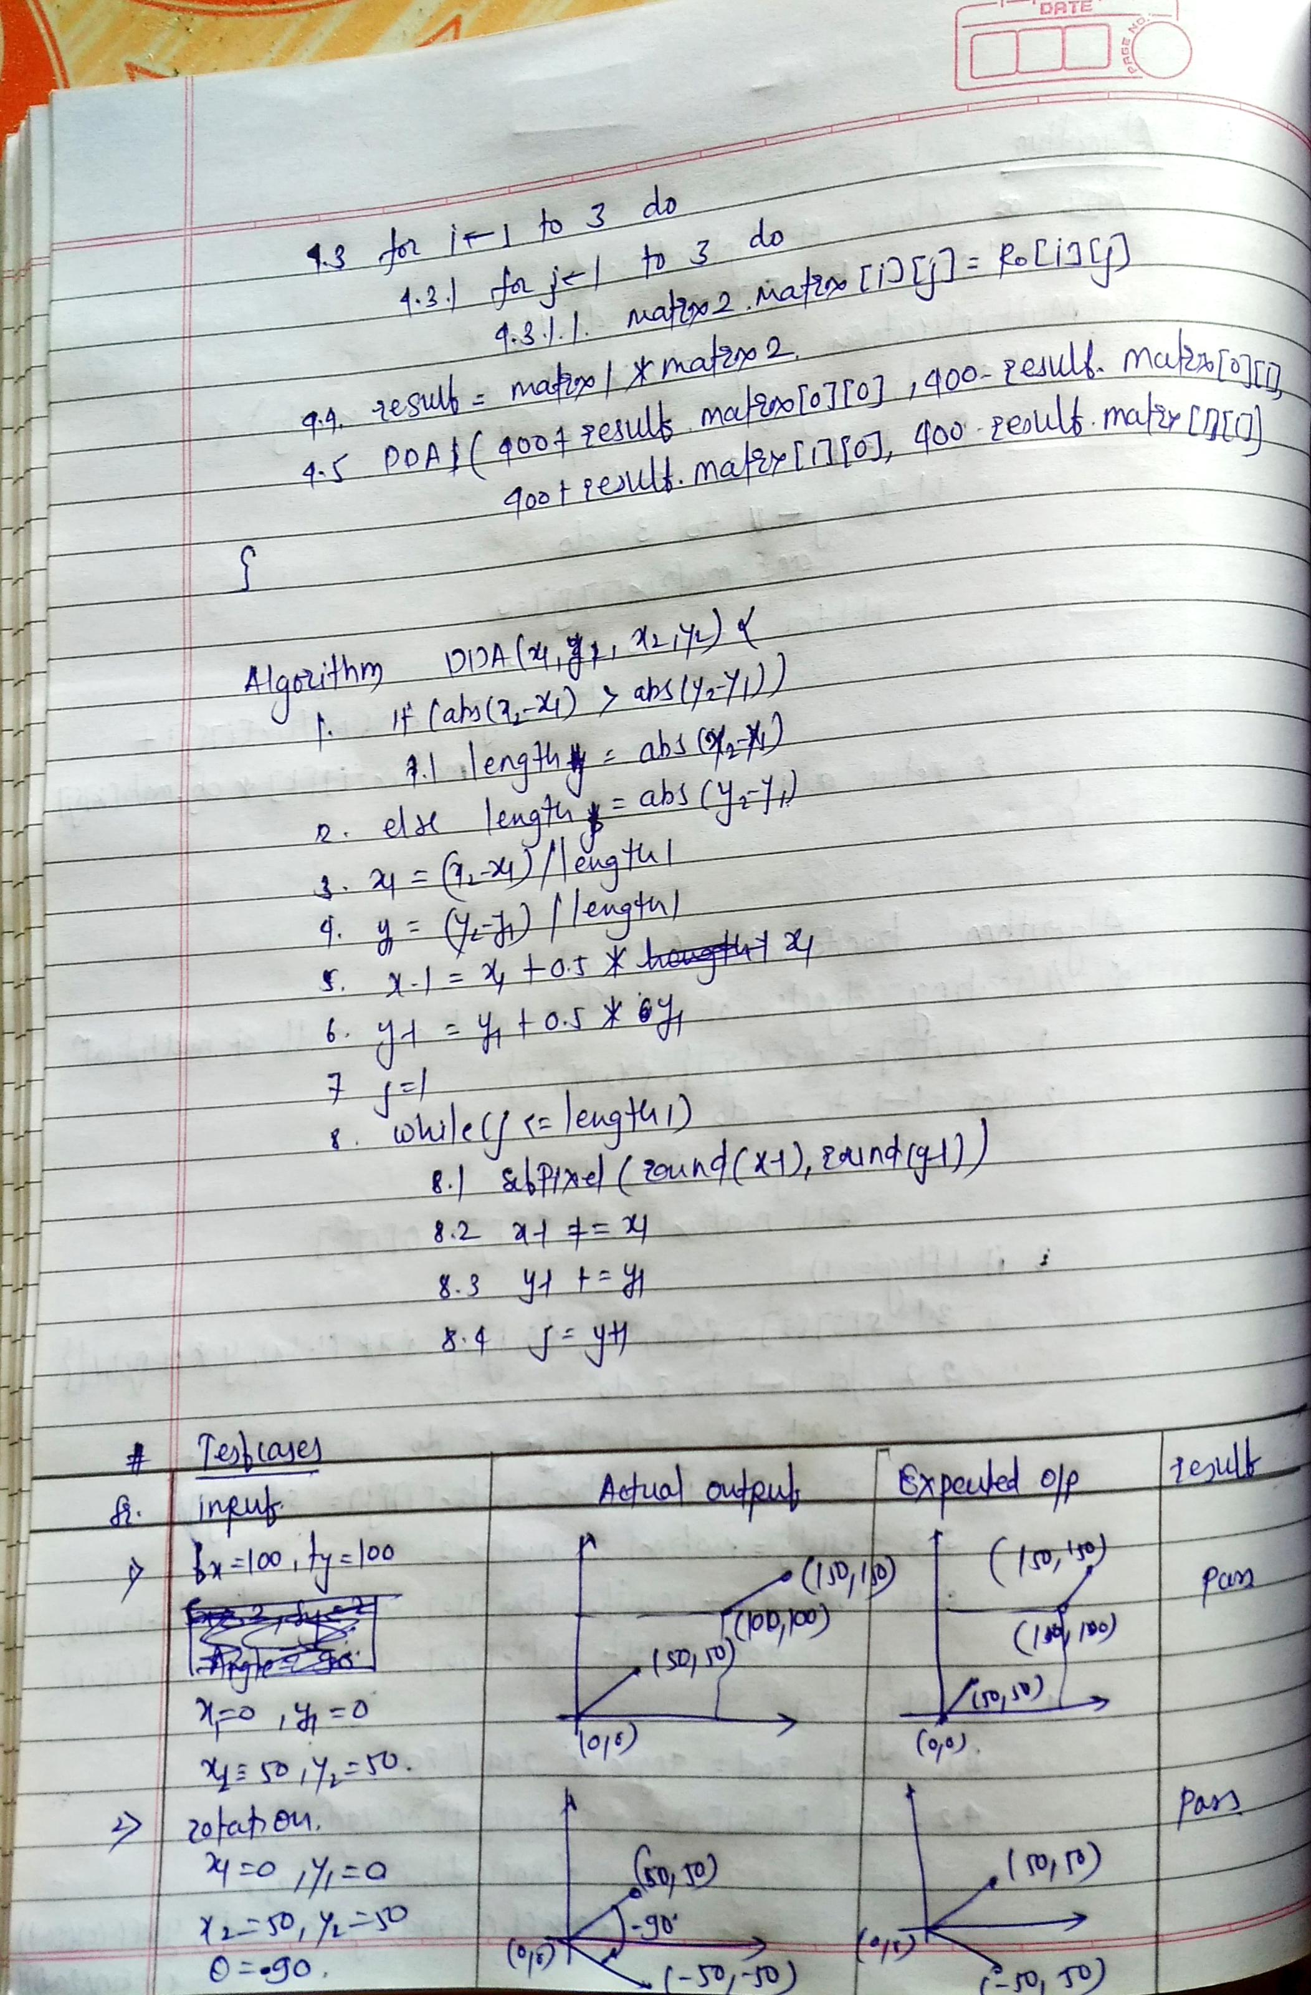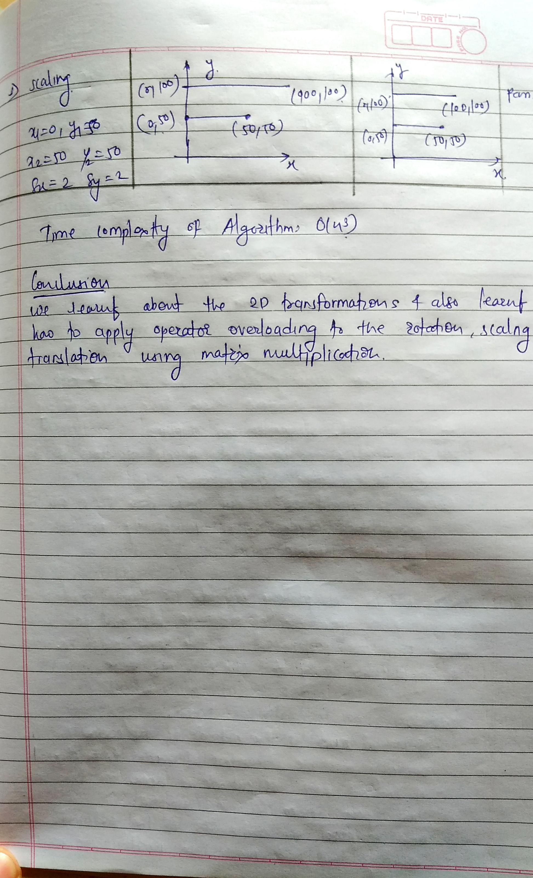

**Output and Explanations:**

**Translation**: The polygon (4 – sides) which in initially drawn at almost centre of console is translated by 200 units in x-direction and by 200 units in y-direction. Since in screen coordinate system +y is in the downword direction and +x is in the right direction, translated object appears at bottom right side of console window.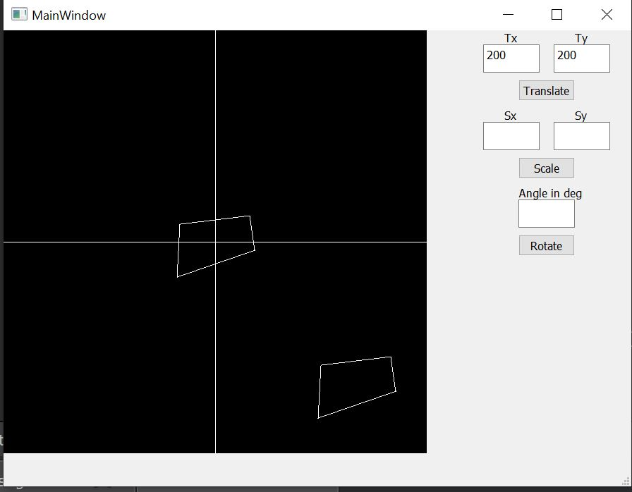

**Scaling**: The polygon (4 - sided) is scaled by 4 units in both x and y direction due to which expands and eventually gets bigger than original.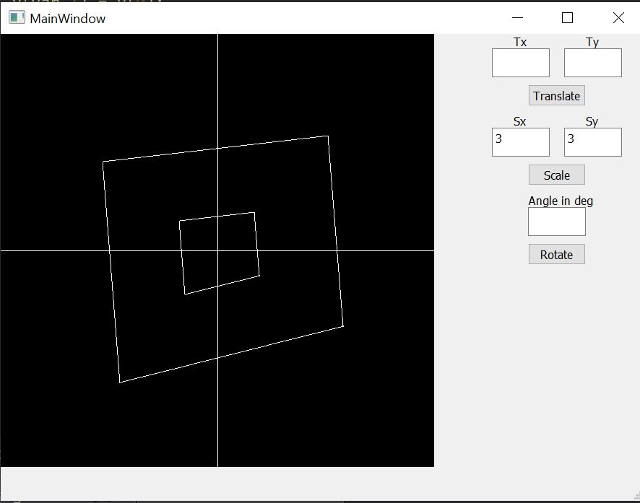

**Rotation**: The four sided polygon is rotated by an angle 180 int x-y plane. The rotated polygon is exactly opposite to the original one (due to 180 degree turn).

