**DSL Assignment07A Screenshots of testcases**

Name: Shubham Chemate

Roll Number: **21118**

Booking Seat:-

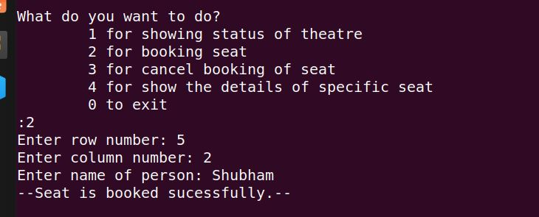

Cancel Booking of seat:-

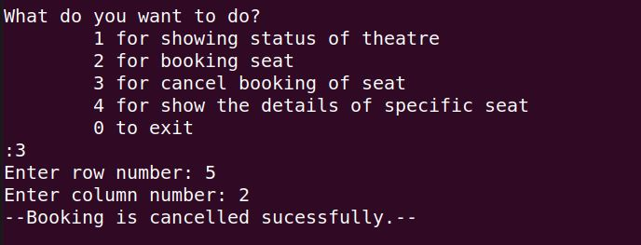

Showing Details of un-booked seat:-

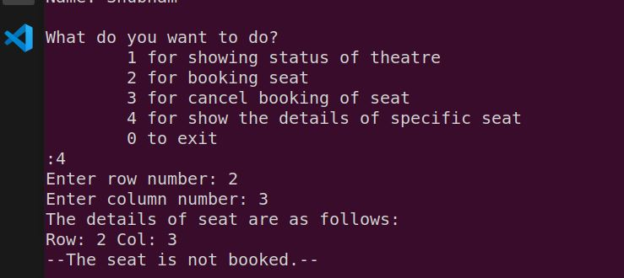

Showing Details of booked seat:-

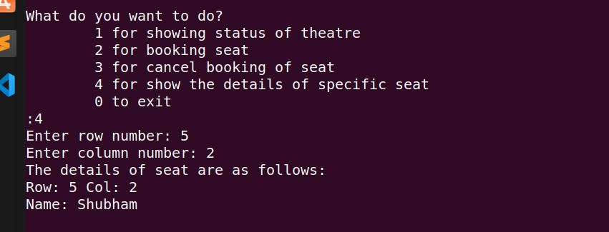

Showing status of entire theatre:-

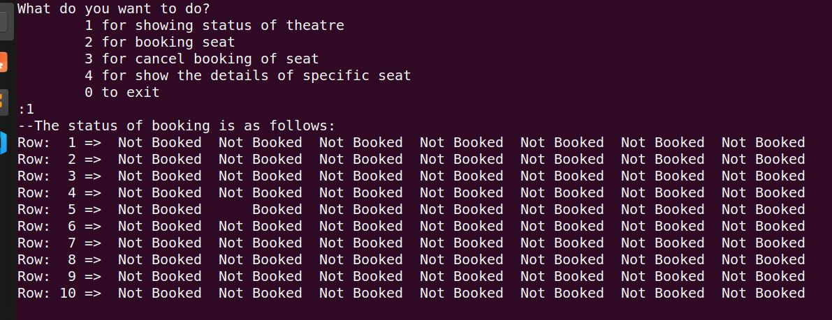

Booking already booked seat:-



  