Testcase#1 : General infix to postfix conversion

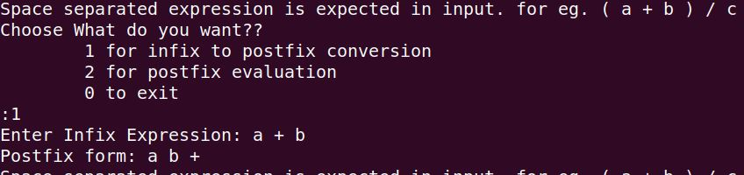

Testcase#2 : Infix to postfix conversion with brackets

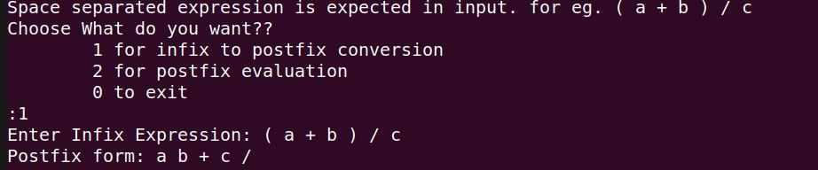

Testcase#3: Infix to postfix conversion for multiple brackets

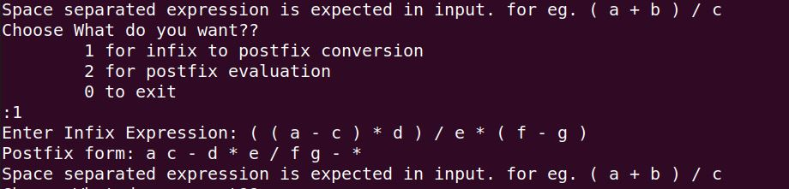

Testcase#4: Postfix evaluation (with ans as float value)

