Testcase#1: Adding job to the queue

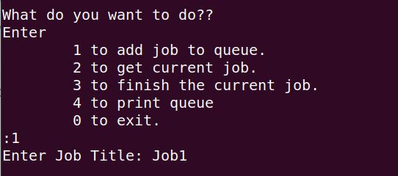

Testcase#2: Adding a job when queue gets full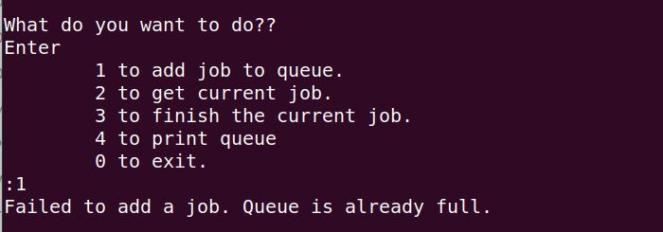

Testcase#3: Getting current running job (front of queue)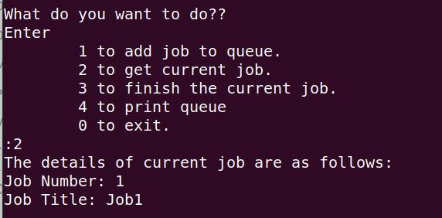

Testcase#4: Printing all jobs in a queue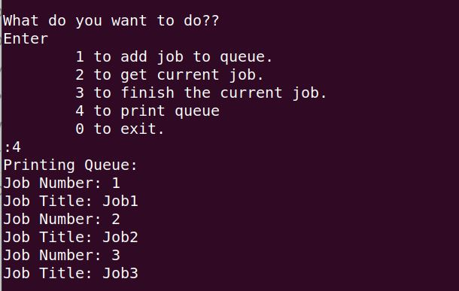

Testcase#5: removing a job from queue