Testcase#1: Adding to priority priority queue 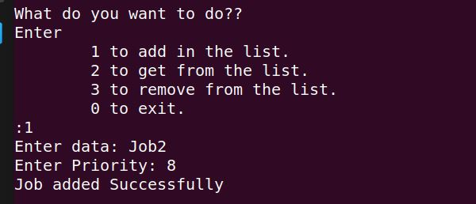

Testcase#2: geeting from priority queue

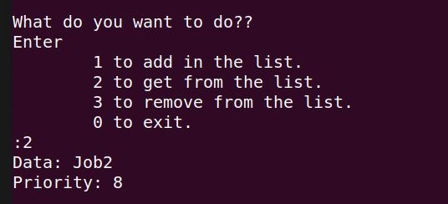

Testcase#3: Adding to full priority queue

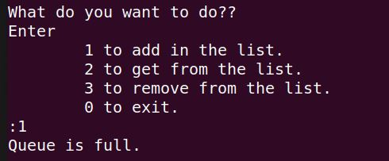

Testcase#4: Removing from priority queue

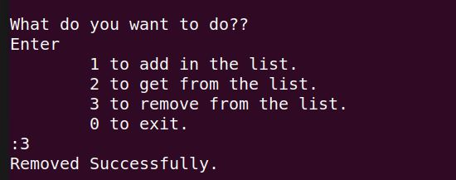

Testcase#5: removing from empty priority queue