**Assignment – 01**

**Name**: Shubham Chemate **Subject:** OOP Lab

**Roll No:** 21118 **Date:** 20-Aug-2020

**Batch:** E-1

**Problem Statement:**

Implement a class Complex which represent the Complex Number data type. Implement the following:

1. Constructor (Including Default constructor which create complex number 0+0i).
2. Overloaded operator+ to add two complex numbers.
3. Overloaded operator* to multiply two complex numbers.
4. Overloaded << and >> to print and read complex numbers.

**Source File:**

Source file (.cpp) is attached with this assignment file.

**Test Cases and Output:**

Consider a as first complex number and b as second complex numbers.

a = (1 + 2i)

b = (2 + 0i)

|  |  |  |
| --- | --- | --- |
| **Test Case** | **Expected Output** | **Program Output** |
| Addition | (3 + 2i) | (3 + 2i) |
| Subtraction | (-1 + 2i) | (-1 + 2i) |
| Multiplication | (2 + 4i) | (2 + 4i) |
| Division | (0.5 + 1i) | (0.5 + 1i) |

Input:

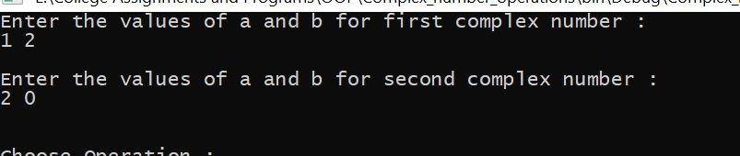

Addition:

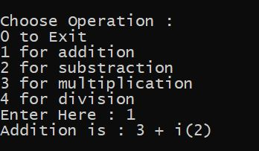

Subtraction:

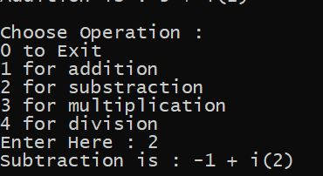

Multiplication:

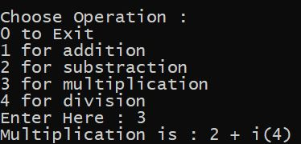

Division:

