**Assignment – 02**

**Name**: Shubham Chemate **Subject:** OOP Lab

**Roll No:** 21118 **Date:** 07-Sept-2020

**Batch:** E-1

**Problem Statement:**

Develop a program in C++ to create a database of student’s information system containing the following information: Name, Roll Number, Class, Division, Date of Birth, Blood Group, Contact Address, Telephone Number, Driving Licence Number and Other. Construct a database with suitable member function. Make use of constructor, default constructor, copy constructor, destructor, static member functions, friend class, this pointer, inline code and dynamic memory allocation operators-new and delete as well as exception handling.

**Source Code:**

Source code file(.cpp) is provided with this document as attachment.

**Input and Output Demo:**

Entering Student Information:

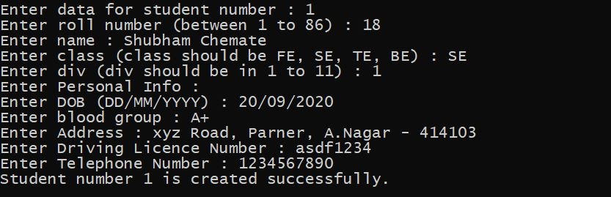

Output (Student Information):

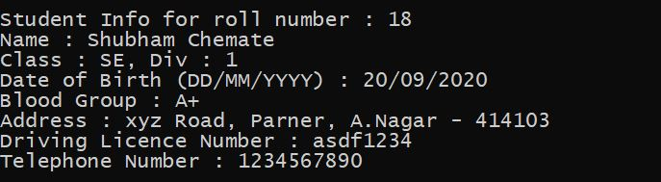

Output (Student Information – through copy constructor (Copies data of first student)):

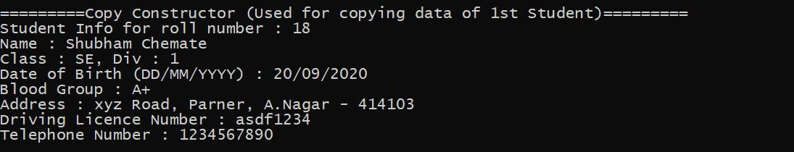

Exception Handling (For invalid roll number):

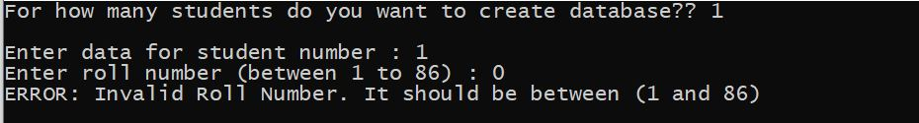

Thank You.