**Assignment – 03**

**Name**: Shubham Chemate **Subject:** OOP Lab

**Roll No:** 21118 **Date:** 15-Oct-2020

**Batch:** E-1

**Problem Statement:**

Imagine a publishing company which does marketing for book and audio cassette versions. Create a class publication that stores the title (a string) and price (type float) of publications. From this class derive two classes: book which adds a page count (type int) and tape which adds a playing time in minutes (type float).

Write a program that instantiates the book and tape class, allows user to enter data and displays the data members. If an exception is caught, replace all member values with zero values.

**Source Code:**

Source code file(.cpp) is provided with this document as attachment.

**Input and Output Demo:**

Entering Information:

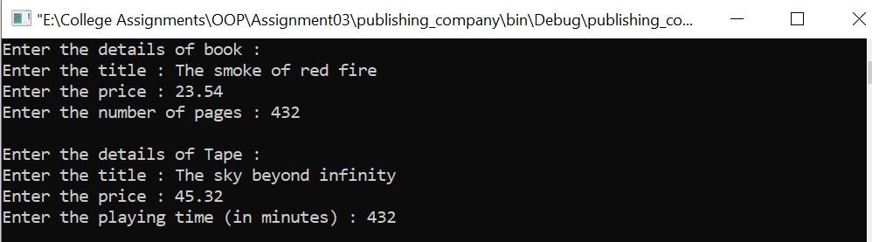

Output (Information):

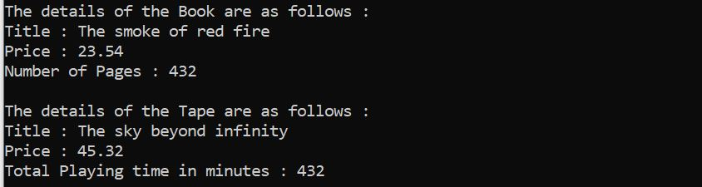

Exception Handling (for invalid price of book and playing time of tape):

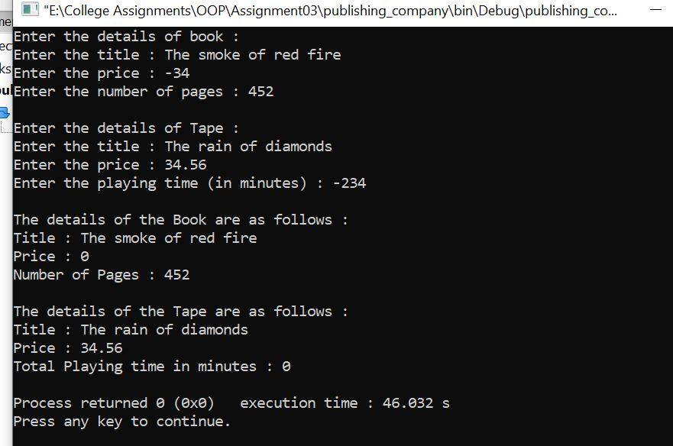

Thank You.