**Assignment – 04**

**Name**: Shubham Chemate **Subject:** OOP Lab

**Roll No:** 21118 **Date:** 26-Oct-2020

**Batch:** E-1

**Problem Statement:**

Write a c++ program that creates an output file, writes information to it, closes the file, open it again as an input file and read the information from the file.

**Source Code:**

Source code file(.cpp) is provided with this document as attachment.

**Input and Output Demo:**

Writing to the newly created file:

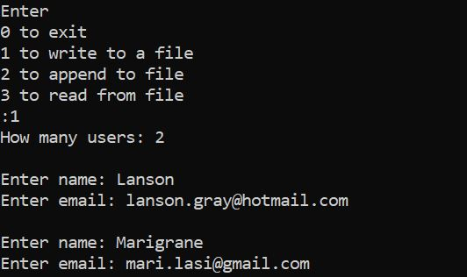

Appending to an existing file (appending to the same file created above):

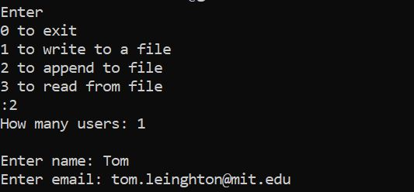

*File before appending:* 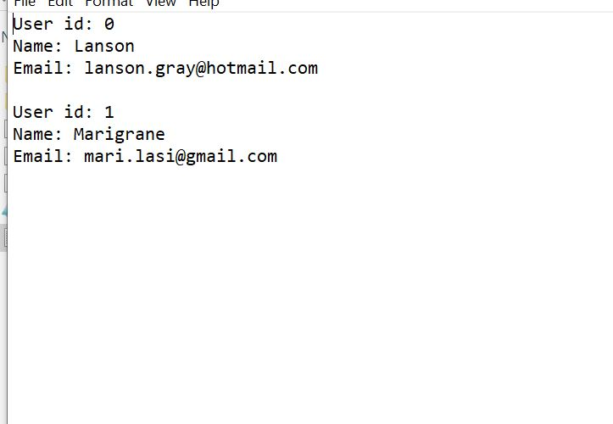

*File after appending:*

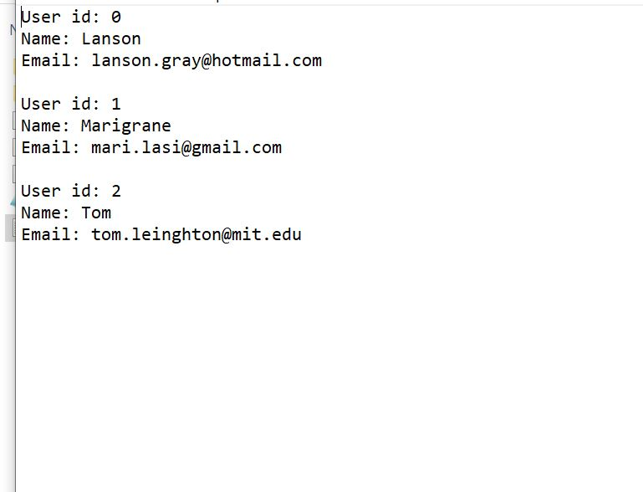

Reading from file:

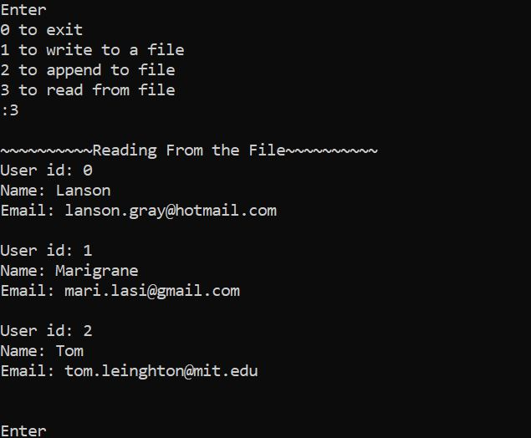

Thank you.