//============================================================================

// Name : 21118_DSA_A03.cpp

// Author : Shubham (Roll No: 21118)

//============================================================================

**#include** <iostream>

**using** **namespace** std;

**class** Node {

**private**:

**int** data;

Node *lChild, *rChild;

**bool** lTh, rTh;

**public**:

**Node**(**int** x = 0) {

data = x;

lChild = rChild = NULL;

lTh = rTh = **true**;

}

**friend** **class** TBST;

};

**class** TBST {

**private**:

Node *root, *head;

**public**:

**TBST**() {

root = NULL;

head = **new** Node(0);

}

Node* **getRoot**() {**return** root;}

**void** **InsertNode**(**int** x) {

**if** (root == NULL) {

root = **new** Node(x);

root->lChild = root->rChild = head;

**return**;

}

Node *curr = root, *prev = NULL;

**while** (curr != head) {

prev = curr;

**if** (x < curr->data) {

**if** (curr->lTh == **false**)

curr = curr->lChild;

**else**

**break**;

}

**else** **if** (x > curr->data) {

**if** (curr->rTh == **false**)

curr = curr->rChild;

**else**

**break**;

}

**else** **if** (x == curr->data)

**return**;

}

curr = **new** Node(x);

**if** (x < prev->data) {

curr->rChild = prev;

curr->lChild = prev->lChild;

prev->lChild = curr;

prev->lTh = **false**;

}

**else** **if** (x > prev->data) {

curr->lChild = prev;

curr->rChild = prev->rChild;

prev->rChild = curr;

prev->rTh = **false**;

}

}

**void** **CreateTree**() {

**while** (**true**) {

cout << "Enter data of node or -1:\n";

**int** x; cin >> x;

**if** (x == -1)

**break**;

InsertNode(x);

ThInorder();

}

}

**void** **ThInorder**() {

**if** (root == NULL) {

cout << "EMPTY TREE\n";

**return**;

}

Node* curr = root;

**while** (curr->lTh == **false**)

curr = curr->lChild;

**while** (curr != head) {

cout << curr->data << " ";

**if** (curr->rTh == **false**) {

curr = curr->rChild;

**while** (curr->lTh == **false**)

curr = curr->lChild;

}

**else**

curr = curr->rChild;

}

cout << **endl**;

}

**void** **ThPreorder**() {

**if** (root == NULL) {

cout << "EMPTY TREE\n";

**return**;

}

Node* curr = root;

**while** (curr != head) {

cout << curr->data << " ";

**if** (curr->lTh == **false**)

curr = curr->lChild;

**else** {

**if** (curr->rTh == **false**)

curr = curr->rChild;

**else** {

**while** (curr != head && curr->rTh == **true**)

curr = curr->rChild;

**if** (curr == head)

**break**;

curr = curr->rChild;

}

}

}

cout << **endl**;

}

**bool** **Search**(Node* curr_root, **int** x, Node*& curr, Node*& parent) {

**if** (curr_root == head)

**return** **false**;

curr = curr_root;

**if** (curr_root->data == x)

**return** **true**;

parent = curr;

**if** (x < curr_root->data)

**return** Search(curr_root->lChild, x, curr, parent);

**else**

**return** Search(curr_root->rChild, x, curr, parent);

}

**void** **deleteNode**(**int** x) {

Node *curr = NULL, *parent = NULL;

**if** (!Search(root, x, curr, parent)) {

cout << "NOT FOUND\n";

**return**;

}

**if** (curr->lTh == **false** && curr->rTh == **false**) {

Node* temp = curr->rChild;

parent = curr;

**while** (temp->lTh == **false**) {

parent = temp;

temp = temp->lChild;

}

curr->data = temp->data;

x = temp->data;

curr = temp;

}

**if** (curr->lTh == **true** && curr->rTh == **true**) {

**if** (curr == parent->lChild) {

parent->lChild = curr->lChild;

parent->lTh = **true**;

}

**else** **if** (curr == parent->rChild) {

parent->rChild = curr->rChild;

parent->rTh = **true**;

}

**delete** curr;

}

**else** **if** (curr->lTh == **false** && curr->rTh == **true**) {

Node* temp = curr->lChild;

**if** (parent->lChild == curr)

parent->lChild = temp;

**else**

parent->rChild = temp;

**while** (temp->rTh == **false**)

temp = temp->rChild;

temp->rChild = curr->rChild;

**delete** curr;

}

**else** **if** (curr->lTh == **true** && curr->rTh == **false**) {

Node* temp = curr->rChild;

**if** (parent->lChild == curr)

parent->lChild = temp;

**else**

parent->rChild = temp;

**while** (temp->lTh == **false**)

temp = temp->lChild;

temp->lChild = curr->lChild;

**delete** curr;

}

}

};

**int** **main**() {

TBST tbst;

**while** (**true**) {

cout << "\nChoose Option:\n";

cout << "\t1 for Insert\n\t2 for Delete\n\t3 for Traversal\n\t0 to Exit\n:";

**int** choice = 0; cin >> choice;

**if** (choice == 0)

**break**;

**switch** (choice) {

**case** 1: {

cout << "Enter data (for insert): ";

**int** x; cin >> x;

tbst.InsertNode(x);

cout << "Inorder: "; tbst.ThInorder();

**break**;

}

**case** 2: {

cout << "Enter data (for delete): ";

**int** x; cin >> x;

tbst.deleteNode(x);

cout << "Inorder: "; tbst.ThInorder();

**break**;

}

**case** 3: {

cout << "Tree Traversals:\n";

cout << "Inorder: "; tbst.ThInorder();

cout << "Preorder: "; tbst.ThPreorder();

**break**;

}

**default**:

cout << "INVALID CHOICE. Try Again.\n";

}

}

cout << "\n----END-----\n";

**return** 0;

}

TESTCASE 1:

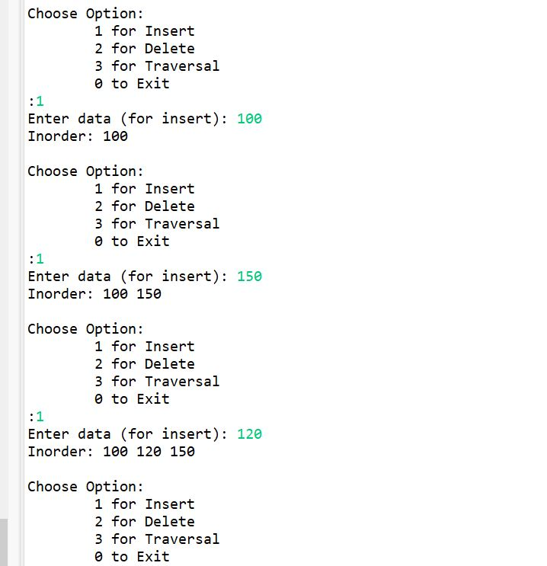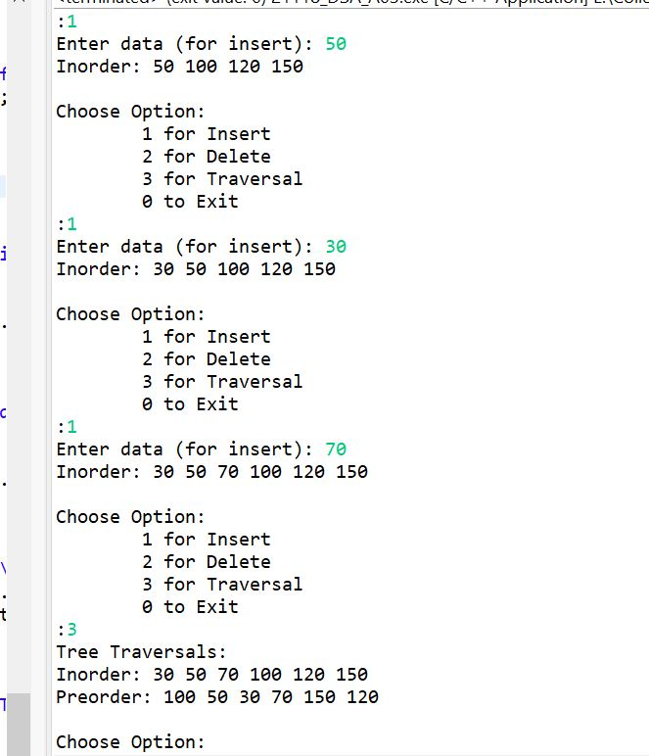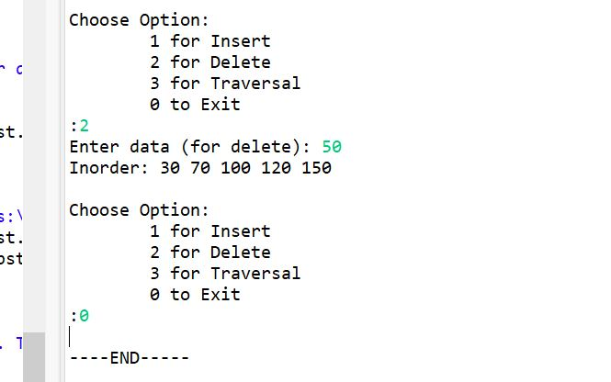

TESTCASE 2:

