*main() function:*

//============================================================================

// Name : 21118_DSA_A07.cpp

// Author : Shubham (Roll No: 21118)

//============================================================================

**#include** <iostream>

**#include** "mst.h"

**using** **namespace** std;

**int** **main**() {

**while** (1) {

**int** n, m, u, v, wt, opt;

cout << "\n\nEnter number of vertices and edges.\n";

cin >> n >> m;

mst mymst(n, m);

cout << "Enter edges and weights:\n";

**for** (**int** i = 0; i < m; i++) {

cin >> u >> v >> wt;

mymst.addEdge(u, v, wt);

}

cout << "How do you want to calculate mst:\n";

cout << "\t1 for Prim's Algorithm\n";

cout << "\t2 for Kruskal's Algorithm\n";

cin >> opt;

**if** (opt == 1)

cout << mymst.prims_mst_wt() << **endl**;

**else** **if** (opt == 2)

cout << mymst.kruskals_mst_wt() << **endl**;

**else**

cout << "INVALID CHOICE.\n";

cout << "Do you want to calculate again?(0 or 1)\n";

cin >> opt;

**if** (opt == 0)

**break**;

}

**return** 0;

}

*mst.h header file(contain declaration of mst class):*

/*

* kruskals_mst.h

*

* Created on: 25-May-2021

* Author: Shubham

*/

**#ifndef** MST_H_

**#define** MST_H_

**class** Edge {

**private**:

**int** u, v, wt;

**public**:

**Edge**() {u=0, v=0, wt=0;}

**Edge**(**int** x, **int** y, **int** w);

**friend** **class** mst;

};

**class** mst {

**private**:

**int** vertices, edges;

**int**\*\* adj_list;

**int**\* par; // to keep track of root node of mst in disjoint mst's (kruskal's algo)

**int** **find_mst**(**int** u);

**void** **union_mst**(**int** u1, **int** u2);

**public**:

**mst**(**int** n, **int** m);

**void** **printGraph**();

**void** **addEdge**(**int** u, **int** v, **int** w);

**int** **prims_mst_wt**();

**int** **kruskals_mst_wt**();

**~mst**();

};

**#endif** /* MST_H_ */

*mst.cpp file(contains implementation of mst class):*

/*

* mst.cpp

*

* Created on: 25-May-2021

* Author: Shubham

*/

**#include** <iostream>

**#include** <algorithm> // for sort function

**#include** "mst.h"

**using** **namespace** std;

**Edge::Edge**(**int** x, **int** y, **int** w) {

u = x, v = y, wt = w;

}

// find mst of vertex u

**int** **mst::find_mst**(**int** u) {

**while** (par[u] != u)

u = par[u];

**return** u;

}

// take union of mst's represented by u1 and u2

**void** **mst::union_mst**(**int** u1, **int** u2) {

**int** x = find_mst(u1), y = find_mst(u2);

**if** (x != y)

par[x] = y;

}

**mst::mst**(**int** n, **int** m) {

vertices = n, edges = m;

par = **new** **int**[n];

adj_list = **new** **int**\*[n];

**for** (**int** i = 0; i < n; i++) {

adj_list[i] = **new** **int**[n];

par[i] = i;

}

**for** (**int** i = 0; i < n; i++)

**for** (**int** j = 0; j < n; j++)

adj_list[i][j] = 0;

}

**void** **mst::addEdge**(**int** u, **int** v, **int** w) {

adj_list[u][v] = w;

adj_list[v][u] = w;

}

**int** **mst::prims_mst_wt**() {

**bool** mst_vert[vertices] = { 0 };

**int** vert_wt[vertices], mst_wt = 0, parent_vert[vertices];

**for** (**int** i = 0; i < vertices; i++)

vert_wt[i] = 10000, parent_vert[i] = -1;

vert_wt[0] = 0;

**while** (1) {

**int** v = -1;

**for** (**int** i = 0; i < vertices; i++)

**if** (!mst_vert[i] && (v == -1 || vert_wt[i] < vert_wt[v]))

v = i;

**if** (v == -1)

**break**;

mst_vert[v] = 1;

**if** (vert_wt[v] == 10000)

vert_wt[v] = 0;

mst_wt += vert_wt[v];

**for** (**int** j = 0; j < vertices; j++)

**if** (adj_list[v][j] && !mst_vert[j]

&& (adj_list[v][j] < vert_wt[j])) {

vert_wt[j] = adj_list[v][j];

parent_vert[j] = v;

}

}

cout << "mst edges:\n";

**for** (**int** i = 0; i < vertices; i++)

**if** (parent_vert[i] != -1)

cout << i << " <-> " << parent_vert[i] << '\n';

**return** mst_wt;

}

**int** **mst::kruskals_mst_wt**() {

**int** mst_wt = 0;

Edge edge_list[edges];

**int** cnt = 0;

**for** (**int** i = 0; i < vertices; i++)

**for** (**int** j = i + 1; j < vertices; j++)

**if** (adj_list[i][j])

edge_list[cnt++] = Edge(i, j, adj_list[i][j]);

// sort function from c++ standard template library with custom comparator (using lambda fn)

sort(edge_list, edge_list + edges, [](Edge e1, Edge e2) {

**return** e1.wt < e2.wt;

});

**int** edge_cnt = 0, i = 0, mst_edges[vertices - 1][2];

**while** (edge_cnt < vertices - 1 && i < edges) {

Edge cur = edge_list[i++];

**int** u_par = find_mst(cur.u), v_par = find_mst(cur.v);

**if** (u_par != v_par) {

mst_edges[edge_cnt][0] = cur.u, mst_edges[edge_cnt][1] = cur.v;

mst_wt += cur.wt, edge_cnt++;

union_mst(u_par, v_par);

}

}

cout << "mst edges:\n";

**for** (**int** i = 0; i < edge_cnt; i++)

cout << mst_edges[i][0] << " <-> " << mst_edges[i][1] << **endl**;

**return** mst_wt;

}

**void** **mst::printGraph**() {

cout << "Adjacency matrix representation of graph: \n";

**for** (**int** i = 0; i < vertices; i++, cout << '\n')

**for** (**int** j = 0; j < vertices; j++)

cout << adj_list[i][j] << " ";

}

**mst::~mst**() {

**for** (**int** i = 0; i < vertices; i++)

**delete**[] adj_list[i];

**delete**[] adj_list;

**delete**[] par;

}

**TESTCASE 1:**

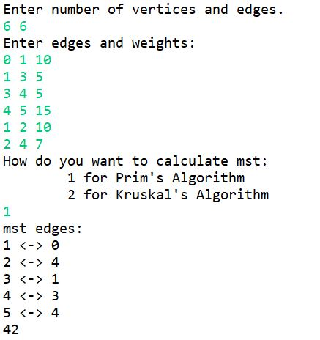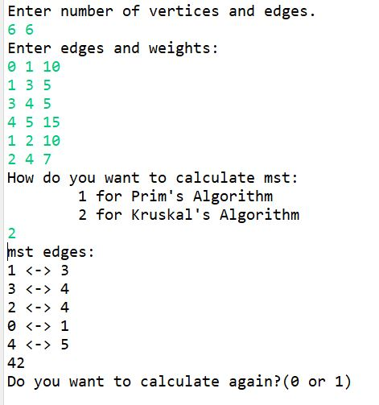

**TESTCASE 2:**

