Assignment No 08

Name: Shubham Chemate

Roll Number: **21118**

PROBLEM STATEMENT /DEFINITION:

Write x86 ALP to perform non-overlapped and overlapped block transfer (with and without string specific instructions). Block containing data can be defined in the data segment

OBJECTIVE:

To learn

* Overlapped / Non – overlapped data transfer in segments
* Block transfer instruction of 8086
* Data storage in the memory and segments

OUTCOME:

Students will study different block transfer instructions and also understood block transfer within different segments

HARDWARE USED:

* Manufacturer and model: Acer Swift-3
* Processor: Intel core i5 – 8265U @1.60 GHz
* Memory: 8GB of DDR4 RAM and 512GB of ROM
* System Type: 64-bit OS, x-64 based PC

SOFTWARE USED:

* Operating system: Windows 10 and Ubuntu 20.04LTS. Using WSL 2 (Windows Subsystem for Linux) and Installed WSL plugin in VS Code.
* Text editor: VS Code (open source edition, version: 1.26.2)
* Assembler: NASM (version: 2.14.02)

THEORY:

Instructions used:

*A] Non-overlapped block transfer:*

1. MOVSB-This is a string instruction and it moves string byte from source to destination
2. REP- This is prefix that are applied to string operation. Each prefix cause the string instruction that follows to be repeated the number of times indicated in the count register.
3. CLD- Clear Direction flag. ESI and EDI will be incremented and DF = 0
4. STD- Set Direction flag. ESI and EDI will be incremented and DF = 1
5. ROL-Rotates bits of byte or word left.
6. AND-AND each bit in a byte or word with corresponding bit in another byte or word.
7. INC-Increments specified byte/word by1.
8. DEC-Decrements specified byte/word by1.
9. JNZ-Jumps if not equal to Zero.
10. JNC-Jumps if no carry is generated.
11. CMP-Compares to specified bytes or words.
12. JBE-Jumps if below or equal.
13. ADD-Adds specified byte to byte or word to word.
14. CALL-Transfers the control from calling program to procedure.
15. RET-Return from where call is made.

*B] Overlapped block transfer:*

1. MOVSB-This is a string instruction and it moves string byte from source to destination.
2. REP- This is prefix that are applied to string operation. Each prefix cause the string instruction that follows to be repeated the number of times indicated in the count register.
3. CLD- Clear Direction flag. ESI and EDI will be incremented and DF = 0
4. STD- Set Direction flag. ESI and EDI will be decremented and DF = 1 2
5. ROL-Rotates bits of byte or word left.
6. AND-AND each bit in a byte or word with corresponding bit in another byte or word.
7. INC-Increments specified byte/word by1.
8. DEC-Decrements specified byte/word by1.
9. JNZ-Jumps if not equal to Zero.
10. JNC-Jumps if no carry is generated.
11. CMP-Compares to specified bytes or words.
12. JBE-Jumps if below or equal.
13. ADD-Adds specified byte to byte or word to word.
14. CALL-Transfers the control from calling program to procedure.
15. RET-Return from where call is made.

ALGORITHMS:

1. Start
2. Initialize data section.
3. Initialize the count, source block and destination block.
4. Using Macro display the Menu for block transfer without string instruction, block transfer with string instruction and exit.
5. If choice = 1, call procedure for non-overlapping block transfer without string instruction.
6. If choice = 2, call procedure for non-overlapping block transfer with string instruction.
7. If choice = 3, call procedure for overlapping block transfer without string instruction.
8. If choice = 4, call procedure for non-overlapping block transfer with string instruction.
9. If choice = 5, terminate the program.

*A] Non-overlapped block transfer:*

* Without string instructions
  1. Initialize ESI and EDI with source and destination address.
  2. Move count in ECX register.
  3. Move contents at ESI to accumulator and from accumulator to memory location of EDI.
  4. Increment ESI and EDI to transfer next content. 5. Repeat procedure till count becomes zero.
* With string instructions
  1. Initialize ESI and EDI with source and destination address.
  2. Move count in ECX register.
  3. Clear the direction flag.
  4. Move the contents from source location to the destination location using string instruction.
  5. Repeat string instruction the number of times indicated in the count register.

*B] Overlapped block transfer:*

* Without string instructions
  1. Initialize ESI and EDI with source and destination address.
  2. Move count in ECX register.
  3. Move source block’s and destination block’s last content address in ESI and EDI.
  4. Move contents at ESI to accumulator and from accumulator to memory location of EDI.
  5. Decrement ESI and EDI to transfer next content. 6. Repeat procedure till count becomes zero.
* With string instructions
  1. Initialize ESI and EDI with source and destination address.
  2. Move count in ECX register.
  3. Move source block’s and destination block’s last content address in ESI and EDI.
  4. Set the direction flag.
  5. Move the data from source location to the destination location using string instruction.
  6. Repeat string instruction the number of times indicated in the count register.

PROGRAM:

; 21118 Shubham

; MPL Assignment No: 04

%macro print 2

mov rax,1

mov rdi,1

mov rsi,%1

mov rdx,%2

syscall

%endmacro

%macro read 2

mov rax,0

mov rdi,1

mov rsi,%1

mov rdx,%2

syscall

%endmacro

%macro exit 0

mov rax,60

mov rdi,0

syscall

%endmacro

section .data

array : dq 01H, 02H, 03H, 04H, 05H, 00H, 00H, 00H, 00H, 00H

ent : db 0x0A

lent : equ $-ent

colon : db " : "

lencol : equ $-colon

before : db "Before copy",10

lenbe : equ $-before

after : db "After copy",10

lenaf : equ $-after

menu :

db "1 : Non-overlapping without string",10

db "2 : Non-overlapping with string",10

db "3 : Overlapping without string",10

db "4 : Overlapping with string",10

db "5 : Exit",10

db "Enter your choice",10

lenmenu : equ $-menu

section .bss

data : resb 16

cnt1 : resb 1

cnt2 : resb 1

choice : resb 2

global _start

section .text

_start:

print menu,lenmenu

read choice,2

cmp byte[choice],31H

JE NOWOS

cmp byte[choice],32H

JE NOWS

cmp byte[choice],33H

JE OWOS

cmp byte[choice],34H

JE OWS

cmp byte[choice],35H

JE exit

; --------------- Labels to call procedures ---------------

NOWOS :

call CALL1

exit

OWOS :

call CALL2

exit

NOWS :

call CALL3

exit

OWS :

call CALL4

exit

; --------------- Hex to Ascii conversion ---------------

h_to_a :

mov rdi,data

mov byte[cnt2],16

UP1 :

rol rbx,4

mov dl,bl

and dl,0FH

cmp dl,09H

jbe NEXT

add dl,07H

NEXT :

add dl,30H

mov byte[rdi],dl

inc rdi

dec byte[cnt2]

JNZ UP1

print data,16

ret

; --------------- Printing array ---------------

print_array :

mov rsi,array ;set source pointer to array

mov byte[cnt1],10 ;count is having 10 because number of numbers in array are 10

UP :

mov rbx,rsi ;first we print addresses so we move rsi for htoa conversion

push rsi ;push rsi because we'll require rsi later

call h_to_a

print colon,lencol ;after printing address we print colon

pop rsi ;pop rsi pushed earlier and we

mov rbx,qword[rsi] ;move byte[rdi] to rbx that is the number to be printed

push rsi

call h_to_a

;after printing address colon and the data at that address

print ent,lent ;we print enter and loop for rest of the array

pop rsi

add rsi,8

dec byte[cnt1]

JNZ UP

ret

; --------------- Non overlapping without string instructions ---------------

CALL1 :

print ent,lent ;print array before copying data

print before,lenbe

call print_array

mov rsi,array ;set source index to first element of array

mov rdi,array+40 ;dest block starts after last element

mov byte[cnt1],5

UP2 :

mov rax,qword[rsi] ;mov data from rsi to rdi using rax variable

mov qword[rdi],rax ;rax is temp for copying

add rsi,8

add rdi,8

dec byte[cnt1]

JNZ UP2

print ent,lent ;print array after copying the contents

print after,lenaf

call print_array

ret

; --------------- Overlapping without string ---------------

CALL2 :

print ent,lent ;print array before copying data

print before,lenbe

call print_array

mov rsi,array ;first array element

add rsi,32 ;third last array element

mov rdi,rsi ;2 overlapping rdi begins from third last element to array

add rdi,24

mov byte[cnt1],5

UP3 :

mov rax,[rsi] ;mov data from rsi to rdi using rax variable

mov [rdi],rax ;rax is temp for copying

sub rsi,8

sub rdi,8

dec byte[cnt1]

JNZ UP3

print ent,lent ;print array after copying the contents

print after,lenaf

call print_array

ret

; --------------- Non overlapping with string ---------------

CALL3 :

print before,lenbe

call print_array

mov rsi,array

mov rdi,array+40

mov byte[cnt1],5

UP4:

CLD ;we clear the direction flag so that we'll increment array addresses automatically

movsq ;mov string of quadword for moving a complete string of data from source to destination

dec byte[cnt1]

JNZ UP4

print ent,lent

print after,lenaf

call print_array

ret

; --------------- Overlapping with string ---------------

CALL4 :

print before,lenbe

call print_array

mov rsi,array ;points to first location

add rsi,32 ; +4 goes to last block

mov rdi,rsi ;des to last block

add rdi,24 ;overlapping two blocks

mov byte[cnt1],5

UP5 :

STD ;std to decrement, cld to increment direction flag

movsq

dec byte[cnt1]

JNZ UP5

print ent,lent

print after,lenaf

call print_array

ret

OUTPUT:

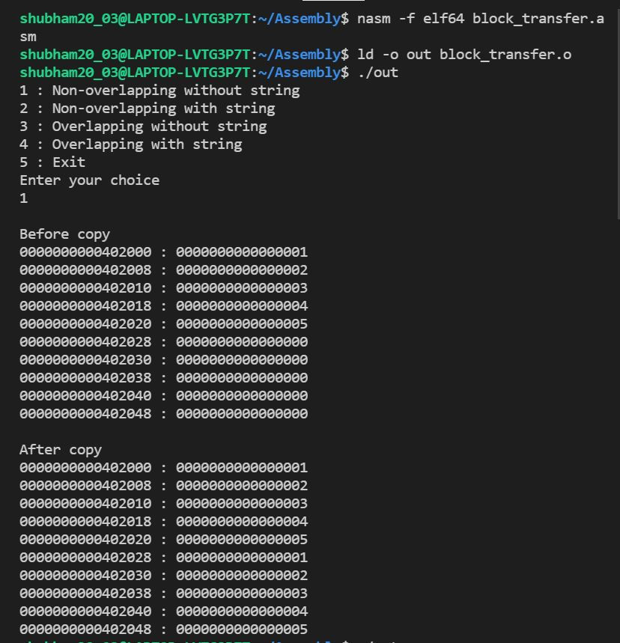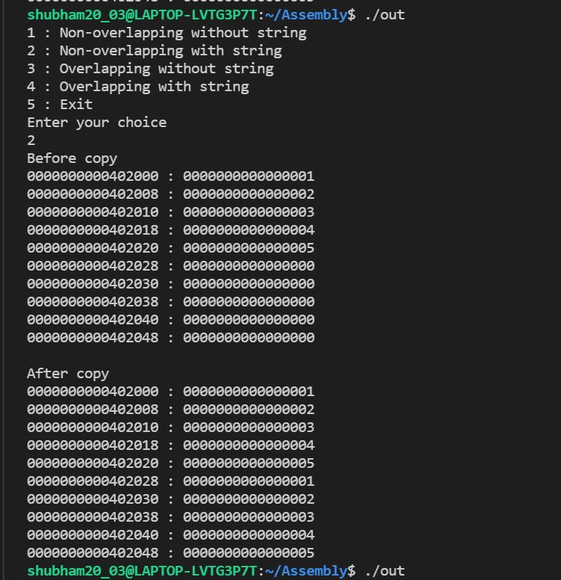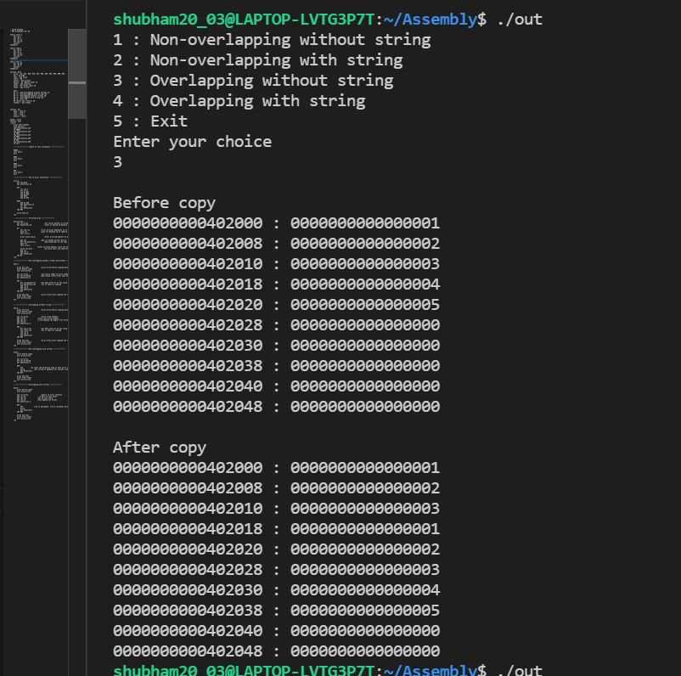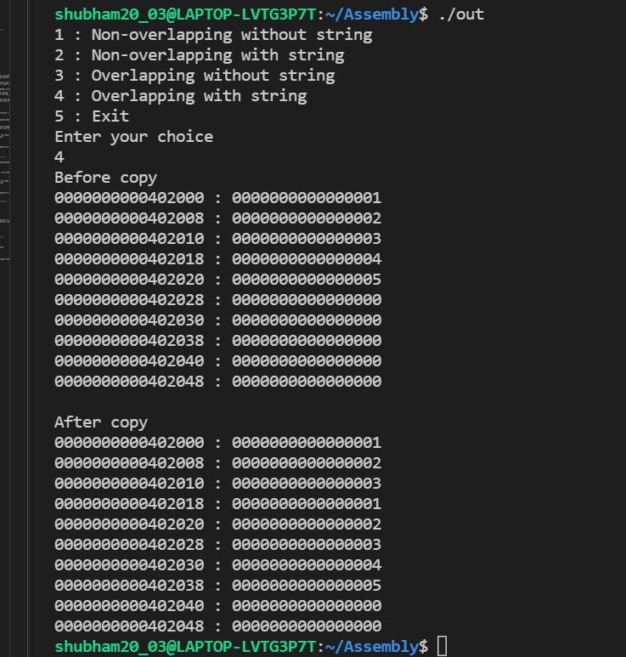

CONCLUSION:

We have studied different block transfer instructions and also understood block transfer within different segments.