
Project Based Learning-II
Batch - E1
Date- February 2nd ,2021

Group members (Roll no and Name)
1. 21105 Aryan Chatterjee
2. 21112 Navin Bhandari
3. 21116 Swapnil Chavan
4. 21118 Shubham Chemate

Title
Electronic Health Record

Motivation
Past history and some general information about a patient is essential for doctors to provide correct treatment. Unfortunately, this also means that patients must carry folders with several documents inside of them concerning their medical reports. Not to mention, patients must also fill out forms whenever they visit the hospital.

All of this hassel is easily eliminated if we can have a single source of information about the patient which hospitals/clinics/doctors may access (as long as they have the patient’s permission). This gets rid of almost all paper work and there is no need to worry about storing medical records safely.

Objective
Build a safe and secure electronic health record system for patients and doctors.

Intended Audience
Medical professionals and patients

Functional Requirements
1. User should be able to create new room
2. User should be able to view rooms
3. User should be able to invite new members to a room
4. User should be able to join a room
5. User should be able to upload a report in a room
6. Room members should be able to view reports in the room

S/W and H/W requirement
Software requirements:
This is going to be a web application. Thus, we must use a web stack.
Web stack:
1. Django and django rest framework
2. SQL Database (Postgres SQL or any other)
3. React
Hardware Requirements: Not applicable

Theory/ Short Description
An electronic health record system comprises three parts
1. The data base
2. The backend logic
3. The frontend

The data base will contain all patient information of all its users. It will also contain medical reports in the form of pdf files.
All of this info will be available to its owner permanently. It will be hidden from other users.

The server logic takes the required query from the frontend and performs various checks, generates tokens for information access and finally generates a data base query and passes on the information to the frontend.

The frontend is a GUI on the web for users to easily interact with the data base (through the backend). It will also contain a pdf viewer in addition to all the basic stuff needed to view data, so that people may easily read the reports without having to download them.

Flowchart
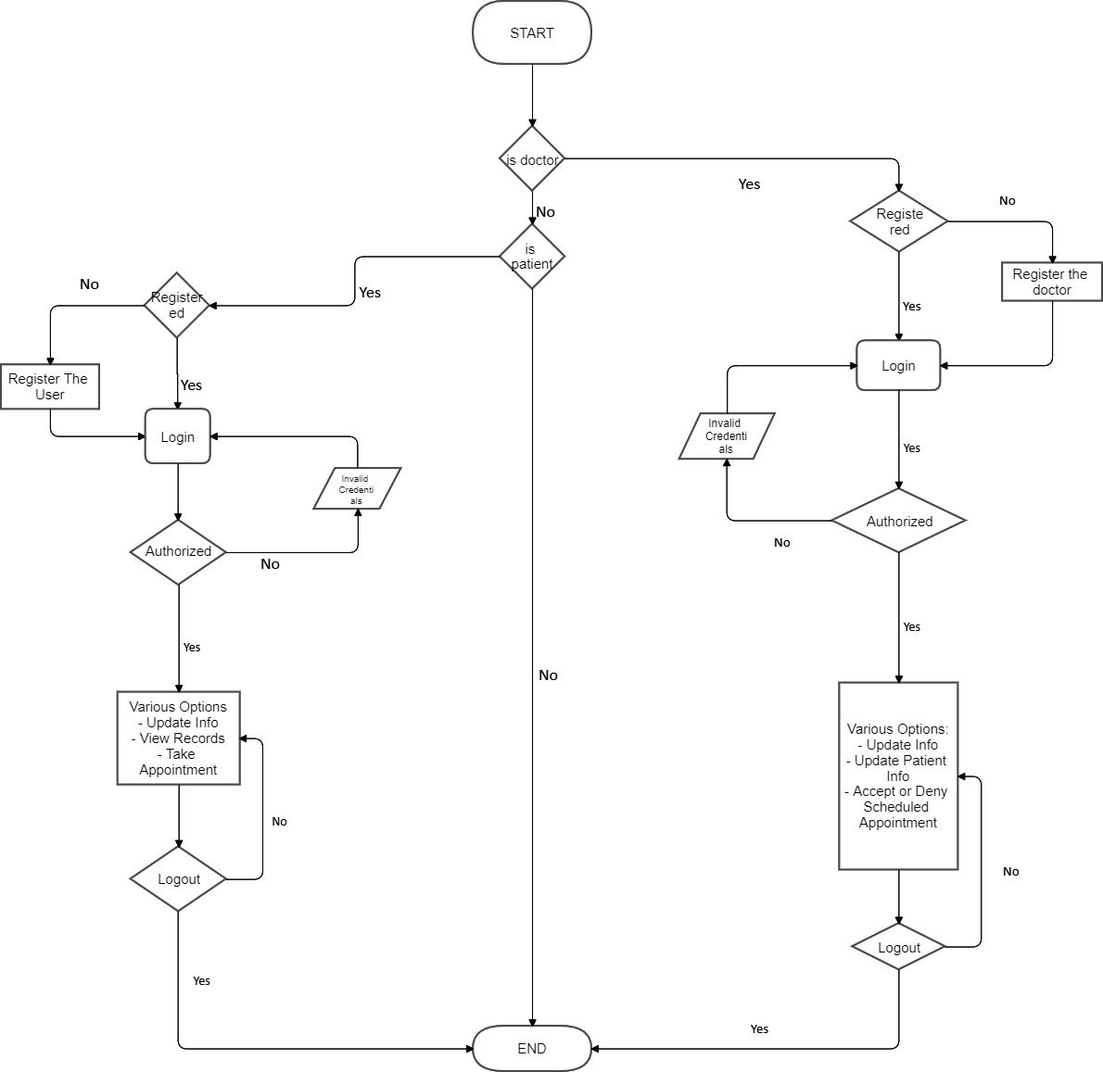

Implementation Details:

An electronic health record system comprises three parts
1. The data base
2. The backend logic
3. The frontend

The application works on the principle of rooms and reports. Where each room has its own passphrase and each report in that room is encrypted using the room’s passphrase. The encryption and decryption processes take place on the client making the application extremely secure.

At the very beginning, the user must login/register and set up a user profile (in case of new user).

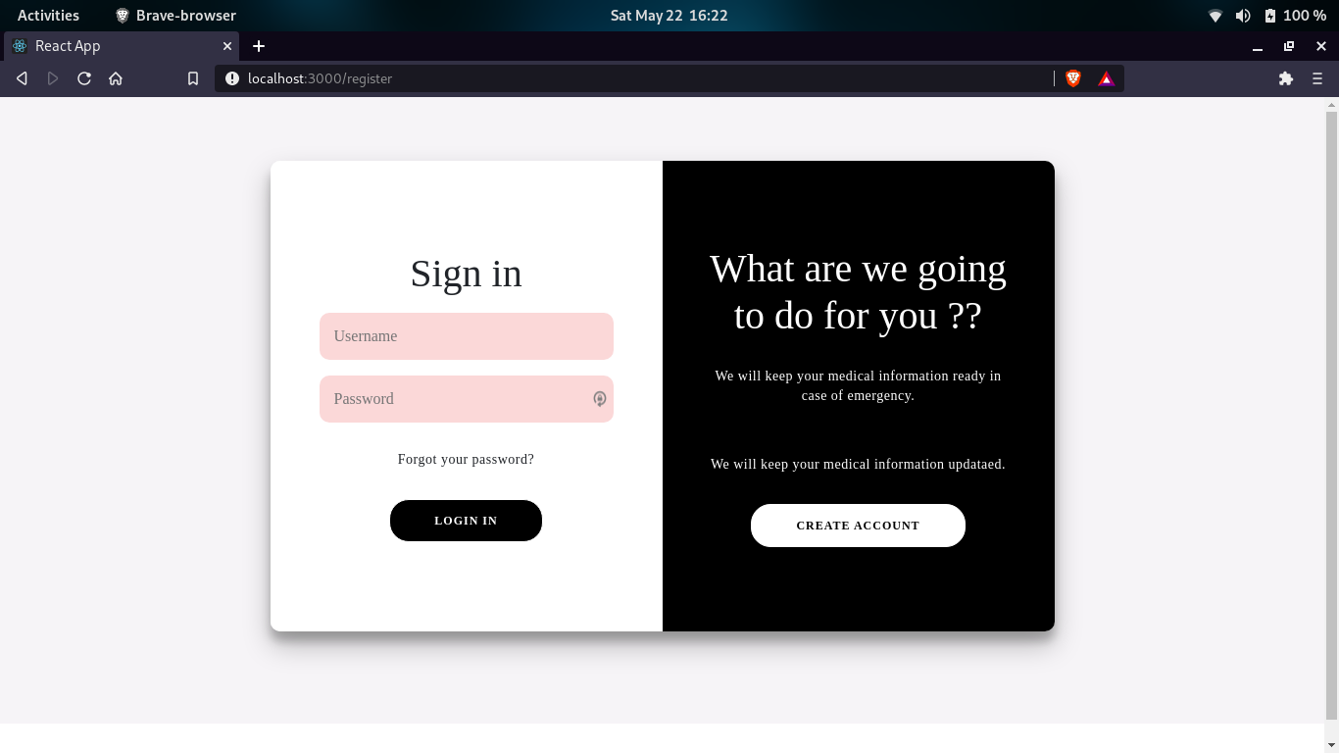

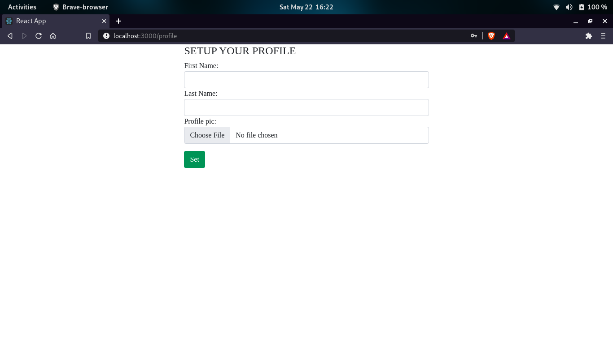
Once on the home page, the user can see all the rooms they are a member of and also create new rooms. If they create a new room, they become the owner of that room.

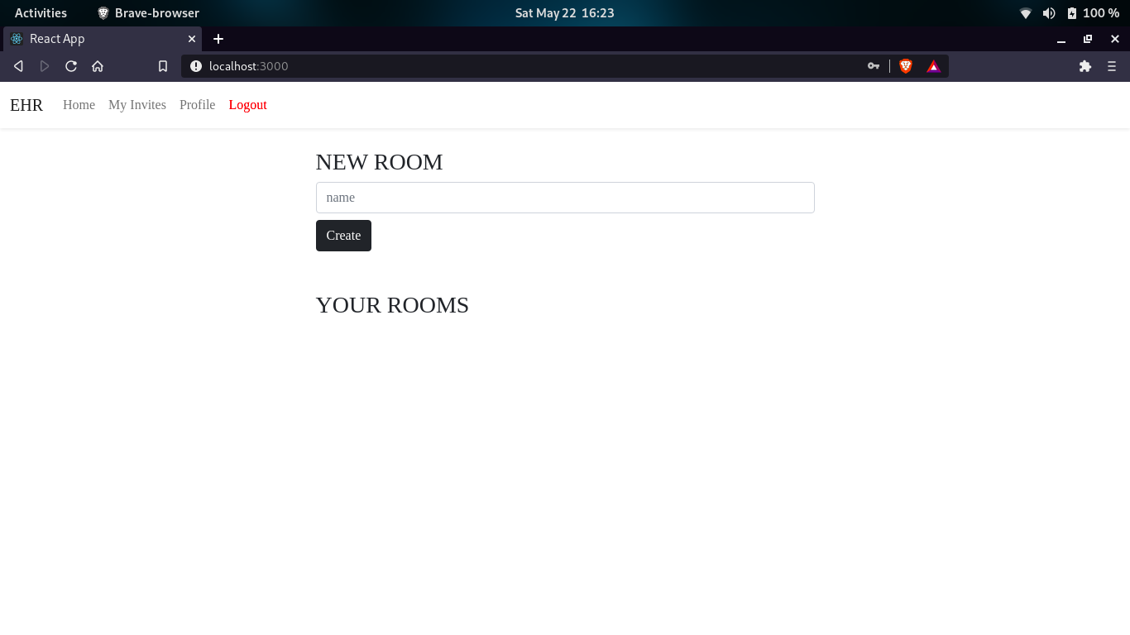

Upon clicking on the details button, the user can see the details of the room, including its unique passphrase, its owner’s username and all its members. From this screen, the owner of the room may also invite new members to the team.

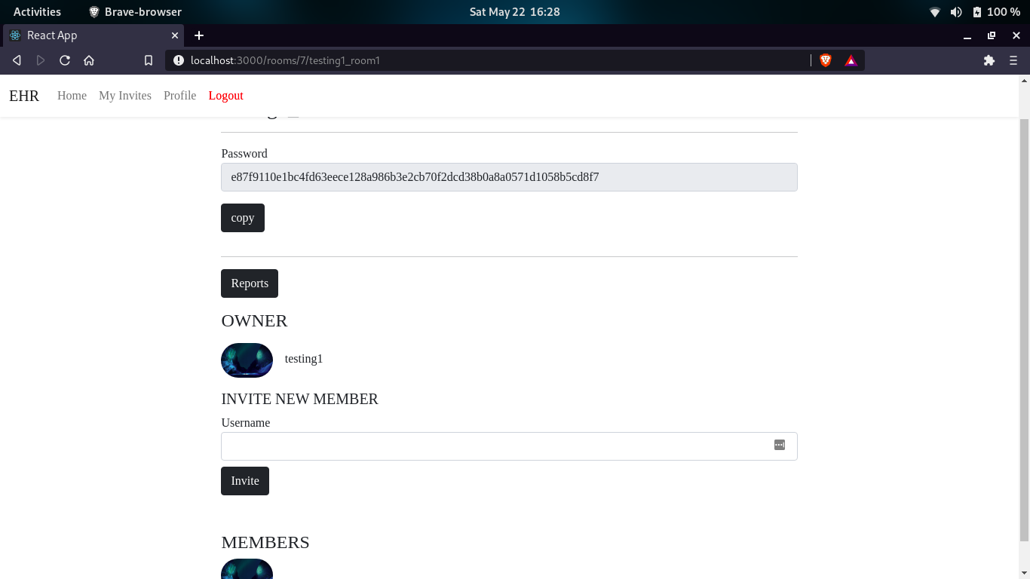

Clicking on the reports button brings up all the reports of the room. From this screen any member of the room may upload a new report.

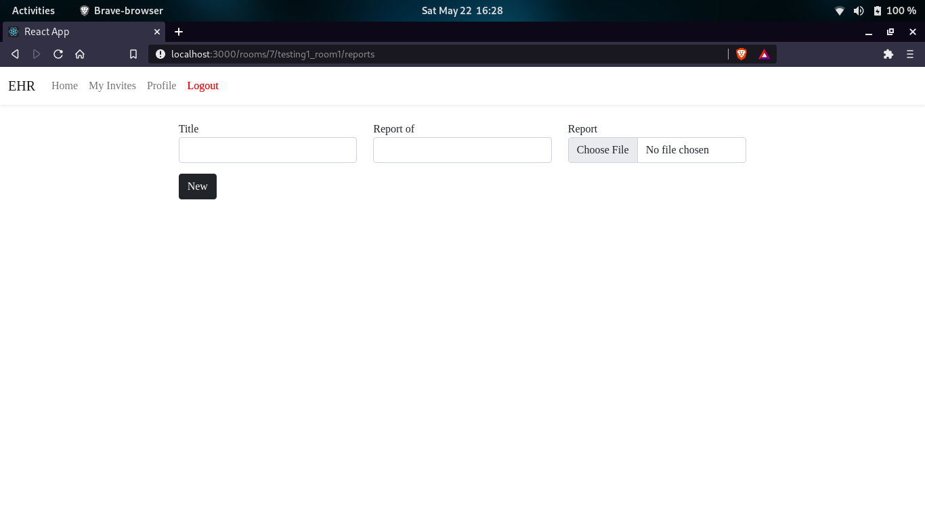

Clicking download button on any of the report cards will download the report onto the user’s computer.

To accept, invitations from other rooms, the user will have to navigate to ‘My Invites’ and there they will find all invitations listed out.
Clicking on accept button for any invitation will open a prompt which will ask for the room’s password. Upon entering that password correctly, the user will become a member of the team.

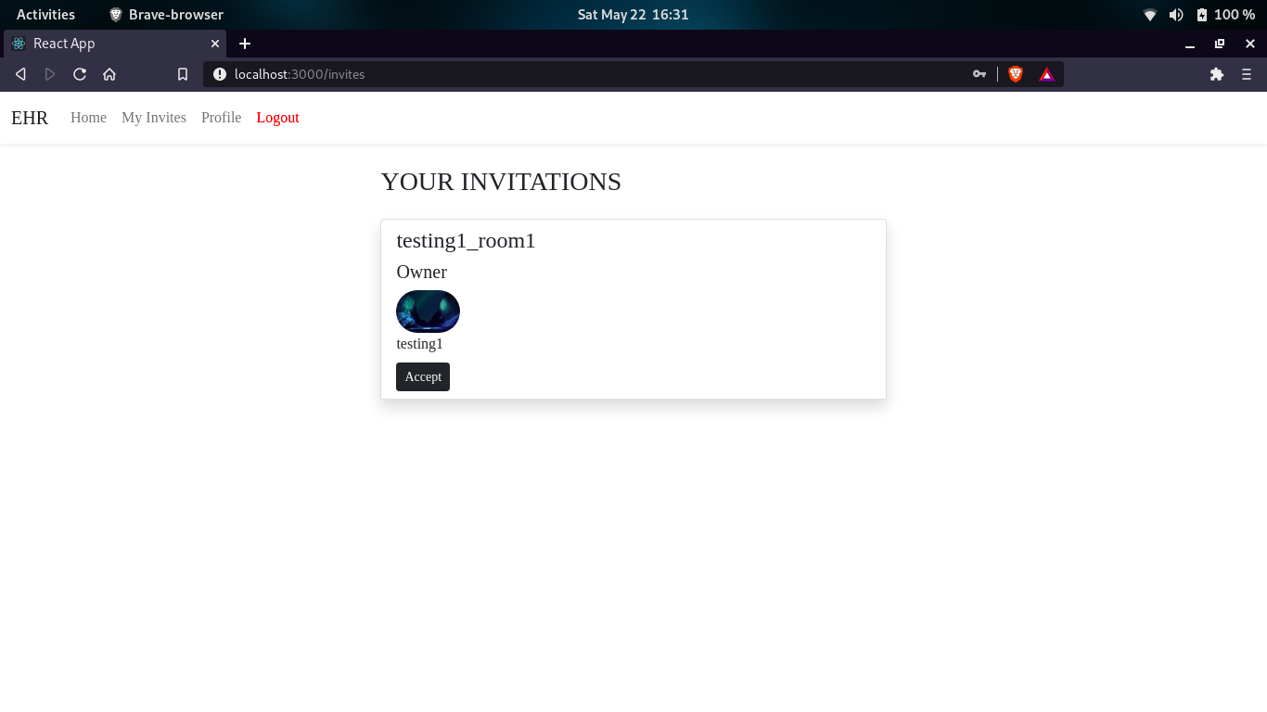

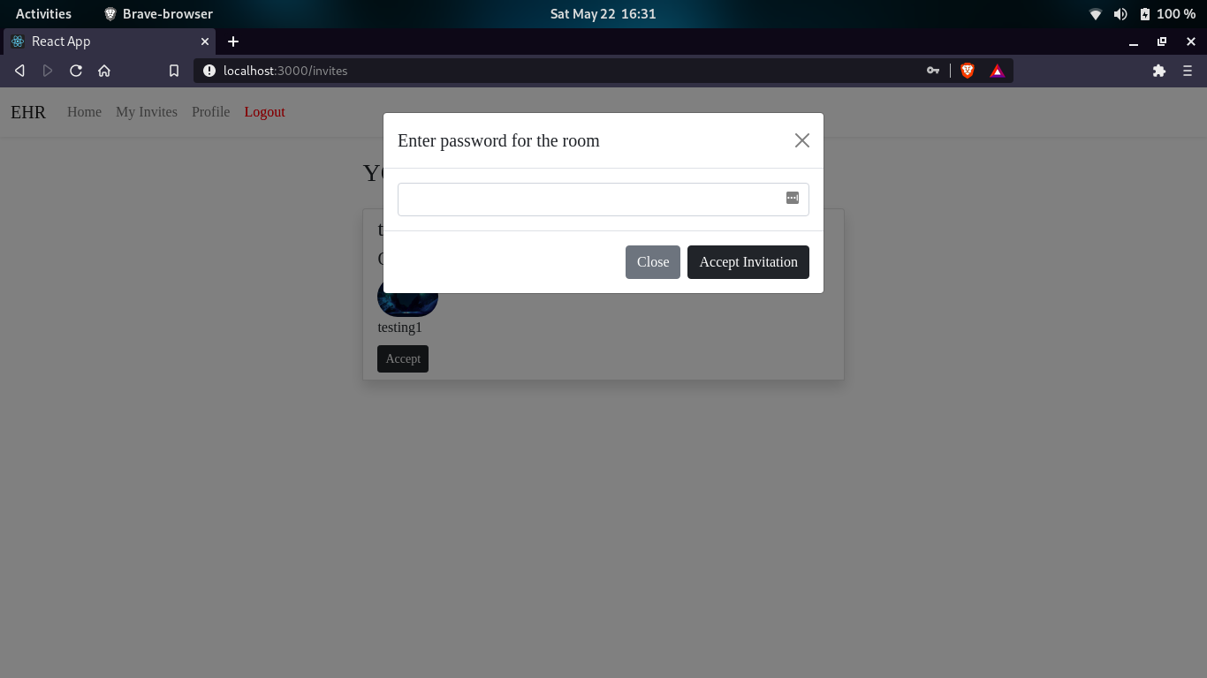

Clicking the logout button on the navbar, log’s the user out of the application

Conclusion
In today’s fast world everything needs to be organized and well maintained. Hospitals need to maintain big paper-load to store patient data. If patient is shifted to another hospital it is very time consuming to carry out medical records with him. Through this project we are trying to replaces traditional form filling and appointment with digital and secure alternative which will help in saving the time and money.

References:
- Wikipedia Page on Electronic Health Record
- Article Published by NCBI (National Centre for Biotechnology Information) on 11 May, 2011 on benefits and drawbacks of digital health record
- Article Published by Online Wiley Library on Clinical Benefits of Electronic Health Record Use: National Findings published on 13 Dec, 2013

