CREATED DATABASE AND TABLE named HACKER::::

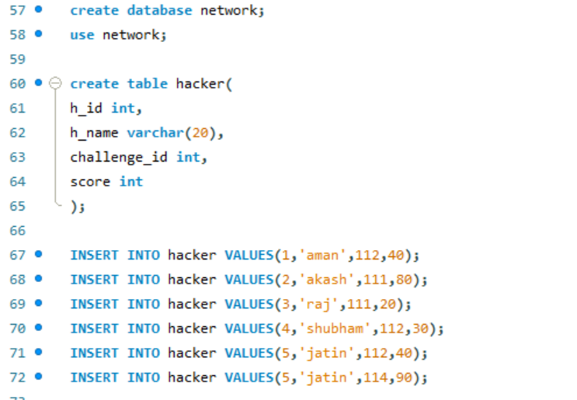

**Output: Hacker table**

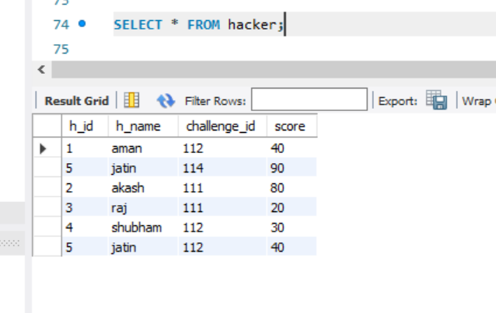

**RANK FUNCTION:**

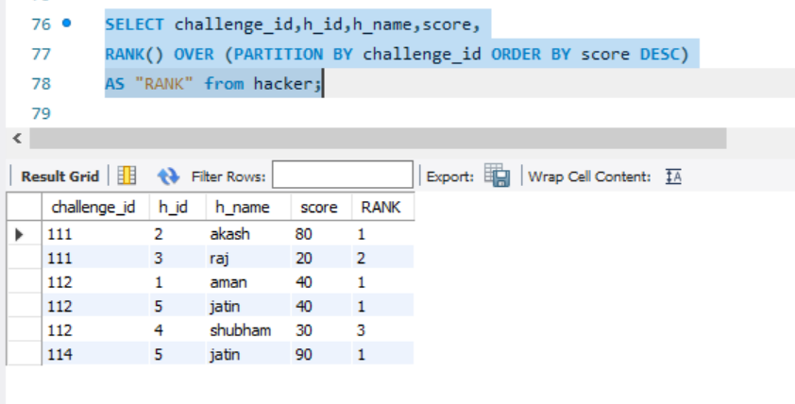

**DENSE_RANK FUNCTION:**

