Olist E-Commerce Marketplace Analysis
Power BI Dashboard and SQL Validation Report
Prepared by: Shubham Kumar Dubey
Tools: Power BI, Power Query, DAX, Google Colab, SQLite SQL

Executive KPI Summary
Metric | Value
Total Revenue | 13,591,643.70
Total Orders | 99,441
Total Customers | 96,096
Total Sellers | 3,095
Total Products | 32,951
Average Order Value | 136.68
Average Review Score | 4.09

Executive Summary
This project analyzes the Brazilian Olist E-Commerce marketplace dataset to understand revenue performance, customer geography, delivery efficiency, product category contribution, payment behavior, review patterns, and seller performance. The final solution includes a three-page Power BI dashboard and a SQL analysis notebook used to validate the major dashboard metrics.
- The marketplace generated total product revenue of 13.59M across 99,441 orders.
- Revenue was strongest in 2018, with 7.39M revenue from 54,011 orders.
- SP was the largest customer revenue state and also the strongest seller hub.
- Health Beauty generated the highest category revenue, while Bed Bath Table had the highest order volume.
- Credit card payments dominated the marketplace, contributing 78.34% of payment value.
- Delivery performance had a clear impact on satisfaction: on-time/early orders averaged 4.29 review score, while delayed orders averaged 2.27.

1. Project Objective
The objective of this project was to build a complete business intelligence analysis for an e-commerce marketplace. The dashboard was designed to help users monitor business growth, sales trends, delivery performance, product and seller contribution, and customer satisfaction.

2. Dataset and Tools
Area | Details
Dataset | Brazilian Olist E-Commerce public dataset
Data tables used | Customers, Orders, Order Items, Payments, Reviews, Products, Sellers, Category Translation
Main dashboard tool | Power BI
Data preparation | Power Query
Calculations | DAX measures and calculated columns
SQL validation | SQLite SQL in Google Colab
Output files | PBIX dashboard, SQL notebook, screenshots, PDF/DOCX report

3. Data Preparation and Model Design
The dataset was imported into Power BI and cleaned using Power Query. The category translation table was used to convert product category names into English, and custom columns were created for delivery analysis.
- Created Purchase Date, Delivery Days, Delay Days, Delivery Status, Order Year, and Month fields in the Orders table.
- Created a clean Category Name field by replacing underscores and formatting category names.
- Used Seller Short ID for readable seller visuals instead of full seller identifiers.
- Built relationships between customers, orders, order items, payments, reviews, products, sellers, and category translation tables.
- Used DAX measures for revenue, orders, customers, sellers, products, average order value, average review score, delivery metrics, and delay rate.

4. Dashboard Pages
The Power BI report contains three analytical pages: Executive Overview, Delivery and Review Analysis, and Product and Seller Analysis.

4.1 Executive Overview
This page presents the high-level business performance using KPI cards, yearly and monthly revenue trends, revenue by product category, revenue by customer state, delivery status, and payment method contribution.
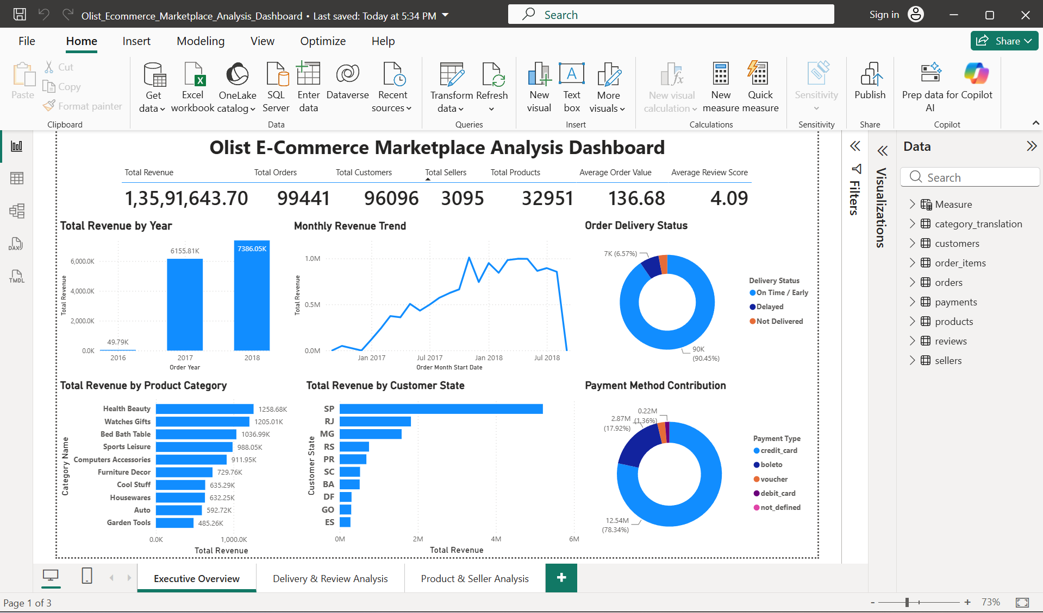
Figure 1: Executive Overview dashboard page

4.2 Delivery and Review Analysis
This page analyzes delivery speed, delay rate, delayed order count, review score distribution, and the relationship between delivery status and customer satisfaction.
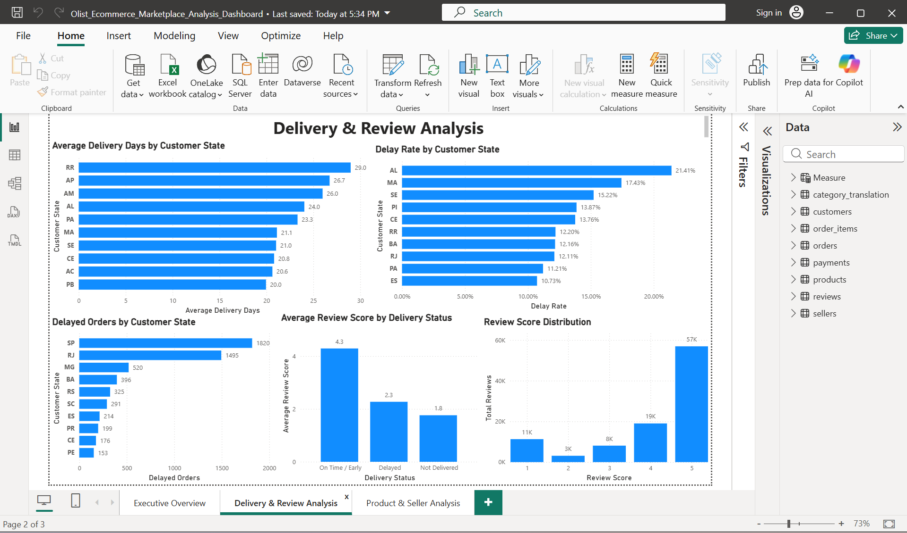
Figure 2: Delivery and Review Analysis dashboard page

4.3 Product and Seller Analysis
This page focuses on top sellers, high-performing product categories, seller state contribution, and product category order volume.
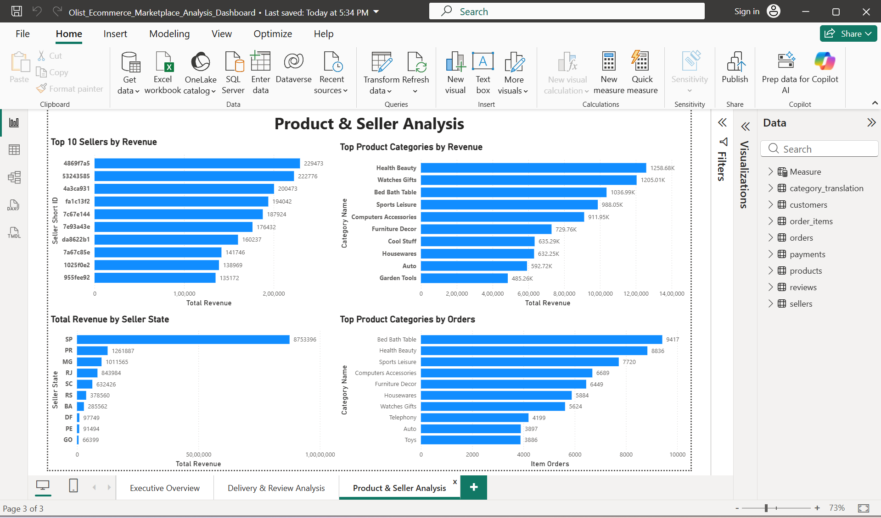
Figure 3: Product and Seller Analysis dashboard page

5. SQL Analysis and Validation
A SQL notebook was created in Google Colab using SQLite. Python was used only to load the Excel files into SQLite tables; the analysis itself was performed using SQL queries. The SQL outputs were used to validate the Power BI dashboard results.
No. | SQL Analysis Area | Purpose
1 | Overall KPIs | Validate revenue, orders, customers, sellers, products, and AOV
2 | Revenue by Year | Validate yearly revenue and order trends
3 | Monthly Revenue Trend | Analyze month-wise order and revenue movement
4 | Top Product Categories by Revenue | Identify highest revenue-generating categories
5 | Revenue by Customer State | Find strongest customer markets by state
6 | Payment Method Contribution | Measure payment value and percentage by method
7 | Delivery Status Analysis | Classify orders as on-time/early, delayed, or not delivered
8 | Delivery Performance by State | Analyze state-level delivery delay risk
9 | Review Score by Delivery Status | Measure how delivery affects satisfaction
10 | Review Score Distribution | Analyze customer review pattern
11 | Top Sellers by Revenue | Identify top seller contribution
12 | Revenue by Seller State | Analyze seller geography performance
13 | Top Product Categories by Orders | Compare order volume by category
14 | Delayed Orders by Customer State | Find states with the largest delayed order counts
15 | Average Delivery Days by State | Find slowest delivery states

6. Key SQL-Validated Findings

6.1 Revenue and Growth
Year | Total Orders | Item Orders | Total Revenue
2016 | 329 | 312 | 49,785.92
2017 | 45,101 | 44,579 | 6,155,806.98
2018 | 54,011 | 53,775 | 7,386,050.80
Revenue grew strongly from 2017 to 2018. The highest monthly revenue periods included November 2017, April 2018, and May 2018.

6.2 Product Category Performance
Category | Orders | Items Sold | Revenue
Health Beauty | 8,836 | 9,670 | 1,258,681.34
Watches Gifts | 5,624 | 5,991 | 1,205,005.68
Bed Bath Table | 9,417 | 11,115 | 1,036,988.68
Sports Leisure | 7,720 | 8,641 | 988,048.97
Computers Accessories | 6,689 | 7,827 | 911,954.32
Health Beauty was the top revenue category, while Bed Bath Table had the highest order and item volume. Watches Gifts generated high revenue despite lower order volume because of a higher average item price.

6.3 Customer Geography
Customer State | Orders | Customers | Revenue
SP | 41,746 | 40,302 | 5,202,955.05
RJ | 12,852 | 12,384 | 1,824,092.67
MG | 11,635 | 11,259 | 1,585,308.03
RS | 5,466 | 5,277 | 750,304.02
PR | 5,045 | 4,882 | 683,083.76
SP was the leading customer state by revenue, orders, and customers. This indicates a high concentration of marketplace activity in Sao Paulo.

6.4 Payment Contribution
Payment Type | Orders | Payment Value | Contribution
Credit Card | 76,505 | 12,542,084.19 | 78.34%
Boleto | 19,784 | 2,869,361.27 | 17.92%
Voucher | 3,866 | 379,436.87 | 2.37%
Debit Card | 1,528 | 217,989.79 | 1.36%
Credit card was the dominant payment method, contributing more than three-fourths of total payment value.

6.5 Delivery and Customer Satisfaction
Delivery Status | Orders | Reviews | Avg Review Score
On Time / Early | 89,941 | 89,308 | 4.29
Delayed | 6,535 | 6,390 | 2.27
Not Delivered | 2,965 | 2,848 | 1.76
The analysis shows a strong relationship between delivery performance and customer satisfaction. On-time or early orders received much higher review scores than delayed or not delivered orders.

6.6 Delay and Delivery Risk by State
State | Delivered Orders | Delayed Orders | Delay Rate
AL | 397 | 85 | 21.41%
MA | 717 | 125 | 17.43%
SE | 335 | 51 | 15.22%
PI | 476 | 66 | 13.87%
CE | 1,279 | 176 | 13.76%
AL had the highest delay rate, while SP had the highest absolute delayed order count due to its very large order volume.
State | Total Orders | Delivered Orders | Avg Delivery Days
RR | 46 | 41 | 28.98
AP | 68 | 67 | 26.73
AM | 148 | 145 | 25.99
AL | 413 | 397 | 24.04
PA | 975 | 946 | 23.32

6.7 Seller Performance
Seller Short ID | State | Orders | Items Sold | Revenue
4869f7a5 | SP | 1,132 | 1,156 | 229,472.63
53243585 | BA | 358 | 410 | 222,776.05
4a3ca931 | SP | 1,806 | 1,987 | 200,472.92
fa1c13f2 | SP | 585 | 586 | 194,042.03
7c67e144 | SP | 982 | 1,364 | 187,923.89
Most of the top revenue sellers were located in SP, confirming the dominance of Sao Paulo as a seller hub.

7. Business Recommendations
- Focus logistics improvement on high-delay-rate states such as AL, MA, SE, PI, and CE.
- Monitor high-volume states like SP and RJ because small delay improvements there can affect many customers.
- Prioritize customer satisfaction initiatives for delayed and not delivered orders because review scores drop sharply in those groups.
- Use Health Beauty and Watches Gifts as key revenue categories and Bed Bath Table as a volume-driving category.
- Strengthen seller support and onboarding in states outside SP to reduce seller-side concentration risk.
- Track payment behavior closely because credit cards dominate payment value, while boleto remains a meaningful secondary method.

8. Conclusion
The Olist E-Commerce Marketplace Analysis project successfully combines Power BI dashboard development with SQL validation. The analysis shows that revenue is concentrated in key states and categories, delivery performance has a major impact on customer reviews, and SP dominates both customer demand and seller supply. The project demonstrates practical skills in data cleaning, data modelling, DAX measure creation, SQL analysis, dashboard design, and business insight generation.

Appendix: Deliverables
File | Purpose
Olist_Ecommerce_Marketplace_Analysis_Dashboard.pbix | Power BI dashboard file
Olist_Ecommerce_SQL_Analysis.ipynb | SQL validation notebook
dashboard_page_1_executive_overview.png | Executive dashboard screenshot
dashboard_page_2_delivery_review_analysis.png | Delivery and review dashboard screenshot
dashboard_page_3_product_seller_analysis.png | Product and seller dashboard screenshot
Olist_Ecommerce_Project_Report.docx / .pdf | Final project report
Dataset source: Brazilian E-Commerce Public Dataset by Olist on Kaggle

