Superstore Sales Analysis Report
Excel | SQL | Power BI | Power Query | DAX
Prepared by Shubham Kumar Dubey

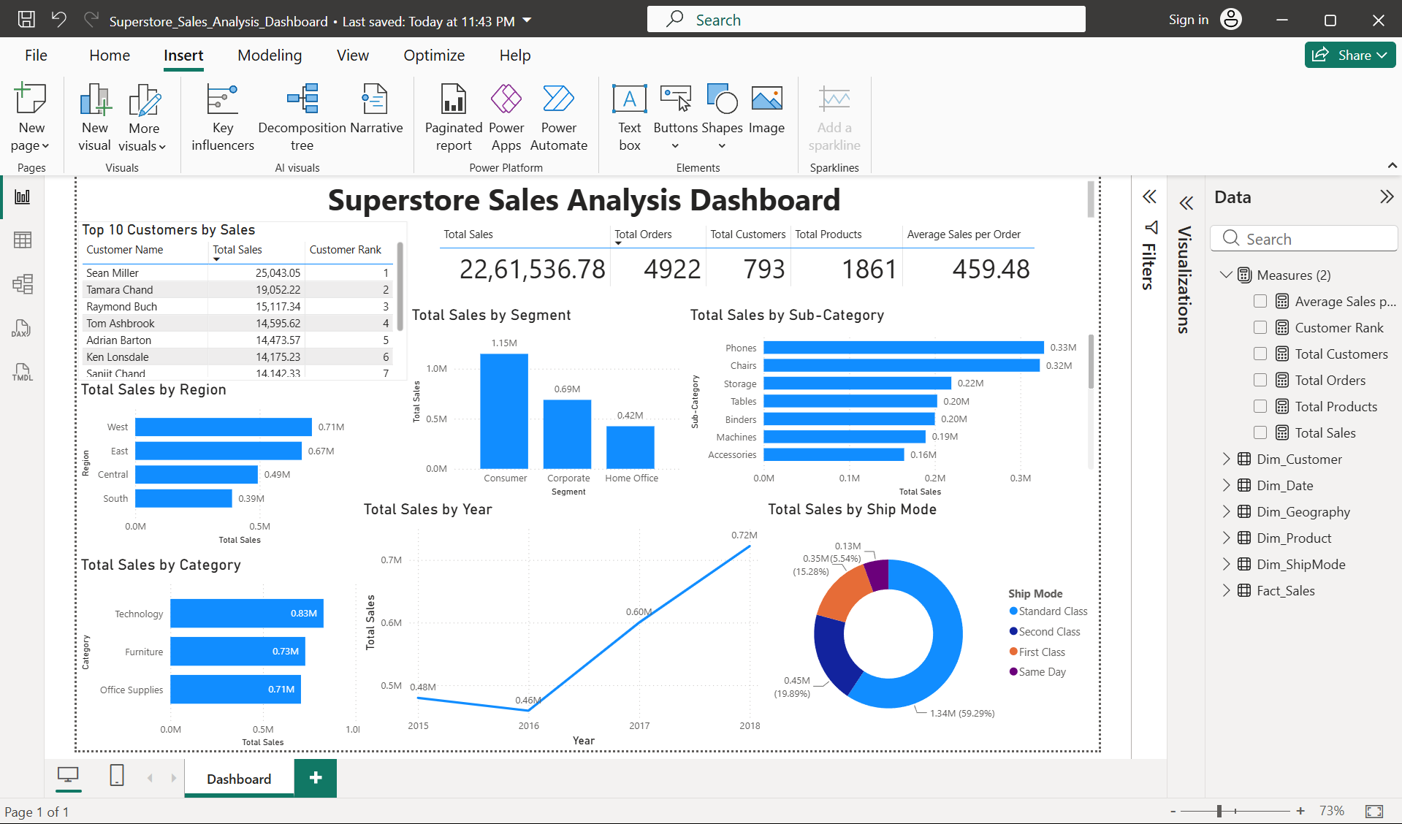
Dashboard Preview

1. Executive Summary
This report presents the final business analysis of the Superstore sales dataset. The project was completed using Excel for initial validation, SQL for analytical queries, and Power BI for data modeling, DAX measures, and dashboard reporting. The analysis focuses on sales performance by region, category, customer segment, product sub-category, ship mode, yearly trend, and top customers.

2. Key Performance Indicators
KPI | Value
Total Sales | 2,261,536.78
Total Orders | 4,922
Total Customers | 793
Total Products | 1,861
Average Sales per Order | 459.48

3. Methodology
- Cleaned and validated the dataset in Excel.
- Performed SQL analysis in Google Colab using SQLite to verify totals, rankings, and business trends.
- Built a Power BI star schema model using one fact table and multiple dimension tables.
- Created DAX measures for sales, orders, customers, products, average sales per order, and customer ranking.
- Designed a Power BI dashboard to summarize business performance clearly.

4. Dataset and Data Model
The dataset contains 9,800 sales records and 18 original columns, including order details, customer information, product details, geography fields, shipping mode, and sales amount.
The Power BI model was structured using a star schema for better analysis and cleaner reporting.
Table | Description
Fact_Sales | Transaction-level sales data with Order ID, dates, keys, geography key, and Sales.
Dim_Customer | Customer ID, Customer Name, and Segment.
Dim_Product | Product ID, Product Name, Category, and Sub-Category.
Dim_Geography | Country, City, State, Postal Code, Region, and GeoKey.
Dim_ShipMode | Shipping mode information.
Dim_Date | Date, Year, Month, and Month Name.

5. Power BI Dashboard
The dashboard includes KPI summary, regional sales, category sales, segment sales, yearly sales trend, sub-category sales, ship mode distribution, and top customer ranking.

6. Key Business Insights

6.1 Sales by Region
Metric | Total Sales
West | 710,219.68
East | 669,518.73
Central | 492,646.91
South | 389,151.46
Insight: West is the highest-performing region, while South has the lowest sales among all regions.

6.2 Sales by Category
Metric | Total Sales
Technology | 827,455.87
Furniture | 728,658.58
Office Supplies | 705,422.33
Insight: Technology is the top-performing category and contributes the highest revenue.

6.3 Sales by Customer Segment
Metric | Total Sales
Consumer | 1,148,060.53
Corporate | 688,494.07
Home Office | 424,982.18
Insight: Consumer customers generate the highest sales, making them the strongest customer segment.

6.4 Sales by Ship Mode
Metric | Total Sales
Standard Class | 1,340,831.31
Second Class | 449,914.18
First Class | 345,572.26
Same Day | 125,219.04
Insight: Standard Class is the dominant shipping mode and contributes the highest sales.

6.5 Top Sub-Categories
Metric | Total Sales
Phones | 327,782.45
Chairs | 322,822.73
Storage | 219,343.39
Tables | 202,810.63
Binders | 200,028.79
Insight: Phones and Chairs are the strongest sub-categories by total sales.

6.6 Top Customers
Rank | Customer Name | Total Sales
1 | Sean Miller | 25,043.05
2 | Tamara Chand | 19,052.22
3 | Raymond Buch | 15,117.34
4 | Tom Ashbrook | 14,595.62
5 | Adrian Barton | 14,473.57
Insight: Sean Miller is the highest-value customer. However, his contribution is only about 1.11% of total sales, meaning revenue is distributed across many customers instead of depending on one customer.

7. SQL Analysis Summary
SQL was used to validate and analyze the dataset before creating the Power BI dashboard. The SQL analysis covered total sales, total orders, total customers, sales by region, category, segment, sub-category, monthly sales trend, customer ranking, regional top customers, customer revenue contribution percentage, top products, and ship mode performance.
The detailed SQL queries are kept separately in the SQL notebook file so that this report remains focused on business insights and final dashboard interpretation.

8. Final Conclusion
The Superstore analysis shows total sales of 2.26M from 4,922 orders and 793 customers. West is the strongest region, Technology is the highest-performing category, and the Consumer segment generates the highest revenue. Phones and Chairs are the top sub-categories, while Standard Class is the leading ship mode. The customer base is distributed, with the top customer contributing only 1.11% of total sales.

9. Skills Demonstrated
- Excel data cleaning and validation
- SQL aggregation and window functions
- Power Query transformation
- Star schema data modeling
- DAX measure creation
- Power BI dashboard design
- Business insight generation
- GitHub project documentation

10. Author
Shubham Kumar Dubey
Aspiring Data Analyst skilled in Excel, SQL, Power BI, Power Query, DAX, and dashboard reporting.

