Explainable Deep Learning for IoT Sensor-Based Machine Failure Prediction in Predictive Maintenance

[Author 1 Name]
[Department name]
[Institution name]
[City, Country]
[email address or ORCID]
[Author 2 Name]
[Department name]
[Institution name]
[City, Country]
[email address or ORCID]
[Author 3 Name]
[Department name]
[Institution name]
[City, Country]
[email address or ORCID]

Abstract—Predictive maintenance uses sensor data to anticipate machine failures before they cause unplanned downtime, yet the deep learning models applied to this task are rarely transparent, and the rarity of failures makes accuracy a misleading measure of their value. This paper presents an explainable failure-prediction framework evaluated on the AI4I 2020 predictive maintenance dataset, which contains 10,000 machine records with a failure rate of 3.39%. A multilayer perceptron (MLP), a long short-term memory network (LSTM) and a one-dimensional convolutional neural network (1D-CNN) are trained under identical conditions with a class-weighted loss. On a held-out test set of 1,500 machines, the MLP achieves the best discrimination, with a ROC-AUC of 0.976, a PR-AUC of 0.720 and a recall of 90.2%, while the 1D-CNN attains the highest recall of 94.1%. Tuning the decision threshold raises the MLP F1-score from 0.413 to 0.724. Exact SHapley Additive exPlanations (SHAP) provide global and per-prediction explanations, and a what-if analysis shows that the learned decision boundaries coincide with the physical tool-wear and power-failure mechanisms of the process. The model is deployed through a REST API that returns a prediction with its explanation in a median time of 17.6 ms.
Keywords—predictive maintenance, explainable artificial intelligence, SHAP, deep learning, Internet of Things, class imbalance, machine failure prediction

Introduction
Unplanned equipment downtime is one of the largest avoidable costs in manufacturing. Maintenance practice has moved from reactive repair and fixed-interval preventive maintenance towards predictive maintenance (PdM), in which equipment condition is monitored continuously and intervention is scheduled only when a failure is likely [1], [2]. Low-cost Internet of Things (IoT) sensors now make it practical to record operating variables such as temperature, rotational speed, torque and tool wear at scale, and machine learning models trained on these signals are widely studied for failure prediction [2], [3].

Problem Statement
Three obstacles limit the use of deep learning for failure prediction on the shop floor. First, failures are rare, so a classifier can reach high accuracy while missing most failures [4]. Second, a maintenance engineer is unlikely to act on an alarm that cannot be justified, and most deep models give no reason for their output [5]. Third, many published studies on public benchmarks report accuracy alone, which hides the trade-off between missed failures and false alarms that determines operational value.

Objectives and Contributions
This work addresses these issues with SHapley Additive exPlanations (SHAP) [6] on the AI4I 2020 predictive maintenance dataset [7], [8]. Its objectives and contributions are as follows:
- A like-for-like comparison of an MLP, an LSTM and a 1D-CNN trained on the same stratified split with the same class-weighted loss, optimiser and early-stopping protocol.
- An evaluation centred on recall, PR-AUC, decision-threshold trade-offs and detection rates for each of the five physical failure modes, rather than on accuracy alone.
- Exact global and local SHAP explanations of the selected model, and a what-if analysis that validates the learned decision boundaries against the physical failure rules of the process.
- A deployed REST service and interactive dashboard that return every prediction together with its explanation.
Section II reviews recent literature, Section III describes the dataset and methodology, Section IV reports and discusses the results, and Section V concludes the paper.

Literature Review
Recent research on data-driven failure prediction can be grouped into three directions: deep learning on sensor streams, imbalance-aware learning on the AI4I 2020 benchmark, and explainable predictive maintenance (XPdM). Table I summarises representative studies published between 2022 and 2025.

Deep Learning on Sensor Data
Wahid et al. [9] compared CNN, LSTM and hybrid CNN-LSTM models on Microsoft's industrial telemetry data and found that the hybrid architecture gave the most reliable failure forecasts, because convolution extracts local patterns and the recurrent layer models their evolution. Pinciroli Vago et al. [10] studied six machine learning and deep learning algorithms on three industrial time-series datasets and showed that the size of the prediction window strongly affects performance, with deep models handling heterogeneous pre-failure patterns better. Elkateb et al. [11] deployed an IoT-based AdaBoost system that classified stop types of knitting machines with 92% accuracy. These studies depend on long sensor histories and do not explain individual predictions.

Imbalance-Aware Learning on AI4I 2020
The AI4I 2020 dataset introduced by Matzka [7] has become a common benchmark. Ghasemkhani et al. proposed Balanced K-Star, a class-balanced instance-based learner that reached 98.75% accuracy [12], and later a Balanced Hoeffding Tree Forest that combines a proximity-driven undersampling scheme with SMOTE for multi-label failure-mode diagnosis, reporting 97.44% mean accuracy [13]. Nadarajan et al. [14] combined sliding-window preprocessing, permutation importance and a tuned XGBoost model (E.XGB) to obtain 99.05% accuracy and an F1-score of 82.25%, but with a failure recall of 73.33%. Prashanth et al. [15] added incremental learning and concept-drift detection to a deep neural network, achieving 84% accuracy and an AUC of 0.87 while adapting to non-stationary data.

Explainable Predictive Maintenance
The survey by Cummins et al. [5] organises XPdM methods into model-agnostic and model-specific families and identifies the lack of rigorous evaluation of explanations as an open challenge. Gawde et al. [16] applied LIME, SHAP, partial dependence and individual conditional expectation plots to classifiers of rotating-machine faults, and showed that the methods provide complementary, human-readable insights.

- Summary of Recent Literature on Machine Failure Prediction (2022–2025)
No. | Title, Year | Methodology | Dataset | Disadvantages | Results
1 [9] | Hybrid CNN-LSTM framework for machine failure prediction, 2022 | CNN, LSTM and CNN-LSTM forecasting models | Microsoft telemetry: voltage, rotation, pressure, vibration, error and maintenance logs | Needs long sensor histories; no explanation of predictions | CNN-LSTM most reliable of the compared models
2 [12] | Balanced K-Star, 2023 | Class-balanced K-Star instance-based learner | AI4I 2020 | Accuracy-centred evaluation; no deep models | 98.75% accuracy (baselines 91.74%)
3 [11] | ML and IoT-based PdM for industrial applications, 2024 | AdaBoost with tuning and cross-validation | Knitting machines, six stop types | Single machine type; no explainability | 92% test accuracy
4 [16] | Explainable PdM of rotating machines (LIME, SHAP, PDP, ICE), 2024 | Frequency-domain features, ML classifiers, four XAI methods | Multi-sensor test rig, five fault classes | Laboratory data; classical models only | Complementary, interpretable fault attributions
5 [5] | Explainable PdM: survey of methods and challenges, 2024 | PRISMA systematic review of XPdM | IEEE Xplore, ACM, ScienceDirect, Scopus | No experimental benchmark | Taxonomy of XPdM; open challenges
6 [10] | Predicting machine failures from multivariate time series, 2024 | Six ML/DL algorithms with varied history and prediction windows | Wrapping machine, blood refrigerator, nitrogen generator | No explainability; window-sensitive results | DL better for heterogeneous pre-failure patterns
7 [15] | Safe and secure AI for PdM with incremental learning and drift detection, 2025 | DNN with incremental learning and drift detection | AI4I 2020 | Lower accuracy than static models without drift | 84% accuracy, AUC 0.87
8 [14] | Enhancing PdM using machine learning (E.XGB), 2025 | Sliding window, permutation importance, tuned XGBoost | AI4I 2020; CNC milling | Failure recall 73.33%; no per-prediction explanation | 99.05% accuracy, F1 82.25%
9 [13] | Balanced Hoeffding Tree Forest (BHTF), 2025 | Hoeffding-tree ensemble, PDU undersampling + SMOTE | AI4I 2020 (failure modes) | Resampling alters class distribution; accuracy-based reporting | 97.44% mean accuracy

Research Gap
Most AI4I studies optimise and report accuracy, which is dominated by the 96.6% majority class, and few compare deep architectures under identical training conditions. Explanations, where provided, are usually global feature rankings that are not validated against the known physics of the process, and per-prediction explanations are rarely available at inference time. The present work targets these gaps.

Methodology

Dataset Overview
The AI4I 2020 dataset [8] is a synthetic dataset that reflects real milling operations. It contains 10,000 records with 14 columns: an identifier, a product ID, the product quality variant (L, M or H), five sensor measurements (Table II), the binary target Machine failure, and five failure-mode flags: tool wear failure (TWF), heat dissipation failure (HDF), power failure (PWF), overstrain failure (OSF) and random failure (RNF). Only 339 records (3.39%) are failures (Fig. 1). The dataset is used because it is public, widely benchmarked [12]–[15] and documents the rules that generate each failure mode, which allows the learned behaviour to be checked against ground truth.
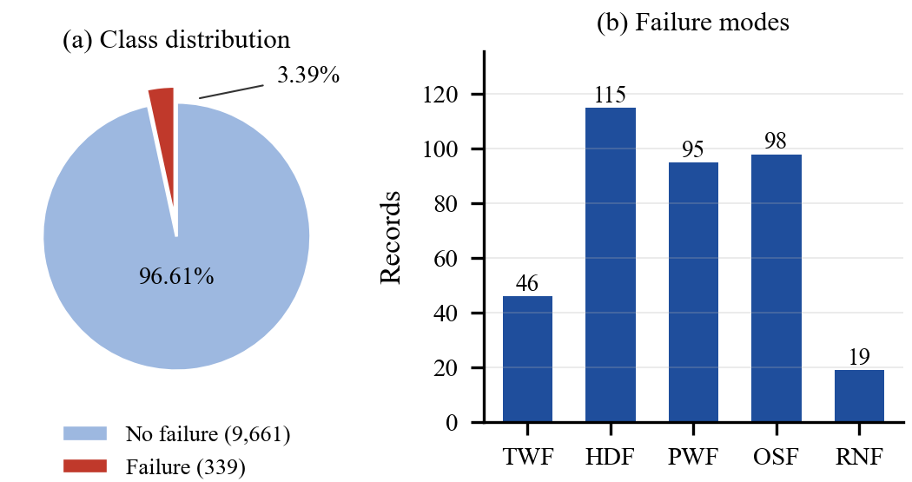
- AI4I 2020 dataset: (a) class distribution of the target; (b) number of records per failure mode.
- Sensor Features of the AI4I 2020 Dataset
Feature | Range | Mean (no failure) | Mean (failure)
Air temperature [K] | 295.3–304.5 | 299.97 | 300.89
Process temp. [K] | 305.7–313.8 | 310.00 | 310.29
Rot. speed [rpm] | 1168–2886 | 1540.3 | 1496.5
Torque [Nm] | 3.8–76.6 | 39.63 | 50.17
Tool wear [min] | 0–253 | 106.7 | 143.8

Failed machines run with markedly higher torque and tool wear. Air and process temperature are strongly correlated (r = 0.876), as are rotational speed and torque (r = −0.875). The failure rate also differs by variant: 3.92% for L, 2.77% for M and 2.09% for H.

Dataset Preprocessing Steps
- Feature selection. The product type and the five sensor readings are retained. Identifiers carry no physical meaning, and the failure-mode flags are removed because they are known only after a failure and would leak the target.
- Encoding and scaling. Numerical features are standardised to zero mean and unit variance and the product type is one-hot encoded, yielding eight inputs.
- Stratified split. The data are divided 70/15/15 into training (7,000 records, 237 failures), validation (1,500, 51) and test (1,500, 51) sets with a fixed seed; transformers are fitted on the training set only.
- Imbalance handling. Instead of synthetic oversampling, the loss is re-weighted (Section III-D), which keeps every training sample real and avoids leakage from resampling.

Methodology Overview
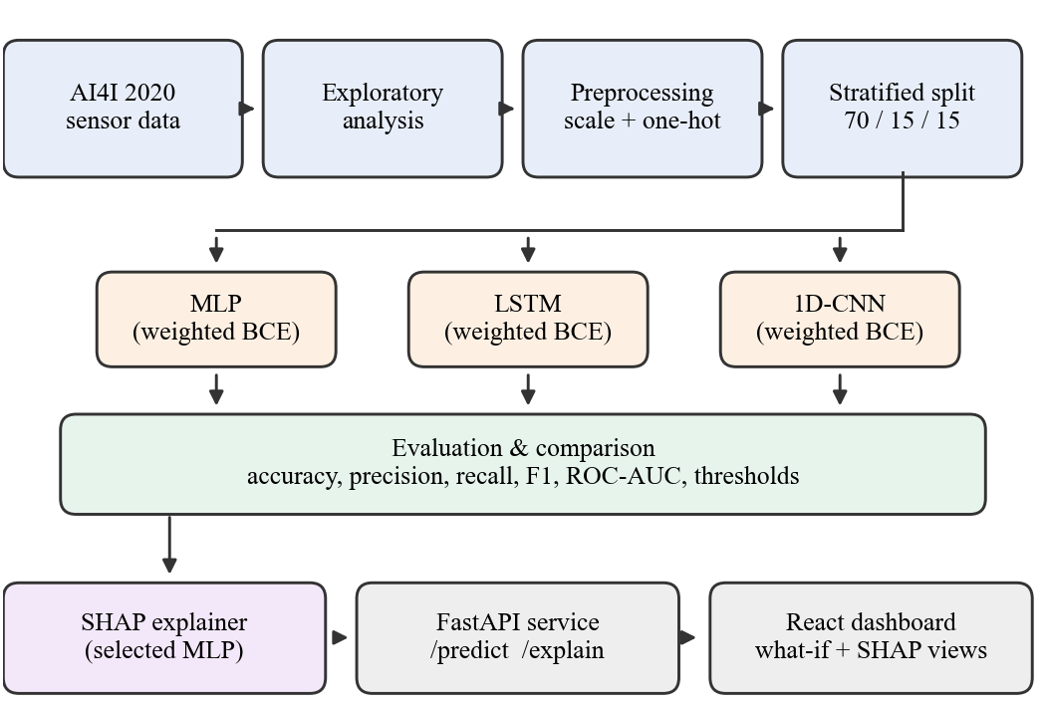
- Methodology of the proposed explainable failure-prediction framework.
Fig. 2 shows the workflow. Three deep architectures are trained and compared, the best model is explained with SHAP, and the trained artefacts are served through an API to a web dashboard. The MLP is the natural model for independent tabular snapshots and is fast at inference. The LSTM [17] and 1D-CNN [18] are included because they dominate the deep PdM literature [9], [10]; applying them to the same data tests whether sequence-oriented inductive biases help when each record is an independent snapshot.
SHAP is chosen for explainability because it is model-agnostic and satisfies local accuracy and consistency [6], [19]. For a model f, the contribution of feature j is its Shapley value over all subsets S of the feature set F:
$φ_{j}=\sum_{S⊆F∖\left\{j\right\}}{\frac{|S|!\left(|F|-|S|-1\right)!}{|F|!}\left[f_{S∪\{j\}}\left(x_{S∪\{j\}}\right)-f_{S}\left(x_{S}\right)\right]}$ (1)
and the contributions sum to the prediction, where φ₀ is the expected output over a background set:
$f\left(x\right)=φ_{0}+\sum_{j=1}^{M}{φ_{j}}$ (2)
With only eight inputs, the values are computed exactly rather than approximated, using 100 background records from the training set; global importance is the mean absolute SHAP value over 100 test records.

Model Training
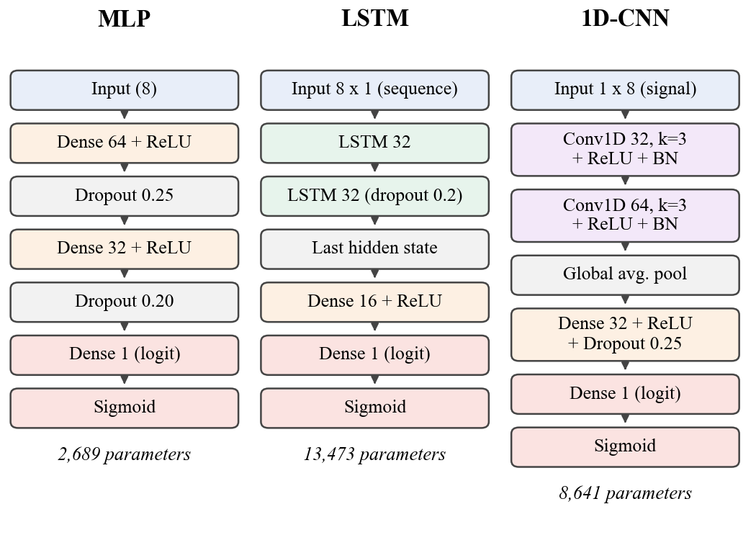
- Architectures of the three deep learning models.
Fig. 3 details the architectures. The MLP uses two ReLU layers with dropout [20]. The LSTM receives the eight features as a sequence of eight steps, and the 1D-CNN treats them as a one-channel signal processed by two convolutional layers with batch normalisation [21] and global average pooling. To counter the 1:28.5 class ratio, all models minimise a binary cross-entropy loss with a positive-class weight equal to the ratio of negative to positive training samples:
$w_{+}=\frac{N_{-}}{N_{+}}=\frac{6763}{237}≈28.5$ (3)
$l_{i}=-\left[w_{+}y_{i}\log{σ\left(z_{i}\right)}+\left(1-y_{i}\right)\log\left(1-σ\left(z_{i}\right)\right)\right]$ (4)
where y_{i} is the label, z_{i} the output logit and σ the sigmoid. Training uses Adam [22], PyTorch [23] and scikit-learn [24] with the settings in Table III, and stops when the validation loss has not improved for 10 epochs, after which the best weights are restored. Fig. 4 shows that all models converge without divergence between training and validation loss.
- Training Configuration and Cost
Setting | MLP | LSTM | 1D-CNN
Trainable parameters | 2,689 | 13,473 | 8,641
Input shape | 8 | 8 × 1 | 1 × 8
Optimiser | Adam | Adam | Adam
Learning rate / decay | 10⁻³ / 10⁻⁵ | 10⁻³ / 10⁻⁵ | 10⁻³ / 10⁻⁵
Batch size / max epochs | 64 / 100 | 64 / 100 | 64 / 100
Epochs until early stop | 93 | 53 | 15
Training time [s] | 32.6 | 88.8 | 18.1
- Measured on an Intel Core i5-12500H CPU with 16 GB RAM, without a GPU.
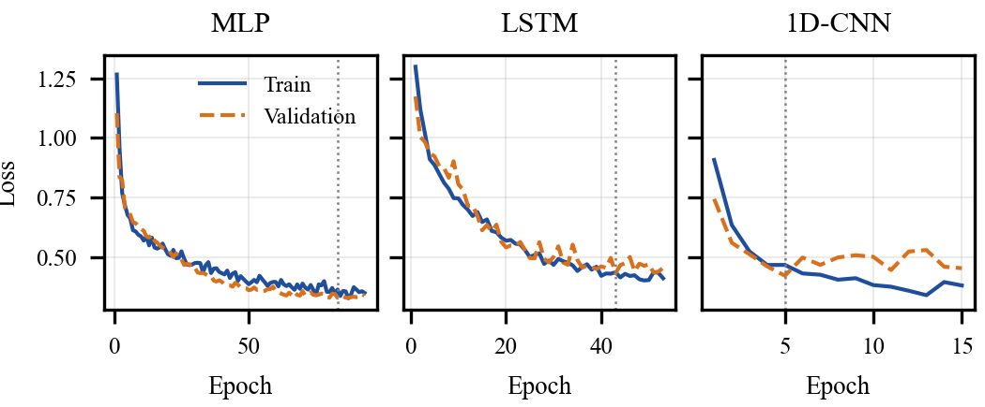
- Training and validation loss of each model (dotted line: epoch with the lowest validation loss).

Results and Discussion

Quantitative Results
Table IV reports test-set performance at the default threshold of 0.5. All models detect at least 88% of failures. The MLP is best on accuracy, precision, F1-score, ROC-AUC and PR-AUC while being the smallest model, and the 1D-CNN achieves the highest recall at the cost of more false alarms. PR-AUC, which is more informative than ROC-AUC under imbalance [25], separates the models clearly: 0.720 for the MLP, 0.599 for the 1D-CNN and 0.485 for the LSTM.
- Test-Set Performance (Threshold 0.5, 1,500 Machines, 51 Failures)
Metric | MLP | LSTM | 1D-CNN
Accuracy | 0.913 | 0.903 | 0.890
Precision | 0.267 | 0.245 | 0.229
Recall | 0.902 | 0.882 | 0.941
Specificity | 0.913 | 0.904 | 0.888
F1-score | 0.413 | 0.383 | 0.368
ROC-AUC | 0.976 | 0.959 | 0.965
PR-AUC | 0.720 | 0.485 | 0.599
- Best value per row in bold. PR-AUC computed as average precision.
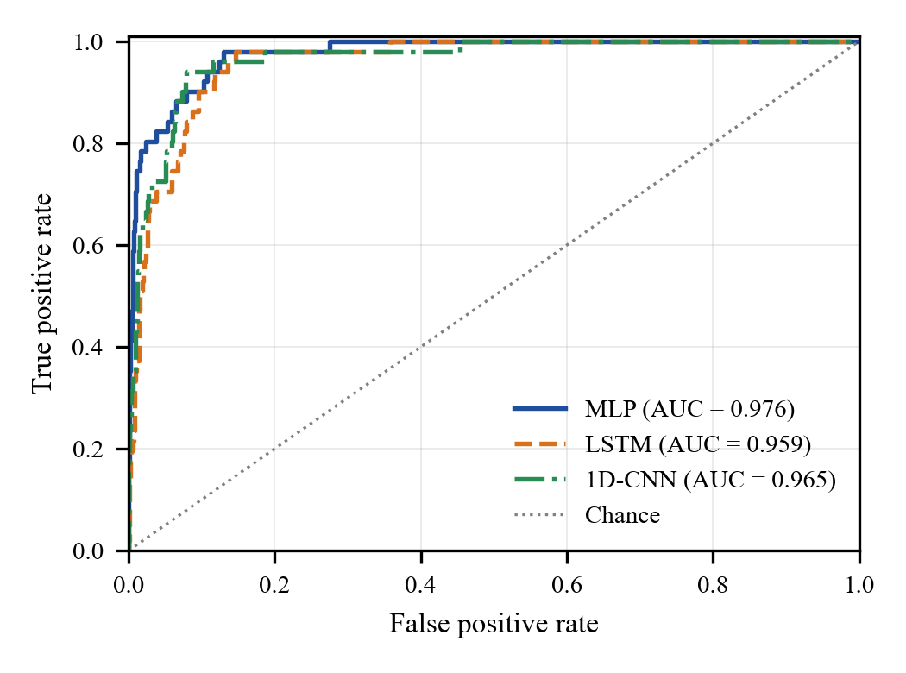
- ROC curves of the three models on the test set.
The ROC curves in Fig. 5 rise steeply for all models, and the confusion matrices in Fig. 6 make the trade-off concrete: the MLP misses 5 of 51 failures with 126 false alarms among 1,449 healthy machines, whereas the 1D-CNN misses 3 with 162 false alarms. The models largely agree on the hard cases; only 2 failures are missed by all three, and a majority vote (recall 0.902, F1-score 0.397) does not improve on the MLP.
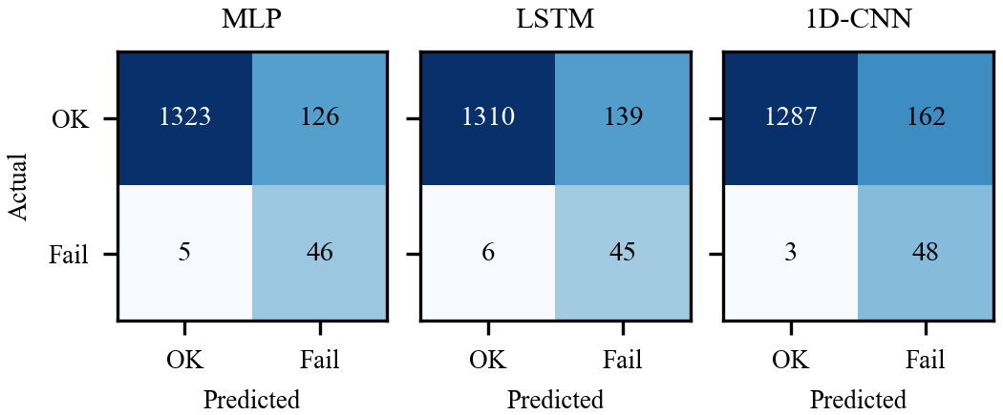
- Confusion matrices at a decision threshold of 0.5.

Decision-Threshold Analysis
The class weighting deliberately favours recall, so precision is low at a threshold of 0.5. Because ROC-AUC is high, the threshold can be set from maintenance costs. Table V shows that raising the MLP threshold to 0.9 cuts false alarms from 126 to 24 at the cost of 6 additional missed failures, and the F1-optimal threshold of 0.93 yields a precision of 0.704, a recall of 0.745 and an F1-score of 0.724. The best F1-scores of the 1D-CNN (0.604) and LSTM (0.551) remain lower, so the MLP is preferred at every operating point.
- Effect of the Decision Threshold on the MLP
Thresh. | Precision | Recall | F1 | FP | FN
0.30 | 0.190 | 0.980 | 0.318 | 213 | 1
0.50 | 0.267 | 0.902 | 0.413 | 126 | 5
0.70 | 0.378 | 0.824 | 0.519 | 69 | 9
0.90 | 0.625 | 0.784 | 0.696 | 24 | 11
0.93 | 0.704 | 0.745 | 0.724 | 16 | 13
- FP: false alarms; FN: missed failures. 0.93 is the F1-optimal threshold.
By failure mode, every model detects all power and overstrain failures in the test set, and the 1D-CNN also detects all 18 heat dissipation failures. Tool wear failures are the hardest (5 of 8 detected by each model), and random failures, which occur independently of operating conditions, are inherently unpredictable.

Comparison with Existing Works
Table VI compares the proposed model with recent studies on AI4I 2020. The accuracy-optimised methods reach 97–99% accuracy, but where recall is reported it is markedly lower: 73.33% for E.XGB and 49.18% for the random forest baseline in [14]. At its default threshold the proposed MLP detects 90.2% of failures, and at the F1-optimal threshold it reaches 98.07% accuracy with a recall comparable to E.XGB. E.XGB retains a higher F1-score, which is consistent with the strength of gradient-boosted trees on tabular data [26]; the proposed framework instead offers a tunable recall–precision trade-off, a deep-model comparison and exact per-prediction explanations validated against the process physics. Because the studies use different splits, the comparison is indicative rather than exact.
- Comparison with Recent Work on AI4I 2020 (%)
Method | Acc. | Prec. | Recall | F1 | Local XAI
Balanced K-Star [12] | 98.75 | NR | NR | NR | No
BHTF [13] | 97.44ª | NR | NR | NR | No
DNN + drift detection [15] | 84.00 | NR | NR | NR | No
Random forest [14] | 98.05 | 78.95 | 49.18 | 60.61 | No
E.XGB [14] | 99.05 | 93.62 | 73.33 | 82.25 | No
Proposed MLP (t = 0.5) | 91.27 | 26.74 | 90.20 | 41.26 | Yes
Proposed MLP (t = 0.93) | 98.07 | 70.37 | 74.51 | 72.38 | Yes
- NR: not reported. ªMean accuracy over failure-mode labels.

Explainability Analysis
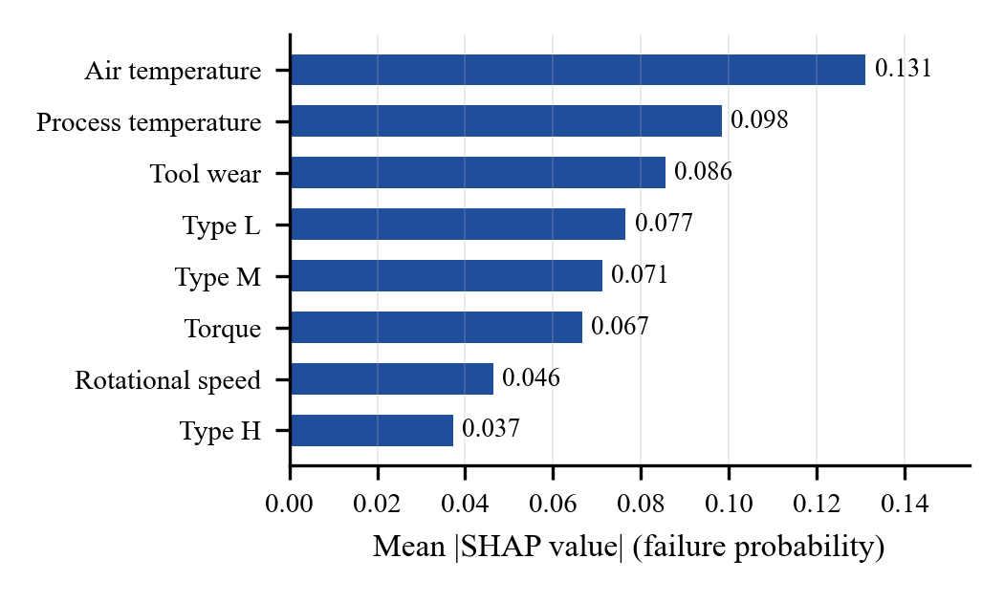
- Global SHAP feature importance of the MLP (mean absolute SHAP value over 100 test records).
Fig. 7 ranks the inputs globally. Air temperature (0.131) and process temperature (0.098) are the most influential, followed by tool wear (0.086), torque (0.067) and rotational speed (0.046). The temperatures matter as a pair because heat dissipation failures occur when their difference becomes small at low speed [8]. The three product-type indicators together contribute 0.185, consistent with the different failure rates of the variants.
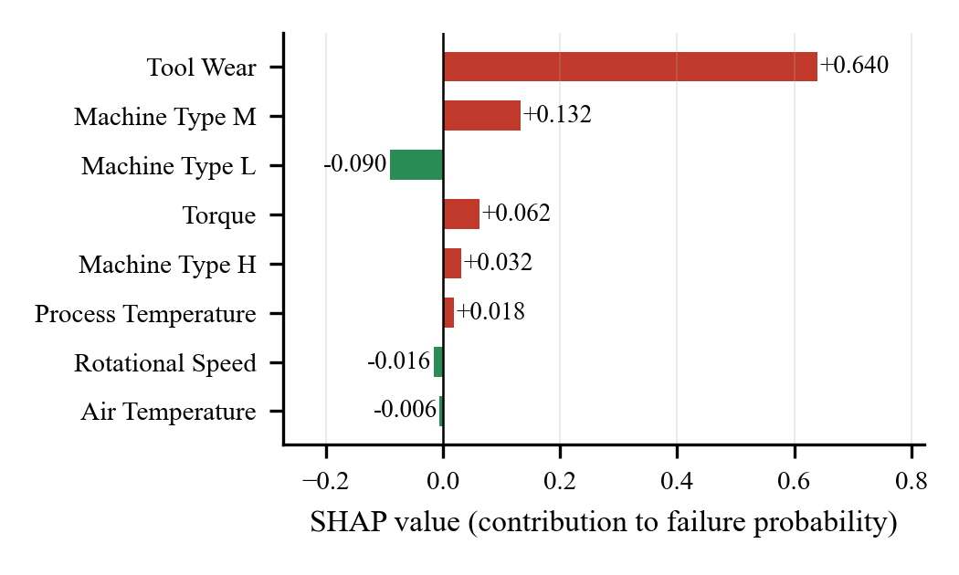
- Local SHAP explanation for a type L machine with 225 min of tool wear (failure probability 0.876).
Fig. 8 explains one prediction for a type L machine at 1,450 rpm, 48.1 Nm and 225 min of tool wear. Most of the predicted risk of 0.876 is attributed to tool wear (+0.640), with smaller contributions from torque (+0.062). The product type is spread across three one-hot features of opposite sign whose sum (+0.074) is the net effect of being type L, so encoded inputs should be read as a group.
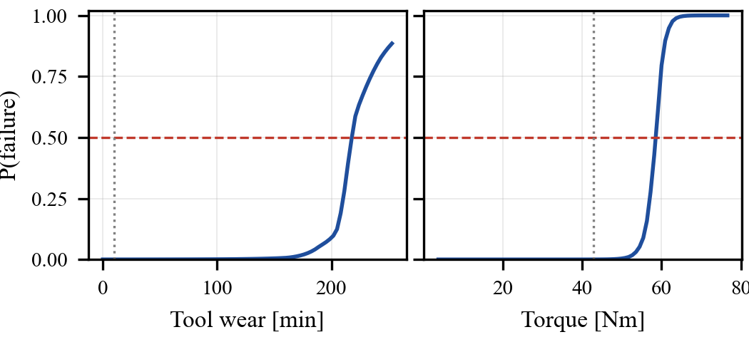
- What-if analysis for a healthy type M machine: failure probability as tool wear (left) or torque (right) varies with all other readings fixed (dotted line: current value).
Fig. 9 varies one reading at a time for a healthy type M machine. The risk crosses 0.5 at a tool wear of about 221 min, inside the 200–240 min window in which tool wear failures are generated [8], and at a torque of about 59.1 Nm, which at 1,408 rpm corresponds to 8.7 kW, close to the 9 kW power-failure limit. The model therefore recovered the physical failure mechanisms without ever seeing the failure-mode labels.

Computation Time and Limitations
Through the REST API on the CPU described in Table III, the median response time over 20 requests is 13.2 ms for a prediction and 17.6 ms for a prediction with an exact SHAP explanation, which is adequate for real-time monitoring. The study is limited by the synthetic nature of AI4I 2020, a single data split with only 51 test failures, and the reduced reliability of SHAP attributions when inputs are strongly correlated.

Conclusion and Future Work
This paper presented an explainable deep learning framework for machine failure prediction on the AI4I 2020 dataset. Under identical class-weighted training, the MLP outperformed the LSTM and 1D-CNN with a ROC-AUC of 0.976, a PR-AUC of 0.720 and a recall of 90.2%, and threshold tuning raised its F1-score to 0.724. Exact SHAP explanations identified temperature, tool wear, torque and product type as the main risk drivers, and a what-if analysis confirmed that the learned boundaries match the tool-wear and power-failure mechanisms of the process. For maintenance teams, the framework provides early warnings that come with a reason, which supports trust and faster diagnosis. For manufacturers, fewer missed failures mean less unplanned downtime, lower repair cost and safer operation, and the CPU-only deployment keeps adoption affordable for small and medium enterprises. The main challenges encountered were the extreme class imbalance and the interpretation of one-hot encoded inputs. Future work will validate the framework on real plant data with genuine sensor time series, use repeated cross-validation with confidence intervals, benchmark gradient-boosted tree models, and extend the task to multi-class prediction of the failure mode.

References
- T. Zonta, C. A. da Costa, R. da Rosa Righi, M. J. de Lima, E. S. da Trindade, and G. P. Li, “Predictive maintenance in the Industry 4.0: A systematic literature review,” Computers & Industrial Engineering, vol. 150, Art. no. 106889, 2020. https://doi.org/10.1016/j.cie.2020.106889
- T. P. Carvalho, F. A. A. M. N. Soares, R. Vita, R. da P. Francisco, J. P. Basto, and S. G. S. Alcalá, “A systematic literature review of machine learning methods applied to predictive maintenance,” Computers & Industrial Engineering, vol. 137, Art. no. 106024, 2019. https://doi.org/10.1016/j.cie.2019.106024
- R. Zhao, R. Yan, Z. Chen, K. Mao, P. Wang, and R. X. Gao, “Deep learning and its applications to machine health monitoring,” Mechanical Systems and Signal Processing, vol. 115, pp. 213–237, 2019. https://doi.org/10.1016/j.ymssp.2018.05.050
- H. He and E. A. Garcia, “Learning from imbalanced data,” IEEE Transactions on Knowledge and Data Engineering, vol. 21, no. 9, pp. 1263–1284, 2009. https://doi.org/10.1109/TKDE.2008.239
- L. Cummins, A. Sommers, S. B. Ramezani, S. Mittal, J. Jabour, M. Seale, and S. Rahimi, “Explainable predictive maintenance: A survey of current methods, challenges and opportunities,” IEEE Access, vol. 12, pp. 57574–57602, 2024. https://doi.org/10.1109/ACCESS.2024.3391130
- S. M. Lundberg and S.-I. Lee, “A unified approach to interpreting model predictions,” in Proc. Advances in Neural Information Processing Systems (NeurIPS), vol. 30, pp. 4765–4774, 2017.
- S. Matzka, “Explainable artificial intelligence for predictive maintenance applications,” in Proc. 3rd Int. Conf. Artificial Intelligence for Industries (AI4I), pp. 69–74, 2020. https://doi.org/10.1109/AI4I49448.2020.00023
- S. Matzka, “AI4I 2020 predictive maintenance dataset,” UCI Machine Learning Repository, 2020. https://doi.org/10.24432/C5HS5C
- A. Wahid, J. G. Breslin, and M. A. Intizar, “Prediction of machine failure in Industry 4.0: A hybrid CNN-LSTM framework,” Applied Sciences, vol. 12, no. 9, Art. no. 4221, 2022. https://doi.org/10.3390/app12094221
- N. O. Pinciroli Vago, F. Forbicini, and P. Fraternali, “Predicting machine failures from multivariate time series: An industrial case study,” Machines, vol. 12, no. 6, Art. no. 357, 2024. https://doi.org/10.3390/machines12060357
- S. N. Elkateb, A. Métwalli, A. Shendy, and A. E. B. Abu-Elanien, “Machine learning and IoT-based predictive maintenance approach for industrial applications,” Alexandria Engineering Journal, vol. 88, pp. 298–309, 2024. https://doi.org/10.1016/j.aej.2023.12.065
- B. Ghasemkhani, O. Aktas, and D. Birant, “Balanced K-Star: An explainable machine learning method for Internet-of-Things-enabled predictive maintenance in manufacturing,” Machines, vol. 11, no. 3, Art. no. 322, 2023. https://doi.org/10.3390/machines11030322
- B. Ghasemkhani, R. A. Kut, D. Birant, and R. Yilmaz, “Balanced Hoeffding Tree Forest (BHTF): A novel multi-label classification with oversampling and undersampling techniques for failure mode diagnosis in predictive maintenance,” Mathematics, vol. 13, no. 18, Art. no. 3019, 2025. https://doi.org/10.3390/math13183019
- A. Nadarajan, I. Ishak, N. Manshor, R. Mohamed, and M. Y. Yusof, “Enhancing predictive maintenance method using machine learning to improve IoT-embedded machinery efficiency and performance,” International Journal of Advanced Computer Science and Applications, vol. 16, no. 10, pp. 255–264, 2025. https://thesai.org/Downloads/Volume16No10/Paper_27-Enhancing_Predictive_Maintenance_Method_Using_Machine_Learning.pdf
- B. S. Prashanth, M. V. Manoj Kumar, N. Almuraqab, and B. H. Puneetha, “Leveraging safe and secure AI for predictive maintenance of mechanical devices using incremental learning and drift detection,” Computers, Materials & Continua, vol. 83, no. 3, pp. 4979–4998, 2025. https://doi.org/10.32604/cmc.2025.060881
- S. Gawde, S. Patil, S. Kumar, P. Kamat, K. Kotecha, and S. Alfarhood, “Explainable predictive maintenance of rotating machines using LIME, SHAP, PDP, ICE,” IEEE Access, vol. 12, pp. 29345–29361, 2024. https://doi.org/10.1109/ACCESS.2024.3367110
- S. Hochreiter and J. Schmidhuber, “Long short-term memory,” Neural Computation, vol. 9, no. 8, pp. 1735–1780, 1997. https://doi.org/10.1162/neco.1997.9.8.1735
- S. Kiranyaz, O. Avci, O. Abdeljaber, T. Ince, M. Gabbouj, and D. J. Inman, “1D convolutional neural networks and applications: A survey,” Mechanical Systems and Signal Processing, vol. 151, Art. no. 107398, 2021. https://doi.org/10.1016/j.ymssp.2020.107398
- L. S. Shapley, “A value for n-person games,” in Contributions to the Theory of Games, vol. II, H. W. Kuhn and A. W. Tucker, Eds. Princeton, NJ, USA: Princeton Univ. Press, pp. 307–317, 1953. https://doi.org/10.1515/9781400881970-018
- N. Srivastava, G. Hinton, A. Krizhevsky, I. Sutskever, and R. Salakhutdinov, “Dropout: A simple way to prevent neural networks from overfitting,” Journal of Machine Learning Research, vol. 15, pp. 1929–1958, 2014.
- S. Ioffe and C. Szegedy, “Batch normalization: Accelerating deep network training by reducing internal covariate shift,” in Proc. 32nd Int. Conf. Machine Learning (ICML), pp. 448–456, 2015.
- D. P. Kingma and J. Ba, “Adam: A method for stochastic optimization,” in Proc. 3rd Int. Conf. Learning Representations (ICLR), 2015. https://doi.org/10.48550/arXiv.1412.6980
- A. Paszke et al., “PyTorch: An imperative style, high-performance deep learning library,” in Proc. Advances in Neural Information Processing Systems (NeurIPS), vol. 32, pp. 8024–8035, 2019.
- F. Pedregosa et al., “Scikit-learn: Machine learning in Python,” Journal of Machine Learning Research, vol. 12, pp. 2825–2830, 2011.
- T. Saito and M. Rehmsmeier, “The precision-recall plot is more informative than the ROC plot when evaluating binary classifiers on imbalanced datasets,” PLoS ONE, vol. 10, no. 3, Art. no. e0118432, 2015. https://doi.org/10.1371/journal.pone.0118432
- L. Grinsztajn, E. Oyallon, and G. Varoquaux, “Why do tree-based models still outperform deep learning on typical tabular data?,” in Proc. Advances in Neural Information Processing Systems (NeurIPS), Datasets and Benchmarks Track, vol. 35, 2022.

