Locator Results Summary

Shubham Kumar

1. Introduction 3

2. Results Summary 3

2.1. Car A with measurement smoothing 3

2.2. Car A without measurement smoothing 3

2.3. Car B with measurement smoothing 4

2.4. Car B with no measurement smoothing 4

# Introduction

This document summarizes the application results and trade-offs

# Results Summary

## Car A with measurement smoothing

The figure below shows the performance. As can be seen, the filter smooths the user positions especially around the peaks and valleys. However, as expected the filter also causes a lag at certain locations.

The yield is 100%

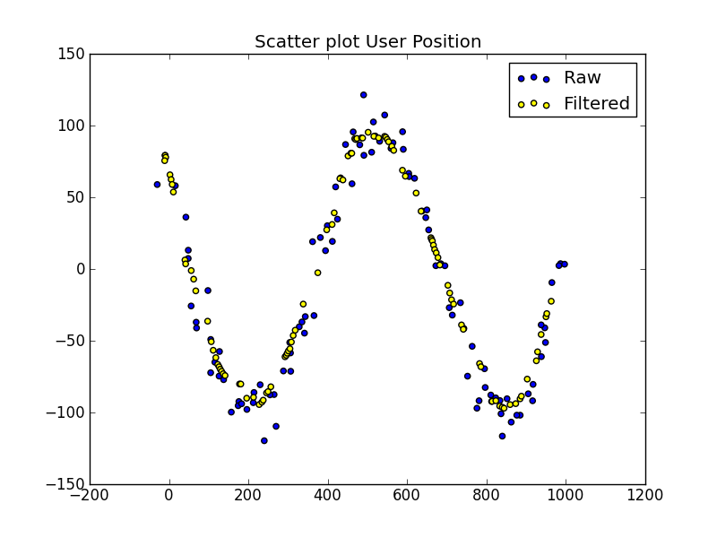

## Car A without measurement smoothing

The figure below shows the performance with measurement smoothing disabled. There is no perceptible improvement or degradation as expected, since the input data is clean.

The yield is 100%



## Car B with measurement smoothing

The figure below shows the performance. As can be seen, the filtered position output is much better and gives a smooth UX. The outliers are handled

The yield is 99%. The loss is related to number of measurements falling below 3 due to measurement filtering

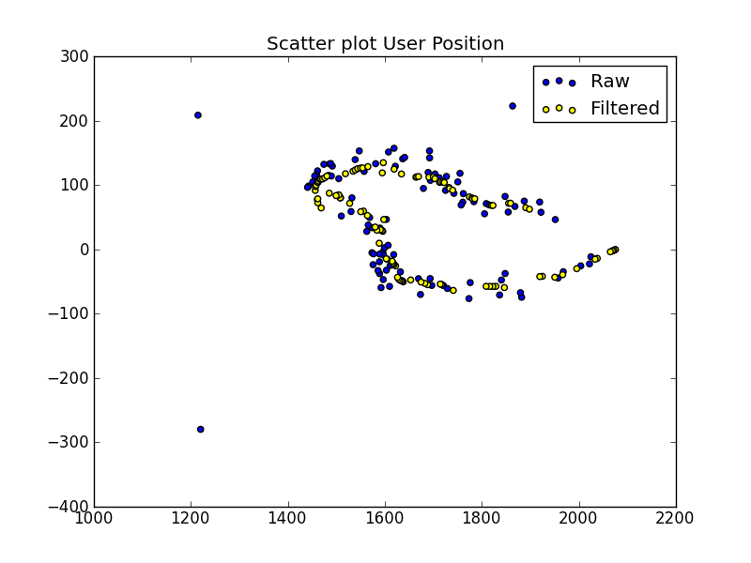

## Car B with no measurement smoothing

The figure below shows the performance without measurement filtering. As can be seen, even though the filtered position output is similar and gives a smooth UX, it comes with a cost of higher yield loss.

The yield drops to 91% and is primarily due to matrix inversion failures. Clearly, even a simple measurement filter helps here.

