In python \n and \t are consider as a single special characters.

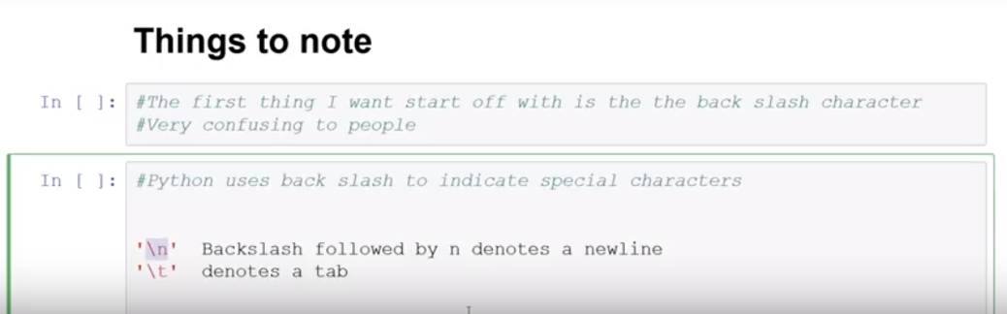

But in python we can use r to use that special characters as a raw string.

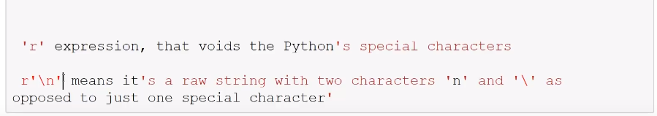

We use re library in python for regex

Using re.search(pattern,String) we find whether that patter find in string or not.

In below it doesn’t find that because pattern is n and string is \n.

Two handle this there are two ways.



First way is to use \ backslash now it finds pattern in sting

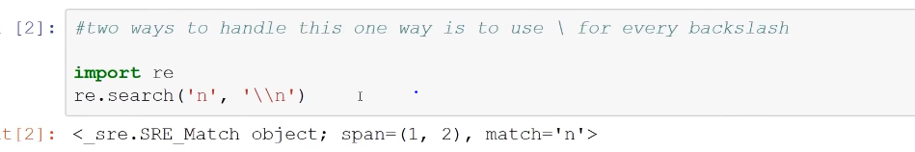

In below 4 it doesn’t find that but it find that in 5 because we use r that converts that string into raw string.

