**Title: Overview of MuseTalk Architecture**

**1. Introduction**

MuseTalk is a state-of-the-art lip-sync generation framework that uses deep learning models to generate accurate and realistic talking videos. The model takes an audio input (speech) and a video (or image) of a subject and synchronizes the lips in the video to match the given audio.

**2. Architecture Overview**

The MuseTalk architecture comprises multiple key components, each responsible for specific tasks in the generation pipeline:

**a. Audio Processor**

* Converts raw audio input into feature vectors.
* Uses a pre-trained **Whisper model** for audio feature extraction.
* The extracted features serve as input to the downstream models for temporal and spatial synchronization.

**b. Image Preprocessing Module**

* Takes video frames or a single image as input.
* Detects facial landmarks and bounding boxes (BBox) to focus on the mouth region.
* Resizes and processes the images to a standard dimension (e.g., 256x256 pixels).

**c. Variational Autoencoder (VAE)**

* The VAE encodes the cropped video frames (mouth region) into **latent representations**.
* The latent representations compress video frame information while preserving details necessary for reconstruction.
* These latent features are passed to the next stage for refinement.

**d. U-Net Architecture**

* The U-Net is a key model responsible for **temporal lip-sync refinement**.
* Inputs:
  + Latent representations of the image from VAE.
  + Audio features extracted from the Whisper model.
* The U-Net learns to generate latent representations of synchronized lip movements based on the input audio.
* Outputs: Refined latent frames with synchronized lip movements.

**e. Pose Estimator (PE)**

* A Pose Estimator model processes audio embeddings to provide additional spatial and temporal features for synchronization.
* Helps improve the natural motion and dynamics of lip movements in the output video.

**f. VAE Decoder**

* Decodes the refined latent representations back to **image frames**.
* The output is a sequence of synchronized mouth images.

**g. Frame Fusion and Video Reconstruction**

* Combines the synchronized mouth images into the original video frames.
* The bounding box information is used to overlay the generated lips on the original frames seamlessly.
* The final frames are compiled into a video at a specified FPS using tools like **FFmpeg**.

**3. Workflow Diagram**

* **Input**: Video/Images + Audio
* **Preprocessing**: Landmark and bounding box detection → Resize frames → Audio feature extraction
* **Latent Encoding**: VAE encodes cropped mouth frames
* **Synchronization**: Audio embeddings + Latent frames processed by U-Net + Pose Estimator
* **Decoding**: VAE Decoder reconstructs refined frames
* **Fusion**: Synchronized lips blended onto original frames
* **Output**: Final Lip-Synced Video

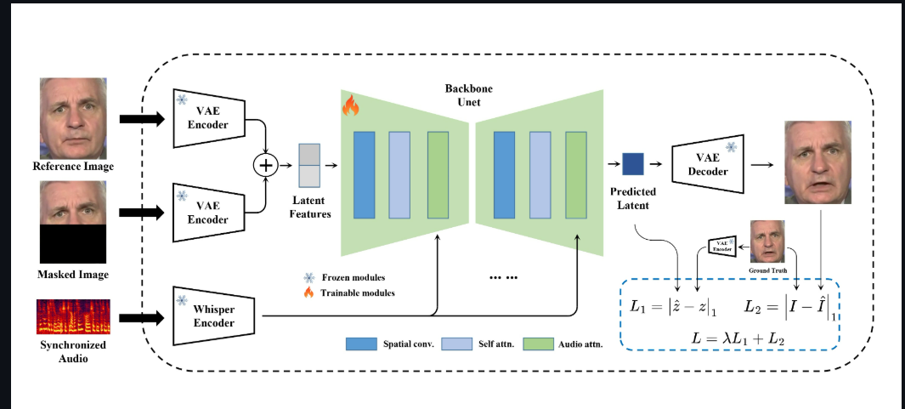

**4. Technical Components**

* **Model Types**:
  + **Whisper**: Audio feature extraction.
  + **VAE**: Frame encoding/decoding.
  + **U-Net**: Lip-sync generation.
* **Frameworks Used**:
  + PyTorch (Deep learning)
  + OpenCV (Image processing)
  + FFmpeg (Video extraction and merging)
* **Hardware Requirements**:
  + GPU for inference (e.g., NVIDIA CUDA support).
  + At least **16GB RAM** for smooth execution.

**5. Advantages of the Architecture**

* **High-Quality Outputs**: The combination of VAE and U-Net ensures precise lip movements and realistic results.
* **Modular Pipeline**: Individual components (e.g., audio processor, pose estimator) can be updated or replaced for improved performance.
* **Scalability**: Works efficiently on short or long videos.
* **Speed Optimization**: Batch processing reduces inference time for large-scale videos.

**6. Conclusion**

MuseTalk architecture leverages advanced deep learning techniques for high-quality and realistic lip-sync video generation. By combining audio features with image latent representations and using powerful models like Whisper and U-Net, it achieves state-of-the-art results in temporal and spatial synchronization of lip movements.