CardioRisk: an end-to-end MLOps pipeline for heart-disease risk prediction
  - AIMLCZG523 Machine Learning Operations, Assignment 1
Shubham Pardeshi (BITS ID: 2025ae05144)
20 October 2026
Table of Contents

Code repository: https://github.com/shubham-pardeshi26/Bits-Sem3-MLOps-Assignment1/
Pipeline video: Watch the pipeline walkthrough (OneDrive)
Charts and the architecture diagram are generated by the code (make eda, make train, scripts/architecture_diagram.py). Of the screenshots (screenshots/01 to 15), the five that prove CI/CD and deployment are in the body and the rest in Appendix C.

1. Summary
Problem. Predict whether a patient has heart disease (UCI attribute num > 0) from 13 routine clinical measurements, and serve the model as a monitored API that runs unchanged on a laptop, in CI and on Kubernetes.
Approach. Most work on this dataset uses only the 303 Cleveland patients. I used all four UCI hospitals (Cleveland, Hungary, Switzerland, VA Long Beach): three times the data, but each site recorded different tests and the disease rate ranges from 36% to 93%. Missing data and hospital shift become the central problems, and the data allows a test at a hospital the model has never seen. The code is one Python package, cardiorisk, with one make target per stage; CI runs the same commands.
Table 1. Headline results (from reports/metrics.json and models/model_card.json).
Item | Result
Data | 918 patients from 4 hospitals (920 raw rows, 2 duplicates dropped), 55% with heart disease
Model search | Majority baseline, logistic regression, random forest, histogram gradient boosting: 85 grid candidates, 5-fold CV
Champion | Elastic-net logistic regression (C = 0.3, l1_ratio = 0.5): CV ROC-AUC 0.907 ± 0.029 on 734 training patients
Hold-out (184 patients, threshold 0.5) | ROC-AUC 0.906, accuracy 0.842, precision 0.829, recall 0.902, F1 0.864
Unseen hospital (leave-one-site-out ROC-AUC) | Cleveland 0.876, Hungary 0.902, Switzerland 0.749, VA 0.730
MLOps | MLflow tracking and registry (cardiorisk-classifier@champion); FastAPI in a non-root image; Kubernetes with Kustomize overlays, LoadBalancer, Ingress and HPA 2-5; Prometheus and Grafana; GitHub Actions CI/CD publishing to GHCR

2. Architecture
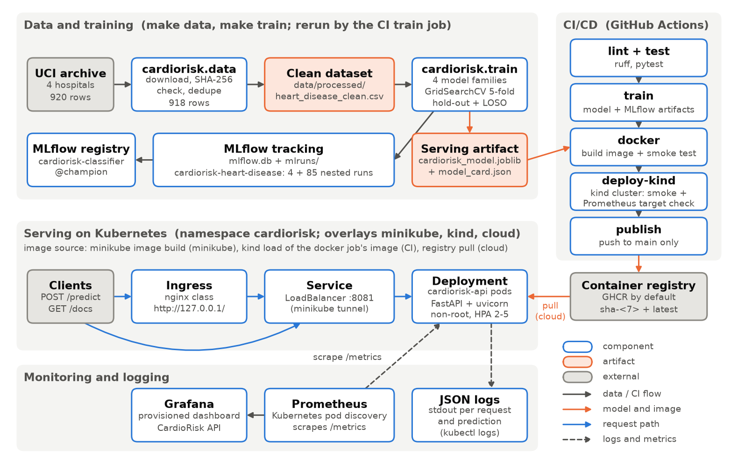
Figure 1. System architecture: data and training, CI/CD, serving on Kubernetes, and monitoring.
Figure 1 shows the four parts: data and training (checksummed data, grid search tracked in MLflow, a serving artifact), CI/CD (retrain, test in Docker and kind, publish from main), serving (FastAPI pods behind a LoadBalancer and an Ingress) and monitoring (Prometheus, Grafana, JSON logs). Each concern has one code path: the cross-validated pipeline is the served object, the API and the CLI share predict_records, and the tested image is the published one.

3. Setup and installation
Prerequisites: Python 3.12 and make; Docker for the container; minikube and kubectl for Kubernetes; Google Chrome only for the PDF of this report.
make setup # .venv with the pinned requirements.txt
make data # verify (or download) the UCI files, write the cleaned CSV
make eda # EDA figures in reports/figures/eda_*.png
make lint test # ruff and the 39 unit tests, as in CI
make train # tune, track in MLflow, save the champion (about 30 s)
make mlflow-ui # MLflow UI on http://127.0.0.1:5001
make serve # API on http://127.0.0.1:8081/docs
make docker-build docker-run # then, in a second terminal: make smoke
make compose-up # API + Prometheus :9090 + Grafana :3000 without Kubernetes
make minikube-start k8s-image k8s-deploy
make report report-pdf # this report: reports/report.docx and .pdf
The API uses host port 8081 and MLflow 5001, because 8000, 8080 and 5000 are often taken; PORT= and MLFLOW_PORT= change them. Every Kubernetes target runs kubectl --context minikube, and make k8s-deploy stops if that context is missing. The README has the full command reference and troubleshooting.

4. Data acquisition and EDA

4.1 Source and cleaning
The UCI Heart Disease dataset (id 45) ships one “processed” file per hospital with the same 14 attributes: Cleveland (303 rows), Hungary (294), Switzerland (123) and VA (200). make data checks the files against SHA-256 digests pinned in data.py and downloads the archive only if one is missing or differs, since a silently republished archive would shift every number here. Raw files and the cleaned CSV are committed, so CI never depends on the UCI server. clean() applies the rules in Table 2, each unit-tested. A site column is kept for stratification and leave-one-site-out evaluation, never as an input.
Table 2. Cleaning rules and how many values they touch.
Rule | Affected | Reason
? read as missing | 1,759 values | UCI marker for “not recorded”
chol == 0 set to missing | 172 rows (all 123 Swiss, 49 VA) | Zero cholesterol is impossible: “not measured”
trestbps == 0 set to missing | 1 row (VA) | Same reason
Exact duplicates dropped | 2 rows (1 Hungary, 1 VA) | A copy could land on both sides of the split
target = (num > 0) | all 918 rows | Hungary coded num only as 0/1, the others graded 1-4
Kept: negative oldpeak (12 rows), extremes such as chol = 603 | - | Clinically real, so no clipping
Imputation is not cleaning: it is part of the model pipeline, fitted on training folds only.

4.2 Exploratory analysis
make eda draws the figures and notebooks/01_eda.ipynb discusses them; Figure 2 is here, the others are in Appendix B. Each finding led to a pipeline decision.
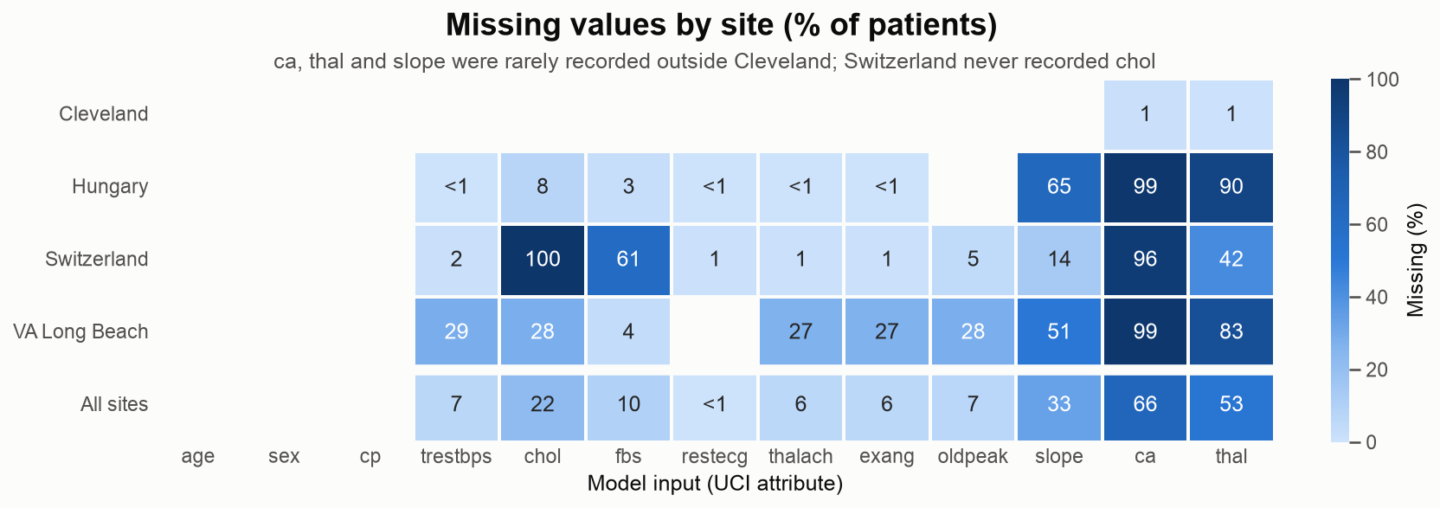
Figure 2. Share of missing values per input and hospital.
- Missingness is structural (Figure 2). ca is missing for 96-99% of patients outside Cleveland, thal for 42-90%, Switzerland never recorded cholesterol, and VA lacks 27-28% of its exercise-test values. Only 299 of 918 rows are complete (297 from Cleveland), so dropping incomplete rows would leave one hospital. Missingness is also informative: the hospital alone ranks patients with ROC-AUC 0.72, and the 35 missingness patterns identify the hospital for 86% of patients. Decision: impute with missing-value indicators, knowing they partly reconstruct the hospital (Section 5.5).
- Class balance (Figure 11). 508 patients (55%) have heart disease, so accuracy is meaningful and no resampling is needed, but the rate is 36% in Hungary, 46% in Cleveland, 74% at VA and 93% in Switzerland. Decision: stratify the split and folds on site x class.
- Distributions and categories (Figures 12, 13). The exercise-test variables separate the classes best (median maximum heart rate 151 vs 128 bpm, ST depression 0.0 vs 1.1 mm); scales differ by two orders of magnitude. Asymptomatic chest pain (cp = 4) has a 79% disease rate against 14% for atypical angina, the codes are not ordinal and “not recorded” has its own rate. Decision: standardise numeric inputs, one-hot encode categorical ones with missing as a category.
- Correlations and heart rate (Figures 14, 15). The strongest correlates of disease are exercise angina (r = 0.46), oldpeak (0.39) and thalach (-0.39); correlation among inputs peaks at 0.39, so no input is dropped by hand. 66% of patients with disease stay below 85% of the age-predicted maximum heart rate, against 40% of those without. Decision: add hr_achieved_frac.

5. Feature engineering and model development

5.1 The pipeline
Everything between a raw record and the classifier is one scikit-learn Pipeline (cardiorisk.features.build_pipeline): (1) features keeps the 13 inputs as floats (JSON null becomes NaN, extra columns are dropped) and adds hr_achieved_frac = thalach / (220 - age); (2) preprocess applies median imputation with missing-value indicators and StandardScaler to numeric inputs, most-frequent imputation with indicators to binary ones, and OneHotEncoder(handle_unknown="ignore") to categorical ones, with NaN as its own category; (3) model is the estimator being tuned. GridSearchCV therefore refits imputers and scaler in every fold (no leakage), and the saved object replays the training transforms, with no second copy of the feature code in the API. The indicators also let the API score a record with only age, sex and cp.

5.2 Candidates, validation and selection
Table 3. Model families, their grids and number of candidates n (train.CANDIDATES).
Family (fixed settings) | Grid | n
Majority baseline (DummyClassifier) | none | 1
Logistic regression (saga, max_iter=5000) | C {0.01, 0.03, 0.1, 0.3, 1, 3} x l1_ratio {0, 0.5, 1} x class_weight {None, balanced} | 36
Random forest (random_state=42) | n_estimators {200, 500} x max_depth {4, 8, None} x min_samples_leaf {1, 3, 10} x max_features {sqrt, 0.5} | 36
Hist. gradient boosting (max_iter=200) | learning_rate {0.03, 0.1} x max_leaf_nodes {4, 8, 16} x l2_regularization {0, 1} | 12
An 80/20 split stratified on site x class gives 734 training and 184 test patients. Five folds of the training split on the same strata are shared by all families, so the comparison is paired. Every fold records ROC-AUC, accuracy, precision, recall and F1 at threshold 0.5. The champion is the non-baseline family with the highest mean CV ROC-AUC, which is threshold-free and insensitive to prevalence; the hold-out is scored once per family, for reporting only. The grids are coarse on purpose: the CV standard deviation is 0.023-0.035 ROC-AUC, while the 18 logistic-regression candidates with C >= 0.3 span only 0.0029, so a finer grid would select noise.

5.3 Results
Table 4. Model comparison (from reports/metrics.md; CV = mean over 5 folds).
Metric | Baseline | Logistic regression (champion) | Random forest | Hist. gradient boosting
CV ROC-AUC | 0.500 ± 0.000 | 0.907 ± 0.029 | 0.897 ± 0.023 | 0.895 ± 0.026
CV accuracy | 0.553 | 0.834 | 0.823 | 0.811
CV precision | 0.553 | 0.853 | 0.829 | 0.815
CV recall | 1.000 | 0.845 | 0.857 | 0.852
CV F1 | 0.712 | 0.849 | 0.843 | 0.833
Test ROC-AUC | 0.500 | 0.906 | 0.896 | 0.900
Test accuracy | 0.554 | 0.842 | 0.853 | 0.853
Test precision | 0.554 | 0.829 | 0.844 | 0.844
Test recall | 1.000 | 0.902 | 0.902 | 0.902
Test F1 | 0.713 | 0.864 | 0.872 | 0.872
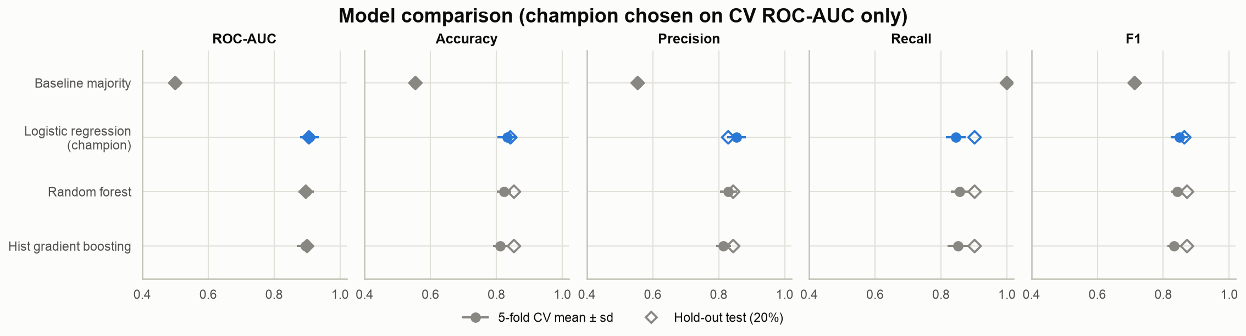
Figure 3. CV mean ± sd (dots) and hold-out score (diamonds) per family for ROC-AUC, accuracy, precision, recall and F1; the champion in blue.
Best settings: logistic regression C = 0.3, l1_ratio = 0.5, no class weight; forest 500 trees of depth 8; boosting learning rate 0.03 with 4 leaves. All three beat the baseline by about 0.40 ROC-AUC, and CV and hold-out agree within 0.01 (Figure 3), so none is overfitted to the folds.
Why logistic regression. It leads on CV ROC-AUC by 0.010-0.012, less than one standard deviation, so the three are statistically tied and the linear model wins on its merits. Boosting’s best configuration used the smallest trees on offer, a sign that extra capacity fits noise at 734 patients; one-hot categories and indicators make the signal close to additive; and the pipeline needs about 205 MiB per pod against 240 MiB for the forest, with coefficients a clinician can read. The ensembles’ higher hold-out accuracy (0.853 vs 0.842) is two patients; switching for it would select on the test set.

5.4 The champion on the hold-out set
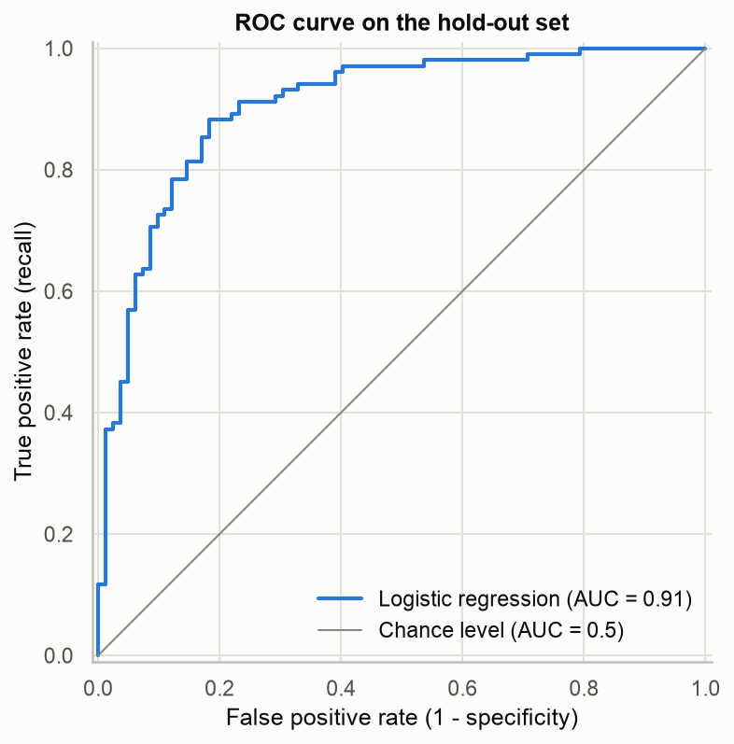 | 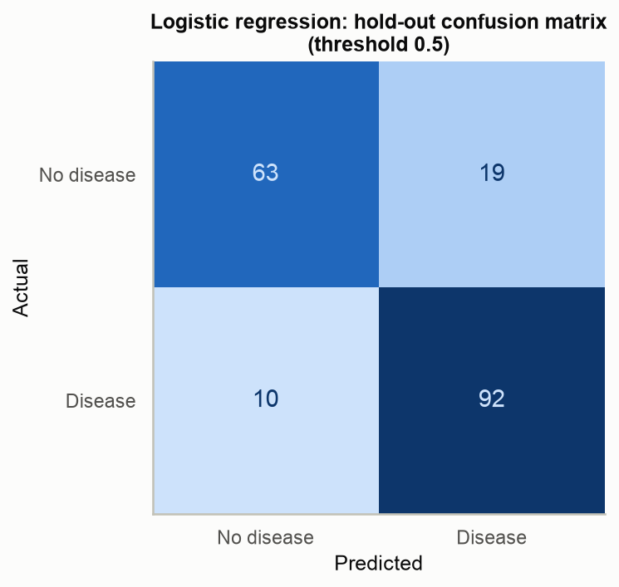
Figure 4. ROC curve on the 184 hold-out patients. | Figure 5. Hold-out confusion matrix at threshold 0.5.
The ROC curve (Figure 4) finds about 80% of disease cases at a 15% false-positive rate. At 0.5 (Figure 5) the model finds 92 of 102 patients with disease (recall 0.902) and clears 63 of 82 without (specificity 0.768): 19 false alarms and 10 missed cases, the right direction for screening. Permutation importance (Figure 16, Appendix B) is led by chest pain type (0.051 ROC-AUC lost), then ca (0.018) and oldpeak (0.014). chol ranks fourth (0.013) despite a correlation of 0.12 because it mostly signals whether cholesterol was measured: shuffling only the recorded values costs about 0.002.

5.5 Leave-one-site-out: how well does the model travel?
Pooled CV mixes all hospitals in every fold. To estimate performance at a new hospital, training refits the champion configuration on three sites and scores it on the fourth (Table 5; chart in Figure 17, Appendix B).
Table 5. Leave-one-site-out results of the champion configuration.
Held-out site | Patients | Disease | ROC-AUC | Accuracy | Recall
Cleveland | 303 | 46% | 0.876 | 0.762 | 0.878
Hungary | 293 | 36% | 0.902 | 0.795 | 0.906
Switzerland | 123 | 93% | 0.749 | 0.772 | 0.791
VA Long Beach | 199 | 74% | 0.730 | 0.759 | 0.831
Transfer to the two lower-prevalence hospitals is almost as good as the pooled hold-out (0.876 and 0.902 against 0.906), but at Switzerland and VA ROC-AUC falls to about 0.74. Both have high prevalence and the most missing data, a signal a model trained elsewhere reads differently. Accuracy hides the drop: calling every patient diseased would already score 0.74 at VA and 0.93 in Switzerland. The hyper-parameters were chosen by CV over all four sites, so these scores are mildly optimistic; at a new hospital I would expect 0.73-0.90 until the model is validated locally. These metrics are also in the model card, MLflow and /model-info.

6. Experiment tracking
MLflow 3.16 tracks every training session in the experiment cardiorisk-heart-disease, with a sqlite backend (the registry needs a database) and artifacts under mlruns/; CI uploads both as the mlflow-tracking artifact. Each session logs four family runs, tagged with training_session and family, holding the estimator parameters, cv_<metric>_mean/std and test_<metric> for the five metrics, the training split as an MLflow dataset (734 rows, with digest), plots (ROC, precision-recall, confusion matrix, permutation importance), cv_results.csv, a classification report and the model. Under them, 85 nested runs (1 + 36 + 36 + 12), one per grid point, hold the hyper-parameters, CV mean and sd, fit_seconds and per-fold scores (cv_folds.json). The champion run adds the tag champion = true, the loso_<site>_* metrics and the leave-one-site-out plot, and registers a new version of cardiorisk-classifier with the alias champion.
Nested runs keep the top-level list at four rows while recording every grid point (Figures 18-22, Appendix C). The registry uses an alias instead of the stages MLflow 3 deprecates; moving @champion is the promotion step. model_card.json and /health report the registry version.

7. Model packaging and reproducibility
Serving artifact. models/cardiorisk_model.joblib is the fitted pipeline scored on the hold-out; models/model_card.json records registry version, hyper-parameters, threshold, metrics, features, MLflow run id, library versions and the SHA-256 of the cleaned table. joblib keeps MLflow out of the image; it can execute code on load, acceptable only because the file comes from the project’s own training job and is never accepted from users.
MLflow model. Each family run also logs the model with skops, which refuses any type not explicitly trusted; code_paths bundles src/cardiorisk, so models:/cardiorisk-classifier@champion loads without the package.
Requirements and determinism. Both requirement files pin exact versions: requirements-serve.txt holds the nine runtime packages the image installs, and requirements.txt adds the training and development tools. One seed (42) drives split, folds, estimators and permutation importance, so make train reproduces every metric.

8. CI/CD pipeline and automated testing
Tests. 39 pytest tests run offline in about 20 s on synthetic patients, plus one gate on the real data. They cover every cleaning rule and the checksum-verified download, the feature formula and a pickle round trip, the CLI, every API contract (null and omitted fields, 422 without echoed values, X-Request-ID, the Prometheus series, JSON logs without patient data) and a reduced train() that must write the card, reports, MLflow runs and alias, with logistic regression reaching CV ROC-AUC >= 0.80 on the real data.
Workflow. .github/workflows/ci.yml runs on every push to main, every pull request and on demand, with six jobs (Figure 6): lint (ruff) and test (pytest, JUnit XML) in parallel; train (data check and full training, model comparison in the run summary, Figure 7); docker (builds the image around this run’s model, smoke test); deploy-kind (a kind cluster with the tested image and the kind overlay, smoke test through the Service, waits until Prometheus reports every API target up); and publish.
Gating and publishing. Each job runs only if its predecessors passed, so nothing untested is published; failing jobs print container logs or the cluster’s pods and events. On a push to main, publish tags the image archive that passed both smoke tests sha-<7> and latest and pushes it without rebuilding, to GHCR with GITHUB_TOKEN by default; repository variables and one secret redirect it to Docker Hub, ECR, GAR or ACR.
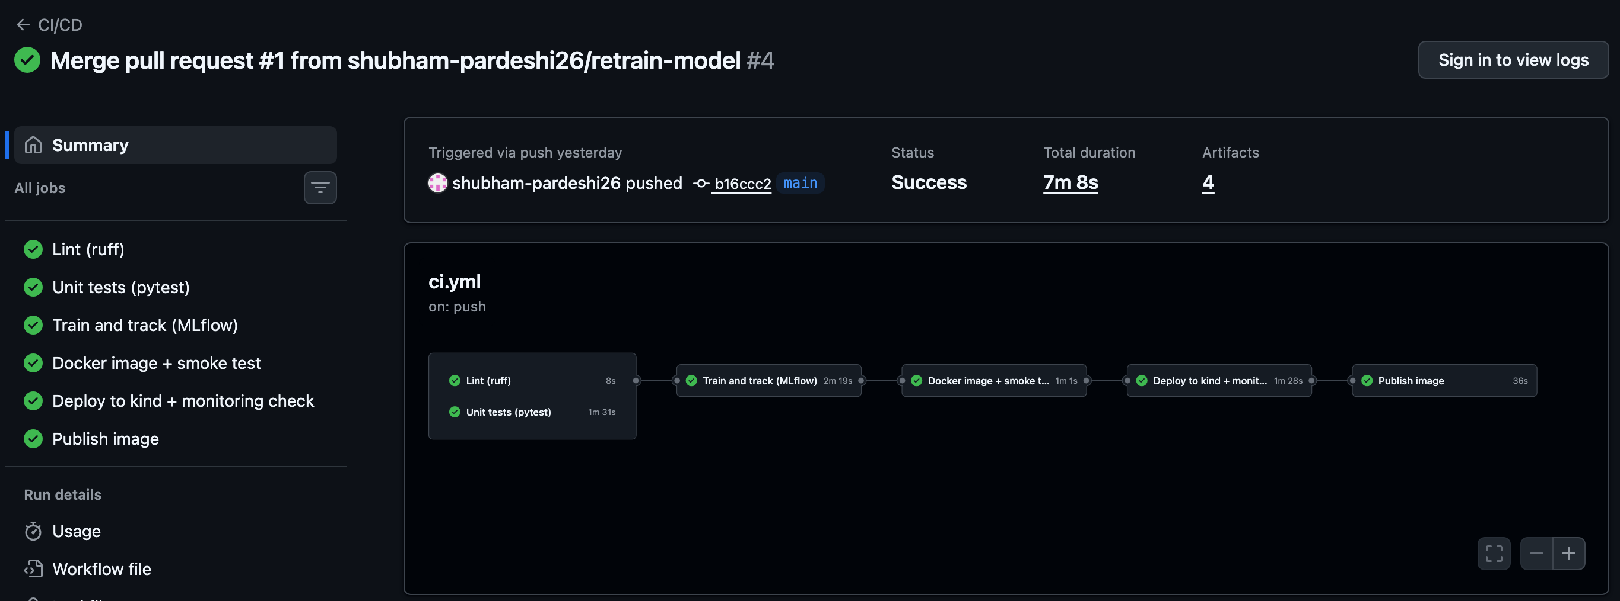
Figure 6. A workflow run with all six jobs green.
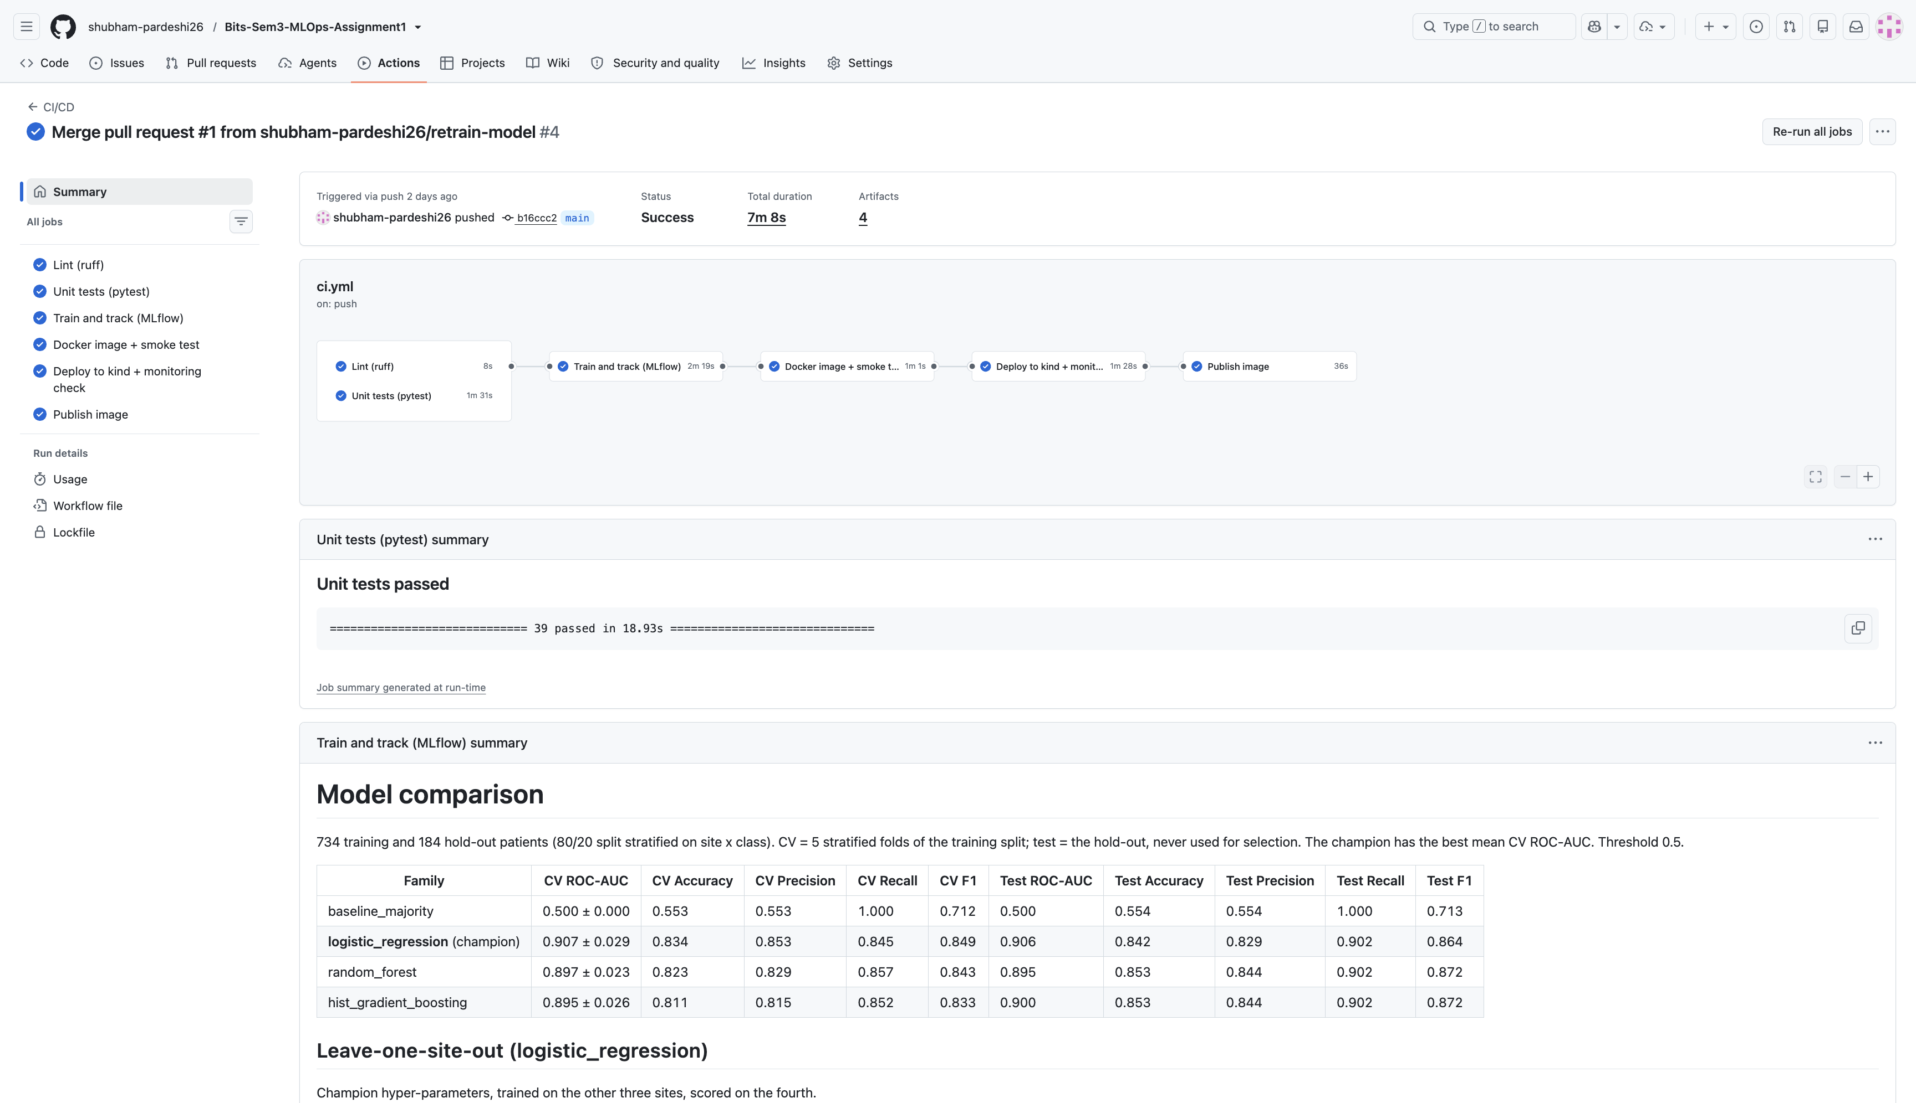
Figure 7. Run summary: unit-test result and the model comparison table.

9. Model containerization
The Dockerfile builds on python:3.12-slim with only requirements-serve.txt, and .dockerignore is an allowlist (requirements-serve.txt, src/, models/). Requirements are installed before code and model are copied, so a retrain rebuilds only the last layers. The model is baked in, so one tag identifies code and model. The app runs as uid 10001 with read-only files and a HEALTHCHECK on /health.
The API (cardiorisk.api:app, container port 8000) has five endpoints: POST /predict, GET /health (liveness and readiness, with the model version), GET /model-info (the model card), GET /metrics (Prometheus) and GET /docs (Swagger UI, prefilled with the sample patient):
curl -s -X POST http://127.0.0.1:8081/predict \
-H 'Content-Type: application/json' -d @scripts/sample_request.json
# {"prediction": 1, "label": "heart_disease", "confidence": 0.9851,
# "probability_disease": 0.9851, "model_version": "3"}
Pydantic rejects codes outside the UCI codebook, implausible measurements and unknown fields, so a misspelt field cannot silently become a missing value; only age, sex and cp are required, and the 422 response does not echo the submitted values. make docker-build, make docker-run and make smoke prove the image (Figures 25-27, Appendix C): the smoke test checks /health, the response contract, 422 for invalid payloads and /metrics.

10. Production deployment
The manifests use Kustomize. base/ holds the namespace cardiorisk, the Deployment, a ClusterIP Service and the HPA; monitoring/ adds Prometheus (with a namespaced Role) and Grafana. Three overlays adapt them: minikube (image built inside minikube, LoadBalancer on port 8081, nginx Ingress), kind (the CI deployment test) and cloud (registry image, LoadBalancer and Ingress, notes for GKE, EKS and AKS).
The HPA owns the replica count (2-5 at 70% CPU). Rolling updates keep every ready pod until its replacement is ready (maxUnavailable: 0), and all probes use /health. Memory is sized from a measured 205 MiB peak (256 MiB request, 512 MiB limit). The namespace enforces the restricted Pod Security Standard (non-root, read-only root filesystem, no capabilities).
The deployment in the screenshots runs on minikube with the Docker driver: make minikube-start (ingress and metrics-server addons), make k8s-image (builds the image inside minikube, so no registry is needed), make k8s-deploy (kubectl --context minikube apply -k deploy/k8s/overlays/minikube), then minikube tunnel in a separate terminal, make smoke against the LoadBalancer and make smoke URL=http://127.0.0.1 against the Ingress (Figures 8, 9). For a managed cluster only the lines in overlays/cloud (image, Ingress class) change.
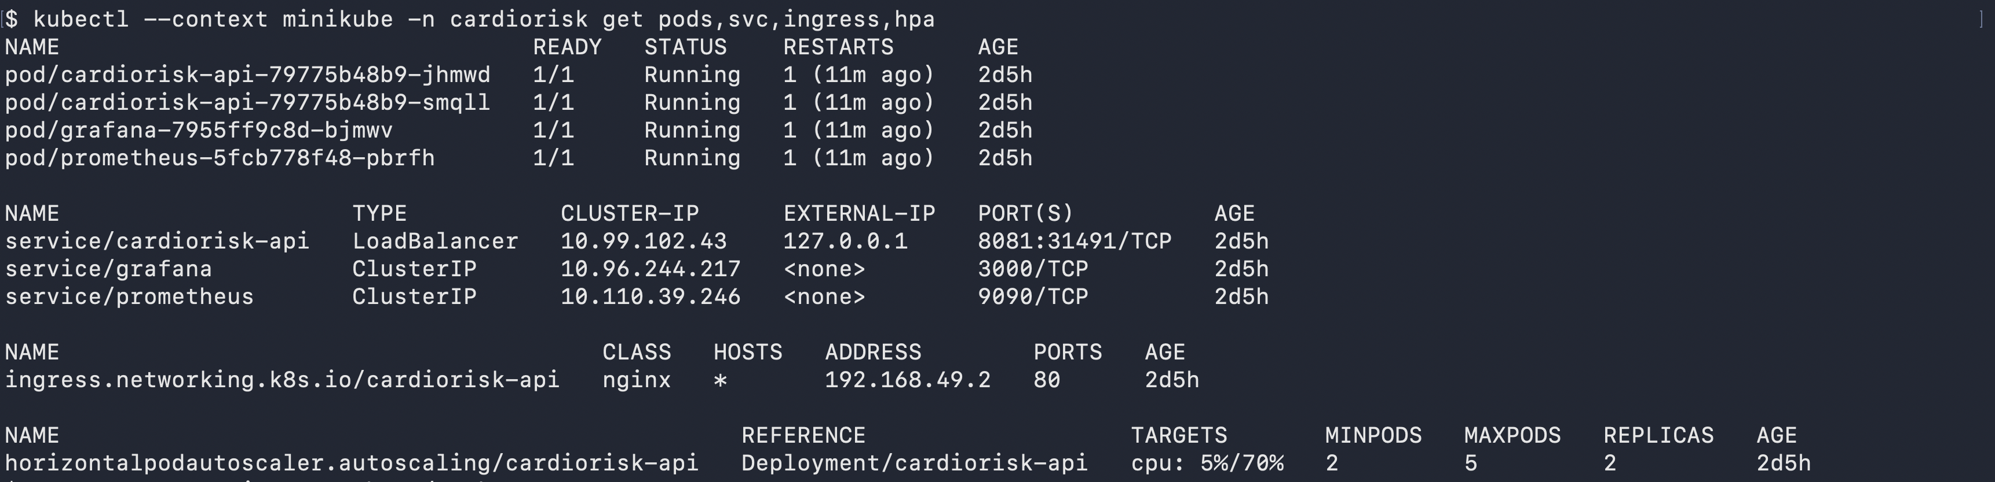
Figure 8. kubectl --context minikube -n cardiorisk get pods,svc,ingress,hpa.
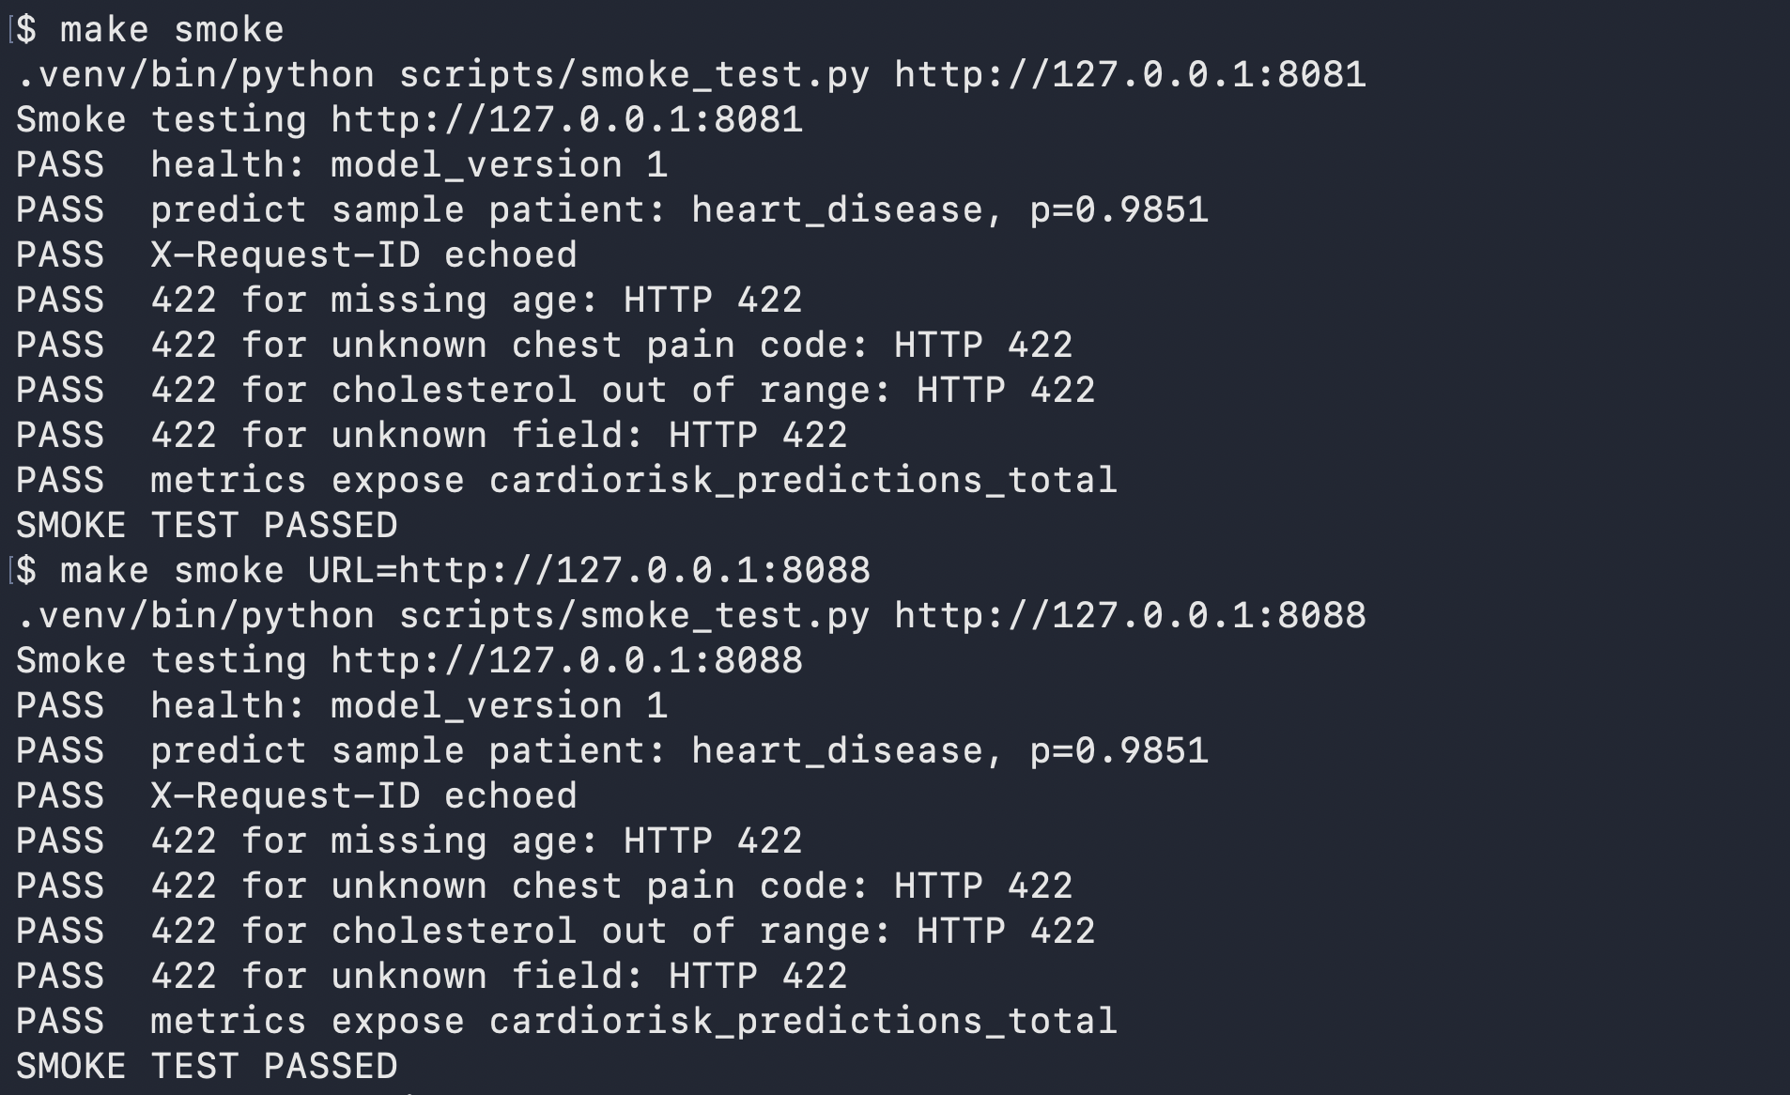
Figure 9. minikube tunnel and make smoke passing against the LoadBalancer and the Ingress.

11. Monitoring and logging
Metrics. The API exports cardiorisk_http_requests_total (by method, route and status) and cardiorisk_http_request_duration_seconds for traffic, errors and latency; cardiorisk_predictions_total by label and cardiorisk_prediction_probability (a coarse drift signal) for the predictions; and cardiorisk_model_info with the version each pod serves. The route label is the route template, so random URLs cannot create unbounded series. Prometheus discovers annotated pods and scrapes every 5 s (Figure 28, Appendix C). Grafana is provisioned from ConfigMaps; the “CardioRisk API” dashboard (Figure 10) shows pods up, model version, prediction mix, request rate, error share, /predict latency p50/p95/p99, memory and the predicted-probability distribution. make load sends 300 varied requests, 10% invalid, so every panel has data.
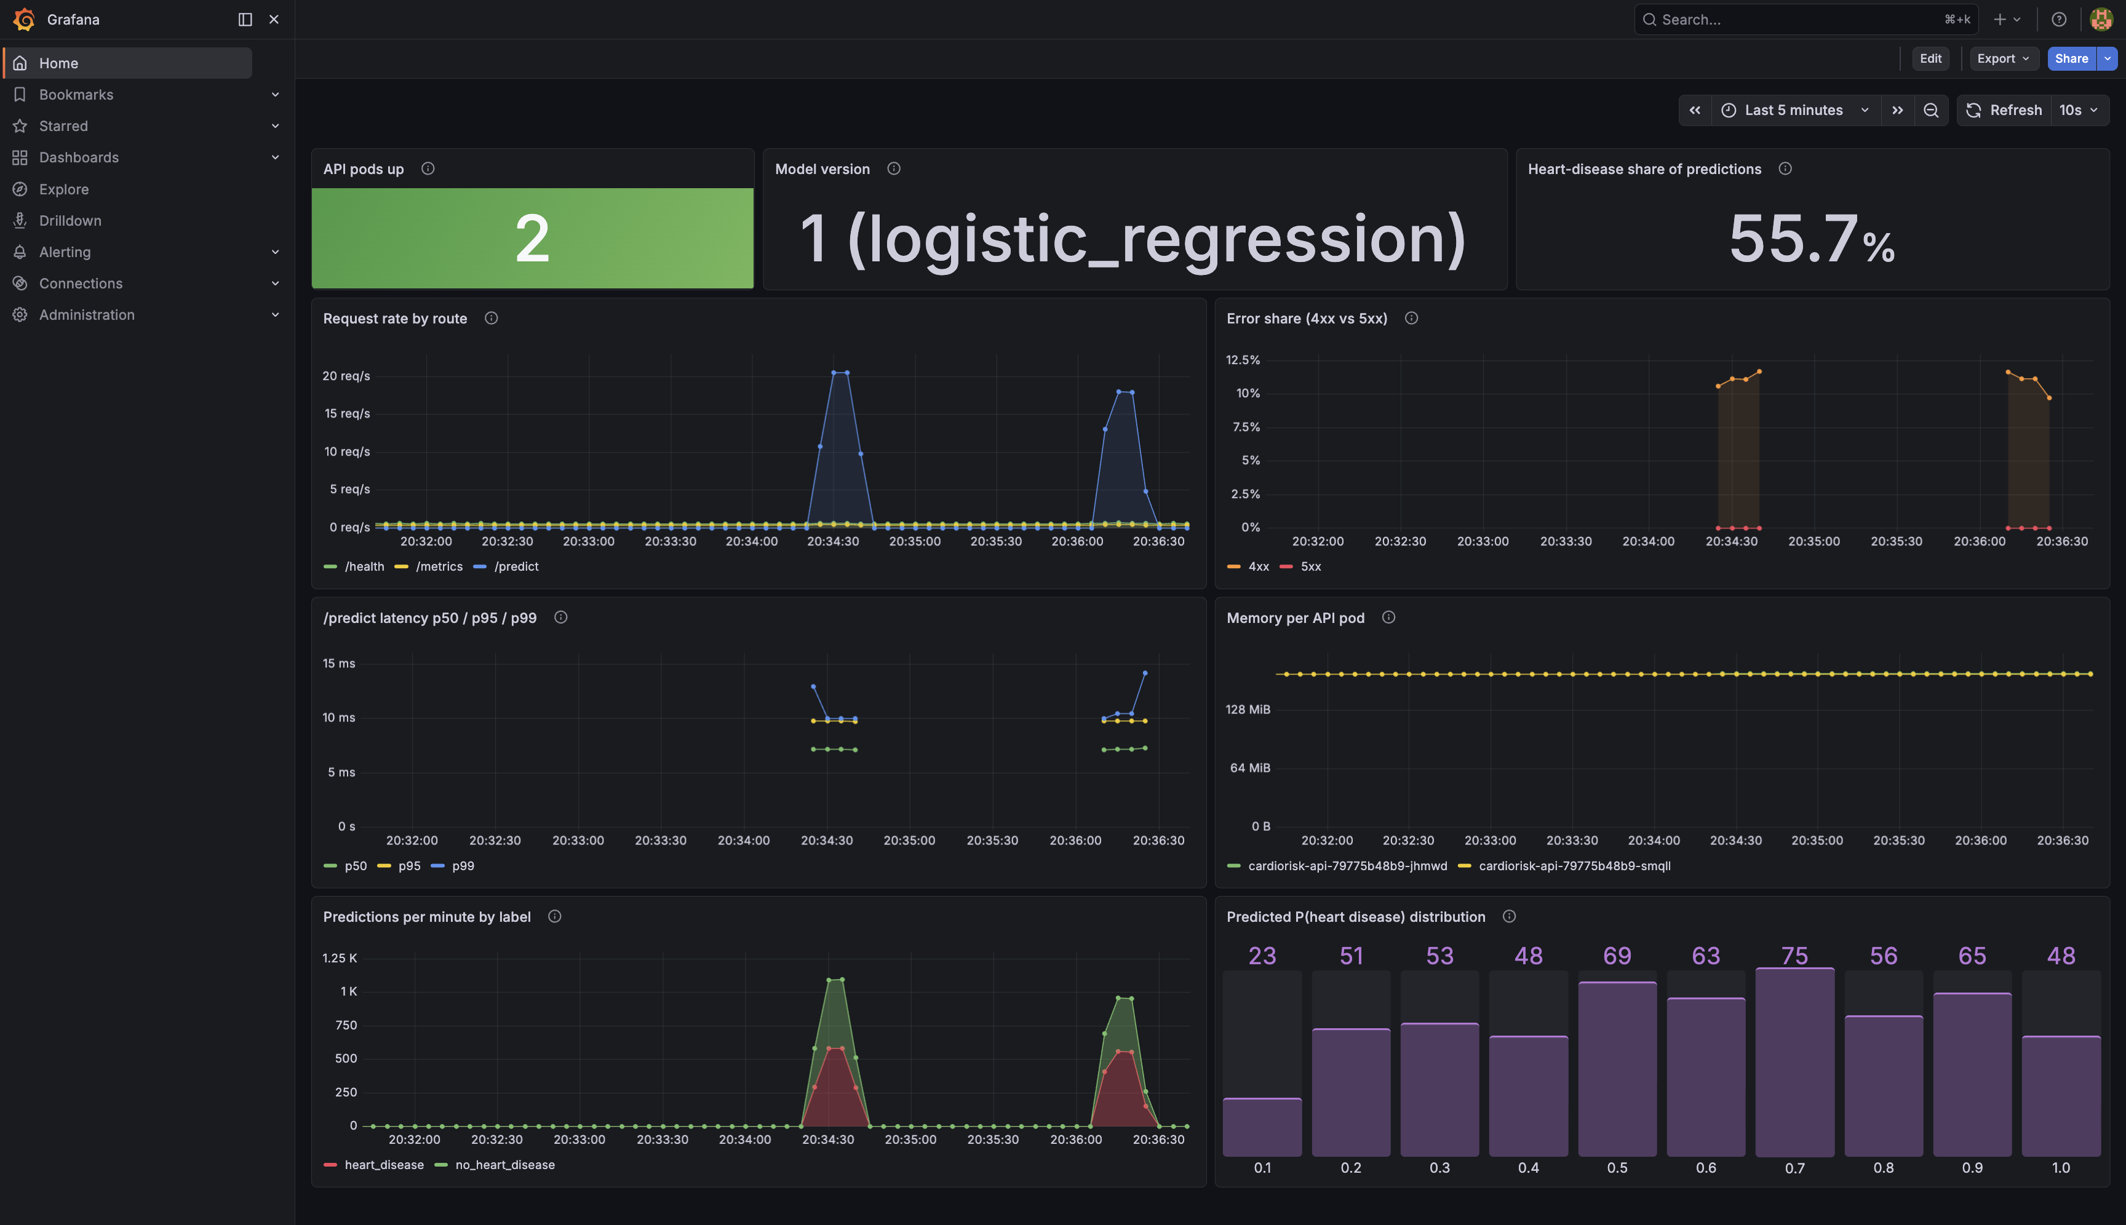
Figure 10. The Grafana “CardioRisk API” dashboard with traffic from make load.
Logs. Every request writes one JSON line to stdout (event, request_id, method, route, status, duration_ms) and every prediction one more (label, probability_disease, model_version), joined by the request id: the caller’s X-Request-ID or a generated one (Figure 29, Appendix C). Probes and scrapes are logged at DEBUG, so the INFO log shows real traffic. Patient features are never logged, which a test enforces.

12. Limitations and future work
- Hospital shift. Leave-one-site-out ROC-AUC drops to 0.73-0.75 at the two high-prevalence sites, and part of the pooled score comes from recognising a hospital by its missing tests. Next: train without missing-value indicators and compare, and tune by nested leave-one-site-out CV.
- Calibration and threshold. Probabilities fitted to the pooled 55% mix are likely off at 93% and 36% sites; training should report the Brier score, sites should recalibrate, and the 0.5 threshold should come from a recall target agreed with clinicians.
- Drift. The probability histogram is a coarse proxy; per-input distributions and missing rates should be compared with the training data, and confirmed diagnoses collected.
- Data and tracking. Checksum pinning suits a static dataset; a growing one needs DVC or remote MLflow storage and a shared tracking server.
- Security and operations. No authentication, TLS or rate limiting (coursework, not a medical device); Prometheus data lives on an emptyDir, and the HPA scales on CPU only.

Appendix A. Repository structure
.
├── src/cardiorisk/ config, data, eda, features, train, predict, api
├── test/ pytest suite (39 tests) and conftest.py
├── notebooks/01_eda.ipynb EDA with commentary
├── scripts/ smoke test, sample request, architecture diagram
├── data/raw/ four UCI site files + codebook (SHA-256 pinned)
├── data/processed/ heart_disease_clean.csv (918 rows)
├── models/ cardiorisk_model.joblib, model_card.json
├── reports/ REPORT.md, report.docx/.pdf, metrics.*, figures/
├── screenshots/ evidence for this report (01-15)
├── deploy/k8s/ base/, monitoring/, overlays/{minikube,kind,cloud}/
├── deploy/compose/ prometheus.yml for docker-compose
├── .github/workflows/ ci.yml
├── Dockerfile, .dockerignore, docker-compose.yml, Makefile
└── pyproject.toml, requirements.txt, requirements-serve.txt
The command reference (every make target and variable) is in README.md and make help.

Appendix B. Additional figures
The EDA figures of Section 4.2 (larger and with commentary in notebooks/01_eda.ipynb), the champion’s permutation importance (Section 5.4) and the leave-one-site-out chart (Section 5.5).
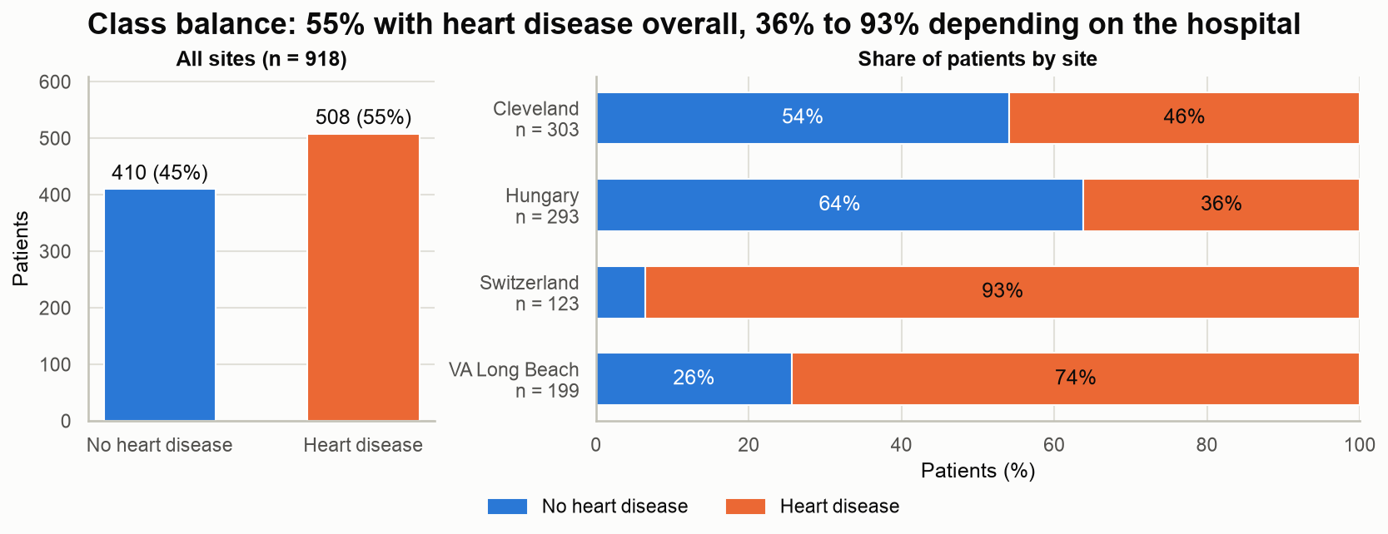 | 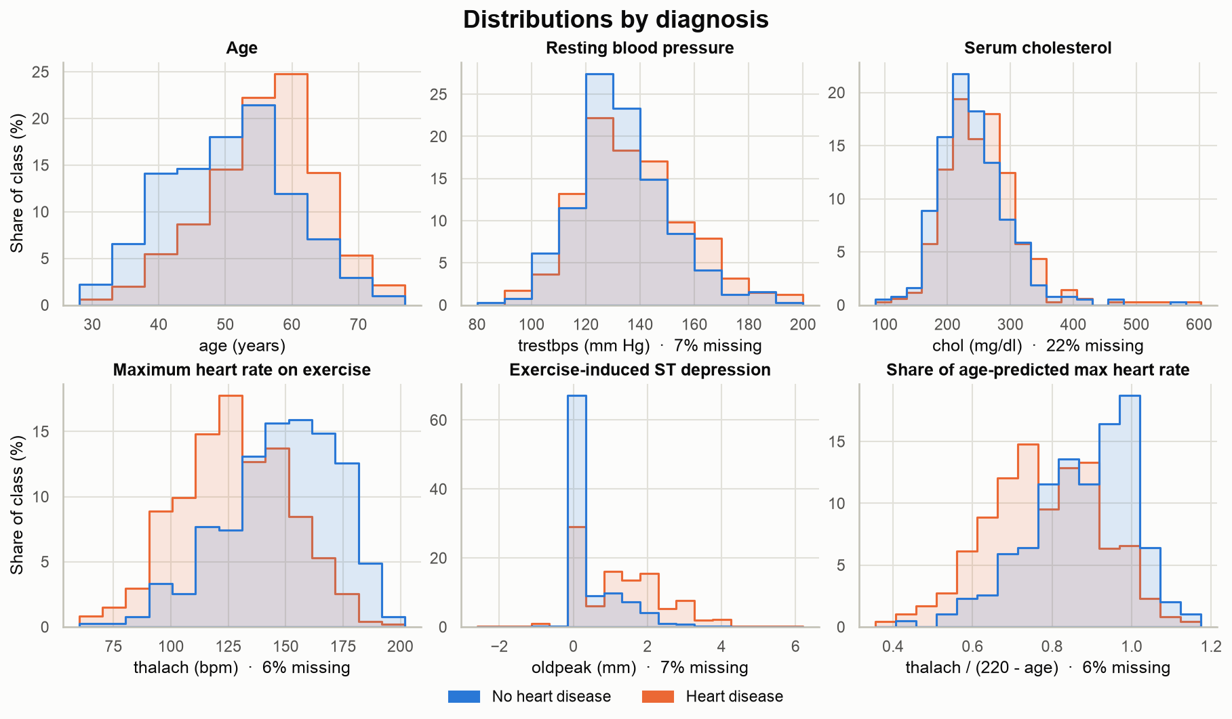
Figure 11. Class balance overall and by hospital. | Figure 12. Numeric inputs by diagnosis.
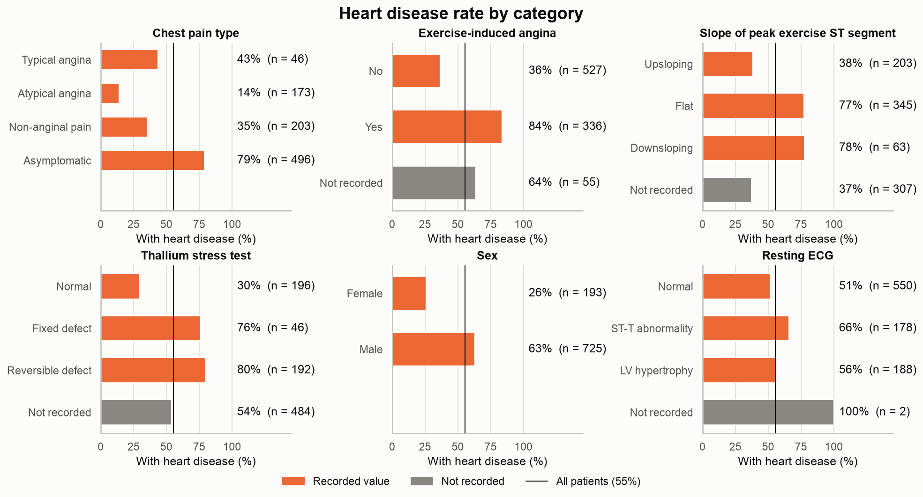 | 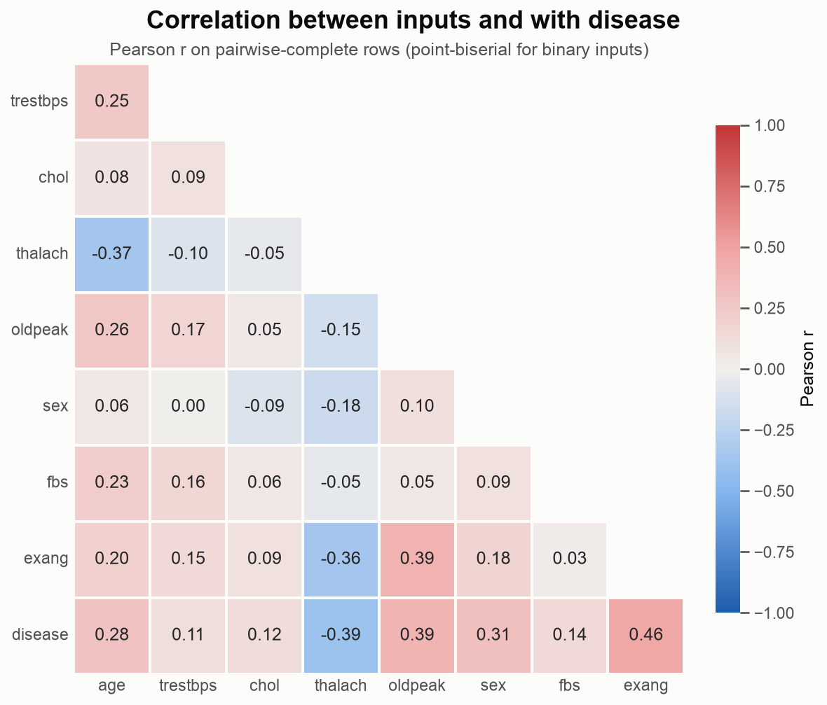
Figure 13. Disease rate per category, “not recorded” as its own bar. | Figure 14. Pearson correlations between the inputs and with disease.
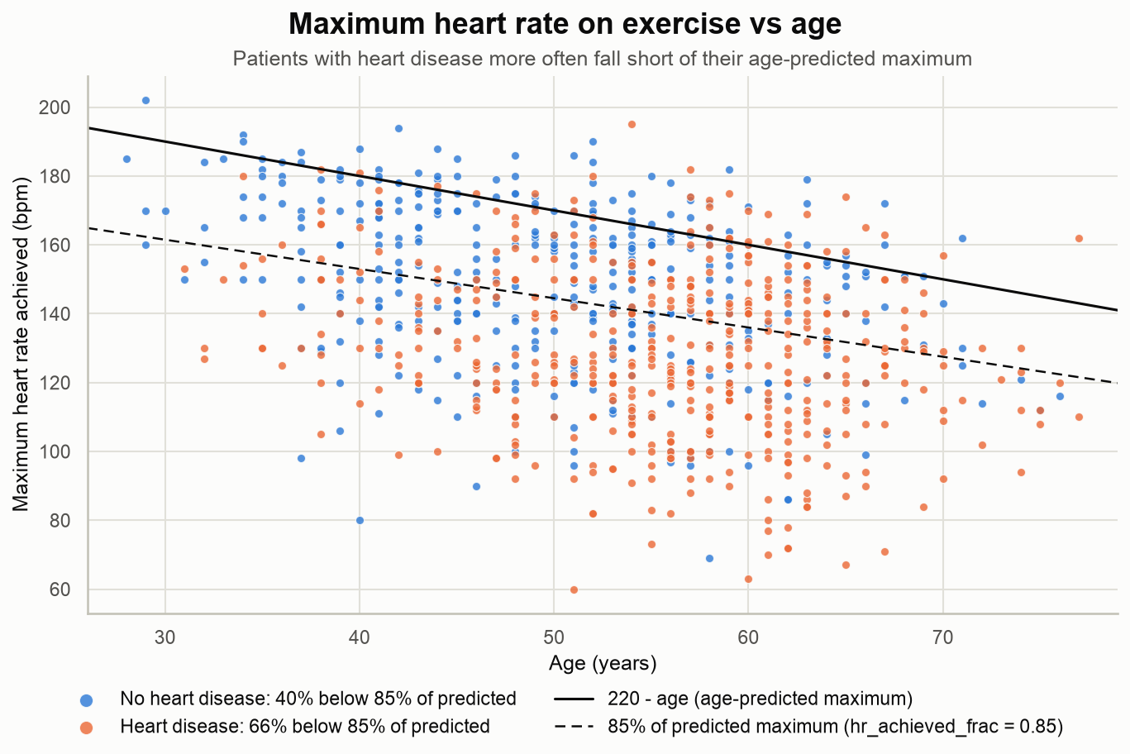 | 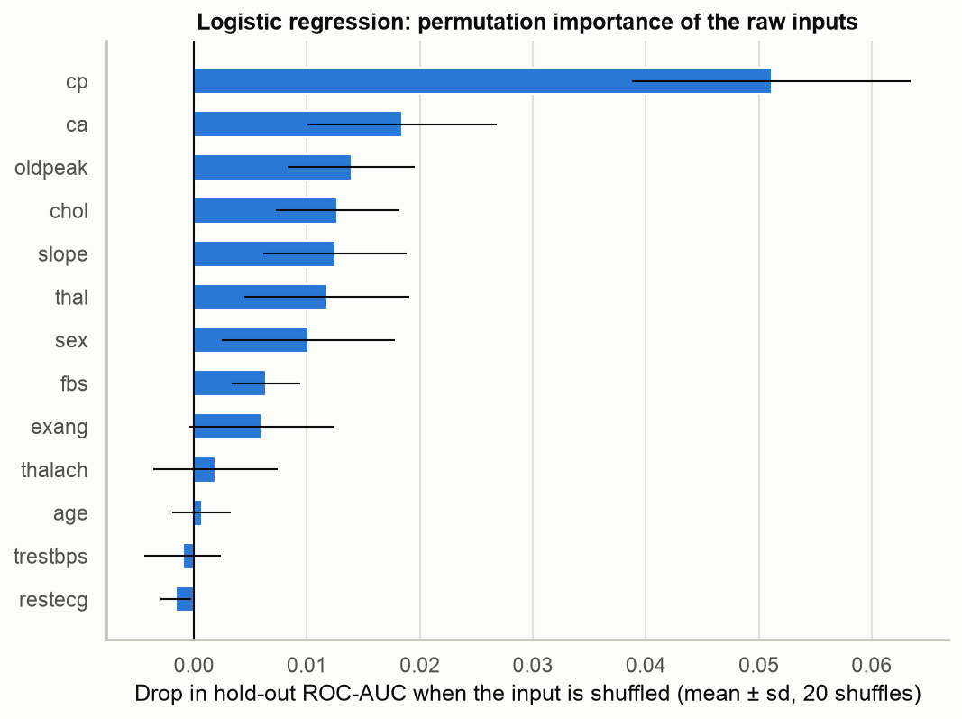
Figure 15. Maximum heart rate against age, with the line 220 - age. | Figure 16. Permutation importance on the hold-out (20 shuffles).
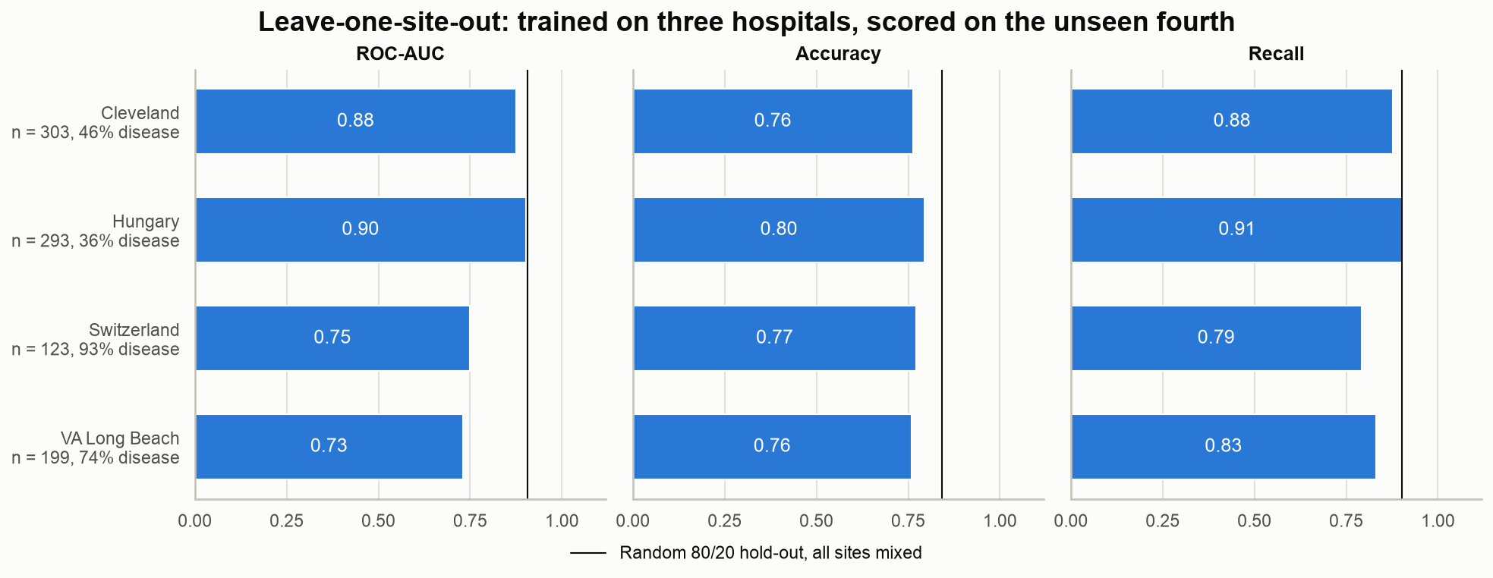
Figure 17. Leave-one-site-out scores of the champion configuration; the vertical line is the random 80/20 hold-out.

Appendix C. Additional screenshots
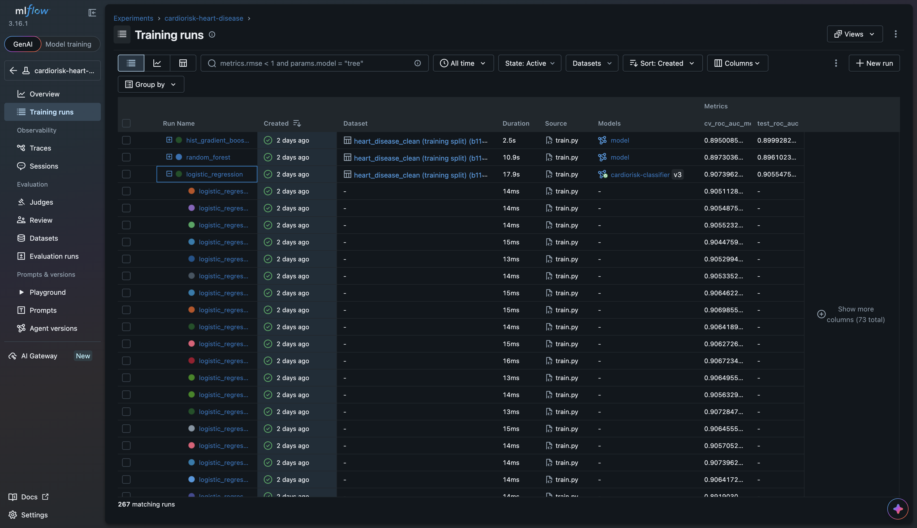 | 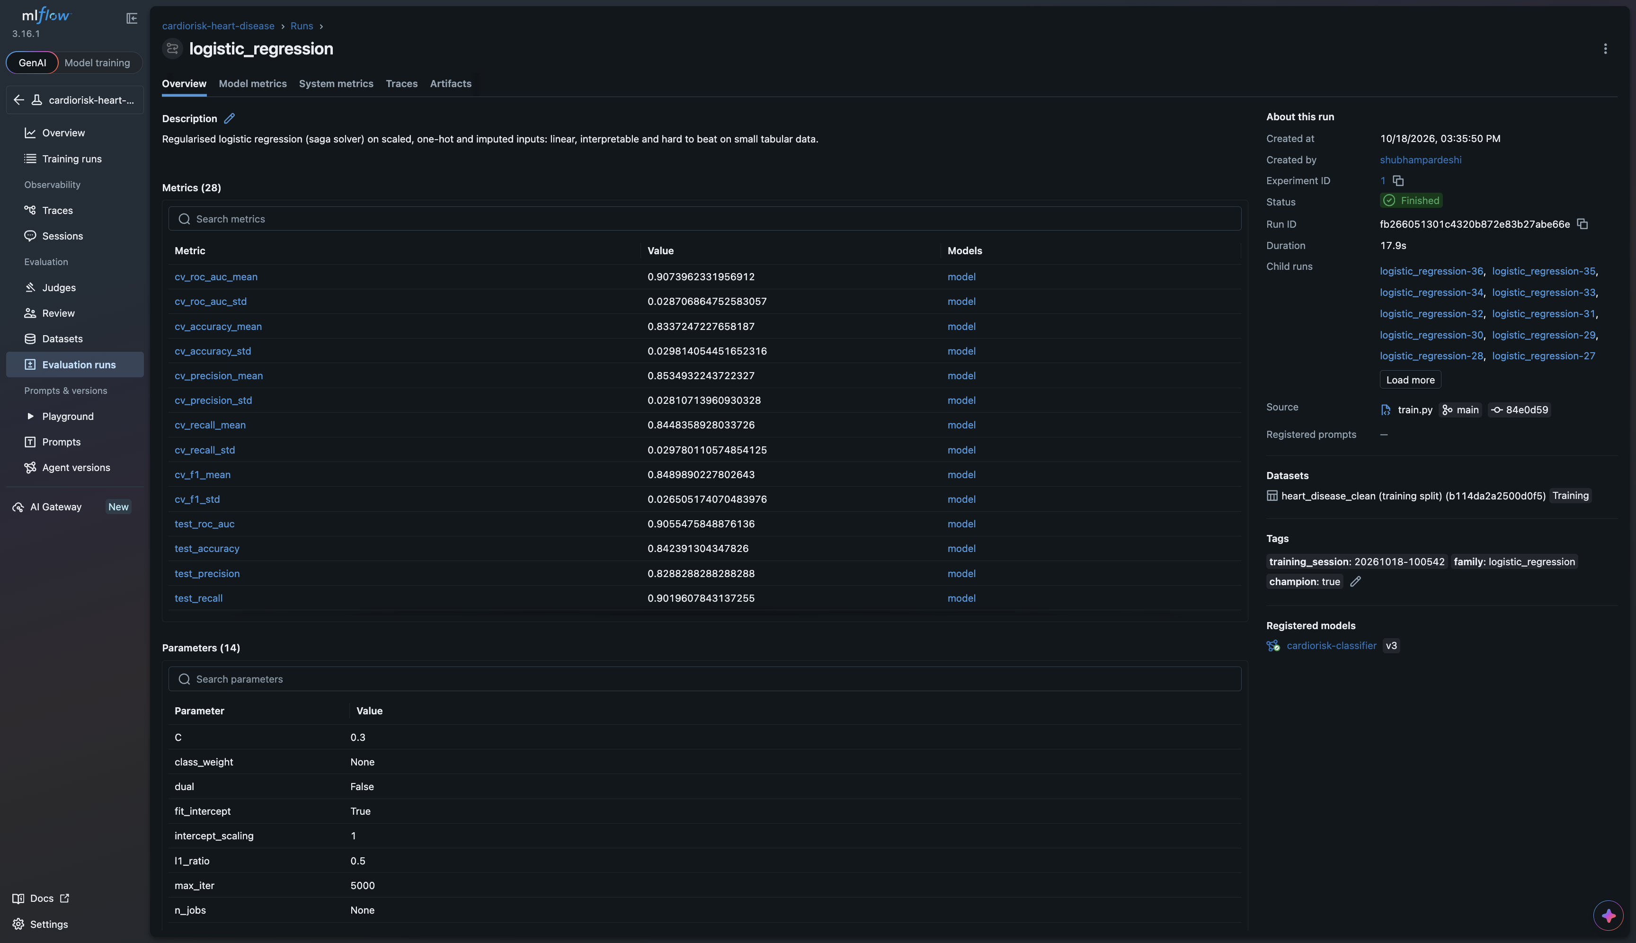
Figure 18. MLflow experiment: the four family runs of a session. | Figure 19. MLflow champion run: metrics and parameters.
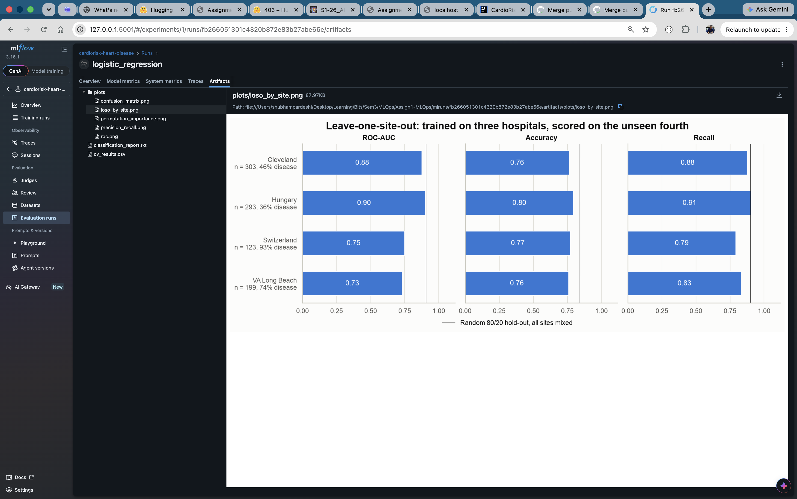 | 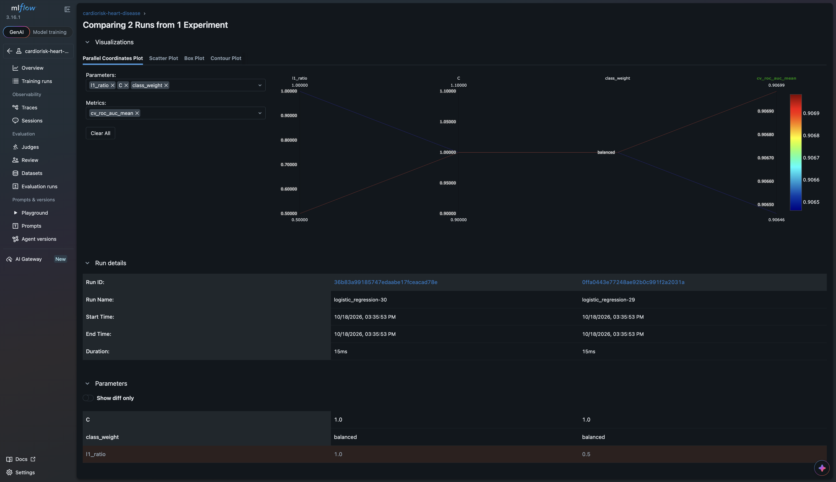
Figure 20. Champion run artifacts: plots/, cv_results.csv, report. | Figure 21. Compare view of the 36 nested logistic-regression runs.
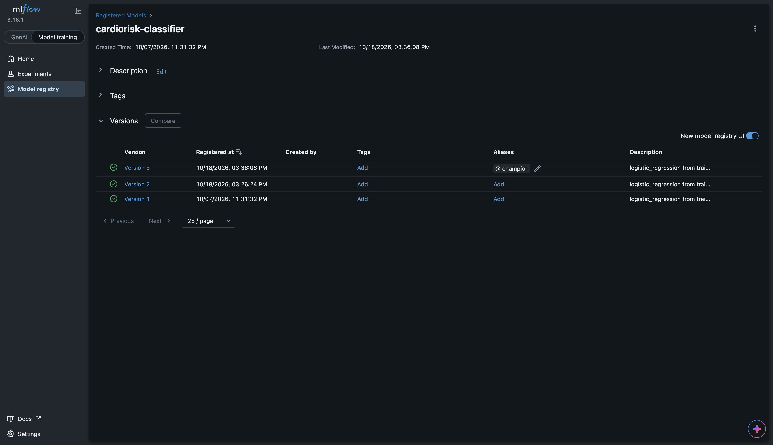 | 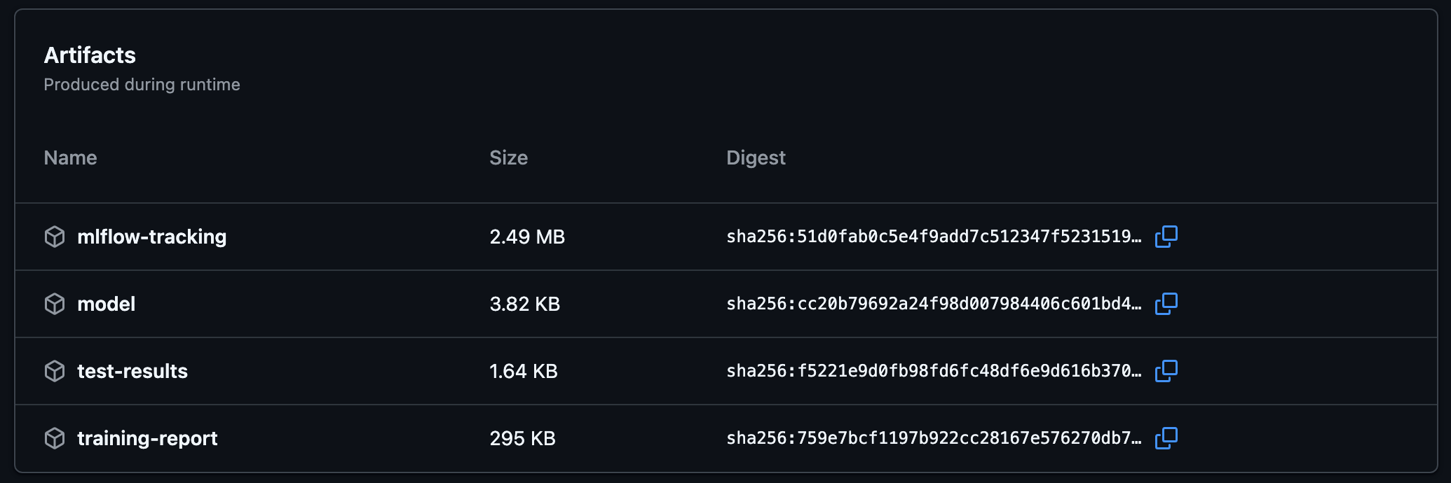
Figure 22. Registry: cardiorisk-classifier@champion. | Figure 23. Artifacts of the workflow run.
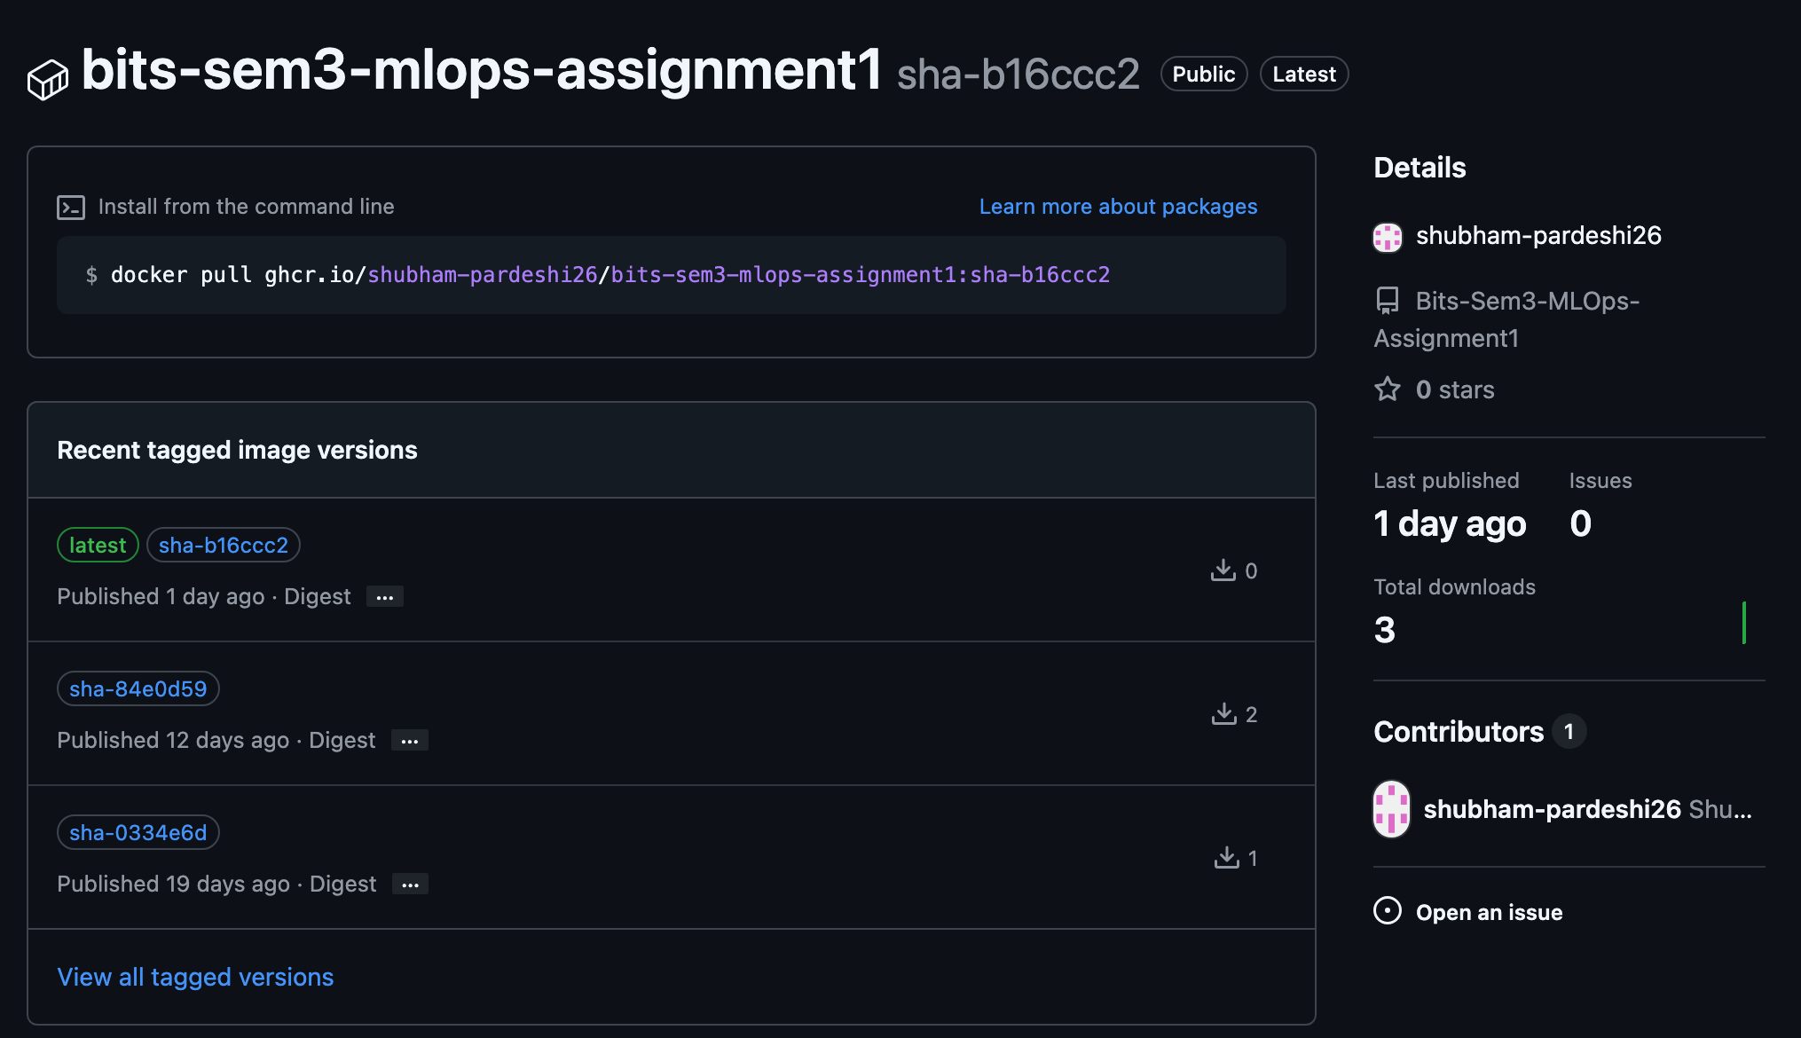 | 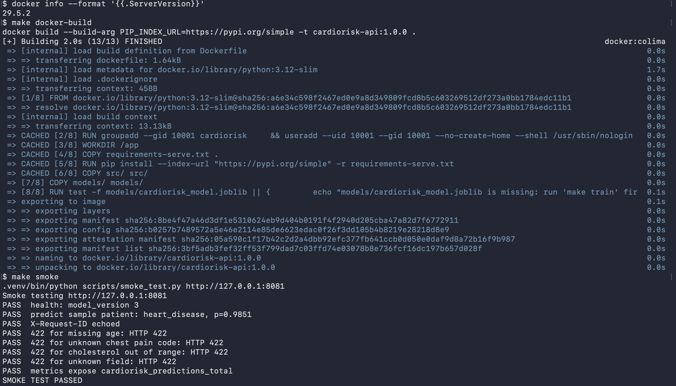
Figure 24. GHCR package, tags sha-<7> and latest. | Figure 25. make docker-build and make smoke passing.
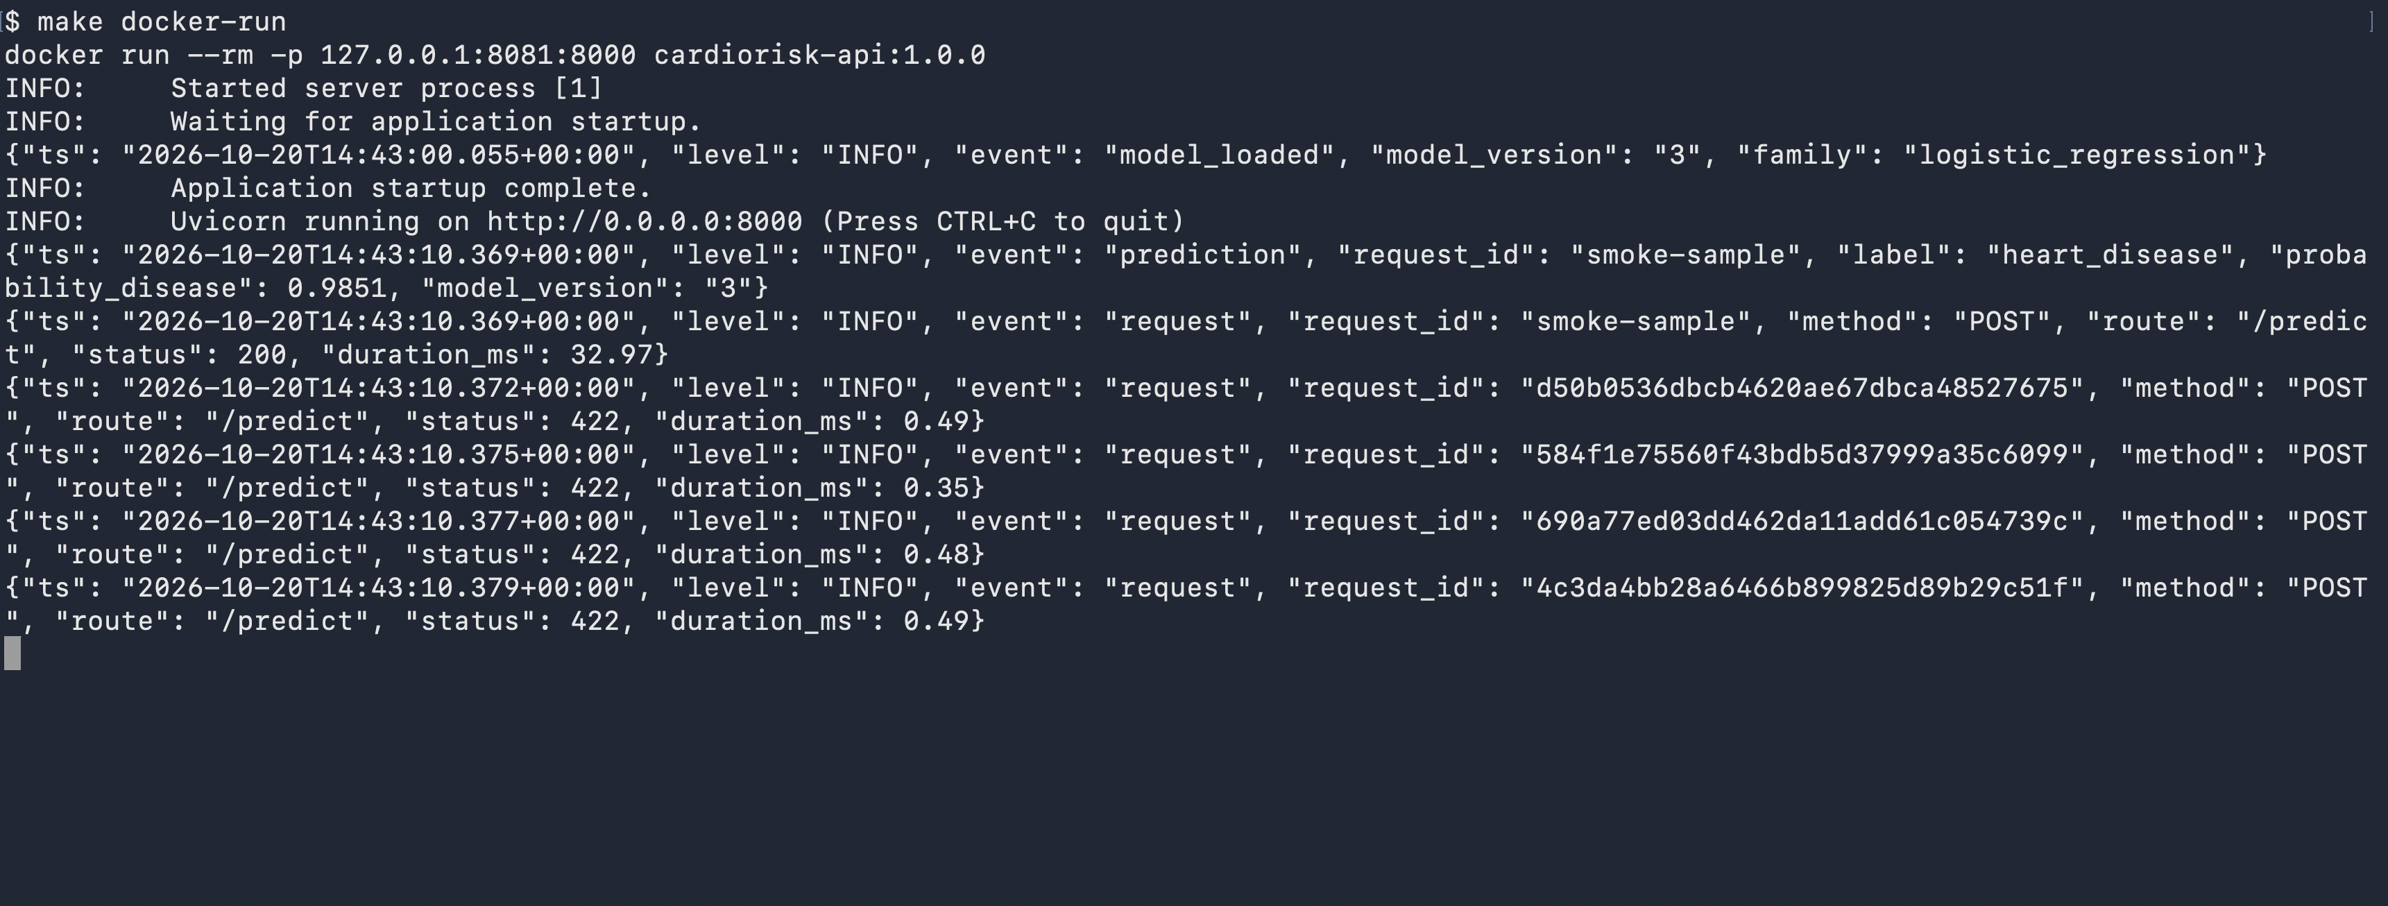 | 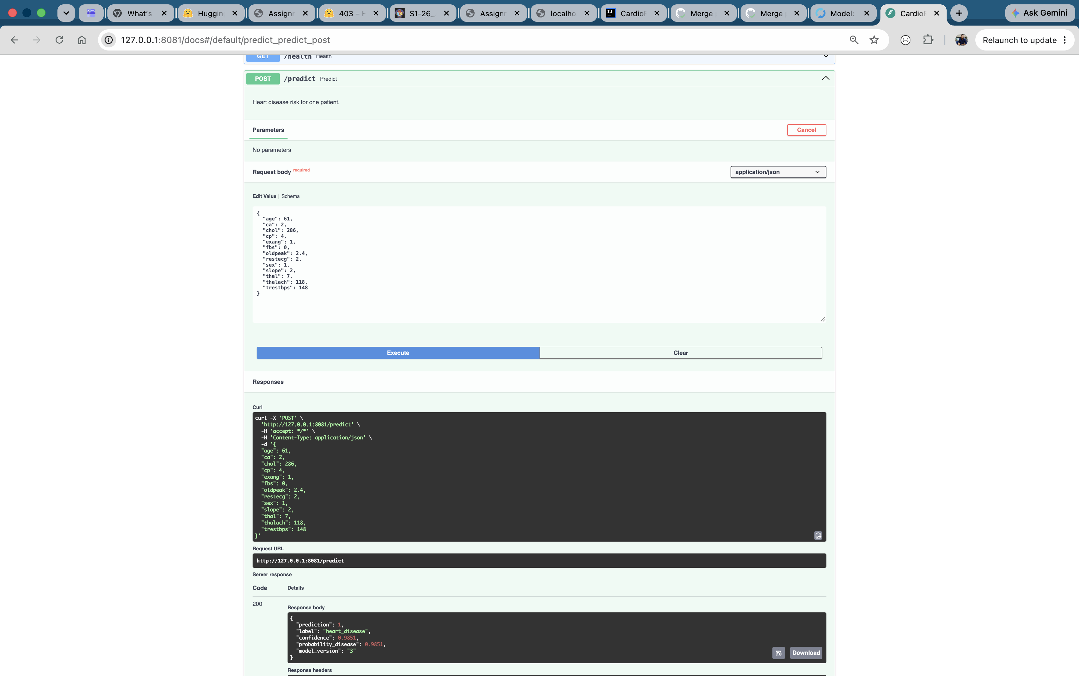
Figure 26. make docker-run: the container’s JSON logs. | Figure 27. Swagger UI: a /predict request and response.
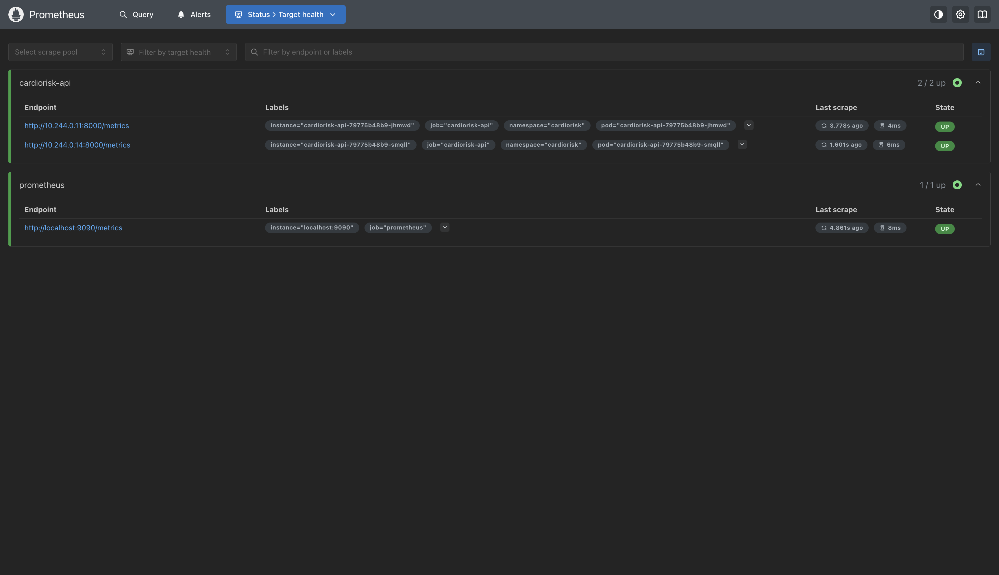 | 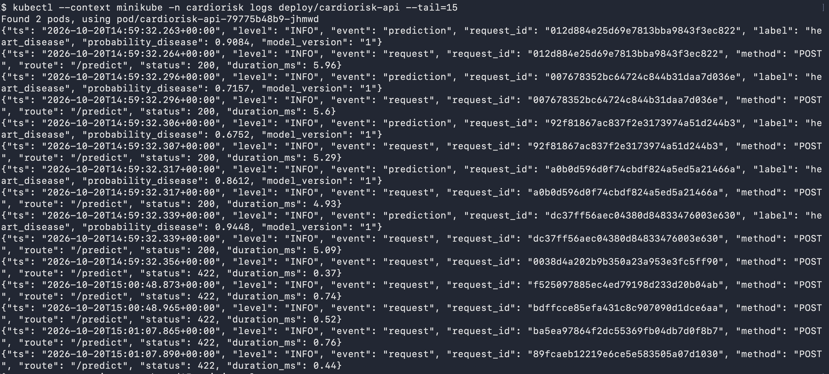
Figure 28. Prometheus: cardiorisk-api pod targets UP. | Figure 29. kubectl logs: JSON request and prediction lines.

