# Git Branch

A Git branch is essentially an independent line of development. You can take advantage of branching when working on new features or bug fixes because it isolates your work from that of other team members.

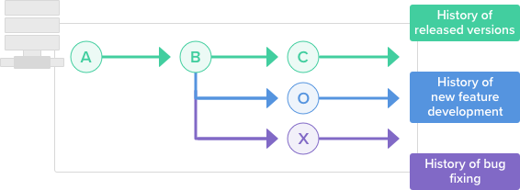

**Check list of branches in your project**

**$ git branch --list**

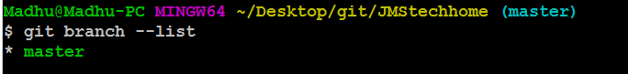

**Create a new branch in local**

Creating a new branch does not change the repository; it simply points out the commit For example, let's create a branch called “bugfix” using the command git branch.

## $ git branch bugfix



Now check the list of branches in local. The green colour indicates you are in that branch.

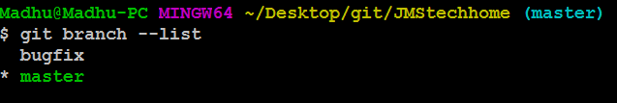

## How to switch the branch

The **git checkout** command allows you to switch branches by updating the files in your working tree to match the version stored in the branch that you wish to switch to.

Earlier I am at master branch now I want switch the branch to bugfix..

$git checkout bugfix

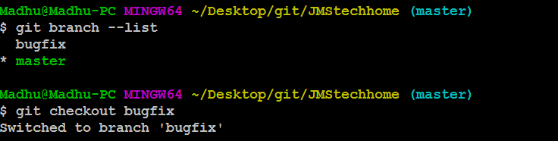

Let’s confirm it..

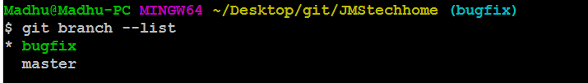

Now you are at bugfix branch.

Based on your requirement you need to modify the existed code or need to write new file…etc.

Let’s create a new file at bugfix branch.

## $ touch bugfix.txt

Write something in that file….

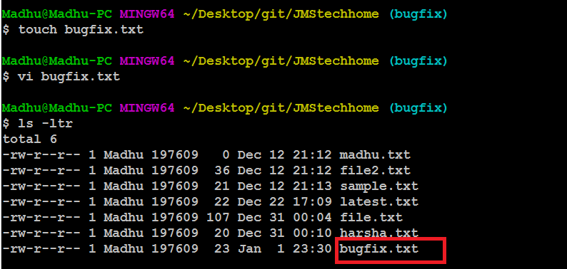

## How to push just created local branch to remote server

Earlier I have only one branch at remote server i.e. master branch.

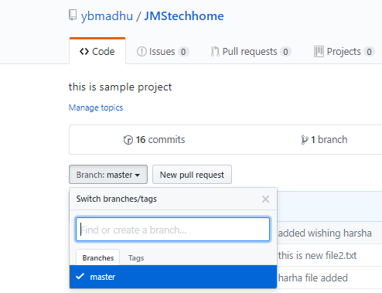

Use below command to push local branch to remote.

## $ git push –u origin <brnch-name>

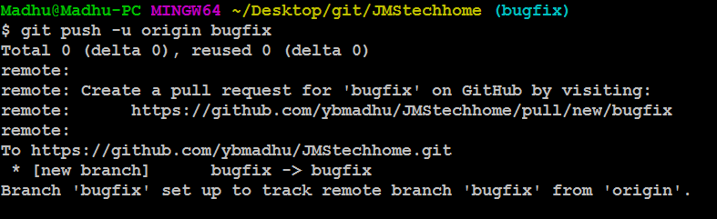

Let’s confirm out local branch is pushed to remote or not…

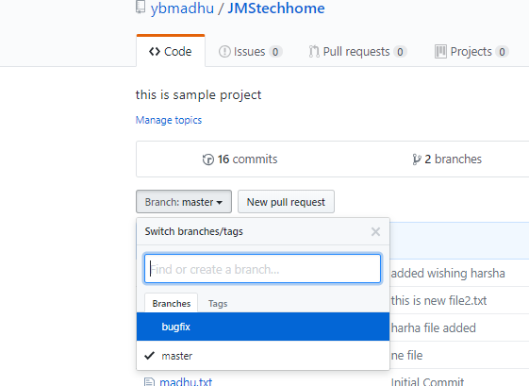

Successfully we are pushed to the bugfix branch to remote server (GitHub).

## How to merge one branch to another branch.

Just we created new branch bugfix and we written one new file bugfix.txt this file is not available in master branch I need to merge this file to master. Let’s do it

First need to commit and push the changes to remote branch.

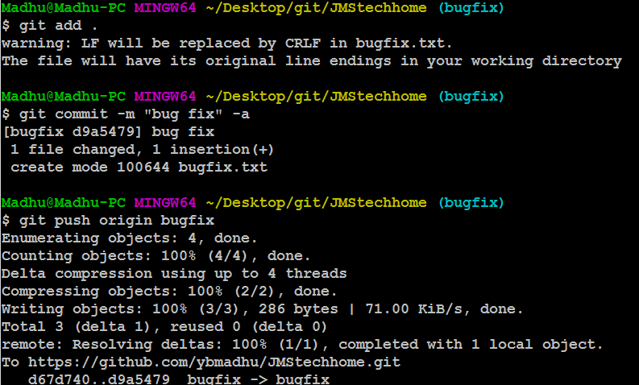

First we need to switch to master branch..

## $ git checkout master

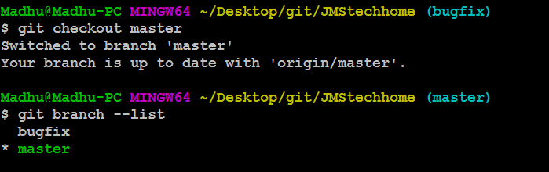

User git merge command to merge two branches..

## $ git merge < which branch needs to merge >

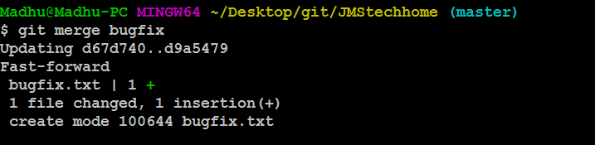

And do **git push** for applying changes to master branch

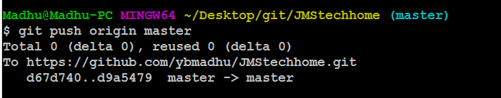

Now let’s check into mater branch in remote server for merging files came or not.

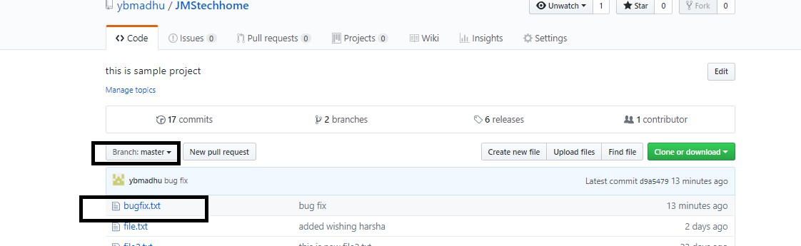

## Delete Branch

Once you’ve finished working on a branch and have merged it into the main code base, you’re free to delete the branch without losing any history.

## $ git branch –d <branch name want to delete>

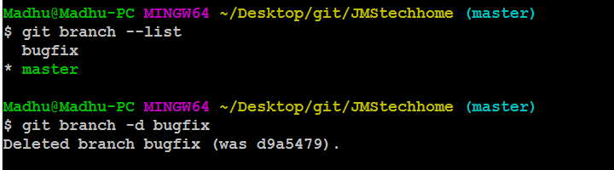

Let’s confirm it

## $ git branch --list



The git branch –d option is not deleted branch in remote repository it will delete only local workspace. If you want to delete branch in remote repository use below command.

## $ git push origin -d bugfix

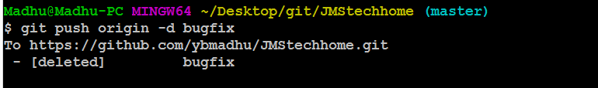

**How to get the new branches form remote server to local**

We can create branch in wo ways one is local just we had discussed and second one is we can create a branch in remote server directly.

If someone created one feature branch in remote server I want to get it into my local system and I need to work out on that branch use below steps…

Use **git fetch** to get the all information in remote server..

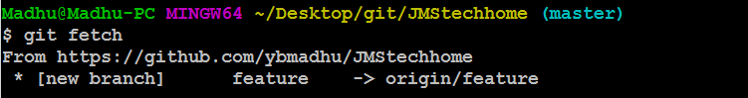

To switch to feature branch use **git checkout** command…

## $ git checkout feature

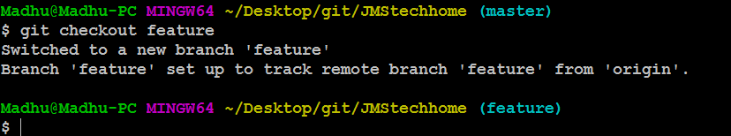

Use below command wants to see local and remote server branches

**$ git branch –a**

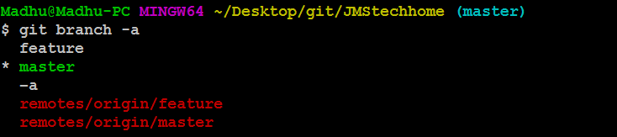

**\*\*\*\*\*\*\*\*\*\*\*\*\*\*\*\* Happy learning \*\*\*\*\*\*\*\*\*\*\*\*\*\*\*\*\*\*\*\*\*\*\*\*\*\*\*\*\*\*\*\*\*\*\*\*\***