**Install Docker on Ubuntu 18.04**

**Introduction**

Docker is an application that makes it simple and easy to run application processes in a container, which are like virtual machines, only more portable, more resource-friendly, and more dependent on the host operating system.

**Installing Docker**

The Docker installation package available in the official Ubuntu 18.04 repository may not be the latest version. To get this latest version, install Docker from the official Docker repository. This section shows you how to do just that.

First, update your existing list of packages:

**$ sudo apt update**

Next, install a few prerequisite packages which let apt use packages over HTTPS:

**$ sudo apt install apt-transport-https ca-certificates curl software-properties-common -y**

Then add the GPG key for the official Docker repository to your system:

In order to ensure the downloads are valid, add the GPG key for the official Docker repository to your system

**$ curl -fsSL https://download.docker.com/linux/ubuntu/gpg | sudo apt-key add -**

Add the Docker repository to APT sources:

**$ sudo add-apt-repository "deb [arch=amd64] https://download.docker.com/linux/ubuntu $(lsb_release -cs) stable"**

Next, update the package database with the Docker packages from the newly added repo:

**$ sudo apt-get update**

Make sure you are about to install from the Docker repo instead of the default Ubuntu 18.04 repo:

$ **apt-cache policy docker-ce**

You should see output similar to the follow:

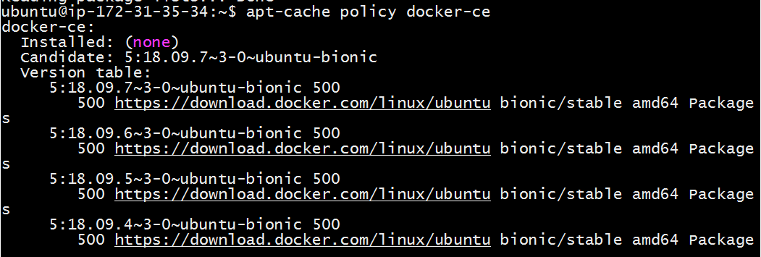

Notice that docker-ce is not installed, but the candidate for installation is from the Docker repository for Ubuntu 18.04 (xenial).

Finally, install Docker:

$ **sudo apt-get install -y docker-ce**

Docker should now be installed, the daemon started, and the process enabled to start on boot. Check that it's running:

$ **sudo systemctl status docker**

The output should be similar to the following, showing that the service is active and running:

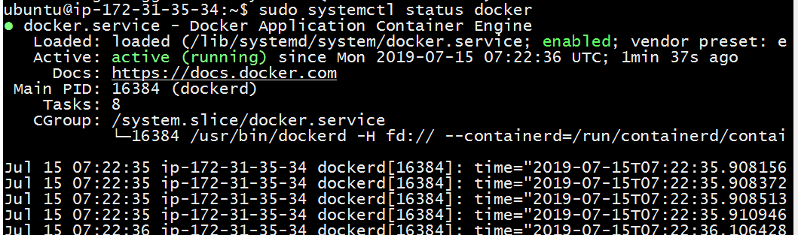

Installing Docker now gives you not just the Docker service (daemon) but also the docker command line utility, or the Docker client.

**Executing the Docker Command Without sudo**

By default, running the docker command requires root privileges — that is, you have to prefix the command with sudo. It can also be run by a user in the docker group, which is automatically created during the installation of Docker. If you attempt to run the docker command without prefixing it with sudo or without being in the docker group, you'll get an output like this:

**$ docker images**



See 'docker run --help'.

If you want to avoid typing sudo whenever you run the docker command, add your username to the docker group:

**$ sudo usermod -aG docker ${USER}**

To apply the new group membership, you can log out of the server and back in, or you can type the following:

$ su - ${USER}

You will be prompted to enter your user's password to continue. Afterwards, you can confirm that your user is now added to the docker group by typing:

$ id -nG

If you need to add a user to the docker group that you're not logged in as, declare that username explicitly using:

$ sudo usermod -aG docker <username>