Install git specific version

Refer this link to down load particular version. <https://mirrors.edge.kernel.org/pub/software/scm/git/>

1. wget <https://mirrors.edge.kernel.org/pub/software/scm/git/git-2.29.0.tar.gz>
2. tar -xvzf git-2.29.0.tar.gz 3. cd git-2.29.0/
3. make configure

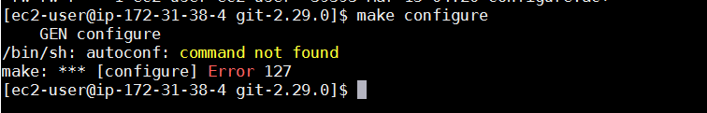

1. sudo yum install autoconf -y
2. make configure

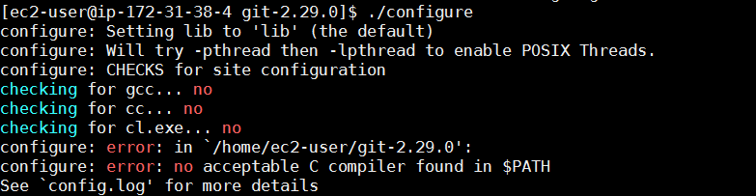

1. sudo yum groupinstall "Development Tools" -y
2. ./configure --prefix=/usr
3. sudo yum install asciidoc
4. sudo yum install xmlto -y
5. sudo yum install install docbook2X -y
6. make all doc info
7. sudo make install install-doc install-html install-info
8. then check git --version