**Push Docker image to ECR Repo**

Freestyle

===========

1. Navigate to the "Plugin Manager" screen, install the "**Amazon ECR**" install plugin without restart.
2. Create “New item” freestyle. Give any job name.

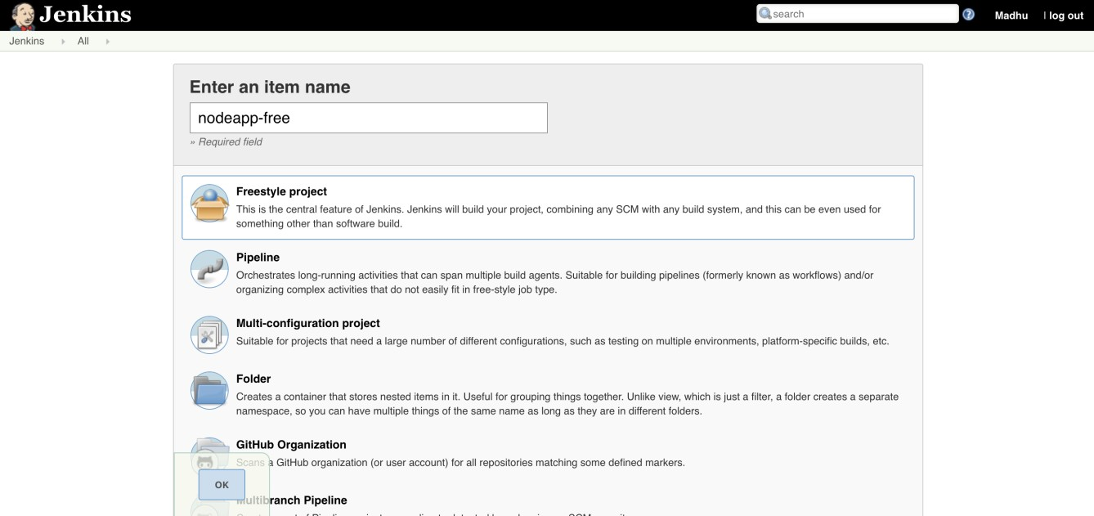

1. Amazon ECR plugin implements a Docker Token producer to convert Amazon credentials to

Jenkins’ API used by (mostly) all Docker-related plugins.

In this producer, you can select your existing registered Amazon credentials for various Docker operations in Jenkins, for sample using **CloudBees Docker Build and Publish plugin**:

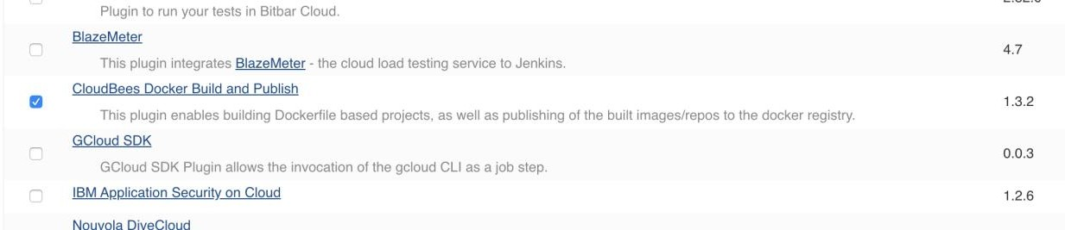

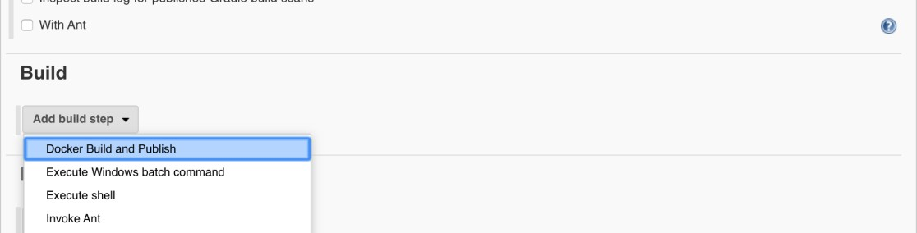

1. Go to Jenkins job configure in build section select **docker build and publish** option.

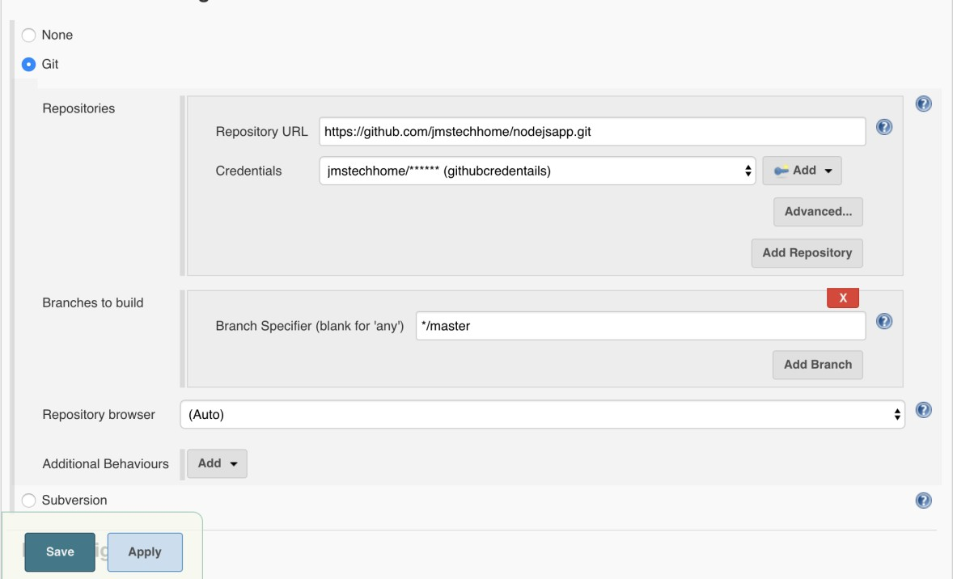

1. Add below details . Make sure before adding this details you must Crete a repo in ecr. And must be added aws credentials.

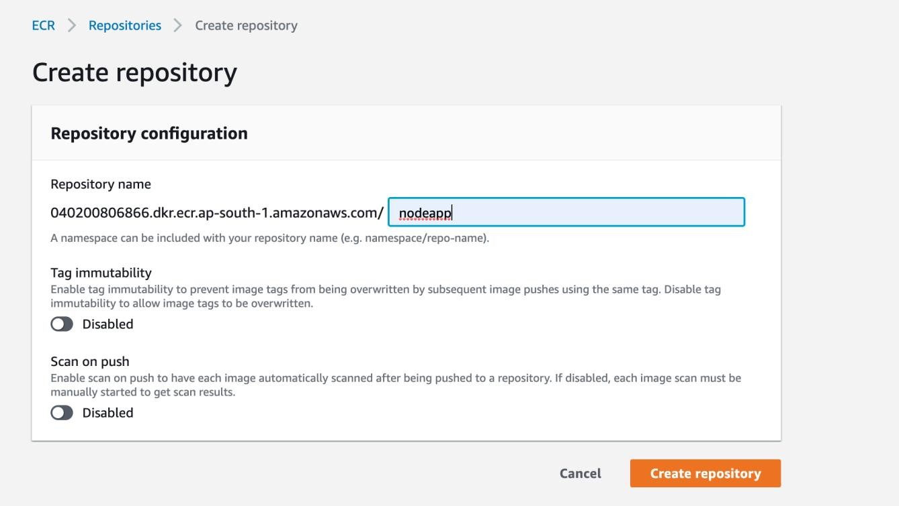

Now build the job and see the output.

If you see below error because of Jenkins user connect docker commands without sudo. Then you must add Jenkins user into docker group and restart the Jenkins.

$ sudo usermod -aG docker jenkins

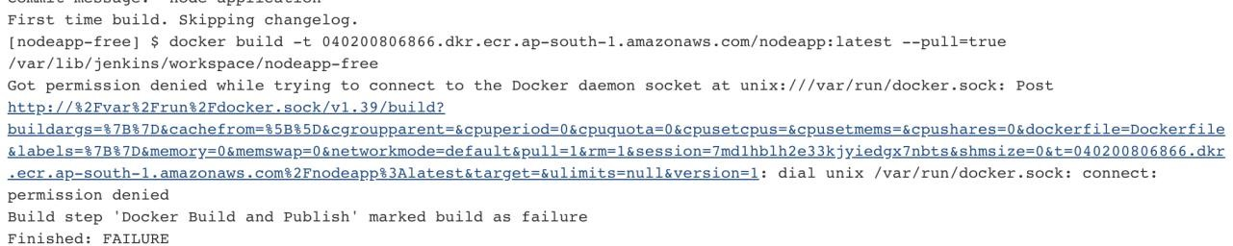

Pipeline

======

1. Create a pipeline job.
2. Write below declarative pipeline code.

pipeline { agent any environment

{

VERSION = "${BUILD_NUMBER}"

PROJECT = 'nodeapp'

IMAGE = "$PROJECT:$VERSION"

ECRURL = 'https://040200806878.dkr.ecr.ap-south-1.amazonaws.com' ECRCRED = 'ecr:ap-south-1:awscredentials'

}

stages { stage('GetSCM') {

steps {

// Get some code from a GitHub repository

git 'https://github.com/jmstechhome/nodejsapp.git'

}

}

stage('Image Build'){ steps{

script{

docker.build('$IMAGE')

}

}

}

stage('Push Image'){ steps{

script

{

docker.withRegistry(ECRURL, ECRCRED)

{

docker.image(IMAGE).push()

}

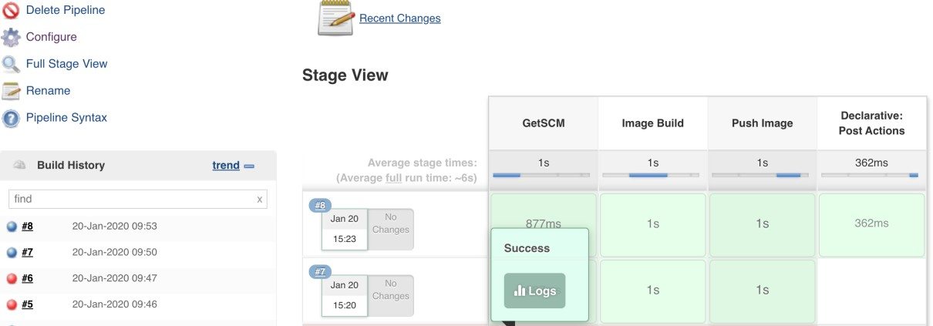

And go and check ecr repo the images is pushed or not.

If you basic auth credentials issue: please do below steps sudo apt install awscli

sudo apt-get install python3-pip sudo pip3 install --upgrade awscli aws configure

eval $(aws ecr get-login --no-include-email --region ap-south-1 | sed 's|https://||')

install “Docker Pipeline plugin” if you see below error

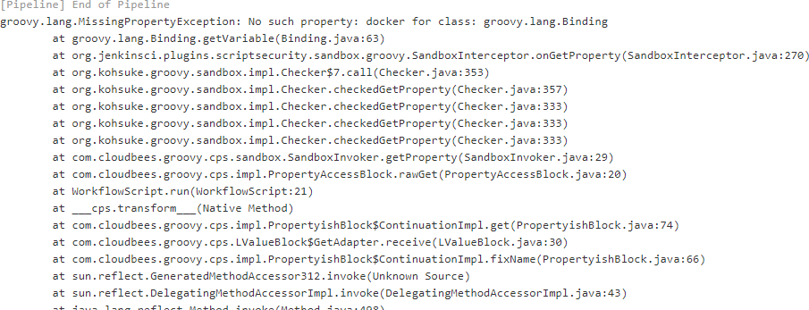

Install Jenkins using custom Dockerfile

$ vi Dockerfile

FROM jenkins/jenkins:lts

USER root

RUN apt update -y && \ apt install -y python3-pip

RUN pip3 install awscli --upgrade USER Jenkins

$ docker build -t madhu_jenkins:v1

$ docker run -d --restart=always -u root -p 8080:8080 -p 50000:50000 -v

$(pwd)/Jenkins_data:/var/jenkins_home -v $(which docker):/usr/bin/docker -v

/var/run/docker.sock:/var/run/docker.sock -v /home/ec2- user/.docker/config.json:/root/.docker/config.json -v ~/.aws:/root/.aws --name jenkins madhu_jenkins:v1