import mysql.connector
import argparse
import pandas as pd
import numpy as np
from mysql.connector import Error
import os
import json
from datetime import datetime

def convert_sr_no(sr_no):
if pd.isna(sr_no):
sr_no = 0
else:
sr_no = int(sr_no)
return sr_no

def required_date(tempdate):
try:
new_date = tempdate[6:] + "/" + tempdate[3:5] + "/" + tempdate[0:2]
return datetime.strptime(new_date, "%Y/%m/%d").date()
except ValueError:
try:
return datetime.strptime(tempdate, "%d/%m/%Y").date()
except ValueError:
# Handle unknown date format or invalid date
return None

def Amount(amount):
if isinstance(amount, str):
amount = amount.replace(',', '')

if amount == 'N/A' or amount == '':
amount = '0'

elif pd.isna(amount):
amount = '0'

try:
return int(amount)
except ValueError:
# Handle invalid amount value
return None

def name(startup_name):
if pd.isna(startup_name):
startup_name = ''
else:
startup_name = str(startup_name)

startup_name = startup_name.replace('\\xc2\\xa0', ' ')
return startup_name

def Industry(industry_vertical):
if pd.isna(industry_vertical):
industry_vertical=''
else:
industry_vertical = str(industry_vertical)

industry_vertical=industry_vertical.replace('\\xc2\\xa0',' ')
return industry_vertical

def Type(investment_type):
if pd.isna(investment_type):
investment_type=''
else:
investment_type=str(investment_type)

investment_type=investment_type.replace('\\xc2\\xa0',' ')
return investment_type

def vertical(sub_vertical):
if pd.isna(sub_vertical):
sub_vertical = ''
else:
sub_vertical = str(sub_vertical)
sub_vertical = sub_vertical.replace('\\xc2\\xa0', ' ')
return sub_vertical

def City1(city):
if pd.isna(city):
city = ''
else:
city = str(city)

city = city.replace('\\xc2\\xa0', ' ')
return city

def Investor(investor_name):
if pd.isna(investor_name):
investor_name = ''
else:
investor_name = str(investor_name)

investor_name = investor_name.replace('\\xc2\\xa0', ' ')
return investor_name

parser = argparse.ArgumentParser()
parser.add_argument('-d','--source_dir', help= "Source directory from which we need to read all files to upload to mysql", type = str)
parser.add_argument('-c','--mysql_details', help = "Path of a JSON file which contains all details of MySQL to which to connect to", type = str)
parser.add_argument('-t','--destination_table', help = 'Name of table to upload this data to', type = str)

args = parser.parse_args()

df1 = pd.read_csv("/home/system/DZ/python/csv_files/startup.csv")
df2 = pd.read_parquet("/home/system/DZ/python/csv_files/consumerInternet.parquet")

final_df = pd.concat([df1,df2])

# print(final_df)

with open(args.mysql_details,'r') as f:
mysql_deatil = json.load(f)

Connection = mysql.connector.connect(
host = mysql_deatil['host'],
user = mysql_deatil['username'],
password = mysql_deatil['password'],
database = mysql_deatil['database']
)

if Connection.is_connected():
print("Mysql is connected")

for index,row in final_df.iterrows():
Sr_no = convert_sr_no(row['Sr_No'])
Date = required_date(row['Date'])
Startup_Name = name(row['Startup_Name'])
Industry_Vertical = Industry(row ['Industry_Vertical'])
SubVertical=vertical(row['SubVertical'])
City = City1(row['City'])
Investors_Name = Investor(row['Investors_Name'])
InvestmentnType = Type(row['InvestmentnType'])
Amount_in_USD = Amount(row['Amount_in_USD'])

try:
cursor = Connection.cursor()
insert_query = "INSERT INTO startup (Sr_No, Date, Startup_Name, Industry_Vertical,SubVertical, City, Investors_Name, InvestmentnType, Amount_in_USD) " \
"VALUES (%s, %s, %s, %s, %s,%s, %s, %s, %s)"

cursor.execute(insert_query, (Sr_no, Date, Startup_Name, Industry_Vertical,SubVertical, City, Investors_Name, InvestmentnType, Amount_in_USD))

Connection.commit()
cursor.close()
except Error as e:
print("Error inserting row:", index)
print(e)

Connection.close()

Table & Schema

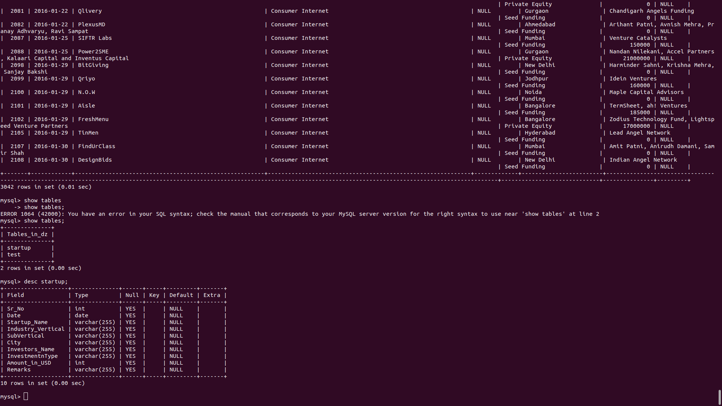

SQL Assignment:-

1) How many startups are there in Pune City?

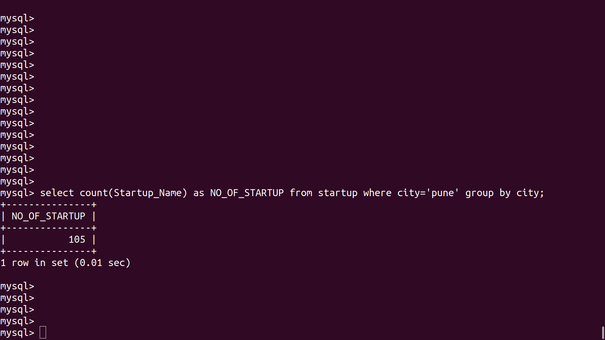

2) How many startups in Pune got their Seed/ Angel Funding?
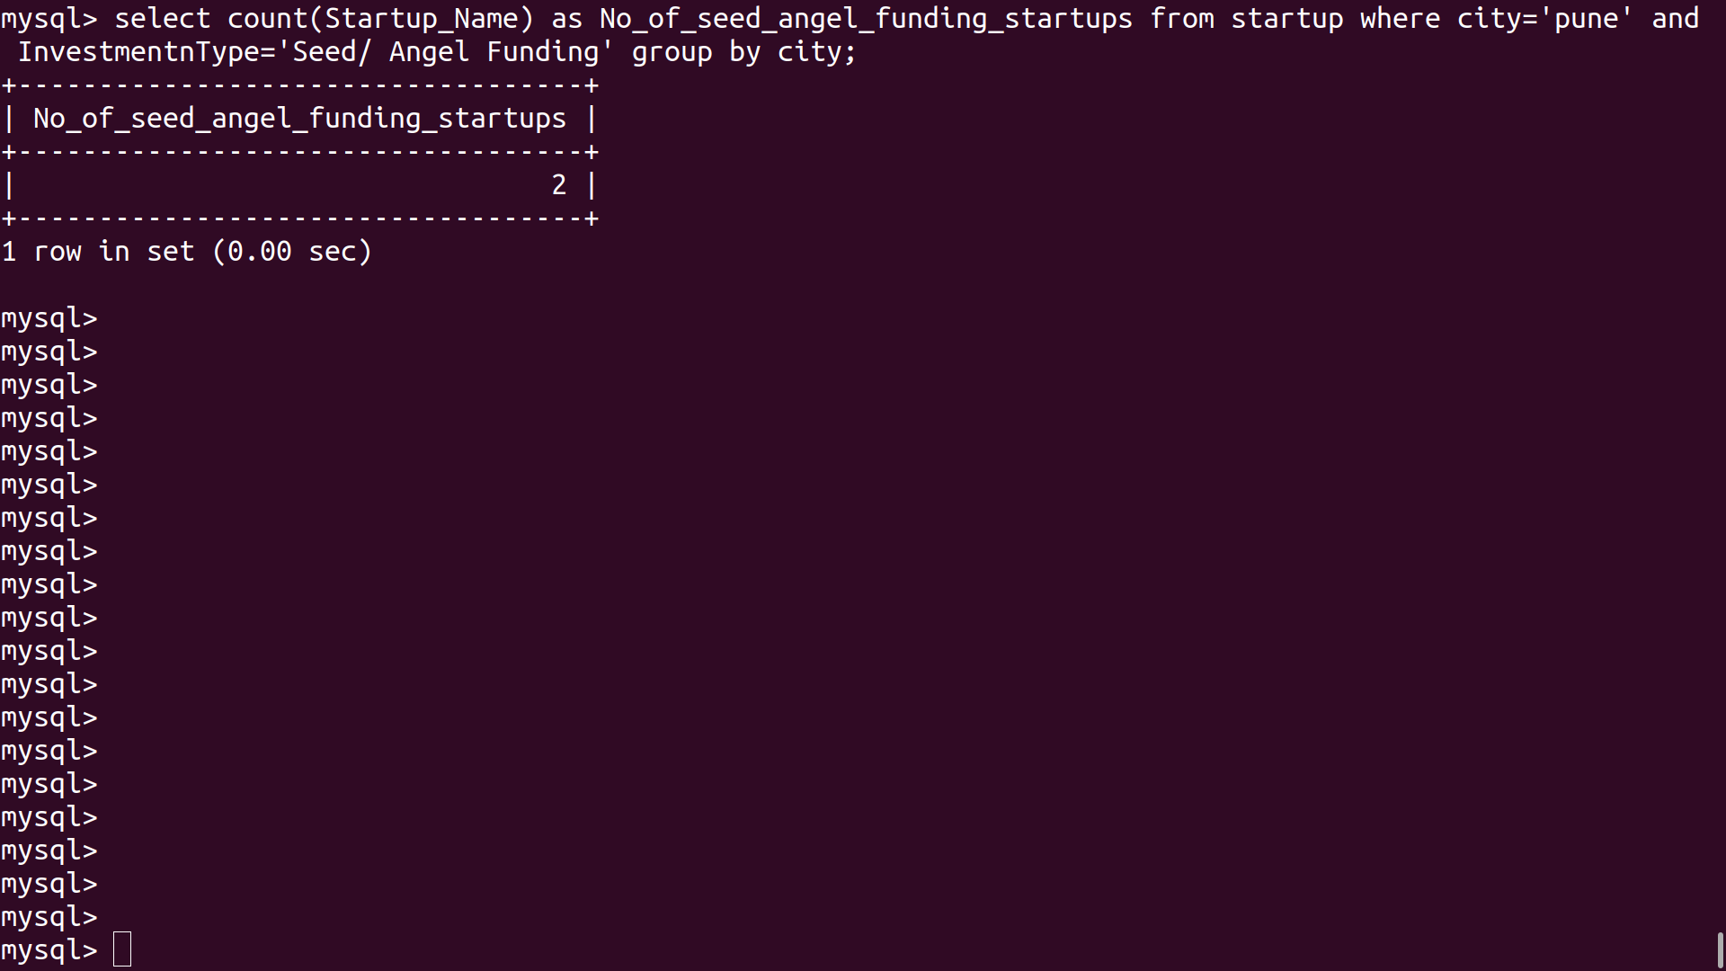

3) What is the total amount raised by startups in Pune City?
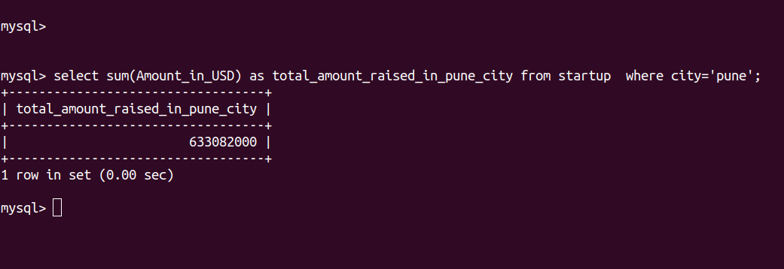

4) What are the top 5 Industry_Vertical which has the highest number of startups in India?
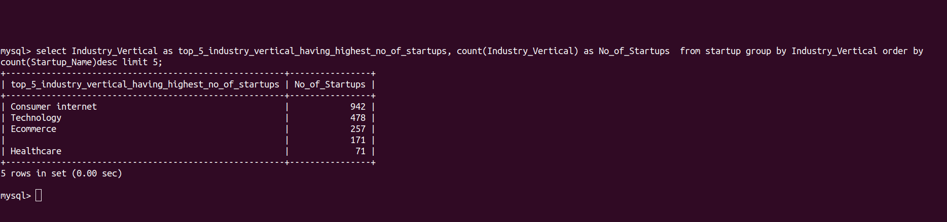

5) Find the top Investor(by amount) of each year.

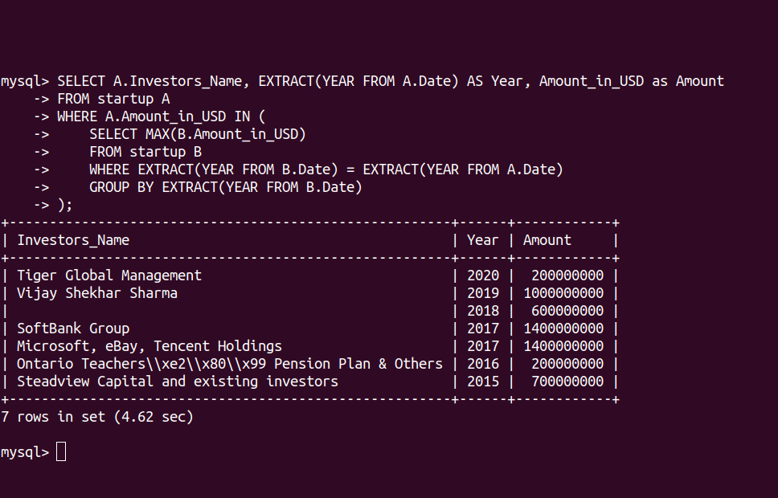

Bonus

1) Find the top startup(by amount raised) from each city?

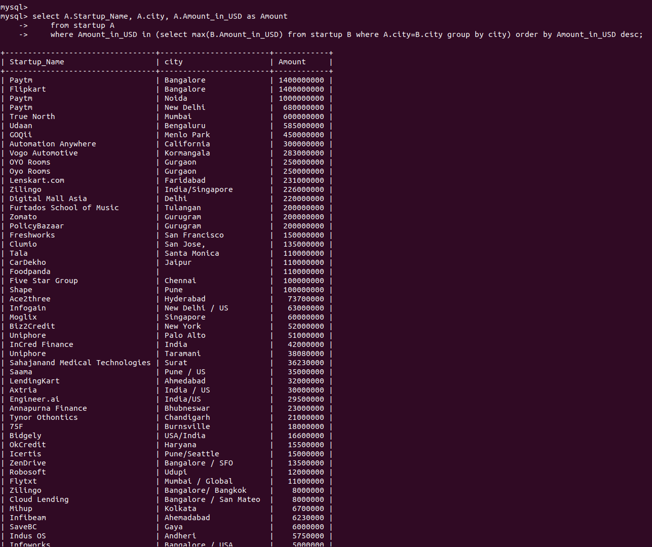

2) Which SubVertical had the highest growth(in number of startups) over the years?
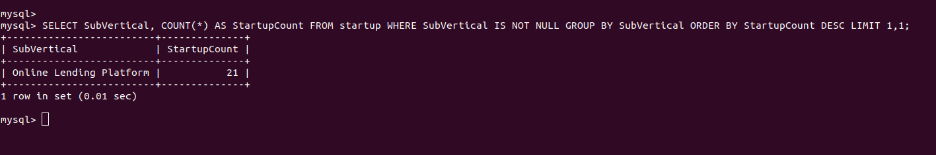

3) Which SubVertical had the highest growth(in funding) over the years?
