Hybrid Intent Understanding Architecture (AI + Non-AI)
This document describes a hybrid intent understanding system that combines symbolic reasoning (ontology graphs and rule validation) with AI techniques (embeddings and large language models). The goal is to achieve high accuracy, explainability, and reliability when interpreting user queries.

Architecture Diagram
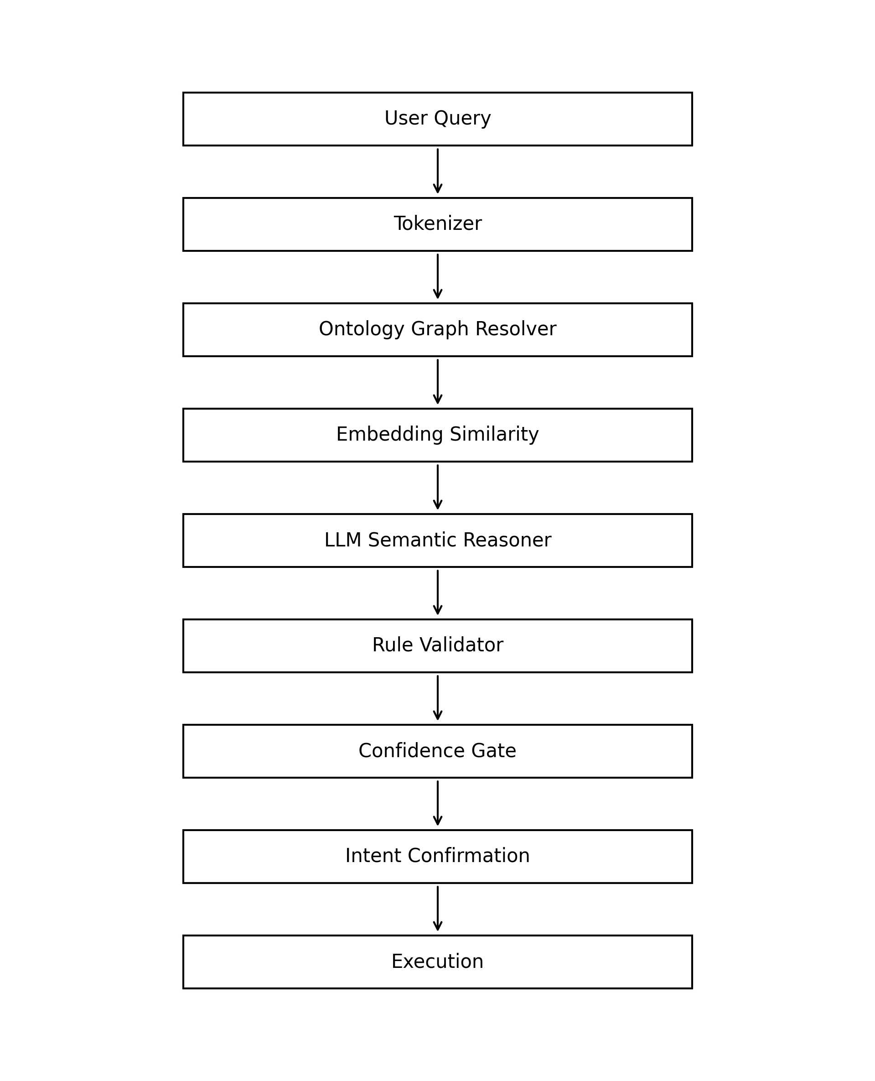

Processing Pipeline

1. User Query
Natural language input from a user. Example: 'I want to purchase 10 Tesla shares'. The system must convert this unstructured request into structured intent.

2. Tokenizer
The text is normalized and split into tokens. Operations include lowercasing, removing punctuation, and lemmatization. Example output: ['purchase','10','tesla','share'].

3. Ontology Graph Resolver
A knowledge graph maps words and synonyms to parent intents. Example: purchase -> BUY_INTENT. This deterministic layer resolves most queries quickly.

4. Embedding Similarity
If graph resolution fails, sentence embeddings are compared with known intent phrases. Vector similarity identifies the closest intent meaning.

5. LLM Semantic Reasoner
For ambiguous language the system calls a large language model which interprets semantic context.

6. Rule Validator
Rules verify logical correctness. Example: BUY intent requires an asset and quantity.

7. Confidence Gate
Confidence scores from earlier stages determine whether the intent is accepted or clarification is required.

8. Intent Confirmation
The system optionally asks the user to confirm the detected intent before execution.

9. Execution
The validated structured intent triggers downstream systems such as APIs, workflows, or database queries.

Example End‑to‑End Flow
Query: 'I want to start a position in Tesla.'
Tokenizer -> ['start','position','tesla']
Graph lookup fails.
Embedding similarity detects relation to 'buy stock'.
Intent = BUY.
Validator detects missing quantity.
System asks: 'How many shares would you like to buy?'

Benefits
• High reliability through deterministic validation
• AI flexibility for natural language understanding
• Explainable reasoning via ontology graph
• Reduced cost by minimizing LLM calls

Expected Performance
Graph resolution: ~80‑85% of queries
Embedding fallback: ~10‑15%
LLM fallback: ~5%
Overall classification accuracy: ~98‑99%
Execution reliability: near 100% when validation and confirmation are applied

