JAVASCRIPT

CHAPTER 01 – INTRODUCTION, BROWSER CONSOLE, BROWSER DIALOGS

Why JavaScript ?

Why JS is important
- JavaScript (JS) is the core of the MERN stack:

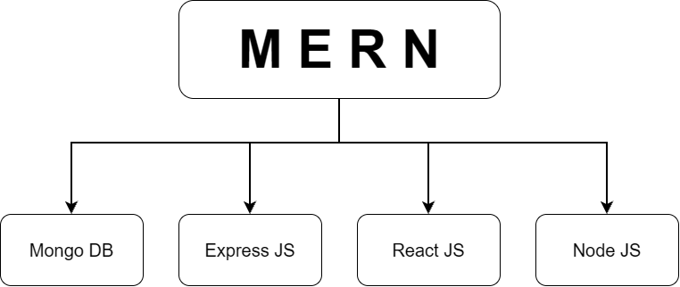

- JS fundamentals are asked in almost every developer interview.
- Tech stack change over time, but strong fundamentals carry over. A person with good JS basics can move from React to Vue or Angular easily.

JS learning roadmap
- Phase 1 (Foundation): What JS is, environment setup, first program, browser APIs, variables, data types, operators, conditionals, loops.
- Phase 2: Functions, Arrays, Objects (in details).
- Later Phases: Objects in depth and classes, asynchronous JS (promises, async / await. Event loop), modern features (destructuring, spread operator, template literals).

History of JavaScript

Timeline
YEAR / PERIOD | EVENT
1989 – 1991 | Tim Berners-Lee creates HTML, HTTP, the first web server, and publishes the first website at info.cern.ch
1993 | NCSA Mosaic, the first highly usable graphical web browser, is released.
1994 | Mosaic’s developers co-found Netscape and launch the Netscape Navigator browser.
1995 | Brendan Eich is hired by Netscape and develops the prototype for a new language called Mocha in 10 days.
1995 | Mocha is briefly renamed LiveScript, and then officially launched as JavaScript.
1995 – 1996 | Microsoft enters the browser wars by launching Internet Explorer (1995) and reverse-engineering JS to release its own clone JScript (1996)
1997 | ECMA International adopts the language and publishes the first official ECMAScript (ES1) standard to ensure cross-browser uniformity.
2008 | Google launches the Chrome browser featuring the open-source ultra-fast V8 JavaScript Engine.
2009 | Ryan Dahl build Node.js on top of Google’s V8 engine, officially bringing JavaScript to server-side backend development.

Why the name “JavaScript”
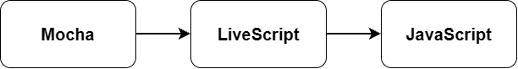
- At that time Java was very popular, so the name was chosen to gain attention.

IMPORTANT:
- JavaScript has no relation to Java.
- The name was only marketing choice.

Why JavaScript was buggy at first
- It was built in only 10 days, so it had many bugs.
- These improved over time through new versions.

The browser compatibility problem
- Microsoft’s browser became very widespread because it shipped by default with Windows, and distribution matters a lot.
- Microsoft copied the idea and built JScript instead of using JavaScript.
- Websites had to be written separately for each browser. Many sites carried a footer such as “Best compatible for Internet Explorer / Netscape Navigator”.
- This hurt both users and developers.

ECMA and ECMAScript
- ECMA (European Computer Manufacturers Association) is the organization that manages standards.
- It created a single standard so all browsers behave the same: ECMAScript.
- JS versions are managed under it.
ERA | NAMING
Early | ES1, ES2, ES3, ES4, ES5
From ES6 | Named by years:  ES2015, ES2016, ES2017….

NOTE:
- ES6 = ES2015. After that, a new version arrives every year.

JavaScript Engines
- Every browser has a JS engine that runs JS code.
BROWSER | ENGINE
Chrome | V8
Mozilla Firefox | SpiderMonkey
Microsoft (Internet Explorer) | Chakra
Safari | JavaScriptCore (marketing name: Nitro)

- Netscape lost money and was later sold. Its code base led to what is now Mozilla Firefox.
- V8 was very fast and optimized, so JS ran very fast in Chrome.

Birth of Node.js
- Ryan Dahl took the V8 engine (written in C++), modified it and combined it with additional C++ code. The result was Node.js, which is open source.
- Before Node.js, JS was only a client-side (browser) language.
- After Node.js, JS can run outside the browser (servers, backends), and JS’s popularity grew a lot.

What is JavaScript ?

Definition
- JavaScript is a single-threaded, synchronous programming (scripting) language that can be used for multiple purposes.

What van we built with JS ?
AREA | TOOLS / EXAMPLE
Frontend (browser features, effects, user interaction) | JS, React, Angular
Backend (Servers) | Node.js, Express
Libraries / Frameworks | React, Angular, Express
Mobile Apps (Hybrid for iOS + Android) | React Native)
Desktop Apps | Electron.js (VS Code is built on it)
Robots | JS code can be used in robotics.
Blockchain dApps (decentralized applications) | JS used to build the frontend that talks to smart contracts

IMPORTANT:
- JS is one of the most popular languages.
- It is both one of the most loved and one of the most hated languages, because it behaves very differently from other languages.

Client-Side vs Server-Side

Client
- Definition:
- The user (or their device/browser) who uses a website.

Server
- Definition:
- A computer and software system designed to provide resources, data and services to other computers (clients) over a network.
- It stores files, runs programs and processes requests, and is usually accessed remotely from phones and laptops.
- Simple mental model:
- Take a computer system and remove the monitor, keyboard, mouse and speaker. Only the CPU remains.
- Connect it to the internet (Ethernet or Wi-Fi) and program it to respond to requests.
- That is a server.

Client-Server Architecture
- The client sends a request, and the server sends back a response.
- Example:
- You open amazon.com.
- You are the client, and Amazon’s servers respond with data.
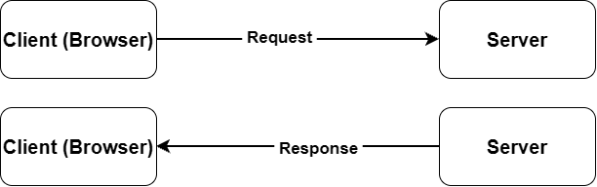

Rendering Types
- Client-Side Rendering (CSR):
- Data arrives at the client, and the page is built (rendered) on the user’s device/browser.
- Example:
- A site’s course list comes from the backend. The browser requests the data and builds the page with the response.
- Server-Side Rendering (SSR):
- The server loads all the data and builds the page.
- The client receives a finished HTML file that already contains the data.

CSR vs SSR comparison
FEATURE | CLIENT-SIDE (CSR) | SERVER-SIDE (SSR)
Where the page is built | User’s browser | Web Server
Initial load | Can be slower (data loads after the markup arrives) | Generally faster (HTML is ready to display).
Interactivity | Faster after load (only specific parts updates) | The full page may reload.
SEO | Weaker | Better
Load on server | Less | More
Load on user’s device | More | Less

IMPORTANT:
- Neither is always better.
- It depends on the use case.
- In general, SSR gives a faster initial load, while CSR gives faster interactivity.
- Both are explained in more detail later in the course.

Setting up: Linking JavaScript to HTML

Inline JS

Definition:
- Inline JS is JavaScript written directly inside an HTML element's attribute (like onclick="...").
- It works like inline CSS inside a style="..." attribute.

Syntax:
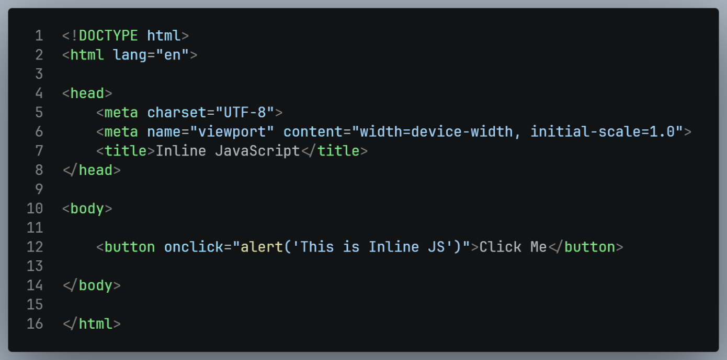
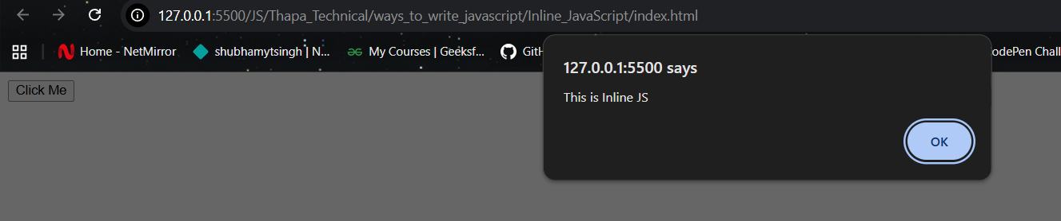

Internal JS

Definition:
- JS written inside a <script> tag in the HTML file.
- It works like internal CSS in a <style> tag.

Syntax:
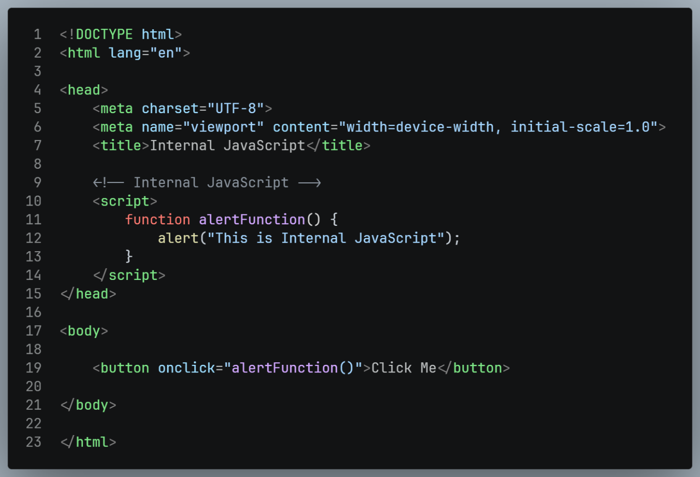
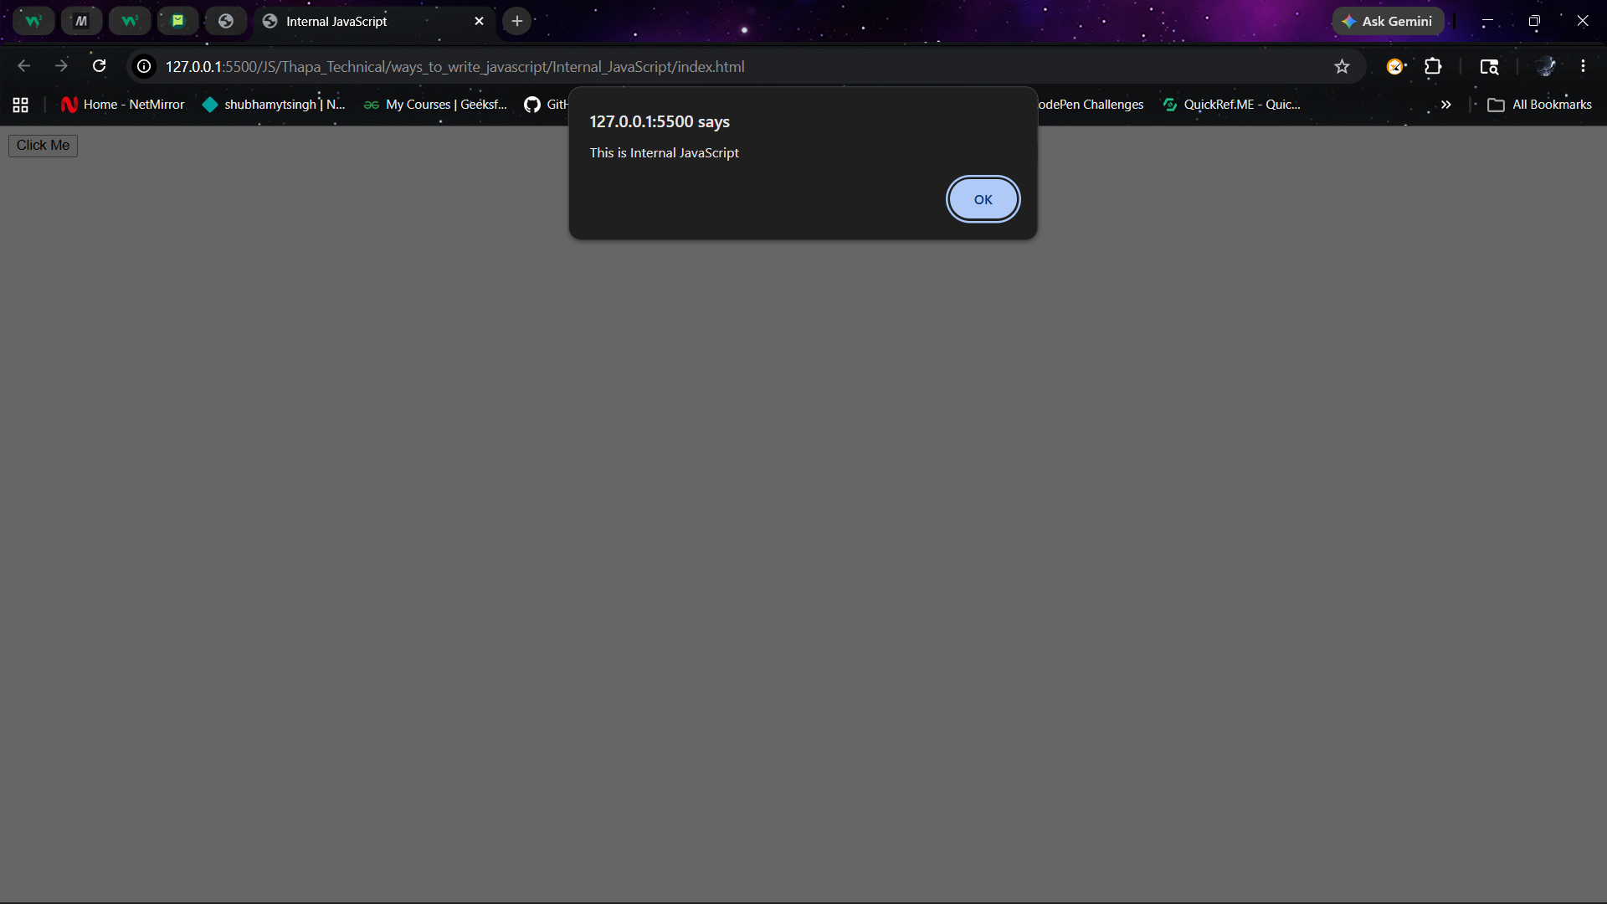

External JS (Recommended):

Definition:
- JS written in a separate .js file and linked with the src attribute.

Syntax:
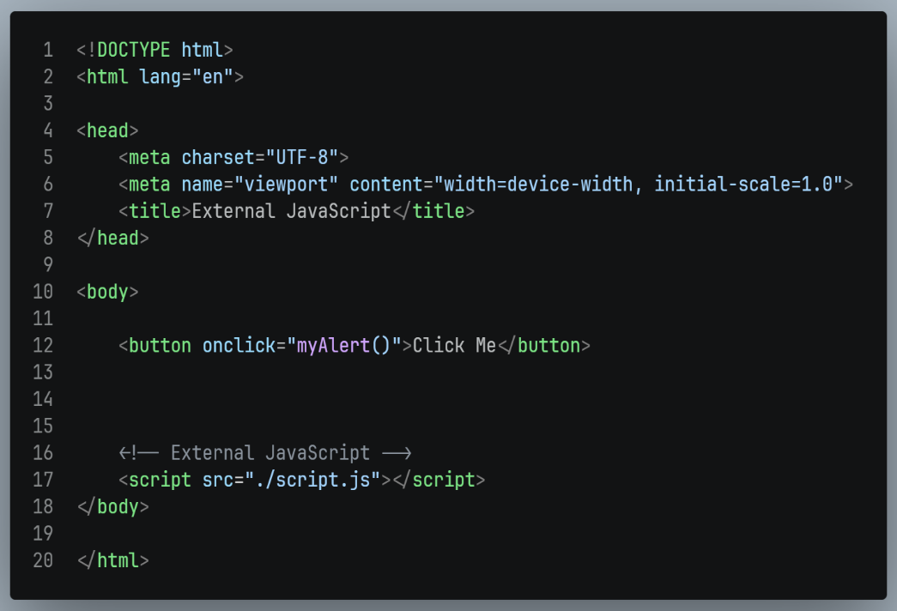
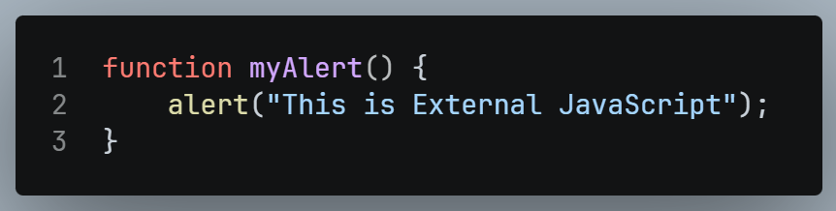
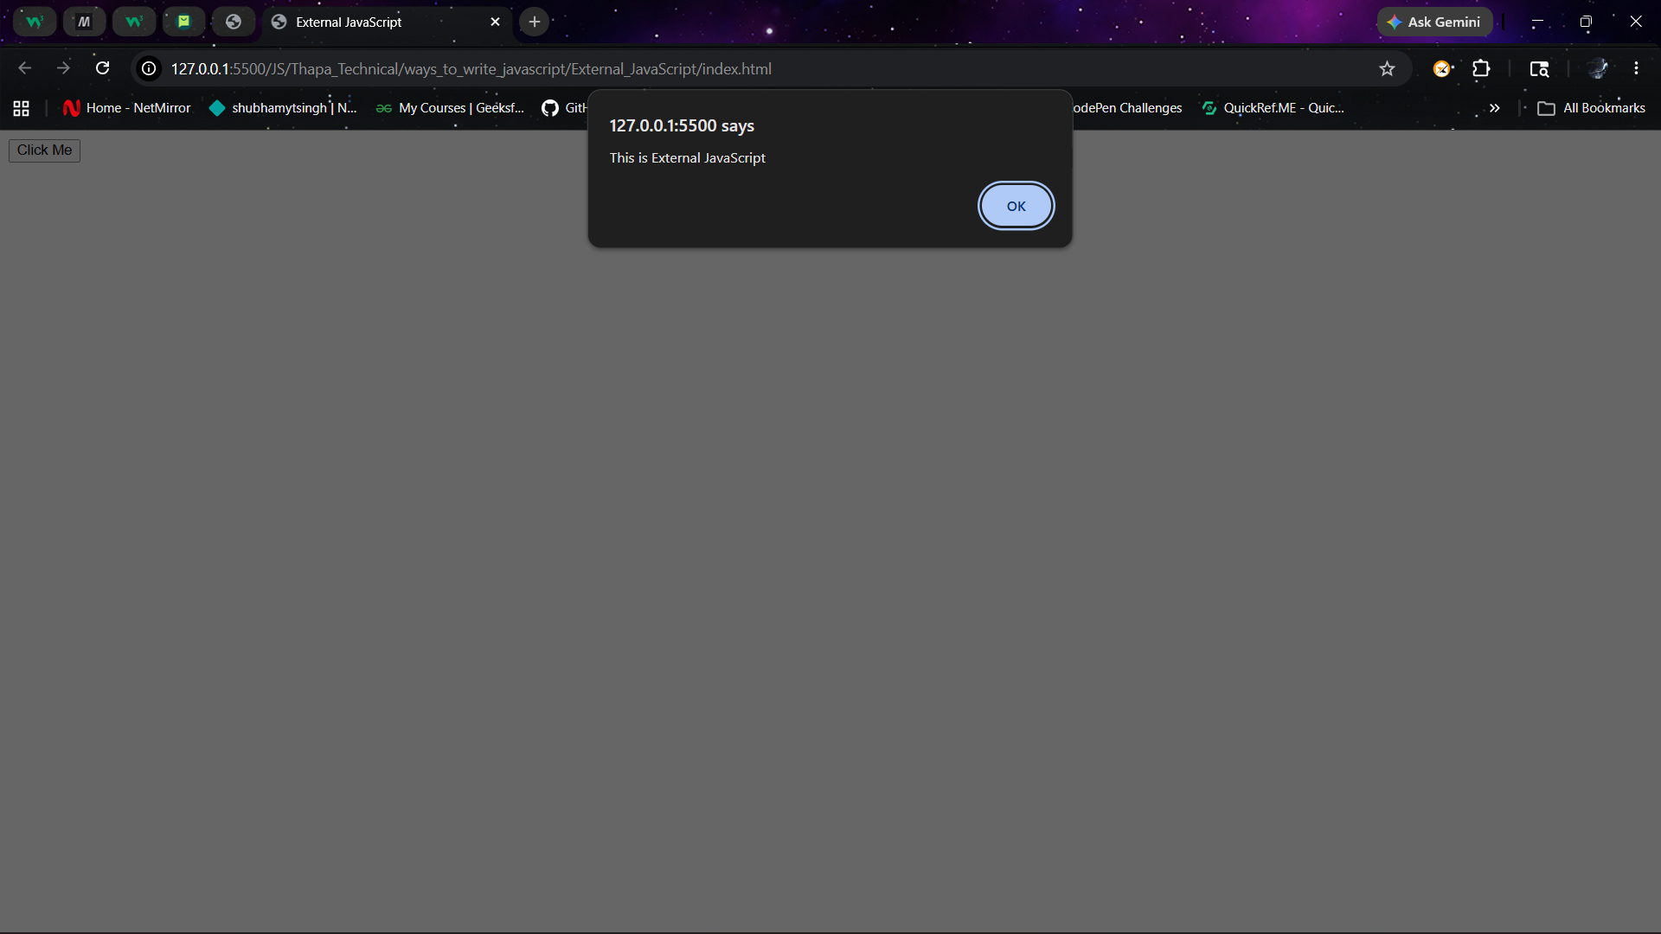
- Place the <script> tag at the end of <body>.
- Create the file (e.g. script.js) in the same folder as index.html.

The Browser Console

What is the Console ?

Definition:
- A window in the browser’s Developer Tools that acts as a playground for developers.
- We use it to see output.

How to open:
- Right-click on the page Inspect Console tab.

Similar Output functions in other languages:
LANGUAGE | PRINT STATEMENT
C | printf
C++ | cout
Java | System.out.println
Python | print
JavaScript | console.log

Other DevTools tabs (for reference)
TAB | PURPOSE
Elements | Inspect HTML and CSS
Console | Output and experiments
Application | Local Storage, session storage, extension storage
Network | Assets and request of the website.
Source | Website structure and code
Performance | Track performance metrics
Lighthouse | Check website quality (e.g., for search engines)

console.log / console.warn / console.error / console.table

Definition:
- Methods for printing messages to the console in different styles.

Syntax:
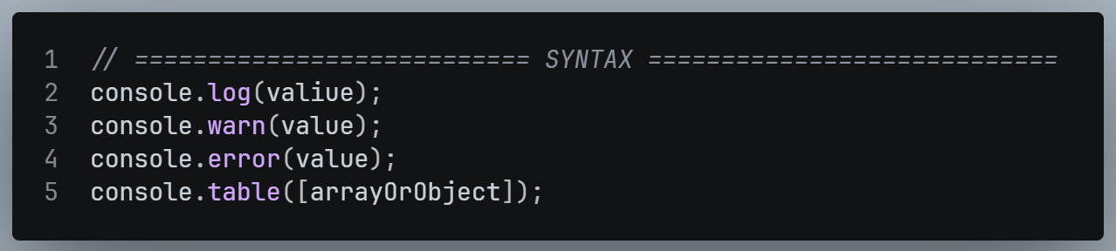

Example:
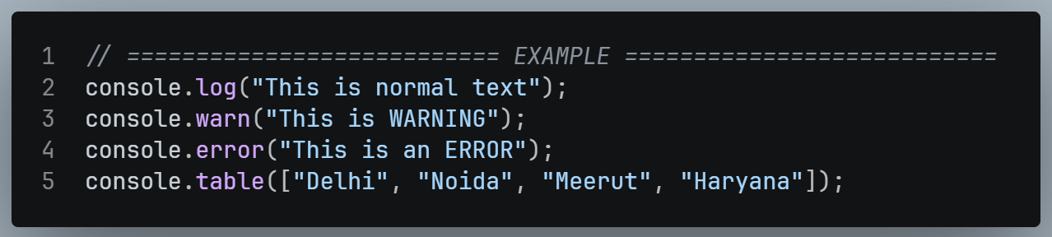

Output:
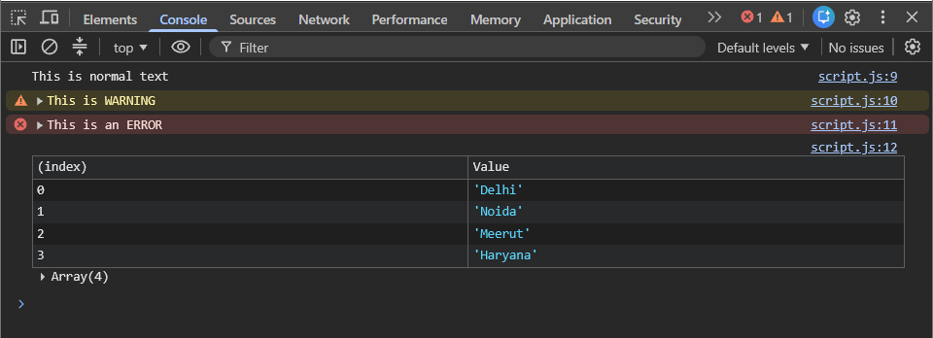

Browser Dialog
- These come from the browser’s Web API.
- They show pop-ups to the user.

alert()

Definition:
- Shows a message pop-up to the user with an OK button.

Example:
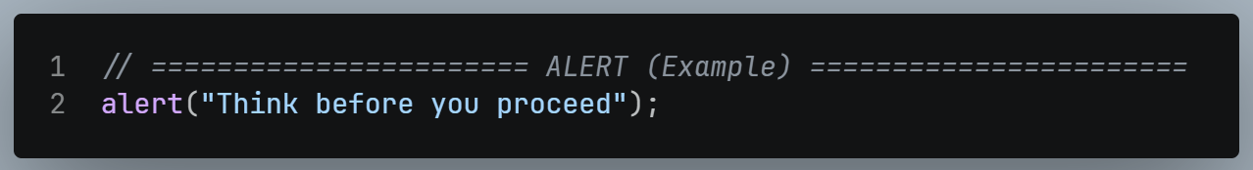

Output:
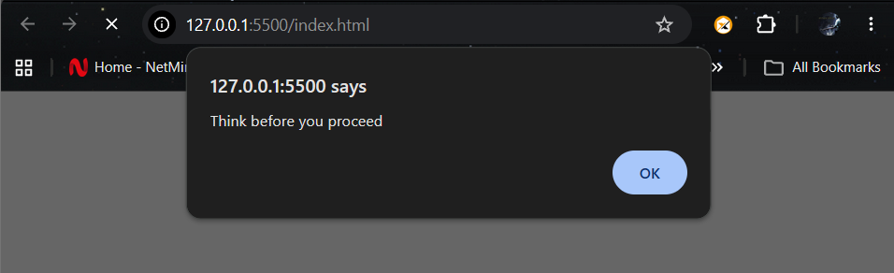

Return value:
- Nothing.
- If stored in a variable, we get undefined

confirm()

Definition:
- Asks a yes / no question and shows OK and Cancel buttons.

Example:
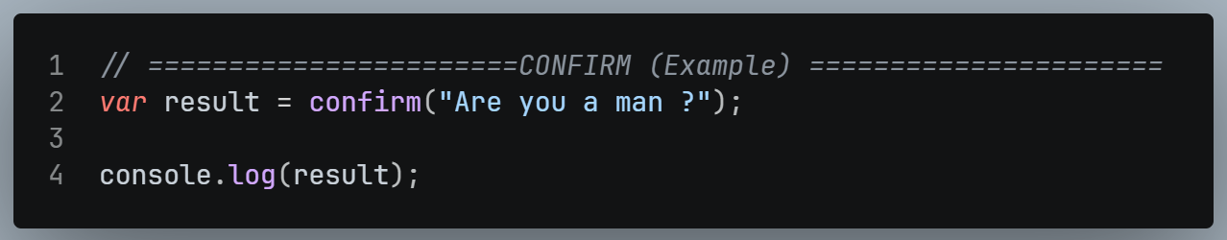

Output:
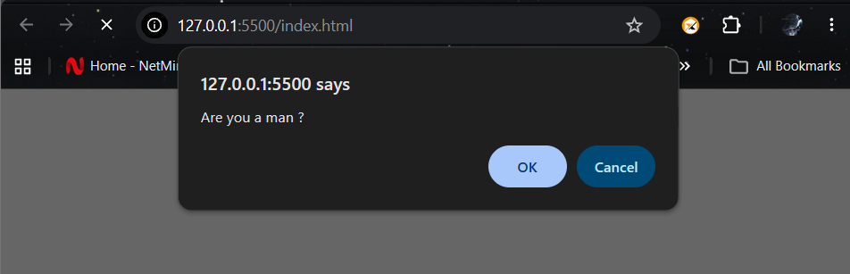

Return Value:
OK true
Cancel false
- The answer can be stored in a variable and used later for logic.

prompt()

Definition:
- Asks the user a question and lets them type an answer.
- It returns what they typed.

Example:
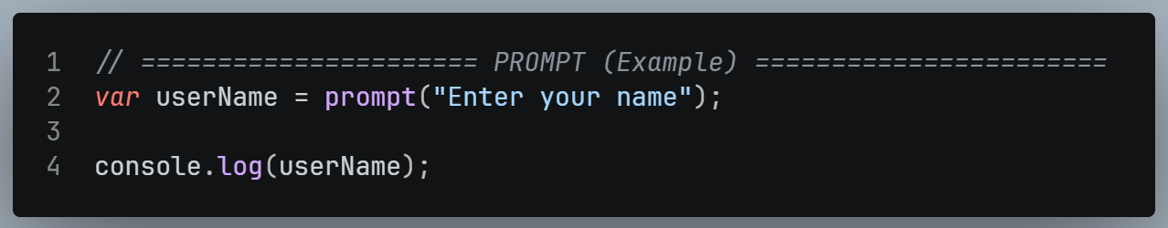

Output:
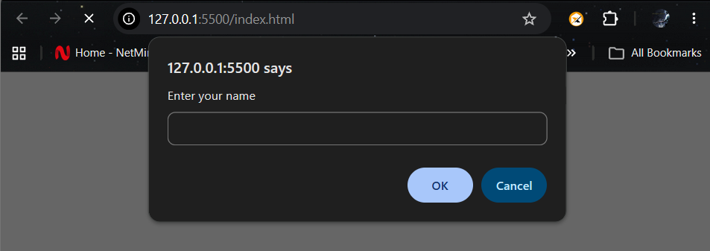

IMPORTANT:
- The answer from prompt() is always a string, even if the user types a number.
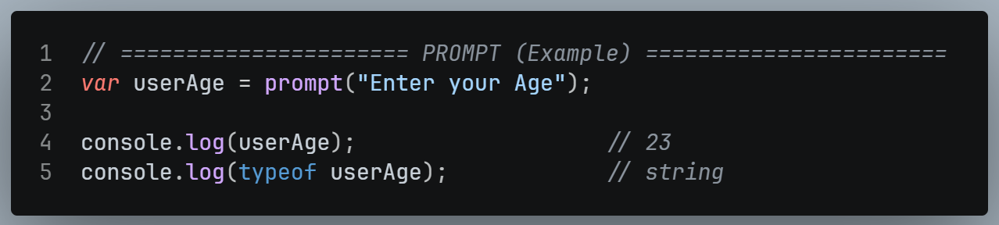
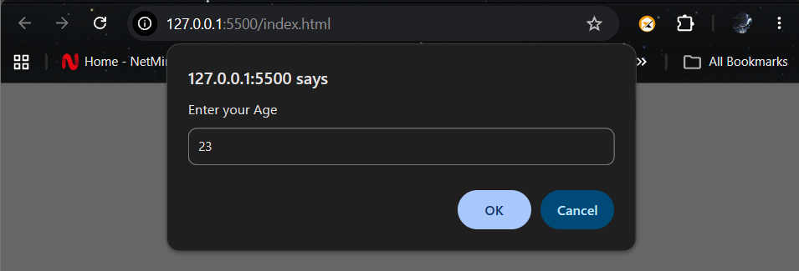

Comparison Table
FEATURE | ALERT | CONFIRM | PROMPT
Purpose | Show a message | Ask yes / no | Ask for input
Buttons | OK | OK, Cancel | OK, Cancel + Input box
Returns | undefined | true / false | string (or null on Cancel)
Store in a variable ? | Not useful | Yes | Yes

CHAPTER 02 - VALUES & VARIABLES
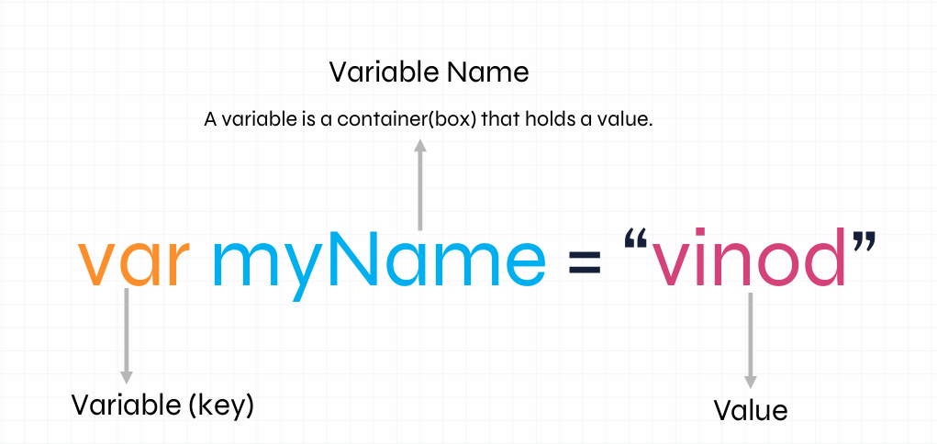

Definition:
- In JavaScript, values & Variables are fundamental concept that form the basic of programming.
- Values:
- A value is a piece of information that a program can work with.
- It can be number, text, true / false, or more complex data.
- Variables:
- A variable is a combination that holds a value.
- It has a name and can be used to store a manipulation data in a program.

Syntax:
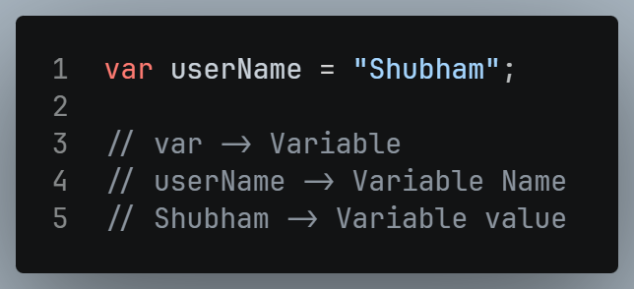

Declaration:

Definition:
- Announcing/creating the variable (reserving a place in memory).

Syntax:
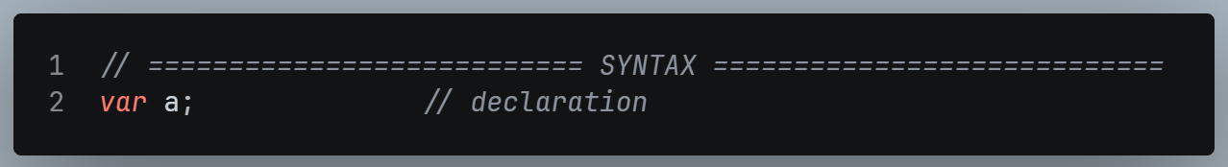

Initialization:

Definition:
- Putting the first value into a declared variable.

Syntax:
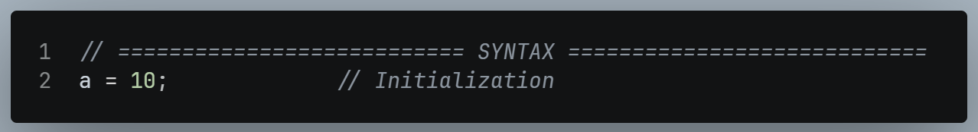

Declaration + Initialization together

Syntax:
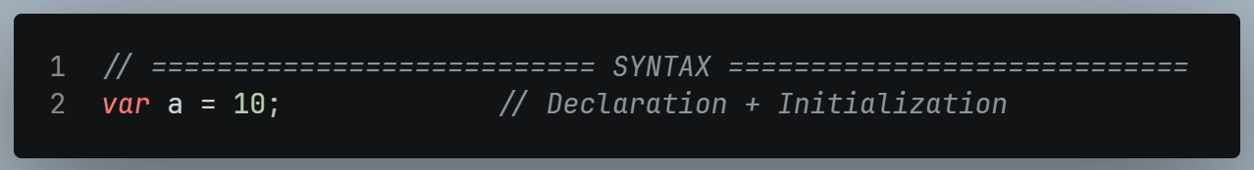

Updating / Re-initialization (Re-assignment)

Definition:
- Changing the value stored in an existing variable.

Example:
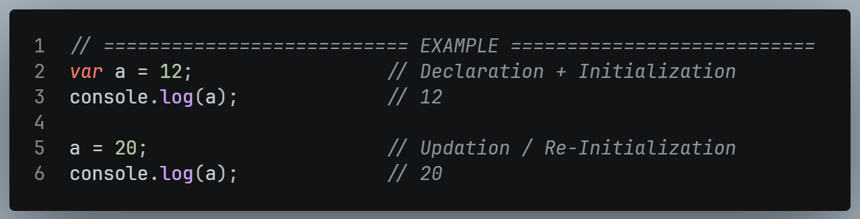

Printing multiple values
- Use a comma , to separate the values.

Example:
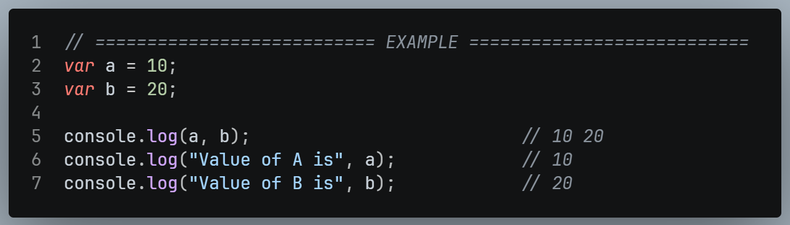
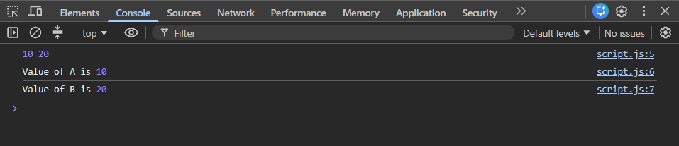

Declare without Initialize
- Printing a variable that was never created given an error:

Example:
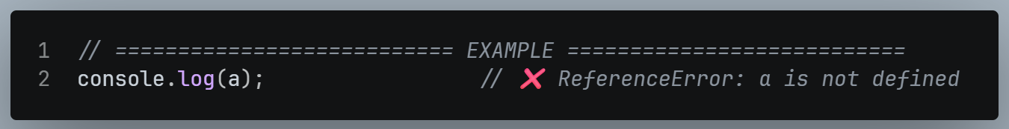

Variable Naming Rules

Rules
- Variable names must start with a letter, an underscore(_), or a dollar sign ($).
- Variable names cannot contain spaces.
- By convention, JavaScript variable names are written in camelCase.
- Variables cannot be the same as reserved keywords such as if or const.
- Variable names are case-sensitive.
- Variable names can be long as we need.

Example
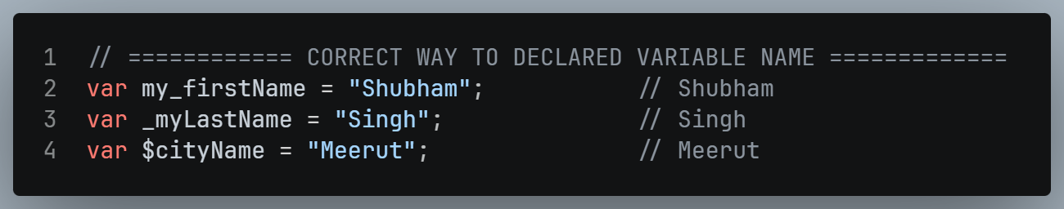
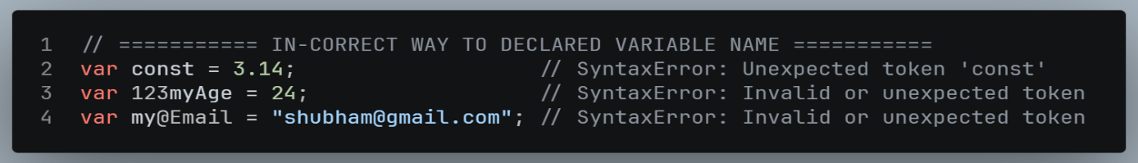

Case Sensitivity
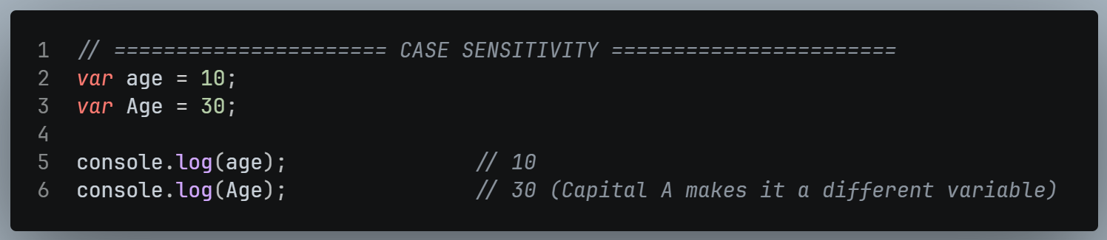

Var vs Let vs Const

var

Definition:
- The oldest way to declare a variable in JavaScript
- It is function scoped and hoisted.

Syntax:
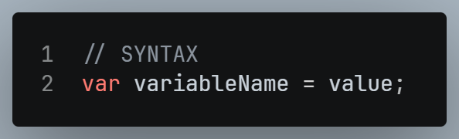

Declared Variable
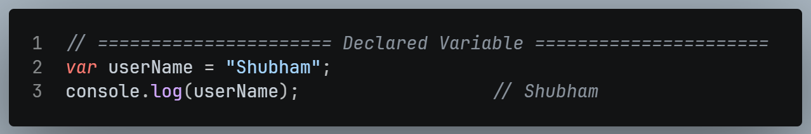

Can be Re-Declared
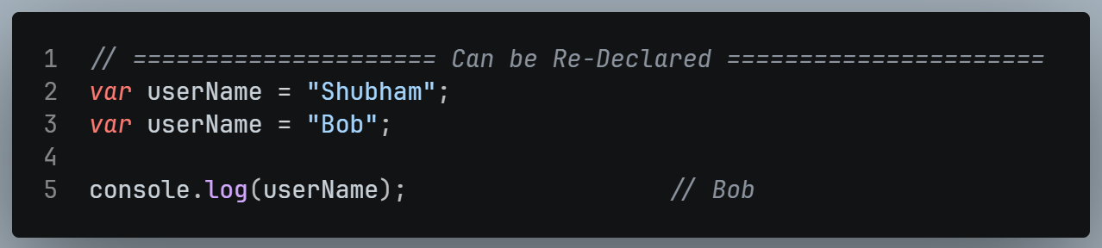

Can be updated
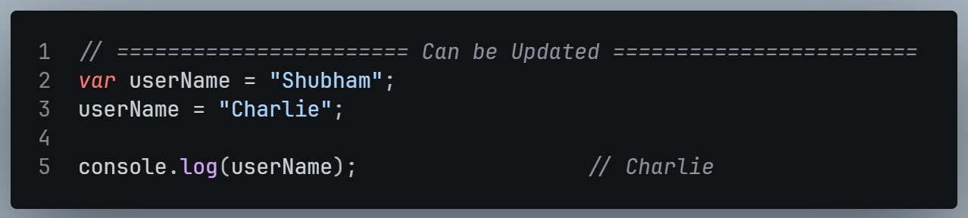

Hoisting with var
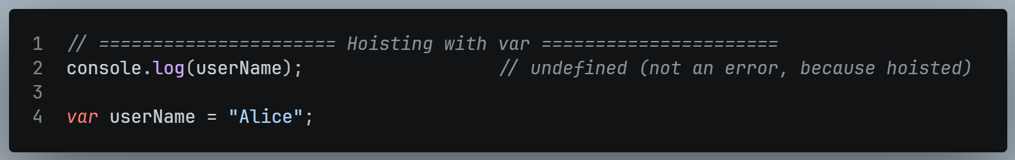

let

Definition:
- Introduced in ES6.
- It is block scoped and not hoisted like var.

Syntax:
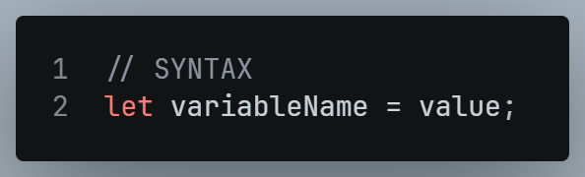

Declared Variable
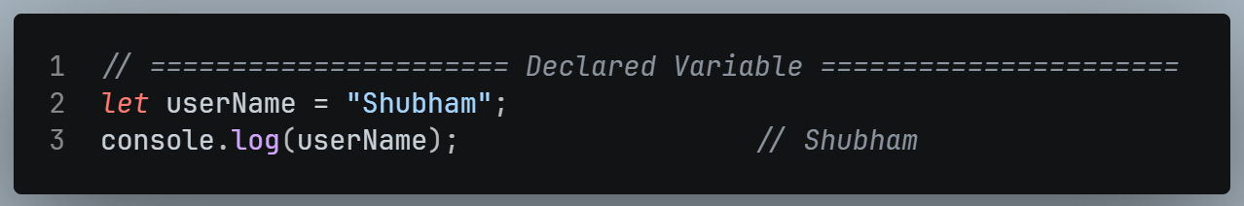

Can be RE-DECLARED
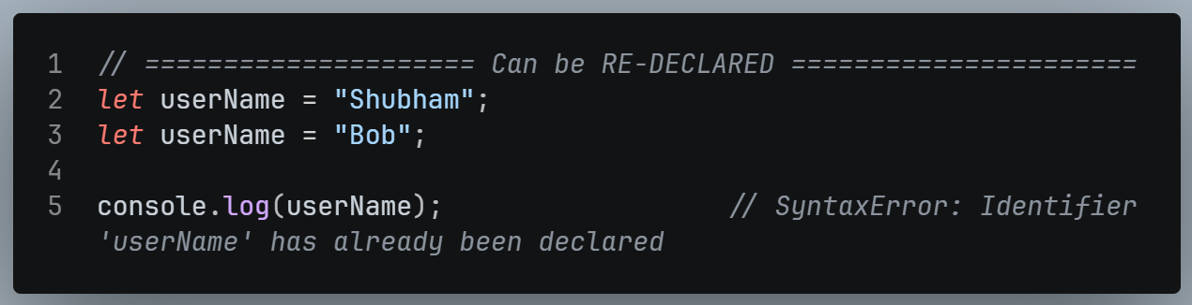

Can be UPDATED
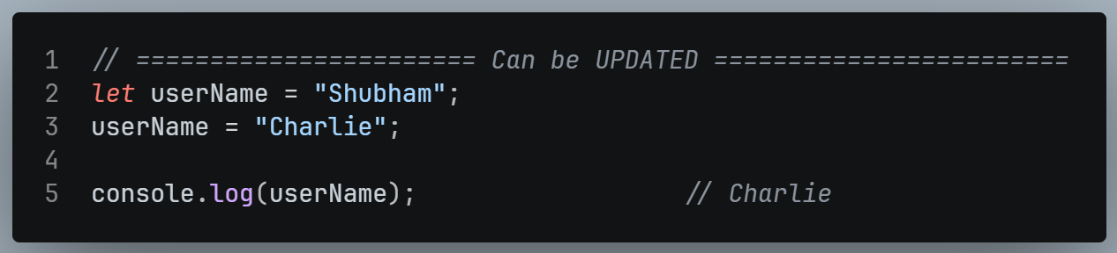

HOISTING with let
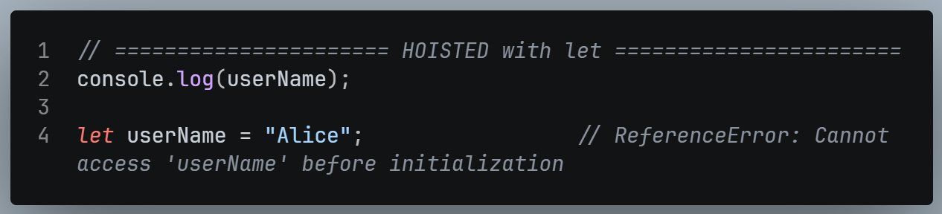

const

Definition:
- Introduced in ES6 alongside let.
- It is block-scoped and creates a read-only reference that cannot be reassigned.

Syntax:
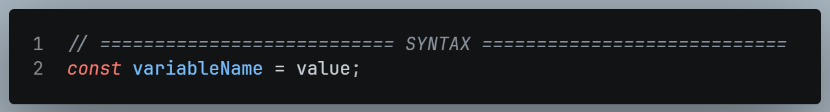

Declared Variable
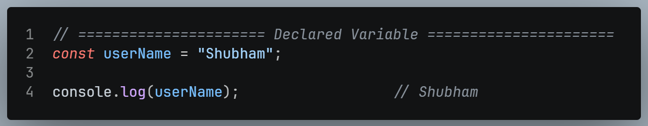

Can be RE-DECLARED
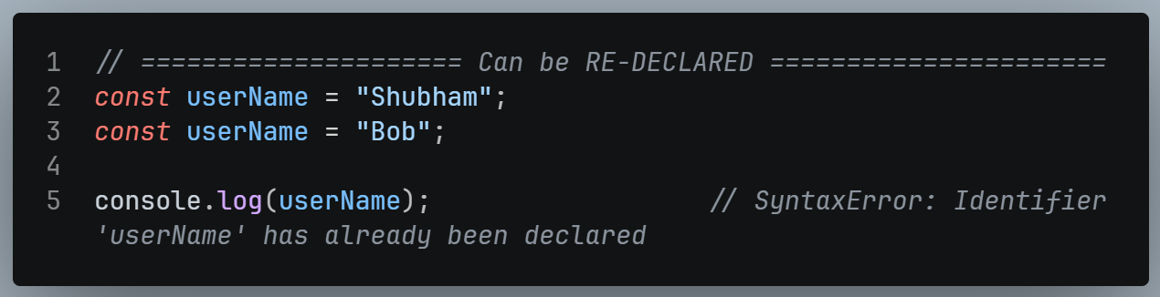

Can be UPDATED
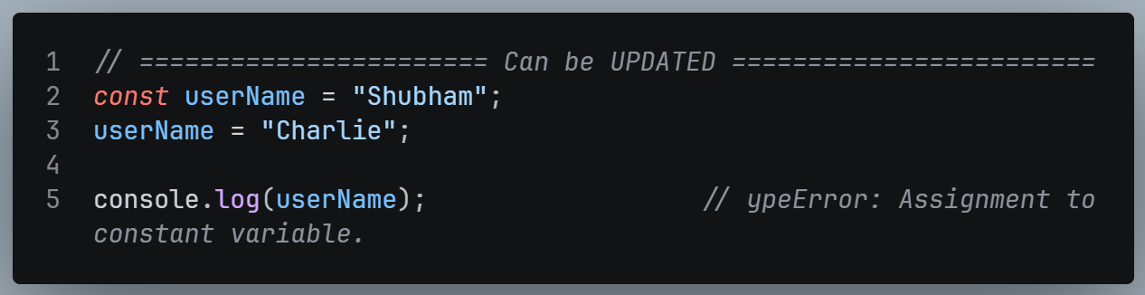

HOISTING with const
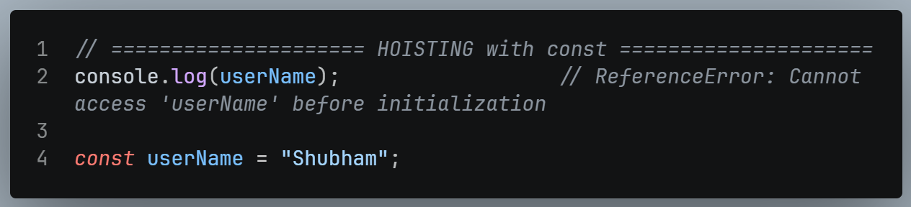

Key Difference
VARIABLE | RE-DECLARED | RE-ASSIGN | HOISTED | SCOPE | WHEN TO USE
var | Yes ✅ | Yes ✅ | Yes ✅ | Function | Old Way.
let | No ❌ | Yes ✅ | No ❌ | Block | Use when value changes.
const | No ❌ | No ❌ | No ❌ | Block | Use when value never changes.

CHAPTER 03 – DATA TYPES

Two Categories
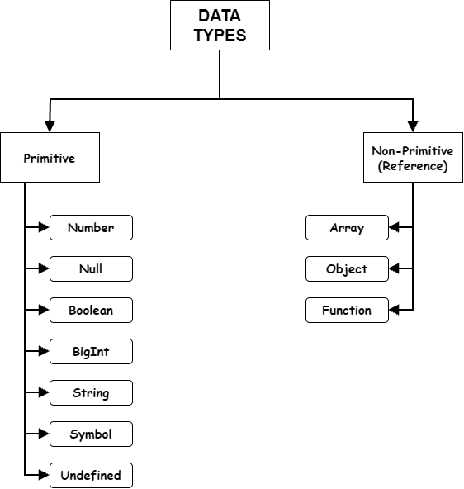
- Total 7 primitive types:
- Number, Null, Boolean, BigInt, String, Symbol, Undefined.
- Non-Primitive: Technically everything is an object.
- Beginner-level view:
- Object, Array, Function

What are a Primitive Data Types ?

Definition:
- Data that is not an object and has no method or properties of its own.
- Primitives are immutable, meaning their actual value cannot be changed once created.
- For now, think of a primitive as a variable that holds one single value at a time.

Number

Definition:
- Any integer / decimal value, positive / negative & floating-point numbers.

Example:
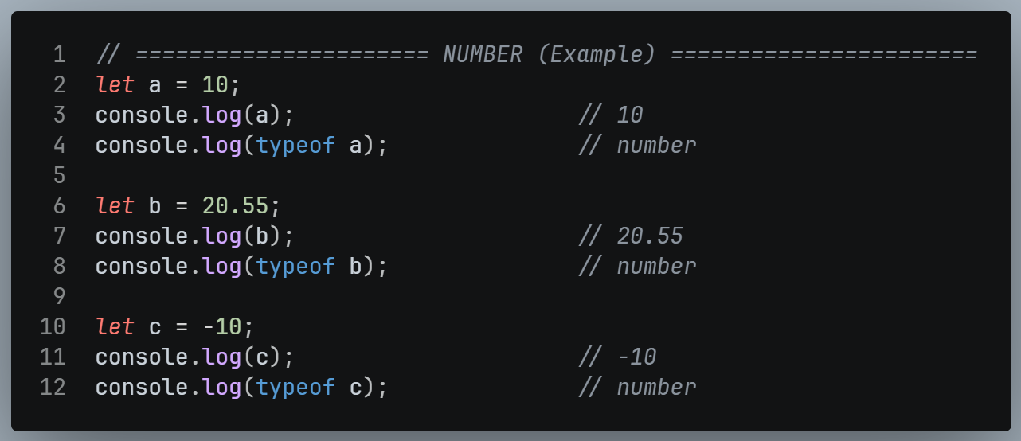

Range of Number:
- JS numbers are 64-bit values.
- Maximum safe integer: 2⁵³ – 1 (9007199254740991)
- Minimum safe integer: -(2⁵³ – 1)
- Beyond this range, use BigInt

String

Definition:
- Any character or set of characters (letters, words, sentences, special characters).
- Strings are written inside single quotes ‘ ‘ OR double quotes “ “

Example:
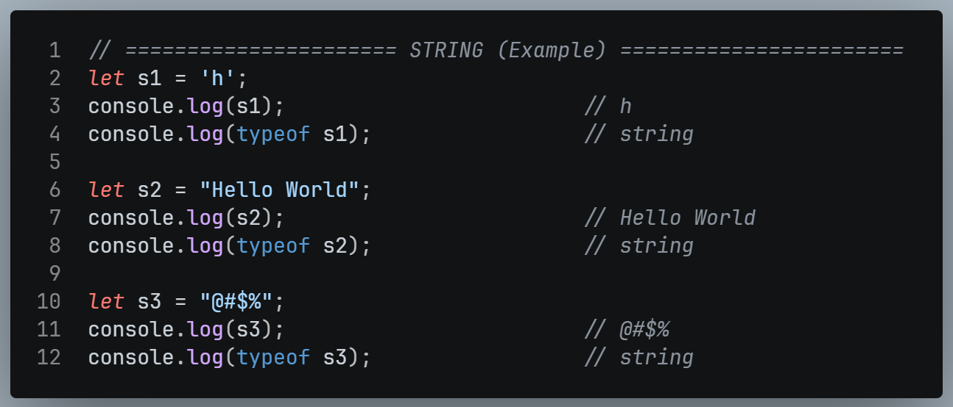

IMPORTANT:
- If we start a string with a single quote, we must end with a single quote.
- Likewise for double quotes.
- Don’t mix them.

Boolean

Definition:
- A data type with only 2 values:
- True
- False
- Used for decisions and conditions.

Example:
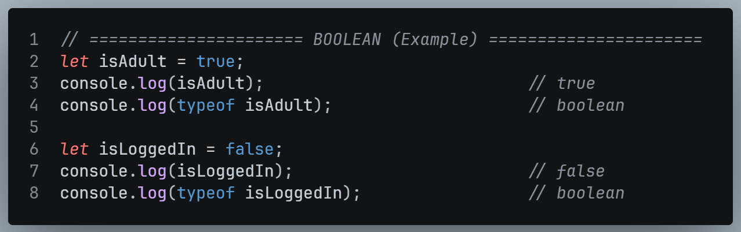

Undefined

Definition:
- The default value automatically assigned by the JS engine to a variable that has been declared but not initialized.

Example:
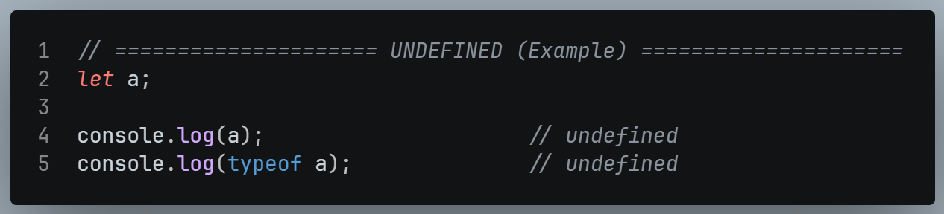

IMPORTANT:
- Undefined does not mean “nothing exists”.
- It is an actual value.

Null

Definition:
- A primitive value representing the intentional absence of any value.
- The developer deliberately marks the variable as empty.

Example:
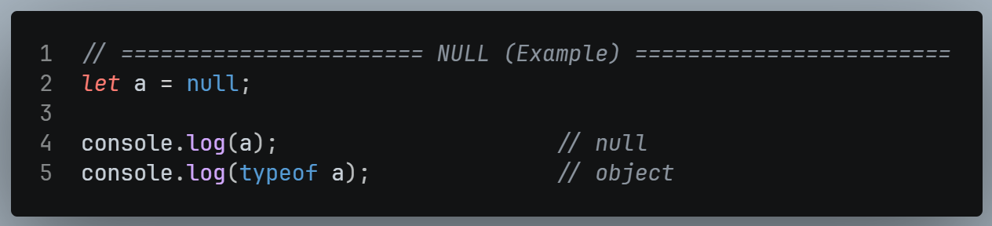

Undefined vs Null
 | UNDEFINED | NULL
Who sets it | JS Engine (Automatically) | Developer (intentionally)
Meaning | Declared but no value assigned yet. | Intentionally empty.
Example | var a; | var a = null;

BigInt

Definition:
- A data type for integers larger than the Number limit (2⁵³ – 1).
- Its range is practically unlimited.
- It is used for large values, e.g., in financial applications.

Syntax:
- Add n at the end of the number.

Example:
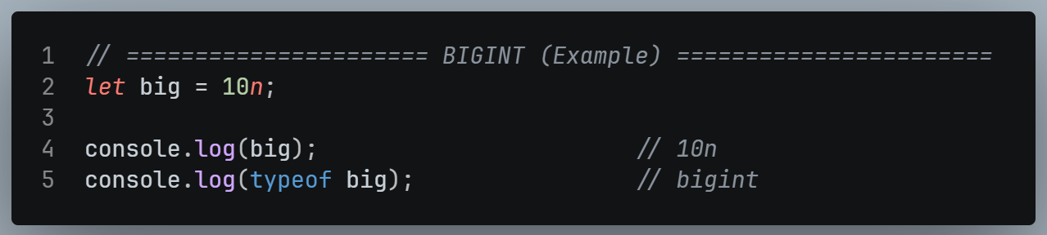

- Very large normal numbers appear in exponent form and cannot be used reliably
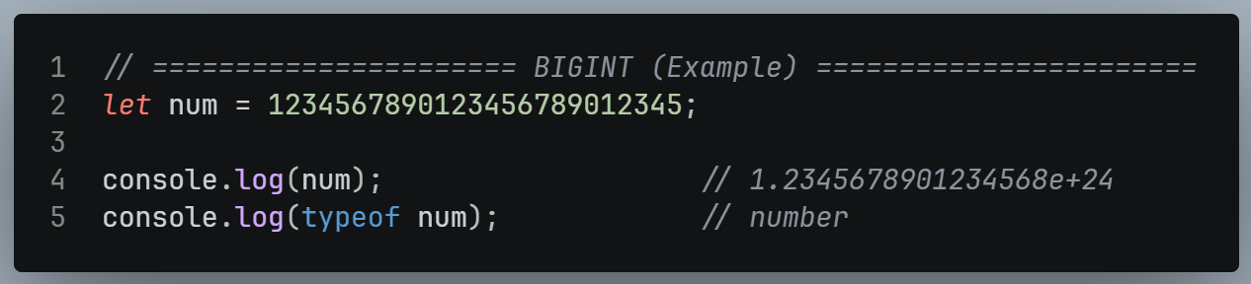
- With n we can work with large numbers properly, including operations.

Symbol

Definition:
- A built-in primitive introduced in ES6 (2015).
- It creates unique and immutable identifiers, mainly used for object property keys so they never collide, even with the same name.

Syntax:
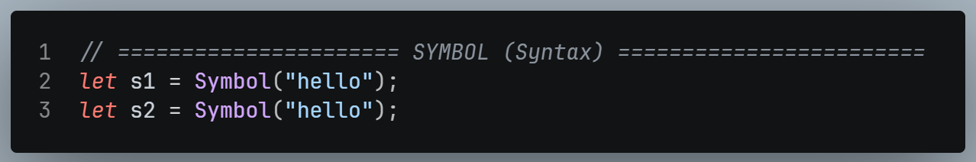

Example:
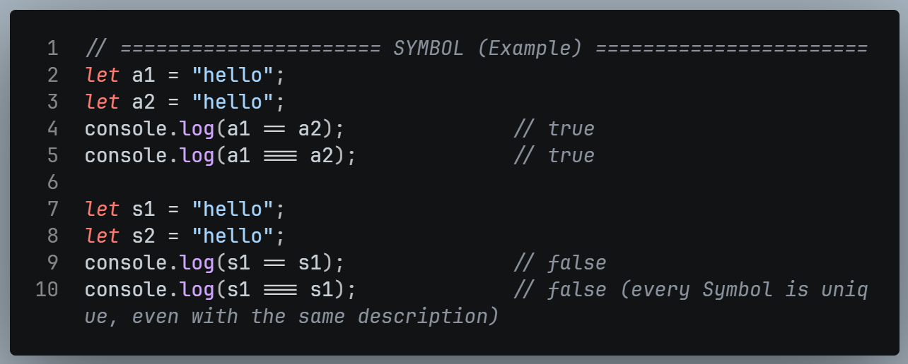

NOTE:
- Symbols are rarely used in everyday development.
- Know the definition for interviews.

typeof Operator

Definition:
- An operator that tells the data type of a value or variable.

Syntax:
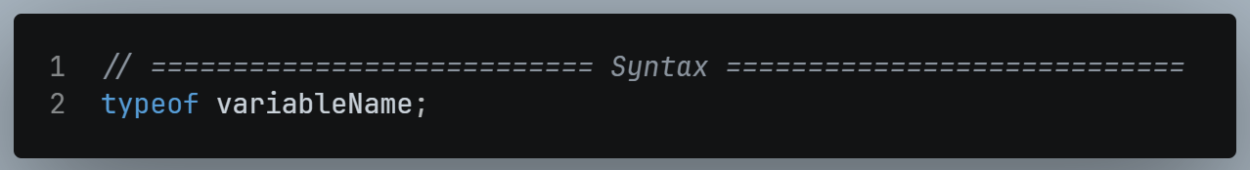

Example:
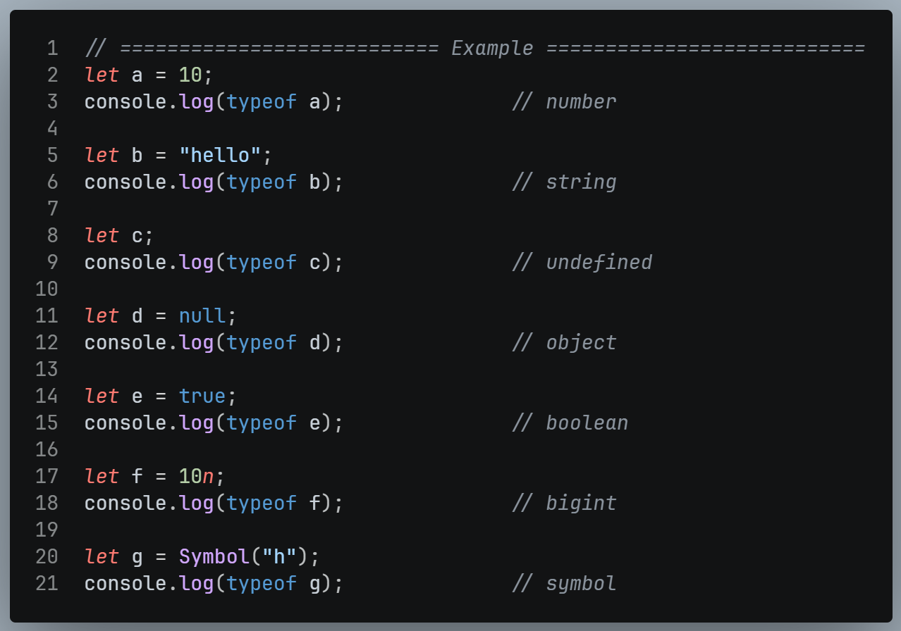

INTERVIEW TIP:
- typeof null returns Object.
- This is a known quirk, a bug caused by JS being built in a hurry (10 days).
- null is still a primitive.

Convert a String into a Number
- We have different ways to convert String into a Number.
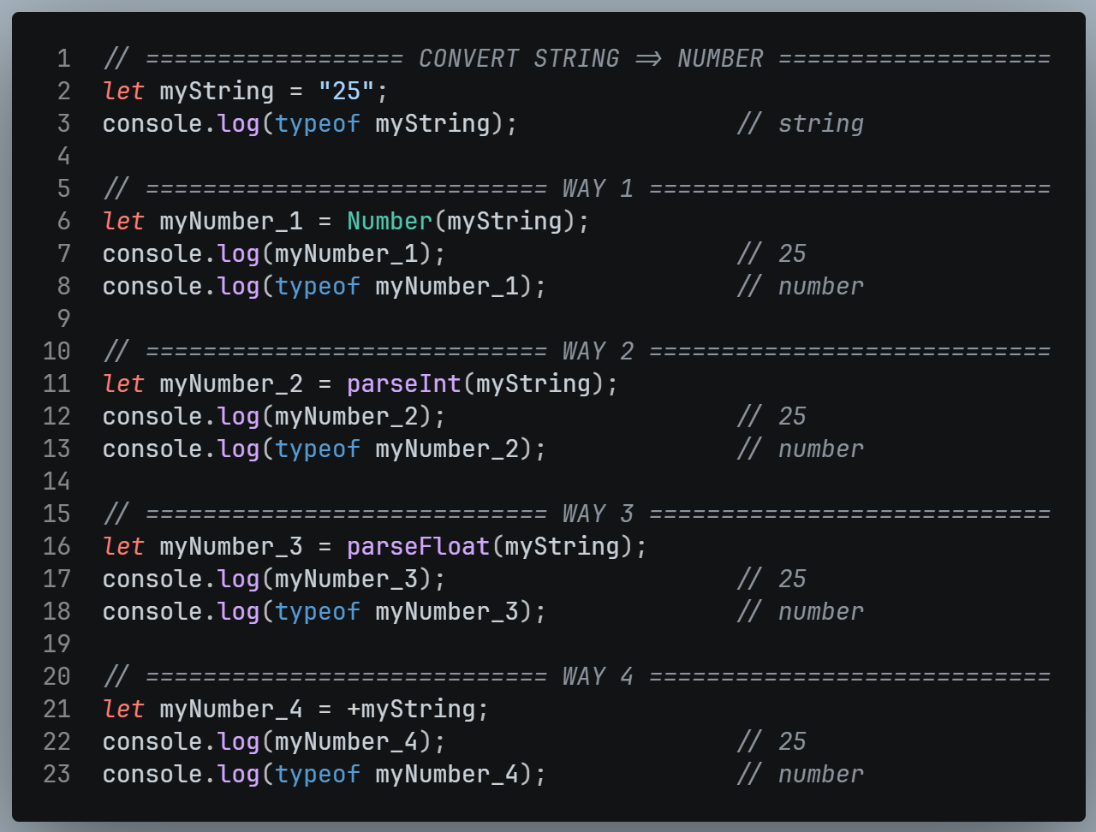

Convert Number into String
- We have 3 ways to convert Number into a String.
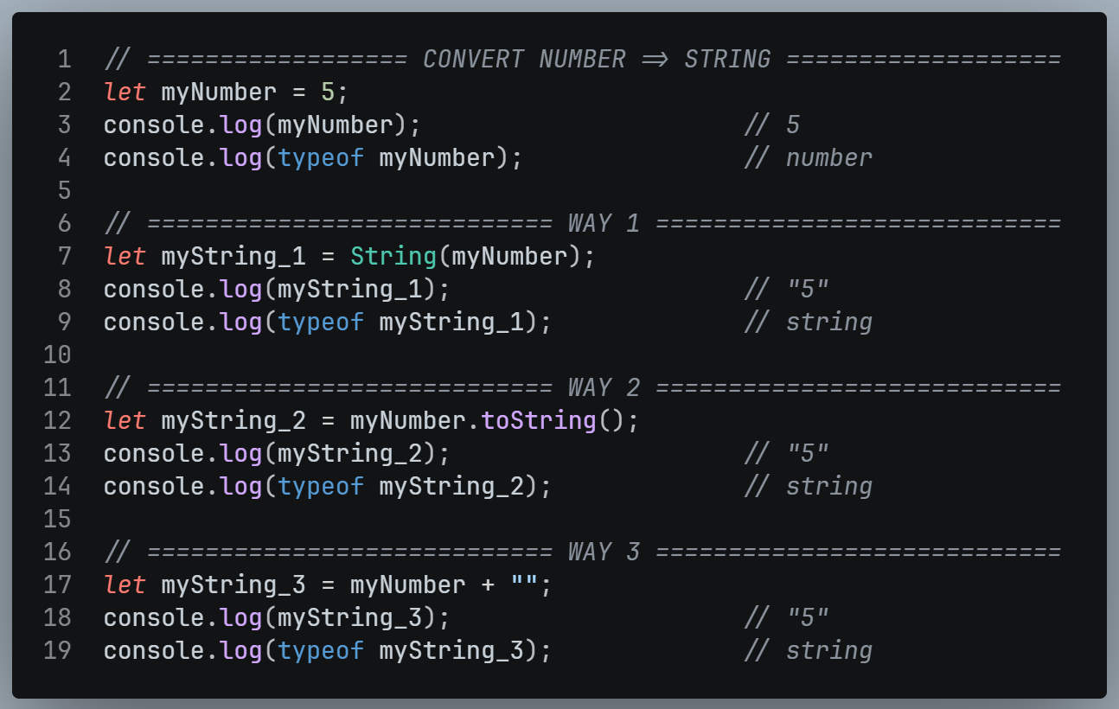

NaN == NaN is false ?
- NaN means Not a Number.
- It appears when we try to do an invalid math operation.
- Because NaN means Not a Number – and two invalid results can come from completely different operations.
- So, JavaScript says they are never equal.
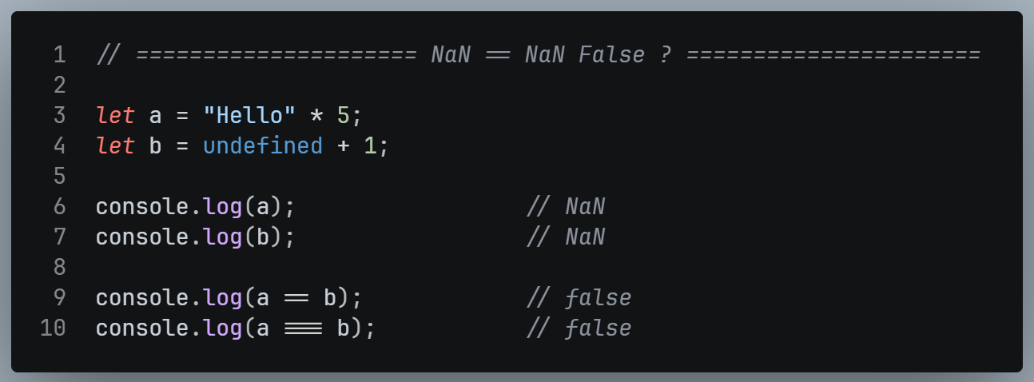

ParseInt & ParseFloat

ParseInt

Definition:
- parseInt is used to parse a string and convert it to an integer (Whole Number).
- parseInt is used for converting to integer and ignores anything after the decimal point.

Example:
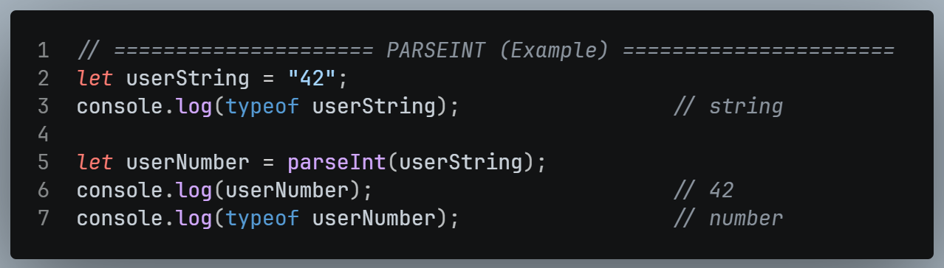

ParseFloat

Definition:
- parseFloat is used to parse a string and convert it to a floating-point number (decimal number).
- parseFloat is used for converting to floating-point numbers, preserving the decimal part.

Example:
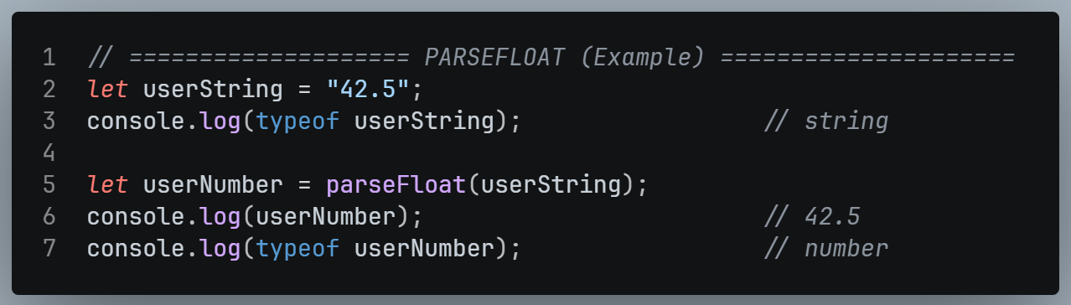

CHAPTER 04 – OPERATORS

Basics

Definition
- An operator is a symbol that carries a specific meaning and performs a specific operation (a specific tasks).
- Examples:
- + adds,
- - subtracts,
- * multiplies,
- / divides.

Operand
- Operand = the value an operator works on.
- In 2 + 3, the operator is + and the operands are 2 and 3

Unary vs Binary Operators
TYPE | OPERANDS NEEDED | EXAAMPLE
Unary | 1 | a++  --a
Binary | 2 | 2 + 3  a > b

Types of Operators
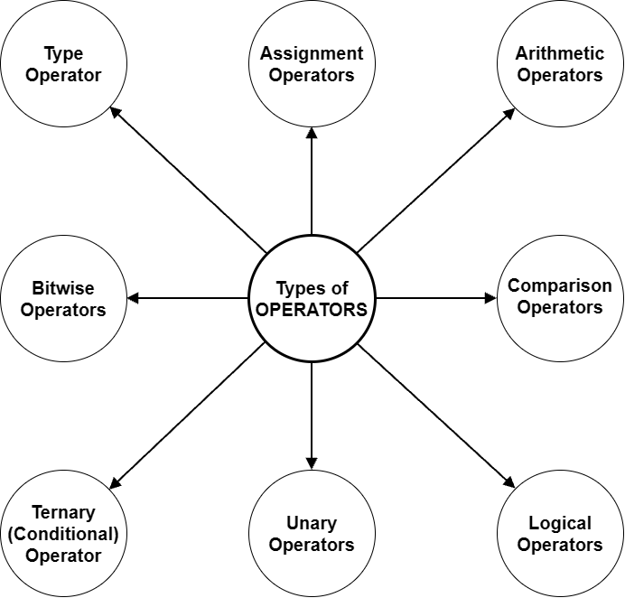

Assignment Operators

Definition
- The assignment operator (=) stores a value in a variable (in its memory location).
- They take the value on the right side of the operator and assign it to the variable on the left side.
- Let x = 10, y = 5
OPERATOR | EXAMPLE | SAME AS | RESULT
= | x = y | x = y | x = 5
+= | x += y | x = x + y | x = 15
-= | x -= y | x = x - y | x = 5
*= | x *= y | x = x * y | x = 50
**= | x **= y | x = x ** y | x = 100000
%= | x %= y | x = x % y | x = 0
/= | x /= y | x = x / y | x = 2

Example
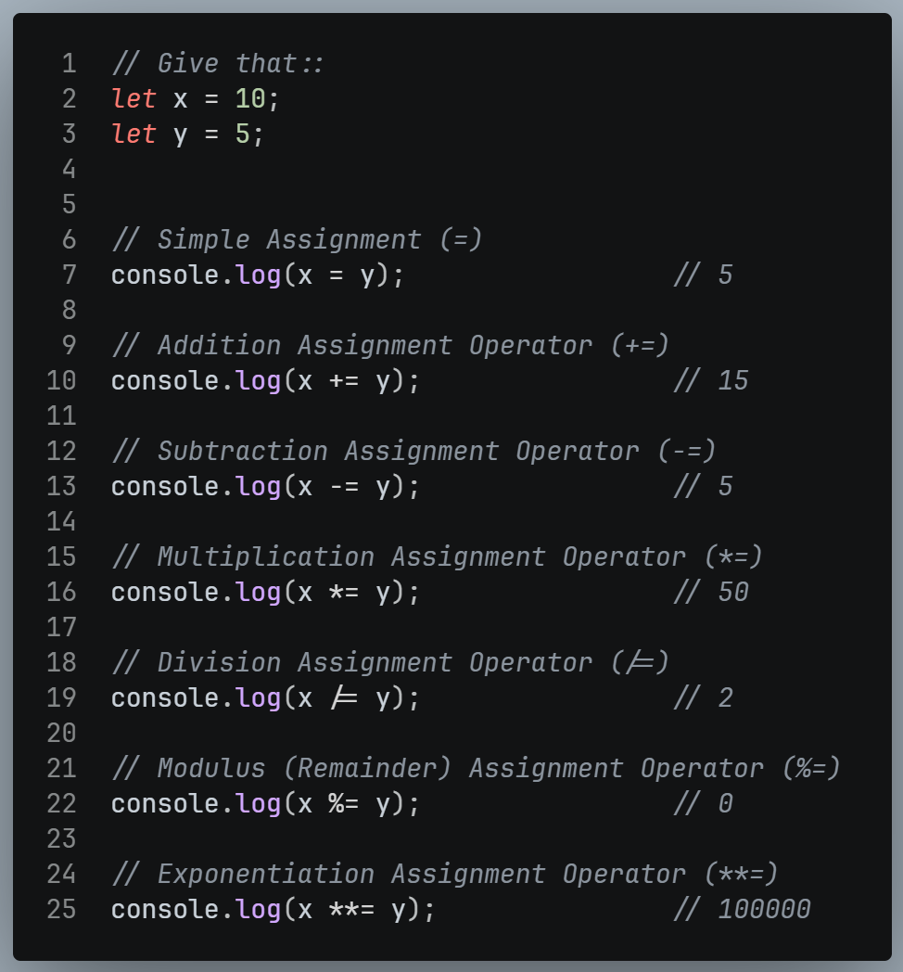

Arithmetic Operators
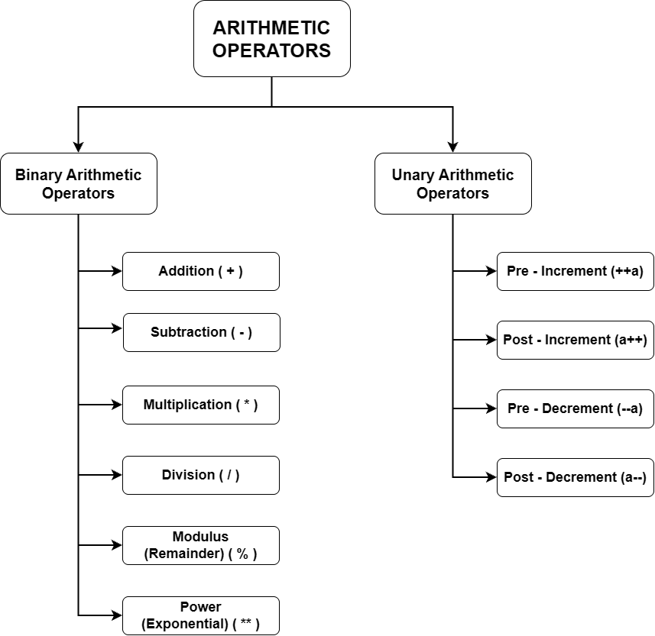

Definition
- Arithmetic Operators in programming language perform basic mathematical operations on variables or values.
- They include addition, subtraction, multiplication, division, modulus, etc.
OPERATOR | OPERATOR NAME
+ | Addition
- | Subtraction
* | Multiplication
/ | Division
% | Modulus (Remainder)
** | Exponential (Power)
++ | Increment
-- | Decrement

Example
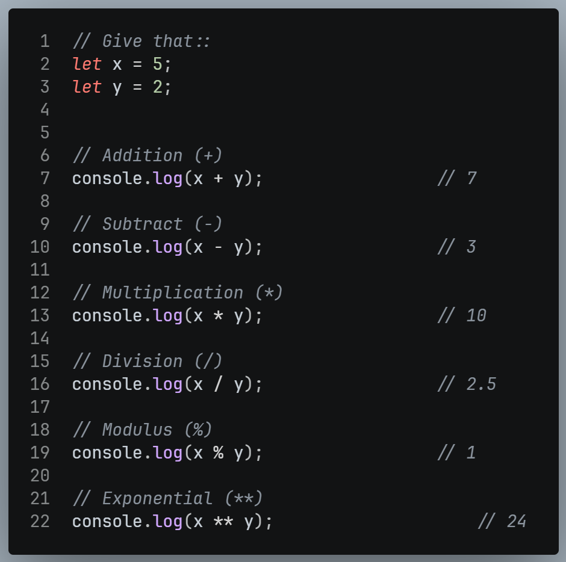
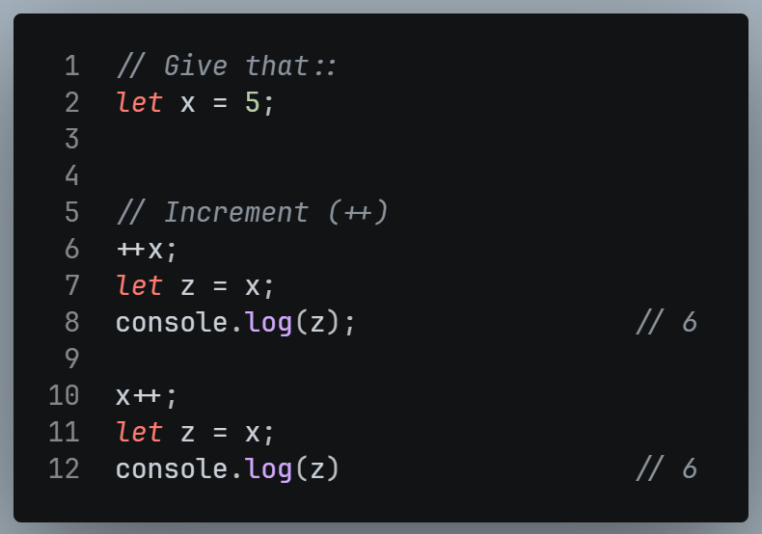
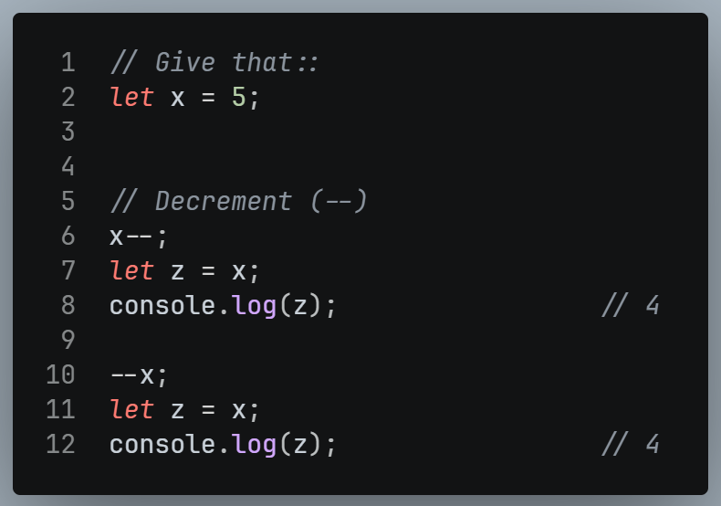

Comparison Operators

Definition
- Comparison operators compare two values.
- The result is always a boolean (true or false), never anything else.

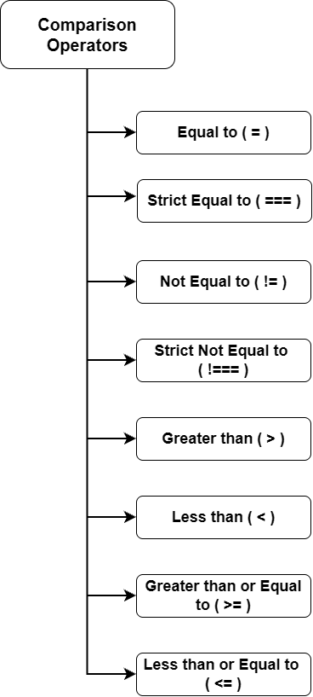
OPERATOR | DESCRIPTION
== | Equal to
=== | Strict Equal to
!= | Not Equal to
!== | Strictly Not Equal to
> | Greater than
< | Less than
>= | Greater than or Equal to
<= | Less than or Equal to

Example
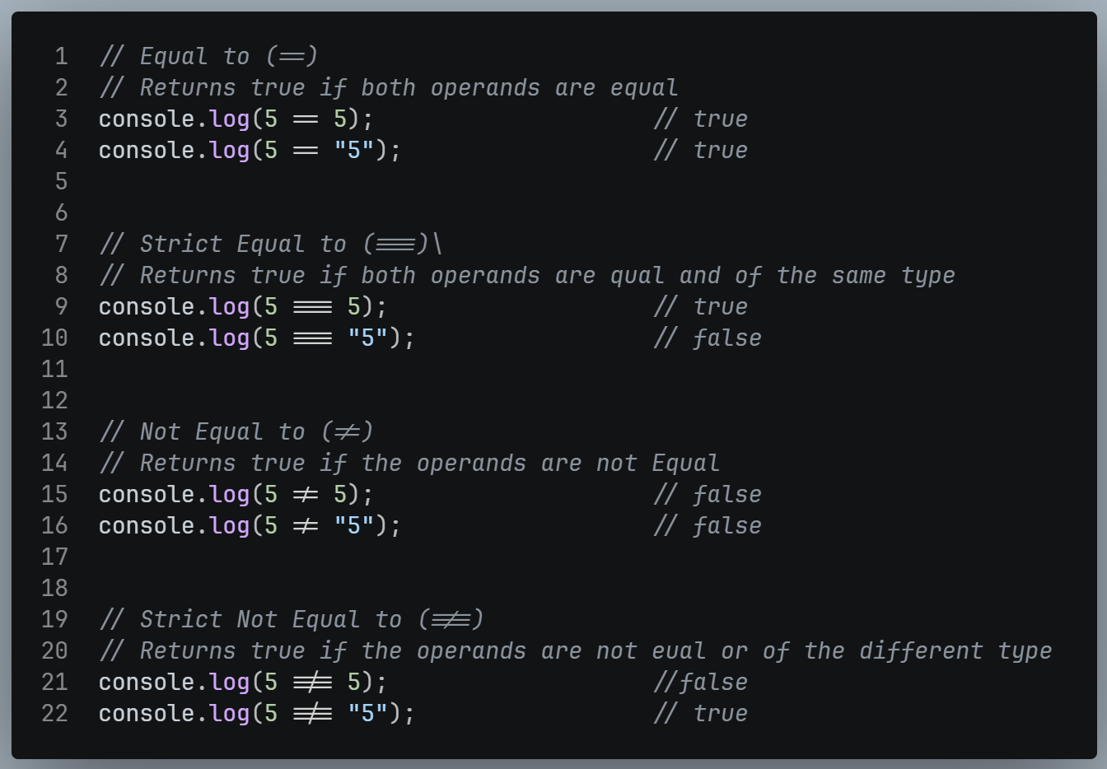

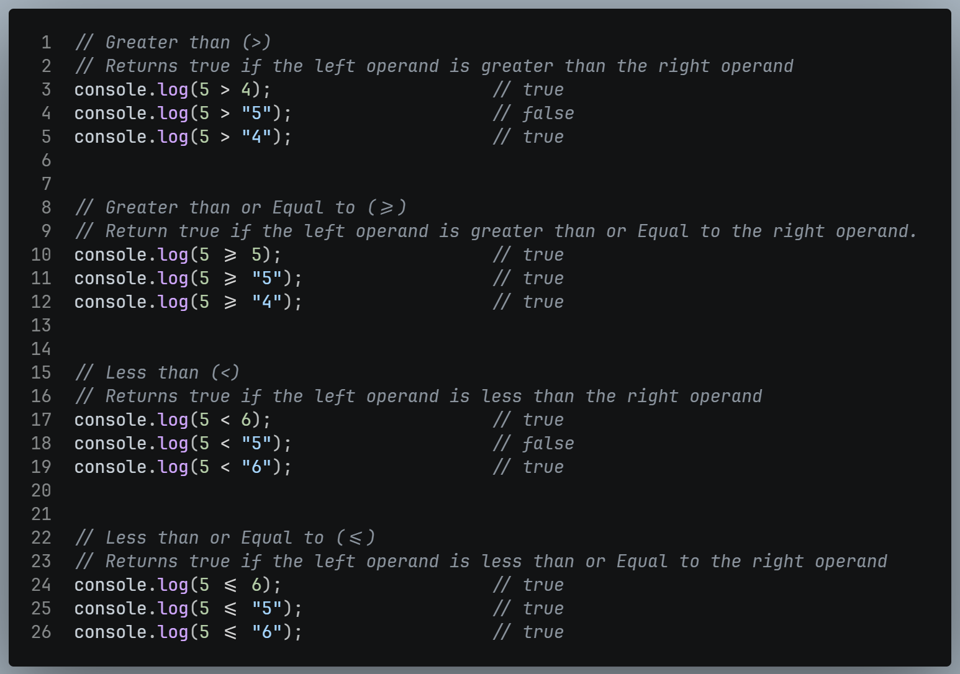

Logical Operators

Definition
- Logical Operators merge two or more conditions or expressions.
- The result is true or false

OPERATOR | NAME
&& | AND
|| | OR
! | NOT

Logical AND Operator |  |  |  | Logical OR Operator |  |  |  | Logical NOT Operator
X | Y | Result |  | X | Y | Result |  | X | Result
true | true | true |  | true | true | true |  | true | false
true | false | false |  | true | false | true |  | false | true
false | true | false |  | false | true | true
false | false | false |  | false | false | false

Example
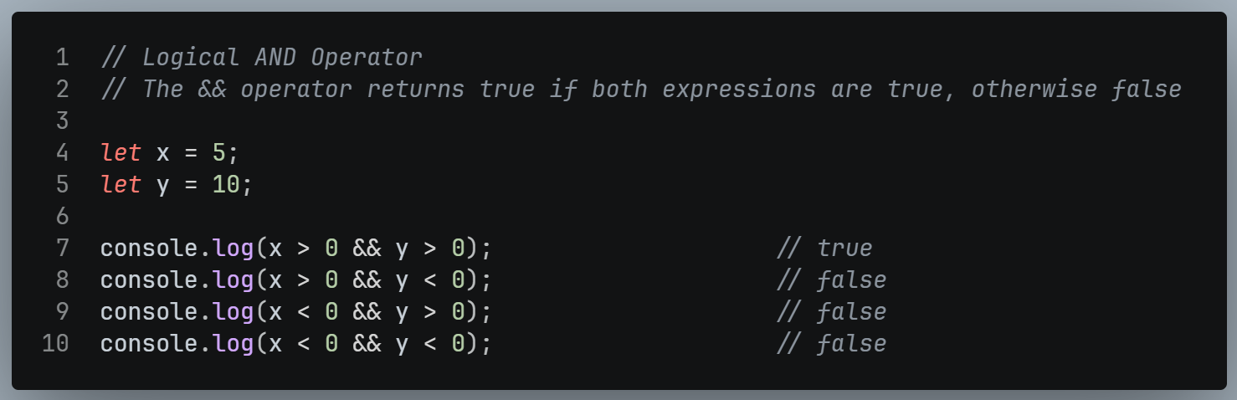
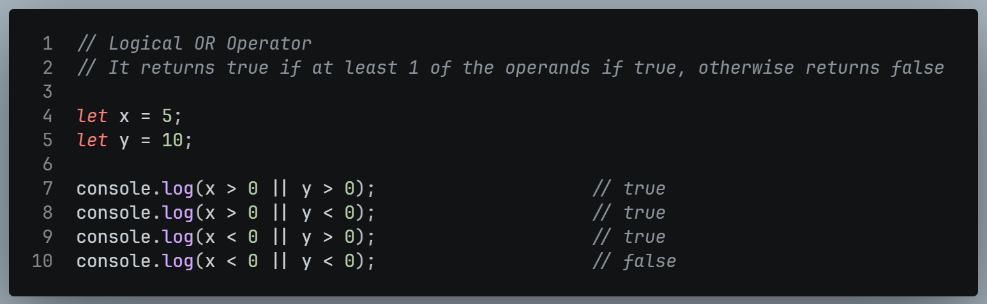
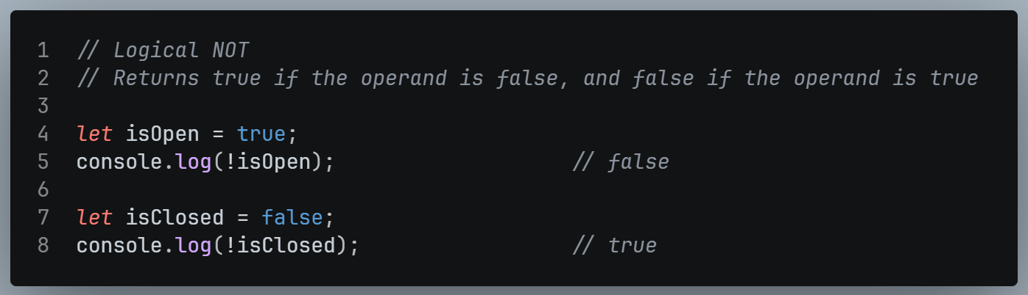

Unary Operators

Definition
- Unary Operators in JavaScript are operators that work with only one operand.
- They perform various operations such as negation, incrementing, decrementing, type conversion, and more.
OPERATOR | NAME | DESCRIPTION
+x | Unary Plus | Convert a value into a number.
-x | Unary Minus | Convert a value into a number and negate it.
++x | Increment (prefix) Operator | Adds 1 first, then uses value.
--x | Decrement (prefix) Operator | Subtract 1 first, then uses value.
x++ | Increment (Postfix) Operator | Uses value first, then adds 1
x-- | Decrement (postfix) Operator | Use value first, then subtract 1

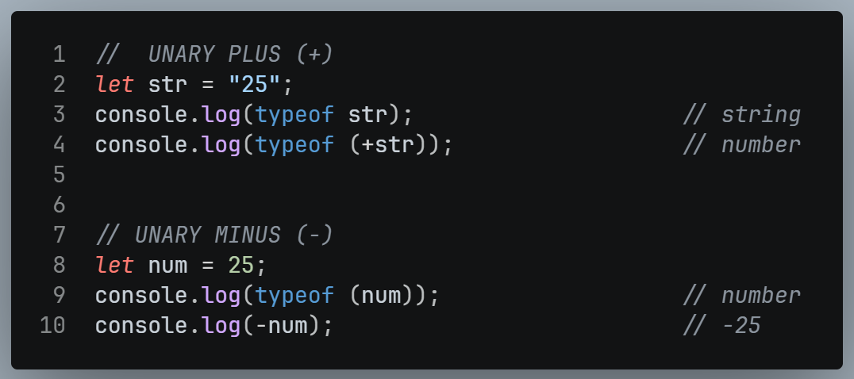
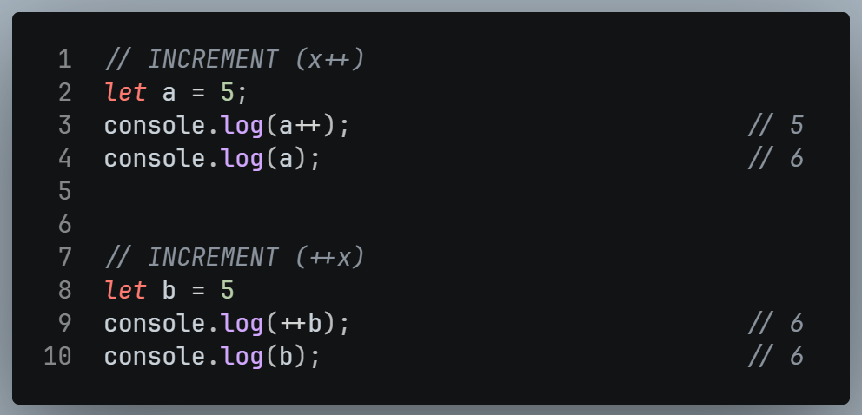
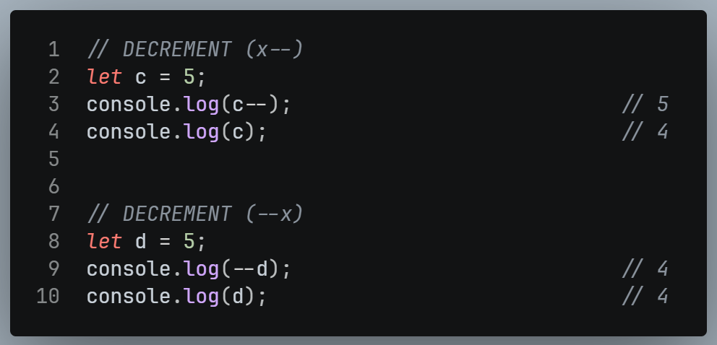

Ternary (Conditional) Operator

Definition
- The ternary operator is a shorthand for writing conditional if…else statement.
- It is called a ternary operator because it takes 3 operands.

Syntax
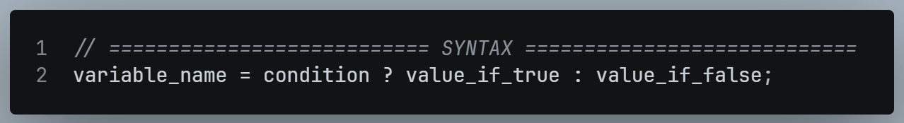
- ? and : are the parts of the syntax.
- If the condition is true, the first value (value_If_true) is returned.
- If the condition is false, the second value (value_if_false) is returned
- The result is usually stored in the variable (variable_name).

Example
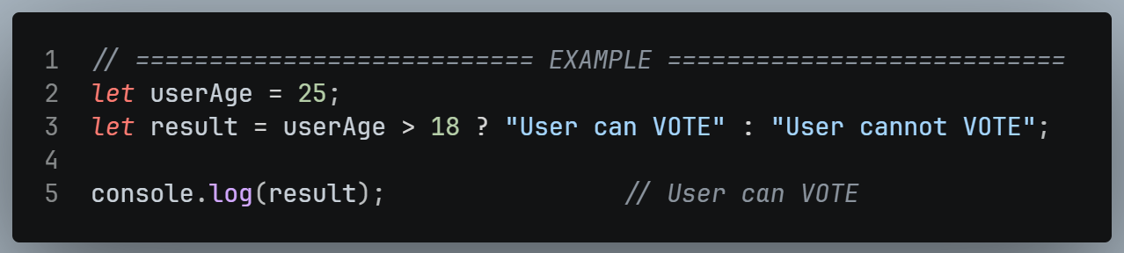
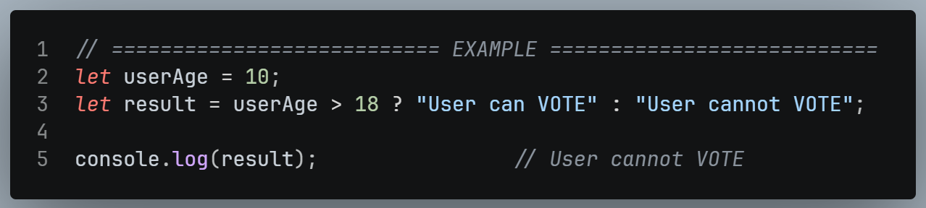

Bitwise Operators

Definition
- A computer understands only bits (0s and 1s).
- Bitwise operators perform operations on the binary representation (bits) of numbers.

OPERATOR | OPERATOR NAME
& | Bitwise AND
| | Bitwise OR
~ | Bitwise NOT
^ | Bitwise XOR
<< | Left Shift
>> | Right Shift

A | B | A & B | A | B | A ^ B
0 | 0 | 0 | 0 | 0
0 | 1 | 0 | 1 | 1
1 | 0 | 0 | 1 | 1
1 | 1 | 1 | 1 | 0

- AND (&)
- Result is 1 only when both bits are 1.
- Otherwise, it is 0.
- OR (|)
- Result is 0 only when both bits are 0.
- Otherwise, it is 1
- NOT (~)
- Flips every bit (0 becomes 1, 1 becomes 0)
- XOR (^)
- Gives 0 is the two bits are the same, 1 if they are different.
- Two identical numbers cancel out to 0.
- Left Shift (<<)
- This is a zero-fill left shift.
- One or more zeros bits are pushed in from the right, and the leftmost bits fall off.
- Right Shift (>>)
- This is a zero-fill right shift.
- One or more zeros bits are pushed in from the left, and the rightmost bits fall off.

Examples
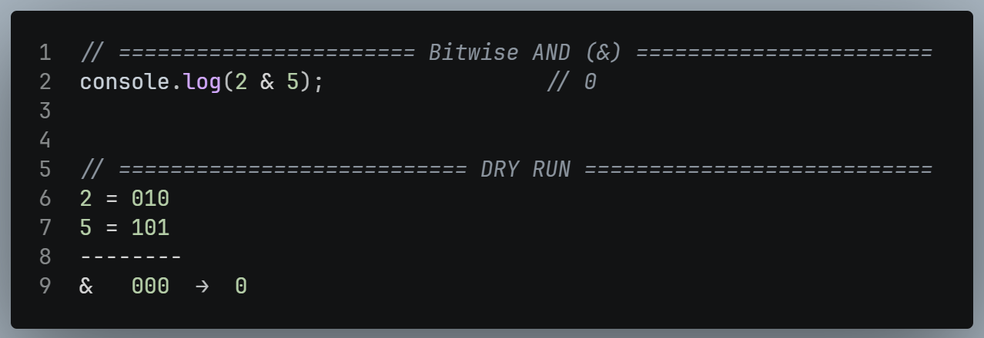
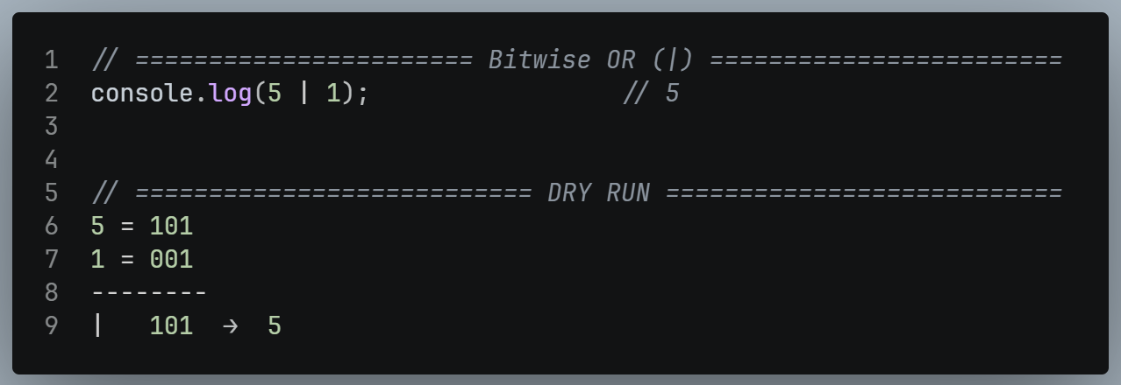
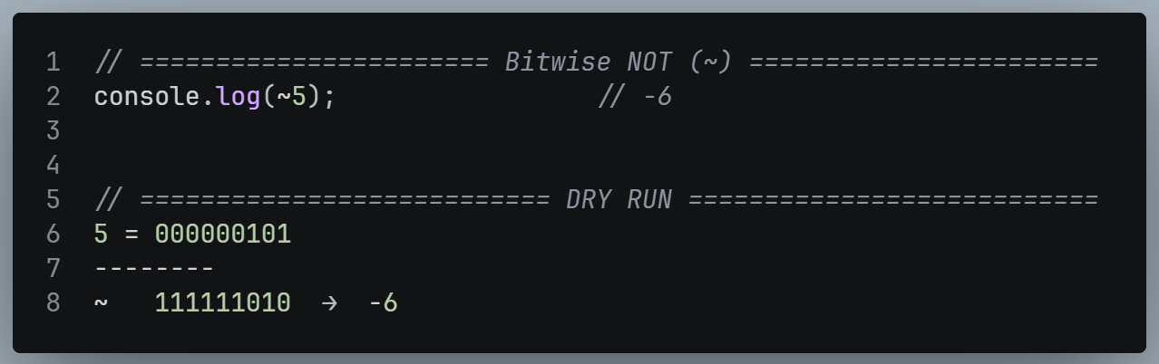
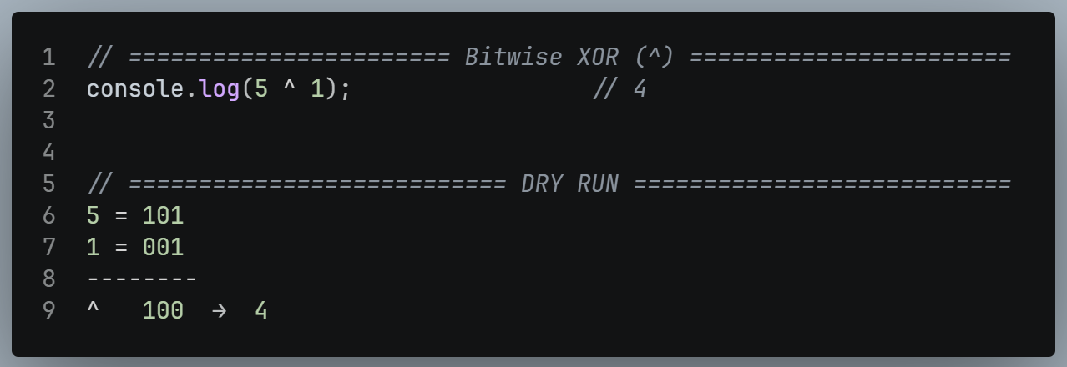

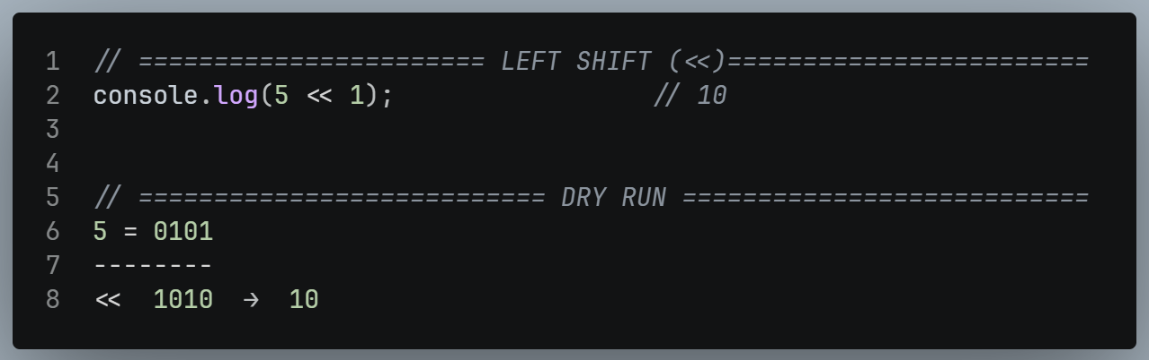
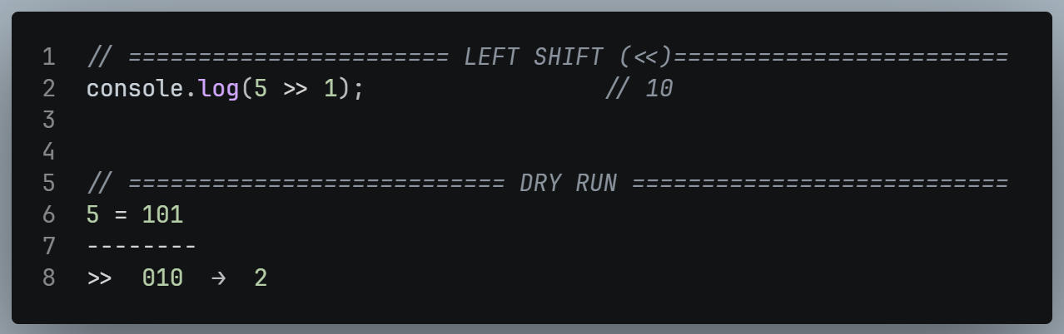

Working with Non-Booleans (Truthy and Falsy)

Why it matters
- Logical operators can also be used with values that are not true or false (numbers, strings, and so on).
- To understand the result, JS treats every value as either falsy or truthy.

Falsy Values
FALSY VALUES | MEANING
false | Boolean false
0 | Zero
undefined | Not Assigned
null | Intentionally empty
NaN | Not a Number
“ “ | Empty String
-O and On | BigInt Zero

Truthy Values
- Anything that is not falsy is truthy.
- Example:
- 7, 18, “Hello”).

Examples
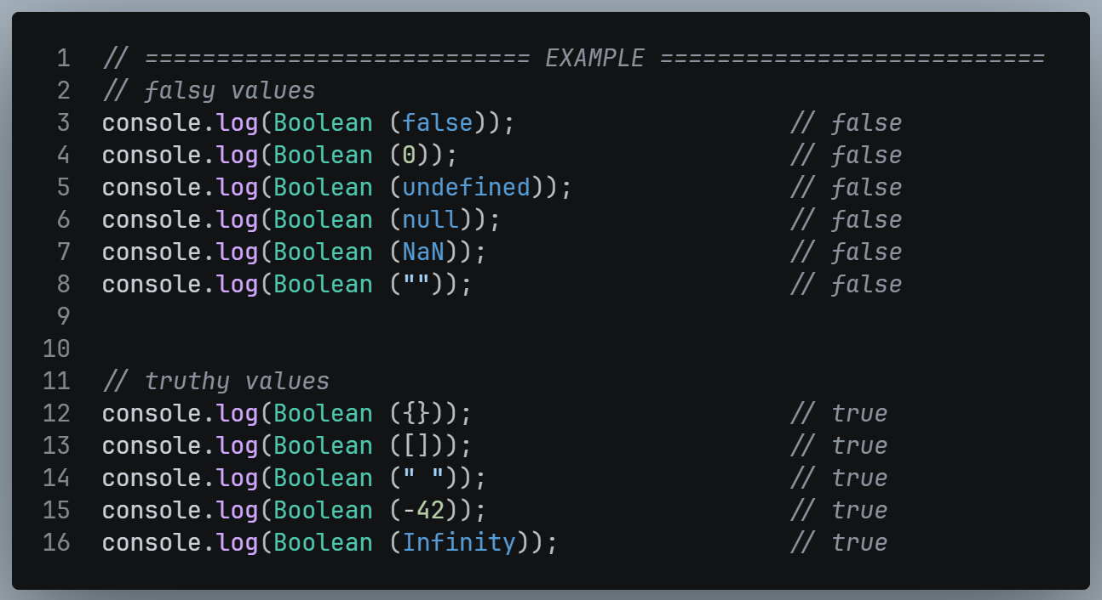

Short-Circuiting

Definition:
- Evaluation stops as soon as the final result is already known.
- The remaining conditions are not checked.
- In ||, evaluation stops at the first truthy values.
- In false || 7 || 11 || 18, false is falsy so JS moves on.
- 7 is truthy, so the result is 7 and 11 and 18 are never checked.

INTERVIEW TIP
- Short-circuiting is a commonly asked concept.
- In ||, evaluate stops at the first truthy value.

EXTRA NOTE
- For &&, evaluate stops at the first falsy value.
- If all are truthy, the last value is returned.
- Example:
- true && “hello”, not true.
- In the same way, || returns the actual value that decided the result, not simply true.

CHAPTER 05 – CONDITIONAL STATEMENTS
(Control Flow)

Conditional Statements (Control Flow)
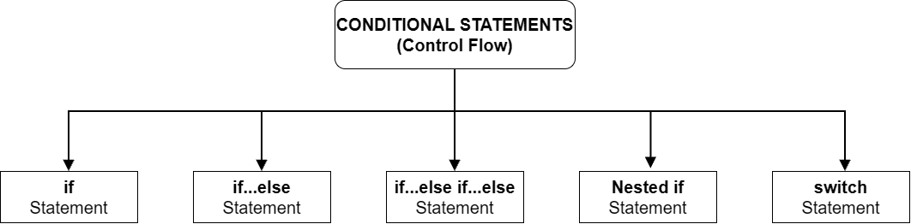

Definition
- Conditionals decides which block of code runs, based on whether a condition is true or false.
- This is also called control flow.

If Statement

Definition
- Runs a block only is the condition is true.
- If the condition is false, the block is skipped.

Syntax
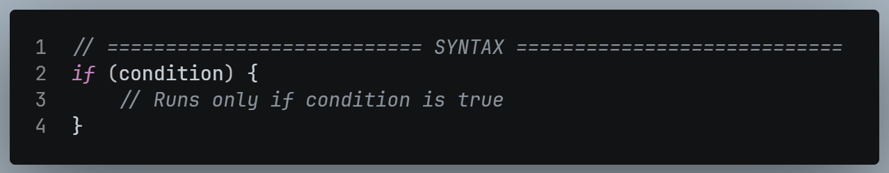

Example
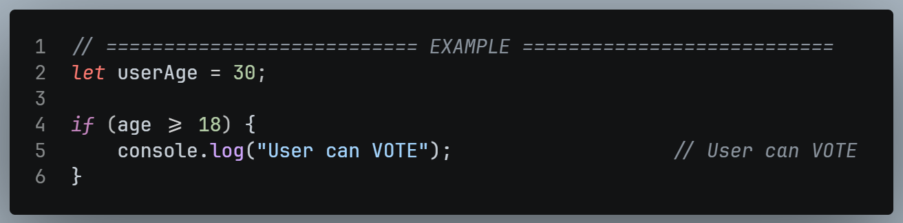
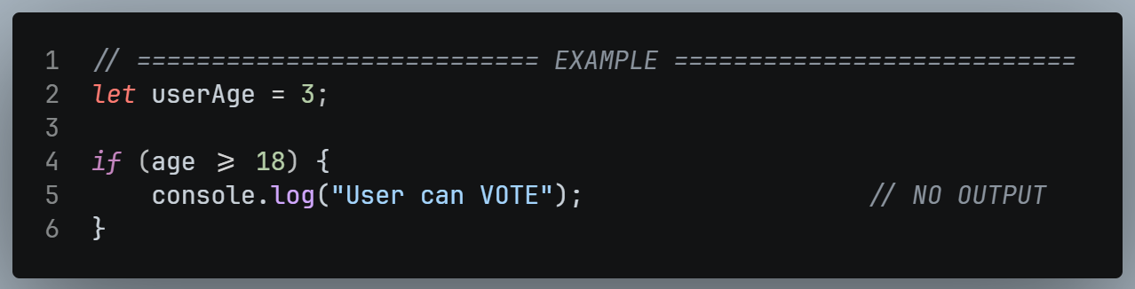

If…else Statement

Definition
- Runs one block if the condition is true, and other block is it is false.

Syntax
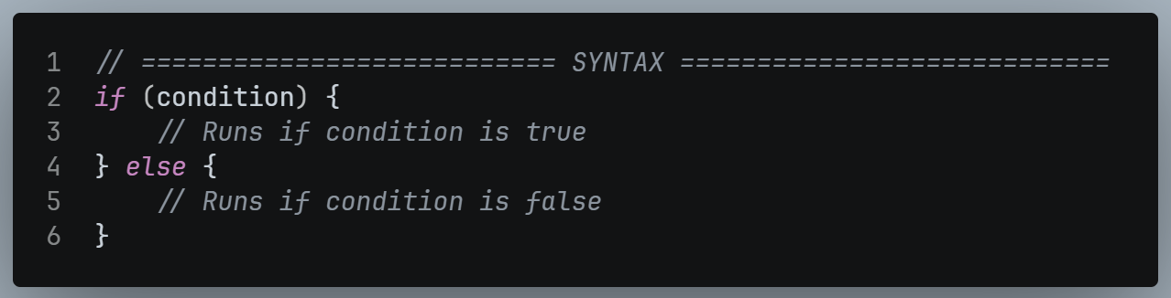

Example
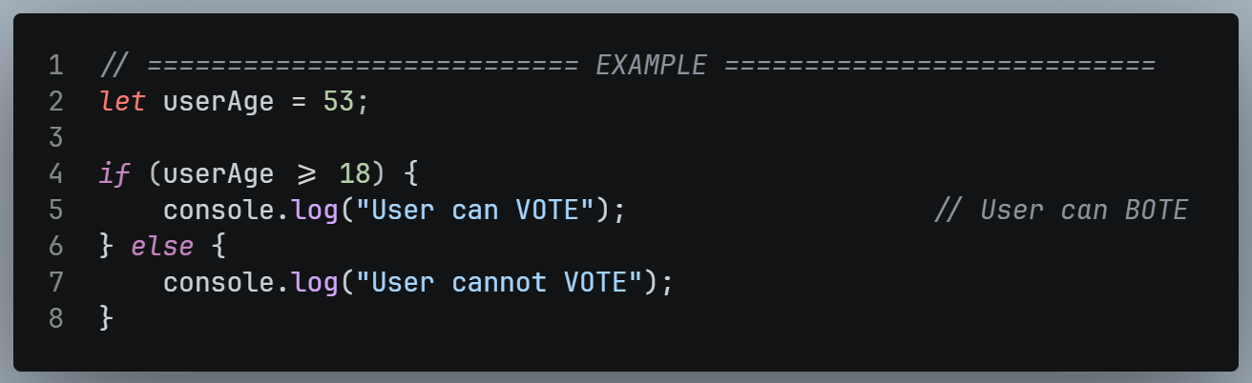

If…else if…else Statement

Definition
- Used to check multiple conditions one after another.

Syntax
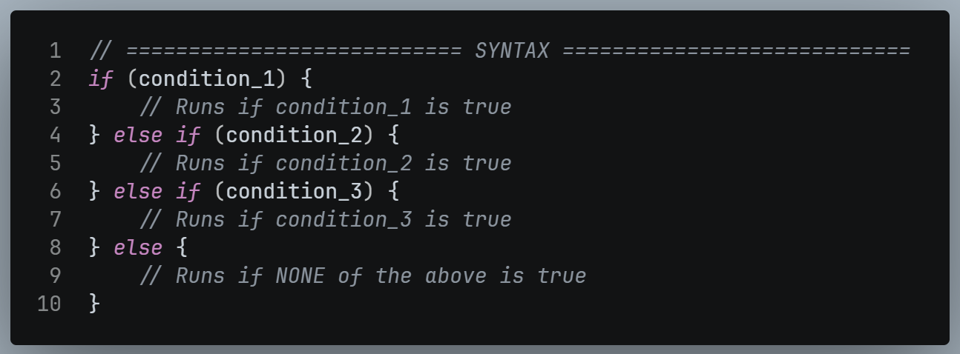

Rules:
- if is mandatory and must come first.
- We can add any number of else if block. Each must have its own condition.
- else at the end is optional.
- As soon as one condition is true, its block runs and JS exits the whole structure. The remaining condition are not checked.
- If no condition is true and else exists, the else block always runs.

Example
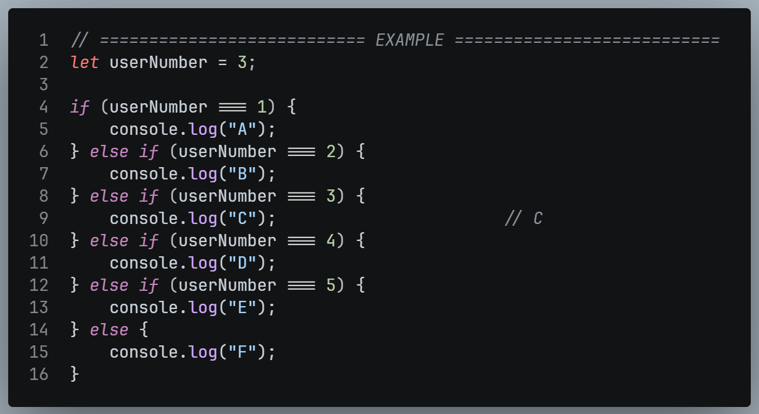

Nested if

Definition
- An if (or if-else) placed inside another if…else if block.

Example
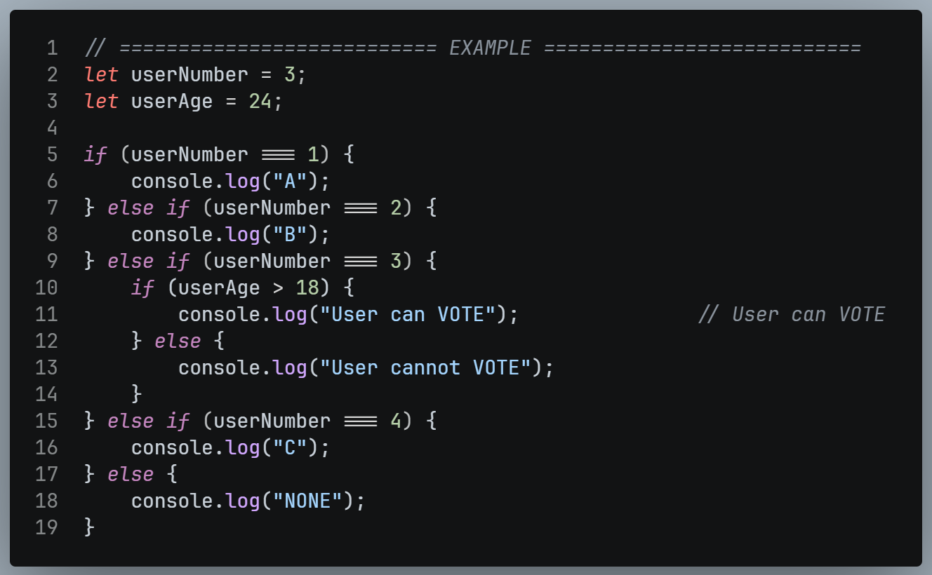

switch Statement

Definition
- A cleaner way to compare 1 value against many fixed cases.
- It is easier to read than many else if block.

Syntax
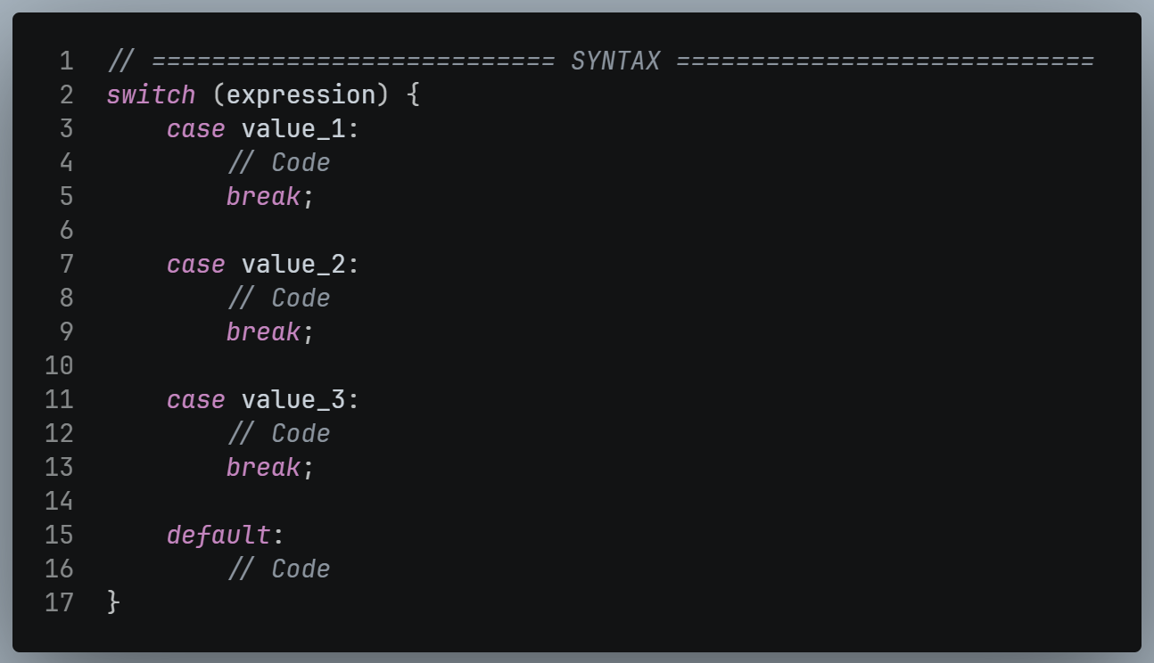

How it works:
- The expression is evaluated and its result is compared with each case value.
- When a case matches, its code runs.
- break exits the switch.
- default runs if no case matches, and it is optional.

Example
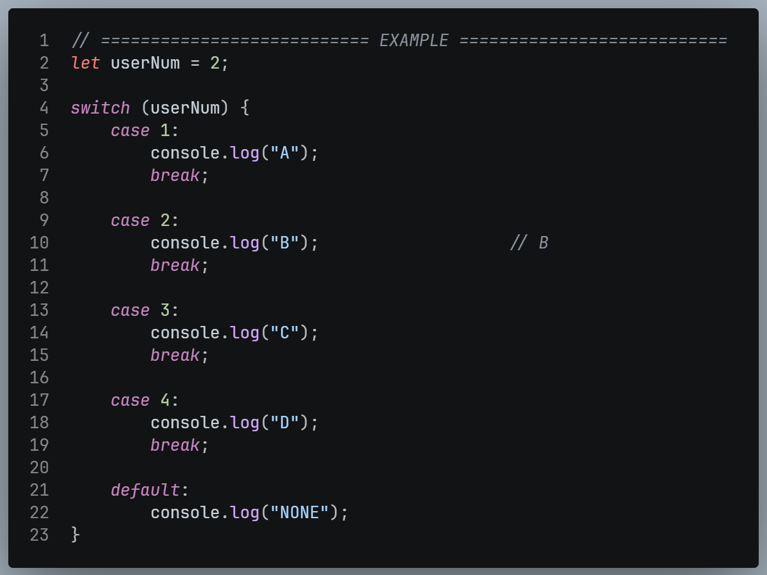

What happens without break ?
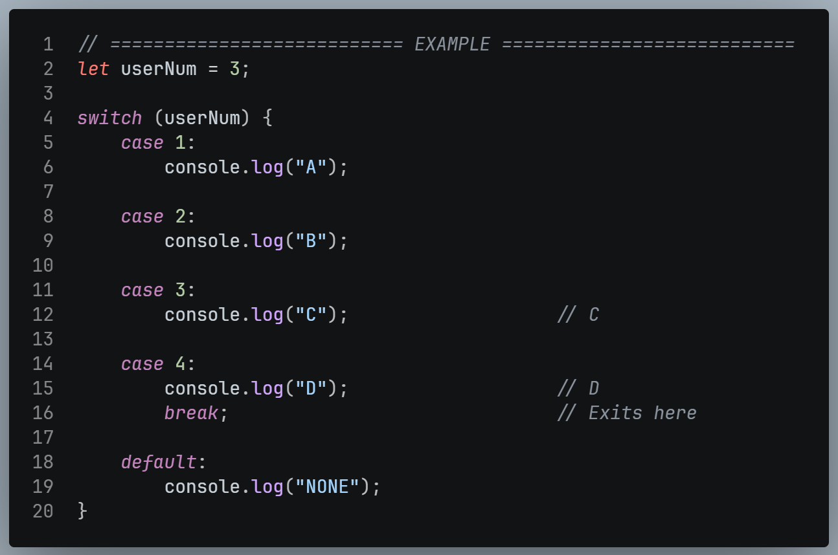

IMPORTANT:
- Always write break after each case, or the code will “fall through” into the cases below.
- The last default does not need a break.

If-else if VS switch
FEATURE | IF…ELSE IF…ELSE | SWITCH
Final block | else (optional) | default (Optional)
Exit after match | Automatic | Needs break
Best for | Complex conditions or range | One value compared with many fixed values
Readability with many cases | Lower | Higher

CHAPTER 06 – LOOPS

Loops

Definition
- A loop executes the same set of instructions repeatedly until a condition stops it.
- Use a loop whenever one task must be performed again and again.

The Problem
- Suppose we want to print Shubham once, then 5 more times, then 12 more times, then 24 more times.
- Without loops, we copy-paste console.log(“Shubham”) again and again.

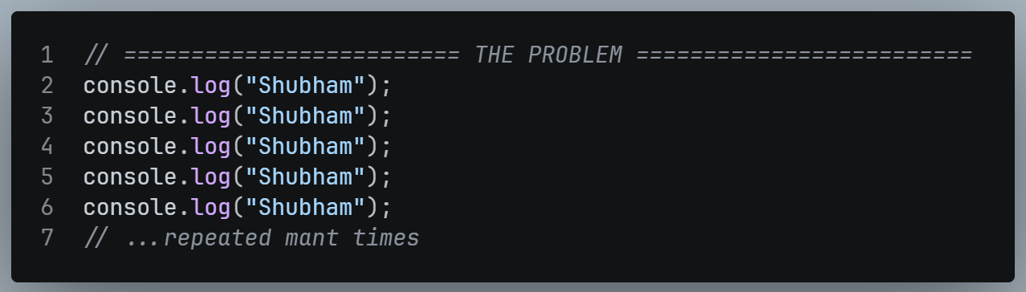

Issues with duplicating code
- ❌ Bulky code:
- The same line is repeated many times.
- ❌ Not maintainable:
- If the name changes from “Shubham” to “Singh”, we must edit every single line.
- ❌ Bug-prone:
- One bug is copied into every duplicate line.

Types of Loops
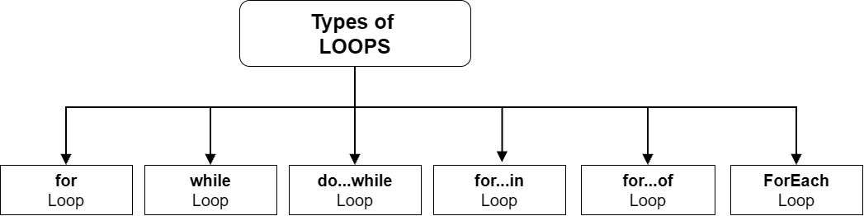

NOTE:
- All loops do the same job (repeat code).
- Only the syntax differs.

Iteration

Definition:
- One full pass through the loop body for one particular value of the loop variable.

Example:
- With i = 5, the processing is the 1st iteration.
- With i = 4, it is the 2nd Iteration, and so on.

for Loop

Syntax
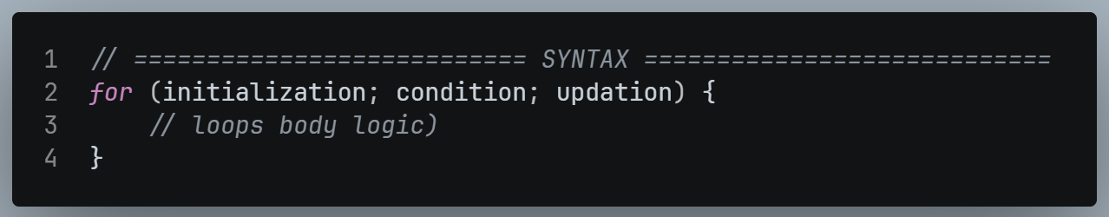
PART | PURPOSE
Initialization | Create and set the loop variable (runs once, at the start).
Condition | - The loop runs while this true.  - When it becomes false, the loop stops.
Updation | Changes the loop variable after each iteration.
Loop Body | The code that gets repeated

IMPORTANT:
- The condition must eventually become false.
- Otherwise, the loop never ends (an infinite loop).

Execution Order
- Initialization (once)
- Check the condition. If it is false, exit the loop.
- Run the body.
- Run the Updation.
- Go back to Step 2
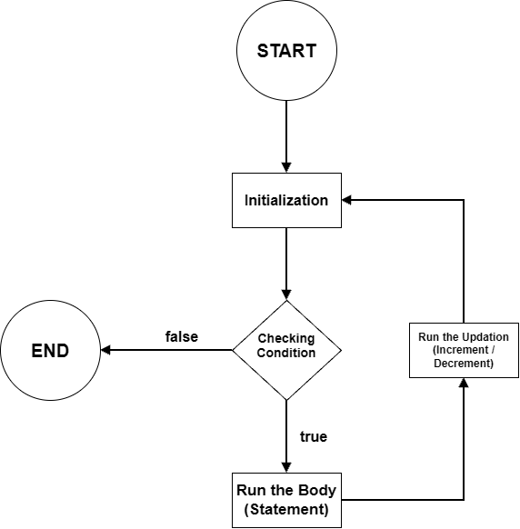

Example 1: Print “Shubham” 10 times
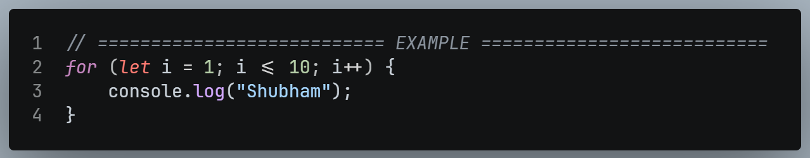

Updation: 3 equivalent ways
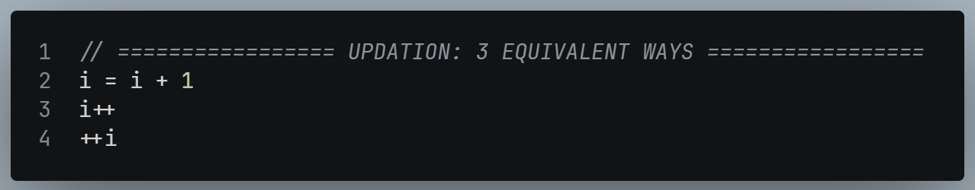

Example 2: Print counting 1 to 5
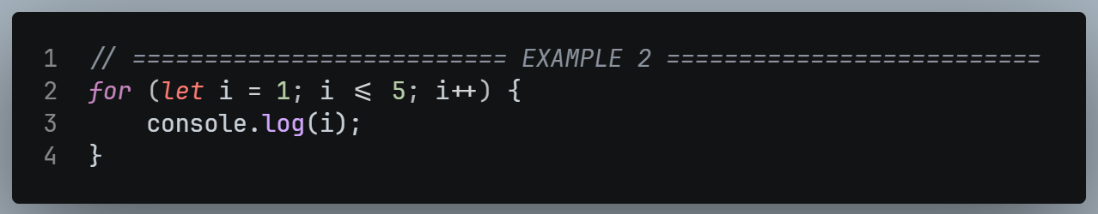

Example 3: Reverse counting 5 to 1
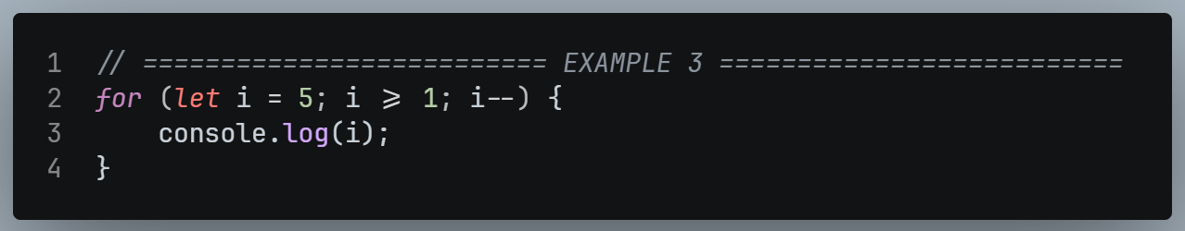

Valid vs Invalid
- ✅ for (let i = 1; i <= 10; i++)
- ❌ for (int i = 1; i <= 10; i++) : int is C / C++ / Java syntax. In JS, use let

break Keyword

Definition
- As soon as break is reached, JS exits the loop immediately, even if the condition is still true.

Syntax
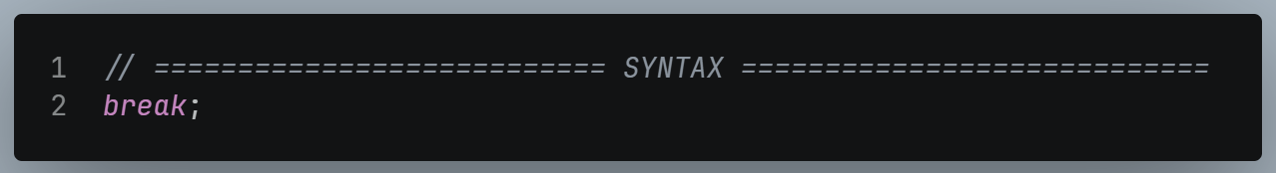

Example
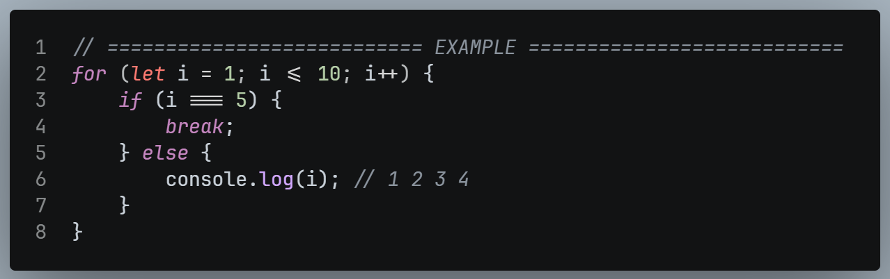

continue Keyword

Definition
- continue skips the rest of the current iteration and jump to the next iteration.

Syntax
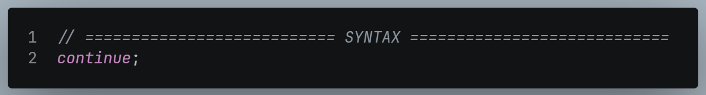

Example
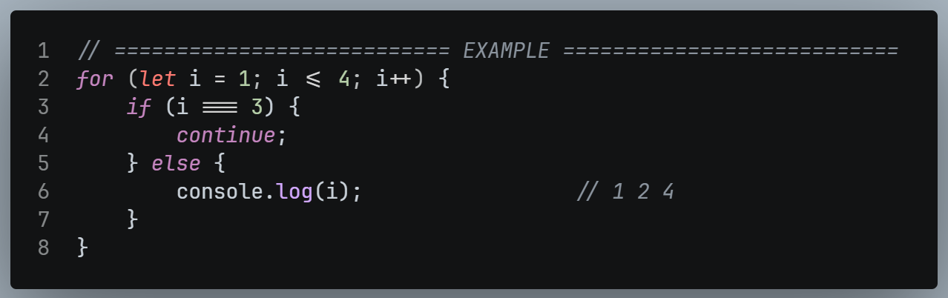

break vs continue
 | break | continue
Effect | Exits the whole loop | Skipps only the current iteration
Loop afterwards | Ends | Continue with the next iteration.

while Loop

Definition
- A loop that keeps running as long as the condition is true.
- Initialization comes before the loop, and Updation is written inside the loop.

Syntax
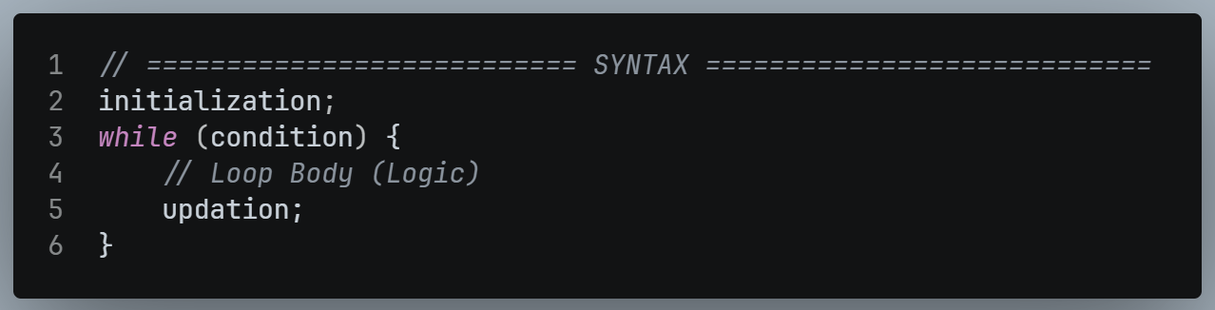

Converting a for loop to a while loop
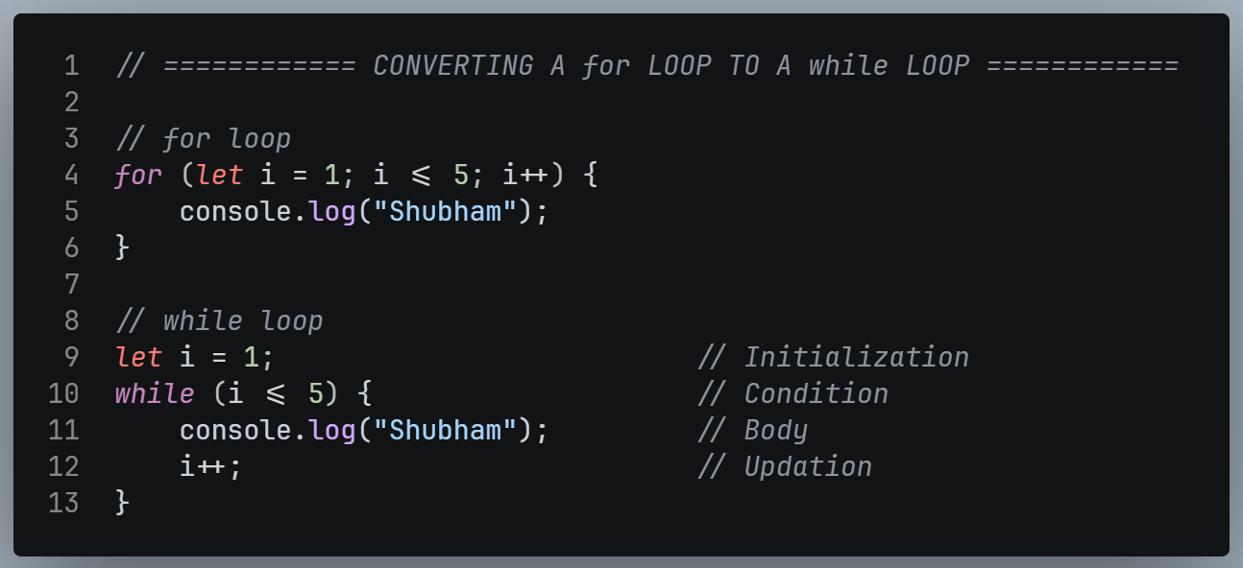

Example: Counting 1 to 5
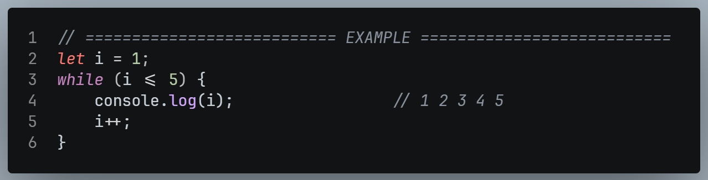

Example: Reverse counting 5 to 1
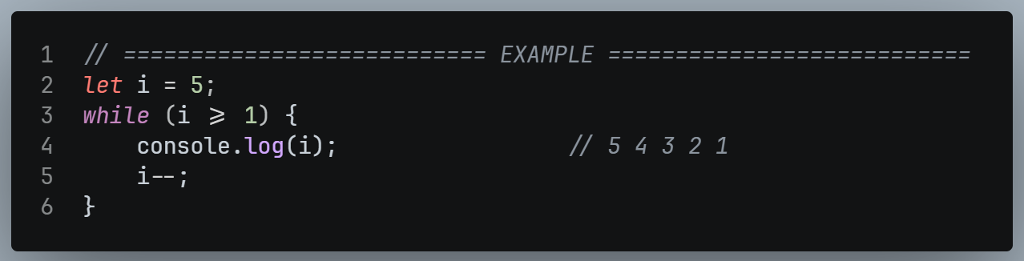

break in a while loop
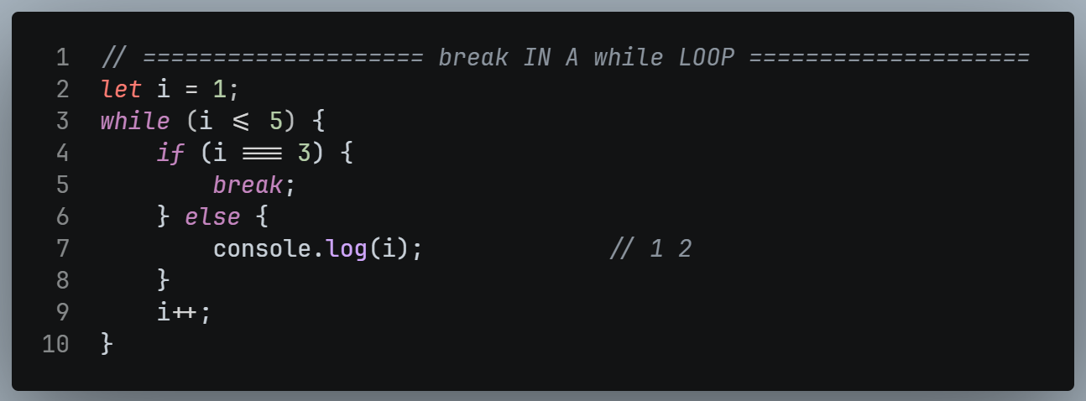

continue in a while loop and the infinite loop trap

❌ Wrong version (infinite loop)

