**Hotel Management System**

### A Project Report

### *Submitted by:*

**Shubham Kumar Verma (21535028)**

### MASTER OF TECHONOLOGY

### IN

**COMPUTER SCIENCE AND ENGINEERING**

at

**IIT ROORKEE**

**October 7, 2021**

## DECLARATION

I hereby declare that the project entitled “**Hotel Management System**” submitted for the M. Tech. Project Lab is my original work.

### Signature of the Student

**Place:** Lucknow

**Date:**07/10/2021

# CERTIFICATE

This is to certify that the project titled “**Hotel Management System**” is the bona fide work carried out by **SHUBHAM KUMAR VERMA**, a student of **M Tech (CSE) of IIT ROORKEE**

LUCKNOW (INDIA)during the academic year 2021-22.

### Signature of the Guide

Place: Lucknow

Date: 07/10/ 2021

**Abstract**

With this project Hotel Management System, I tried to implement the basic functionalities of a typical hotel management software. Along with this I have satisfied the constraints as given in the problem statement of the sheet. Users with this software can add employees, hotel staff and rooms. User of this software can manage the hotel via reservation desk available under management tab.

**Introduction**

The project, Hotel Management System is a desktop-based application that allows the hotel manager to handle all hotel activities online. Interactive GUI and the ability to manage various rooms, employees, drivers and customers make this system very flexible and convenient.

The application of the Hotel Management System bears the following functions to use by the Administrator:

* Add a new Room
* Add an Employee
* Add a new Customer
* Check room status
* Check all employees’ details
* Check all Customers’ details
* Update room status
* Update check status etc.

1. **Admin**: Admin can add a new room, a new employee and a new driver.

1. **Receptionist**: Receptionist can add a new customer and allocate rooms, can check all room details, customers details, employee details, search for a particular room etc.

**Software Requirements**

**User Interface:**

The User interface required to be developed for the system should be user friendly and attractive.

There are two sets of java APIs for graphics programming:

AWT (Abstract Windowing Toolkit) and Swing.

* AWT API was introduced in JDK 1.0. Most of the AWT components have become obsolete and should be replaced by newer Swing components.

* Swing API, a much more comprehensive set of graphics libraries that enhances the AWT, was introduced as part of Java Foundation Classes (JFC) after the release of JDK 1.1. JFC consists of Swing, Java2D, Accessibility, Internationalization, and Pluggable Look-and-Feel Support APIs. JFC was an add-on to JDK 1.1 but has been integrated into core Java since JDK 1.2.

**Software Interfaces**

Programming Language: -   Java

Back End Tool             : - MySQL 5.5 command line client

**Database Table Created**

**Database Name: -** projecthms

**Tables Created:** -

1. **Login Table**

Sql query: -

create table login( username varchar(30),password varchar(30),

primary key(username));

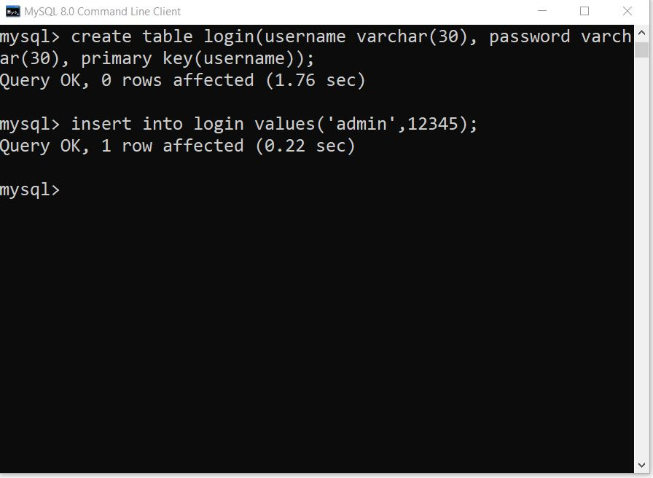

1. **Employee Table**

Sql query: -

create table employee( name varchar(30),age varchar(10),gender varchar(30),job varchar(30),salary varchar(30), phone varchar(30),aadhar varchar(30), email varchar(40),primary key(aadhar));

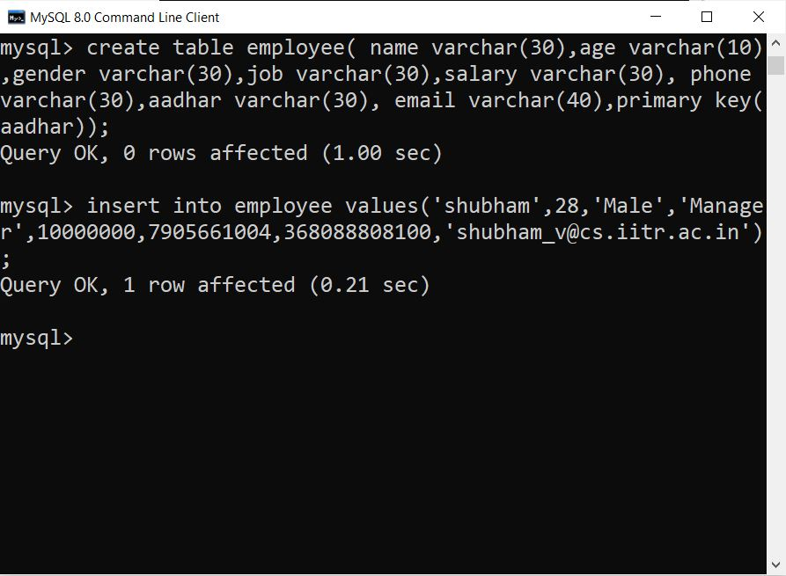

1. **Customer Table: -**

Sql Query: - create table customer (id varchar (30), number varchar (30), name varchar (30), gender varchar (30), country varchar (30), room_number varchar (30), status varchar (30), deposit varchar (30), primary key(number));

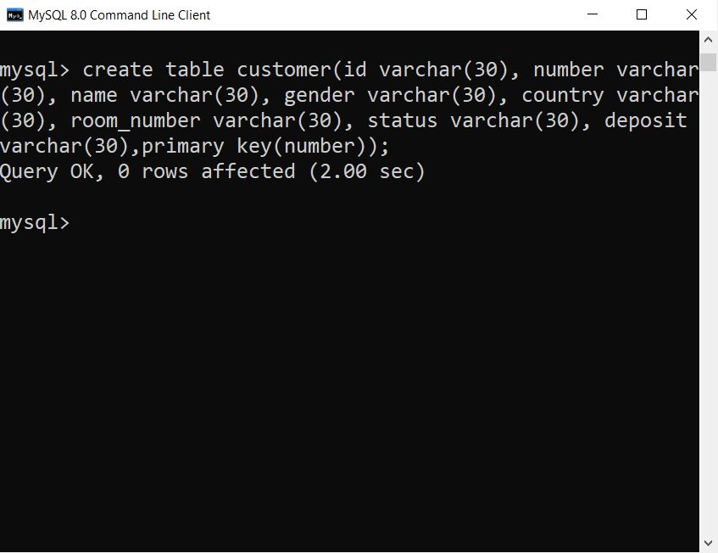

4**.Room Table**

Sql query:- create table room(room_number varchar(20), availability varchar(20), clean_status varchar(20), price varchar(20), bed_type varchar(30),primary key(room_number));

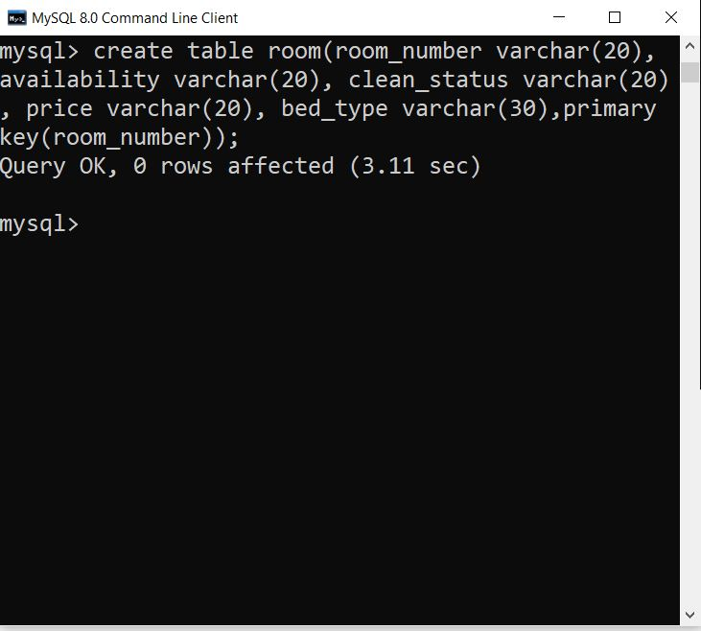

1. **Checkin Table: -**

Sql query: - CREATE TABLE checkin (

mobile VARCHAR(15),

RoomType VARCHAR(10),

RoomNo VARCHAR(5),

checkin_date CHAR(10),

checkout_date CHAR(10),

FOREIGN KEY (Mobile) REFERENCES customer(number) ON DELETE CASCADE ON UPDATE CASCADE,

FOREIGN KEY (Roomno) REFERENCES room(room_number) ON DELETE SET NULL ON UPDATE CASCADE

);

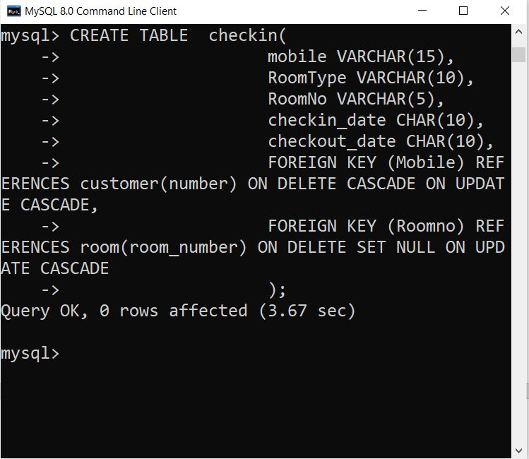

1. **Payment Table**

Sql query: - CREATE TABLE IF NOT EXISTS payment (

mobile VARCHAR(15),

pay VARCHAR(10) NOT NULL,

FOREIGN KEY (mobile) REFERENCES customer(number) ON DELETE CASCADE ON UPDATE CASCADE

);

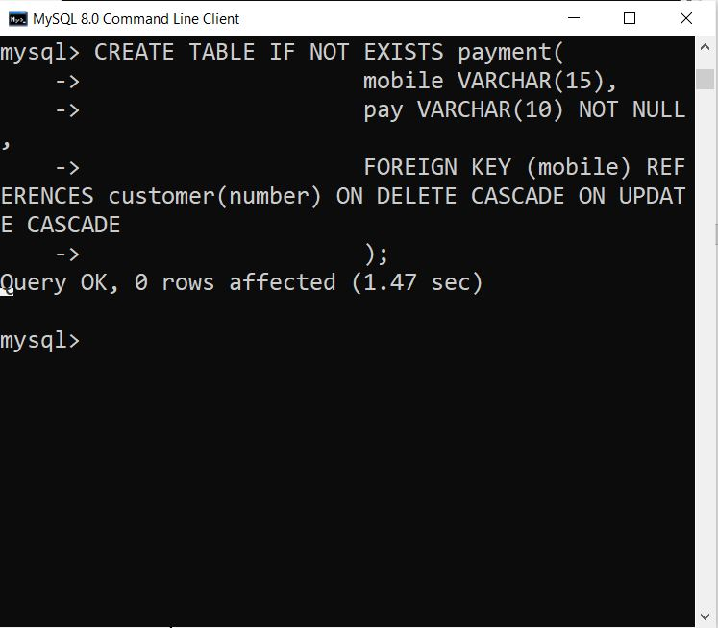

1. **Department Table**

Sql Query: - create table department (department varchar (30), budget varchar (30), primary key(department));

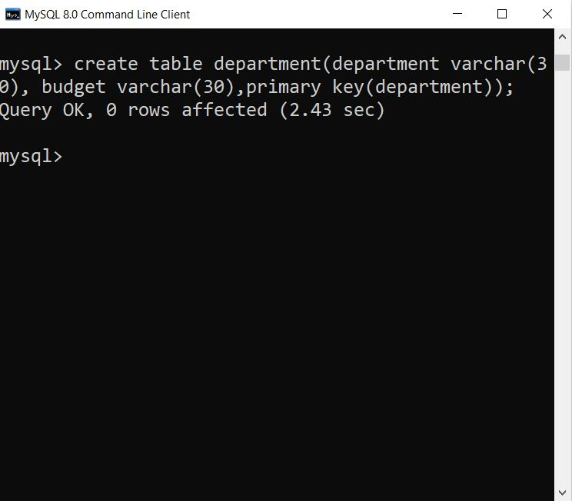



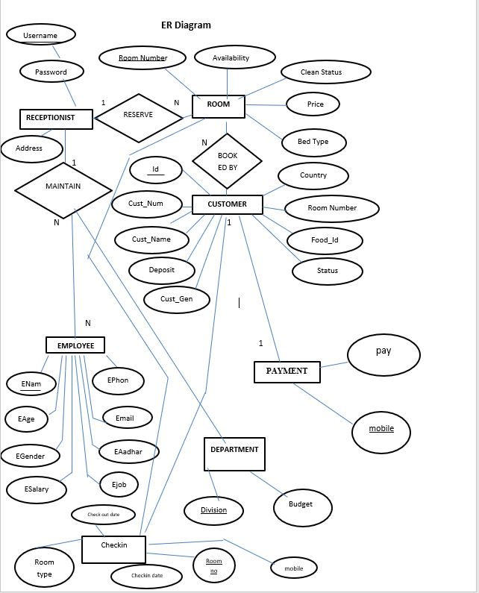

**ER Diagram Image (file provided with report for full view)**

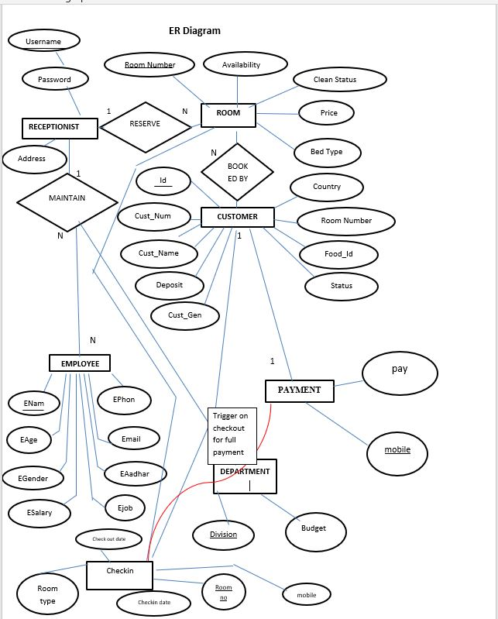

**ER diagram update is shown be red line**

**On checkout a trigger will be initiated and outstanding amount should be made zero. This ensures customer pays for his full duration of stay.**

**Hotel Management Software functionalities**

1. **Home Frame**

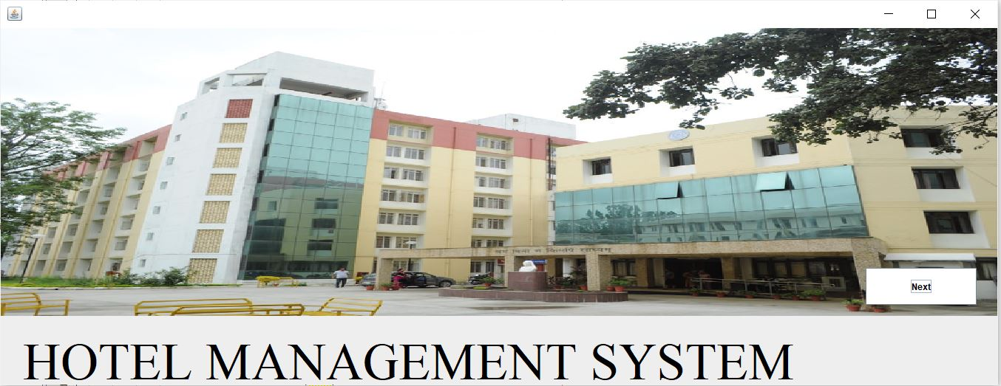

1. **Login Frame**

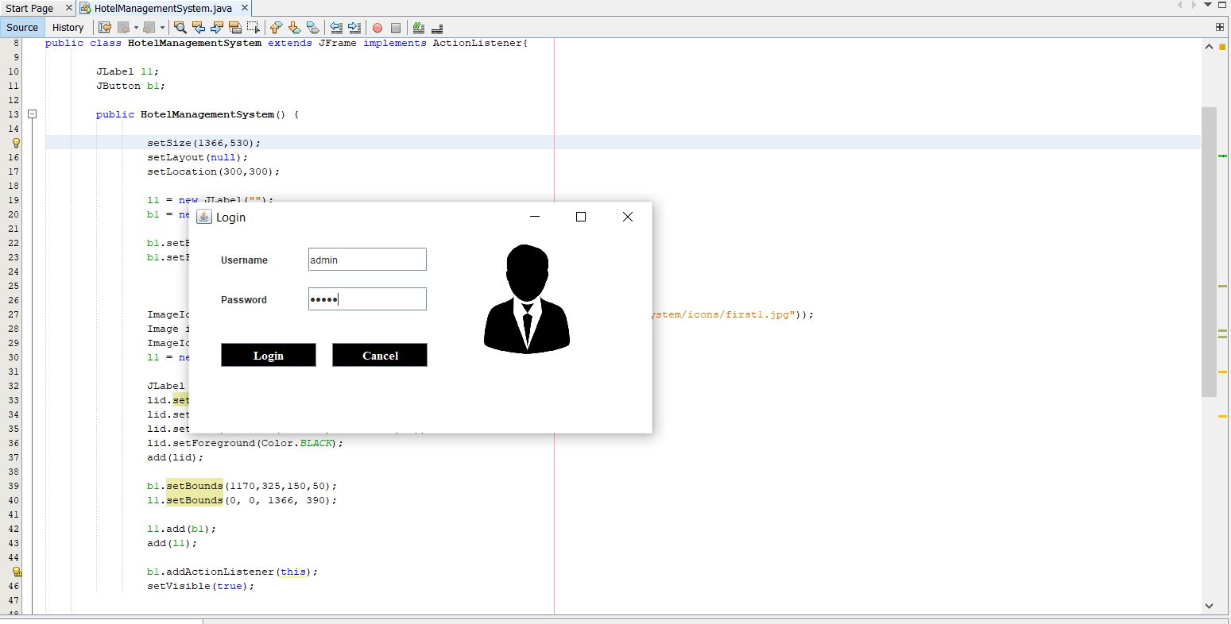

1. **Hotel Management Page After Login**

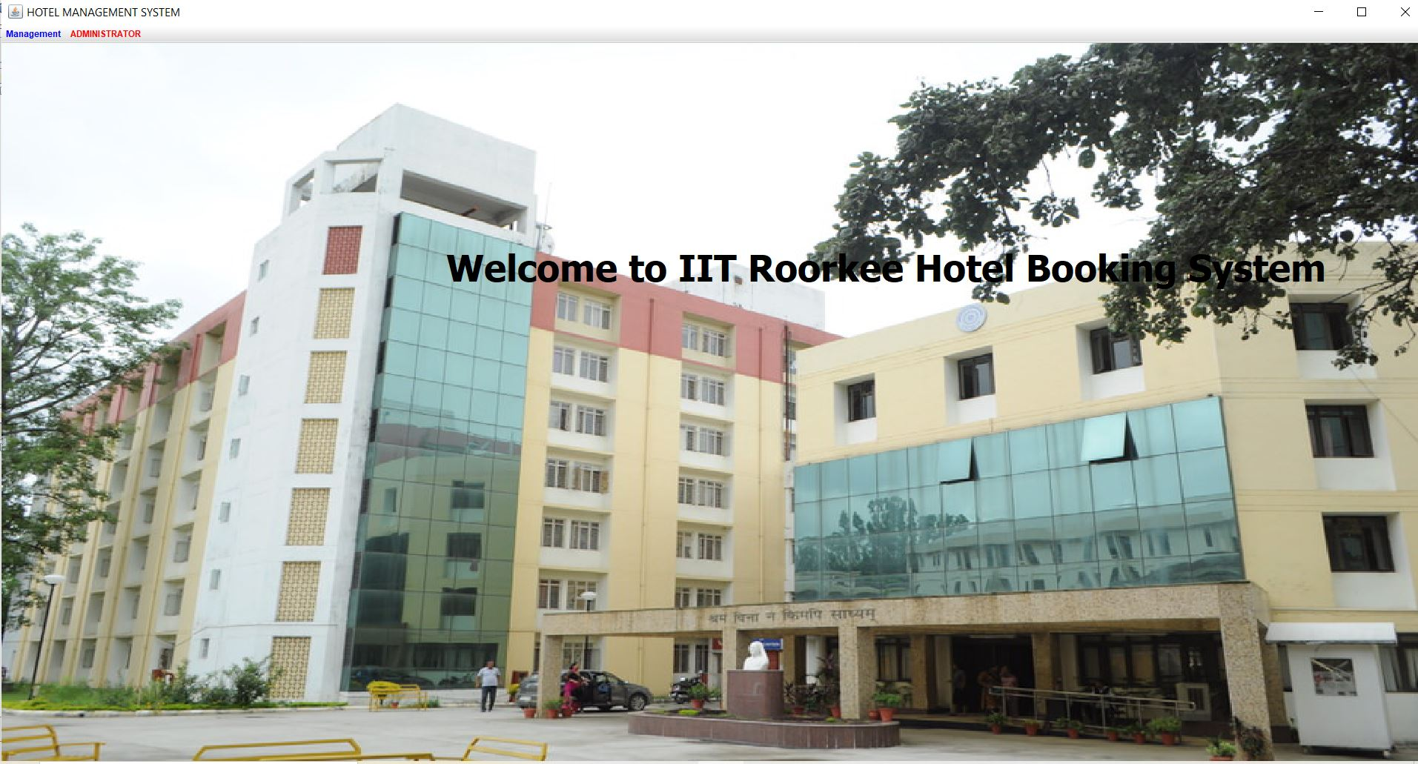

1. **Add Employees**

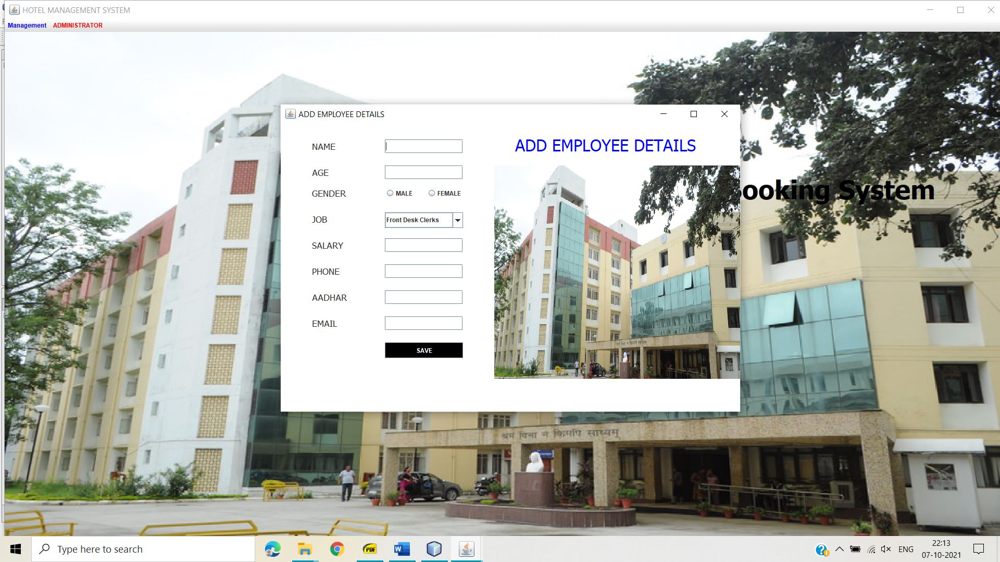

1. **Add Rooms**

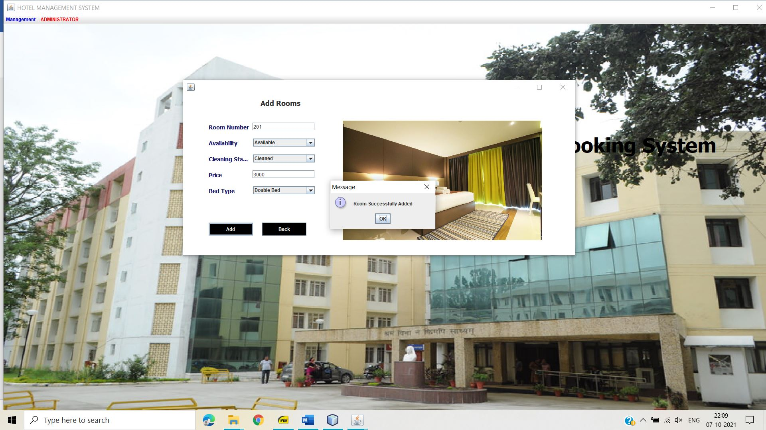

1. **Reception Desk**

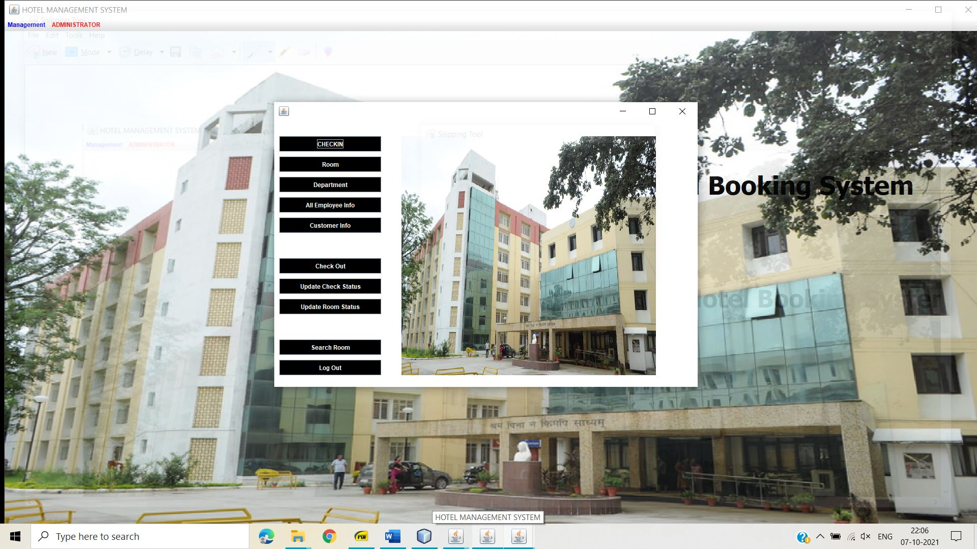

1. **Customer Form Page**

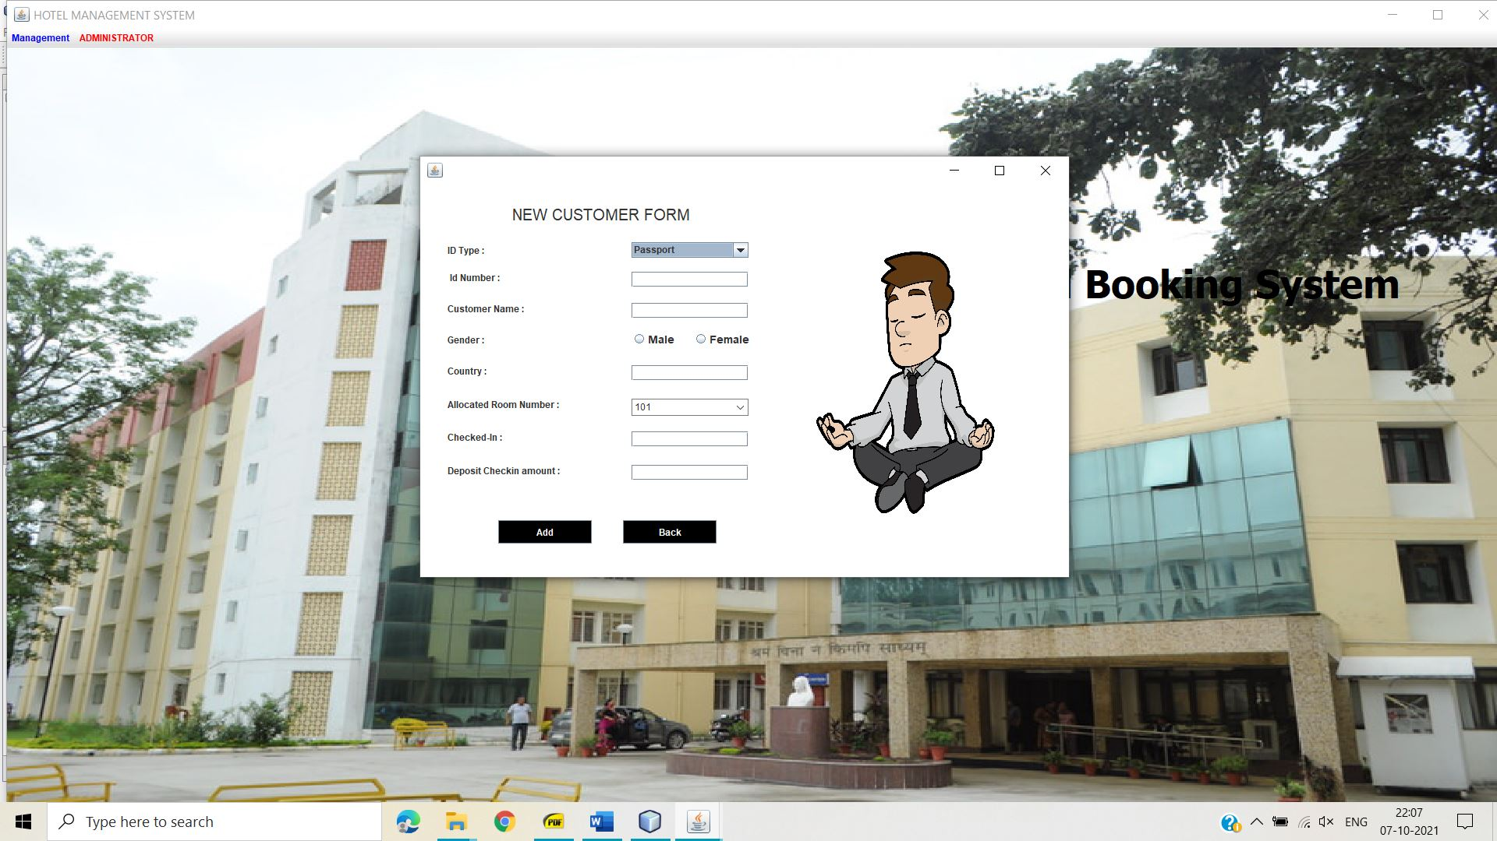

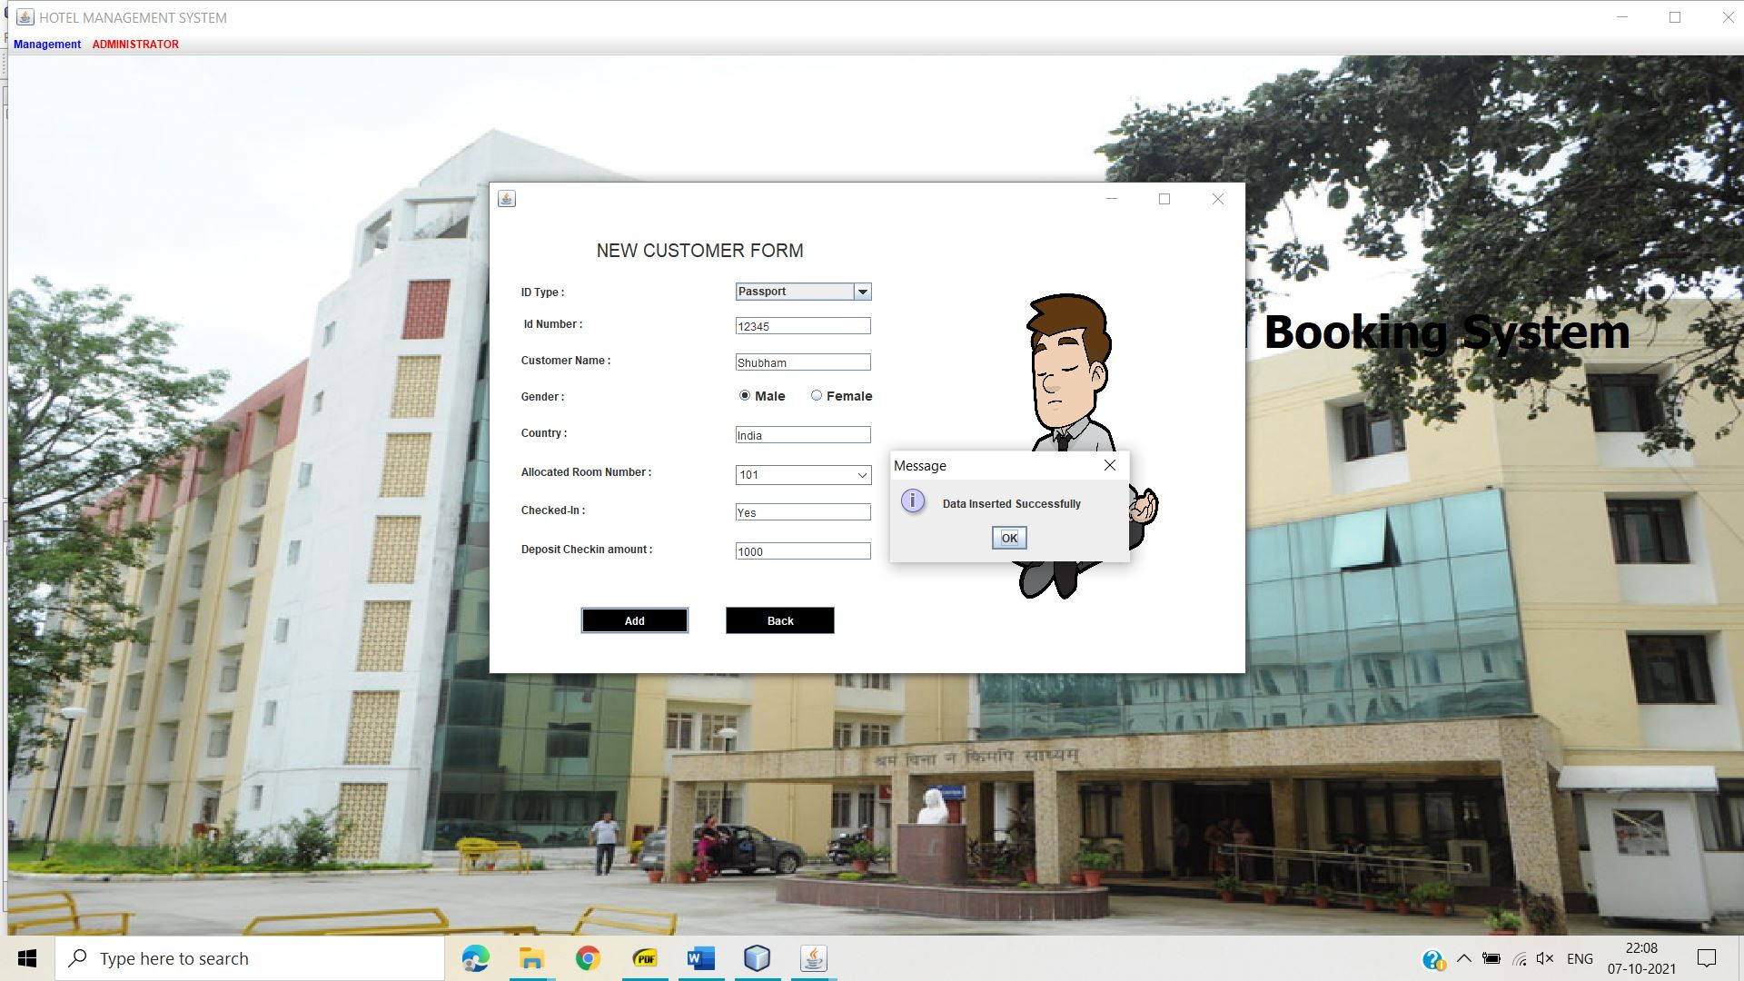

1. **Showing Employee Details**

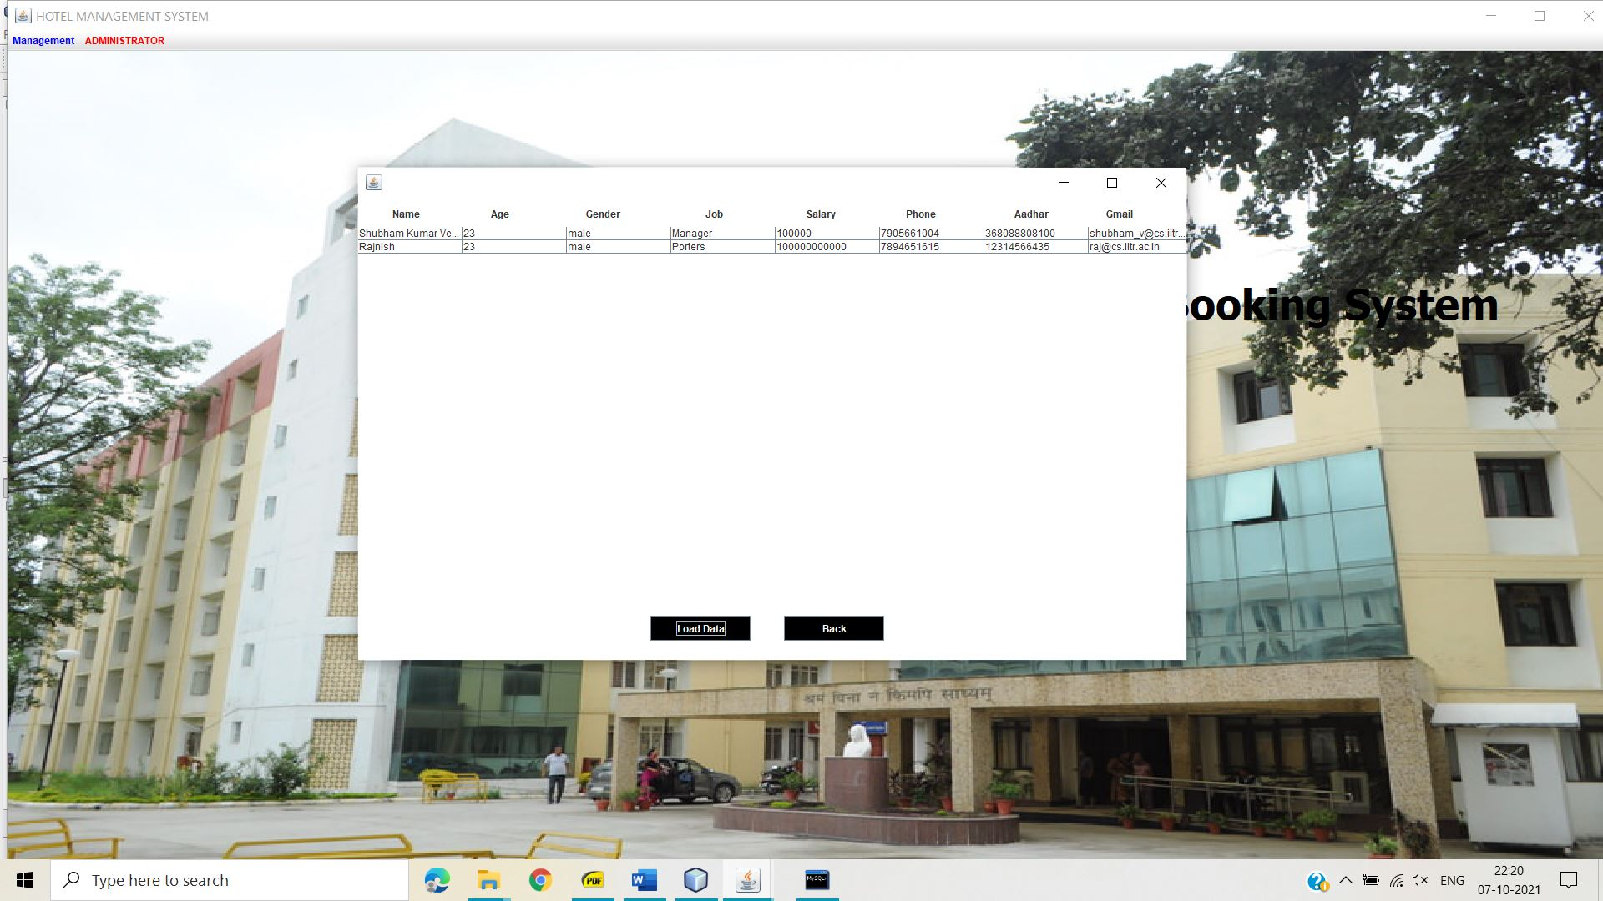

1. **Updating Room Status**

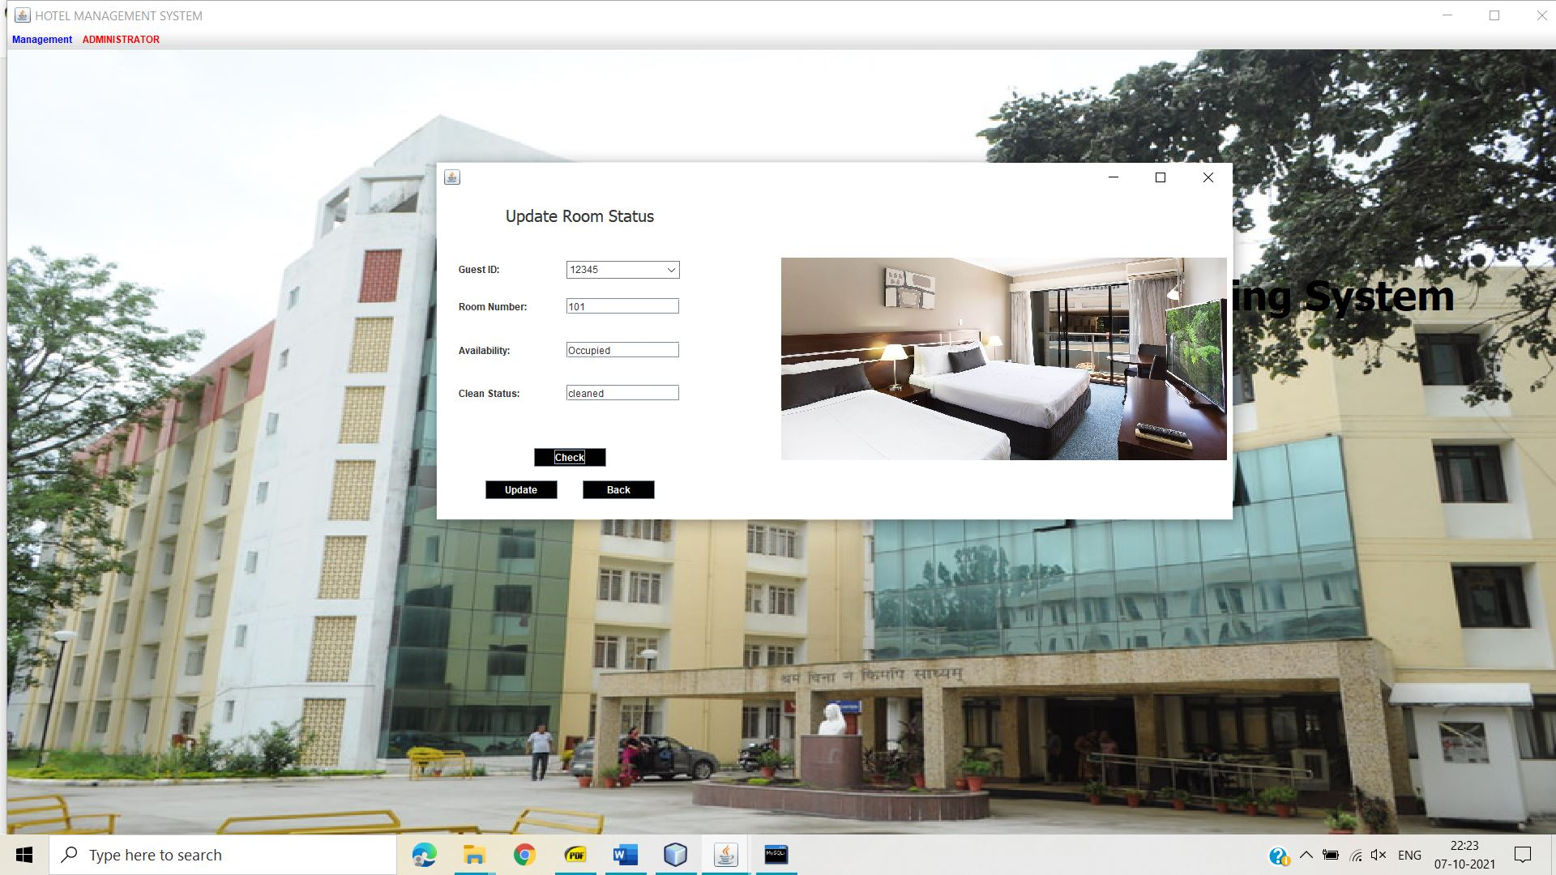

1. **Checkin details**

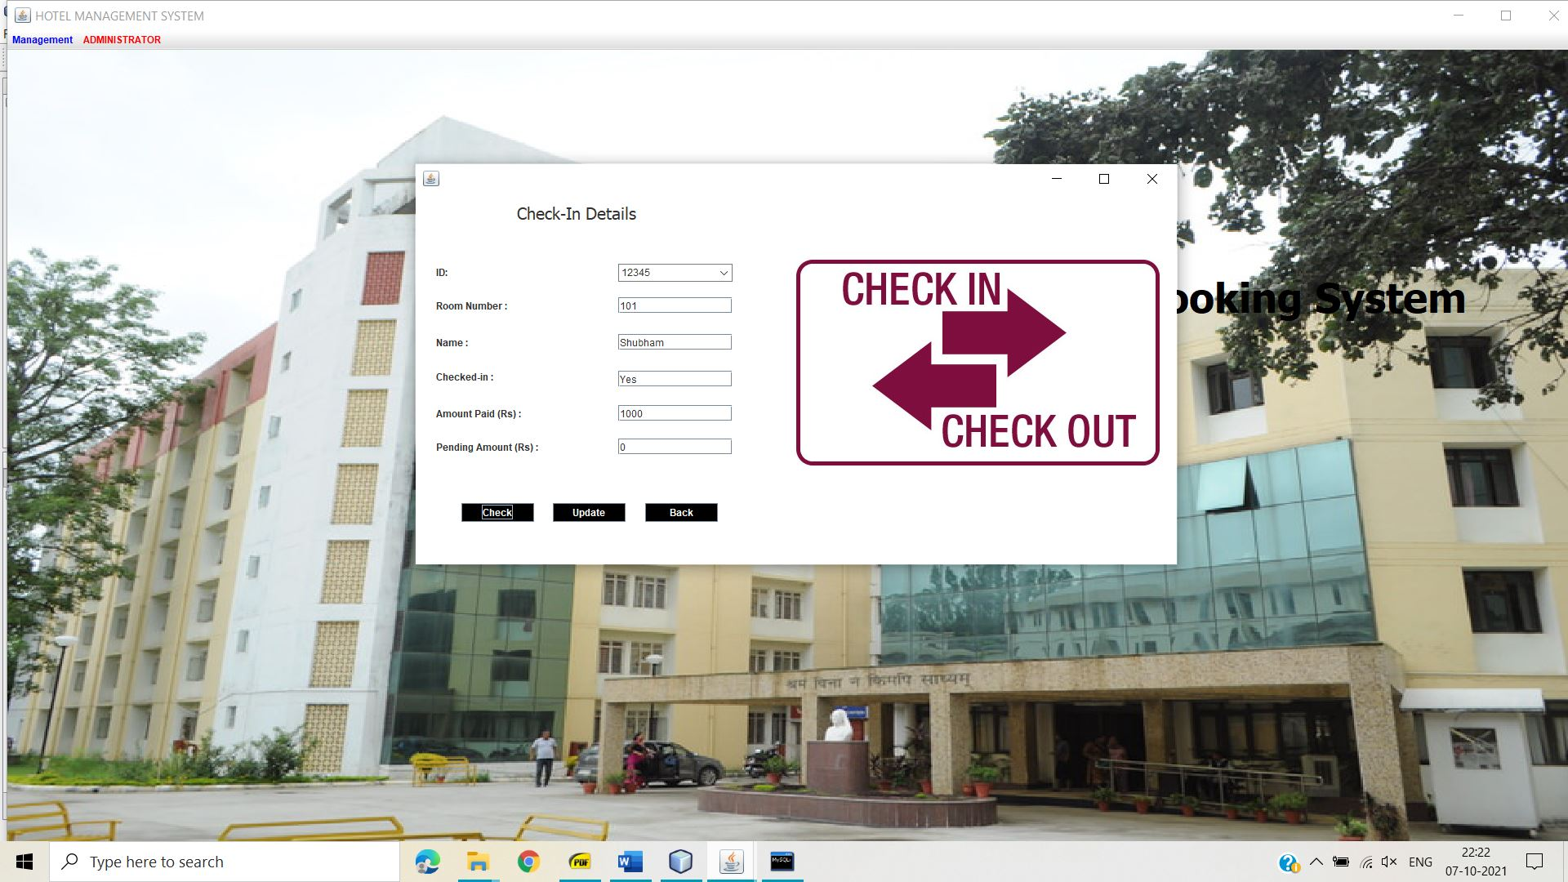

1. **Search Available room**

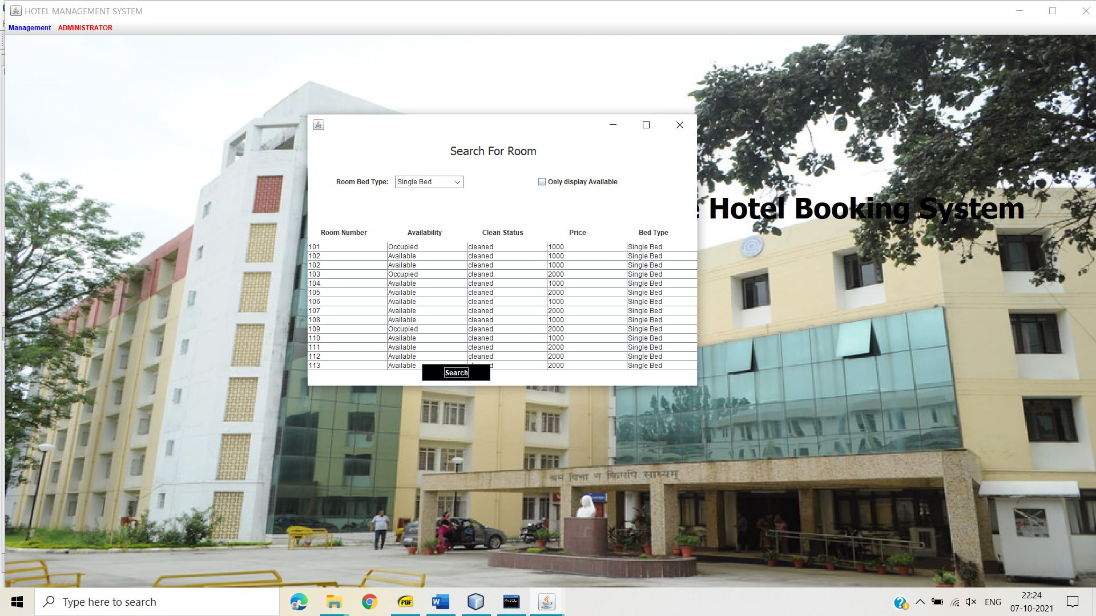

**Conclusion**

Throughout the building of this software, I referred to YouTube videos and online documentation available for building GUI. This simple but powerful software will help to achieve everyday task and we can enhance it further which changes in database.