# TCL

## Commit

CREATE TABLE Director( director_id INt unique, dfname varchar(20) not NULL, dlname varchar(20), birth_year int,

death_year int

);

INSERT INTO DIRECTOR VALUES

(1234567,'David','Crononberg',1940,1980), (1234568,'Sidney','Lumet',1950,2010);

commit;

SELECT * FROM DIRECTOR;

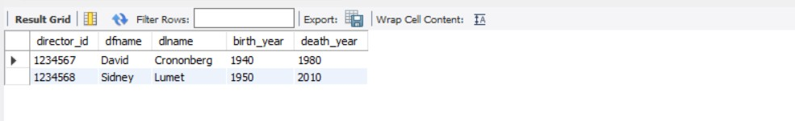

## Rollback

INSERT INTO DIRECTOR VALUES (1234569,'Anurag','Kashyap',1945,2018);

SELECT * FROM DIRECTOR;

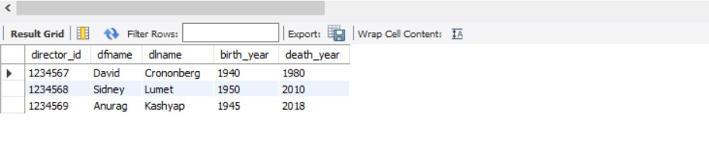

rollback;

SELECT * FROM DIRECTOR;

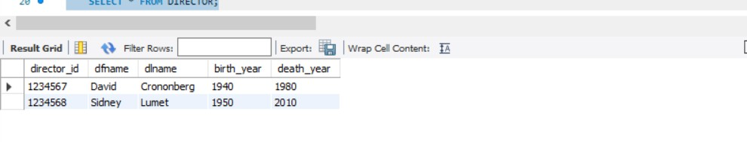

## Savepoint

update director set dfname='Utsav' where director_id=1234568; savepoint b;

select * from director;

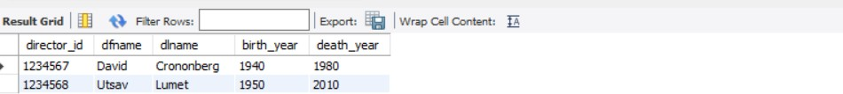

delete from director where director_id=1234567; select * from director;

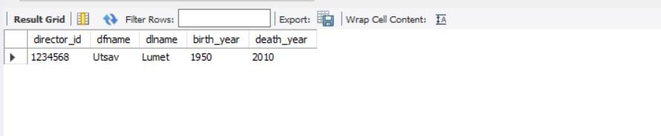

rollback to b;

select * from director;

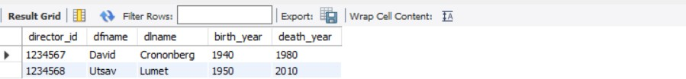

### Grant

**DCL**

CREATE USER 'shubham'@'localhost' IDENTIFIED BY 'pswd';

GRANT insert, update,select ON user.director TO 'shubham'@'localhost'; SHOW GRANTS FOR 'shubham'@'localhost';

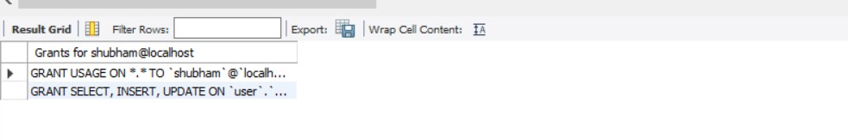

## Revoke

REVOKE update ON user.director FROM 'shubham'@'localhost'; SHOW GRANTS FOR 'shubham'@'localhost';

