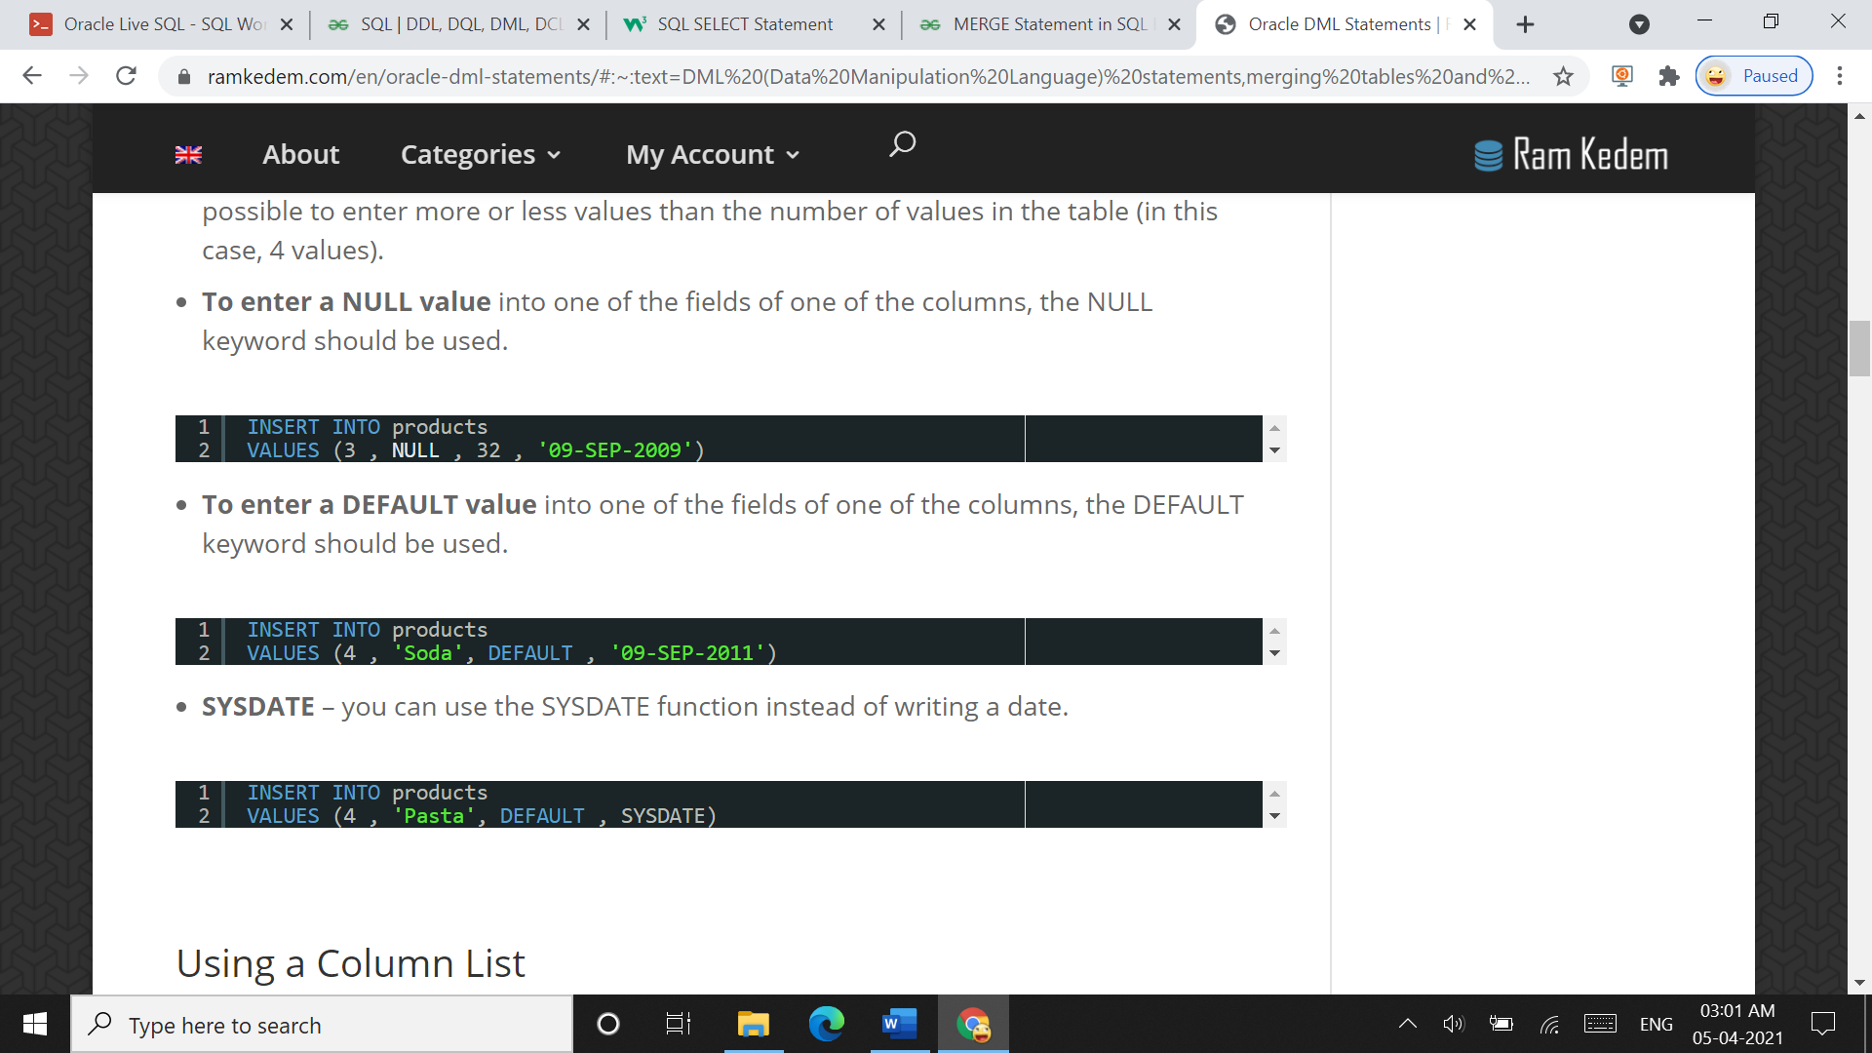

INSERT INTO PRODUCER(company_id,company_name) VALUES(2345677,'Aashirvad Cinemas');

INSERT INTO PRODUCER(company_id,company_name) VALUES(2345678,'AVM Production');

INSERT INTO PRODUCER VALUES(2345679,'Columbia Pictures','US');

INSERT INTO PRODUCER(company_id,company_name) VALUES(2345680,'Bing Bang Entertainments');

INSERT INTO PRODUCER VALUES(2345681,'Warner Bros','America');

SELECT * FROM PRODUCER;

INSERT INTO DIRECTOR VALUES(1234567,'David','Crononberg',1940,1980);

INSERT INTO DIRECTOR VALUES(1234568,'Sidney','Lumet',1950,2010);

INSERT INTO DIRECTOR VALUES(1234569,'Anurag','Kashyap',1945,2018);

SELECT * FROM DIRECTOR;

INSERT INTO CUSTOMER VALUES(345678,'Shubham','Jaiswal','Male','06-May-2001','shub@gmail.com',1,'Boisar','Saidham',401501,'India',6);

INSERT INTO CUSTOMER VALUES(345679,'Utsav','Dabhi','Male','10/April/2001','utsav@gmail.com',1,'Miraroad','Rooprajat',201506,'China',9);

INSERT INTO CUSTOMER VALUES(345680,'Sejal','Pathak','Female','29-November-2005','sejal@gmail.com',0,'Bandra','Yogihill',603207,'US',1);

SELECT * FROM CUSTOMER;

INSERT INTO STAFF VALUES(456789,'Rakesh','Joshi','rakesh@gmail.com','23/January/1998','Male','Borivali','Gandhi Nagar',501431,'Japan');

INSERT INTO STAFF VALUES(456790,'Jack','Peraz','jack@gmail.com','12/March/1967','Male','Gateway','BandStand',704504,'America');

INSERT INTO STAFF VALUES(456791,'Linda','Ford','linda@gmail.com','17/June/1990','Female','London','Tembhode',754255,'California');

SELECT * FROM STAFF;

INSERT INTO Customer_phone VALUES(9876567822,345678);

INSERT INTO Customer_phone VALUES(6789123465,345680);

SELECT * FROM CUSTOMER_PHONE;

INSERT INTO STAFF_PHONE VALUES(2233675519,456791);

INSERT INTO STAFF_PHONE VALUES(7866452159,456790);

SELECT * FROM STAFF_PHONE;

INSERT INTO RENTAL VALUES(55667788,'1/April/2021','15/April/2021',456789);

INSERT INTO RENTAL VALUES(88776655,'10/January/2021','10-February-2021',456791);

SELECT * FROM RENTAL;

INSERT INTO RENT VALUES(345679,88776655);

INSERT INTO RENT VALUES(345680,55667788);

SELECT * FROM RENT;

INSERT INTO PAYMENT VALUES(876521679,'Credit Card',67,'28/March/2021',55667788,345680,456789);

INSERT INTO PAYMENT VALUES(876553771,'UPI',91,'9-January-2021',88776655,345679,456791);

SELECT * FROM PAYMENT;

INSERT INTO MOVIE VALUES(991133,99,45,7,'Three',2015,'American erotic horror film','Knock Knock',30,'Horror',2345681,1234567,null);

INSERT INTO MOVIE VALUES(991134,142,55,10,'One',1994,'Loosely Based on a Real Person (or Two) Tom Hanks','Forrest Gump',23,'Comedy-Drama',2345681,1234568,55667788);

INSERT INTO MOVIE VALUES(991135,125,115,9,'Five',2020,'Science fiction horror film','The Invisible Man',20,'Science Fiction',2345679,1234567,null);

INSERT INTO MOVIE VALUES(991136,135,92,30,'Four',2021,'Biographical sports film','Saina',100,'Sports-Drama',2345677,1234569,88776655);

SELECT * FROM MOVIE;

INSERT INTO MOVIE_LANGUAGE VALUES('English',991133);

INSERT INTO MOVIE_LANGUAGE VALUES('English',991134);

INSERT INTO MOVIE_LANGUAGE VALUES('English',991135);

INSERT INTO MOVIE_LANGUAGE VALUES('Hindi',991136);

SELECT * FROM MOVIE_LANGUAGE;

INSERT INTO ACTOR VALUES(91256777,'Parineeti','Chopra');

INSERT INTO ACTOR VALUES(91256778,'Harriet','Dyer');

INSERT INTO ACTOR VALUES(91256779,'Manav','Kaul');

INSERT INTO ACTOR VALUES(91256780,'Will','Smith');

INSERT INTO ACTOR VALUES(91256781,'Hanna','Hall');

INSERT INTO ACTOR VALUES(91256782,'Shahrukh','Khan');

INSERT INTO ACTOR VALUES(91256783,'Aldis','Hodge');

INSERT INTO ACTOR VALUES(91256784,'Ankur','Vikal');

INSERT INTO ACTOR VALUES(91256785,'Michael','Dorman');

INSERT INTO ACTOR VALUES(91256786,'Keanu','Reeves');

INSERT INTO ACTOR VALUES(91256787,'Lorenza','Izzo');

INSERT INTO ACTOR VALUES(91256788,'Colleen','Camp');

INSERT INTO ACTOR VALUES(91256789,'Elvis','Presley');

INSERT INTO ACTOR VALUES(91256790,'Haley','Joel');

SELECT * FROM ACTOR;

INSERT INTO ACTED_IN VALUES('Singer',91256777,991136);

INSERT INTO ACTED_IN VALUES('Dancer',91256778,991135);

INSERT INTO ACTED_IN VALUES('Stuntman',91256779,991136);

INSERT INTO ACTED_IN VALUES('Criminal',91256781,991134);

INSERT INTO ACTED_IN VALUES('Robber',91256783,991135);

INSERT INTO ACTED_IN VALUES('Rider',91256784,991136);

INSERT INTO ACTED_IN VALUES('Comedian',91256785,991135);

INSERT INTO ACTED_IN VALUES('Villian',91256786,991133);

INSERT INTO ACTED_IN VALUES('God',91256788,991133);

INSERT INTO ACTED_IN VALUES('Tourist',91256789,991134);

INSERT INTO ACTED_IN VALUES('Hero',91256790,991134);

SELECT * FROM ACTED_IN;

--UPDATE SINGLE COLUMN

UPDATE CUSTOMER SET CFNAME='Roshni' WHERE MEMBER_ID=345680;

SELECT * FROM CUSTOMER;

--UPDATE MULTIPLE COLUMN

UPDATE CUSTOMER SET EMAIL='roshni@gmail.com',ACTIVE=1,NO_OF_RENTALS=6 WHERE MEMBER_ID=345680;

SELECT * FROM CUSTOMER WHERE MEMBER_ID=345680;

--DELETE COMMAND

DELETE FROM ACTOR WHERE ACTOR_ID=91256780;

SELECT * FROM ACTOR;