### **1. Check for existing SSH keys**

You should check for existing SSH keys on your local computer. You can use an existing SSH key with Bitbucket Server if you want, in which case you can go straight to either [SSH user keys for personal use](https://confluence.atlassian.com/bitbucketserver/ssh-user-keys-for-personal-use-776639793.html) or [SSH access keys for system use](https://confluence.atlassian.com/bitbucketserver/ssh-access-keys-for-system-use-776639781.html).

Open a command prompt, and run:

cd %userprofile%/.ssh

* If you see "No such file or directory", then there aren't any existing keys:  [go to step 3](https://confluence.atlassian.com/bitbucketserver/creating-ssh-keys-776639788.html" \l "CreatingSSHkeys-step3).
* Check to see if you have a key already:

dir id_*

If there are existing keys, you may want to use those: go to either [SSH user keys for personal use](https://confluence.atlassian.com/bitbucketserver/ssh-user-keys-for-personal-use-776639793.html) or [SSH access keys for system use](https://confluence.atlassian.com/bitbucketserver/ssh-access-keys-for-system-use-776639781.html).

### **2. Back up old SSH keys**

If you have existing SSH keys, but you don't want to use them when connecting to Bitbucket Server, you should back those up.

In a command prompt on your local computer, run:

mkdir key_backup

copy id_rsa* key_backup

### **3. Generate a new SSH key**

If you don't have an existing SSH key that you wish to use, generate one as follows:

1. Log in to your local computer as an administrator.
2. In a command prompt, run:

ssh-keygen -t rsa -C "your_email@example.com"

Associating the key with your email address helps you to identify the key later on.

Note that the ssh-keygen command is only available if you have already [installed Git](https://confluence.atlassian.com/bitbucketserver/installing-and-upgrading-git-776640906.html) (with Git Bash).  
You'll see a response similar to this:



1. Just press <Enter> to accept the default location and file name. If the .ssh directory doesn't exist, the system creates one for you.
2. Enter, and re-enter, a passphrase when prompted. The whole interaction will look similar to this:  
   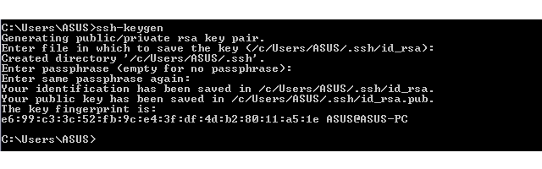
3. You're done! Now go to either [SSH user keys for personal use](https://confluence.atlassian.com/bitbucketserver/ssh-user-keys-for-personal-use-776639793.html) or [SSH access keys for system use](https://confluence.atlassian.com/bitbucketserver/ssh-access-keys-for-system-use-776639781.html).