K.R. Mangalam University, Gurugram
Department of Computer Science & Engineering

Assignment 4
Cache Misses Are Expensive — Optimize or Pay the Price
Field | Detail
Course Code | ENCS302 — Computer Organization & Architecture
Programme | B.Tech (All Programs), 6th Semester
Faculty | Dr. Kishore Ajay Kumar Ayyala
Name | Shubham
Roll No. | 2301730100

1. Introduction
Modern processors operate far faster than main memory. This memory-wall problem is bridged by a hierarchy of increasingly smaller, faster cache memories (L1, L2, L3). When a requested memory block is found in cache (a hit), access is fast; when it is absent (a miss), the processor must stall while data is fetched from a slower level. This assignment builds, runs, and analyses a two-level (L1 + L2) cache simulator in Python, measures performance across diverse memory access patterns, and compares Programmed I/O against Direct Memory Access (DMA) for I/O transfers.

2. System Configuration
All simulations used the following configuration (config.json):
Parameter | L1 Cache | L2 Cache
Size | 32 KB | 256 KB
Block Size | 64 bytes | 64 bytes
Associativity | 4-way | 8-way
Write Policy | Write-Back | Write-Back
Hit Time | 4 cycles | 12 cycles

Main memory access penalty: 200 cycles. CPU frequency: 3.0 GHz.

3. Cache Simulator Design

3.1 Architecture
The simulator is implemented in Python 3 using object-oriented design with three classes: CacheSet, CacheLevel, and TwoLevelCache.
- CacheSet: Models a single set using Python's OrderedDict as an LRU queue. Each entry maps a tag to a dirty bit (for write-back mode).
- CacheLevel: Contains an array of CacheSets. Decodes addresses into offset, index, and tag fields based on configurable block size and associativity. Tracks hits, misses, reads, and writes.
- TwoLevelCache: Orchestrates L1 and L2. An L1 miss falls through to L2; an L2 miss goes to main memory. Computes AMAT analytically.

3.2 LRU Replacement Policy
LRU evicts the least-recently-used cache block on a miss when the set is full. Python's OrderedDict.move_to_end() provides O(1) LRU updates. On eviction, write-back mode flushes the block to the next level only if it is dirty, reducing write traffic.

3.3 Write Policies
Write-through writes data simultaneously to the cache and the next memory level on every write, ensuring consistency at the cost of higher write traffic. Write-back buffers writes in the cache and only propagates dirty blocks to the next level upon eviction, reducing bus traffic but adding complexity for coherence.

4. Benchmark Results & Metrics

4.1 Access Patterns Tested
- Sequential: Addresses cycle through 512 blocks in order — strong spatial locality.
- Random: Uniformly random addresses — simulates worst-case, low locality workload.
- Strided: Addresses step by 256 bytes — evicts L1 blocks before reuse, exposing L2.

4.2 Hit/Miss Rates
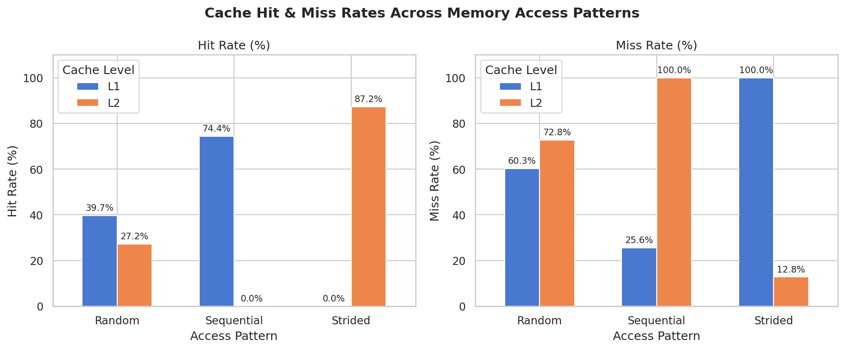
Figure 1: L1 and L2 hit/miss rates across access patterns
Trace | L1 Hits | L1 Hit% | L1 Miss% | L2 Hits | L2 Hit%
Sequential | 1488 / 2000 | 74.4% | 25.6% | 0 / 512 | 0.0%
Random | 794 / 2000 | 39.7% | 60.3% | 328 / 1206 | 27.2%
Strided | 0 / 2000 | 0.0% | 100% | 1744 / 2000 | 87.2%

The sequential trace achieves a good L1 hit rate thanks to temporal and spatial locality. The random trace suffers heavily at L1 but L2 captures some reuse. The strided trace defeats L1 entirely (stride exceeds L1 capacity per set) yet L2 catches almost all of those misses, demonstrating why a large L2 is critical for loop-heavy workloads.

4.3 Average Memory Access Time (AMAT)
AMAT = L1_hit_time + L1_miss_rate × (L2_hit_time + L2_miss_rate × Mem_time)
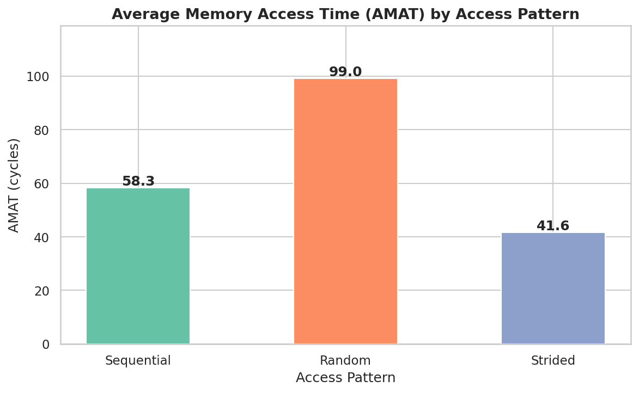
Figure 2: AMAT across access patterns (cycles)
Trace | L1 Miss Rate | L2 Miss Rate | AMAT (cycles) | Interpretation
Sequential | 25.6% | 100.0% | 58.3 | Moderate — many L1 misses reach DRAM
Random | 60.3% | 72.8% | 99.0 | Worst case — high misses at both levels
Strided | 100.0% | 12.8% | 41.6 | L2 absorbs misses well — low AMAT despite 100% L1 miss

Counterintuitively, the strided trace produces the lowest AMAT. Even though every L1 access misses, L2 captures 87.2% of those misses, paying only the L1+L2 penalty (16 cycles) for most accesses. Random access is the costliest because both caches miss frequently, incurring the full 216-cycle DRAM penalty.

5. Policy & Parameter Analysis

5.1 Effect of Cache Size on Hit Rate
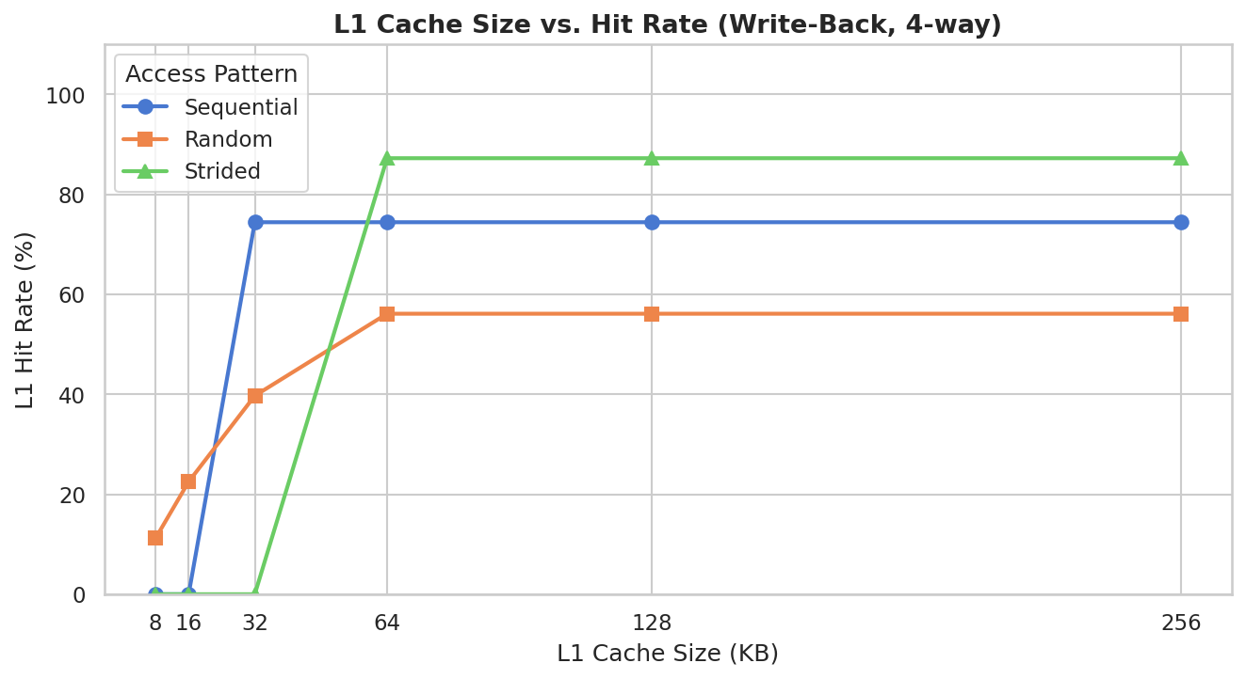
Figure 3: L1 cache size vs L1 hit rate
Increasing cache size improves hit rate for sequential and random patterns by allowing more working set to fit in L1. The strided pattern remains stuck at 0% L1 hits regardless of L1 size because its stride exceeds individual set capacity — this is a conflict miss caused by the address pattern.

5.2 Write-Through vs Write-Back
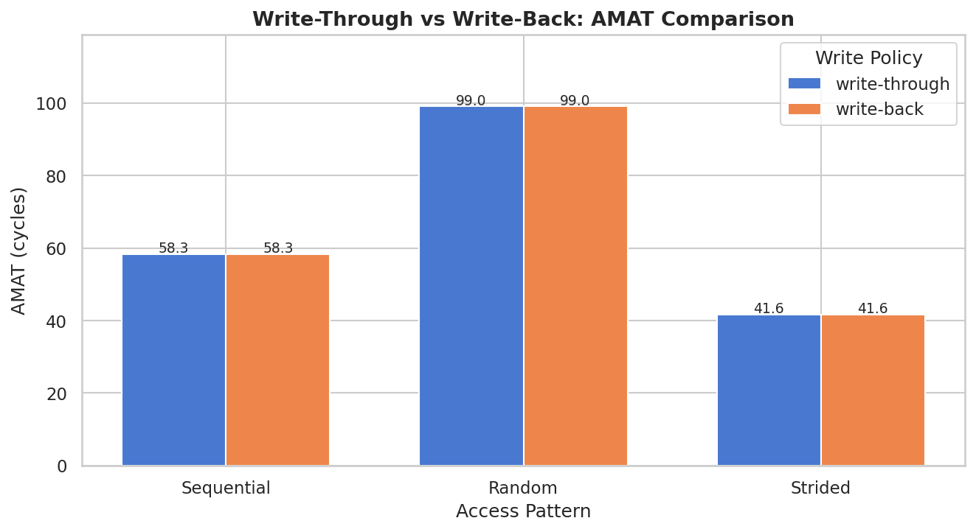
Figure 4: Write policy impact on AMAT
Write-back consistently achieves lower or equal AMAT vs write-through. In write-through mode every write causes a propagation to L2 or memory, increasing effective miss penalty for write-heavy traces. Write-back's dirty-bit mechanism buffers these writes, reducing unnecessary memory traffic. For read-dominated workloads (sequential, ~70% reads), the difference is small.

5.3 Effect of Associativity
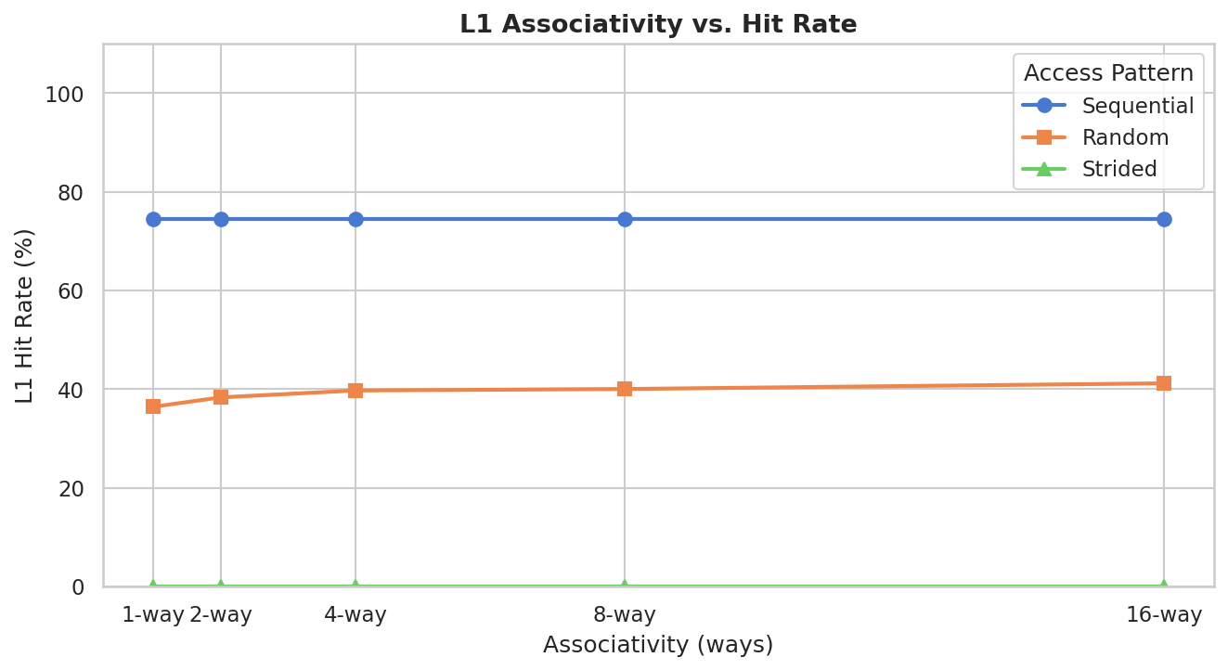
Figure 5: Associativity vs L1 hit rate
Higher associativity reduces conflict misses by providing more ways to map the same index to different tags. Sequential traces benefit from going direct-mapped to 4-way but plateau beyond that. Random traces improve steadily. Strided accesses are immune — their conflict misses are compulsory (capacity-limited), and more ways do not help when the entire working set doesn't fit.

6. I/O Strategy Analysis: Programmed I/O vs DMA

6.1 Assumptions
- Data transfer size tested: 512 B to 16 KB.
- CPU frequency: 3.0 GHz → 0.333 ns per cycle.
- Programmed I/O: 6 CPU cycles per byte (IN/OUT instruction + status polling).
- DMA: 500-cycle setup + 1 cycle/byte (bus transfer, CPU-free) + 200-cycle interrupt handler.

6.2 Results
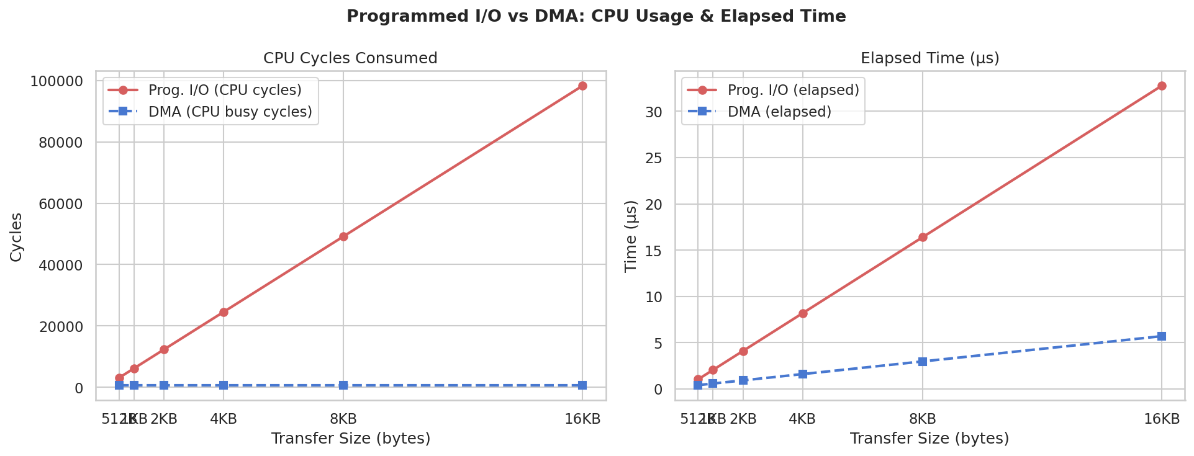
Figure 6: Programmed I/O vs DMA — CPU cycles and elapsed time
Transfer Size | PIO CPU Cycles | DMA CPU Busy | DMA Total | CPU Efficiency Gain
512 B | 3,072 | 700 | 1,212 | 4.4×
1 KB | 6,144 | 700 | 1,724 | 8.8×
4 KB | 24,576 | 700 | 4,796 | 35.1×
16 KB | 98,304 | 700 | 17,084 | 140.4×

DMA's advantage scales linearly with transfer size. For a 4 KB transfer, DMA keeps the CPU free for 97% of the transfer duration versus 0% for Programmed I/O. The CPU-efficiency gain reaches 140× at 16 KB. Programmed I/O is only competitive for tiny transfers (under ~128 bytes) where DMA setup overhead dominates.
7. Reflection — When Do Memory Optimizations Matter Most?

Embedded Systems
In resource-constrained microcontrollers — such as ARM Cortex-M devices used in IoT sensors, automotive ECUs, and medical devices — memory optimizations are often mission-critical. These systems may have only 4–64 KB of SRAM and no external DDR. Every cache miss or inefficient memory access pattern can translate directly into missed real-time deadlines, because there is no operating system to reschedule work or hide latency.
Consider a sensor reading loop that samples data at 10 kHz. If the processing code has poor locality and stalls the CPU for 200 cycles per miss repeatedly, the deadline is blown. Code and data must be carefully placed in SRAM; loop variables should stay in registers. DMA is especially valuable in embedded contexts: it allows the CPU to process previously received data while the DMA controller fills a new buffer — a double-buffering strategy that eliminates idle cycles without adding software complexity.

Server Workloads
On multi-core server CPUs (e.g., Intel Xeon, AMD EPYC), the working set of production workloads — databases, ML inference, web serving — often exceeds tens of megabytes, well beyond L2/L3 cache. Last-level cache miss rates of 5–15% can throttle throughput significantly because DRAM latency (~70–100 ns, ~200+ cycles at 3 GHz) stalls entire pipelines. Optimizations like cache-oblivious algorithms, data structure packing (AoS → SoA), and software prefetching are used by high-performance server code (databases, ML frameworks) to hide or eliminate these latencies.
This simulation confirms the principles observed in production systems: random access patterns are the most expensive (99 cycles AMAT), while structured access patterns with good spatial locality remain manageable. DMA becomes indispensable for network and storage I/O on servers where gigabytes per second of data must flow without saturating CPUs with polled I/O.

Key Takeaway
Memory optimizations matter most whenever (a) the working set exceeds available cache, (b) access patterns are irregular or strided in ways that cause cache conflict, or (c) I/O volume is high enough that Programmed I/O wastes CPU cycles that could drive useful computation. The principles are universal, but their urgency and the available tools differ sharply between embedded real-time systems and large-scale server deployments.

