Analytics-Driven Decision Support Framework for Enterprise Food Operations and Employee Health Management
Course No. : S1-26_MBAZG622T
Course Title: Project
Project Report
Student Name: Shubham Kumar
BITS ID: 2024HB21026
Program: MBA in Business Analytics

Project Area: Bangalore, Karnataka, IN

Work Integrated Learning Programmes Division (WILPD),
BIRLA INSTITUTE OF TECHNOLOGY & SCIENCE, PILANI,
VIDYA VIHAR, PILANI, RAJASTHAN - 333031.
(July,2026)

TABLE OF CONTENTS

Section No. | Section Name | Page No.
1 | Executive Summary of Mid-Semester Progress | 15
2 | Background | 16
3 | Problem Statement | 17
Chapter 1 | Expanded Requirement Statement and Problem Context | 18
4 | Motivation for this project | 19
5 | Project Objectives | 20
Chapter 2 | Project Objectives and Success Measures | 21
6 | Project Scope | 22
Chapter 3 | Scope, Assumptions, and Boundaries | 23
Chapter 4 | Literature Review and Research Gap | 24
7 | Proposed methodology | 28
Chapter 5 | Research Methodology | 30
8 | Plan of Work | 32
Chapter 6 | Plan Versus Progress | 33
Chapter 7 | Detailed Work Completed till Mid-Semester | 35
9 | Resource Requirements and Plan for their availability | 44
Chapter 8 | Resources and Availability | 45
10 | Risks and Mitigation Plan | 46
Chapter 9 | Risks, Mitigations, and Ethical Controls | 47
Chapter 10 | Issues Faced and Resolutions | 48
11 | Expected Benefits | 49
Chapter 11 | Preliminary Conclusions and Recommendations | 50
Annexure A | Dataset Dictionary | 51
Annexure B | Reproducible KPI Snapshot | 54
Annexure C | Selected Implementation Excerpts | 55
Annexure D | References Added for the Expanded Report | 56
Annexure E | Summary of How Project Outline Feedback Was Addressed | 57
12 | References | 64
13 | Glossary | 65
14 | Particulars of Student | 66
15 | Particulars of the Supervisor and Additional Examiner | 67
16 | Remarks of the Supervisor on Project Report | 68

List of Figures

Figure 1: Business Analytics value framework for the proposed abstract.
Figure 2: Proposed Business Analytics methodology roadmap.
Figure 3: Conceptual framework flow for the abstract/proposal.
Figure 4. Plan vs. progress Gantt chart across the six project phases (weeks on the x-axis).
Figure 5. Energy and source distribution from the project exploratory analysis.
Figure 6. Major nutrition-feature correlations used for exploratory analysis.
Figure 7. Clustering quality exploration from the project analysis.
Figure 8. K-means cluster visualization using principal-component projection.
Figure 9. Nutrition-profile comparison across descriptive clusters.
Figure 10. Reproducible dashboard KPI experiment and eligible-candidate analysis.

Project Type: Academic Project (Type 3)

Project Area:

Business Analytics, Employee Health Management, Food Operations Analytics, Supply Chain Analytics

_____________________________________________________________________________________

Analytics-Driven Decision Support Framework for Enterprise Food Operations and Employee Health Management

Executive Summary of Mid-Semester Progress
This section documents the research framing, dataset preparation, implementation evidence, preliminary findings, risks, and next steps completed at the mid-semester stage. It is written as an academic progress report for an MBA in Business Analytics project. The approved Project Report structure that follows is retained without alteration; this summary and the chapters after each corresponding approved section add the evidence gathered since the proposal stage.
The project develops a food intelligence decision-support prototype for enterprise food operations and employee wellness. Its current contribution is a traceable catalogue that connects nutrition facts with recipe evidence, ingredient information, declared allergens, semantic representations, and dashboard-based analysis. The work is exploratory and decision-support oriented; it does not provide clinical advice, diagnostic conclusions, or production deployment claims.
Graph RAG remains an optional advanced extension in the approved outline. It is deliberately excluded from the current achievement claims because its retrieval quality and operational complexity require further research validation. This decision narrows the mid-semester deliverable to reliable data preparation, semantic retrieval, graph modelling, and a transparent dashboard prototype.
Enterprise cafeterias and institutional food services must balance nutritional transparency, recipe evidence, food safety awareness, and practical menu planning. Yet food information is commonly fragmented across nutrition tables, recipe sources, ingredient records, and manually maintained menu documents. This project addresses that fragmentation by developing an analytics-driven food intelligence prototype for decision support.
The mid-semester implementation has produced a processed catalogue containing 1,014 uniquely identified food records and 97 analytical fields. The catalogue contains macronutrient and micronutrient facts, engineered ratios, recipe-match evidence, ingredient details were available, source-declared allergens, semantic text, embedding readiness, and nutrition-cluster labels. A total of 449 records has confirmed exact or alias recipe matches, while 187 records are retained in a review queue and 378 records remain unlinked rather than being assigned unsupported evidence.
Semantic representations have been generated for all 1,014 catalogue records using the all-MiniLM-L6-v2 sentence-transformer model. The resulting embedding matrix has dimensions 1,014 x 256 and supports natural-language discovery of comparable foods. The project also includes a Neo4j graph ingestion design and a Streamlit dashboard prototype. The dashboard presents menu-level nutrition patterns, evidence coverage, allergen visibility, semantic exploration, and constraint-based menu planning.
The preliminary result is not a claim that the system optimizes live cafeteria operations. Rather, it demonstrates that disparate food datasets can be integrated into an auditable analytical foundation. The next work focuses on evaluation: confirming fuzzy recipe matches, validating graph ingestion, constructing a labelled semantic-retrieval test set, and gathering user feedback on dashboard usefulness.

Background

Modern organizations are increasingly investing in employee wellness, workplace experience, and data-driven operational management. Food services such as enterprise cafeterias, institutional kitchens, and corporate catering facilities are no longer limited to meal preparation activities; they influence employee satisfaction, workplace health, operating efficiency, and organizational productivity.

Food operations face practical business challenges. Cafeteria and kitchen managers must plan menus, estimate preparation time, manage ingredient availability, control operational bottlenecks, minimize wastage, and ensure safe food choices for employees with dietary restrictions or allergen concerns. These decisions are often made using manual judgment, static menu records, and fragmented data sources.

At the same time, modern food-service environments require stronger nutritional transparency and explainable recommendations. Recipes, ingredients, nutrients, allergens, dietary categories, regions, and courses are naturally connected entities. A graph-based analytical approach can therefore support more structured reasoning than flat menu records.

This project proposes an analytics-driven decision support framework for enterprise food operations and employee health management. The framework is positioned as a Business Analytics solution that combines predictive analytics, semantic menu intelligence, knowledge graph modeling, and explainable natural language decision support.

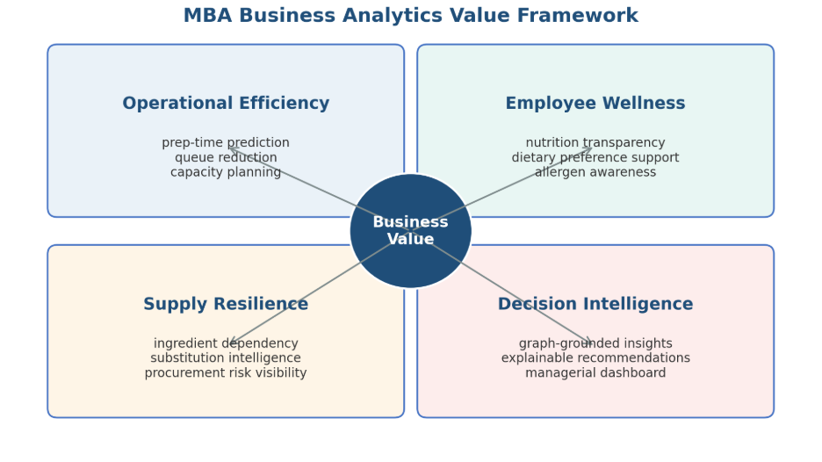
Figure 1: Business Analytics value framework for the proposed abstract.

Problem Statement

Enterprise cafeterias and institutional food operations typically operate under multiple constraints related to time, cost, nutrition, safety, and supply continuity. However, many such environments lack an integrated analytics framework that converts food, ingredient, nutritional, and operational data into actionable business insights.

- Operational planning problem: Limited ability to predict preparation time, kitchen workload, and peak-hour resource requirements.
- Menu intelligence problem: Menu records usually do not capture semantic similarity, ingredient substitutes, regional variations, and overlapping raw material dependencies.
- Nutrition and wellness problem: Employees increasingly require dietary transparency, but traditional cafeteria systems may not provide explainable nutritional or allergen guidance.
- Supply chain dependency problem: Ingredient shortages or price fluctuations can affect multiple dishes, but dependency visibility is often weak.
- AI reliability problem: Generic AI responses can be unsupported. In food and health contexts, decision support must be grounded in validated data relationships.

Therefore, there is a requirement for an integrated Business Analytics framework that supports cafeteria managers, employee wellness teams, and business stakeholders through predictive analytics, explainable recommendations, and dashboard-based decision support.

Chapter 1: Expanded Requirement Statement and Problem Context

1.1 Enterprise Food Operations Landscape
Enterprise cafeterias, institutional kitchens, and corporate food-service environments operate as recurring service systems. Their menu decisions influence employee experience, perceived wellness support, food availability, and kitchen workload. Unlike a simple retail catalogue, a cafeteria menu must be interpreted in relation to nutrition, ingredient composition, recipe complexity, allergy declarations, substitutions, and operational feasibility.
Food operations data is usually distributed across separate artifacts. Nutrition sources provide nutrient composition but rarely contain recipe ingredients or preparation methods. Recipe sources provide textual instructions and ingredients but may differ in naming conventions, serving assumptions, and cultural terminology. Allergen information can be incomplete or inconsistent. These conditions make it difficult to present reliable, comprehensible, and evidence-aware information to managers and users.

1.2 Operational, Wellness, and Analytics Challenges
Table 1. Operational, wellness, and analytics challenges mapped to the project's response.
Challenge area | Observed decision problem | Analytics response in this project
Menu information | Nutrition and recipe details exist in separate sources. | Create a canonical food catalogue with source-aware evidence fields.
Wellness transparency | Users need understandable information about nutrients and declared allergens. | Provide filtering and readable nutrition summaries without clinical claims.
Evidence quality | Dish names can be ambiguous across datasets. | Separate confirmed matches, review candidates, and unmatched records.
Menu discovery | Keyword search does not identify semantically comparable dishes. | Generate sentence embeddings for similarity-based exploration.
Relationship visibility | Ingredients, allergens, and nutrients are connected but hard to query together. | Model these entities and relations through a knowledge-graph design.

1.3 Refined Problem Statement
The central research problem is the absence of a transparent and integrated analytics layer that can connect food nutrition, recipe evidence, ingredients, declared allergens, and semantic similarity for enterprise food decision support. Existing raw datasets provide useful individual facts but do not directly support auditable menu exploration or managerial comparison.
Accordingly, the project investigates whether public food and recipe data can be transformed into a structured, evidence-aware catalogue and made accessible through analytics, semantic retrieval, graph modelling, and dashboard interaction. The project is evaluated as an applied prototype, not as a deployed operational system or medical recommendation engine.

Motivation for this project

The motivation for this project comes from the intersection of Business Analytics, AI-enabled decision support, employee wellness, and food operations optimization.

From a business perspective, enterprise cafeterias are high-volume service systems where small inefficiencies in preparation planning, food availability, or menu design can affect employee satisfaction, waiting time, food wastage, and operating cost. A data-driven framework can help managers move from reactive decision-making to proactive planning.

From an employee wellness perspective, workplace food environments can influence dietary choices and health awareness. An analytics framework that improves transparency around ingredients, nutrients, dietary categories, and allergens can support broader employee well-being initiatives.

From an MBA Business Analytics perspective, this project applies predictive modeling, data preparation, machine learning, dashboard development, decision support, supply chain analytics, and stakeholder communication. It converts technical capability into managerial value and demonstrates how analytics can solve practical business problems.

Project Objectives

The primary objective is to design and develop an analytics-driven decision support framework that improves enterprise food operations and supports employee health management through predictive analytics, knowledge graph intelligence, and explainable AI.

- Objective 1 - Operational Analytics: Develop machine learning models that predict food preparation time and operational complexity.
- Objective 2 - Menu Intelligence: Implement semantic similarity capabilities to identify similar dishes, possible substitutes, and menu redundancies.
- Objective 3 - Knowledge Graph Modeling: Create a structured food knowledge graph representing relationships among dishes, ingredients, nutrients, allergens, dietary categories, regions, courses, and operational dependencies.
- Objective 4 – Exploration of Explainable Decision Support: Use a Graph RAG-based query layer to enable graph-grounded, evidence-based, and auditable responses.
- Objective 5 - Supply Chain and Dependency Analytics: Identify high-dependency ingredients, ingredient overlap across dishes, and potential single points of failure in procurement and menu planning.
- Objective 6 - Employee Wellness Analytics: Support nutrition-aware food recommendations and dietary transparency.
- Objective 7 - Dashboard and Business Communication: Deliver an interactive dashboard that communicates operational, nutritional, and managerial insights to business users.

The success of the project will be evaluated using:
- Prediction Accuracy (MAE / RMSE)
- Model Explainability
- Reduction in manual menu analysis effort
- Ability to identify ingredient dependencies
- Quality of generated business insights
- Dashboard usability and decision-support effectiveness

Chapter 2: Project Objectives and Success Measures

2.1 Objective Interpretation at Mid-Semester
Table 2. Approved objectives interpreted against mid-semester evidence.
Approved objective | Mid-semester interpretation | Current evidence
Operational analytics | Prepare data and derived features that can later support operational models. | Recipe time and ingredient fields are available in source data; no final prediction model is claimed.
Menu intelligence | Enable comparable-food discovery beyond literal keywords. | 1,014 semantic documents and embeddings have been prepared.
Knowledge graph modelling | Define a relationship model and reproducible ingestion path. | Neo4j schema constraints and ingestion script implemented; validation remains pending.
Explainable decision support | Make evidence status and applied filters visible. | Dashboard presents match status, nutrition fields, declared allergens, and source-aware warnings.
Supply-chain dependency analytics | Establish ingredient-level evidence for later dependency analysis. | Ingredients are available for matched records; network analysis is future work.
Employee wellness analytics | Support non-clinical nutrition-aware food exploration. | Rule-based wellness filters are implemented in the dashboard.
Dashboard communication | Present the catalogue to non-technical decision makers. | Functional Streamlit prototype with manager, governance, planner, and explorer views.

2.2 SMART Objective Mapping
Table 3. SMART mapping of core project objectives.
Objective | Specific | Measure | Time-bound mid-semester evidence
Build canonical catalogue | Integrate nutrition and recipe evidence. | Unique food codes, evidence fields, quality checks. | Completed prototype catalogue.
Support semantic discovery | Embed food records for similarity retrieval. | Embedding coverage and retrieval test cases. | Embedding coverage completed; formal relevance evaluation pending.
Create graph foundation | Represent food relationships in Neo4j. | Constraints, node/edge ingestion, validation queries. | Schema and script completed; execution validation pending.
Deliver dashboard | Expose useful filters and evidence to users. | Working views, KPI outputs, user feedback. | Prototype completed; usability study pending.
The success measures have been deliberately separated into implementation measures and outcome measures. Implementation measures, such as record count, match coverage, embedding coverage, and dashboard availability, can be verified now. Outcome measures, such as reduced manual analysis effort, improved planning quality, or user satisfaction, require a future user study or a live organizational setting and are not claimed at this stage.

Project Scope

In-Scope Items

- Collection and integration of Indian food and nutrient datasets.
- Data cleaning, missing value treatment, standardization, and feature engineering.
- Predictive modeling for preparation-time and kitchen-complexity analytics.
- Semantic recipe representation for similarity search and menu intelligence.
- Knowledge graph modeling for dishes, ingredients, nutrients, allergens, regions, courses, and diets.
- Executive dashboard and business insight presentation.
- Evaluation of model outputs using prediction accuracy, recommendation relevance, explainability, and business usefulness.

Exploratory Scope Items

- Graph RAG-based natural language query interface for explainable decision support.

Out-of-Scope Items

- Real-time IoT kitchen sensor integration.
- Direct integration with live Point of Sale payment systems.
- Clinical diagnosis or medical treatment recommendation.
- Replacement of certified dietitians, doctors, or nutrition professionals.
- Full-scale enterprise deployment across multiple physical cafeteria locations.
- Real-time employee health record integration.
This project is positioned as a decision support and analytics framework, not as a clinical diagnosis tool.

Chapter 3: Scope, Assumptions, and Boundaries

3.1 In-Scope Work
• Integration of a nutrition-oriented food catalogue with publicly available recipe and allergen-supporting datasets.
• Data profiling, duplicate control, text normalization, evidence-status labelling, and feature engineering.
• Recipe title matching using exact, alias, and review-oriented fuzzy matching stages.
• Nutrition clustering for descriptive portfolio analysis.
• Sentence-transformer embeddings and semantic similar-food retrieval.
• Knowledge graph schema and repeatable Neo4j ingestion design for dishes, nutrients, ingredients, and allergens.
• A Streamlit dashboard with manager, data-quality, menu-planning, catalogue, and semantic-exploration views.

3.2 Out-of-Scope Work
• Live point-of-sale, procurement, inventory, kitchen sensor, employee-health, or personal medical data integration.
• Clinical nutrition assessment, diagnosis, treatment, or allergy guarantees.
• Claims of business savings, waste reduction, revenue improvement, or operational throughput without organizational data.
• Production rollout across multiple cafeterias and real-time automated menu decisions.
• Graph RAG as a completed project deliverable; it is retained only as a future optional extension.

3.3 Research Assumptions and Constraints
The work assumes that the available datasets are suitable for exploratory analytics, while recognizing that public datasets are heterogeneous. Nutrient values are treated as dataset-provided estimates. Recipe matches are treated as evidence only when the match status is confirmed; review and unmatched records must not be presented as verified recipe links.
The main constraints are limited project time, incomplete recipe linkage, possible differences in recipe serving conventions, restricted access to live operational data, and local-compute limits for model and database experiments. These constraints shape the project toward a decision-support prototype rather than a production system.

Chapter 4: Literature Review and Research Gap

4.1 Food Analytics and Nutrition-Aware Decision Support
Food informatics combines structured nutrient data, food descriptions, recipes, ingredients, and consumer-facing decision support. The challenge is not only to store food facts, but to preserve their source, units, context, and uncertainty. In an enterprise setting, this creates a need for interfaces that make food information understandable without oversimplifying safety or nutrition evidence.
Recommendation systems can help users navigate large catalogues, but nutrition-aware settings require transparent constraints. A ranked food should be accompanied by the facts and filters that produced the ranking. This principle motivates the present project's evidence-status fields and visible nutrition filters rather than opaque recommendation scores alone.
Min et al. (2019) survey food computing broadly, covering recognition, retrieval, recommendation, and nutrition monitoring, and note that most systems specialize in a single stage rather than connecting nutrient facts, recipe evidence, and user-facing explanation end to end. Freyne and Berkovsky (2010) show that ingredient-level recommendation is more acceptable to users than opaque recipe-level ranking, which supports this project's decision to expose ingredients and nutrients rather than a single unexplained score. Trattner and Elsweiler (2017) further argue that food recommenders must be evaluated against health-aware and diversity-aware criteria, not accuracy alone, reinforcing the project's calibrated, non-clinical framing.

4.2 Workplace Wellness and Food Transparency
Workplace wellness research indicates that food environments may influence dietary behavior, but intervention effects depend on context, design, and employee participation. The project therefore avoids causal claims. Instead, it treats nutrition-aware menu discovery and transparent information display as enabling capabilities that can be evaluated with users in a later stage.
The dashboard language is intentionally non-clinical. For example, a high-protein option is defined as a food satisfying a configured threshold in the dataset; it is not represented as an individually suitable health recommendation. This distinction is central to responsible analytics in a food-service setting.
Peñalvo et al. (2021) find mixed but generally positive effects of workplace wellness programmes on dietary habits, contingent on programme design and voluntary participation, which supports treating this project's nutrition filters as an enabling tool rather than a guaranteed behavior-change intervention. Ge, Ricci, and Massimo (2015) similarly propose health-aware recommendation as a decision-support layer that should be combined with, not substituted for, professional dietary guidance, a position consistent with the out-of-scope boundary defined in Chapter 3.

4.3 Semantic Search and Sentence Embeddings
Traditional keyword search depends on literal token overlap. Food naming is particularly variable because recipes may use regional names, preparation methods, ingredient references, or synonymous dish terms. Transformer architectures introduced contextual language representation, and Sentence-BERT subsequently enabled efficient sentence-level similarity comparison. These developments make semantic retrieval appropriate for food catalogue exploration.
In this project, semantic text includes dish identity, recipe evidence when available, allergens, ingredients, instructions, and selected nutrient facts. The embedding does not establish nutritional equivalence or ingredient safety. It acts as a discovery mechanism that surfaces comparable records for human review.
Devlin et al. (2019) introduced bidirectional transformer pretraining (BERT), which underlies most modern sentence-embedding models, including the all-MiniLM-L6-v2 model used in this project. Teng, Lin, and Adamic (2012) show that ingredient-co-occurrence networks can reveal substitution patterns in recipes, a complementary signal to text-based similarity that could extend this project's semantic layer in later phases.

4.4 Knowledge Graphs and Explainability
Knowledge graphs represent entities and relationships explicitly. A graph model is useful in food analytics because a dish may have many nutrients, ingredients, and allergens, while the same ingredient may occur in many dishes. Graph modelling supports relationship-oriented questions that are difficult to express through a single flat table.
The project adopts a property-graph approach using Neo4j. It places nutrient amounts on relationships between Dish and Nutrient nodes, retains declared allergen evidence separately, and uses unique constraints to make ingestion repeatable. The immediate value is structural transparency, even before advanced graph analytics or natural-language generation is attempted.
Ehrlinger and Wöß (2016) note that knowledge graphs are most useful when entity and relationship semantics are explicit and queryable, rather than merely stored as connected records; the constraint-based schema in this project follows that recommendation. Robinson, Webber, and Eifrem (2015) similarly argue that graph databases suit domains with many-to-many relationships, such as dishes sharing ingredients or nutrients, which are awkward to express in normalized relational tables.

4.5 Explainable and Responsible AI
Explainable AI emphasizes that an analytical output should be interpretable by the people who must act on it. In the present prototype, explainability is delivered through visible evidence status, source-aware fields, declared filters, and inspectable details. This approach is preferable at the current stage to presenting a black-box recommendation without provenance.
Responsible AI also requires an appropriate boundary for automated outputs. The project identifies uncertainty rather than concealing it: unmatched records stay unmatched, review records are marked for validation, declared allergens are not promoted to guarantees, and no medical or clinical advice is generated.
Ribeiro, Singh, and Guestrin (2016) argue that trust in a model's output depends on the user being able to see which evidence drove a specific prediction; this project applies the same principle at the data layer by keeping match method, match score, and evidence status visible alongside every record. Doshi-Velez and Kim (2017) caution that interpretability requirements differ by application stakes, which supports treating food-safety-adjacent outputs, such as allergen exclusions, with stricter evidence requirements than descriptive nutrition clustering.

4.6 Research Gap
Table 4. Research gap identified between existing literature streams and this project.
Research stream | Typical contribution | Gap addressed by this project
Nutrition databases | Provide nutrient composition. | Often lack linked recipe evidence and business-facing exploration.
Recipe recommendation | Suggest recipes or similar dishes. | May not preserve nutrition provenance and match confidence.
Knowledge graphs | Represent connected entities. | Often not combined with a practical menu-planning dashboard.
Workplace wellness | Studies food environment interventions. | Needs transparent tools for nutrition and menu information exploration.
Semantic retrieval | Discovers contextually similar text. | Requires domain-specific safeguards against unsupported equivalence claims.
The identified gap is a lightweight, traceable prototype that integrates nutrition data, recipe evidence, semantic discovery, graph structure, and managerial dashboarding while explicitly exposing uncertainty. The contribution is integration and auditability rather than a claim of novel machine-learning architecture.

Proposed methodology

The project will follow a structured Business Analytics methodology consisting of six phases. The focus of this abstract is to define the analytical approach and expected business value, not to provide detailed implementation code or system deployment steps.
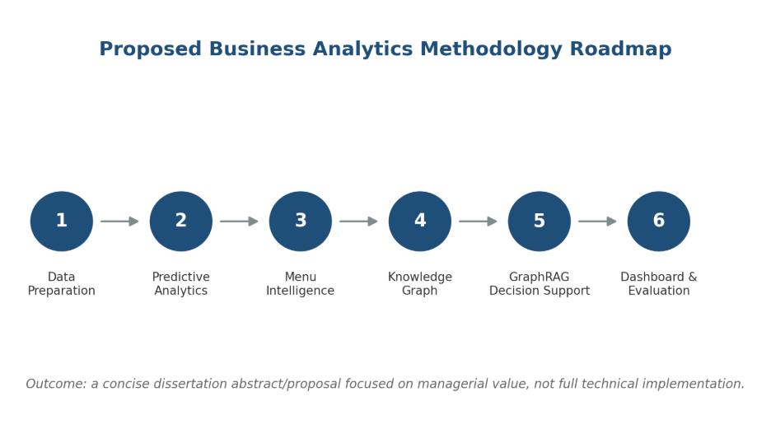
Figure 2: Proposed Business Analytics methodology roadmap.

Phase 1: Data Collection and Preparation
Collect and integrate food, ingredient, and nutrient datasets. Clean, standardize, transform, and engineer variables such as total preparation time, ingredient count, complexity score, course category, regional category, and dietary classification.

Phase 2: Predictive Analytics and Machine Learning
Build predictive models for operational planning. Regression models such as Random Forest, Gradient Boosting, or XGBoost may be evaluated using metrics such as Mean Absolute Error, Root Mean Squared Error, and R-squared.

Phase 3: Semantic Search and Menu Intelligence
Create semantic representations of dishes using dish names, ingredients, diet type, preparation method, course, and region. Use these representations for similarity search, recipe clustering, and substitution discovery.

Phase 4: Knowledge Graph Construction
Develop a graph-based representation of food operations where entities such as Dish, Ingredient, Nutrient, Allergen, Diet Type, Region, and Course are connected through meaningful relationships.

Phase 5: Graph RAG-Based Explainable Decision Support (Optional Advanced Extension)
Integrate graph retrieval with a natural language interface so that user responses are grounded in structured facts rather than unsupported generation.

Phase 6: Dashboard Development and Business Evaluation (Prototype Dashboard)
Build a dashboard covering preparation-time prediction, menu similarity, ingredient dependency, nutrition and allergen insights, and executive summaries.

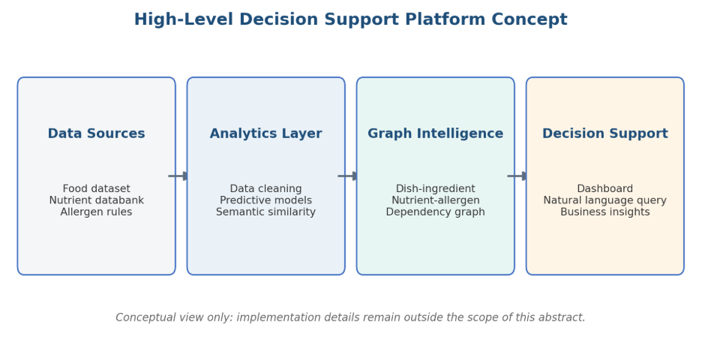
Figure 3: Conceptual framework flow for the abstract/proposal.

Chapter 5: Research Methodology

5.1 Research Design
The project follows an applied analytics and design-science orientation. It addresses a practical decision-support problem by constructing and evaluating an artefact: an evidence-aware food intelligence prototype. Quantitative methods are used for profiling, matching coverage, descriptive clustering, and semantic-retrieval preparation. Design-science elements are reflected in iterative creation of data structures, retrieval components, graph design, and dashboard views.
The unit of analysis is a canonical food record. A record is identified by food_code and may be linked to zero or one supporting recipe record. The design intentionally separates data facts from derived features and confidence labels, enabling later audit and revision.

5.2 Data Processing Workflow
Table 5. Seven-step data processing workflow from source profiling to dashboard delivery.
Step | Method | Output
1. Source profiling | Inspect dimensions, columns, identifiers, and missingness. | Documented source roles and quality checks.
2. Canonicalization | Standardize identifiers, names, numeric fields, and text. | Canonical food catalogue.
3. Recipe matching | Exact/alias matching followed by fuzzy review candidates. | Matched, review, and unmatched evidence labels.
4. Feature engineering | Create ratios, ingredient counts, semantic text, and cluster labels. | Analysis-ready fields.
5. Semantic representation | Encode semantic text using all-MiniLM-L6-v2. | 1,014 x 256 embedding matrix.
6. Graph modelling | Define nodes, relationships, constraints, and batch ingestion. | Neo4j-ready ingestion pipeline.
7. Dashboard prototype | Expose KPIs, filters, details, and semantic search. | Streamlit decision-support interface.

5.3 Research Questions
• RQ1: Can heterogeneous nutrition and recipe data be consolidated into an evidence-aware food catalogue suitable for analytics?
• RQ2: Can sentence embeddings support discovery of semantically comparable food records beyond keyword search?
• RQ3: Can a knowledge-graph model make dish, nutrient, ingredient, and declared-allergen relationships more visible and queryable?
• RQ4: Can a dashboard present food evidence in a form useful for menu exploration without making unsupported health or operational claims?

5.4 Evaluation Plan
Mid-semester evaluation focuses on artefact completeness and traceability: unique catalogue identifiers, non-negative constrained nutrient fields, match-status counts, recipe evidence coverage, embedding coverage, graph schema existence, and dashboard functionality. Subsequent evaluation will use manual review of fuzzy recipe matches, labelled retrieval queries for Precision@K, graph node/edge parity checks, and a structured usability review with potential users.

5.5 Hypotheses
The following hypotheses operationalize the research questions above. Each is stated as testable and is intended to be confirmed or rejected using the evaluation methods in Section 5.4 during the remaining project phases; none is treated as already proven at the mid-semester stage.
• H1 (linked to RQ1): A canonical catalogue built from heterogeneous nutrition and recipe sources can achieve unique-key integrity and traceable evidence status without manual record-by-record reconciliation.
• H2 (linked to RQ2): Sentence-embedding retrieval returns food records that domain-plausible reviewers judge as topically relevant more often than a literal keyword match on food names alone.
• H3 (linked to RQ3): A property-graph representation of dishes, nutrients, ingredients, and allergens allows relationship queries (for example, shared-ingredient or allergen-exclusion queries) that are not directly expressible as a single filter on the flat catalogue.
• H4 (linked to RQ4): A dashboard that exposes evidence status and applied filters is preferred by reviewers over an equivalent view that only shows a ranked recommendation without supporting evidence.

Plan of Work

Chapter 6: Plan Versus Progress
Table 6. Plan versus progress across the six project phases.
Phase | Planned deliverable | Actual mid-semester status | Progress
1. Data collection and preparation | Integrated, cleaned, feature-ready catalogue. | Completed core catalogue, matching outputs, ratios, clusters, semantic fields, and quality checks. | 90%
2. Predictive analytics | Preparation-time and complexity models. | Data fields and features identified; final benchmark models and metrics not yet exported. | 35%
3. Semantic search | Embedding generation and similarity exploration. | All catalogue records embedded; local and Qdrant-oriented retrieval paths implemented. | 80%
4. Knowledge graph | Neo4j graph and validation. | Schema constraints and ingestion script implemented; database execution and count validation pending. | 45%
5. Graph RAG (optional) | Graph-grounded language interface. | Deferred from achievement scope pending quality evaluation and simplification. | 0%
6. Dashboard | Managerial decision-support prototype. | Functional Streamlit dashboard and reproducible KPI experiment completed; formal usability evaluation pending. | 75%
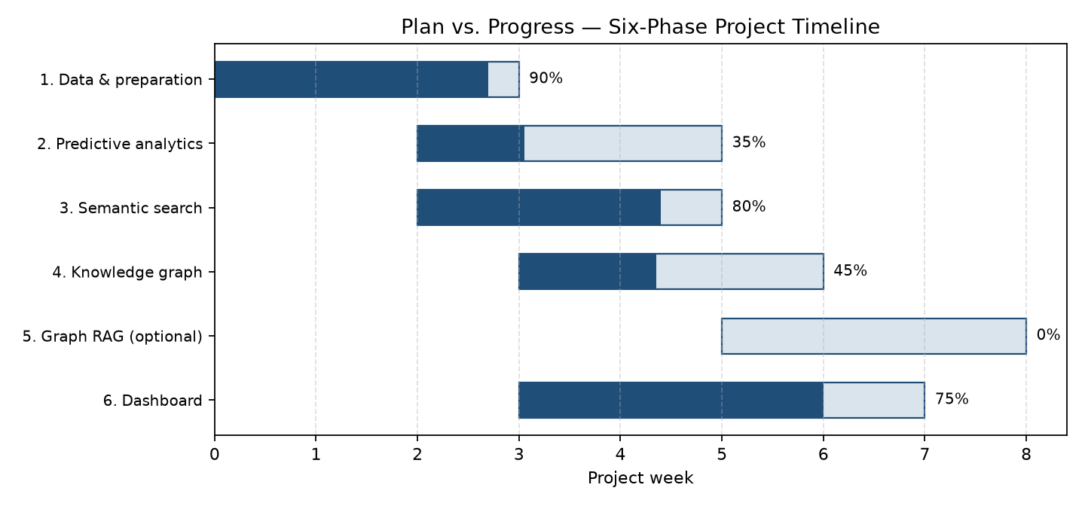
Figure 4. Plan vs. progress Gantt chart across the six project phases (weeks on the x-axis).

6.1 Milestone Interpretation
The project has progressed fastest in the data and interface layers because these provide the reliable foundation required for later modelling. The deliberate deferral of Graph RAG is a scope-control decision. It reduces the risk of presenting unvalidated generated recommendations and directs the remaining effort toward data quality, semantic evaluation, graph validation, and user-facing usefulness.
The main schedule deviation is that predictive modelling and graph validation are behind the initial conceptual plan. The corrective action is to use the established canonical catalogue as the single input for those tasks, avoiding further data restructuring. This ensures that future experiments use the same identifiers, match-status policy, and feature definitions as the dashboard.

Chapter 7: Detailed Work Completed till Mid-Semester
This chapter is organized by project phase, consistent with the six-phase methodology defined in the approved outline and the phase-wise implementation plan maintained for this project. Phase 4 (Graph RAG) is intentionally excluded from achievement claims in this chapter; it is retained only as an optional, deferred extension because its retrieval quality has not yet been validated.
Table 7. Mapping of report subsections to the project's six-phase methodology.
Project phase | Phase goal | Report subsection | Mid-semester status
Phase 0 - Foundation and governance | Freeze schema, nutrient dictionary, and validation rules. | 7.2 Data Cleaning and Evidence Management | Core validation checks implemented; formal contract documents pending.
Phase 1 - Data and classical ML | Clean data, engineer features, and benchmark baseline models. | 7.1-7.4 | Cleaning, matching, and features completed; baseline model metrics pending.
Phase 2 - Embeddings and semantic retrieval | Generate dish embeddings and enable similarity search. | 7.5 Semantic Search Design and Implementation | Embedding generation completed for the full catalogue.
Phase 3 - Knowledge graph construction | Model dishes, nutrients, ingredients, and allergens in Neo4j. | 7.6 Knowledge Graph Design | Schema and ingestion script implemented; ingestion validation pending.
Phase 4 - Graph RAG (optional, deferred) | Graph-grounded natural-language decision support. | Not claimed in this chapter | Excluded from mid-semester achievements pending quality evaluation.
Phase 5 - Dashboard and delivery | Deliver a decision-support interface for business users. | 7.7 Dashboard Design and Implemented Views | Functional Streamlit prototype completed; usability evaluation pending.

7.1 Dataset Identification and Roles
Table 8. Datasets used in the prototype and their primary roles.
Dataset | Records | Primary role | Use in prototype
Processed canonical catalogue | 1,014 food records; 97 fields | Central analytical dataset | Dashboard, embeddings, graph ingestion.
Indian Food Dataset | 5,938 recipes | Recipe composition and operational context | Ingredients, instructions, cuisine, time, ingredient count.
Allergen support dataset | 399 food-product records | Allergen seed information | Supporting allergen identification and review.
Recipe matching source | 2,231,142 raw rows examined | Recipe title evidence | Exact/alias and fuzzy review linkage.

The dataset architecture assigns one primary responsibility to each source. The canonical nutrition catalogue is the authority for nutrient facts. Recipe sources enrich records only when a match is supported. This source-role policy reduces the risk of blending incompatible facts or treating a similarly named recipe as a confirmed nutritional equivalent.

7.2 Data Cleaning and Evidence Management
Data cleaning included identifier checks, text handling, numeric-field inspection, and duplicate treatment. The processed catalogue contains 1,014 unique food_code values. Core nutrition fields checked for this report, including energy, protein, carbohydrate, fat, fiber, and sodium, have no negative recorded values. This is a basic but important validity condition before visualization or filtering.
Recipe-linking evidence is stored explicitly. Of the 1,014 foods, 449 are confirmed through exact or alias matching. Another 187 are plausible fuzzy candidates retained for review, and 378 have no accepted match. This policy protects the integrity of recipe and allergen details: a food record is not given recipe-derived facts merely because a name appears superficially similar.

7.3 Feature Engineering
Table 9. Engineered features and their analytical purpose.
Feature | Definition | Analytical purpose
ingredient_count | Count derived from a non-empty matched ingredient list. | Supports recipe-complexity and filter analysis.
protein_to_carb_ratio | protein_g divided by carb_g with numerical protection. | Compares macronutrient balance.
fat_to_carb_ratio | fat_g divided by carb_g with numerical protection. | Supports descriptive nutrition analysis.
calorie_to_protein_ratio | energy_kcal divided by protein_g with numerical protection. | Supports protein-density comparison.
semantic_text | Structured textual representation of food facts and recipe evidence. | Input for sentence embedding.
nutrition_cluster | Unsupervised label based on nutrition-profile features. | Portfolio segmentation, not clinical classification.
match_status | matched, review, or unmatched. | Controls appropriate use of recipe evidence.

7.4 Exploratory Analysis and Nutrition Clusters

Exploratory visualization was used to understand energy distributions, source composition, correlations among major nutrition features, and the quality of cluster separation. Clustering produces two descriptive menu segments in the current processed catalogue. Cluster 0 contains 709 records and has lower median energy and protein values than Cluster 1, which contains 305 records. These labels are used for portfolio comparison only and should not be interpreted as good-versus-bad food categories.
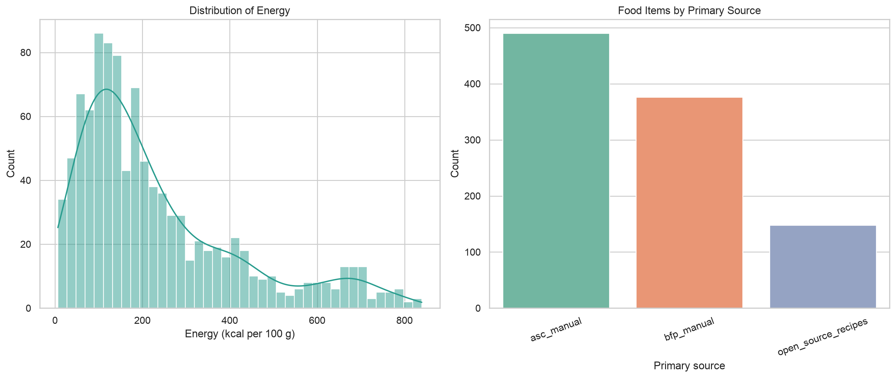
Figure 5. Energy and source distribution from the project exploratory analysis.
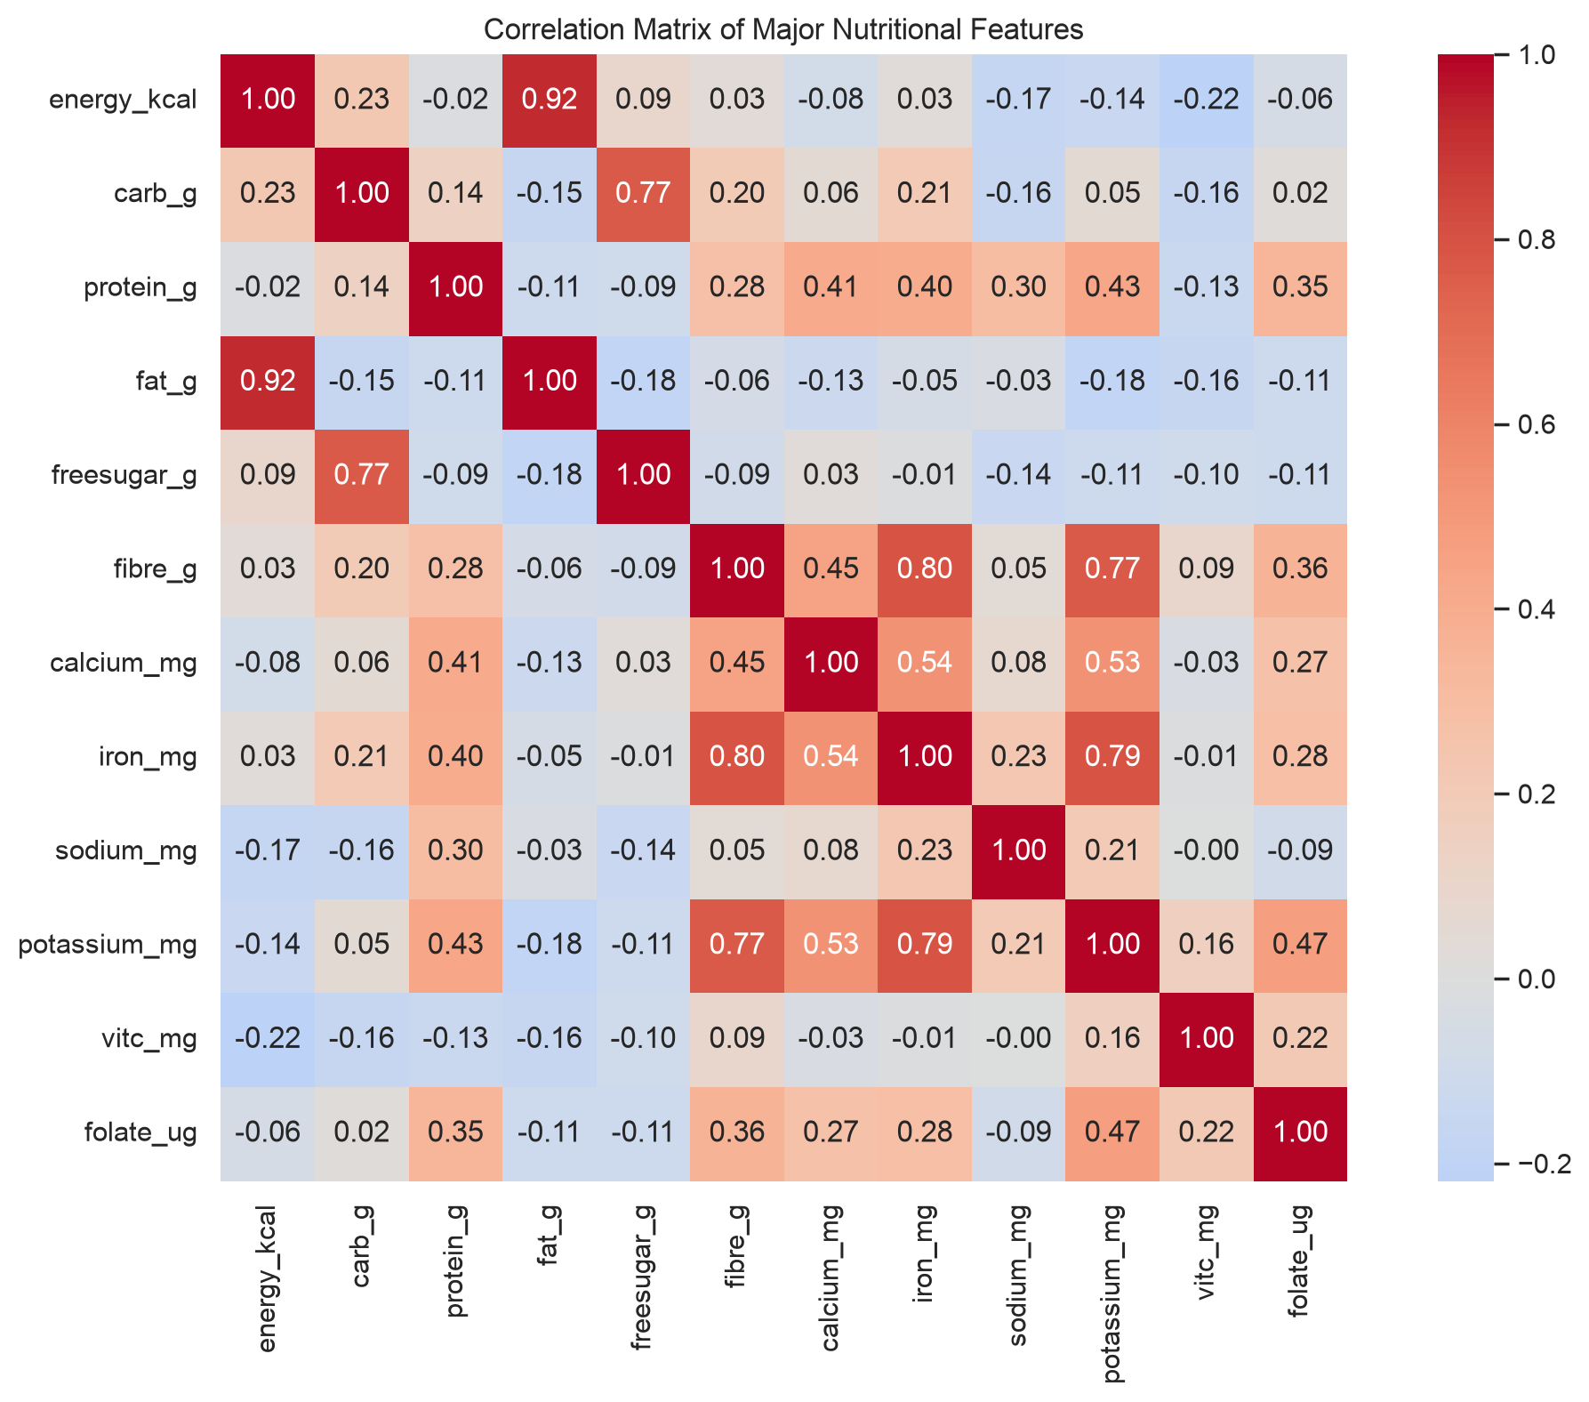
Figure 6. Major nutrition-feature correlations used for exploratory analysis.
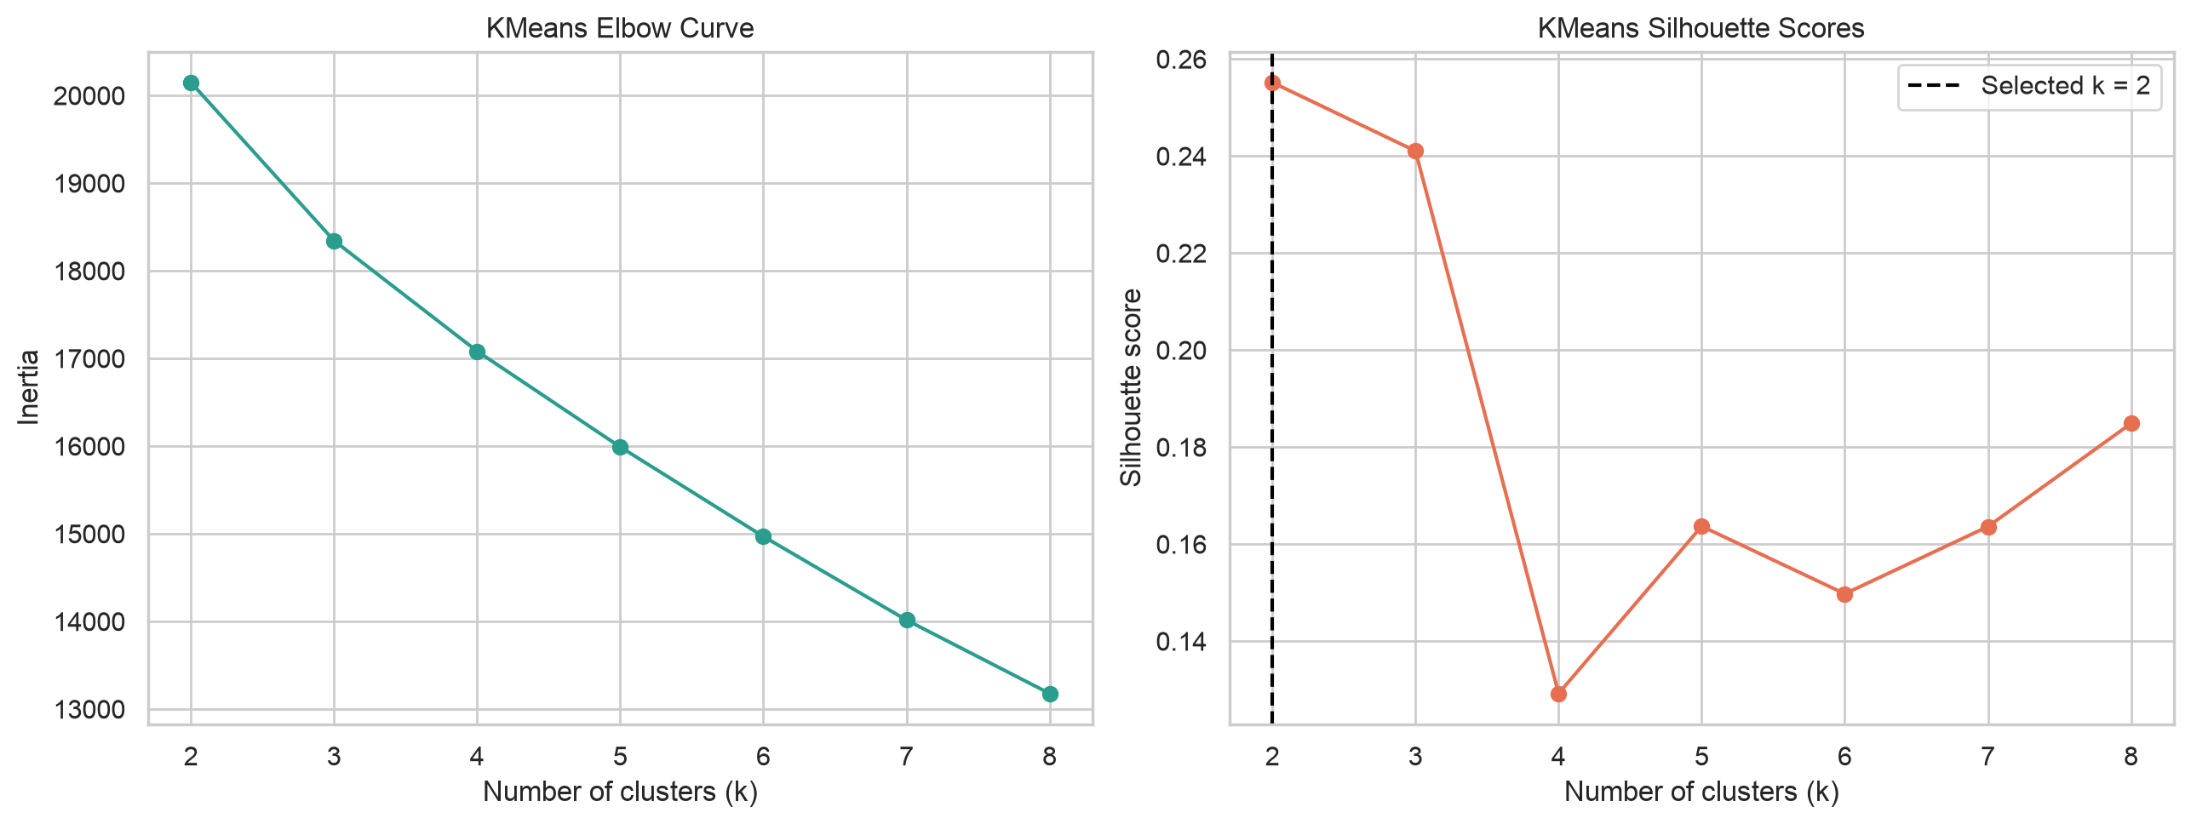
Figure 7. Clustering quality exploration from the project analysis.
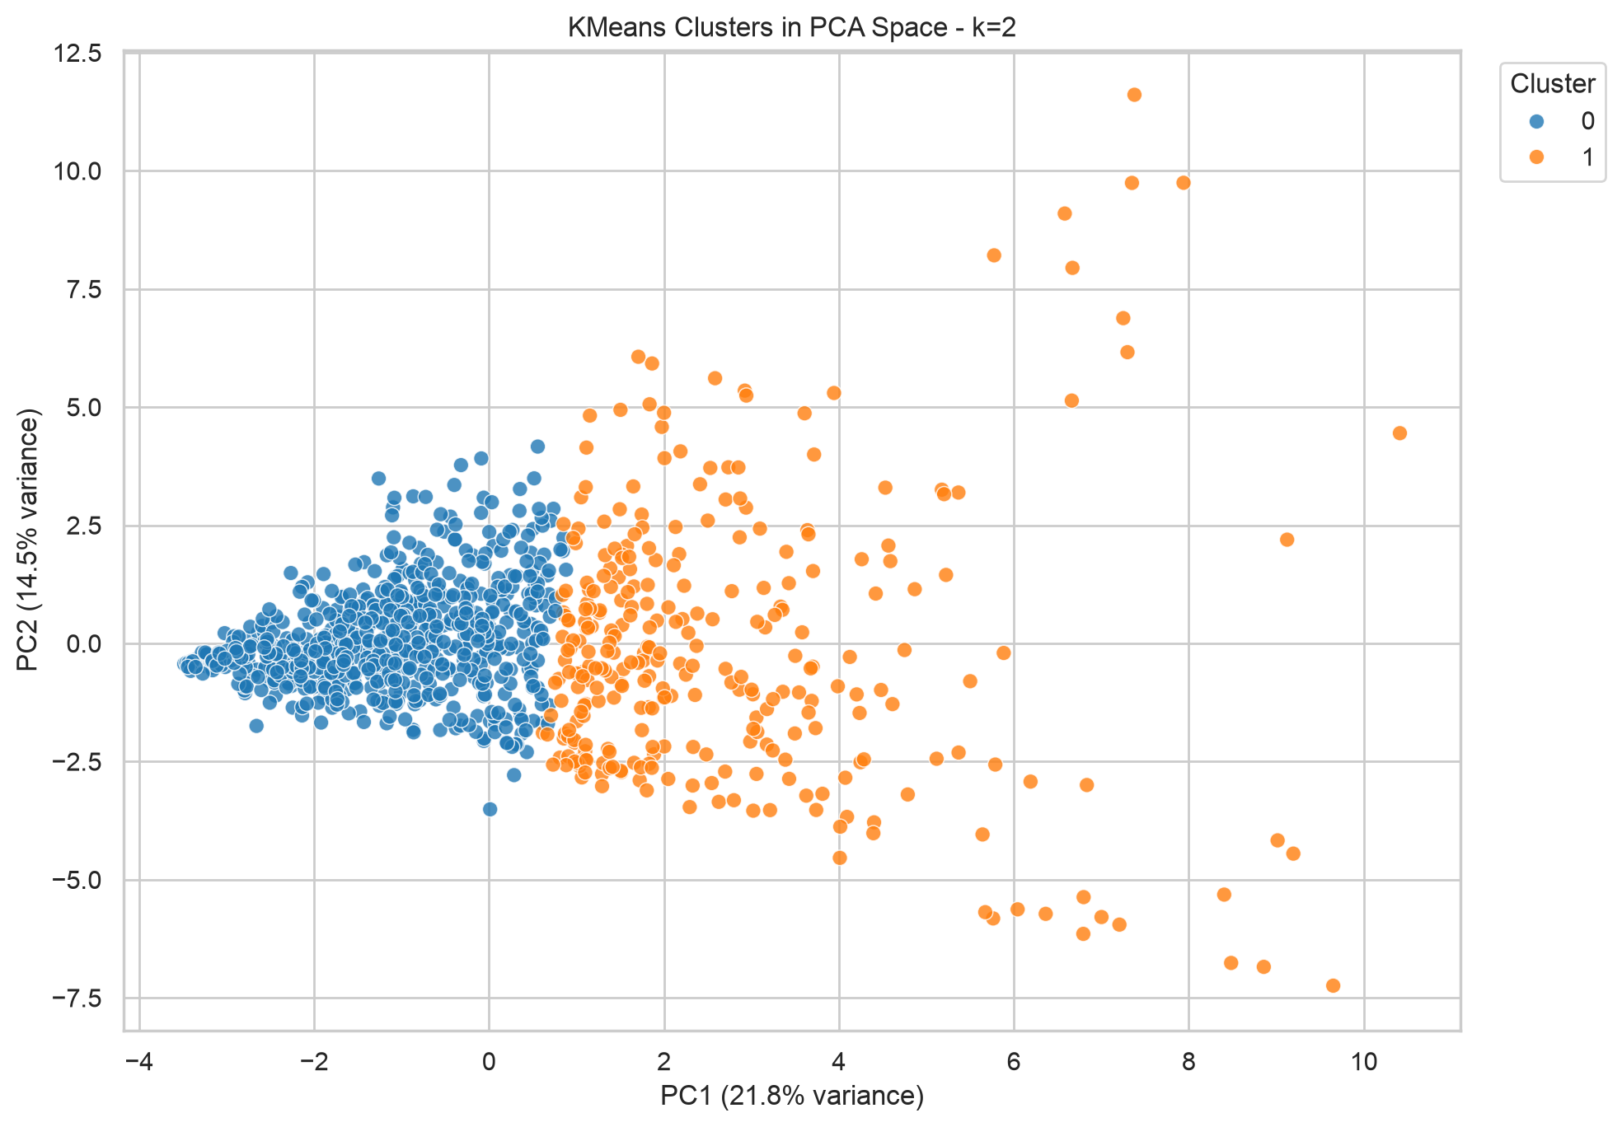
Figure 8. K-means cluster visualization using principal-component projection.
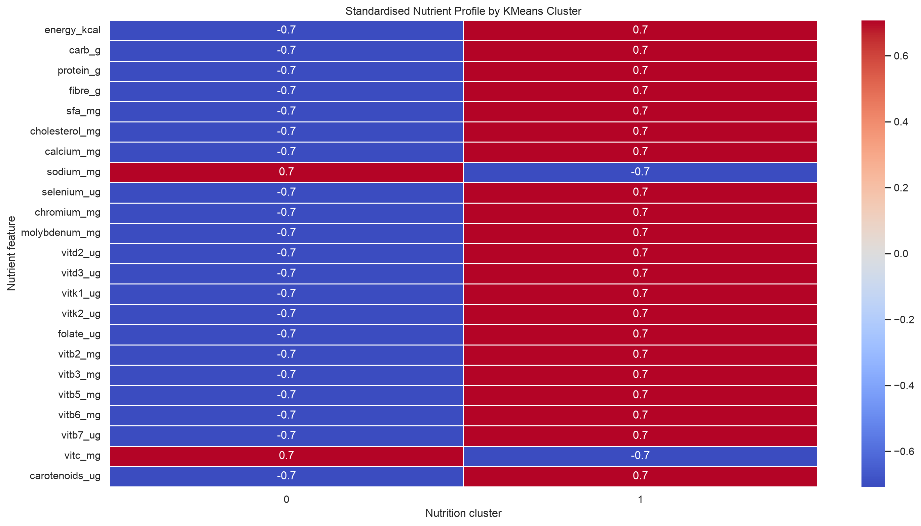
Figure 9. Nutrition-profile comparison across descriptive clusters.

7.5 Semantic Search Design and Implementation
For semantic search, each catalogue record is transformed into semantic text. The text combines food name, food code, linked recipe name, ingredients and instructions when verified, declared allergens, and selected nutrition facts. This design permits a user query to express an intention, such as finding a higher-protein food or discovering comparable dishes, without requiring exact dish-name wording.
The all-MiniLM-L6-v2 model creates a 256-dimensional embedding for each record. The saved matrix has one row per catalogue record, resulting in a 1,014 x 256 artifact. The system supports a Qdrant-oriented vector-database path and a local matrix fallback. The fallback is important for reproducible demonstrations because it allows semantic ranking without requiring a running external vector service.
Retrieval results are treated as candidates for exploration. A high semantic similarity score does not prove that two dishes are interchangeable, share ingredients, have identical cost, or are equally suitable for allergies. The dashboard therefore presents similarity as a discovery signal alongside evidence and nutrition fields.

7.6 Knowledge Graph Design

The implemented Neo4j ingestion design defines Dish, Nutrient, Ingredient, and Allergen nodes. A Dish node is keyed by food_code. Nutrient amounts and units are stored as properties on HAS_NUTRIENT relationships, which preserves a natural representation of the statement that a given dish has a particular nutrient quantity. Ingredient and declared-allergen relationships are added only from available catalogue evidence.
The graph design uses uniqueness constraints for Dish.food_code, Nutrient.name, Ingredient.name, and Allergen.name. This makes the ingest process re-runnable and reduces accidental duplication. Graph ingestion counts and relationship integrity checks are planned for the remaining semester work; they are not represented as completed results in this report.

Table 10. Knowledge-graph node and relationship types and their evidence policy.
Node / relation | Meaning | Evidence policy
Dish | Canonical food record. | Created for each unique food_code.
Nutrient | Named nutrition attribute. | Linked where numeric catalogue value is present.
Ingredient | Recipe ingredient token. | Linked only where recipe evidence is available.
Allergen | Declared allergen term. | Source-declared information; not inferred clinical safety.
HAS_NUTRIENT | Dish-to-nutrient relationship with amount and unit. | Derived from processed nutrition fields.
HAS_INGREDIENT | Dish-to-ingredient relationship. | Derived from linked recipe evidence.
HAS_DECLARED_ALLERGEN | Dish-to-allergen relationship. | Derived from catalogue allergen field.

7.7 Dashboard Design and Implemented Views
The dashboard is designed for four audiences: general users seeking a meal, cafeteria planners selecting candidates, managers reviewing overall coverage, and governance teams examining data quality. The primary interaction pattern is progressive filtering: users begin with a practical goal and add nutrition, evidence, allergen, or ingredient constraints only when required.
The Manager Overview reports catalogue size, confirmed recipe evidence, allergen information coverage, data-source count, nutrition clusters, and summary nutrition values. The Business, Operations and Strategy Scorecard intentionally distinguishes currently available menu evidence from unavailable commercial measures such as sales, inventory, waste, supplier performance, and kitchen timings. This avoids presenting missing business data as analytics results.
The Wellness Menu Planner applies transparent AND-based rules. For example, a high-protein profile filters for protein values at or above 10 g, while a heart-conscious profile applies sodium and cholesterol ceilings. The Food Intelligence Workspace permits keyword, nutrient, recipe-evidence, declared-allergen, and ingredient-count filters. A Semantic Similar-Food Explorer presents embedding-based comparable foods for review.
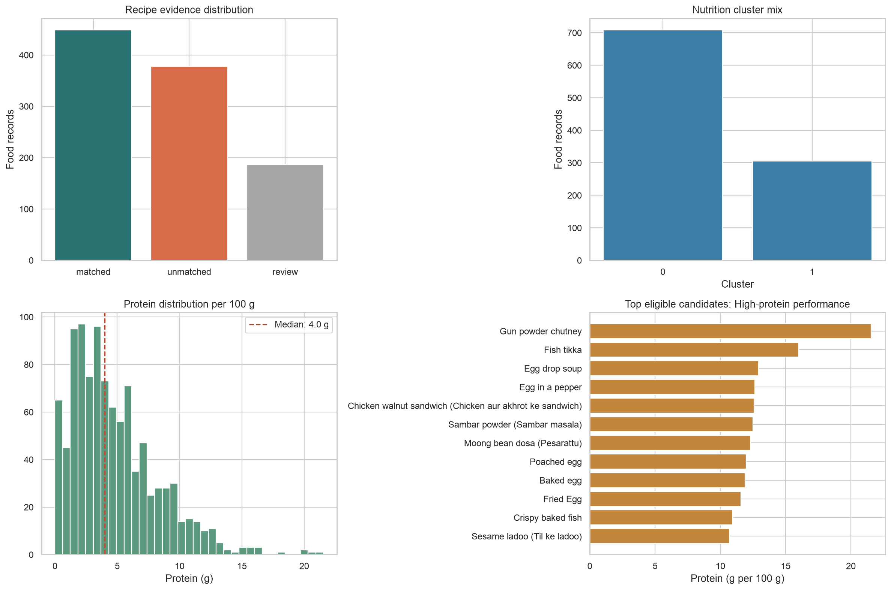
Figure 10. Reproducible dashboard KPI experiment and eligible-candidate analysis.

Phase | Activity | Key Deliverable | Business Relevance
Phase 1 | Data collection, cleaning, and standardization | Cleaned master analytical dataset | Reliable foundation for analysis
Phase 2 | Predictive model development | Preparation-time prediction model | Better kitchen planning
Phase 3 | Semantic similarity and recipe clustering | Menu intelligence module | Improved menu planning and substitutes
Phase 4 | Knowledge graph schema and ingestion | Food operations knowledge graph | Relationship-based decision support
Phase 5 | Exploratory Graph RAG Integration | Conceptual / Prototype Explainable Query Framework | Auditable natural language insights
Phase 6 | Dashboard creation and evaluation | Interactive analytics dashboard | Stakeholder-ready business communication
Final | Documentation and validation | Dissertation report and presentation | Academic submission package

Resource Requirements and Plan for their availability

Human Resources
- Student researcher
- Academic supervisor
- Optional inputs from food operations or nutrition domain experts
Data Resources
- Indian Food Dataset
- Indian Nutrient Databank
- Food ingredient and nutrition reference data
- Curated dietary and allergen information
Software Resources
- Python, Pandas, NumPy, Scikit-learn
- Machine learning models such as XGBoost or Random Forest
- Sentence embedding and similarity search tools
- Graph database such as Neo4j
- Lang Chain or Graph RAG framework
- Streamlit or equivalent dashboard framework
- Visualization library such as Plotly
Hardware Resources
- Standard laptop or workstation
- Cloud-hosted database environment, if required

Most software resources are open-source or available through free academic/developer tiers. The datasets are expected to be publicly available or academically usable. The project can be executed using a standard development environment without requiring specialized hardware.

Chapter 8: Resources and Availability
Table 11. Resource categories, availability, and handling approach.
Resource category | Required resource | Availability at mid-semester | Handling approach
Human | Student researcher and academic supervisor. | Available. | Iterative development and academic review.
Data | Nutrition, recipe, ingredient, and allergen-supporting datasets. | Available as local project data. | Use source-role and evidence-status policy.
Software | Python, Pandas, scikit-learn, Sentence Transformers, Streamlit. | Available through project environment. | Versioned dependency specification in pyproject.toml.
Vector retrieval | Qdrant or local embedding matrix. | Local artifact available; service optional. | Use local fallback during demonstrations.
Graph database | Neo4j local or managed instance. | Ingestion code ready; validated instance pending. | Complete validation in remaining work.
Hardware | Standard laptop/workstation. | Available. | Batch embedding and local artifacts limit compute requirements.
The resource strategy emphasizes reproducibility and low-cost tooling. Open-source Python libraries and locally stored artifacts allow the majority of the prototype to run without paid cloud services. Where infrastructure is unavailable, the design exposes clear fallback behavior rather than silently returning incomplete results.

Risks and Mitigation Plan

Risk | Impact | Likelihood | Mitigation Plan
Data quality issues such as missing values or inconsistent dish names | High | High | Apply data cleaning, imputation, standardization, and validation rules.
Inaccurate preparation-time prediction | Medium | Medium | Compare multiple models, tune parameters, validate results, and document limitations.
Ingredient name ambiguity across Indian regional foods | High | Medium | Use standardized naming, aliases, and entity resolution.
AI hallucination in nutrition or allergen responses | High | Medium | Restrict responses to graph-validated outputs and highlight source-grounded reasoning.
Knowledge graph complexity | Medium | Medium | Start with a manageable schema and expand iteratively.
Project timeline and integration complexity | Medium | Medium | Use phased development and prioritized a working minimum viable product.
Health-related interpretation risk | High | Low | Avoid medical diagnosis and position the output as decision support only.

Chapter 9: Risks, Mitigations, and Ethical Controls
Table 12. Identified risks, impact, mitigation, and contingency plans.
Risk | Potential impact | Mitigation | Contingency
Ambiguous recipe names | Incorrect ingredients or allergens could be linked. | Use confirmed, review, and unmatched evidence states. | Exclude review records from safety-sensitive use.
Missing allergen information | False confidence in food safety. | Display Not reported and source-declared wording. | Require manual recipe verification before approval.
Unit or serving inconsistencies | Misleading nutrition comparison. | Keep per-100 g and serving fields separate. | Document basis in all dashboard labels.
Semantic false similarity | Users may assume two foods are interchangeable. | Describe semantic search as discovery only. | Inspect recipe evidence and nutrition facts before decision.
Graph ingestion failure | Graph evidence may be incomplete. | Use constraints and count-validation checks. | Continue dashboard using canonical catalogue.
Scope expansion | Optional advanced features delay core deliverables. | Defer Graph RAG and prioritize evaluation. | Limit final scope to validated prototype capabilities.
Medical misuse | Users may treat dashboard output as health advice. | Use non-clinical language and visible disclaimers. | Refer users to qualified professionals for clinical concerns.
Ethically, the prototype follows the principle of calibrated claims. It reports what the dataset and implementation can support, labels what is uncertain, and avoids health, operational, or commercial conclusions that would require additional evidence. This approach is especially important because food information affects wellbeing and can be interpreted as safety guidance.

Chapter 10: Issues Faced and Resolutions
Table 13. Issues encountered during data preparation and their resolutions.
Issue | Resolution applied | Status
Large and duplicated recipe source | Removed duplicate titles and used a controlled matching pipeline. | Completed for current catalogue.
Dish-name variation | Applied exact/alias confirmation plus separate fuzzy review candidates. | Review queue remains for manual validation.
Partial recipe coverage | Preserved unmatched nutrition records without manufactured recipe facts. | Handled through evidence-status display.
Allergen uncertainty | Used declared data and not reported labels rather than guarantees. | Implemented in data and dashboard.
Vector-service dependency | Implemented local saved-embedding fallback. | Available for local demonstration.
Graph RAG complexity and unreliable early output | Marked as optional and removed from current achievement scope. | Deferred for later evaluation.
The key technical lesson is that evidence management is more important than forcing full coverage. Preserving unmatched and review states creates a more honest system and provides a clear backlog for future data validation. A second lesson is that advanced generated interfaces should not be prioritized ahead of trustworthy data, transparent filters, and reproducible retrieval behavior.

Expected Benefits

Chapter 11: Preliminary Conclusions and Recommendations

11.1 Preliminary Conclusions
The mid-semester work demonstrates the feasibility of constructing an evidence-aware food intelligence catalogue from heterogeneous public sources. The prototype integrates 1,014 nutrition records with recipe evidence, ingredients where supported, allergen declarations, derived analytical features, semantic embeddings, and dashboard-ready structures.
The recipe matching results show that linkage quality must be treated as a first-class analytical variable. A confirmed match rate of 44.28% is useful but not sufficient to justify attaching recipe evidence to every food record. The additional 18.44% review queue increases potential coverage, but it should remain visibly unconfirmed until manual validation is completed.
Semantic retrieval is technically feasible for the complete catalogue, with 100% embedding coverage. Its value is in expanding food discovery beyond keyword search. However, formal relevance testing is needed before claiming that it improves menu decisions. The graph design provides a transparent structure for connected food facts, but successful Neo4j ingestion and integrity validation remain required.
The Streamlit dashboard is a meaningful prototype outcome because it turns the dataset into an inspectable decision-support surface. It makes uncertainty visible and explicitly distinguishes currently available menu analytics from unavailable sales, cost, inventory, waste, and operational data.

11.2 Recommendations for Remaining Work
• Manually validate a sample of fuzzy recipe-match candidates and publish precision estimates for the matching process.
• Train and evaluate a preparation-time or recipe-complexity model only after confirming target completeness and preventing feature leakage.
• Build a labelled semantic-query set and report Precision@5 or a comparable retrieval metric.
• Execute the Neo4j ingestion pipeline, record node and relationship counts, and run integrity queries.
• Conduct a small usability evaluation with representative dashboard users and document task completion, clarity, and perceived usefulness.
• Keep Graph RAG optional until it can be evaluated against deterministic dashboard and graph-query baselines.

Annexure A: Dataset Dictionary
This annexure documents the processed canonical catalogue used by the dashboard, embedding pipeline, and graph ingestion design. Field definitions are concise descriptions for report interpretation; the source dataset remains the authoritative technical record.
Table 14. Dataset dictionary, fields 1-24.
Field | Description
food_code | Unique identifier for the canonical food record.
food_name | Canonical dish or food name from the nutrition source.
match_status | Evidence status: matched, review, or unmatched.
match_method | Method used to link a food to a recipe record.
match_score | Similarity or confidence score for the recipe match.
allergens | Source-declared allergen information; not a clinical guarantee.
document_id | Processed catalogue field retained for analysis and traceability.
semantic_text | Text payload used to generate the semantic embedding.
embedding_status | Readiness state for semantic retrieval.
recipe_name | Linked recipe title when supporting evidence is available.
ingredients | Recipe ingredient list when a recipe link exists.
ingredient_count | Derived count of available recipe ingredients.
instructions | Recipe preparation instructions when available.
primarysource | Origin or source category of the nutrition record.
energy_kj | Energy measurement in kilojoules, generally per 100 g unless prefixed by unit_serving.
energy_kcal | Energy measurement in kilocalories, generally per 100 g unless prefixed by unit_serving.
carb_g | Nutrient amount in grams.
protein_g | Nutrient amount in grams.
fat_g | Nutrient amount in grams.
freesugar_g | Nutrient amount in grams.
fibre_g | Nutrient amount in grams.
sfa_mg | Nutrient amount in milligrams.
mufa_mg | Nutrient amount in milligrams.
pufa_mg | Nutrient amount in milligrams.

Annexure A: Dataset Dictionary (continued)
Table 15. Dataset dictionary, fields 25-48.
Field | Description
cholesterol_mg | Nutrient amount in milligrams.
calcium_mg | Nutrient amount in milligrams.
phosphorus_mg | Nutrient amount in milligrams.
magnesium_mg | Nutrient amount in milligrams.
sodium_mg | Nutrient amount in milligrams.
potassium_mg | Nutrient amount in milligrams.
iron_mg | Nutrient amount in milligrams.
copper_mg | Nutrient amount in milligrams.
selenium_ug | Nutrient amount in micrograms.
chromium_mg | Nutrient amount in milligrams.
manganese_mg | Nutrient amount in milligrams.
molybdenum_mg | Nutrient amount in milligrams.
zinc_mg | Nutrient amount in milligrams.
vita_ug | Nutrient amount in micrograms.
vite_mg | Nutrient amount in milligrams.
vitd2_ug | Nutrient amount in micrograms.
vitd3_ug | Nutrient amount in micrograms.
vitk1_ug | Nutrient amount in micrograms.
vitk2_ug | Nutrient amount in micrograms.
folate_ug | Nutrient amount in micrograms.
vitb1_mg | Nutrient amount in milligrams.
vitb2_mg | Nutrient amount in milligrams.
vitb3_mg | Nutrient amount in milligrams.
vitb5_mg | Nutrient amount in milligrams.

Annexure A: Dataset Dictionary (continued)
Table 16. Dataset dictionary, fields 49-72.
Field | Description
vitb6_mg | Nutrient amount in milligrams.
vitb7_ug | Nutrient amount in micrograms.
vitb9_ug | Nutrient amount in micrograms.
vitc_mg | Nutrient amount in milligrams.
carotenoids_ug | Nutrient amount in micrograms.
servings_unit | Processed catalogue field retained for analysis and traceability.
unit_serving_energy_kj | Nutrient value expressed for the reported serving unit.
unit_serving_energy_kcal | Nutrient value expressed for the reported serving unit.
unit_serving_carb_g | Nutrient value expressed for the reported serving unit.
unit_serving_protein_g | Nutrient value expressed for the reported serving unit.
unit_serving_fat_g | Nutrient value expressed for the reported serving unit.
unit_serving_freesugar_g | Nutrient value expressed for the reported serving unit.
unit_serving_fibre_g | Nutrient value expressed for the reported serving unit.
unit_serving_sfa_mg | Nutrient value expressed for the reported serving unit.
unit_serving_mufa_mg | Nutrient value expressed for the reported serving unit.
unit_serving_pufa_mg | Nutrient value expressed for the reported serving unit.
unit_serving_cholesterol_mg | Nutrient value expressed for the reported serving unit.
unit_serving_calcium_mg | Nutrient value expressed for the reported serving unit.
unit_serving_phosphorus_mg | Nutrient value expressed for the reported serving unit.
unit_serving_magnesium_mg | Nutrient value expressed for the reported serving unit.
unit_serving_sodium_mg | Nutrient value expressed for the reported serving unit.
unit_serving_potassium_mg | Nutrient value expressed for the reported serving unit.
unit_serving_iron_mg | Nutrient value expressed for the reported serving unit.
unit_serving_copper_mg | Nutrient value expressed for the reported serving unit.

Annexure A: Dataset Dictionary (continued)
Table 17. Dataset dictionary, fields 73-96.
Field | Description
unit_serving_selenium_ug | Nutrient value expressed for the reported serving unit.
unit_serving_chromium_mg | Nutrient value expressed for the reported serving unit.
unit_serving_manganese_mg | Nutrient value expressed for the reported serving unit.
unit_serving_molybdenum_mg | Nutrient value expressed for the reported serving unit.
unit_serving_zinc_mg | Nutrient value expressed for the reported serving unit.
unit_serving_vita_ug | Nutrient value expressed for the reported serving unit.
unit_serving_vite_mg | Nutrient value expressed for the reported serving unit.
unit_serving_vitd2_ug | Nutrient value expressed for the reported serving unit.
unit_serving_vitd3_ug | Nutrient value expressed for the reported serving unit.
unit_serving_vitk1_ug | Nutrient value expressed for the reported serving unit.
unit_serving_vitk2_ug | Nutrient value expressed for the reported serving unit.
unit_serving_folate_ug | Nutrient value expressed for the reported serving unit.
unit_serving_vitb1_mg | Nutrient value expressed for the reported serving unit.
unit_serving_vitb2_mg | Nutrient value expressed for the reported serving unit.
unit_serving_vitb3_mg | Nutrient value expressed for the reported serving unit.
unit_serving_vitb5_mg | Nutrient value expressed for the reported serving unit.
unit_serving_vitb6_mg | Nutrient value expressed for the reported serving unit.
unit_serving_vitb7_ug | Nutrient value expressed for the reported serving unit.
unit_serving_vitb9_ug | Nutrient value expressed for the reported serving unit.
unit_serving_vitc_mg | Nutrient value expressed for the reported serving unit.
unit_serving_carotenoids_ug | Nutrient value expressed for the reported serving unit.
protein_to_carb_ratio | Derived protein-to-carbohydrate ratio.
fat_to_carb_ratio | Derived fat-to-carbohydrate ratio.
calorie_to_protein_ratio | Derived energy-to-protein ratio.

Annexure A: Dataset Dictionary (continued)
Table 18. Dataset dictionary, fields 97-97.
Field | Description
nutrition_cluster | Unsupervised nutrition-profile segment for descriptive analysis.

Annexure B: Reproducible KPI Snapshot
Table 19. Reproducible KPI snapshot computed directly from project artifacts.
Metric | Value
Catalogue dishes | 1014
Unique food codes | 1014
Confirmed recipe matches | 449
Confirmed match rate | 44.28%
Review candidates | 187
Review or confirmed coverage | 62.72%
Unmatched records | 378
Allergen declaration coverage | 59.07%
Semantic document coverage | 100.00%
Records with ingredient counts | 636
Data-source categories | 3
Raw recipe rows examined | 2,231,142
These values are derived from local project artifacts at report-generation time. They support reproducibility because the report can be regenerated after any validated change to the catalogue or matching pipeline.

Annexure C: Selected Implementation Excerpts
The following excerpts are included to document the implemented analytical logic. Full source code is retained in the project repository. Code excerpts are provided as technical evidence and should be read together with the data-quality and scope limitations described in the main report.

C.1 Evidence-aware menu filtering
def apply_menu_filters(catalog, profile, sources=None, statuses=None, allergens_to_avoid=None):
candidates = catalog.copy()
if sources:
candidates = candidates[candidates["primarysource"].isin(sources)]
if statuses:
candidates = candidates[candidates["match_status"].isin(statuses)]
for allergen in allergens_to_avoid or []:
candidates = candidates[~candidates["allergens"].str.contains(
allergen, case=False, na=False, regex=False
)]
for field, (minimum, maximum) in WELLNESS_GOALS[profile].items():
if minimum is not None:
candidates = candidates[candidates[field].ge(minimum)]
if maximum is not None:
candidates = candidates[candidates[field].le(maximum)]
return candidates

C.2 Neo4j schema constraints
statements = [
"CREATE CONSTRAINT dish_food_code IF NOT EXISTS "
"FOR (dish:Dish) REQUIRE dish.food_code IS UNIQUE",
"CREATE CONSTRAINT ingredient_name IF NOT EXISTS "
"FOR (ingredient:Ingredient) REQUIRE ingredient.name IS UNIQUE",
"CREATE CONSTRAINT nutrient_name IF NOT EXISTS "
"FOR (nutrient:Nutrient) REQUIRE nutrient.name IS UNIQUE",
"CREATE CONSTRAINT allergen_name IF NOT EXISTS "
"FOR (allergen:Allergen) REQUIRE allergen.name IS UNIQUE",
]

C.3 Graph nutrient relationship ingestion
UNWIND $rows AS row
MATCH (dish:Dish {food_code: row.food_code})
MERGE (nutrient:Nutrient {name: row.name})
MERGE (dish)-[measurement:HAS_NUTRIENT]->(nutrient)
SET measurement.amount = row.amount, measurement.unit = row.unit

C.4 Local embedding retrieval fallback
catalog = pd.read_csv(DATA_PATH).dropna(subset=["semantic_text"]).reset_index(drop=True)
embeddings = np.load(EMBEDDINGS_PATH)
if len(catalog) != len(embeddings):
raise ValueError("Catalog rows and saved embedding rows do not match.")
scores = embeddings @ query_vector
indices = np.argsort(scores)[-top_k:][::-1]
return [{"food_code": catalog.iloc[index]["food_code"],
"score": round(float(scores[index]), 4)} for index in indices]

Annexure D: References Added for the Expanded Report
Devlin, J., Chang, M.-W., Lee, K., & Toutanova, K. (2019). BERT: Pre-training of deep bidirectional transformers for language understanding. Proceedings of NAACL-HLT.
Doshi-Velez, F., & Kim, B. (2017). Towards a rigorous science of interpretable machine learning. arXiv:1702.08608.
Edge, D., Trinh, H., Cheng, N., Bradley, J., Chao, A., Mody, A., Truitt, S., Metropolitansky, D., Ness, R. O., & Larson, J. (2025). From local to global: A Graph RAG approach to query-focused summarization. arXiv:2404.16130.
Ehrlinger, L., & Wöß, W. (2016). Towards a definition of knowledge graphs. Proceedings of the SEMANTiCS Posters and Demos Track.
Freyne, J., & Berkovsky, S. (2010). Intelligent food planning: Personalized recipe recommendation. Proceedings of the 15th International Conference on Intelligent User Interfaces (IUI), 321-324.
Ge, M., Ricci, F., & Massimo, D. (2015). Health-aware food recommender system. Proceedings of the 9th ACM Conference on Recommender Systems, 333-334.
Kusner, M. J., Sun, Y., Kolkin, N. I., & Weinberger, K. Q. (2015). From word embeddings to document distances. Proceedings of the 32nd International Conference on Machine Learning.
Lewis, P., Perez, E., Piktus, A., et al. (2020). Retrieval-augmented generation for knowledge-intensive NLP tasks. Advances in Neural Information Processing Systems, 33.
Min, W., Jiang, S., Liu, L., Rui, Y., & Jain, R. (2019). A survey on food computing. ACM Computing Surveys, 52(5), 1-36.
Peñalvo, J. L., Sagastume, D., Mertens, E., Uzhova, I., Smith, J., Wu, J. H. Y., et al. (2021). Effectiveness of workplace wellness programmes for dietary habits, overweight, and cardiometabolic health: A systematic review and meta-analysis. Lancet Public Health, 6(9), e648-e660.
Reimers, N., & Gurevych, I. (2019). Sentence-BERT: Sentence embeddings using Siamese BERT-networks. Proceedings of EMNLP-IJCNLP.
Ribeiro, M. T., Singh, S., & Guestrin, C. (2016). "Why should I trust you?": Explaining the predictions of any classifier. Proceedings of the 22nd ACM SIGKDD International Conference on Knowledge Discovery and Data Mining, 1135-1144.
Robinson, I., Webber, J., & Eifrem, E. (2015). Graph databases: New opportunities for connected data. O'Reilly Media.
Teng, C.-Y., Lin, Y.-R., & Adamic, L. A. (2012). Recipe recommendation using ingredient networks. Proceedings of the 4th Annual ACM Web Science Conference, 298-307.
Trattner, C., & Elsweiler, D. (2017). Food recommender systems: important contributions, challenges and future research directions. arXiv:1711.02760.
Vaswani, A., Shazeer, N., Parmar, N., et al. (2017). Attention is all you need. Advances in Neural Information Processing Systems, 30.
World Health Organization. (2023). Healthy diet. https://www.who.int/news-room/fact-sheets/detail/healthy-diet
Yan, S.-Q., Gu, J.-C., Zhu, Y., & Ling, Z.-H. (2024). Corrective retrieval augmented generation. arXiv:2401.15884.

Annexure E: Summary of How Project Outline Feedback Was Addressed
Table 20. Mapping of project outline feedback to actions taken in this report.
Outline feedback / requirement | Action taken in the mid-semester report
Keep the work aligned to objectives | Each implemented component is mapped to an approved objective and its current evidence level.
Use an academic-project methodology | Added research design, research questions, evaluation plan, literature review, and research gap.
Show actual progress | Added reproducible counts for catalogue size, matching outcomes, embedding coverage, and dashboard scope.
Explain scope and limitations | Added explicit in-scope, out-of-scope, assumptions, constraints, risks, and ethical controls.
Provide detailed work completed | Documented data preparation, evidence policy, feature engineering, semantic retrieval, graph design, and dashboard implementation.
Avoid unsupported claims | Deferred Graph RAG, operational savings, clinical guidance, and unvalidated model-performance assertions.
The report has been expanded using project-specific evidence and original explanatory writing. It should be reviewed by the student and faculty guide before submission, particularly for institutional formatting, certificate wording, final page numbering, and confirmation that all claims match the latest validated artifacts.

Operational Benefits: Improved preparation-time forecasting, workload planning, service scheduling, and reduction of peak-hour bottlenecks.

Cost and Supply Chain Benefits: Better visibility into ingredient dependencies, high-frequency raw materials, procurement risk, and menu redundancy.

Employee Wellness Benefits: Improved nutritional transparency, allergen awareness, dietary preference support, and healthier menu decision-making.

Decision Support Benefits: Conversion of fragmented food and nutrition data into structured, explainable, and manager-friendly insights.

Business Analytics Benefits: Practical application of predictive modeling, semantic analytics, knowledge graph modeling, dashboarding, and stakeholder communication.

Strategic Benefits: Prototype for analytics-led transformation in enterprise food services and employee-centric workplace systems.

References

- Yan, S.-Q., Gu, J.-C., Zhu, Y., & Ling, Z.-H. (2024). Corrective Retrieval Augmented Generation. arXiv preprint arXiv:2401.15884.
- Edge, D., Trinh, H., Cheng, N., Bradley, J., Chao, A., Mody, A., Truitt, S., Metropolitansky, D., Ness, R. O., & Larson, J. (2025). From Local to Global: A Graph RAG Approach to Query-Focused Summarization. arXiv preprint arXiv:2404.16130
- Vaswani, A., Shazeer, N., Parmar, N., Uszkoreit, J., Jones, L., Gomez, A. N., Kaiser, Ł., & Polosukhin, I. (2017). Attention Is All You Need. In Advances in Neural Information Processing Systems (NeurIPS), Vol. 30.
- Larson, J., & Truitt, S. (2024). Graph RAG: Unlocking LLM discovery on narrative private data. Microsoft Research.
- Peñalvo, J. L., Sagastume, D., Mertens, E., Uzhova, I., Smith, J., Wu, J. H. Y., et al. (2021). Effectiveness of workplace wellness programmes for dietary habits, overweight, and cardiometabolic health: A systematic review and meta-analysis. The Lancet Public Health.
- Reimers, N., & Gurevych, I. (2019). Sentence-BERT: Sentence Embeddings using Siamese BERT-Networks. EMNLP-IJCNLP.
- Robinson, I., Webber, J., & Eifrem, E. (2015). Graph Databases: New Opportunities for Connected Data. O’Reilly Media.
- World Health Organization. Workplace health.

Glossary

Term | Meaning
Business Analytics | Use of data, statistical methods, and analytical models to support business decision-making.
Decision Support System | A system that helps managers make informed decisions using data, models, and insights.
Machine Learning | Algorithms that learn patterns from historical data and make predictions.
Predictive Analytics | Analytics technique used to forecast likely future outcomes.
Knowledge Graph | Structured representation of entities and relationships.
Graph RAG | Retrieval-Augmented Generation using graph-based retrieval and reasoning.
Semantic Search | Search method that identifies meaning and context rather than only matching keywords.
Vector Embedding | Numerical representation of text or entities used for similarity comparison.
Allergen | A substance that may trigger allergic reactions in sensitive individuals.
Supply Chain Dependency | Reliance of multiple products or operations on common raw materials.
Employee Wellness Analytics | Use of data and analytics to support workplace health and well-being programs.
Dashboard | Visual interface that presents key metrics and insights for business users.

BIRLA INSTITUTE OF TECHNOLOGY & SCIENCE, PILANI
Work Integrated Learning Programmes Division (WILPD)

Particulars of Student

Student Id | 2024HB21026
Student Name | Shubham Kumar
Student E-Mail Address | Shubham.Kumar.3@team.telstra.com / 2024hb21026@wilp.bits-pilani.ac.in
Employing Organization and Location | Telstra, Bangalore, India
Programme Name | MBA in Business Analytics
Semester | Final semester
Project Title | Analytics-Driven Decision Support Framework for Enterprise Food Operations and Employee Health Management

Particulars of the Supervisor and Additional Examiner

 | Supervisor | Additional Examiner
Name | Mrigank Sharma | Madhu Khiani
Qualification | Master of Computer Applications (MCA) | Bachelor Of Technology, IIT Roorkee
Designation | Chapter Lead | Senior Chapter Lead
Employing Organization and Location | Telstra, Bangalore, India | Telstra, Bangalore, India
Phone No (with STD code) | +91 9008018305 | +91 9741411771
Email Address | Mrigank.Sharma@team.telstra.com | Madhu.Khiani@team.telstra.com

Remarks of the Supervisor on Project Report
The proposed project addresses a relevant business analytics problem and demonstrates appropriate application of data analytics, machine learning, and decision-support concepts. The scope, methodology, and expected outcomes are suitable for an MBA in Business Analytics dissertation and provide potential value in the areas of food operations, employee wellness, and business intelligence.
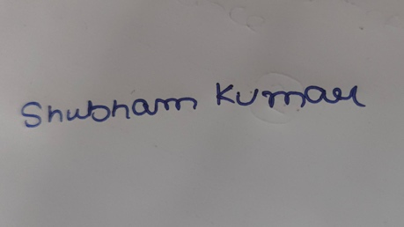 |  | 
Signature of Student | Signature of Supervisor | Signature of Additional Examiner
Name: Shubham Kumar | Name: Mrigank Sharma | Name: Madhu Khiani

