Analytics-Driven Decision Support Framework for Enterprise Food Operations and Employee Health Management
Course No. : S1-26_MBAZG622T
Course Title: Project
Project Report
Student Name: Shubham Kumar
BITS ID: 2024HB21026
Program: MBA in Business Analytics

Project Area: Bangalore, Karnataka, IN

Work Integrated Learning Programmes Division (WILPD),
BIRLA INSTITUTE OF TECHNOLOGY & SCIENCE, PILANI,
VIDYA VIHAR, PILANI, RAJASTHAN - 333031.
(November, 2026)
TABLE OF CONTENTS

Section No. | Section Name | Page No.
1 | Executive Summary of Mid-Semester Progress | 12
2 | Background | 13
3 | Problem Statement | 14
Chapter 1 | Expanded Requirement Statement and Problem Context | 16
4 | Motivation for this project | 17
5 | Project Objectives | 18
Chapter 2 | Project Objectives and Success Measures | 20
6 | Project Scope | 21
Chapter 3 | Scope, Assumptions, and Boundaries | 23
Chapter 4 | Literature Review and Research Gap | 25
7 | Proposed methodology | 28
Chapter 5 | Research Methodology | 31
8 | Plan of Work | 33
Chapter 6 | Plan Versus Progress | 33
Chapter 7 | Detailed Work Completed till Mid-Semester | 35
9 | Resource Requirements and Plan for their availability | 45
Chapter 8 | Resources and Availability | 47
10 | Risks and Mitigation Plan | 48
Chapter 9 | Risks, Mitigations, and Ethical Controls | 49
Chapter 10 | Issues Faced and Resolutions | 50
11 | Expected Benefits | 50
Chapter 11 | Preliminary Conclusions and Recommendations | 52
Chapter 12 | Summary of Project Outcomes | 53
Chapter 13 | Research Method and Evidence Base | 57
Chapter 14 | Business Context, Stakeholders and Strategic Fit | 59
Chapter 15 | System Architecture and Data Foundation | 64
Chapter 16 | Role-Based Service Design and Operations | 72
Chapter 17 | Analytics and Decision Support | 86
Chapter 18 | Verification, Testing and Findings | 93
Chapter 19 | Consumer Behaviour, Ethics, Privacy and Governance | 96
Chapter 20 | Financial Appraisal, Benefits and Balanced Scorecard | 100
Chapter 21 | KPI Framework and Measurement Plan | 104
Chapter 22 | Pilot Design, Change Management and Roadmap | 107
Chapter 23 | Risks and Limitations | 111
Chapter 24 | Conclusions and Recommendations | 113
Annexure A | Dataset Dictionary | 115
Annexure B | Reproducible KPI Snapshot | 121
Annexure C | Selected Implementation Excerpts | 122
Annexure D | Summary of How Project Outline Feedback Was Addressed | 123
Annexure E | Evidence and Reproduction Register | 124
Annexure F | API Operation Catalogue | 125
Annexure G | Selected Logic Excerpts | 126
Annexure H | Demonstration Script and Viva Preparation | 127
 | References | 128
 | Glossary | 131
 | Particulars of Student | 133
 | Particulars of the Supervisor and Additional Examiner | 134
 | Remarks of the Supervisor on Project Report | 135
List of Figures

Figure 1: Business Analytics value framework for the proposed abstract.
Figure 2: Proposed Business Analytics methodology roadmap.
Figure 3: Conceptual framework flow for the abstract/proposal.
Figure 4. Plan vs. progress Gantt chart across the six project phases (weeks on the x-axis).
Figure 5. Energy and source distribution from the project exploratory analysis.
Figure 6. Major nutrition-feature correlations used for exploratory analysis.
Figure 7. Clustering quality exploration from the project analysis.
Figure 8. K-means cluster visualization using principal-component projection.
Figure 9. Nutrition-profile comparison across descriptive clusters.
Figure 10. Reproducible dashboard KPI experiment and eligible-candidate analysis.
Figure 11: Plan versus final status across the six project phases (planning windows from Figure 4).
Figure 12: From the mid-semester catalogue to the ECOS operating service.
Figure 13: Enterprise food-service value chain and the ECOS layers that support it.
Figure 14: Stakeholder map: influence on and interest in the ECOS service.
Figure 15: System context of ECOS as implemented (derived from the project asset docs/assets/system-context.svg).
Figure 16: Target architecture poster for ECOS (existing project artefact; reconciled with the implementation in the table below).
Figure 17: Module connections of ECOS (derived from the project asset docs/assets/module-connections.svg).
Figure 18: From Qdrant payload to menu-ready recipe: the catalogue synchronisation pipeline.
Figure 19: Catalogue profile: diet mix, declared allergens, nutrition tags and estimated prices.
Figure 20: Service blueprint: employee touchpoints, kitchen activity, manager decisions and supporting data.
Figure 21: Order lifecycle (derived from the project asset docs/assets/order-lifecycle.svg).
Figure 22: Employee workspace: (a) Home; (b) Menu, For you (synthetic demonstration data).
Figure 23: Employee workspace: (a) Plan my day; (b) My orders.
Figure 24: Employee workspace: (a) My wellness; (b) Profile and preferences.
Figure 25: Manager workspace: (a) Today; (b) Live orders.
Figure 26: Manager workspace: (a) Inventory, Stock; (b) Today's consumption; (c) Risk and impact.
Figure 27: Manager workspace: (a) Forecasting; (b) Executive.
Figure 28: Manager workspace: (a) Menu management; (b) Copilot.
Figure 29: Recommendation pipeline: hard filters, scoring terms and the explanation shown to the employee.
Figure 30: Wellness score against the number of tagged portions ordered in a month.
Figure 31: Forecast pipeline: features, chronological split, evaluation and serving gate.
Figure 32: Forecast errors against the baseline and the stability of the serving gate.
Figure 33: Executed checks by group (138 backend and 34 user-interface, all passed).
Figure 34: Cumulative discounted cash flow and NPV under the three illustrative scenarios.
Figure 35: Management value chain (project asset docs/assets/management-value-chain.svg): where ECOS benefits are expected to arise.
Figure 36: Stage-gate pilot design with gate criteria.
Figure 37: Management roadmap: first 90 days and months 3 to 12 (planning windows, not commitments).
Figure 38: Pilot risk heat map (likelihood by impact, before controls).

Project Type: Academic Project (Type 3)

Project Area:

Business Analytics, Employee Health Management, Food Operations Analytics, Supply Chain Analytics

_____________________________________________________________________________________
List of Tables

Table 1. Operational, wellness, and analytics challenges mapped to the project's response.
Table 2. Approved objectives interpreted against mid-semester evidence.
Table 3. SMART mapping of core project objectives.
Table 4. Research gap identified between existing literature streams and this project.
Table 5. Seven-step data processing workflow from source profiling to dashboard delivery.
Table 6. Plan versus progress across the six project phases.
Table 7. Mapping of report subsections to the project's six-phase methodology.
Table 8. Datasets used in the prototype and their primary roles.
Table 9. Engineered features and their analytical purpose.
Table 10. Knowledge-graph node and relationship types and their evidence policy.
Table 11. Resource categories, availability, and handling approach.
Table 12. Identified risks, impact, mitigation, and contingency plans.
Table 13. Issues encountered during data preparation and their resolutions.
Table 14. Dataset dictionary, fields 1-24.
Table 15. Dataset dictionary, fields 25-48.
Table 16. Dataset dictionary, fields 49-72.
Table 17. Dataset dictionary, fields 73-96.
Table 18. Dataset dictionary, fields 97-97.
Table 19. Reproducible KPI snapshot computed directly from project artifacts.
Table 20. Mapping of project outline feedback to actions taken in this report.
Table 21. Project plan phases and their final status
Table 22. ECOS at a glance, with the evidence class of each fact
Table 23. Evidence classes and the inferences they permit
Table 24. Verification environment
Table 25. Stakeholders, needs and decision rights
Table 26. Strategic choices and their costs
Table 27. Levels of objective for the next evaluation stage
Table 28. Final scope boundary
Table 29. Target architecture compared with the verified implementation
Table 30. Technology stack and evidence class
Table 31. Suggested owners by capability
Table 32. MongoDB collections and their integrity rules
Table 33. Profile of the synchronised catalogue (1,014 dishes, run of 8 November 2026)
Table 34. Security controls in the verified implementation
Table 35. Who decides what in the manager workspace
Table 36. Service blueprint by stage
Table 37. Order states and what they mean for management
Table 38. Controls on the ordering and stock path
Table 39. Inventory risks and controls
Table 40. Procurement maturity, from visibility to invoice matching
Table 41. Operational review rhythm
Table 42. Hard filters applied before ranking (in order)
Table 43. Scoring terms of the recommendation heuristic
Table 44. Record to keep when a forecast drives a decision
Table 45. Forecast evaluation on synthetic demonstration history
Table 46. Stability of the serving gate (40 simulated histories per scenario)
Table 47. Standard for copilot answers
Table 48. Executed checks by suite and group
Table 49. Findings from the verification run
Table 50. Ladder for measuring consumer behaviour
Table 51. Guardrails for wellness features
Table 52. Minimum data-quality dimensions
Table 53. Checklist before any data use
Table 54. Controls across the analytics lifecycle
Table 55. Cost categories for a lifecycle view
Table 56. Illustrative appraisal under three scenarios (rupees in lakh; investment 12 lakh, three years)
Table 57. Register of benefit hypotheses
Table 58. Pilot scorecard by perspective
Table 59. Service and adoption KPIs
Table 60. Analytics and control KPIs
Table 61. Availability of KPI data in the current system
Table 62. Proposed pilot parameters
Table 63. Kotter's eight steps applied to the ECOS pilot
Table 64. Lifecycle stages and gate evidence
Table 65. Responsibility assignment for the pilot (R responsible, A accountable, C consulted, I informed)
Table 66. Risk register for the pilot
Table 67. Threats to validity and how they are handled
Table 68. Outcome of the research questions and hypotheses
Table 69. Status of the approved objective themes
Table 70. Prioritised recommendations
Table 71. Evidence register
Table 72. Operations of the ECOS service
Table 73. Eight-step demonstration script
Table 74. Likely questions and defensible answers

Analytics-Driven Decision Support Framework for Enterprise Food Operations and Employee Health Management

Executive Summary of Mid-Semester Progress
This section documents the research framing, dataset preparation, implementation evidence, preliminary findings, risks, and next steps completed at the mid-semester stage. It is written as an academic progress report for an MBA in Business Analytics project. The approved Project Report structure that follows is retained without alteration; this summary and the chapters after each corresponding approved section add the evidence gathered since the proposal stage.
The project develops a food intelligence decision-support prototype for enterprise food operations and employee wellness. Its current contribution is a traceable catalogue that connects nutrition facts with recipe evidence, ingredient information, declared allergens, semantic representations, and dashboard-based analysis. The work is exploratory and decision-support oriented; it does not provide clinical advice, diagnostic conclusions, or production deployment claims.
Graph RAG remains an optional advanced extension in the approved outline. It is deliberately excluded from the current achievement claims because its retrieval quality and operational complexity require further research validation. This decision narrows the mid-semester deliverable to reliable data preparation, semantic retrieval, graph modelling, and a transparent dashboard prototype.
Enterprise cafeterias and institutional food services must balance nutritional transparency, recipe evidence, food safety awareness, and practical menu planning. Yet food information is commonly fragmented across nutrition tables, recipe sources, ingredient records, and manually maintained menu documents. This project addresses that fragmentation by developing an analytics-driven food intelligence prototype for decision support.
The mid-semester implementation has produced a processed catalogue containing 1,014 uniquely identified food records and 97 analytical fields. The catalogue contains macronutrient and micronutrient facts, engineered ratios, recipe-match evidence, ingredient details were available, source-declared allergens, semantic text, embedding readiness, and nutrition-cluster labels. A total of 449 records has confirmed exact or alias recipe matches, while 187 records are retained in a review queue and 378 records remain unlinked rather than being assigned unsupported evidence.
Semantic representations have been generated for all 1,014 catalogue records using the all-MiniLM-L6-v2 sentence-transformer model. The resulting embedding matrix has dimensions 1,014 x 256 and supports natural-language discovery of comparable foods. The project also includes a Neo4j graph ingestion design and a Streamlit dashboard prototype. The dashboard presents menu-level nutrition patterns, evidence coverage, allergen visibility, semantic exploration, and constraint-based menu planning.
The preliminary result is not a claim that the system optimizes live cafeteria operations. Rather, it demonstrates that disparate food datasets can be integrated into an auditable analytical foundation. The next work focuses on evaluation: confirming fuzzy recipe matches, validating graph ingestion, constructing a labelled semantic-retrieval test set, and gathering user feedback on dashboard usefulness.

Background

Modern organizations are increasingly investing in employee wellness, workplace experience, and data-driven operational management. Food services such as enterprise cafeterias, institutional kitchens, and corporate catering facilities are no longer limited to meal preparation activities; they influence employee satisfaction, workplace health, operating efficiency, and organizational productivity.

Food operations face practical business challenges. Cafeteria and kitchen managers must plan menus, estimate preparation time, manage ingredient availability, control operational bottlenecks, minimize wastage, and ensure safe food choices for employees with dietary restrictions or allergen concerns. These decisions are often made using manual judgment, static menu records, and fragmented data sources.

At the same time, modern food-service environments require stronger nutritional transparency and explainable recommendations. Recipes, ingredients, nutrients, allergens, dietary categories, regions, and courses are naturally connected entities. A graph-based analytical approach can therefore support more structured reasoning than flat menu records.

This project proposes an analytics-driven decision support framework for enterprise food operations and employee health management. The framework is positioned as a Business Analytics solution that combines predictive analytics, semantic menu intelligence, knowledge graph modeling, and explainable natural language decision support.

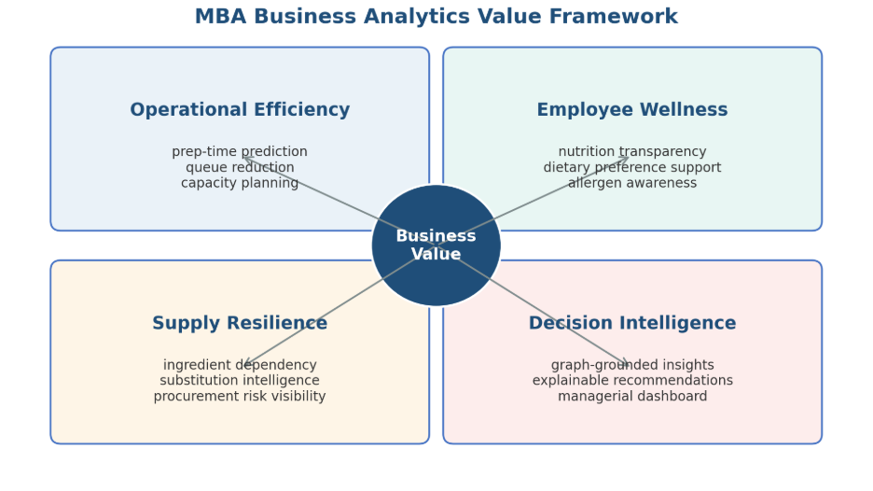
Figure 1: Business Analytics value framework for the proposed abstract.

Problem Statement

Enterprise cafeterias and institutional food operations typically operate under multiple constraints related to time, cost, nutrition, safety, and supply continuity. However, many such environments lack an integrated analytics framework that converts food, ingredient, nutritional, and operational data into actionable business insights.

- Operational planning problem: Limited ability to predict preparation time, kitchen workload, and peak-hour resource requirements.
- Menu intelligence problem: Menu records usually do not capture semantic similarity, ingredient substitutes, regional variations, and overlapping raw material dependencies.
- Nutrition and wellness problem: Employees increasingly require dietary transparency, but traditional cafeteria systems may not provide explainable nutritional or allergen guidance.
- Supply chain dependency problem: Ingredient shortages or price fluctuations can affect multiple dishes, but dependency visibility is often weak.
- AI reliability problem: Generic AI responses can be unsupported. In food and health contexts, decision support must be grounded in validated data relationships.

Therefore, there is a requirement for an integrated Business Analytics framework that supports cafeteria managers, employee wellness teams, and business stakeholders through predictive analytics, explainable recommendations, and dashboard-based decision support.

Chapter 1: Expanded Requirement Statement and Problem Context

1.1 Enterprise Food Operations Landscape
Enterprise cafeterias, institutional kitchens, and corporate food-service environments operate as recurring service systems. Their menu decisions influence employee experience, perceived wellness support, food availability, and kitchen workload. Unlike a simple retail catalogue, a cafeteria menu must be interpreted in relation to nutrition, ingredient composition, recipe complexity, allergy declarations, substitutions, and operational feasibility.
Food operations data is usually distributed across separate artifacts. Nutrition sources provide nutrient composition but rarely contain recipe ingredients or preparation methods. Recipe sources provide textual instructions and ingredients but may differ in naming conventions, serving assumptions, and cultural terminology. Allergen information can be incomplete or inconsistent. These conditions make it difficult to present reliable, comprehensible, and evidence-aware information to managers and users.

1.2 Operational, Wellness, and Analytics Challenges
Table 1. Operational, wellness, and analytics challenges mapped to the project's response.
Challenge area | Observed decision problem | Analytics response in this project
Menu information | Nutrition and recipe details exist in separate sources. | Create a canonical food catalogue with source-aware evidence fields.
Wellness transparency | Users need understandable information about nutrients and declared allergens. | Provide filtering and readable nutrition summaries without clinical claims.
Evidence quality | Dish names can be ambiguous across datasets. | Separate confirmed matches, review candidates, and unmatched records.
Menu discovery | Keyword search does not identify semantically comparable dishes. | Generate sentence embeddings for similarity-based exploration.
Relationship visibility | Ingredients, allergens, and nutrients are connected but hard to query together. | Model these entities and relations through a knowledge-graph design.

1.3 Refined Problem Statement
The central research problem is the absence of a transparent and integrated analytics layer that can connect food nutrition, recipe evidence, ingredients, declared allergens, and semantic similarity for enterprise food decision support. Existing raw datasets provide useful individual facts but do not directly support auditable menu exploration or managerial comparison.
Accordingly, the project investigates whether public food and recipe data can be transformed into a structured, evidence-aware catalogue and made accessible through analytics, semantic retrieval, graph modelling, and dashboard interaction. The project is evaluated as an applied prototype, not as a deployed operational system or medical recommendation engine.

Motivation for this project

The motivation for this project comes from the intersection of Business Analytics, AI-enabled decision support, employee wellness, and food operations optimization.

From a business perspective, enterprise cafeterias are high-volume service systems where small inefficiencies in preparation planning, food availability, or menu design can affect employee satisfaction, waiting time, food wastage, and operating cost. A data-driven framework can help managers move from reactive decision-making to proactive planning.

From an employee wellness perspective, workplace food environments can influence dietary choices and health awareness. An analytics framework that improves transparency around ingredients, nutrients, dietary categories, and allergens can support broader employee well-being initiatives.

From an MBA Business Analytics perspective, this project applies predictive modeling, data preparation, machine learning, dashboard development, decision support, supply chain analytics, and stakeholder communication. It converts technical capability into managerial value and demonstrates how analytics can solve practical business problems.

Project Objectives

The primary objective is to design and develop an analytics-driven decision support framework that improves enterprise food operations and supports employee health management through predictive analytics, knowledge graph intelligence, and explainable AI.

- Objective 1 - Operational Analytics: Develop machine learning models that predict food preparation time and operational complexity.
- Objective 2 - Menu Intelligence: Implement semantic similarity capabilities to identify similar dishes, possible substitutes, and menu redundancies.
- Objective 3 - Knowledge Graph Modeling: Create a structured food knowledge graph representing relationships among dishes, ingredients, nutrients, allergens, dietary categories, regions, courses, and operational dependencies.
- Objective 4 – Exploration of Explainable Decision Support: Use a Graph RAG-based query layer to enable graph-grounded, evidence-based, and auditable responses.
- Objective 5 - Supply Chain and Dependency Analytics: Identify high-dependency ingredients, ingredient overlap across dishes, and potential single points of failure in procurement and menu planning.
- Objective 6 - Employee Wellness Analytics: Support nutrition-aware food recommendations and dietary transparency.
- Objective 7 - Dashboard and Business Communication: Deliver an interactive dashboard that communicates operational, nutritional, and managerial insights to business users.

The success of the project will be evaluated using:
- Prediction Accuracy (MAE / RMSE)
- Model Explainability
- Reduction in manual menu analysis effort
- Ability to identify ingredient dependencies
- Quality of generated business insights
- Dashboard usability and decision-support effectiveness

Chapter 2: Project Objectives and Success Measures

2.1 Objective Interpretation at Mid-Semester
Table 2. Approved objectives interpreted against mid-semester evidence.
Approved objective | Mid-semester interpretation | Current evidence
Operational analytics | Prepare data and derived features that can later support operational models. | Recipe time and ingredient fields are available in source data; no final prediction model is claimed.
Menu intelligence | Enable comparable-food discovery beyond literal keywords. | 1,014 semantic documents and embeddings have been prepared.
Knowledge graph modelling | Define a relationship model and reproducible ingestion path. | Neo4j schema constraints and ingestion script implemented; validation remains pending.
Explainable decision support | Make evidence status and applied filters visible. | Dashboard presents match status, nutrition fields, declared allergens, and source-aware warnings.
Supply-chain dependency analytics | Establish ingredient-level evidence for later dependency analysis. | Ingredients are available for matched records; network analysis is future work.
Employee wellness analytics | Support non-clinical nutrition-aware food exploration. | Rule-based wellness filters are implemented in the dashboard.
Dashboard communication | Present the catalogue to non-technical decision makers. | Functional Streamlit prototype with manager, governance, planner, and explorer views.

2.2 SMART Objective Mapping
Table 3. SMART mapping of core project objectives.
Objective | Specific | Measure | Time-bound mid-semester evidence
Build canonical catalogue | Integrate nutrition and recipe evidence. | Unique food codes, evidence fields, quality checks. | Completed prototype catalogue.
Support semantic discovery | Embed food records for similarity retrieval. | Embedding coverage and retrieval test cases. | Embedding coverage completed; formal relevance evaluation pending.
Create graph foundation | Represent food relationships in Neo4j. | Constraints, node/edge ingestion, validation queries. | Schema and script completed; execution validation pending.
Deliver dashboard | Expose useful filters and evidence to users. | Working views, KPI outputs, user feedback. | Prototype completed; usability study pending.
The success measures have been deliberately separated into implementation measures and outcome measures. Implementation measures, such as record count, match coverage, embedding coverage, and dashboard availability, can be verified now. Outcome measures, such as reduced manual analysis effort, improved planning quality, or user satisfaction, require a future user study or a live organizational setting and are not claimed at this stage.

Project Scope

In-Scope Items

- Collection and integration of Indian food and nutrient datasets.
- Data cleaning, missing value treatment, standardization, and feature engineering.
- Predictive modeling for preparation-time and kitchen-complexity analytics.
- Semantic recipe representation for similarity search and menu intelligence.
- Knowledge graph modeling for dishes, ingredients, nutrients, allergens, regions, courses, and diets.
- Executive dashboard and business insight presentation.
- Evaluation of model outputs using prediction accuracy, recommendation relevance, explainability, and business usefulness.

Exploratory Scope Items

- Graph RAG-based natural language query interface for explainable decision support.

Out-of-Scope Items

- Real-time IoT kitchen sensor integration.
- Direct integration with live Point of Sale payment systems.
- Clinical diagnosis or medical treatment recommendation.
- Replacement of certified dietitians, doctors, or nutrition professionals.
- Full-scale enterprise deployment across multiple physical cafeteria locations.
- Real-time employee health record integration.
This project is positioned as a decision support and analytics framework, not as a clinical diagnosis tool.

Chapter 3: Scope, Assumptions, and Boundaries

3.1 In-Scope Work
• Integration of a nutrition-oriented food catalogue with publicly available recipe and allergen-supporting datasets.
• Data profiling, duplicate control, text normalization, evidence-status labelling, and feature engineering.
• Recipe title matching using exact, alias, and review-oriented fuzzy matching stages.
• Nutrition clustering for descriptive portfolio analysis.
• Sentence-transformer embeddings and semantic similar-food retrieval.
• Knowledge graph schema and repeatable Neo4j ingestion design for dishes, nutrients, ingredients, and allergens.
• A Streamlit dashboard with manager, data-quality, menu-planning, catalogue, and semantic-exploration views.

3.2 Out-of-Scope Work
• Live point-of-sale, procurement, inventory, kitchen sensor, employee-health, or personal medical data integration.
• Clinical nutrition assessment, diagnosis, treatment, or allergy guarantees.
• Claims of business savings, waste reduction, revenue improvement, or operational throughput without organizational data.
• Production rollout across multiple cafeterias and real-time automated menu decisions.
• Graph RAG as a completed project deliverable; it is retained only as a future optional extension.

3.3 Research Assumptions and Constraints
The work assumes that the available datasets are suitable for exploratory analytics, while recognizing that public datasets are heterogeneous. Nutrient values are treated as dataset-provided estimates. Recipe matches are treated as evidence only when the match status is confirmed; review and unmatched records must not be presented as verified recipe links.
The main constraints are limited project time, incomplete recipe linkage, possible differences in recipe serving conventions, restricted access to live operational data, and local-compute limits for model and database experiments. These constraints shape the project toward a decision-support prototype rather than a production system.

Chapter 4: Literature Review and Research Gap

4.1 Food Analytics and Nutrition-Aware Decision Support
Food informatics combines structured nutrient data, food descriptions, recipes, ingredients, and consumer-facing decision support. The challenge is not only to store food facts, but to preserve their source, units, context, and uncertainty. In an enterprise setting, this creates a need for interfaces that make food information understandable without oversimplifying safety or nutrition evidence.
Recommendation systems can help users navigate large catalogues, but nutrition-aware settings require transparent constraints. A ranked food should be accompanied by the facts and filters that produced the ranking. This principle motivates the present project's evidence-status fields and visible nutrition filters rather than opaque recommendation scores alone.
Min et al. (2019) survey food computing broadly, covering recognition, retrieval, recommendation, and nutrition monitoring, and note that most systems specialize in a single stage rather than connecting nutrient facts, recipe evidence, and user-facing explanation end to end. Freyne and Berkovsky (2010) show that ingredient-level recommendation is more acceptable to users than opaque recipe-level ranking, which supports this project's decision to expose ingredients and nutrients rather than a single unexplained score. Trattner and Elsweiler (2017) further argue that food recommenders must be evaluated against health-aware and diversity-aware criteria, not accuracy alone, reinforcing the project's calibrated, non-clinical framing.

4.2 Workplace Wellness and Food Transparency
Workplace wellness research indicates that food environments may influence dietary behavior, but intervention effects depend on context, design, and employee participation. The project therefore avoids causal claims. Instead, it treats nutrition-aware menu discovery and transparent information display as enabling capabilities that can be evaluated with users in a later stage.
The dashboard language is intentionally non-clinical. For example, a high-protein option is defined as a food satisfying a configured threshold in the dataset; it is not represented as an individually suitable health recommendation. This distinction is central to responsible analytics in a food-service setting.
Peñalvo et al. (2021) find mixed but generally positive effects of workplace wellness programmes on dietary habits, contingent on programme design and voluntary participation, which supports treating this project's nutrition filters as an enabling tool rather than a guaranteed behavior-change intervention. Ge, Ricci, and Massimo (2015) similarly propose health-aware recommendation as a decision-support layer that should be combined with, not substituted for, professional dietary guidance, a position consistent with the out-of-scope boundary defined in Chapter 3.

4.3 Semantic Search and Sentence Embeddings
Traditional keyword search depends on literal token overlap. Food naming is particularly variable because recipes may use regional names, preparation methods, ingredient references, or synonymous dish terms. Transformer architectures introduced contextual language representation, and Sentence-BERT subsequently enabled efficient sentence-level similarity comparison. These developments make semantic retrieval appropriate for food catalogue exploration.
In this project, semantic text includes dish identity, recipe evidence when available, allergens, ingredients, instructions, and selected nutrient facts. The embedding does not establish nutritional equivalence or ingredient safety. It acts as a discovery mechanism that surfaces comparable records for human review.
Devlin et al. (2019) introduced bidirectional transformer pretraining (BERT), which underlies most modern sentence-embedding models, including the all-MiniLM-L6-v2 model used in this project. Teng, Lin, and Adamic (2012) show that ingredient-co-occurrence networks can reveal substitution patterns in recipes, a complementary signal to text-based similarity that could extend this project's semantic layer in later phases.

4.4 Knowledge Graphs and Explainability
Knowledge graphs represent entities and relationships explicitly. A graph model is useful in food analytics because a dish may have many nutrients, ingredients, and allergens, while the same ingredient may occur in many dishes. Graph modelling supports relationship-oriented questions that are difficult to express through a single flat table.
The project adopts a property-graph approach using Neo4j. It places nutrient amounts on relationships between Dish and Nutrient nodes, retains declared allergen evidence separately, and uses unique constraints to make ingestion repeatable. The immediate value is structural transparency, even before advanced graph analytics or natural-language generation is attempted.
Ehrlinger and Wöß (2016) note that knowledge graphs are most useful when entity and relationship semantics are explicit and queryable, rather than merely stored as connected records; the constraint-based schema in this project follows that recommendation. Robinson, Webber, and Eifrem (2015) similarly argue that graph databases suit domains with many-to-many relationships, such as dishes sharing ingredients or nutrients, which are awkward to express in normalized relational tables.

4.5 Explainable and Responsible AI
Explainable AI emphasizes that an analytical output should be interpretable by the people who must act on it. In the present prototype, explainability is delivered through visible evidence status, source-aware fields, declared filters, and inspectable details. This approach is preferable at the current stage to presenting a black-box recommendation without provenance.
Responsible AI also requires an appropriate boundary for automated outputs. The project identifies uncertainty rather than concealing it: unmatched records stay unmatched, review records are marked for validation, declared allergens are not promoted to guarantees, and no medical or clinical advice is generated.
Ribeiro, Singh, and Guestrin (2016) argue that trust in a model's output depends on the user being able to see which evidence drove a specific prediction; this project applies the same principle at the data layer by keeping match method, match score, and evidence status visible alongside every record. Doshi-Velez and Kim (2017) caution that interpretability requirements differ by application stakes, which supports treating food-safety-adjacent outputs, such as allergen exclusions, with stricter evidence requirements than descriptive nutrition clustering.

4.6 Research Gap
Table 4. Research gap identified between existing literature streams and this project.
Research stream | Typical contribution | Gap addressed by this project
Nutrition databases | Provide nutrient composition. | Often lack linked recipe evidence and business-facing exploration.
Recipe recommendation | Suggest recipes or similar dishes. | May not preserve nutrition provenance and match confidence.
Knowledge graphs | Represent connected entities. | Often not combined with a practical menu-planning dashboard.
Workplace wellness | Studies food environment interventions. | Needs transparent tools for nutrition and menu information exploration.
Semantic retrieval | Discovers contextually similar text. | Requires domain-specific safeguards against unsupported equivalence claims.
The identified gap is a lightweight, traceable prototype that integrates nutrition data, recipe evidence, semantic discovery, graph structure, and managerial dashboarding while explicitly exposing uncertainty. The contribution is integration and auditability rather than a claim of novel machine-learning architecture.

Proposed methodology

The project will follow a structured Business Analytics methodology consisting of six phases. The focus of this abstract is to define the analytical approach and expected business value, not to provide detailed implementation code or system deployment steps.
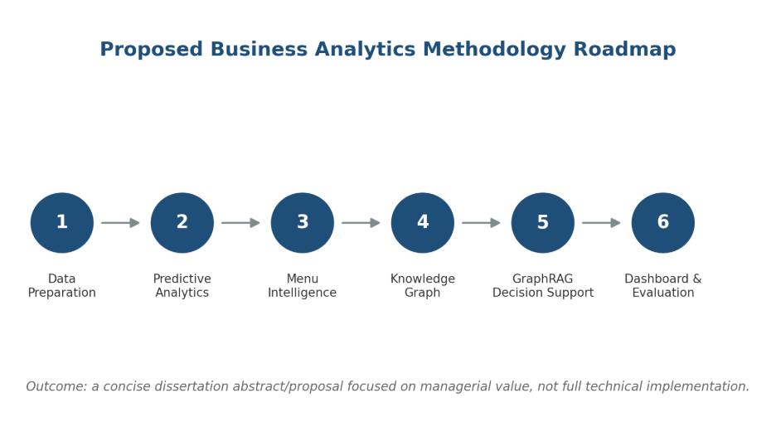
Figure 2: Proposed Business Analytics methodology roadmap.

Phase 1: Data Collection and Preparation
Collect and integrate food, ingredient, and nutrient datasets. Clean, standardize, transform, and engineer variables such as total preparation time, ingredient count, complexity score, course category, regional category, and dietary classification.

Phase 2: Predictive Analytics and Machine Learning
Build predictive models for operational planning. Regression models such as Random Forest, Gradient Boosting, or XGBoost may be evaluated using metrics such as Mean Absolute Error, Root Mean Squared Error, and R-squared.

Phase 3: Semantic Search and Menu Intelligence
Create semantic representations of dishes using dish names, ingredients, diet type, preparation method, course, and region. Use these representations for similarity search, recipe clustering, and substitution discovery.

Phase 4: Knowledge Graph Construction
Develop a graph-based representation of food operations where entities such as Dish, Ingredient, Nutrient, Allergen, Diet Type, Region, and Course are connected through meaningful relationships.

Phase 5: Graph RAG-Based Explainable Decision Support (Optional Advanced Extension)
Integrate graph retrieval with a natural language interface so that user responses are grounded in structured facts rather than unsupported generation.

Phase 6: Dashboard Development and Business Evaluation (Prototype Dashboard)
Build a dashboard covering preparation-time prediction, menu similarity, ingredient dependency, nutrition and allergen insights, and executive summaries.

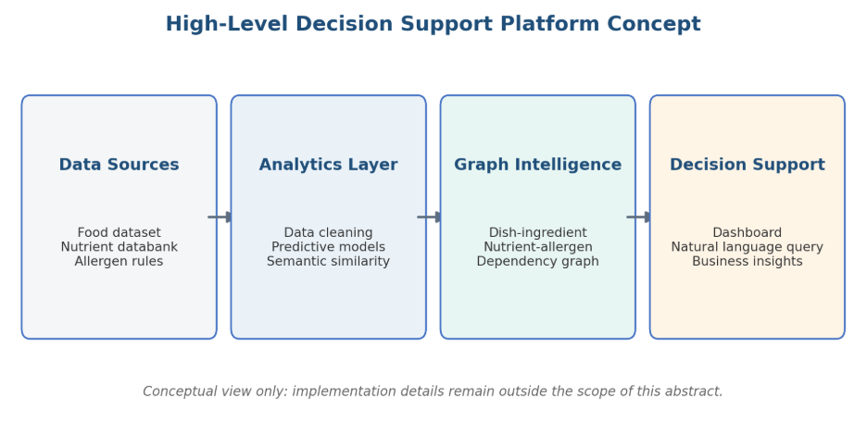
Figure 3: Conceptual framework flow for the abstract/proposal.

Chapter 5: Research Methodology

5.1 Research Design
The project follows an applied analytics and design-science orientation. It addresses a practical decision-support problem by constructing and evaluating an artefact: an evidence-aware food intelligence prototype. Quantitative methods are used for profiling, matching coverage, descriptive clustering, and semantic-retrieval preparation. Design-science elements are reflected in iterative creation of data structures, retrieval components, graph design, and dashboard views.
The unit of analysis is a canonical food record. A record is identified by food_code and may be linked to zero or one supporting recipe record. The design intentionally separates data facts from derived features and confidence labels, enabling later audit and revision.

5.2 Data Processing Workflow
Table 5. Seven-step data processing workflow from source profiling to dashboard delivery.
Step | Method | Output
1. Source profiling | Inspect dimensions, columns, identifiers, and missingness. | Documented source roles and quality checks.
2. Canonicalization | Standardize identifiers, names, numeric fields, and text. | Canonical food catalogue.
3. Recipe matching | Exact/alias matching followed by fuzzy review candidates. | Matched, review, and unmatched evidence labels.
4. Feature engineering | Create ratios, ingredient counts, semantic text, and cluster labels. | Analysis-ready fields.
5. Semantic representation | Encode semantic text using all-MiniLM-L6-v2. | 1,014 x 256 embedding matrix.
6. Graph modelling | Define nodes, relationships, constraints, and batch ingestion. | Neo4j-ready ingestion pipeline.
7. Dashboard prototype | Expose KPIs, filters, details, and semantic search. | Streamlit decision-support interface.

5.3 Research Questions
• RQ1: Can heterogeneous nutrition and recipe data be consolidated into an evidence-aware food catalogue suitable for analytics?
• RQ2: Can sentence embeddings support discovery of semantically comparable food records beyond keyword search?
• RQ3: Can a knowledge-graph model make dish, nutrient, ingredient, and declared-allergen relationships more visible and queryable?
• RQ4: Can a dashboard present food evidence in a form useful for menu exploration without making unsupported health or operational claims?

5.4 Evaluation Plan
Mid-semester evaluation focuses on artefact completeness and traceability: unique catalogue identifiers, non-negative constrained nutrient fields, match-status counts, recipe evidence coverage, embedding coverage, graph schema existence, and dashboard functionality. Subsequent evaluation will use manual review of fuzzy recipe matches, labelled retrieval queries for Precision@K, graph node/edge parity checks, and a structured usability review with potential users.

5.5 Hypotheses
The following hypotheses operationalize the research questions above. Each is stated as testable and is intended to be confirmed or rejected using the evaluation methods in Section 5.4 during the remaining project phases; none is treated as already proven at the mid-semester stage.
• H1 (linked to RQ1): A canonical catalogue built from heterogeneous nutrition and recipe sources can achieve unique-key integrity and traceable evidence status without manual record-by-record reconciliation.
• H2 (linked to RQ2): Sentence-embedding retrieval returns food records that domain-plausible reviewers judge as topically relevant more often than a literal keyword match on food names alone.
• H3 (linked to RQ3): A property-graph representation of dishes, nutrients, ingredients, and allergens allows relationship queries (for example, shared-ingredient or allergen-exclusion queries) that are not directly expressible as a single filter on the flat catalogue.
• H4 (linked to RQ4): A dashboard that exposes evidence status and applied filters is preferred by reviewers over an equivalent view that only shows a ranked recommendation without supporting evidence.

Plan of Work

Chapter 6: Plan Versus Progress
Table 6. Plan versus progress across the six project phases.
Phase | Planned deliverable | Actual mid-semester status | Progress
1. Data collection and preparation | Integrated, cleaned, feature-ready catalogue. | Completed core catalogue, matching outputs, ratios, clusters, semantic fields, and quality checks. | 90%
2. Predictive analytics | Preparation-time and complexity models. | Data fields and features identified; final benchmark models and metrics not yet exported. | 35%
3. Semantic search | Embedding generation and similarity exploration. | All catalogue records embedded; local and Qdrant-oriented retrieval paths implemented. | 80%
4. Knowledge graph | Neo4j graph and validation. | Schema constraints and ingestion script implemented; database execution and count validation pending. | 45%
5. Graph RAG (optional) | Graph-grounded language interface. | Deferred from achievement scope pending quality evaluation and simplification. | 0%
6. Dashboard | Managerial decision-support prototype. | Functional Streamlit dashboard and reproducible KPI experiment completed; formal usability evaluation pending. | 75%
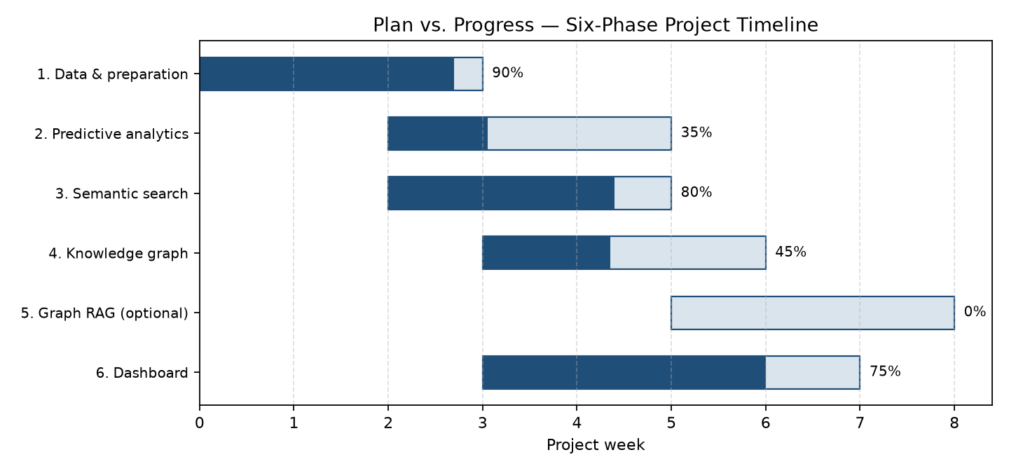
Figure 4. Plan vs. progress Gantt chart across the six project phases (weeks on the x-axis).

6.1 Milestone Interpretation
The project has progressed fastest in the data and interface layers because these provide the reliable foundation required for later modelling. The deliberate deferral of Graph RAG is a scope-control decision. It reduces the risk of presenting unvalidated generated recommendations and directs the remaining effort toward data quality, semantic evaluation, graph validation, and user-facing usefulness.
The main schedule deviation is that predictive modelling and graph validation are behind the initial conceptual plan. The corrective action is to use the established canonical catalogue as the single input for those tasks, avoiding further data restructuring. This ensures that future experiments use the same identifiers, match-status policy, and feature definitions as the dashboard.

Chapter 7: Detailed Work Completed till Mid-Semester
This chapter is organized by project phase, consistent with the six-phase methodology defined in the approved outline and the phase-wise implementation plan maintained for this project. Phase 4 (Graph RAG) is intentionally excluded from achievement claims in this chapter; it is retained only as an optional, deferred extension because its retrieval quality has not yet been validated.
Table 7. Mapping of report subsections to the project's six-phase methodology.
Project phase | Phase goal | Report subsection | Mid-semester status
Phase 0 - Foundation and governance | Freeze schema, nutrient dictionary, and validation rules. | 7.2 Data Cleaning and Evidence Management | Core validation checks implemented; formal contract documents pending.
Phase 1 - Data and classical ML | Clean data, engineer features, and benchmark baseline models. | 7.1-7.4 | Cleaning, matching, and features completed; baseline model metrics pending.
Phase 2 - Embeddings and semantic retrieval | Generate dish embeddings and enable similarity search. | 7.5 Semantic Search Design and Implementation | Embedding generation completed for the full catalogue.
Phase 3 - Knowledge graph construction | Model dishes, nutrients, ingredients, and allergens in Neo4j. | 7.6 Knowledge Graph Design | Schema and ingestion script implemented; ingestion validation pending.
Phase 4 - Graph RAG (optional, deferred) | Graph-grounded natural-language decision support. | Not claimed in this chapter | Excluded from mid-semester achievements pending quality evaluation.
Phase 5 - Dashboard and delivery | Deliver a decision-support interface for business users. | 7.7 Dashboard Design and Implemented Views | Functional Streamlit prototype completed; usability evaluation pending.

7.1 Dataset Identification and Roles
Table 8. Datasets used in the prototype and their primary roles.
Dataset | Records | Primary role | Use in prototype
Processed canonical catalogue | 1,014 food records; 97 fields | Central analytical dataset | Dashboard, embeddings, graph ingestion.
Indian Food Dataset | 5,938 recipes | Recipe composition and operational context | Ingredients, instructions, cuisine, time, ingredient count.
Allergen support dataset | 399 food-product records | Allergen seed information | Supporting allergen identification and review.
Recipe matching source | 2,231,142 raw rows examined | Recipe title evidence | Exact/alias and fuzzy review linkage.

The dataset architecture assigns one primary responsibility to each source. The canonical nutrition catalogue is the authority for nutrient facts. Recipe sources enrich records only when a match is supported. This source-role policy reduces the risk of blending incompatible facts or treating a similarly named recipe as a confirmed nutritional equivalent.

7.2 Data Cleaning and Evidence Management
Data cleaning included identifier checks, text handling, numeric-field inspection, and duplicate treatment. The processed catalogue contains 1,014 unique food_code values. Core nutrition fields checked for this report, including energy, protein, carbohydrate, fat, fiber, and sodium, have no negative recorded values. This is a basic but important validity condition before visualization or filtering.
Recipe-linking evidence is stored explicitly. Of the 1,014 foods, 449 are confirmed through exact or alias matching. Another 187 are plausible fuzzy candidates retained for review, and 378 have no accepted match. This policy protects the integrity of recipe and allergen details: a food record is not given recipe-derived facts merely because a name appears superficially similar.

7.3 Feature Engineering
Table 9. Engineered features and their analytical purpose.
Feature | Definition | Analytical purpose
ingredient_count | Count derived from a non-empty matched ingredient list. | Supports recipe-complexity and filter analysis.
protein_to_carb_ratio | protein_g divided by carb_g with numerical protection. | Compares macronutrient balance.
fat_to_carb_ratio | fat_g divided by carb_g with numerical protection. | Supports descriptive nutrition analysis.
calorie_to_protein_ratio | energy_kcal divided by protein_g with numerical protection. | Supports protein-density comparison.
semantic_text | Structured textual representation of food facts and recipe evidence. | Input for sentence embedding.
nutrition_cluster | Unsupervised label based on nutrition-profile features. | Portfolio segmentation, not clinical classification.
match_status | matched, review, or unmatched. | Controls appropriate use of recipe evidence.

7.4 Exploratory Analysis and Nutrition Clusters

Exploratory visualization was used to understand energy distributions, source composition, correlations among major nutrition features, and the quality of cluster separation. Clustering produces two descriptive menu segments in the current processed catalogue. Cluster 0 contains 709 records and has lower median energy and protein values than Cluster 1, which contains 305 records. These labels are used for portfolio comparison only and should not be interpreted as good-versus-bad food categories.
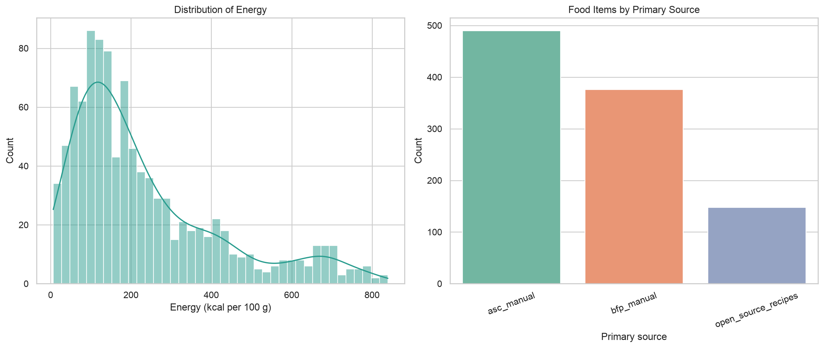
Figure 5. Energy and source distribution from the project exploratory analysis.
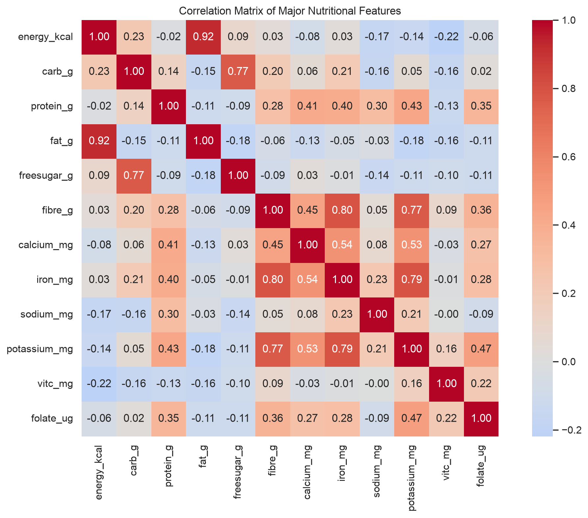
Figure 6. Major nutrition-feature correlations used for exploratory analysis.
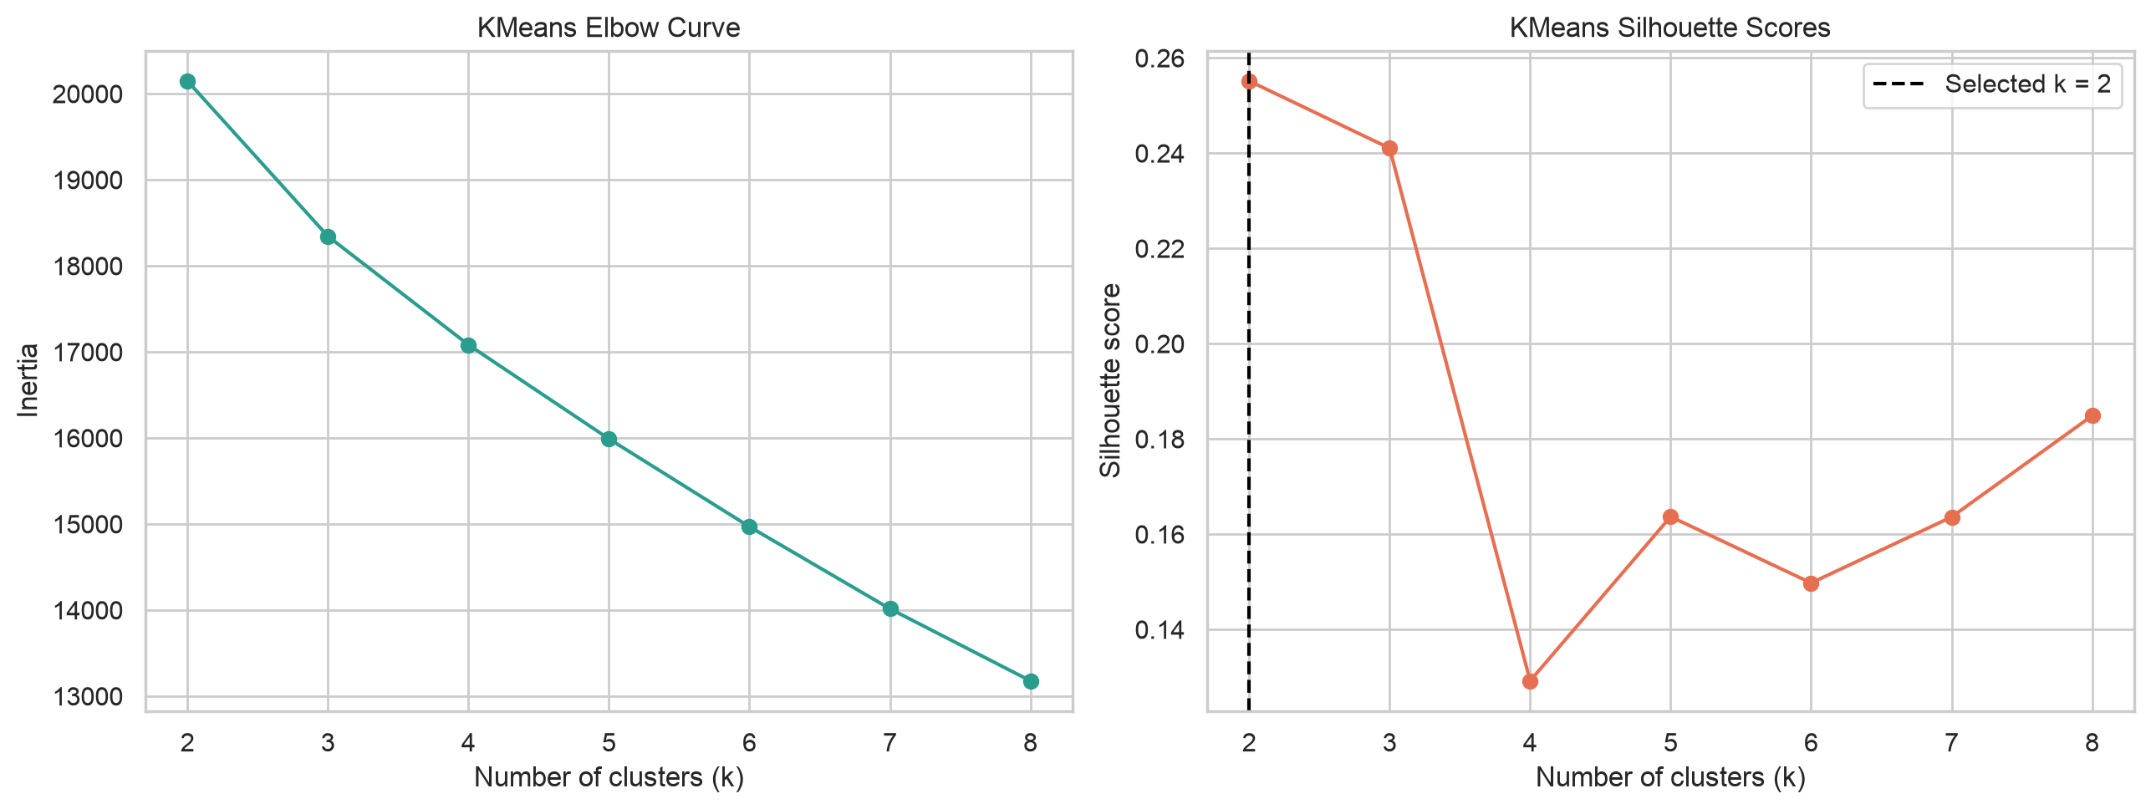
Figure 7. Clustering quality exploration from the project analysis.
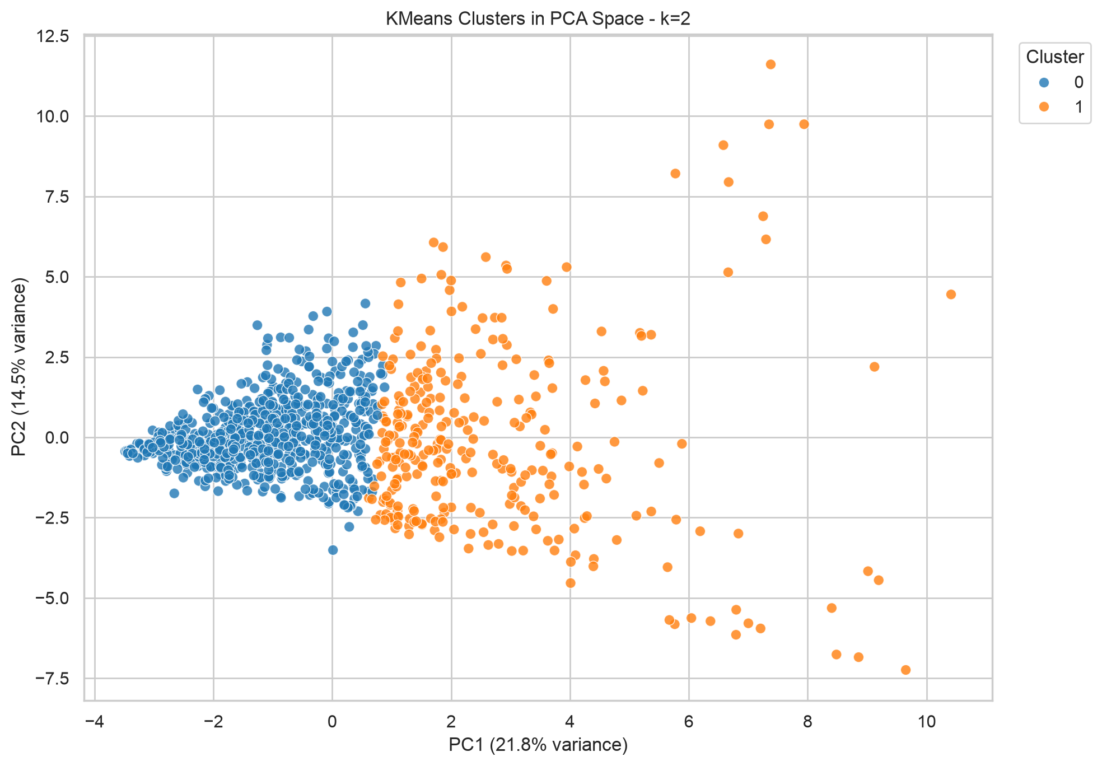
Figure 8. K-means cluster visualization using principal-component projection.
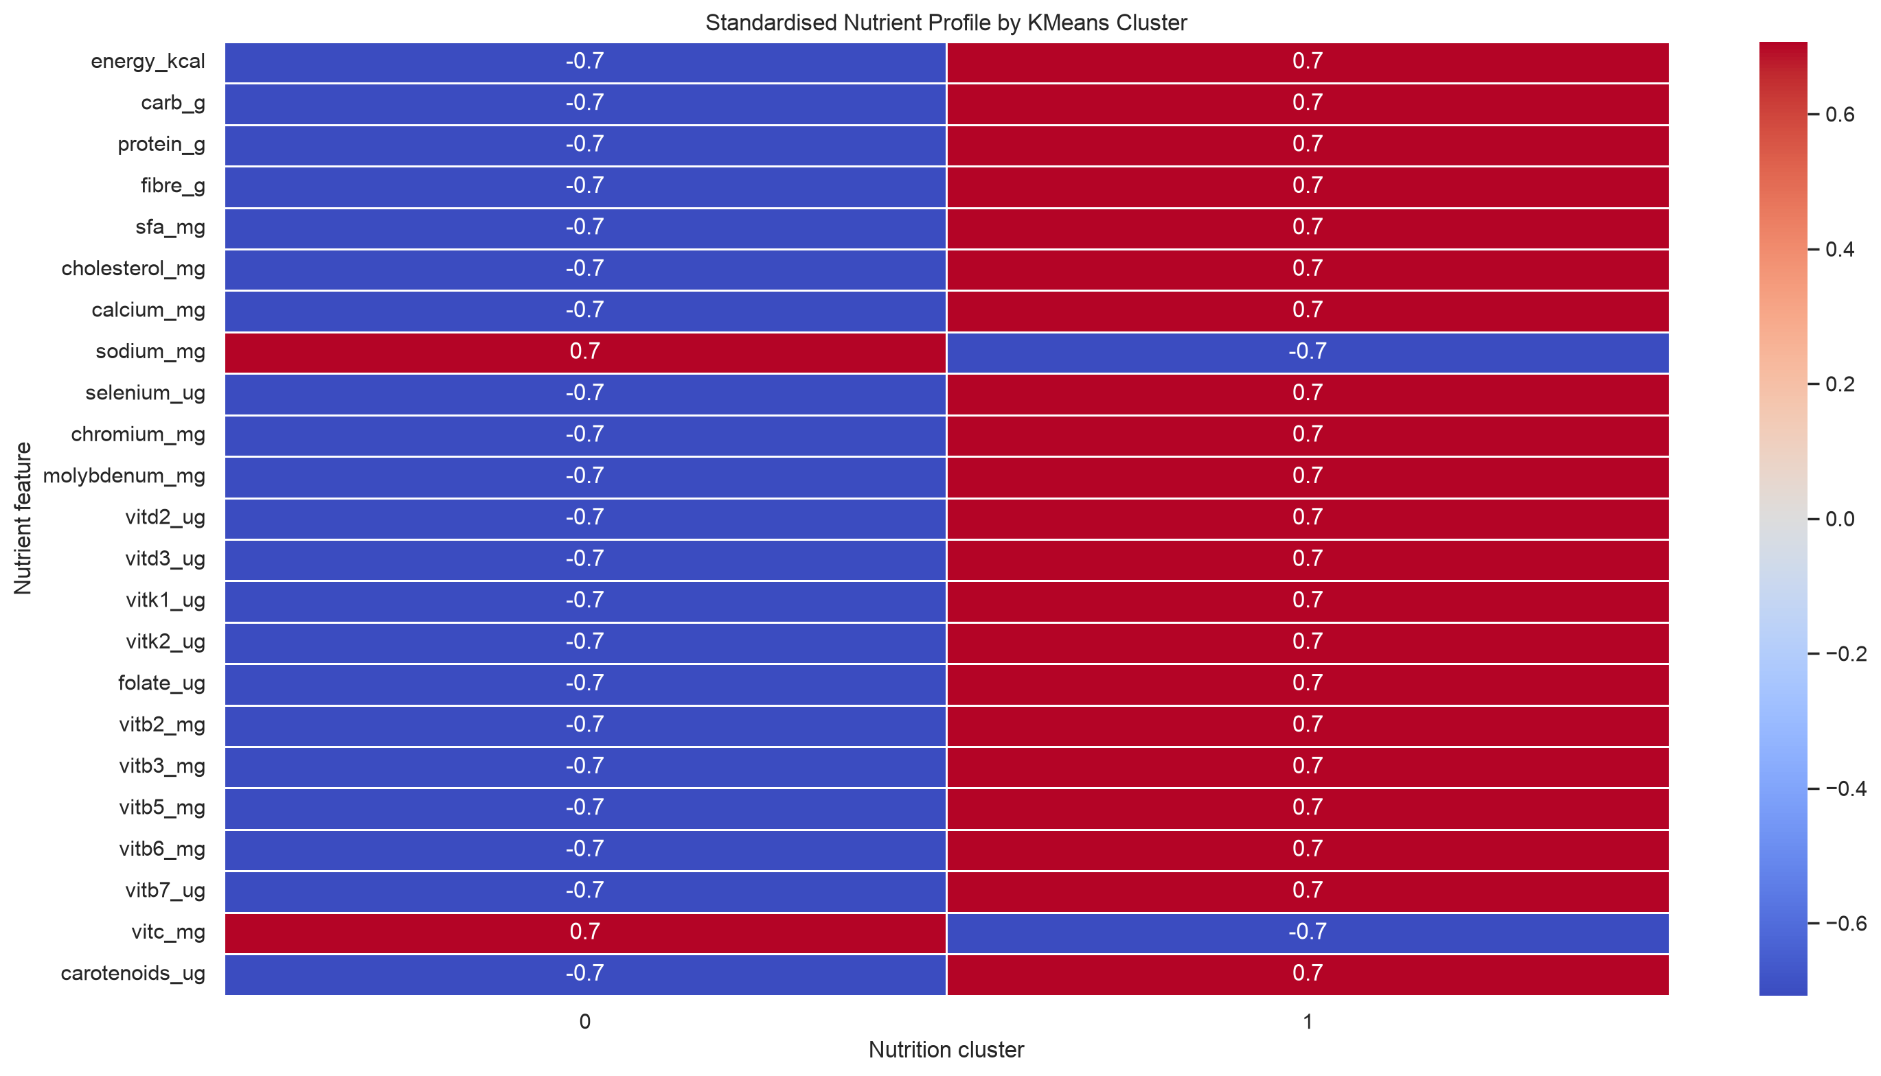
Figure 9. Nutrition-profile comparison across descriptive clusters.

7.5 Semantic Search Design and Implementation
For semantic search, each catalogue record is transformed into semantic text. The text combines food name, food code, linked recipe name, ingredients and instructions when verified, declared allergens, and selected nutrition facts. This design permits a user query to express an intention, such as finding a higher-protein food or discovering comparable dishes, without requiring exact dish-name wording.
The all-MiniLM-L6-v2 model creates a 256-dimensional embedding for each record. The saved matrix has one row per catalogue record, resulting in a 1,014 x 256 artifact. The system supports a Qdrant-oriented vector-database path and a local matrix fallback. The fallback is important for reproducible demonstrations because it allows semantic ranking without requiring a running external vector service.
Retrieval results are treated as candidates for exploration. A high semantic similarity score does not prove that two dishes are interchangeable, share ingredients, have identical cost, or are equally suitable for allergies. The dashboard therefore presents similarity as a discovery signal alongside evidence and nutrition fields.

7.6 Knowledge Graph Design

The implemented Neo4j ingestion design defines Dish, Nutrient, Ingredient, and Allergen nodes. A Dish node is keyed by food_code. Nutrient amounts and units are stored as properties on HAS_NUTRIENT relationships, which preserves a natural representation of the statement that a given dish has a particular nutrient quantity. Ingredient and declared-allergen relationships are added only from available catalogue evidence.
The graph design uses uniqueness constraints for Dish.food_code, Nutrient.name, Ingredient.name, and Allergen.name. This makes the ingest process re-runnable and reduces accidental duplication. Graph ingestion counts and relationship integrity checks are planned for the remaining semester work; they are not represented as completed results in this report.

Table 10. Knowledge-graph node and relationship types and their evidence policy.
Node / relation | Meaning | Evidence policy
Dish | Canonical food record. | Created for each unique food_code.
Nutrient | Named nutrition attribute. | Linked where numeric catalogue value is present.
Ingredient | Recipe ingredient token. | Linked only where recipe evidence is available.
Allergen | Declared allergen term. | Source-declared information; not inferred clinical safety.
HAS_NUTRIENT | Dish-to-nutrient relationship with amount and unit. | Derived from processed nutrition fields.
HAS_INGREDIENT | Dish-to-ingredient relationship. | Derived from linked recipe evidence.
HAS_DECLARED_ALLERGEN | Dish-to-allergen relationship. | Derived from catalogue allergen field.

7.7 Dashboard Design and Implemented Views
The dashboard is designed for four audiences: general users seeking a meal, cafeteria planners selecting candidates, managers reviewing overall coverage, and governance teams examining data quality. The primary interaction pattern is progressive filtering: users begin with a practical goal and add nutrition, evidence, allergen, or ingredient constraints only when required.
The Manager Overview reports catalogue size, confirmed recipe evidence, allergen information coverage, data-source count, nutrition clusters, and summary nutrition values. The Business, Operations and Strategy Scorecard intentionally distinguishes currently available menu evidence from unavailable commercial measures such as sales, inventory, waste, supplier performance, and kitchen timings. This avoids presenting missing business data as analytics results.
The Wellness Menu Planner applies transparent AND-based rules. For example, a high-protein profile filters for protein values at or above 10 g, while a heart-conscious profile applies sodium and cholesterol ceilings. The Food Intelligence Workspace permits keyword, nutrient, recipe-evidence, declared-allergen, and ingredient-count filters. A Semantic Similar-Food Explorer presents embedding-based comparable foods for review.
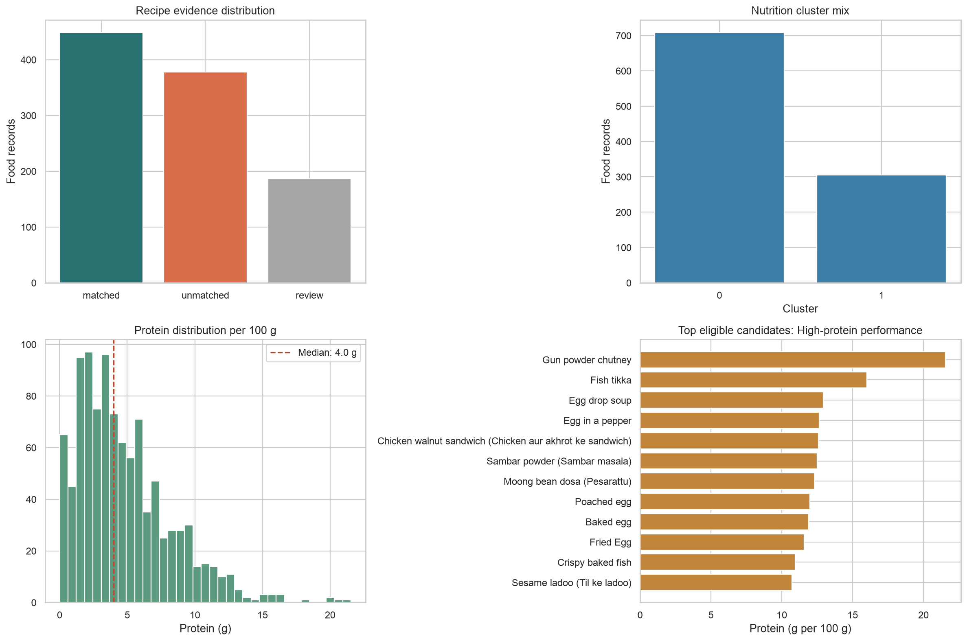
Figure 10. Reproducible dashboard KPI experiment and eligible-candidate analysis.

Phase | Activity | Key Deliverable | Business Relevance
Phase 1 | Data collection, cleaning, and standardization | Cleaned master analytical dataset | Reliable foundation for analysis
Phase 2 | Predictive model development | Preparation-time prediction model | Better kitchen planning
Phase 3 | Semantic similarity and recipe clustering | Menu intelligence module | Improved menu planning and substitutes
Phase 4 | Knowledge graph schema and ingestion | Food operations knowledge graph | Relationship-based decision support
Phase 5 | Exploratory Graph RAG Integration | Conceptual / Prototype Explainable Query Framework | Auditable natural language insights
Phase 6 | Dashboard creation and evaluation | Interactive analytics dashboard | Stakeholder-ready business communication
Final | Documentation and validation | Dissertation report and presentation | Academic submission package

Resource Requirements and Plan for their availability

Human Resources
- Student researcher
- Academic supervisor
- Optional inputs from food operations or nutrition domain experts
Data Resources
- Indian Food Dataset
- Indian Nutrient Databank
- Food ingredient and nutrition reference data
- Curated dietary and allergen information
Software Resources
- Python, Pandas, NumPy, Scikit-learn
- Machine learning models such as XGBoost or Random Forest
- Sentence embedding and similarity search tools
- Graph database such as Neo4j
- Lang Chain or Graph RAG framework
- Streamlit or equivalent dashboard framework
- Visualization library such as Plotly
Hardware Resources
- Standard laptop or workstation
- Cloud-hosted database environment, if required

Most software resources are open-source or available through free academic/developer tiers. The datasets are expected to be publicly available or academically usable. The project can be executed using a standard development environment without requiring specialized hardware.

Chapter 8: Resources and Availability
Table 11. Resource categories, availability, and handling approach.
Resource category | Required resource | Availability at mid-semester | Handling approach
Human | Student researcher and academic supervisor. | Available. | Iterative development and academic review.
Data | Nutrition, recipe, ingredient, and allergen-supporting datasets. | Available as local project data. | Use source-role and evidence-status policy.
Software | Python, Pandas, scikit-learn, Sentence Transformers, Streamlit. | Available through project environment. | Versioned dependency specification in pyproject.toml.
Vector retrieval | Qdrant or local embedding matrix. | Local artifact available; service optional. | Use local fallback during demonstrations.
Graph database | Neo4j local or managed instance. | Ingestion code ready; validated instance pending. | Complete validation in remaining work.
Hardware | Standard laptop/workstation. | Available. | Batch embedding and local artifacts limit compute requirements.
The resource strategy emphasizes reproducibility and low-cost tooling. Open-source Python libraries and locally stored artifacts allow the majority of the prototype to run without paid cloud services. Where infrastructure is unavailable, the design exposes clear fallback behavior rather than silently returning incomplete results.

Risks and Mitigation Plan

Risk | Impact | Likelihood | Mitigation Plan
Data quality issues such as missing values or inconsistent dish names | High | High | Apply data cleaning, imputation, standardization, and validation rules.
Inaccurate preparation-time prediction | Medium | Medium | Compare multiple models, tune parameters, validate results, and document limitations.
Ingredient name ambiguity across Indian regional foods | High | Medium | Use standardized naming, aliases, and entity resolution.
AI hallucination in nutrition or allergen responses | High | Medium | Restrict responses to graph-validated outputs and highlight source-grounded reasoning.
Knowledge graph complexity | Medium | Medium | Start with a manageable schema and expand iteratively.
Project timeline and integration complexity | Medium | Medium | Use phased development and prioritized a working minimum viable product.
Health-related interpretation risk | High | Low | Avoid medical diagnosis and position the output as decision support only.

Chapter 9: Risks, Mitigations, and Ethical Controls
Table 12. Identified risks, impact, mitigation, and contingency plans.
Risk | Potential impact | Mitigation | Contingency
Ambiguous recipe names | Incorrect ingredients or allergens could be linked. | Use confirmed, review, and unmatched evidence states. | Exclude review records from safety-sensitive use.
Missing allergen information | False confidence in food safety. | Display Not reported and source-declared wording. | Require manual recipe verification before approval.
Unit or serving inconsistencies | Misleading nutrition comparison. | Keep per-100 g and serving fields separate. | Document basis in all dashboard labels.
Semantic false similarity | Users may assume two foods are interchangeable. | Describe semantic search as discovery only. | Inspect recipe evidence and nutrition facts before decision.
Graph ingestion failure | Graph evidence may be incomplete. | Use constraints and count-validation checks. | Continue dashboard using canonical catalogue.
Scope expansion | Optional advanced features delay core deliverables. | Defer Graph RAG and prioritize evaluation. | Limit final scope to validated prototype capabilities.
Medical misuse | Users may treat dashboard output as health advice. | Use non-clinical language and visible disclaimers. | Refer users to qualified professionals for clinical concerns.
Ethically, the prototype follows the principle of calibrated claims. It reports what the dataset and implementation can support, labels what is uncertain, and avoids health, operational, or commercial conclusions that would require additional evidence. This approach is especially important because food information affects wellbeing and can be interpreted as safety guidance.

Chapter 10: Issues Faced and Resolutions
Table 13. Issues encountered during data preparation and their resolutions.
Issue | Resolution applied | Status
Large and duplicated recipe source | Removed duplicate titles and used a controlled matching pipeline. | Completed for current catalogue.
Dish-name variation | Applied exact/alias confirmation plus separate fuzzy review candidates. | Review queue remains for manual validation.
Partial recipe coverage | Preserved unmatched nutrition records without manufactured recipe facts. | Handled through evidence-status display.
Allergen uncertainty | Used declared data and not reported labels rather than guarantees. | Implemented in data and dashboard.
Vector-service dependency | Implemented local saved-embedding fallback. | Available for local demonstration.
Graph RAG complexity and unreliable early output | Marked as optional and removed from current achievement scope. | Deferred for later evaluation.
The key technical lesson is that evidence management is more important than forcing full coverage. Preserving unmatched and review states creates a more honest system and provides a clear backlog for future data validation. A second lesson is that advanced generated interfaces should not be prioritized ahead of trustworthy data, transparent filters, and reproducible retrieval behavior.

Expected Benefits

Operational Benefits: Improved preparation-time forecasting, workload planning, service scheduling, and reduction of peak-hour bottlenecks.

Cost and Supply Chain Benefits: Better visibility into ingredient dependencies, high-frequency raw materials, procurement risk, and menu redundancy.

Employee Wellness Benefits: Improved nutritional transparency, allergen awareness, dietary preference support, and healthier menu decision-making.

Decision Support Benefits: Conversion of fragmented food and nutrition data into structured, explainable, and manager-friendly insights.

Business Analytics Benefits: Practical application of predictive modeling, semantic analytics, knowledge graph modeling, dashboarding, and stakeholder communication.

Strategic Benefits: Prototype for analytics-led transformation in enterprise food services and employee-centric workplace systems.

Chapter 11: Preliminary Conclusions and Recommendations

11.1 Preliminary Conclusions
The mid-semester work demonstrates the feasibility of constructing an evidence-aware food intelligence catalogue from heterogeneous public sources. The prototype integrates 1,014 nutrition records with recipe evidence, ingredients where supported, allergen declarations, derived analytical features, semantic embeddings, and dashboard-ready structures.
The recipe matching results show that linkage quality must be treated as a first-class analytical variable. A confirmed match rate of 44.28% is useful but not sufficient to justify attaching recipe evidence to every food record. The additional 18.44% review queue increases potential coverage, but it should remain visibly unconfirmed until manual validation is completed.
Semantic retrieval is technically feasible for the complete catalogue, with 100% embedding coverage. Its value is in expanding food discovery beyond keyword search. However, formal relevance testing is needed before claiming that it improves menu decisions. The graph design provides a transparent structure for connected food facts, but successful Neo4j ingestion and integrity validation remain required.
The Streamlit dashboard is a meaningful prototype outcome because it turns the dataset into an inspectable decision-support surface. It makes uncertainty visible and explicitly distinguishes currently available menu analytics from unavailable sales, cost, inventory, waste, and operational data.

11.2 Recommendations for Remaining Work
• Manually validate a sample of fuzzy recipe-match candidates and publish precision estimates for the matching process.
• Train and evaluate a preparation-time or recipe-complexity model only after confirming target completeness and preventing feature leakage.
• Build a labelled semantic-query set and report Precision@5 or a comparable retrieval metric.
• Execute the Neo4j ingestion pipeline, record node and relationship counts, and run integrity queries.
• Conduct a small usability evaluation with representative dashboard users and document task completion, clarity, and perceived usefulness.
• Keep Graph RAG optional until it can be evaluated against deterministic dashboard and graph-query baselines.

Chapter 12: Summary of Project Outcomes

12.1 Purpose and reading guide
The first eleven chapters record the project as it stood at the mid-semester review: a processed catalogue of 1,014 foods, semantic embeddings and a first dashboard, with the knowledge graph and Graph RAG still ahead. The remaining chapters record what the project became. The prototype was integrated into a role-based service, the Enterprise Cafeteria Operating System (ECOS), and was then examined as a manager would examine any proposed operating change: does it work, what does it rely on, what can it not yet claim, what would it cost, and what should be done next?
The report keeps one discipline throughout. Every statement is tied to an evidence class (Chapter 13): it was executed on 8 November 2026, code-inspected, documented, user-reported, proposed, or is an illustrative assumption. The sections below summarise the answers; the later chapters give the evidence.

12.2 Progress against the project plan
Table 21 compares the six phases of the original plan with their final status, and Figure 11 shows the same comparison graphically. Four phases were delivered or completed, one was re-scoped from preparation-time modelling to demand forecasting, and two ambitions in the approved outline, a property-graph knowledge base and Graph RAG, were not delivered. Declaring that openly is part of the contribution: the assessed artefact is a working decision-support service, not a research graph platform.
Table 21. Project plan phases and their final status
Plan phase | At mid-semester | Final status (8 Nov 2026) | Where
1. Data and preparation | Catalogue of 1,014 records, 97 analytical fields | Completed and now consumed by the application; profiled in Chapter 15 | Chapter 15
2. Predictive analytics | Planned as preparation-time and complexity models | Re-scoped to demand forecasting: Random Forest against a same-weekday baseline with a serving gate | Chapter 17
3. Semantic search | Embeddings ready | Delivered: 256-dimension cosine index in Qdrant; similarity contributes up to +0.30 to the recommendation score | Chapter 17
4. Knowledge graph | Schema designed | Design only: relationships are document references in MongoDB and Qdrant payloads, not a graph database | Chapter 15, Chapter 24
5. Graph RAG (optional) | Excluded from claims | Not delivered; the copilot answers from eight rule-based intents with optional LLM wording | Chapter 17
6. Dashboard | First dashboard and KPI experiment | Delivered as ECOS: 5 employee and 7 manager views over 42 API operations | Chapter 16

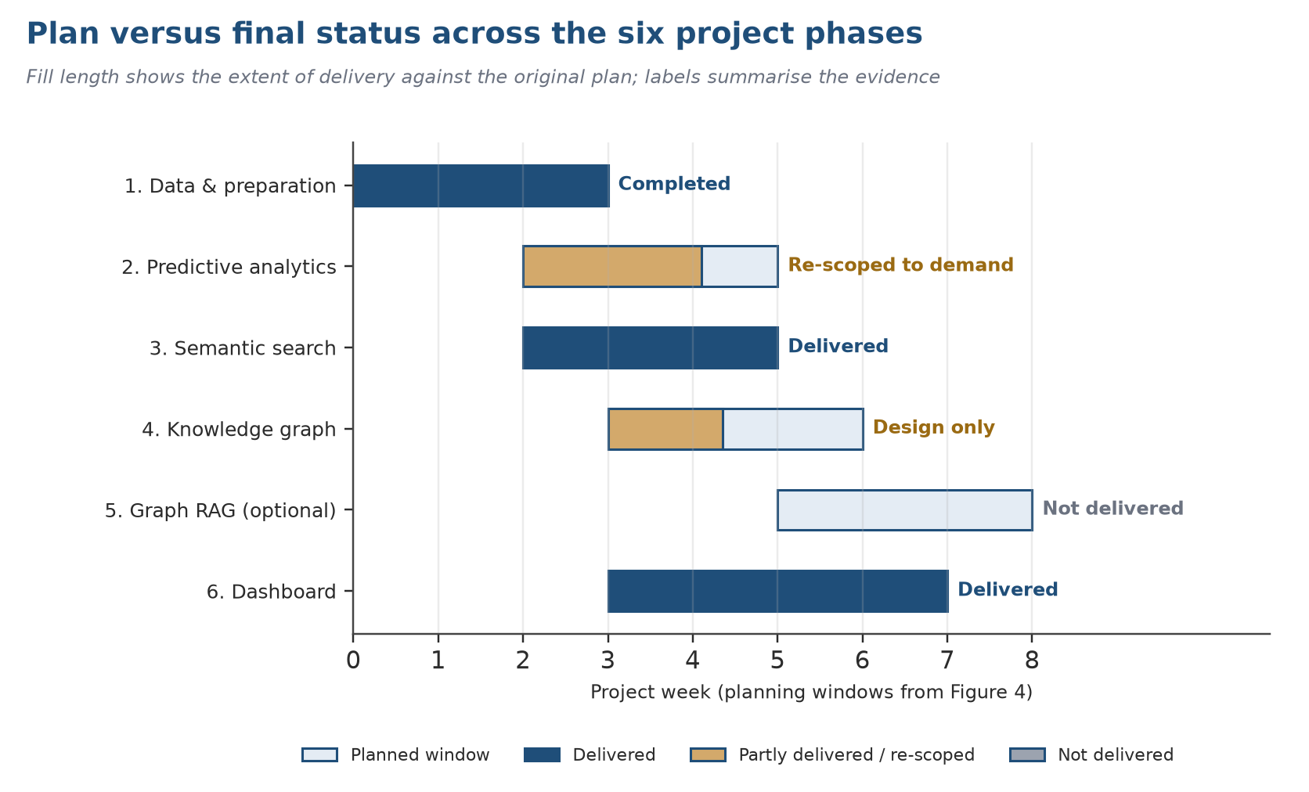
Figure 11. Plan versus final status across the six project phases (planning windows from Figure 4).

12.3 ECOS at a glance
Table 22. ECOS at a glance, with the evidence class of each fact
Dimension | Fact | Evidence class
Application surface | Two role workspaces: five employee pages and seven manager pages (listed in Chapter 16) | Executed
Service interface | 14 routers, 42 operations on 39 paths under /api/v1 | Code-inspected
Data stores | MongoDB, 9 collections, synchronous PyMongo; Qdrant food_nutrients with 1,014 vectors (256 dimensions, cosine) | Executed
Ordering controls | Idempotent checkout, conditional stock decrement with rollback, at most 10 per dish and 15 lines, lifecycle confirmed, preparing, ready, collected | Executed
Recommendation | Hard filters (availability, diet, allergen, intent, budget, energy) followed by an additive score; match percentage capped at 99 | Executed
Forecasting | Random Forest (200 trees, depth 8) against a same-weekday-4 baseline, chronological 80/20 split, served only if MAE is not above baseline | Executed
Verification | 138 backend and 34 user-interface checks, all passed | Executed
Forecast study | Customers: MAE 2.231 against baseline 1.641 (gate fails). Dishes: 0.792 against 0.793 (gate passes by 0.001) | Executed, synthetic data
Finance | Base case NPV +7.89 lakh, IRR 44.6%; downside NPV -4.79 lakh | Illustrative assumption

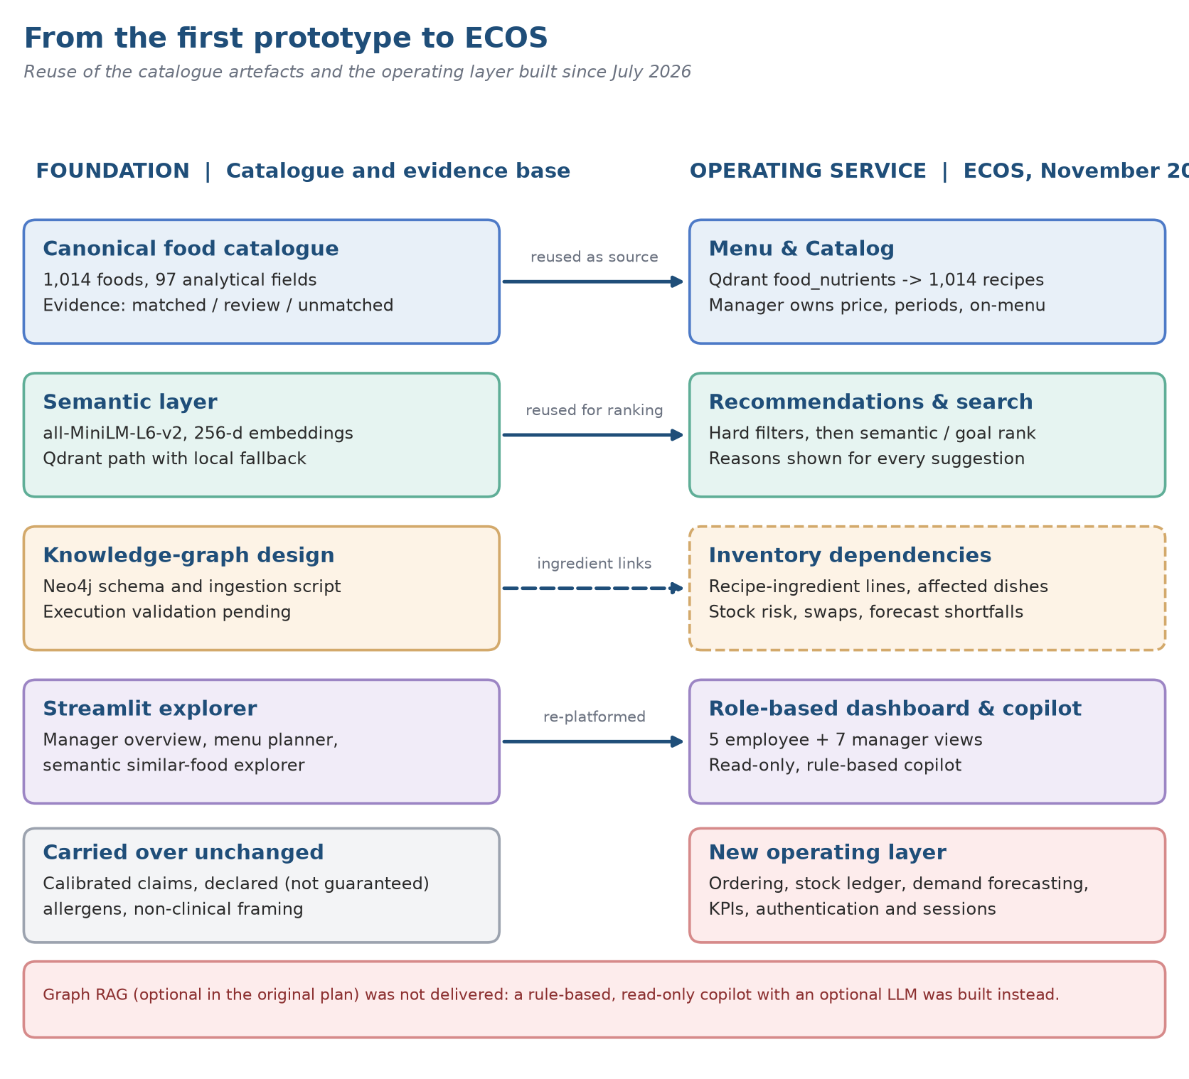
Figure 12. From the mid-semester catalogue to the ECOS operating service.

12.4 Management decision brief
Two questions need an answer. Is the prototype fit to serve as a structured demonstration and learning aid? And is further evidence-gathering worth sponsoring? To the first, the evidence says yes: stakeholders can inspect an integrated operating concept through the interface, and Chapter 18 shows it works as designed on synthetic data. A firm business case, a service-level promise, or confidence that its suggestions outperform current practice would go beyond what has been shown.
A staged approval is sensible. Begin by keeping the demonstration on synthetic or approved data, labelled as such. Before going live, settle the site, the evaluation window, the people responsible, a data-quality checklist, privacy limits and the conditions for stopping. Collect before-and-after measures with identical definitions, and treat any change seen during a pilot as an association unless a sound comparison exists. Finish with a go/no-go meeting that includes operations, finance, purchasing, IT, privacy and staff representatives.
Three principles should bind any pilot. For safety, a named manager confirms stock, menu changes, reorders and any action based on a forecast; the software never places supplier orders on its own. For information, every menu, allergen and nutrition statement has an accountable source and a review date, and wellness indicators make no medical claim. For money, demonstration order values are not audited revenue, the mock payment collects nothing, and savings remain scenarios until procurement and finance confirm them.
Recommendation
Advance to a governed single-site pilot; do not scale. The prototype is sound enough to learn from and not yet sound enough to rely on. Five conditions should be met first (findings B1 to B4 and B7 in Chapter 18): correct the wellness score and its caption (B1), carry the catalogue evidence status into the application (B2), harden the forecast serving gate (B3), define a stricter healthy-dish rule (B4), and limit managers to aggregate wellness data (B7).
The strongest positive finding is the integrity of the ordering and stock path; the clearest warning is that a forecast gate that passes on a coin-flip is not yet a control.

Chapter 13: Research Method and Evidence Base

13.1 Research design
The project follows a design-science logic (Hevner, March, Park and Ram, 2004; Peffers et al., 2007): an artefact is built to address a managerial problem and then evaluated against explicit criteria. Because the artefact is a prototype running on synthetic operational data without live users, the evaluation is a demonstration with a critical audit, not a field experiment. The MBA lens enters through the questions put to the artefact: strategic fit (Porter, 1996), service design and operations (Shostack, 1984; Parasuraman, Zeithaml and Berry, 1985), analytics governance (Davenport and Harris, 2007; Sculley et al., 2015), financial appraisal (net present value, internal rate of return, payback) and behaviour and ethics (Thaler and Sunstein, 2008; Davis, 1989).
The four research questions and hypotheses stated in Chapter 5 (Sections 5.3 and 5.5) are carried forward unchanged and answered in Chapter 24.

13.2 Evidence classes
The catalogue work used a three-state match status for records. This chapter adds a classification of the claims themselves, so that a reader can see what each statement rests on (Table 23).
Table 23. Evidence classes and the inferences they permit
Class | Basis | May be stated | May not be inferred
Executed | A test, run or measurement performed on 8 November 2026 on the environment in Table 24 | The result of that run | Behaviour in production, with real users or on other data
Code-inspected | A named source file or function was read | A rule, threshold or workflow exists in code | That it ran correctly unless it is also executed
Documented | README, API documentation, earlier chapters | Design intent and published contract | That the running system still matches
User-reported | Statement by the project owner | The statement, attributed | Independent verification
Proposed | Management design in this report | A recommended practice or gate | Current capability
Illustrative assumption | Hypothetical figures | How a formula behaves | A forecast, saving or return

13.3 Verification environment and data
All executed evidence was produced on one laptop in isolated, throwaway databases created for this report. The owner's own databases, containers and credentials were not read or modified. The food catalogue is real (the 1,014-record Qdrant collection built earlier in the project). Users, orders, stock and history are synthetic demonstration data: 30 users, eight weeks of history and 920 orders, all flagged source = demo_seed. Figures derived from them describe the behaviour of the software, not of any cafeteria.
Table 24. Verification environment
Component | Version or setting
Machine | Apple M3 Pro, macOS 26.7
Language and libraries | Python 3.12.10; FastAPI 0.162.0; Uvicorn 0.52.4; Streamlit 1.62.0; Pydantic 2.13.4; pandas 3.0.5; NumPy 2.5.2; scikit-learn 1.9.0
Data services | MongoDB 8.3.4 (private instance, three throwaway databases); PyMongo 4.16.0; Qdrant client 1.19.0 against the local food_nutrients collection
Test harnesses | Backend smoke test (backend/smoke_test.py); user-interface test with Streamlit AppTest (dashboard/ui_smoke_test.py)
Data | Catalogue: 1,014 real records. Operations: synthetic, 30 users, 920 orders, 14 September to 6 November 2026
Screenshots | Captured from the running application with a headless browser (Chapter 16)

13.4 Limits of the evidence
• No users were studied. Usability, adoption and behaviour change remain hypotheses; no survey or interview data were collected.
• Operational data are synthetic. Forecast errors, order counts and revenue-like figures demonstrate mechanics, not performance.
• One run, one machine. The checks establish that the software behaves as designed in this environment, not that it is robust under load or failure.
• Financial figures are hypothetical. They illustrate method; none is derived from cafeteria records.

Chapter 14: Business Context, Stakeholders and Strategic Fit

14.1 The operating problem and value proposition
Think of a cafeteria as a compact production system whose parts depend on one another. Changing the menu changes what must be bought; what is in stock limits what can be substituted; expected attendance and habits set how much to cook; those decisions decide queues and leftovers; and the accuracy of nutrition and allergen labels decides whether diners trust the counter. If the relevant records sit in separate sheets, sales files, recipe documents and chat threads, someone must stitch them together by hand, and the cost shows up as repeated effort, exceptions found too late, mismatched menu descriptions and decisions that are hard to justify afterwards.
This report therefore treats the issue as one of coordination and decision quality rather than assuming a service has failed. Nothing has been measured at a real site for waste, stockouts, diner dissatisfaction, lost revenue or preparation delay. The working proposition is that one shared, role-appropriate view of the facts could make problems visible sooner and decisions easier to retrace. Evidence from a real site is still needed before any benefit is asserted.
Value arises on both sides of the counter. Diners get quick access to the menu, their own order history and declared dietary details, with suggestions they may ignore. Managers get orders, stock, menu operations, past behaviour and planning signals in one place for their reviews. The aim is not to showcase AI but to cut avoidable handoffs, expose exceptions earlier and tighten follow-up, on condition that the underlying data and controls are dependable.
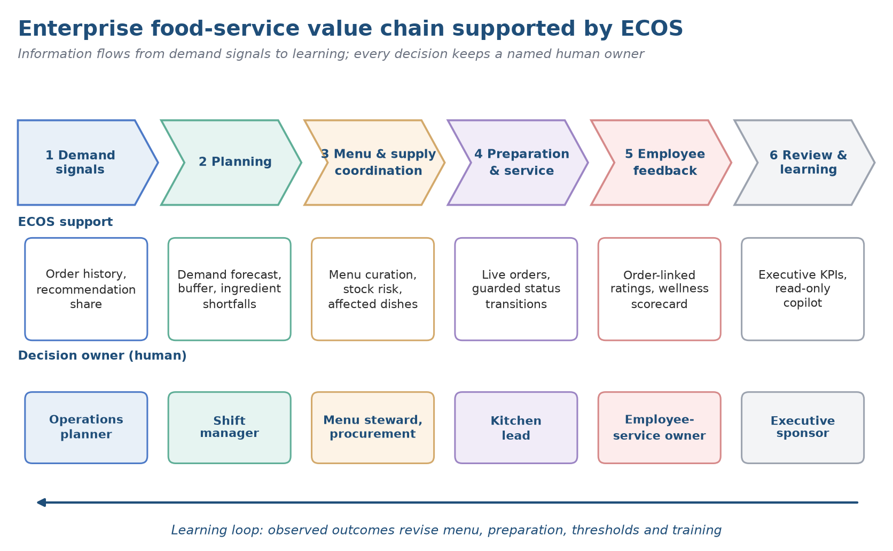
Figure 13. Enterprise food-service value chain and the ECOS layers that support it.

14.2 Stakeholders and their influence
Different groups want different things from the platform. Diners ask for easy choice, dependable availability, accurate descriptions, clear prices and respectful treatment of dietary data. Supervisors want an up-to-date picture and the power to fix wrong data. Menu planners trade off variety, nutrition, cost, ingredients and kitchen capacity. Buyers and suppliers need stable specifications and lead times, finance needs costs that reconcile, and IT and governance staff need access control, supportability and privacy protection. Staff representatives want a guarantee that wellness indicators will not be turned into surveillance or a basis for discrimination.
Engagement works best when tied to decisions. For each group, name the question being asked, the evidence offered and the decision the group may influence. Diners can test menu clarity; operators can check that stock and order views suit a real shift; purchasing can say how a restock hint would turn into a request; finance can settle cost definitions; privacy and HR can draw the boundary around wellness data; IT can state what service and recovery it needs.
Table 25. Stakeholders, needs and decision rights
Stakeholder | Engagement evidence | Decision right to clarify | Primary need
Employee | Usability session (none held yet) | Consent, preferences, how feedback is given | Reliable choice and trustworthy menu facts
Shift manager | Observed walk-through of a shift task | Whether to hold, amend or reject a suggestion | Quick handling of exceptions
Menu owner | Menu change log | Publishing and recipe versions | A feasible menu with safe substitutes
Procurement | Requisition and approval record | Releasing any supplier-facing order | Specifications and timing it can act on
Finance | Reconciliation and sign-off | Accounting definitions | Cost and benefit logic that can be audited
IT and privacy | Readiness review | Go-live and data access | A secure service that can be supported
Employee representative | Governance meeting notes | Raising objections to wellness practices | Fair and non-coercive use

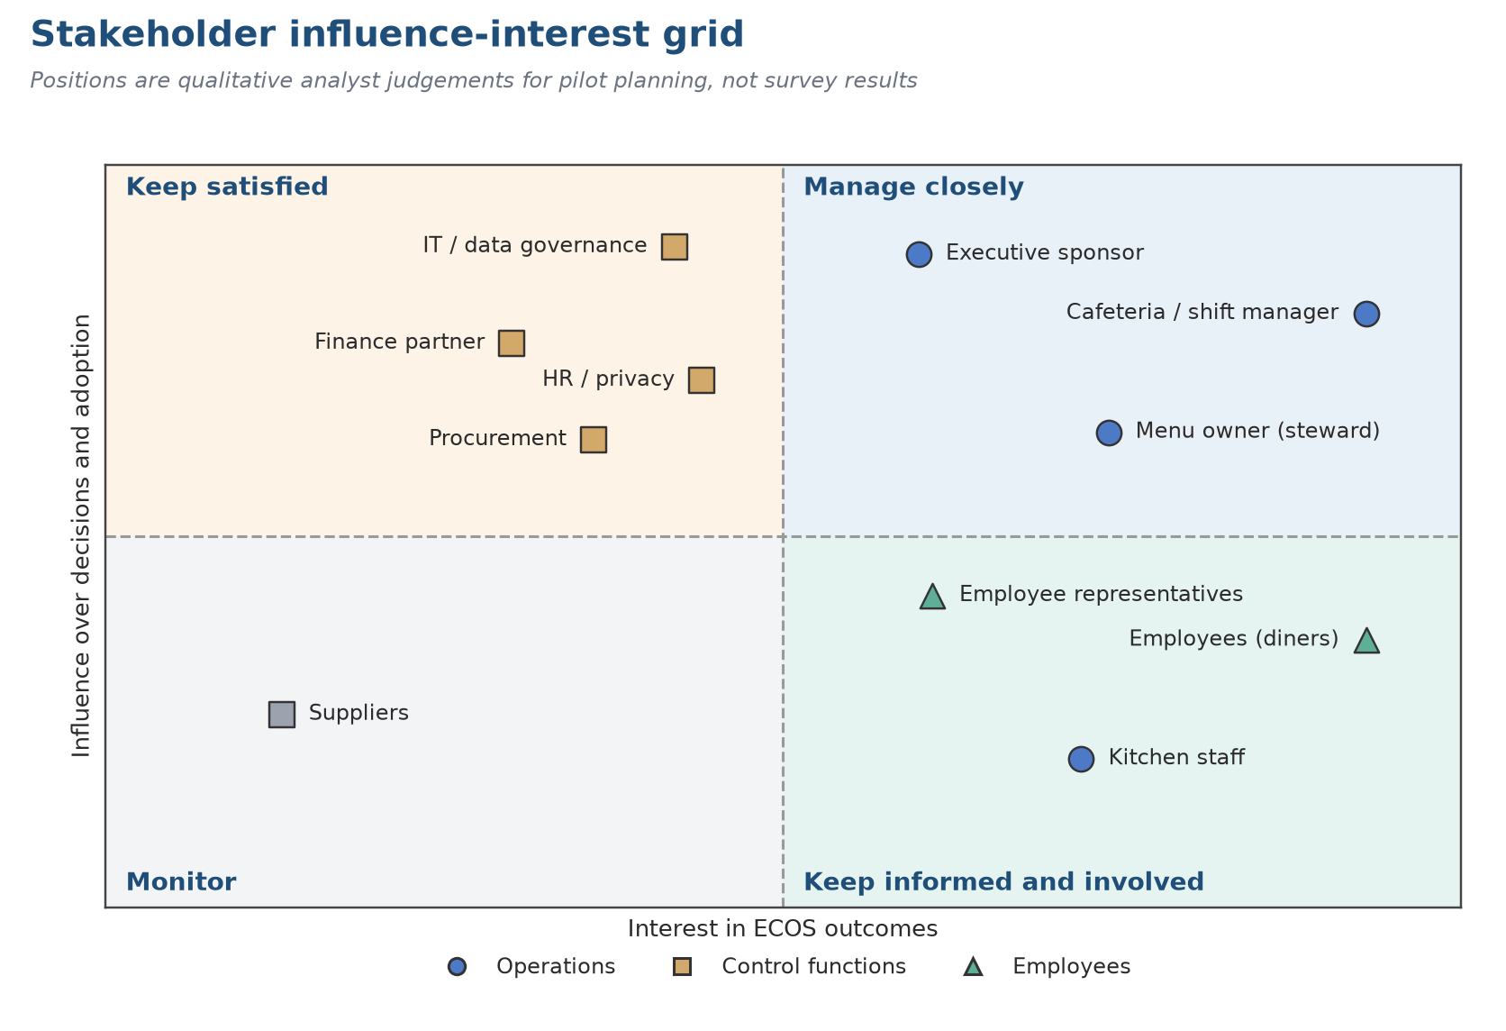
Figure 14. Stakeholder map: influence on and interest in the ECOS service.

14.3 Strategic fit and positioning
A strategy is a set of deliberate choices with costs attached, not a feature list. The sensible place for ECOS is as a decision aid that links what diners see with what managers run. Presenting it as a substitute for purchasing systems, as health care, or as an automatic production planner would overreach. Keeping to the narrower role leaves one answerable question: does shared, role-specific information improve coordination and learning at an acceptable level of privacy, operational and financial risk?
Porter separates operational effectiveness from strategy, and the distinction matters here. A new interface may speed up what already happens, yet durable advantage needs a distinctive, mutually reinforcing set of activities that suit the organisation. For a cafeteria that set includes curated menu data, accessible choice, timely order visibility, regular stock review, human planning informed by forecasts, and a standing performance review. A gap in any one, such as stale stock records or an unowned menu attribute, leaves the dashboard exposing a weak process rather than repairing it.
Put as a hypothesis: when managers get timely, reasonably complete information along with clear decision rights, their calls on demand, stock and menu become more consistent; when diners see accurate information and keep control of their choice, trust and convenience may improve. Each link has to be measured. Having the technology does not mean it is used, and being used does not mean outcomes improve.
Table 26. Strategic choices and their costs
Choice | Trade-off to manage | Benefit sought
Support decisions rather than automate them | Needs manager time and training | Managers stay answerable
Keep recommendations optional | Click-through may stay modest, which is acceptable | Employee autonomy
Release in phases | Some handoffs stay manual | Controls stay manageable
Publish food attributes openly | More stewardship effort; uncertainty must be disclosed | Informed choice
Scale only on evidence | Visible growth is slower | Limits early commitment

14.4 Objectives and scope
Objectives should distinguish deliverables, operational outcomes and long-term impacts (Table 27). A screen or an endpoint is a deliverable; a shorter reconciliation delay is an outcome; better wellbeing is an impact that needs a stronger design and a longer horizon. This report claims deliverables only, and states the evidence that would be needed for the other two levels.
Table 27. Levels of objective for the next evaluation stage
Level | Evidence needed | Example objective
Deliverable | Versioned build with acceptance criteria | Role-specific menu, order, stock and planning views exist
Process outcome | Timestamped queue and disposition records | Exceptions reach the responsible manager
Service outcome | Defined denominator and baseline | More orders completed; items available
Resource outcome | Physical counts and measured waste | Better stock planning, fewer avoidable leftovers
Employee outcome | Privacy-safe, non-coercive measurement | Informed, voluntary choice

The final scope is narrower than the approved vision and broader than the mid-semester prototype (Table 28). Two items from the approved outline remain outside it: a property-graph knowledge base and Graph RAG.
Table 28. Final scope boundary
Inside the delivered and verified scope | Outside (not assumed delivered)
Role-based employee and manager views with 42 API operations | Ten independently deployable production services
Ordering with idempotency, stock control and a four-state lifecycle | Payment settlement; revenue or cash collection
Inventory edit with validation before commit, movement history and risk view | Supplier master, purchase orders, supplier transmission
Forecast pipeline, evaluation and serving gate on synthetic history | A validated, continuously monitored production forecast
Rule-based, read-only copilot with optional LLM wording | Autonomous actions; general-purpose generative assistant
Semantic ranking over the 1,014-record catalogue | Property-graph knowledge base; Graph RAG

Chapter 15: System Architecture and Data Foundation

15.1 Architecture in one view
ECOS has three tiers. A Streamlit dashboard renders the employee and manager workspaces. A FastAPI service exposes 42 operations under /api/v1, authenticated with a session token in the X-Session-Token header. State lives in MongoDB (nine collections, synchronous PyMongo). The food catalogue is read from a Qdrant collection and synchronised into MongoDB, and a local sentence-embedding model (all-MiniLM-L6-v2, truncated to 256 dimensions) ranks dishes semantically when it is ready. An optional language model may rephrase copilot answers; nothing depends on it. The root app.py starts the API on the loopback interface, waits for its health check and then launches the dashboard. Figure 15 shows the components and their boundaries.
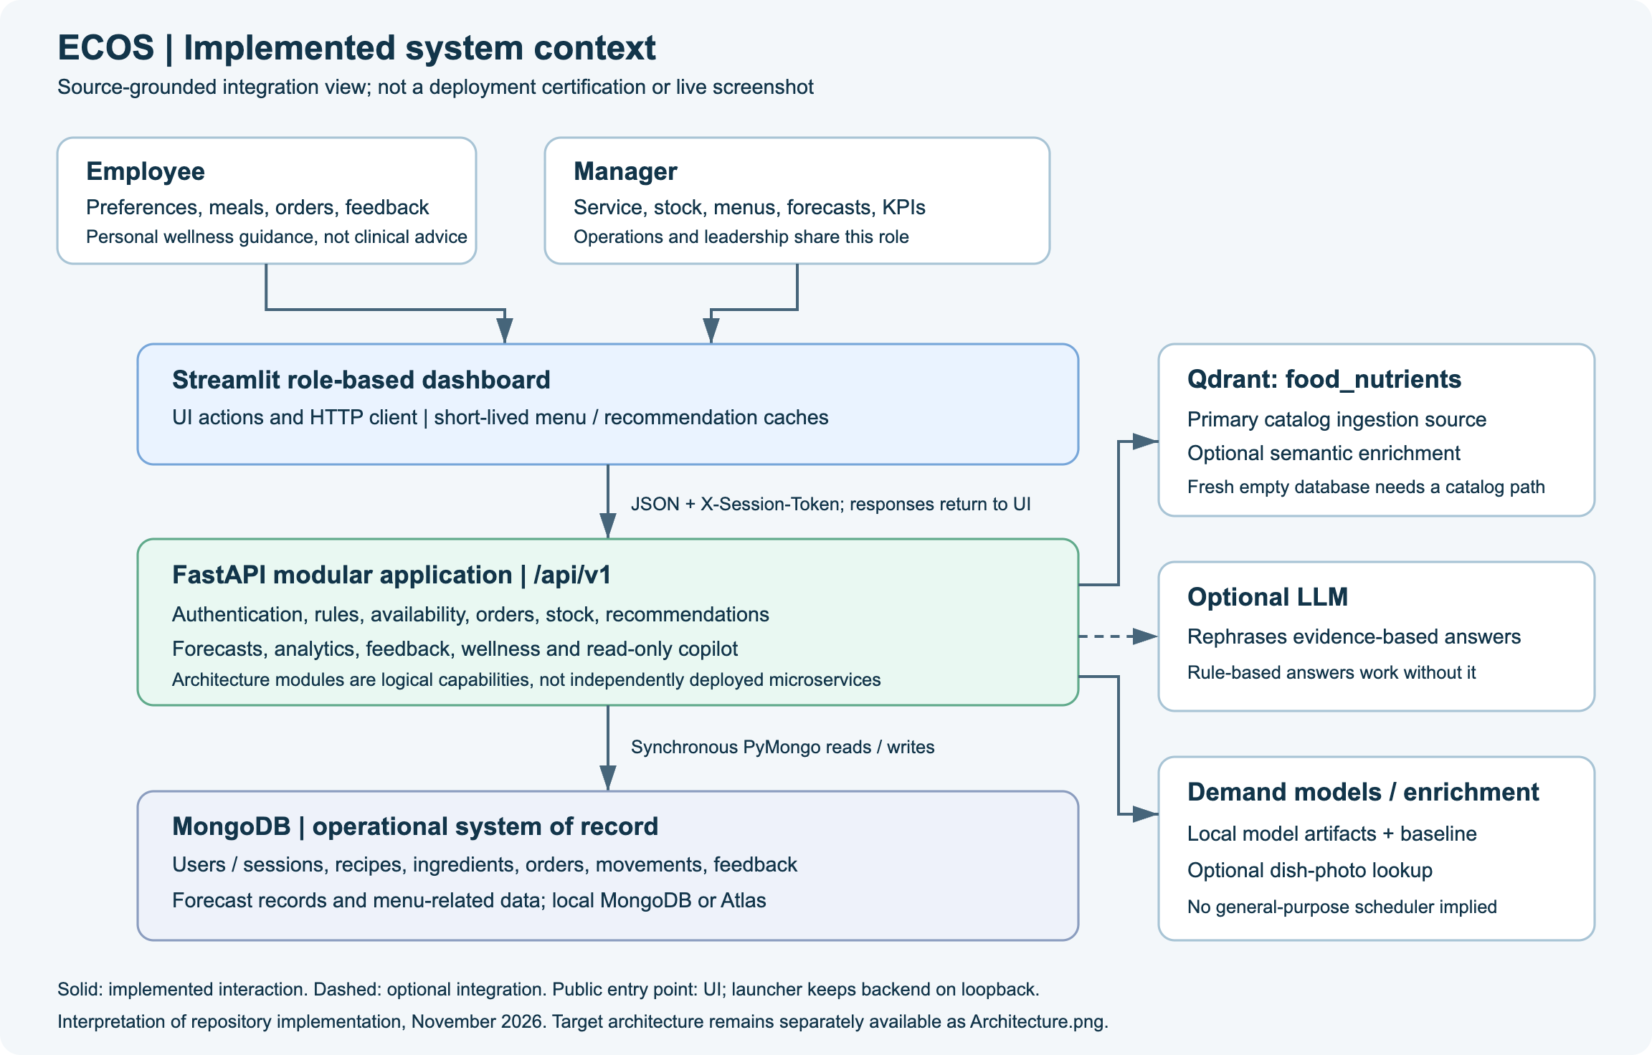
Figure 15. System context of ECOS as implemented (derived from the project asset docs/assets/system-context.svg).

15.2 Target architecture and what was built
The architecture poster of the project (Figure 16) is the target picture: ten backend modules, four user groups, an asynchronous MongoDB Atlas layer, scheduled background jobs and three business outcomes. It remains a valid communication artefact, but several of its elements are targets rather than features. Table 29 reconciles the poster with the verified implementation so that the picture is not read as a statement of capability.
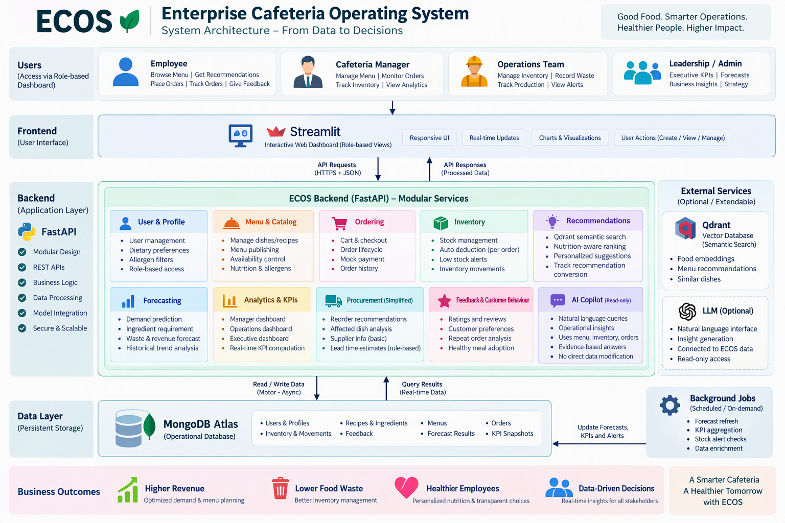
Figure 16. Target architecture poster for ECOS (existing project artefact; reconciled with the implementation in the table below).
Table 29. Target architecture compared with the verified implementation
Poster element | As built and verified | Management consequence
Four user groups (employee, manager, operations team, leadership) | Two roles, employee and manager; operations and executive views are manager pages | Do not imply four role types; finer role separation is future work
Streamlit with real-time updates | Streamlit re-runs on interaction; periodic refresh only for the catalogue panel (10 s) and a reconnect banner (5 s) | No push channel; managers see state as of their last action or refresh
Ten backend modules | 14 routers; procurement exists only as replenishment suggestions and affected-dish analysis inside inventory | No supplier master or purchase orders; keep human approval
MongoDB Atlas with Motor (async) | MongoDB with synchronous PyMongo; no Atlas dependency in the verified run | Review concurrency and connection pooling before load
Menus and KPI snapshots as stored data | No such collections: the menu is a flag on recipes; KPIs are computed on demand | No historical KPI series unless snapshots are added
Qdrant as external semantic search | Qdrant holds the 1,014 catalogue vectors; ranking proceeds without semantics until the model is ready | Semantic ranking is an enhancement, not a dependency
Scheduled and on-demand background jobs | On-demand only (catalogue sync, forecast run, model retraining); no scheduler | Assign a trigger, an owner and an alert for every job
Outcomes: higher revenue, lower waste, healthier employees | Targets; no waste logging, no revenue (mock payment), no health measurement | Measure before claiming (Chapters 20 and 21)

15.3 Technology stack
Table 30. Technology stack and evidence class
Layer | Technology | Role in ECOS | Evidence
Presentation | Streamlit 1.62.0 | Role-based workspaces, forms and charts; session restore; reconnect banner | Executed
Service | FastAPI 0.162.0, Uvicorn 0.52.4, Pydantic 2.13.4 | 14 routers, 42 operations; request models enforce limits (10 per dish, 15 lines) | Executed
Persistence | MongoDB 8.3.4, PyMongo 4.16.0 | Nine collections; unique and partial unique indexes; TTL index on sessions | Executed
Catalogue and semantics | Qdrant client 1.19.0; all-MiniLM-L6-v2 (256 dimensions) | 1,014 vectors with cosine distance; catalogue sync; cached query embeddings | Executed
Analytics | scikit-learn 1.9.0, pandas 3.0.5, NumPy 2.5.2 | Random Forest demand model, same-weekday baseline, evaluation | Executed
Optional language model | Configured through utilities.py and ECOS_LLM_MODEL | Rephrases rule-based copilot answers; absent in the verified run | Code-inspected
Packaging | Dockerfile, docker-compose.dev.yml, start.sh | UI on port 7860 in the container, mapped to 8501 on the host | Documented

15.4 Module design and ownership
Dividing a system into modules clarifies who owns what, how far a change spreads and where a fault can be contained. The interface documentation groups functions into user profiles, menu and catalogue, ordering, inventory, recommendations, forecasting, analytics and KPIs, a simplified purchasing view, feedback and behaviour, and the copilot, alongside platform services. Management's question is whether the result is one coherent product with clean handoffs or a set of adjacent features that define things differently.
It helps to follow the business information rather than the network calls. Suggestions depend on reliable menu attributes and availability. Ordering depends on item identity, price and order state. Stock risk depends on units, consumption figures and links from recipes to ingredients. Forecasts depend on dated history and a clear baseline. Analytics depend on consistent order events, and the copilot depends on whatever rules and records it may read. Where an upstream definition is shaky, a polished screen downstream can make the doubt look like certainty.
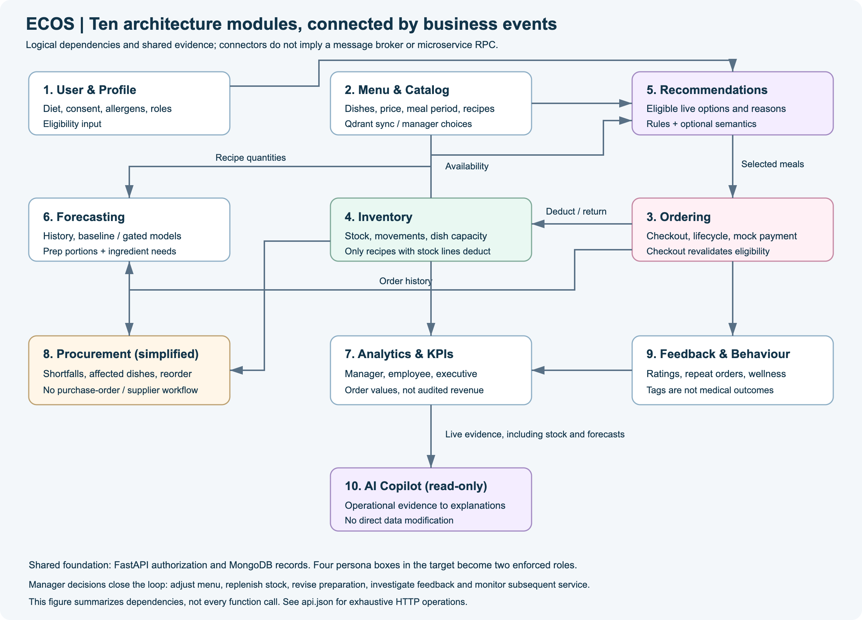
Figure 17. Module connections of ECOS (derived from the project asset docs/assets/module-connections.svg).
Table 31. Suggested owners by capability
Capability | Key contract | Technology or data owner | Business owner
Menu and catalogue | Versioned dish with declared attributes | Product or data team | Menu steward
Ordering | Lifecycle state; idempotent event | Application owner | Service operations
Inventory | Item, unit, balance, movement | Data or API owner | Stock controller
Forecasting | Horizon, unit, model or baseline status | Analytics owner | Operations planner
Recommendations | Explainable rule; opt-out | Product or analytics owner | Employee-service owner
Executive KPIs | Approved metric dictionary | Finance or data owner | Leadership sponsor
Copilot | Read-only scope; cited basis; fallback | Product owner | Operations owner

15.5 Data model
Table 32. MongoDB collections and their integrity rules
Collection | Purpose | Key fields and indexes
users | Accounts and preferences | user_id unique; role; scrypt password hash; diet, goals, declared allergens, favourites; failed-login counter and lock time
ingredients | Stock master | ingredient_id unique; name, unit, quantity, reorder point
recipes | Dishes synchronised from the catalogue plus menu settings | dish_id unique; catalog_code; index on (on_menu, meal_periods); nutrition, declared allergens, tags, ingredient lines, price, component and portion flags
orders | Order header and lines | order_id unique; (user_id, date); (status, date); partial unique (user_id, request_id) for idempotency; created_at and one timestamp per status
inventory_movements | Stock ledger | (ingredient_id, created_at); order_id; movement types such as order_consumption and order_cancelled
feedback | One rating per order | order_id unique; user_id; rating
forecasts | Stored forecast runs | (date, created_at)
sessions | Server-side sessions | token_hash unique (SHA-256 of the token); expires_at with a TTL index
meta | Catalogue-sync status | Single document with _id = catalog_sync

15.6 Data foundation: the 1,014-dish catalogue
The catalogue built earlier in the project is the only real dataset in the project. Figure 18 shows how it reaches the application: records are read from Qdrant, normalised to per-portion values where the payload allows, given an inferred diet label where the source has none, tagged by transparent nutrition rules, assigned an estimated price and meal periods, and written to the recipes collection without overwriting menu choices made by managers. Table 33 and Figure 19 profile the result.
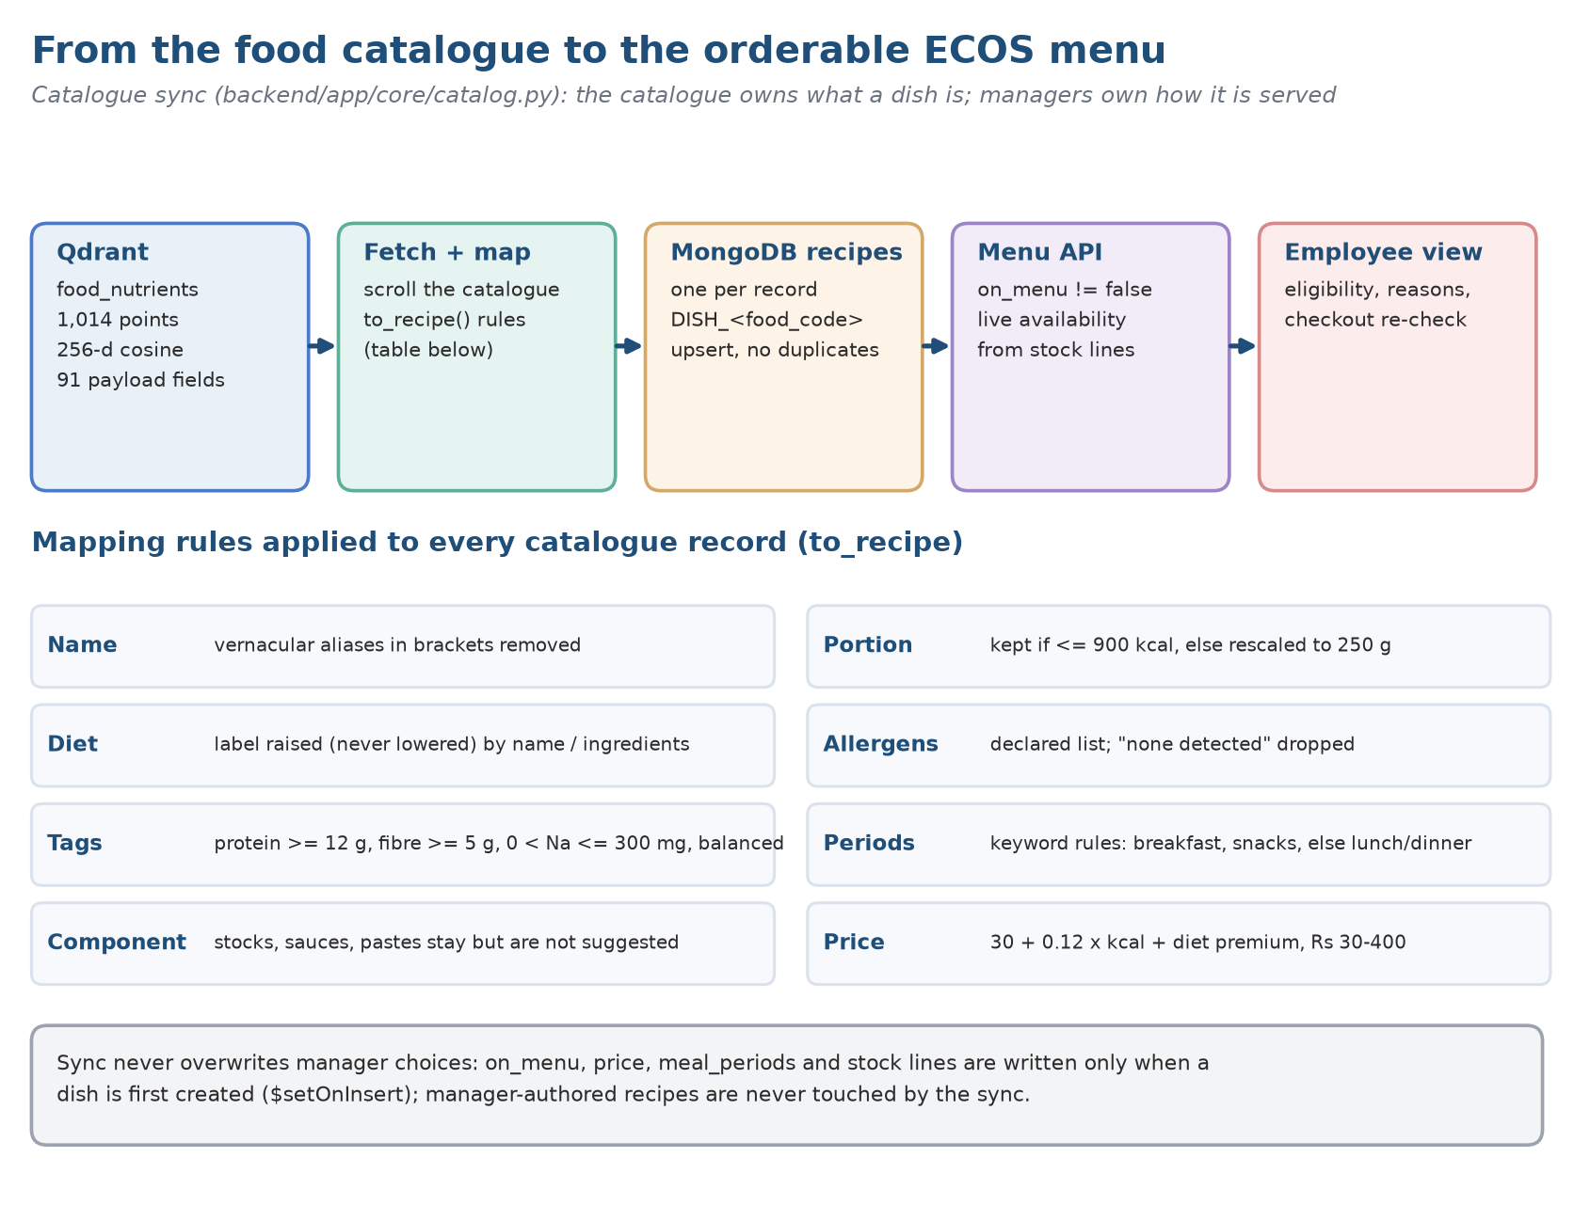
Figure 18. From Qdrant payload to menu-ready recipe: the catalogue synchronisation pipeline.
Table 33. Profile of the synchronised catalogue (1,014 dishes, run of 8 November 2026)
Attribute | Measure | Reading
Diet | Vegetarian 695 (68.5%), egg 160 (15.8%), non-vegetarian 159 (15.7%) | Diet label inferred by rule for 382 dishes (37.7%); 632 carry a source label
Declared allergens | 599 dishes (59.1%) declare at least one: milk 422, egg 196, wheat 98, tree nuts 63, mustard 59, celery 36, peanut 28 | No declaration is not the same as allergen-free: 415 dishes declare nothing
Nutrition tags | Lower sodium 729, high protein 224, high fibre 205, balanced 171 | Rules: protein at least 12 g; fibre at least 5 g; sodium above 0 and at most 300 mg; balanced = protein 7 g, fibre 3 g, at most 550 kcal
Tag coverage | At least one tag on 941 dishes (92.8%); none on 73; tags per dish 0: 73, 1: 669, 2: 169, 3: 90, 4: 13 | The healthy-dish test is permissive (Finding B4)
Meal periods | Lunch and dinner 539, snacks 357, breakfast 62, breakfast and snacks 56 | Assigned by rule, not by kitchen practice
Data quality flags | Components 106; portion-normalised 201; ingredient text 636 (62.7%) | Components (sauces, chutneys, doughs) are not suggested unless searched for
Estimated price | Median 70 rupees, interquartile range 50 to 100, mean 86.8, range 30 to 290 | Price = 30 + 0.12 x kcal + diet premium (0, 10, 40), rounded to 5, clipped to 30 to 400
Energy and nutrients | Energy median 256 kcal (mean 408); protein median 5.7 g; fibre 1.9 g; sodium 163 mg | Values are catalogue estimates, not laboratory measurements

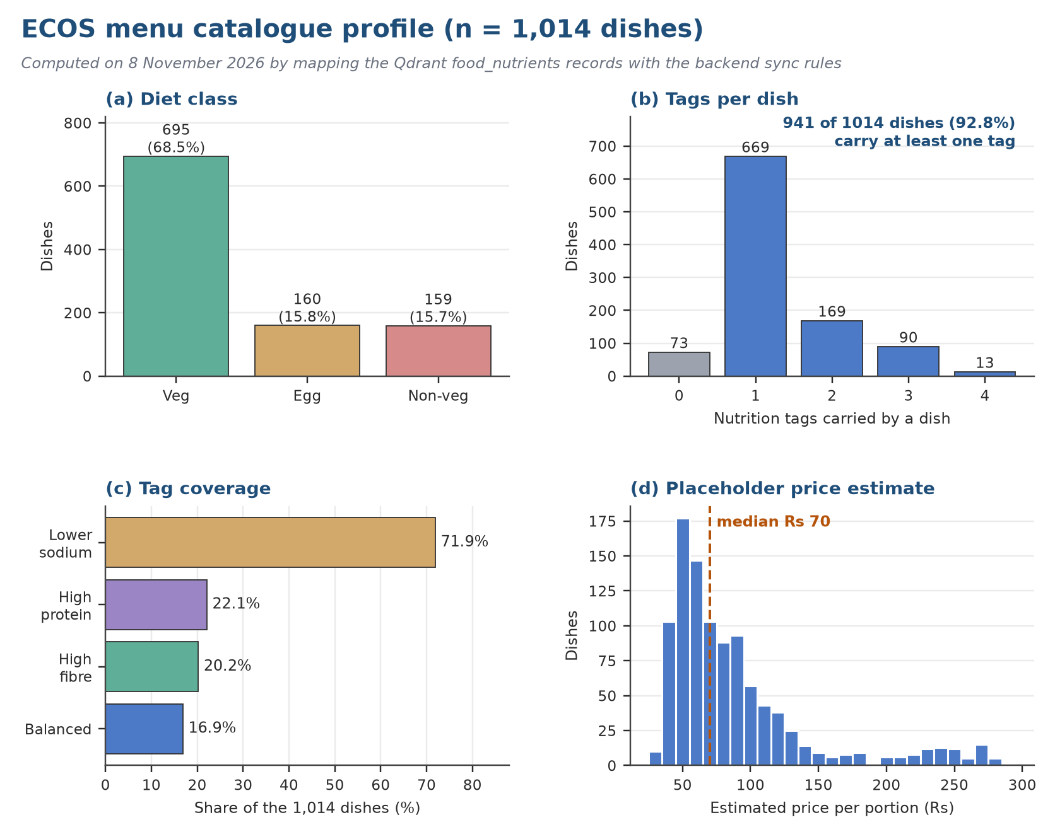
Figure 19. Catalogue profile: diet mix, declared allergens, nutrition tags and estimated prices.
Three management implications follow. First, a third of the diet labels are inferred, so diet filtering is only as reliable as the inference rule and should be stewarded (risk R1). Second, 41% of dishes declare no allergen, which must be presented as unknown rather than safe. Third, the prices are modelled estimates, so any rupee figure derived from them is a demonstration value.

15.7 Security and privacy controls as implemented
Table 34. Security controls in the verified implementation
Control | Implementation | Evidence
Password storage | scrypt key derivation (n = 2^14, r = 8, p = 1); no plain-text passwords | Executed
Sessions | Random token; only its SHA-256 digest is stored; 30-minute sliding idle expiry; TTL index removes expired sessions | Executed
Brute-force protection | Five consecutive wrong passwords lock the account for five minutes (HTTP 429) | Executed
Authorisation | Server-side role checks: employees reach only their own orders and wellness; status changes, stock edits, uploads, forecasts and copilot are manager-only | Executed
Safety gates on the server | Diet and allergen eligibility are re-checked at checkout; per-dish and per-order limits are enforced | Executed
Input validation | Pydantic request models; stock and recipe uploads are validated before any change is committed | Executed
Language-model minimisation | Only compact facts (dish and ingredient names, the rule answer and its evidence) are sent; the copilot is read-only | Code-inspected
Secrets | Supplied through environment variables; env.template lists them | Documented

Chapter 16: Role-Based Service Design and Operations

16.1 Employee experience
The employee workspace has five destinations: Home, Menu (For you, Full menu, Plan my day), My orders, My wellness and Profile. The journey runs from discovery to commitment to feedback: the employee sees dishes that are available and eligible for the declared diet and allergens, reads why a dish was recommended, places an order whose payment is the mock state demo_paid (the interface states that no money is taken), follows its status, rates it, and sees a monthly food-choice scorecard.
Three design properties matter for management. Safety is enforced on the server: eligibility is re-checked at checkout, so a manipulated client cannot order a dish that the profile excludes. Recommendations are explainable: each card carries up to five reasons (for example “Matches your high protein goal”, “One of your regulars (3 orders)”, “Popular this fortnight”) and a match percentage capped at 99 so that it is never shown as certainty. Choice is preserved: the full menu is always one step away.
The My wellness page shows a monthly score between 0 and 100: 20 points to start, 10 for every portion that carries at least one nutrition tag, 5 for every other portion, capped at 100 (Formula 1). The score is computed over every non-cancelled order of the month, including orders that are confirmed but not yet collected, whereas the tag shares on the same page use collected orders only; the page caption says a pending order counts once collected. This inconsistency is Finding B1 in Chapter 18. The page also says plainly that it summarises recorded choices only and makes no medical or clinical assessment.
Proposed principles for employee service: availability that is clearly shown; accessible wording and interaction; open price and dietary information; easy-to-reach non-personalised options; simple correction and support; and nobody penalised at work for taking part in the wellness feature.

16.2 Manager work and decision rights
A manager's day is full of disturbances: demand swings, substitutions, deliveries, thin staffing, bad data and escalations from diners. Seven workspaces are provided, namely the Today board, the Live orders queue, Inventory, Menu management, Forecasting, the Executive view and the Copilot, which divides the immediate operational picture from planning and review. What is established is that these views exist. Frequency of use, adequacy of refresh speed and any gain in efficiency are not.
Each view must come with decision rights. Someone has to be entitled to pause an uncertain item, change a menu description, look into a stock gap, alter a planning assumption, confirm a production quantity from a forecast, and approve a substitute ingredient once allergens are rechecked. Where nobody is named, the dashboard is merely a pleasant window onto unresolved problems.
Table 35. Who decides what in the manager workspace
Decision | Required check | Accountable owner | Responsible operator
Mark an item unavailable | Confirm physical stock; tell employees | Cafeteria manager | Shift lead
Change a published menu entry | Check price, ingredients, allergens and effective date | Operations owner | Menu steward
Commit a stock adjustment | Reconcile with source evidence | Inventory owner | Authorised stock editor
Use a forecast as a planning input | Look at coverage, the baseline, exceptions and capacity | Operations owner | Planner or manager
Raise a supplier request | Apply delegated authority and supplier terms | Procurement approver | Procurement
Resolve an employee complaint | Record the outcome; protect personal data | Employee-service owner | Service desk or manager

The inventory area has four tabs: Stock, Edit stock, Today's consumption and Risk & impact. Spreadsheet edits are validated before they are committed, and the screen shows movement history, affected dishes and replenishment context, so that changes are less likely to go unnoticed. Before real records rely on this, check who may edit, what happens when two people edit at once, how physical counts are done, whether an edit can be rolled back and how long the audit trail is kept.
In the verification run the inventory group (17 checks) and the upload group (6 checks) passed. Rollback of a committed stock edit, retention of the audit trail and behaviour under concurrent editors were not tested.

16.3 Blueprint of the service and its operating model
A service blueprint lines up what diners experience, what staff do out of sight, the systems underneath and the evidence left behind. For ECOS this matters because a successful order needs a current menu, believable stock, interpreted order events and a person ready to handle exceptions, none of which is visible in the click itself. The blueprint exposes the steps where information or authority is missing.
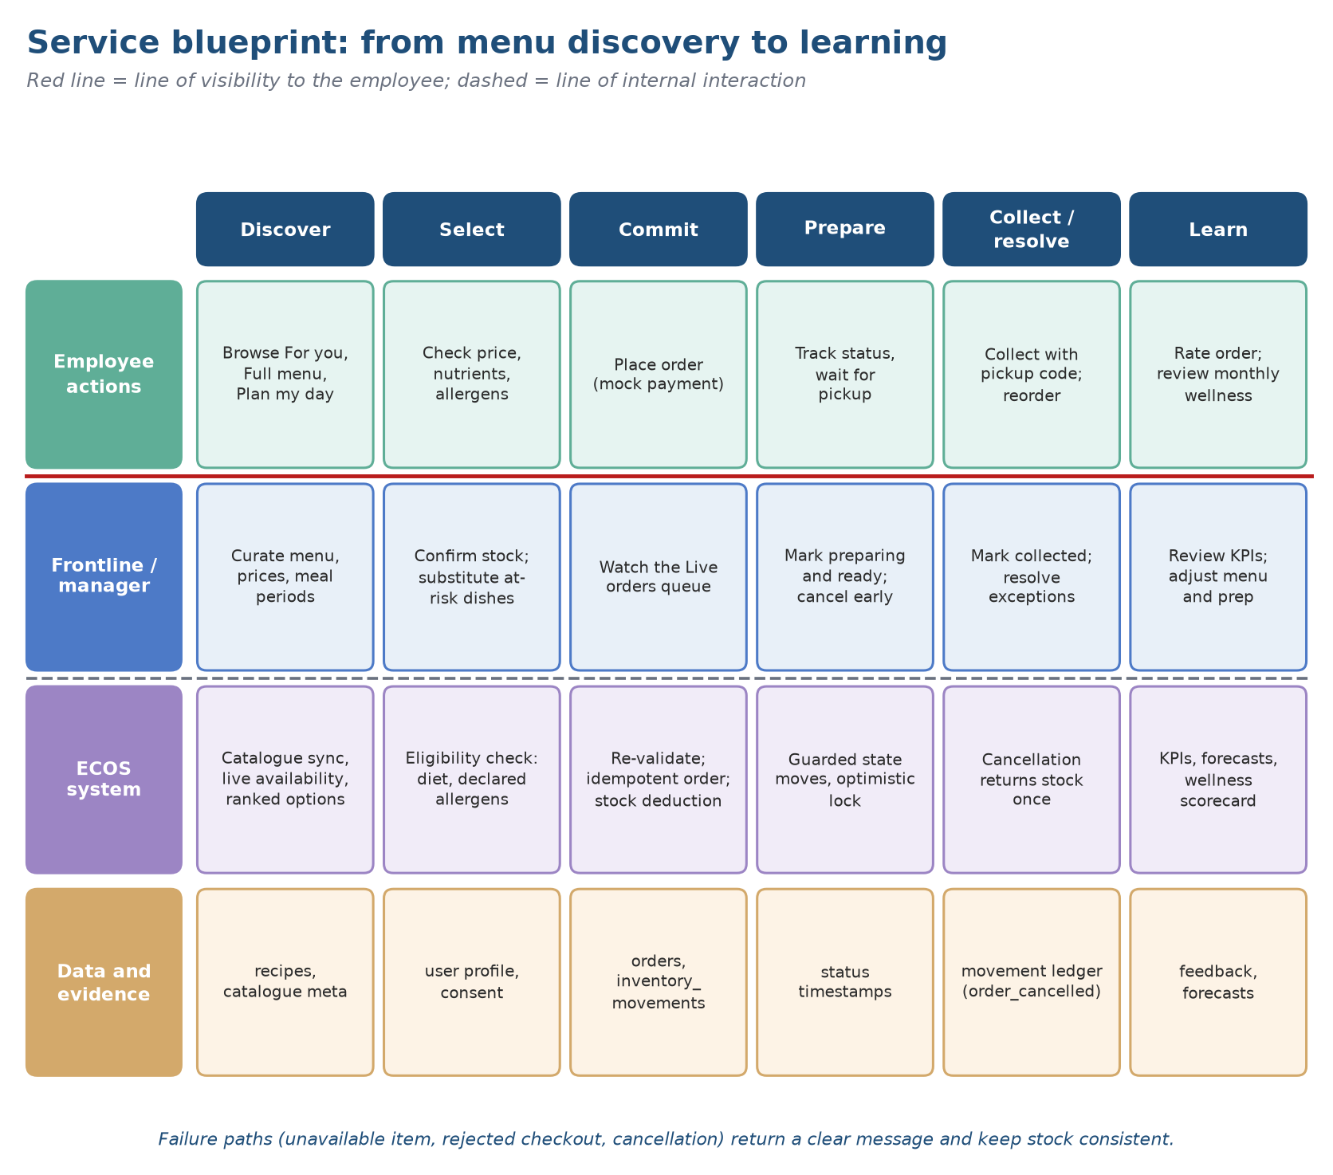
Figure 20. Service blueprint: employee touchpoints, kitchen activity, manager decisions and supporting data.
Table 36. Service blueprint by stage
Stage | Employee-facing action | Backstage work | Evidence or control
Discover | Looks through the menu and any suggestions | Staff keep dishes, prices, ingredients and availability up to date | Menu version history and a named attribute owner
Select | Reads an item and its declared details | Stock and substitutions are checked against the item | Timestamp on availability and a periodic review
Commit | Confirms a demonstration order | The order state is saved and shown to operations | Safe-to-repeat submission and a clear confirmation
Prepare | Waits for the order | The kitchen orders its work and deals with problems | History of status changes and a named escalation contact
Collect or resolve | Picks up the order or asks for help | A manager handles missing items, delays and swaps | Outcome code and a recovery log
Learn | Looks back at orders and may rate them | Behaviour is summarised and used for planning | Analytics with minimal personal detail

Every step should have a named service owner, frontline role, data steward, technical contact, escalation trigger and a fallback if the system is unavailable. Falling back to manual working is part of a resilient design rather than a defeat: an approved paper or shared menu and a written routine for updating stock keep service going during an outage.

16.4 Order lifecycle and service recovery
An order passes through states and cannot be reduced to one count. ECOS implements five: confirmed, preparing, ready, collected and cancelled, with cancellation reachable only from confirmed or preparing (Figure 21). Only managers change status. Each update is conditional on the previous status, so two managers acting at once cannot both succeed; the second receives a conflict response and must refresh.
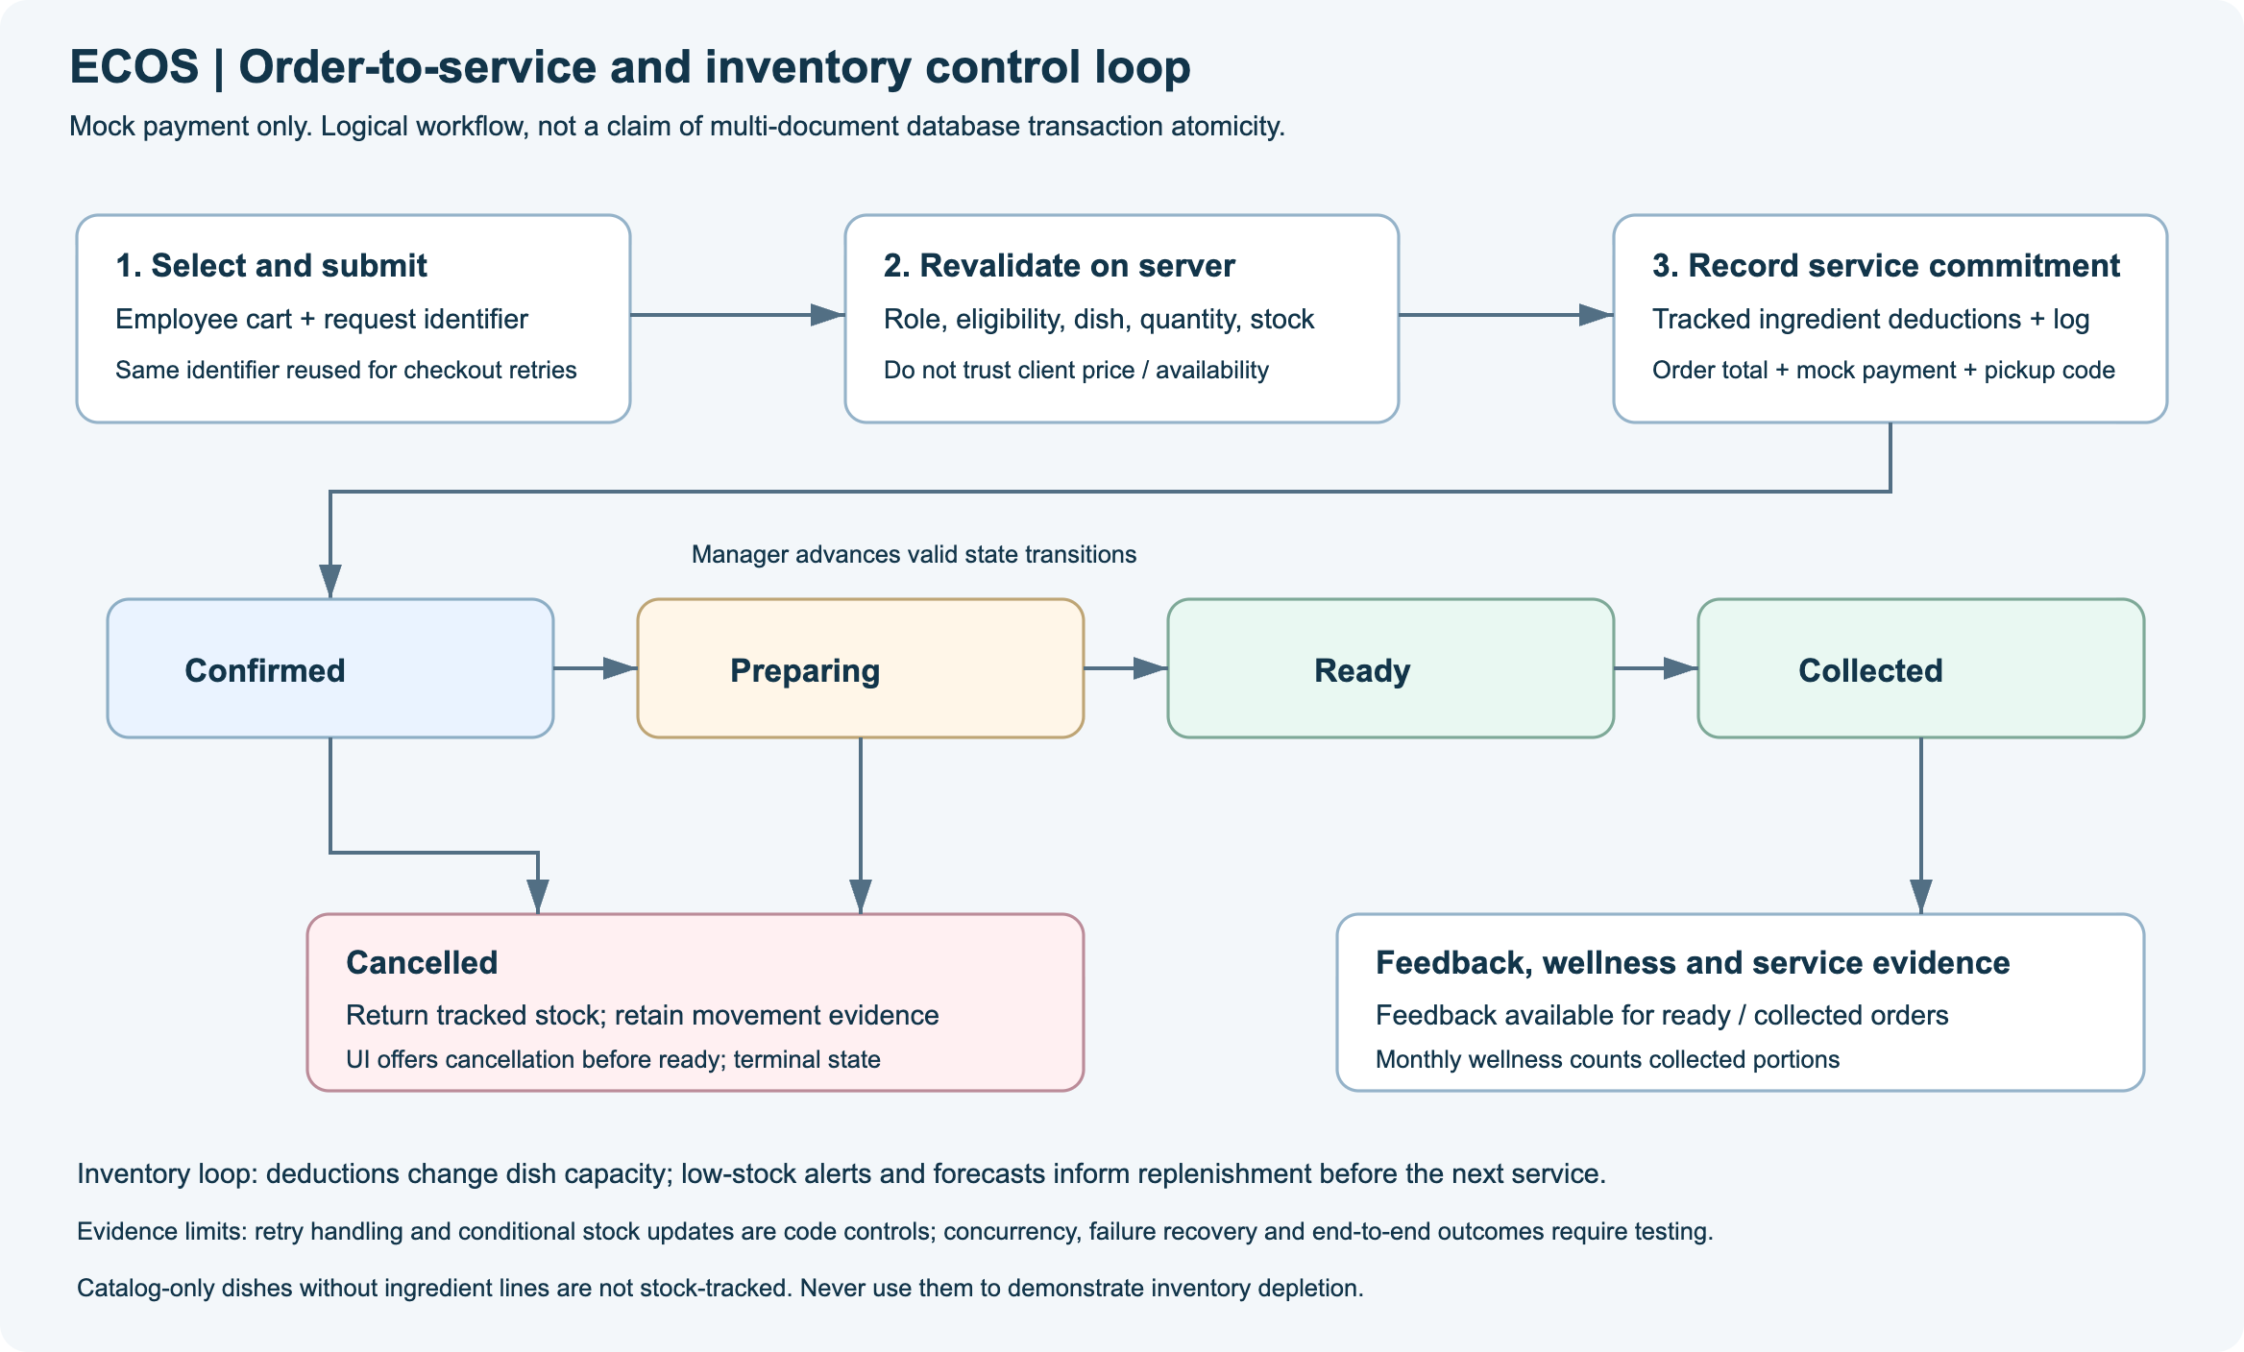
Figure 21. Order lifecycle (derived from the project asset docs/assets/order-lifecycle.svg).
Table 37. Order states and what they mean for management
State | What it means for management | Not to be mistaken for
confirmed | Order accepted; ingredients have been deducted from stock | Prepared, paid or collected
preparing | Kitchen has started the order | Ready for collection
ready | Waiting at the counter; cancellation is no longer possible | Collected
collected | Handed over; counts as completed for completion rate and tag shares | Paid or consumed
cancelled | Stock returned once; excluded from forecast training and from recommendation history | Zero demand or employee dissatisfaction

Table 38. Controls on the ordering and stock path
Control | How it works | Why it matters
Idempotent checkout | The client sends a client_request_id; a unique partial index on (user_id, request_id) makes a retry return the original receipt | Retries and double clicks cannot create duplicate orders
Atomic stock deduction | Each ingredient is decremented only if enough remains; on failure everything already taken is restored and a conflict is returned | No negative stock and no half-filled order
Compensation | If the order cannot be stored, the stock, the movements and the order are rolled back | A failed order never loses inventory
Cancellation | Allowed until ready; ingredients are returned once and recorded as order_cancelled movements | Stock stays reconcilable after recovery
Limits | At most 10 portions per dish and 15 lines per order | Guards against input errors and hoarding
Payment | Mock state demo_paid; no money is taken | Order totals are demonstration values, not revenue

Service recovery is a management capability. When a dish is unavailable the server names the dish and the reason in a clear conflict message. Because payment is a mock state there is no refund path; a paid production service would need an approved payment design and a ledger that reconciles exactly with the order states above.

16.5 Inventory control, waste and procurement
Stock policy has to tie together demand, replenishment lead time, shelf life, menu design, storage space and physical control. The manager's inventory area provides tabs for Stock, Edit stock, Today's consumption and Risk & impact. Checked spreadsheet uploads, movement history, affected-dish lists and replenishment hints give a base for disciplined review; they do not, however, make a complete ledger or an optimal replenishment policy.
First decide what the shown quantity means: physically on hand, promised to orders, reserved, on the way, or estimated use. Units need explicit conversion rules, because cases, kilograms, portions and recipe amounts cannot be compared without them. Every adjustment should capture the person, time, item, amount, unit, reason and supporting evidence. Compare periodic physical counts with system balances and investigate gaps instead of overwriting them.
Table 39. Inventory risks and controls
Risk condition | Decision owner | Preventive or detective practice
Out-of-date stock record | Inventory owner | Timestamp each balance; count on a fixed rhythm
Unit mismatch | Data steward | Controlled item master; review conversions
Unapproved adjustment | Operations manager | Role-based authorisation; reason code
Duplicate import | Authorised editor | File or version identifier; preview before commit
Hidden substitution risk | Menu steward | Show affected dishes and attributes
Waste not captured | Shift lead | Standard reason and quantity capture

A risk-and-impact view helps only when its score can be explained. A manager should be able to see what drives a high value: a thin balance, heavy forecast usage, an unreliable delivery window, or an ingredient shared across many dishes. Treat criticality as a plain operating rule. Calling it a stockout probability would need calibration against what actually happened.
Finding B5. ECOS records consumption caused by orders and manual stock movements, but it has no waste-logging transaction (spoilage, preparation waste, surplus) and no supplier, lead-time or purchase-order fields. Waste reduction and procurement savings, two of the three outcomes on the architecture poster, therefore cannot be evidenced from the system as it stands.
Purchasing converts a plan into a binding commercial act. The project papers call purchasing simplified: there is neither a full supplier master nor a purchase-order flow. Accordingly, a restock hint, an ingredient-risk display or a manager's choice to reorder should never be described as a supplier order, a commitment or an integration with purchasing.
Connecting purchasing later would require a governed item and supplier master, approved vendors, contract terms, price history, lead times, minimum order sizes, delivery calendars, substitutes, approval limits and invoice matching. The workflow must keep apart a forecast quantity, a suggested need, a requisition, an approved order, a supplier acknowledgement, a goods receipt and an invoice, since each carries different legal, operational and financial weight.
Table 40. Procurement maturity, from visibility to invoice matching
Stage | What the system can do | What must be shown before moving on
1. Visibility | Display stock levels and usage | Shared definitions of items and units
2. Suggestion | Offer a restocking scenario | Written assumptions and a human check
3. Requisition | Raise an internal request | An approval flow that stops duplicates
4. Purchase order | Commit through authorised buyers | Supplier records, contract terms, approvals and an audit trail
5. Receipt and matching | Log deliveries and invoices | Quantity and price agree; differences are resolved

16.6 Operating cadence and service management
Running a dependable service takes more than code: a daily routine, escalation paths, support, incident tracking and a way to recover. The root app.py waits for a local health check before it starts the dashboard. That suits demonstrations but says nothing about production monitoring, scaling, uptime, backups or incident handling.
Define service hours, a support channel, severity levels, target response times, who owns each shift and what the fallbacks are. If the dashboard fails mid-service, the cafeteria keeps serving from an approved offline menu with manual order and stock routines, and reconciles afterwards. Staff need to know what can safely be re-keyed, what must never be keyed twice, and who has the authority to declare normal service restored.
Table 41. Operational review rhythm
Cadence | Output | Review focus
Start of shift | Named owner; shift risks | Availability, open exceptions, data age
Before service | Availability list; substitution notice | Menu and stock confirmation
During service | Resolution; message to employees | Delays, stockouts, order problems
End of shift | Reconciliation; carried-over actions | Orders, stock movement, waste, incidents
Weekly | Approved process changes | Forecast error, menu mix, repeat issues
Monthly | Continue, change or stop decision | Scorecard, privacy and governance, benefits

16.7 Screen walkthrough
The plates that follow are screenshots of the running application captured with a headless browser on 8 November 2026. They show the synthetic demonstration identities and data described in Chapter 13; names, order values and stock levels are not real. They are included as evidence that the workflows described above exist and render, not as evidence of usability.
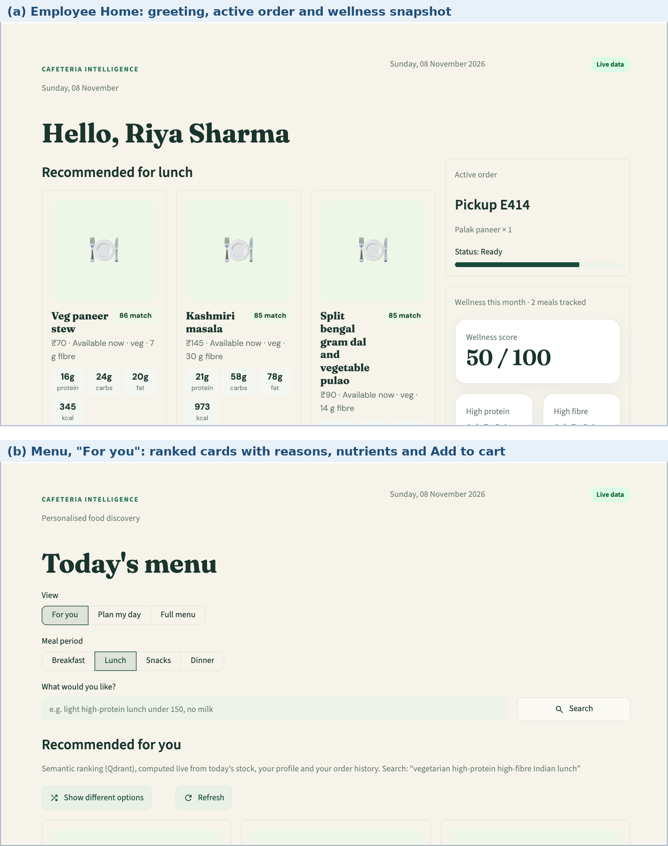
Figure 22. Employee workspace: (a) Home; (b) Menu, For you (synthetic demonstration data).
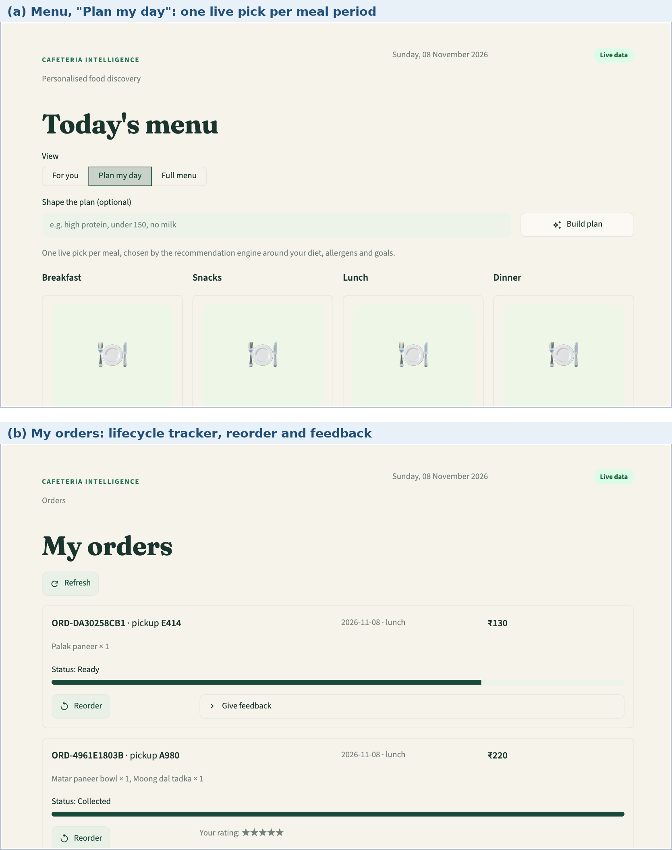
Figure 23. Employee workspace: (a) Plan my day; (b) My orders.
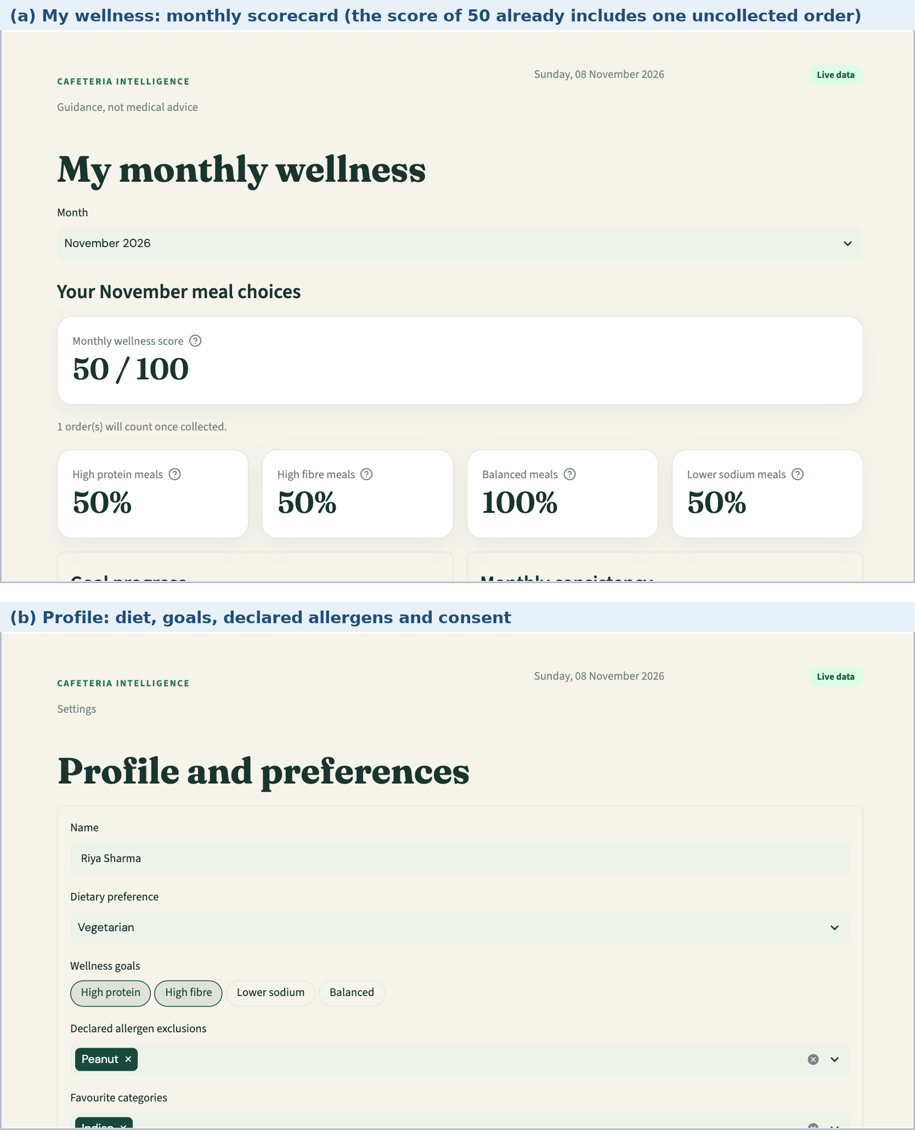
Figure 24. Employee workspace: (a) My wellness; (b) Profile and preferences.
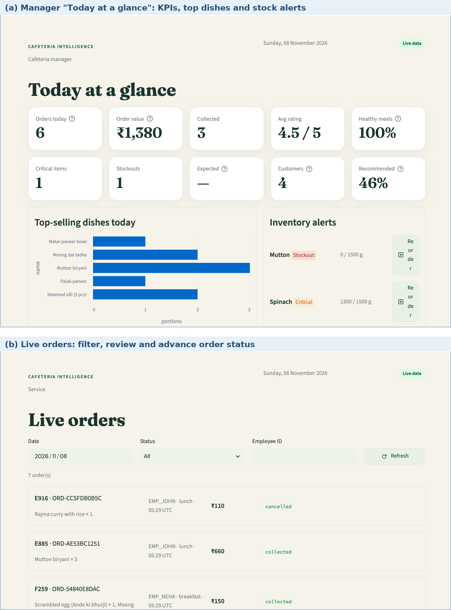
Figure 25. Manager workspace: (a) Today; (b) Live orders.
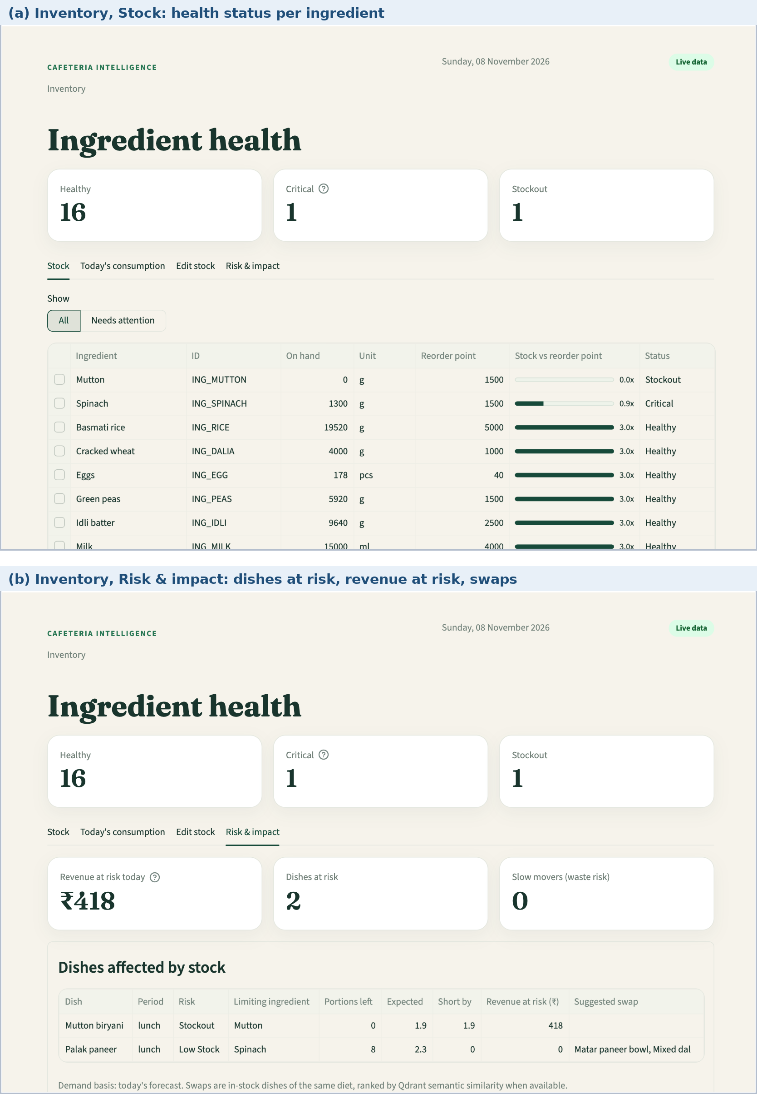
Figure 26. Manager workspace: (a) Inventory, Stock; (b) Today's consumption; (c) Risk and impact.
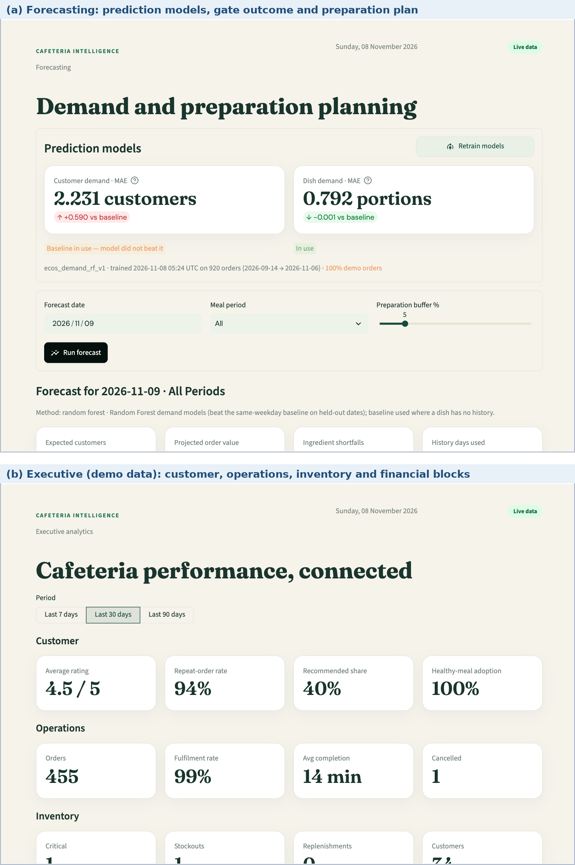
Figure 27. Manager workspace: (a) Forecasting; (b) Executive.
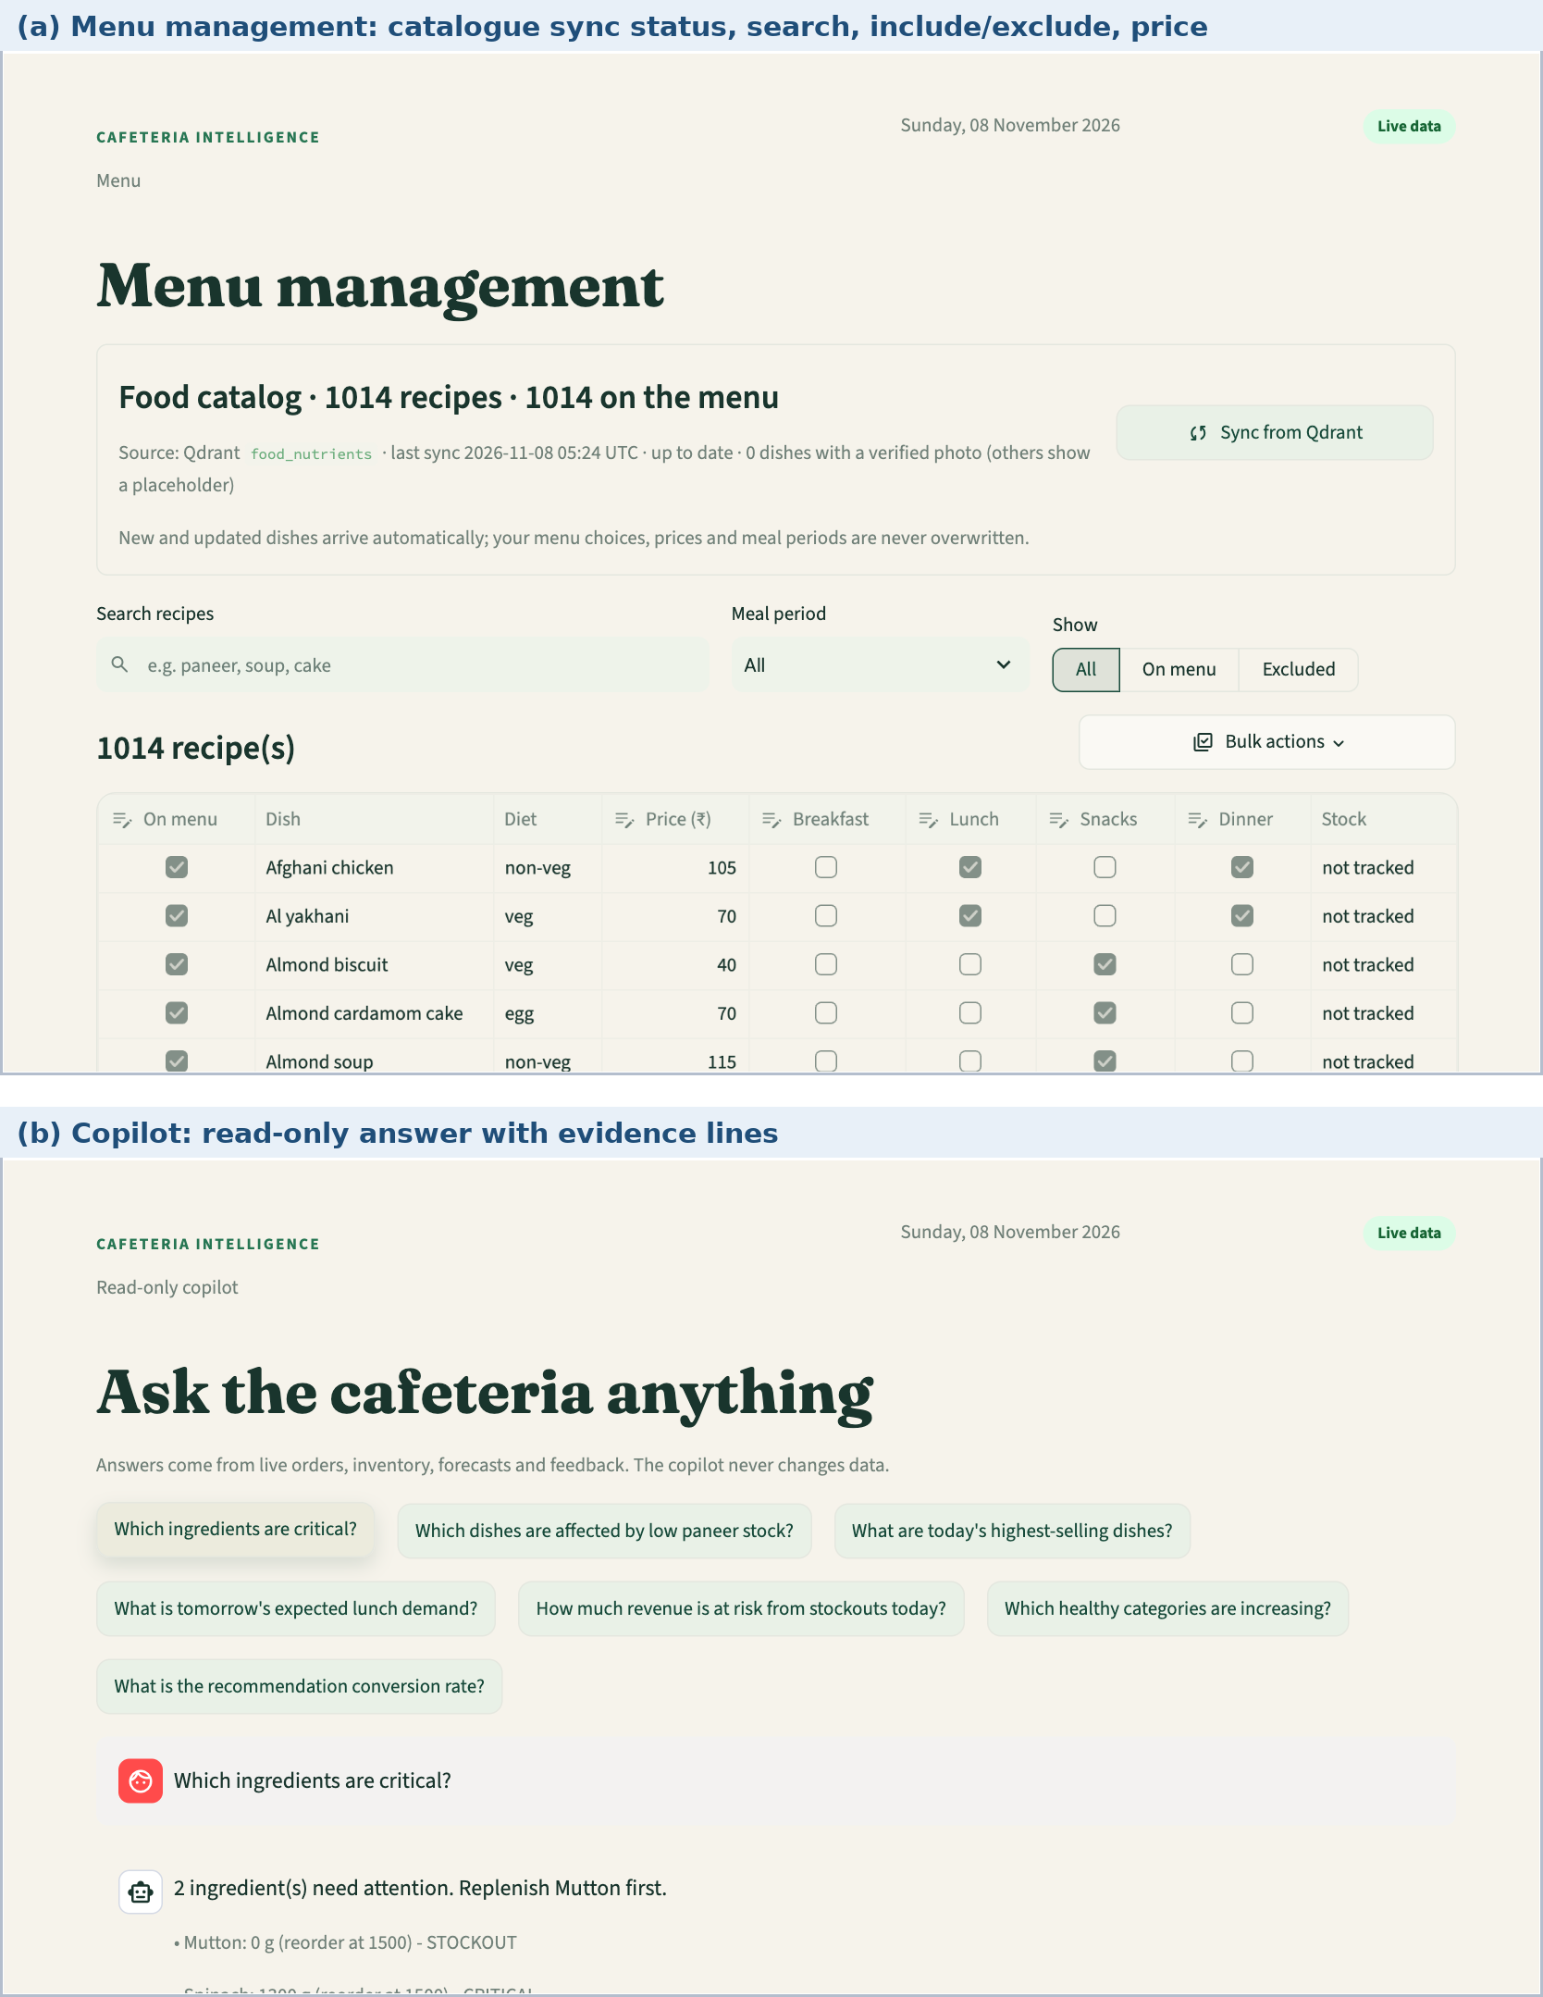
Figure 28. Manager workspace: (a) Menu management; (b) Copilot.

Chapter 17: Analytics and Decision Support

17.1 Recommendation engine
The recommender is a transparent two-stage pipeline (Figure 29). Stage one applies hard filters that are never traded off against ranking. Stage two scores the surviving dishes with an additive heuristic whose terms are shown to the user as reasons. The design choice is deliberate: safety attributes (allergens, diet, budget) are constraints, while taste and goals are preferences.
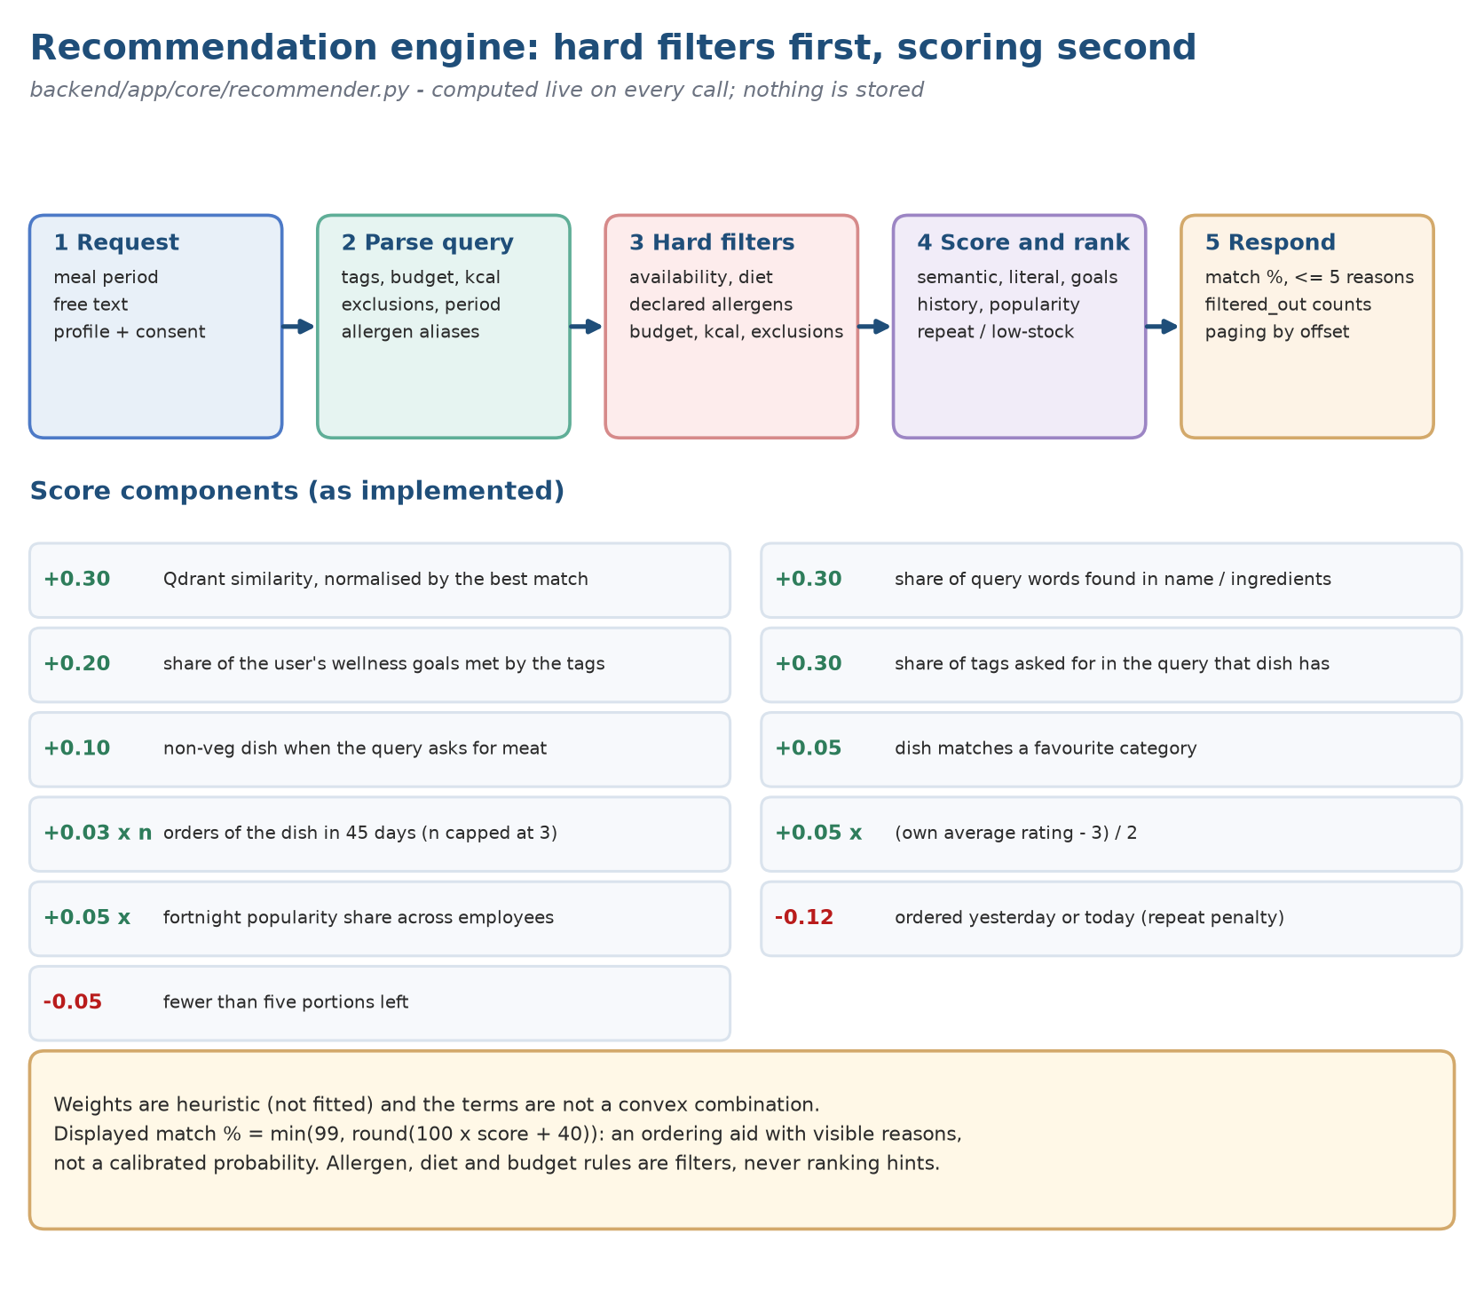
Figure 29. Recommendation pipeline: hard filters, scoring terms and the explanation shown to the employee.
Table 42. Hard filters applied before ranking (in order)
Filter | Rejects a dish when
Unavailable | It is off the menu for the period, or stock for any ingredient line is exhausted
Seen | The caller has already used it, for example in the current day plan
Side item | It is a component (sauce, chutney, dough and similar) and the query names no search term
Diet or allergen | It conflicts with the profile; allergen names are canonicalised so that gluten also blocks wheat and dairy blocks milk
Allergen in the query | The text names an allergen the user excluded in words
Excluded term | The query says “without” a named ingredient that the dish contains
Diet intent | The query asks for vegetarian or vegan and the dish is not
Budget | Price exceeds the stated maximum
Calories | Energy is above the stated maximum or below the stated minimum

Table 43. Scoring terms of the recommendation heuristic
Term | Contribution | Reading
Semantic similarity | up to +0.30 | Similarity to the query or profile text, relative to the best candidate; only when the embedding model is ready
Literal term match | up to +0.30 | Share of query words found in the dish text
Goal match | up to +0.20 | Share of the user's wellness goals met by the dish tags
Query tags | up to +0.30 | Share of requested tags (for example high protein) met
Meat intent | +0.10 | Query asks for meat and the dish is non-vegetarian
Favourite category | +0.05 | Dish text matches a favourite category in the profile
Order history | +0.03 per order, at most 3 | Dishes the user has ordered in the last 45 days
Rating | +0.05 x (rating - 3) / 2 | Rating the user gave to the dish, default 3
Popularity | up to +0.05 | Fortnight popularity relative to the most popular dish
Repeat penalty | -0.12 | Ordered within the last day
Low stock | -0.05 | Fewer than five portions left

The match percentage is min(99, round(100 x score + 40)). The constant 40 is a presentation offset, not a probability; the cap at 99 keeps the interface from implying certainty. No reviewer-labelled relevance test was run, so ranking quality (hypothesis H2 in Chapter 5) remains untested; the executed checks show only that the filters and the ordering behave as specified.

17.2 Nutrition tags and the wellness score
A dish receives a nutrition tag when it meets a threshold: protein of at least 12 g (high protein), fibre of at least 5 g (high fibre), sodium above 0 and at most 300 mg (lower sodium), or protein of at least 7 g with fibre of at least 3 g and at most 550 kcal (balanced). The four tags together define a “healthy” portion. Because 92.8% of the catalogue qualifies, almost every portion earns the full 10 points, and the score saturates at 100 after eight portions in a month (Figure 30). The score therefore measures ordering volume more than ordering quality (Finding B4).
Formula 1. Monthly wellness score (h = portions with a nutrition tag, o = other portions)
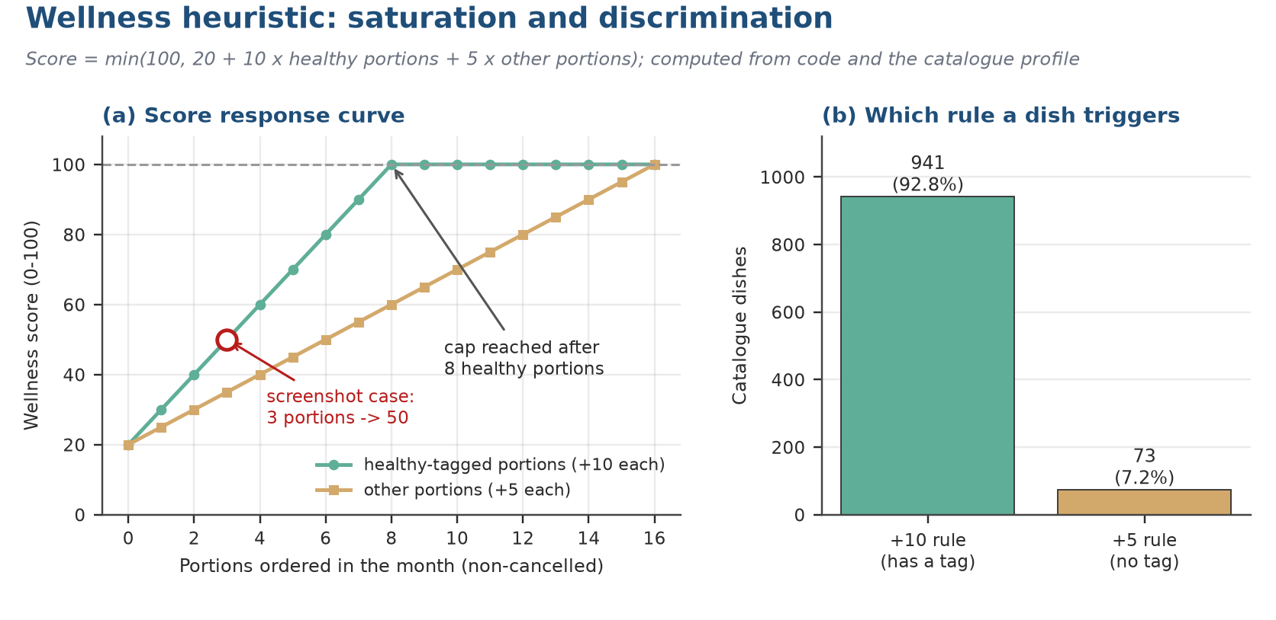
Figure 30. Wellness score against the number of tagged portions ordered in a month.

17.3 Demand forecasting
The forecasting module predicts customers per service date and meal period, and portions per dish. Each lag feature is computed only from earlier services of the same group, so no future information leaks into a prediction (Figure 31). The inputs are the meal period, the day of the week, the previous value, the four-service rolling mean and same_weekday_4, the mean of up to four preceding services on the same weekday. A Random Forest (200 trees, depth 8, minimum leaf 2, seed 42) is trained on the first 80% of service dates and tested on the last 20%. Training is refused below 12 customer rows, 20 dish rows or five service dates. The model is served only if its mean absolute error does not exceed that of the baseline (Formula 2); otherwise the baseline is used.
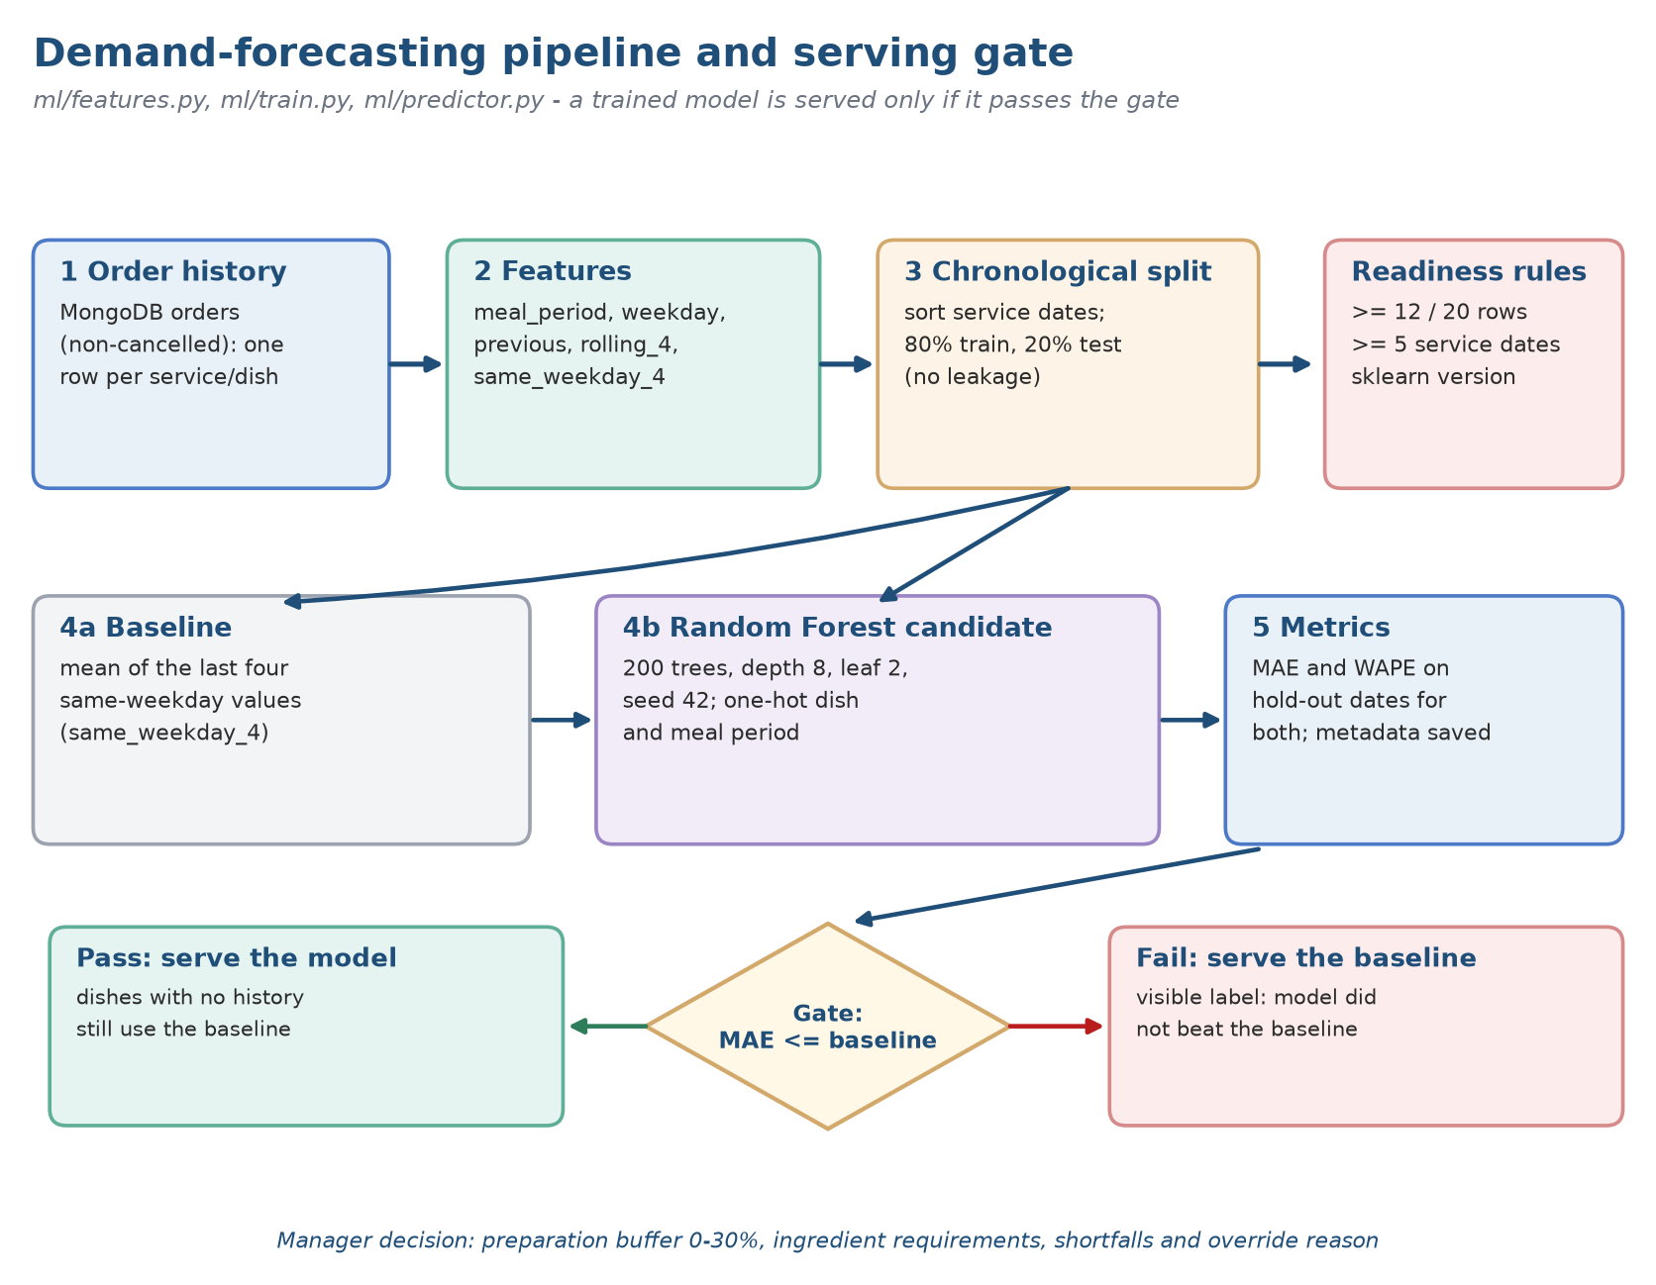
Figure 31. Forecast pipeline: features, chronological split, evaluation and serving gate.
Formula 2. Serving gate for the demand model
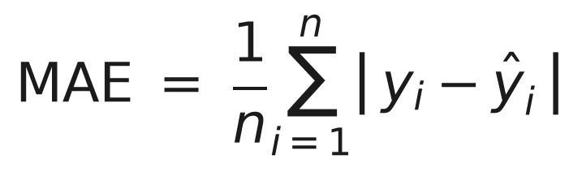
Formula 3. Mean absolute error
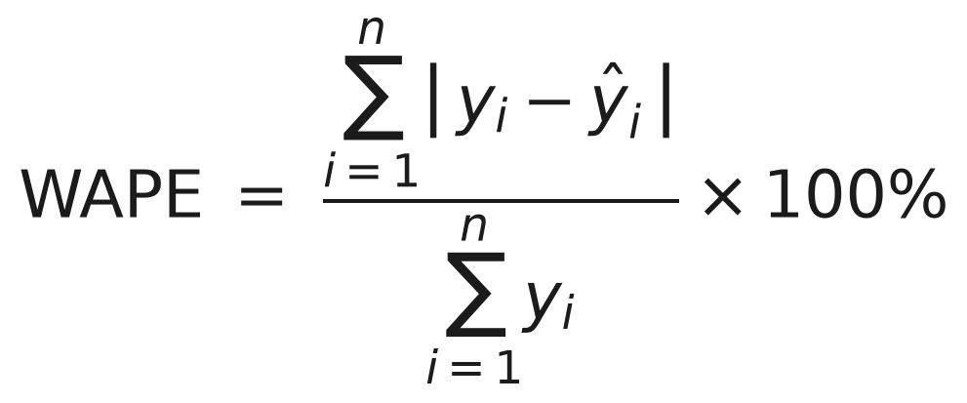
Formula 4. Weighted absolute percentage error
The baseline is itself one of the model's inputs, so on thin history the model can at best refine it. The manager chooses a safety buffer of 0 to 30% in the interface (the API accepts 0 to 50%), and the preparation quantity is the rounded-up product of the forecast and the buffer (Formula 5).

Formula 5. Preparation quantity (forecast d, buffer b in per cent)
A forecast matters only if someone uses it to decide something: it needs a defined horizon and a person answerable for the call. On the Forecasting page a manager picks dates, meal periods and a buffer between 0 and 30 per cent, and can retrain the models. These controls allow planning scenarios to be explored; they do not prove accuracy or show that any buffer is best.
Weigh the forecast against expected attendance and event calendars, and also against past demand, menu changes, availability limits, local conditions and kitchen capacity. State the horizon and the unit (orders or servings), and warn when history is thin or has changed shape. The buffer is a setting the manager chooses; it is not a statistical confidence band.
Table 44. Record to keep when a forecast drives a decision
Field | What it must contain
Forecast | Predicted demand for a stated dish, meal period, date and unit
Baseline | A simple comparator, for instance past demand on the same weekday
Buffer | The extra margin chosen, with who chose it and why
Limits | Stock on hand, staffing, preparation time, menu availability
Decision | Whether the manager accepted, changed or overrode it, and the reason
Result | What actually happened, measured with the same definition

What was run. The pipeline was trained on the synthetic history (920 orders on 39 service dates from 14 September to 6 November 2026, 100% demonstration orders), with the test period starting on 28 October. Table 45 gives the result and Figure 32 compares the errors.
Table 45. Forecast evaluation on synthetic demonstration history
Target | Rows train / test | MAE model | MAE baseline | WAPE model | WAPE baseline | Gate | Bootstrap MAE difference (95% CI)
Customers per meal period | 124 / 32 | 2.231 | 1.641 | 39.22% | 28.85% | Fails | +0.590 [0.050, 1.118]
Dish portions | 589 / 152 | 0.792 | 0.793 | 66.12% | 66.21% | Passes by 0.001 | -0.0011 [-0.0868, 0.0869]

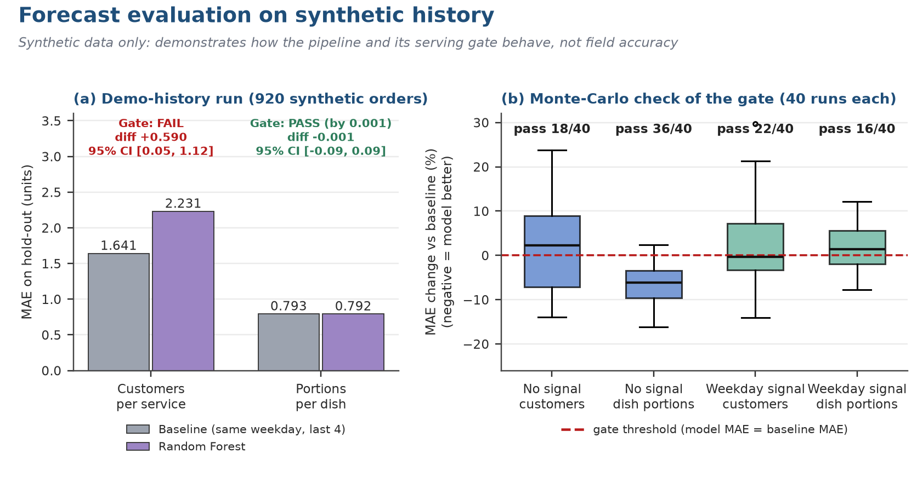
Figure 32. Forecast errors against the baseline and the stability of the serving gate.
The customer model is clearly worse than its baseline, and the dish model is statistically indistinguishable from it: its confidence interval spans zero and the gate is passed by one thousandth of an order. Because the data are random demonstration orders, a good model is not expected; the useful question is whether the gate can tell a useful model from a useless one.
Table 46 answers it with a Monte-Carlo study: 40 synthetic histories per scenario, each of about eight weeks. When demand has no signal at all, the dish model passes the gate in 90% of runs and the customer model in 45%. When demand has a genuine weekday pattern, the dish model passes in only 40% of runs and the customer model in 55%. A gate that approves noise and rejects signal at similar rates is not a control (Finding B3).
Table 46. Stability of the serving gate (40 simulated histories per scenario)
Scenario | Target | Gate passes (of 40) | Median MAE difference vs baseline | P10 / P90
No demand signal | Customers | 18 | +2.2% | -11.2% / +13.9%
No demand signal | Dishes | 36 | -6.1% | -11.2% / -0.3%
Weekday signal | Customers | 22 | -0.3% | -7.3% / +11.6%
Weekday signal | Dishes | 16 | +1.3% | -5.9% / +8.3%

Recommended hardening of the gate
Require at least 12 to 16 weeks of history before a model can be served; demand a minimum improvement margin (for example 5% lower MAE); require the bootstrap interval of the difference to exclude zero or use rolling-origin evaluation; add a second naive benchmark (seasonal naive); report results by meal period; and show the source of every displayed number (model, baseline or fallback).

17.4 Inventory risk and replenishment
Each ingredient has a reorder point. The Stock tab compares on-hand quantity with it, Today's consumption derives usage from orders, and Risk and impact lists the ingredients under pressure together with the dishes they affect. The suggested replenishment is a transparent rule (Formula 6), not an optimiser: it restores stock to twice the reorder point. It is a prompt for a human decision, not a purchase order.
Formula 6. Suggested replenishment quantity

17.5 Copilot
The copilot is available to managers only and is read-only. It recognises eight kinds of question (dishes hit by a shortage, stock risk, inventory alerts, forecasts, the trend in healthy choices, recommendation conversion, best-selling dishes and a sales summary) and otherwise says it cannot help. Every reply carries the intent, an evidence list, the source (rules or llm), a read-only flag and an as-of timestamp. When a language model is configured it rephrases the rule answer from a compact fact sheet; when it is not, the rule answer is returned unchanged. Table 47 states the interaction standard.
Table 47. Standard for copilot answers
When the manager asks | The answer should
about stock risk | give the rule used and the age of the balance
for a forecast | say whether it comes from the model, the baseline or a fallback, and give the horizon and unit
about a substitute | show the ingredient and declared-attribute checks
for wellness advice | refuse clinical advice and point to menu facts and support
to place a purchase order | explain that supplier ordering lies outside this simplified workflow
and data are missing | say so plainly instead of guessing

Chapter 18: Verification, Testing and Findings

18.1 Test strategy and results
Two executable suites ship with the repository. The backend smoke test drives the API against an empty and a seeded database; the user-interface test drives the Streamlit application with the framework's AppTest harness. Both were run on 8 November 2026 against throwaway databases (Table 24). All 172 checks passed: 138 backend and 34 user-interface (Table 48, Figure 33).
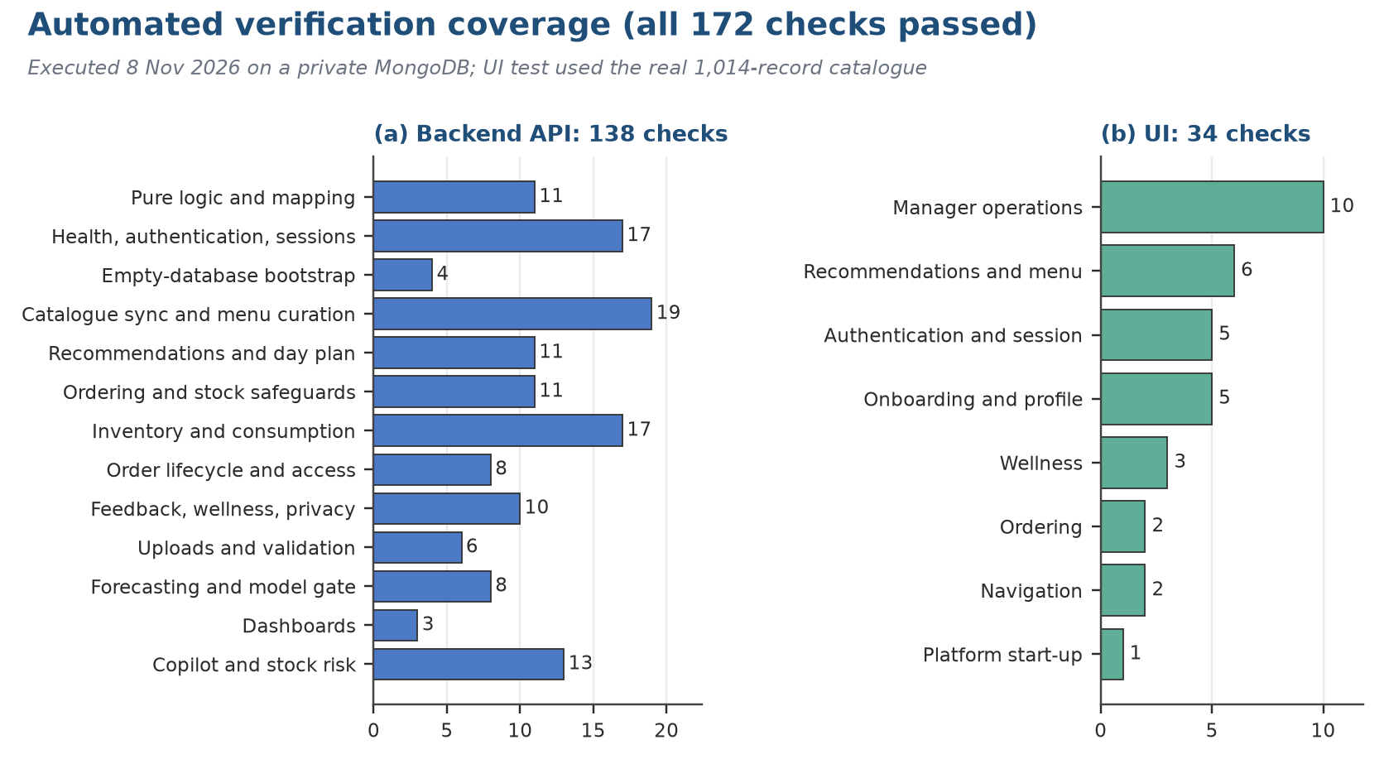
Figure 33. Executed checks by group (138 backend and 34 user-interface, all passed).
Table 48. Executed checks by suite and group
Suite | Group | Checks | Coverage
Backend | Pure logic | 11 | Scoring, tag rules, allergen canonicalisation and price estimate helpers
Backend | Authentication and sessions | 17 | Login, lockout, session refresh and expiry, logout, role gates
Backend | Empty database | 4 | Safe behaviour before any data exists
Backend | Catalogue sync and menu | 19 | Synchronisation of 1,014 recipes, menu flags, availability and periods
Backend | Recommendations and day plan | 11 | Hard filters, ranking, explanations, meal plan
Backend | Ordering | 11 | Checkout, idempotent retry, stock deduction, limits
Backend | Inventory | 17 | Stock edits, alerts, movements, affected dishes, replenishment
Backend | Order lifecycle | 8 | Allowed and refused transitions, cancellation and stock return
Backend | Feedback, wellness, privacy | 10 | One rating per order, scorecard, access to other users' data
Backend | Uploads | 6 | Validation before commit for stock and recipe files
Backend | Forecast and model | 8 | Run, latest, model status, refusal on thin history
Backend | Dashboards | 3 | Employee, manager and executive payloads
Backend | Copilot and risk | 13 | Intents, read-only contract, evidence, stock risk
User interface | Manager operations | 10 | Today, live orders, inventory, forecasting, executive, copilot pages
User interface | Recommendations and menu | 6 | For you, full menu, plan my day
User interface | Authentication and session | 5 | Login gate, session restore, logout
User interface | Onboarding and profile | 5 | Preferences, allergens, goals
User interface | Wellness, ordering, navigation, platform | 8 | Scorecard page, cart and checkout, role navigation, reconnect banner

18.2 What the tests do not prove
• Performance and scale. No load, soak or failure-injection test was run; the persistence layer is synchronous.
• Usability. The user-interface suite checks that pages render and behave, not that people can use them.
• Forecast usefulness. The model tests check mechanics on synthetic history, not accuracy on real demand.
• Data truth. Allergen and nutrition values are catalogue estimates; no laboratory or supplier verification was performed.
• Security assurance. Controls were exercised functionally; no penetration test or dependency audit was performed.

18.3 Findings register
The verification surfaced seven findings (Table 49). They are product-quality observations for the owner. None invalidates the purpose of the prototype, but B1 to B3 should be closed before any pilot report quotes the indicators they affect.
Table 49. Findings from the verification run
ID | Finding | Evidence | Severity | Recommended action
B1 | The wellness score counts orders that are not yet collected, while the page caption says it counts collected orders | wellness_score() includes every non-cancelled order; month_stats() uses collected only; captured wellness screen | Medium | Count collected orders only or change the caption; add a regression check
B2 | Evidence status is set to “confirmed” for every dish; the three-state match status defined for the catalogue is not carried into the application | Qdrant payload has no match_status field | Medium | Carry the status into the payload and show it next to nutrition values
B3 | The forecast serving gate is a bare comparison on one split and does not discriminate | ml/train.py; Table 46 | High | History minimum, improvement margin, interval or rolling-origin test, second baseline
B4 | The healthy-dish rule is permissive: 92.8% of dishes qualify and the score saturates after eight portions | Table 33; Figure 30 | Medium | Tier the tags or weight by nutrient quality; re-baseline the KPI
B5 | No waste log and no supplier or lead-time fields | Table 32 | Medium | Add a waste transaction with reason codes and a supplier master before benefit claims
B6 | Documentation is stale: API_ENDPOINTS.md states 33 endpoints, 60+ checks and 21 of 21 passing | Actual: 42 operations on 39 paths; 138 backend and 34 UI checks | Low | Generate the endpoint list from the OpenAPI export and quote counts from a run
B7 | A manager can read any employee's monthly wellness and trend through the API | require_self_or_manager on both wellness endpoints | Medium | Limit managers to aggregates above a minimum group size and log privileged access

Reading the findings
The ordering and stock path, the part of ECOS that handles money-like and safety-critical state, passed every check and shows careful engineering (idempotency, conditional updates, compensation). The findings cluster in the interpretive layer: indicators whose meaning is more generous than their definition (B1, B3, B4) and evidence that is stated more strongly than it is carried (B2). That is the usual failure pattern of analytics products, and it is cheap to fix before a pilot and expensive to fix after.

Chapter 19: Consumer Behaviour, Ethics, Privacy and Governance
ECOS touches three sensitive areas: personal food choices, declared diet and allergens (which can reveal religion or health), and a wellness score. Governance is therefore treated as part of the product. The technical controls are in Chapter 15; this chapter sets out the management rules that must accompany them.

19.1 Consumer behaviour and choice architecture
The ordering screen doubles as a marketing channel. What people pick is shaped by availability, perceived price, wording, social cues, default placement, suggestions, convenience and timing. A “For you” shelf helps discovery but also directs attention, so ethical practice asks whether diners receive a fair and understandable choice, not just whether engagement goes up.
Counting recommended items is not the same as measuring conversion. An impression or a click does not show that the person chose, completed, collected or ate the dish, nor that they would have chosen differently without the suggestion. A trustworthy funnel tracks each stage on its own: exposure, then engagement, then selection, then the committed order, then fulfilment, with cancellations, substitutions and repeat use recorded alongside, each under a single event definition and privacy-aware aggregation.
Table 50. Ladder for measuring consumer behaviour
Step | Example measurement | What it does not tell you
Visibility | Count of times a suggestion was shown | Only that it could be seen
Interest | Opening a dish page or saving it | Attention rather than a wish to buy
Selection | Adding a dish to the cart | The cart may still be abandoned
Commitment | Placing the order | It may not be fulfilled or paid
Fulfilment | Order handed over | Whether the food was eaten
Repeat | Choosing the dish again later | Habit or preference, not proven loyalty

ECOS records whether each order line came from a recommendation (the recommended flag), so the share of ordered lines that were recommended can be measured. Impressions and detail views are not logged, so the earlier stages of the measurement ladder cannot yet be observed.

19.2 Wellness ethics and inclusion
Wellness analytics at work raise special sensitivity because power is unequal. A feature intended kindly can still feel mandatory if managers see named choices or staff fear an effect on appraisals, benefits or standing. ECOS should hence handle wellness information as an optional service signal with tight purpose limits, never as a score for managing people.
In ECOS the wellness score is a rule-based, voluntary indicator shown to the employee, with an explicit non-clinical disclaimer. Two design facts need policy attention: the score rewards volume more than quality (Finding B4), and the API allows a manager to read any individual's score (Finding B7). Purpose limitation therefore has to be enforced by policy and by access control, not left to good intentions.
The interface keeps estimated nutrition apart from measured values and warns that declared allergens do not guarantee freedom from cross-contact. That warning should remain visible where choices are made. In production, add source provenance, review dates, version history, a way to correct errors and an escalation route for people who need a reliable answer; a kitchen that cannot verify cross-contact controls must not imply a guarantee.
Table 51. Guardrails for wellness features
Principle | What it requires in practice
Free choice | Declining or ignoring the feature carries no penalty
Purpose limits | Data never reused for appraisal, promotion or discipline
Data minimisation | Gather as little as possible and aggregate where it can be done
Openness | Explain how scores work, what they leave out and where data come from
Inclusion | Every diet, culture and access need keeps its full range of choices
Right to challenge | People can fix wrong data and ask a human to look again
No clinical role | Nothing is diagnosed, treated or inferred about health

Management must also decide whether wellness features start switched off, sit in a store separate from operational data, or are reported only when groups are large enough. HR, privacy, legal, staff representatives and security should all review. Legal compliance is outside this report and needs qualified advice for the jurisdiction and the data flows concerned.

19.3 Data governance and privacy
Data quality, meaning and ownership set an upper limit on what the platform is worth to management. A dish code that shifts between menus, mismatched stock units, absent service dates or outdated allergen declarations can mislead even if the software runs as written. Governing data is thus part of operating the service, not a preliminary IT chore.
Begin with an inventory of datasets that records for each the owner, steward, source, refresh frequency, retention, sensitivity, definition and permitted purpose, together with a dictionary for each field that feeds a decision. Spell out what “order count” includes (cancelled? pending?), the unit and timestamp for “stock”, how “consumption” differs from sales, and who approved the rule behind “healthy portion”.
Table 52. Minimum data-quality dimensions
Dimension | Owner | Example test
Completeness | Menu steward | All required dish fields filled
Validity | Data steward | Units, dates and values obey defined rules
Consistency | Product or data owner | Same item, unit and status meaning in every view
Timeliness | Operations owner | Age of the data is visible and within threshold
Uniqueness | Application owner | No duplicated item or event identifiers
Accuracy | Operational controller | A sampled record matches the authoritative source
Lineage | Analytics owner | Each output traces to a source version and transformation

Privacy governance begins with the reason for each field and the decision it feeds. A field needed to fulfil an order does not thereby justify every other use. Wellness analytics, personalisation, recovery of failed service, forecasting and finance reconciliation each need a stated purpose and access rule; nothing should be retained or linked just because it might be useful someday.
Before a live pilot, carry out a privacy-by-design review: list categories, identifiers, sources, users, purposes, retention, storage, transfers, deletion and access; ask whether any field hints at diet-related restrictions, religious practice or health; and test whether individual-level analysis is truly needed or an aggregate suffices. Remember that small teams can be identified even in aggregates.
Table 53. Checklist before any data use
Question | Answer needed before the pilot starts
What is the reason for collecting it? | A specific purpose approved for the service or the evaluation
Who may see identifiable records? | Named roles holding only the access they need
How long will it be stored? | A retention schedule, with proof of deletion
Can an employee fix errors? | A clear contact point and correction route
Could it influence employment decisions? | It must be ruled out explicitly for wellness participation and scores
Does an outside provider touch it? | Review of data transfer and contract
What happens after misuse or a breach? | Defined steps for escalation, containment and notification

The NIST Privacy Framework offers risk-management guidance and is neither a certificate nor a legal safe harbour. The NIST AI Risk Management Framework could guide governance if more advanced AI arrives. Today the copilot is rule-based and read-only, with a language model only optionally rewording answers, and it should be described that way. Indian law and company policy call for review by qualified specialists.

19.4 Analytics and model governance
Analytics governance asks who owns the business question, who owns the method, where the data come from, who approves changes, who acts on the result and how mistakes are corrected. It covers plain rules as well as statistical models, since a rule-based score can mislead when its assumptions stay hidden.
Table 54. Controls across the analytics lifecycle
Step | Evidence of control
Define the use | The decision it supports, who uses it and what it must not be used for
Prepare data | Origin, lineage, quality checks and what was excluded
Build | Code under version control with reproducible dependencies
Test | Baseline comparison, time-ordered holdout, error and subgroup review
Approve | Named sign-off from business and analytics
Release | Artefact identity, start date and rollback plan
Watch | Coverage, drift, outputs, errors, overrides and incidents
Retire | Why it was withdrawn, where it is archived and what users are told

For the Random Forest, keep a governance file containing feature definitions, training cut-off, chronological split, baseline calculation, MAE and WAPE by segment, minimum-history rule, library version, artefact hash and activation decision. The serving gate is a helpful guardrail but should be read alongside segment results and the cost of errors, because a model that only just clears the aggregate bar may still be unfit for a high-risk dish or a quiet period.

Chapter 20: Financial Appraisal, Benefits and Balanced Scorecard

20.1 Cost model
Management accounting moves the discussion from features to the allocation of resources. Start by separating demonstration figures from accounting records: the Executive view labels demonstration order values as unaudited revenue and the demonstration checkout says nothing is charged. Keep those labels visible in screenshots and slides. An order value is useful for illustrating the interface; it is not booked sales, cash in hand, margin or audited revenue.
A future cost model should distinguish one-off from recurring cost. One-off items cover training, integration, discovery, build, data clean-up, change management and privacy assessment. Recurring items cover support, model monitoring, hosting, the database service, stewardship of menu and data, security review, supplier integration and the staff time absorbed by exceptions. Opportunity cost counts too: time a manager spends validating data is a real resource even though no bill arrives.
Table 55. Cost categories for a lifecycle view
Cost category | Evidence source | Example driver
Technology | Approved estimate or invoice | Hosting, storage, database, monitoring
Implementation | Time records and vendor statements | Engineering, integration, migration
Operations | Staff hours and service logs | Support, incidents, menu and data stewardship
Change | Attendance and effort records | Training, communication, backfill
Control | Approved engagement and time | Privacy, audit, testing, legal review
Transition | Project plan and process records | Parallel running, manual fallback, retirement

20.2 Investment appraisal with illustrative inputs
The appraisal below is entirely hypothetical. It uses round numbers that are not estimates for ECOS or for any cafeteria, and exists to show how the decision logic works and how sensitive it is. Assume an up-front investment of 12 lakh rupees, a constant annual net benefit for three years, and no tax, inflation or residual value. The net present value is given by Formula 7, and the annual benefit at which the project exactly breaks even by Formula 8.
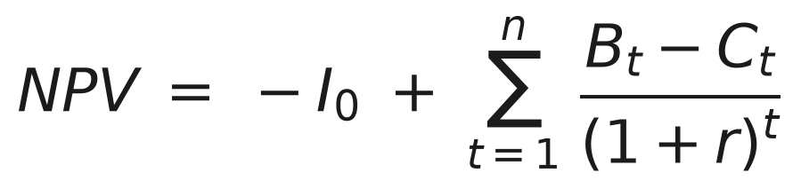
Formula 7. Net present value
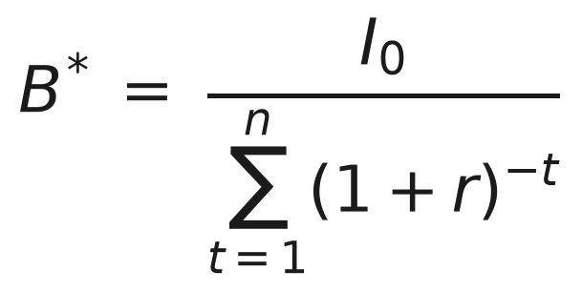
Formula 8. Break-even annual net benefit (B*) over n years at discount rate r
Table 56. Illustrative appraisal under three scenarios (rupees in lakh; investment 12 lakh, three years)
Scenario | Annual net benefit | Discount rate | NPV | IRR | Simple payback | Discounted payback | Break-even benefit | Profitability index
Downside | 3 | 12% | -4.79 | -13.1% | 4.0 years | Not within 3 years | 5.00 | 0.60
Base illustration | 8 | 10% | +7.89 | 44.6% | 1.5 years | 1.72 years | 4.83 | 1.66
Upside | 12 | 8% | +18.93 | 83.9% | 1.0 year | 1.09 years | 4.66 | 2.58

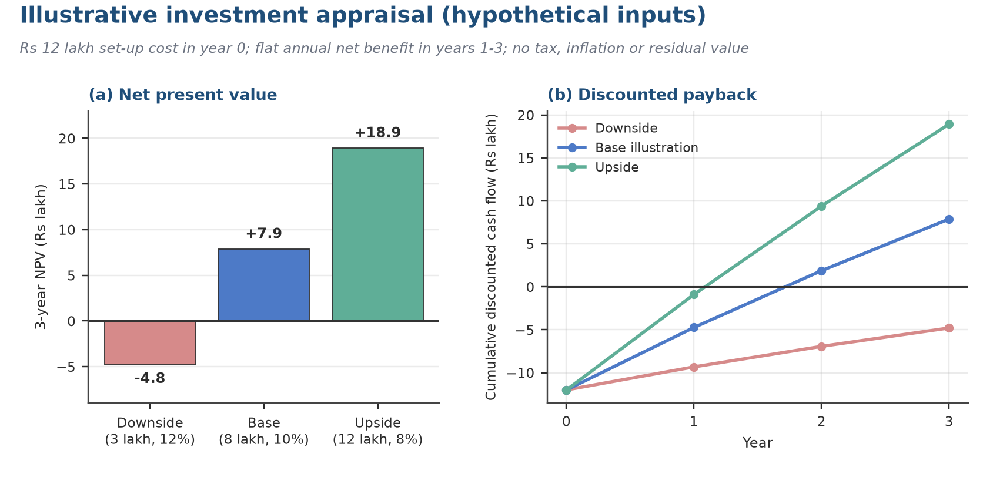
Figure 34. Cumulative discounted cash flow and NPV under the three illustrative scenarios.
Reading the result. The decision turns on one number: whether the true annual net benefit exceeds roughly 4.7 to 5.0 lakh. In the base illustration the NPV stays positive until the benefit falls about 40% below the assumed 8 lakh. For scale, 5 lakh a year is about 1,900 rupees per working day (260 days); for a cafeteria serving 300 meals a day, an illustrative figure, that is roughly 6 rupees of net benefit per meal. Whether waste reduction, shorter exception handling and fewer stock-outs can deliver that, net of the cost of stewardship, is precisely what the pilot must measure. Because B5 means waste is not yet measurable inside ECOS, the benefit side cannot currently be evidenced from the system.
A genuine appraisal swaps each assumption for approved local evidence, compares against leaving things as they are and against a simple shared spreadsheet, and sees a small pilot as an option purchase: a bounded cost that buys the information needed for a later scale decision. Benefits of employee experience should be reported on the scorecard, not converted into invented rupee values.

20.3 Benefits realisation
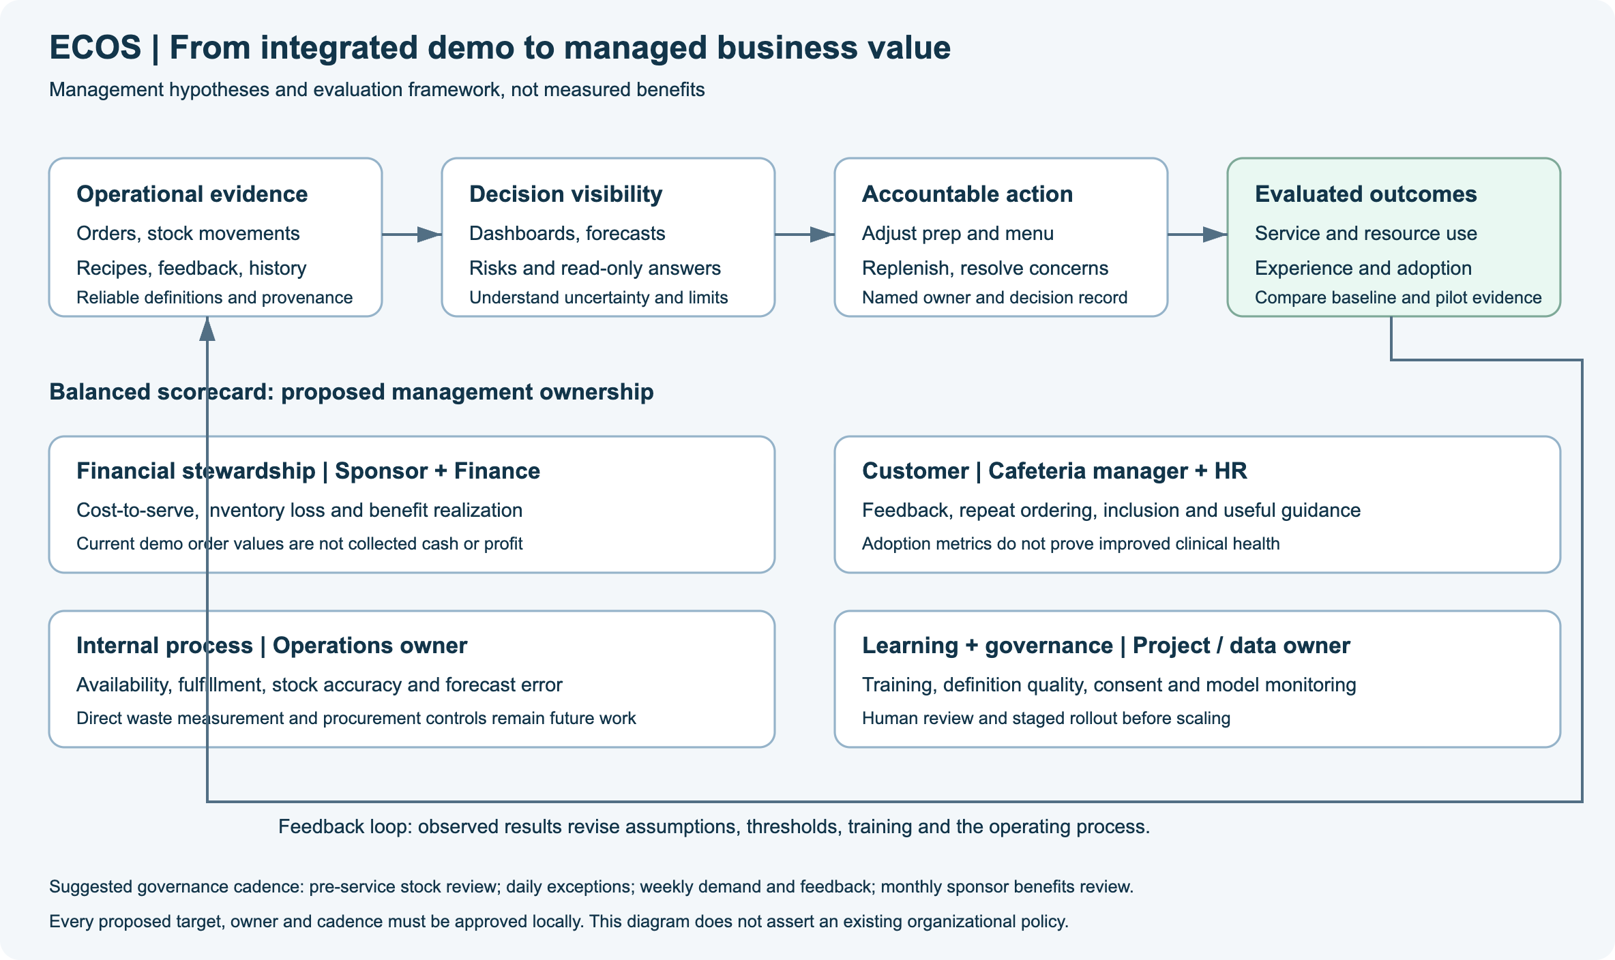
Figure 35. Management value chain (project asset docs/assets/management-value-chain.svg): where ECOS benefits are expected to arise.
Realising benefits has to be planned before the system is built. Each benefit needs an owner, baseline, method for setting targets, metric definition, evidence source, measurement schedule, dependencies and a due date. Software can be delivered without the benefit following if processes, training, decision rights and data quality stay the same; after handover the sponsor, not the developer, should hold the benefit case.
Table 57. Register of benefit hypotheses
Benefit hypothesis | Accountable owner | Outcome evidence | Leading indicator
Faster awareness of exceptions | Operations manager | Resolution time and service log | Time from event to visible queue
Better stock decisions | Inventory owner | Availability, variance and waste data | Completeness of counts and reconciliations
More informed menu choice | Menu or employee-service owner | Employee feedback; completed selections | Attribute completeness; views
Better demand planning | Planner | Actual outcomes; override reasons | Forecast coverage; baseline comparison
Stronger management review | Executive sponsor | Decisions recorded; actions closed | KPI definitions and freshness

20.4 Balanced scorecard
The Balanced Scorecard ties strategy to financial, customer, internal-process and learning measures. For ECOS its job is to stop leaders from improving one result while harming another, not to fill four quadrants with hopeful targets. Kaplan and Norton emphasise measures that turn strategy into action. The scorecard here should be built in stages: definitions and baselines first, targets second, review of outcomes and trade-offs third.
Table 58. Pilot scorecard by perspective
Perspective | Question to ask | Candidate measure | Safeguard
Financial | Is the money spent and saved responsibly? | Validated lifecycle cost and cashable benefit | Demonstration order value never counted as revenue
Employee | Is the service clear and trusted by diners? | Tasks completed, problems resolved, voluntary comments | The whole menu stays available; wellness can be declined
Internal process | Do service and stock decisions stay under control? | Availability, reconciliation and closing of exceptions | Accuracy and safety checks
Learning | Is the organisation getting better from evidence? | Completeness of data, review of model against baseline, staff readiness | No scaling up before a gate decision

Chapter 21: KPI Framework and Measurement Plan
Definitions have to come before dashboards. This chapter fixes the pilot's definitions, using the formulas executed in Chapter 17, and checks which of them ECOS can already compute from the data it stores (Table 61).

21.1 Service and adoption KPIs
A metric is worth only as much as its definition. The starter set below needs local validation. Every metric should have a stable name, a purpose, a formula with numerator and denominator, inclusion rules, a time grain, segments, an owner, a way of setting targets and a statement of its limits.
Table 59. Service and adoption KPIs
KPI | Interpretation limit | Definition
Order completion rate | Rules for cancellation, substitution and eligibility must be fixed first | Orders that reach the completed state as a share of eligible submitted orders
Availability rate | Requires a recorded history of availability | Share of item-periods on offer that were actually available
Stockout incidence | Depends on how an event is defined and reported | Confirmed stockouts relative to the volume served
Exception resolution time | Quote the median and the spread rather than the mean alone | Time from logging an exception to resolving it
Menu data completeness | A full field is not necessarily a correct one | Required fields that are filled, as a share of all required fields
Employee task success | The sample and study design must be reported | People who finish a set task unaided, as a share of those who try
Adoption by role | Logging in is not value; do not set coercive targets | Eligible users who perform a defined qualifying action, as a share of all eligible users
Repeat selection | Does not prove loyalty or satisfaction | People who pick the same dish again within a set window


Formula 9. Completion rate
Exclude from the denominator only cases that are documented, such as duplicate test records, and report how many were excluded. Where demonstration orders are involved, call the result demonstration behaviour rather than sales conversion. If the completed state only means collected, avoid describing it as a paid conversion.

21.2 Analytics and control KPIs
Alongside outcomes, this scorecard tracks how good the decision process is. Forecast error, comparison with the baseline, data coverage, stock reconciliation and the reasons behind overrides each reveal a different way things go wrong, so a single blended score would hide them.
Table 60. Analytics and control KPIs
KPI | Control interpretation | Definition
MAE | In the units of the target; report by segment | Average of the absolute gap between actual and forecast on a defined holdout
WAPE | Becomes unstable when total demand is zero or very small | Total absolute gap divided by total actual demand
Forecast coverage | Count fallbacks and gaps separately | Share of eligible item-periods that received a valid forecast
Baseline improvement | Positive only if the candidate has the lower error | Reduction in MAE relative to the baseline MAE
Forecast bias | The sign matters for surplus versus shortage cost | Average of forecast minus actual
Reconciliation variance | Note unit and count date; investigate rather than smooth away | Absolute difference between recorded and counted quantity
Edit audit completeness | A complete log does not show that the change was correct | Share of stock changes that record who, why, when and on what source
Model override rate | Capture reasons; never use as a penalty | Share of reviewed outputs that were changed or rejected


Formula 10. Baseline improvement
When baseline MAE is zero the ratio has no meaning and must not be quoted as a percentage. Clearing the gate on overall MAE does not make a model safe: look for failures in individual segments, thin data and unequal costs of over- and under-forecasting, and report coverage so that low error on easy cases is not read as general usefulness.
In Chapter 17 the baseline comparison was reproduced on the synthetic history: the customer model had a baseline improvement of about -36% (it was worse), the dish model about 0%. These are the values this framework would report, and they illustrate why the interval and the segment view matter more than the sign.
Control KPIs need thresholds with matching actions, because a threshold nobody can act on is merely an alarm. If reconciliation variance goes beyond the agreed tolerance, the owner checks item mapping, unit conversion, timing, shrinkage and whether the process was followed. If forecast coverage drops, managers fall back to a labelled baseline or a manual plan.

21.3 Data contract: what ECOS records today
Table 61. Availability of KPI data in the current system
KPI | Source in ECOS | Available now | Gap to close
Order completion rate | orders.status, created_at, collected_at | Yes | Define eligible orders and separate demonstration data
Service time | created_at to ready_at and collected_at | Yes | Define the outlier rule
Availability rate | Computed from stock when a menu is requested | No history | Persist availability snapshots
Stockout incidence | Not recorded as events | No | Log stockout events with reason
Menu data completeness | Fields on recipes | Computable | Approve the required-field list
Recommendation conversion | recommended flag on order lines | Partial | Impressions are not logged
Forecast MAE and WAPE | Orders, forecasts, model metadata | Training run only | Rolling evaluation in operation
Reconciliation variance | inventory_movements | Partial | Physical counts are not modelled
Waste | None | No | Finding B5
Adoption by role | sessions, orders | Partial | Define the qualifying action

Chapter 22: Pilot Design, Change Management and Roadmap

22.1 Pilot design and decision gates
The recommended path is a four-phase, stage-gated programme (Figure 36): charter and baseline, controlled demonstration, single-site pilot and a scale decision. Each gate needs evidence, a named approver and an explicit stop condition, and the default when evidence is missing is to adapt or stop, never to proceed. Table 62 sets the pilot parameters.
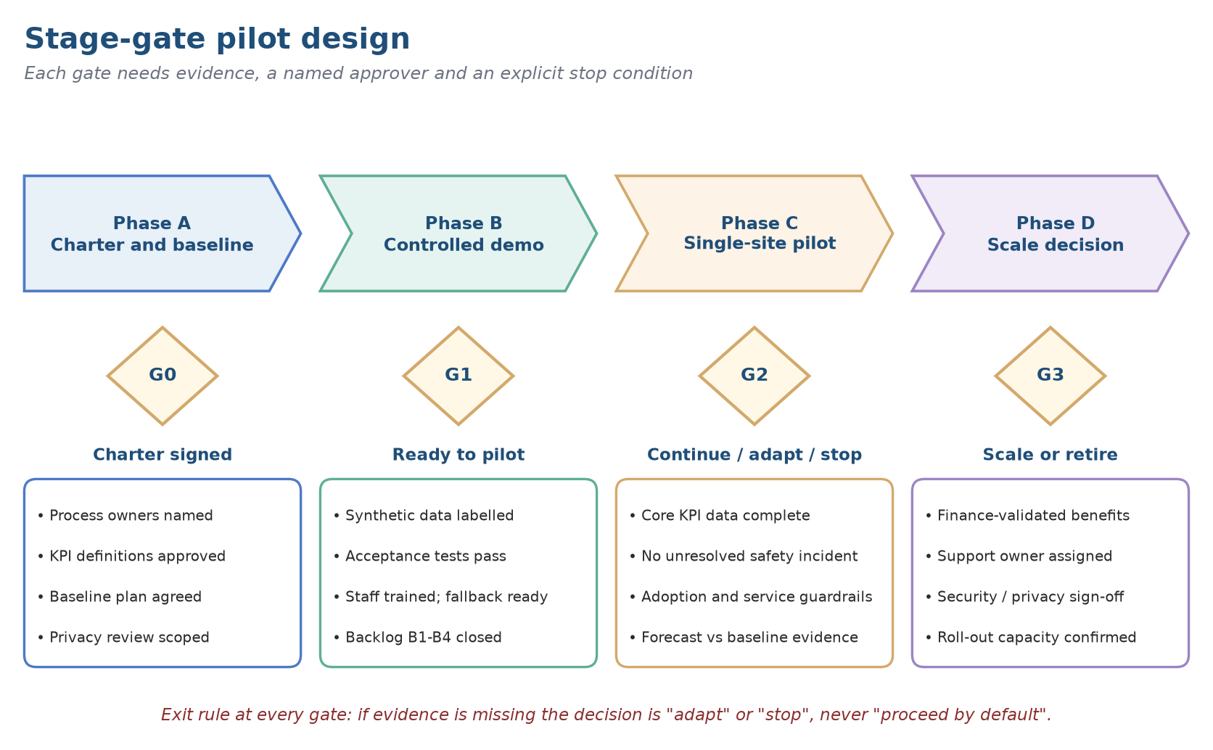
Figure 36. Stage-gate pilot design with gate criteria.
Table 62. Proposed pilot parameters
Parameter | Proposal
Site and owners | One cafeteria with a named menu steward, inventory owner and shift lead; operations sponsor as approver
Timeline | Baseline measurement from week 0 to week 8; pilot operation from week 8; interim review at week 12 (G2*); evaluation to month 6; scale-or-retire decision at month 11 to 12 (G3)
Population | Employees who opt in; the full menu stays available to everyone; no employment use of wellness data
Data | Real orders only, flagged by source; demonstration data excluded from every KPI
Primary KPIs | Order completion rate, availability rate, exception resolution time, menu data completeness
Guardrails | Cancellation and stockout rates, opt-out rate, privacy incidents, forecast override rate
Comparison | Pre-pilot baseline and, if a second site exists, a staggered start; otherwise report association, not causation
Stop conditions | Unresolved allergen or safety incident; privacy breach; stock data integrity failure; breach of an adoption guardrail

22.2 Adoption and change management
Technology adoption depends on perceived usefulness and ease of use (Davis, 1989), and change efforts usually fail for organisational rather than technical reasons (Kotter, 1995). Table 63 translates the eight steps of Kotter's model into pilot actions.
Table 63. Kotter's eight steps applied to the ECOS pilot
Step | Action in the pilot | Evidence of progress
1. Create urgency | Share the baseline on exception handling, stock accuracy and menu data gaps | Baseline report accepted by the sponsor
2. Guiding coalition | Operations, finance, IT and privacy, and an employee representative | Charter signed (G0)
3. Vision | A cafeteria that decides with timely, explainable information while humans stay accountable | One-page vision approved
4. Volunteer army | Shift leads and menu stewards as champions; employees opt in | Named champions per shift
5. Remove barriers | Close B1 to B4 and B7; agree fallback procedures; train on the stock edit flow | Gate G1 passed
6. Short-term wins | Visible exception queue and cleaner menu data within the first weeks | Interim review (G2*)
7. Sustain | Weekly review of forecast, stock and incidents; adapt the KPI dictionary under version control | Review minutes and closed actions
8. Anchor | Move ownership of definitions and benefits to the business sponsor | Handover accepted (G3)

22.3 Roadmap
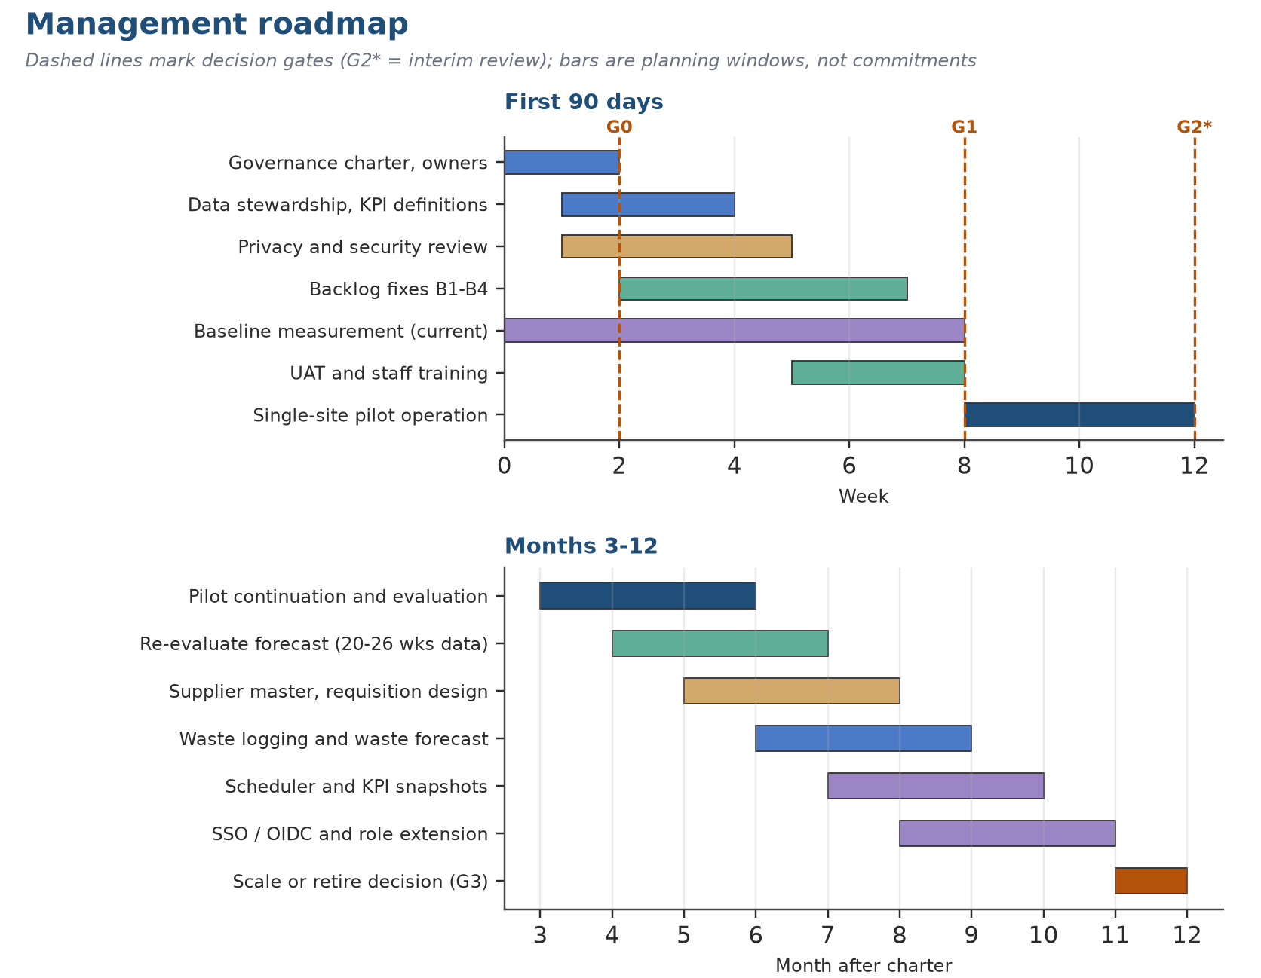
Figure 37. Management roadmap: first 90 days and months 3 to 12 (planning windows, not commitments).
A good lifecycle provides governance from first discovery to handover. The report favours stage gates over building until finished: each gate asks for business evidence, technical evidence, a control review, a named approver and written exit criteria. Merged code alone is not a reason for a feature to move on.
Table 64. Lifecycle stages and gate evidence
Stage | Gate evidence | Core work
Discover | Approved problem and process owner | Interview stakeholders; map current state; plan baseline
Define | Signed pilot charter with acceptance criteria | Scope, requirements, data contracts, risk assessment
Design | Review by operations, IT, finance, privacy | Service blueprint; role, privacy and control design
Build | Versioned release; test evidence | Implement priority workflows with traceability
Verify | Defects resolved; readiness decision | Functional, usability, data, performance, recovery tests
Pilot | Baseline; monitoring; incident and feedback logs | Controlled operation and measurement
Evaluate | Finance and business benefit review | Compare outcomes, costs and limits
Hand over or retire | Operational acceptance or safe shutdown | Ownership, support, documentation, decommissioning

22.4 Ownership and accountability
Table 65. Responsibility assignment for the pilot (R responsible, A accountable, C consulted, I informed)
Activity | Operations sponsor | Cafeteria manager | Menu and inventory owner | Data and IT owner | Finance | Privacy and HR
Menu and allergen data accuracy | A | C | R | C | I | I
Stock adjustments and counts | I | A | R | C | I | -
Forecast activation and override | A | R | C | C | I | -
KPI definitions and dashboard | A | C | C | R | C | I
Privacy and wellness rules | C | I | - | R | - | A
Incident response | A | R | C | R | - | C
Benefits validation | A | C | C | C | R | I

Chapter 23: Risks and Limitations

23.1 Risk assessment
Fourteen risks were scored for likelihood and impact on a five-point scale before pilot controls (Figure 38, Table 66). The scores are prioritisation aids, not probabilities. The highest-scoring risk is stale or wrong menu attributes (R1); the most frequent are the weak forecast gate, the evidence status that is not carried, and the dependency on one maintainer (R4, R12, R14).
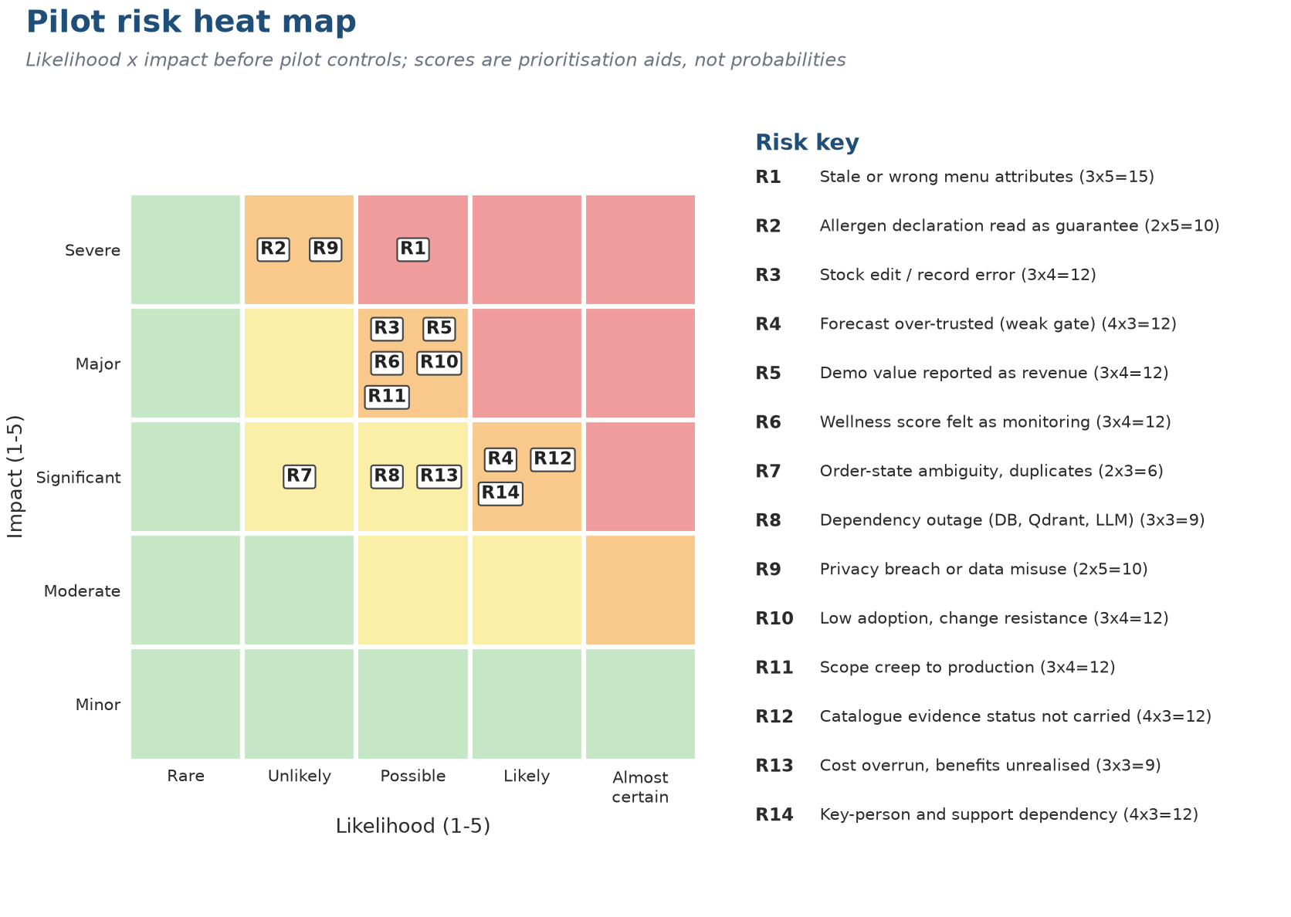
Figure 38. Pilot risk heat map (likelihood by impact, before controls).
Table 66. Risk register for the pilot
ID | Risk | L | I | Score | Principal control | Owner
R1 | Stale or wrong menu attributes | 3 | 5 | 15 | Stewarded approval, effective dates, completeness review | Menu steward
R2 | Allergen declaration read as a guarantee | 2 | 5 | 10 | Prominent “declared, not guaranteed” label; unknown shown as unknown; staff route | Food-safety owner
R3 | Stock edit or record error | 3 | 4 | 12 | Role access, validation preview, reason codes, reconciliation | Inventory owner
R4 | Forecast over-trusted (weak gate) | 4 | 3 | 12 | Harden the gate (B3); label the source; log overrides | Analytics owner
R5 | Demonstration value reported as revenue | 3 | 4 | 12 | Persistent demo label; metric dictionary; finance review | Finance owner
R6 | Wellness score felt as monitoring | 3 | 4 | 12 | Voluntary use; aggregate-only manager access (B7); no employment use | Privacy and HR
R7 | Order-state ambiguity, duplicates | 2 | 3 | 6 | Idempotency and conditional transitions (implemented); exception report | Service owner
R8 | Dependency outage (database, Qdrant, language model) | 3 | 3 | 9 | Manual fallback menu; health checks; labelled degradation | IT owner
R9 | Privacy breach or data misuse | 2 | 5 | 10 | Minimisation, retention schedule, access logging, breach process | Privacy owner
R10 | Low adoption, change resistance | 3 | 4 | 12 | Co-design, training, observed task checks | Change lead
R11 | Scope creep to production | 3 | 4 | 12 | Stage gates, change log, adapt-or-stop default | Sponsor
R12 | Catalogue evidence status not carried | 4 | 3 | 12 | Carry the three-state status (B2) and show it beside nutrition values | Product owner
R13 | Cost overrun, benefits unrealised | 3 | 3 | 9 | Lifecycle cost model, benefits register, interim review | Finance and sponsor
R14 | Key-person and support dependency | 4 | 3 | 12 | Runbook, documentation, second maintainer | IT owner

Risk management connects uncertainty to an owner, prevention, detection, response and what remains afterwards. A risk with nobody in charge is not controlled, and a control with no evidence cannot be tested. The register above is a design for the pilot and should be tuned in a workshop with operations, finance, purchasing, IT, privacy and staff representatives.

23.2 Limitations and threats to validity
Table 67. Threats to validity and how they are handled
Type | Threat | Handling
Construct | The wellness score and the match percentage are proxies, not measures of wellbeing or relevance | Defined, caveated and listed as findings (B1, B4)
Internal | Demonstration orders are random, so forecast errors reflect the generator, not behaviour | The study tests the gate with simulation rather than claiming model accuracy
External | One catalogue, one machine, no real users or site | Pilot design; replication at a second site
Statistical | Small test sets (32 and 152 rows) and a single run | Bootstrap intervals; Monte-Carlo repetition for the gate
Reliability | One verification day | Versions and artefacts recorded in Annexure E; repeat before the pilot

Chapter 24: Conclusions and Recommendations

24.1 Answers to the research questions
The research questions in Chapter 5 were posed with testable hypotheses, and none was treated as proven at the mid-semester review. Table 68 records what the evidence supports.
Table 68. Outcome of the research questions and hypotheses
RQ / H | Statement (abridged) | Evidence now available | Verdict
RQ1 / H1 | Heterogeneous data consolidated into an evidence-aware catalogue with unique keys and traceable evidence status | 1,014 records synchronised under a unique dish_id index; evidence status not carried into the application (B2) | Partly supported
RQ2 / H2 | Embeddings find semantically comparable foods beyond keyword search | Embeddings (256 dimensions) feed the ranking; no reviewer-labelled relevance test was run | Implemented, not tested
RQ3 / H3 | A property graph makes dish, ingredient and allergen relationships queryable | No property graph; relationship queries (affected dishes, allergen exclusion) answered through document links | Not tested as stated
RQ4 / H4 | A dashboard exposing evidence and filters is preferred to one that only ranks | Reasons, hard filters and disclaimers are shown; no preference study; evidence status is not shown (B2) | Implemented, not tested

24.2 Closure of the approved objective themes
Table 69. Status of the approved objective themes
Objective theme | Final status | Basis
Operational analytics | Partly delivered | Demand forecasting instead of preparation-time modelling; gate needs hardening (B3)
Menu intelligence | Delivered | Semantic ranking, component handling, explainable reasons
Food relationships | Partly delivered | Document references for ingredients, allergens and tags; no graph database
Explainable decision support | Partly delivered | Reason strings and evidence lists; no Graph RAG
Supply-chain dependency | Delivered (simplified) | Affected-dish and stock-risk views; no supplier master
Nutrition-aware choice | Delivered with caveats | Tag rules are permissive (B4); score definition inconsistent (B1)
Dashboard for management | Delivered | 5 employee and 7 manager views; 172 executed checks

24.3 Contributions
• Managerial. A decision lens that separates safety constraints from preferences, indicators from outcomes, and demonstration values from revenue, together with a gated pilot design, a KPI dictionary and a risk register.
• Methodological. An evidence-class discipline and a Monte-Carlo test of a serving gate, which shows that a bare comparison with a baseline cannot separate signal from noise on eight weeks of history.
• Practical. A verified, integrated prototype with an auditable ordering and stock path, 172 executed checks, a profiled catalogue and a findings backlog ready for the owner to act on.

24.4 Recommendations
Table 70. Prioritised recommendations
# | Recommendation | Owner | By
1 | Close findings B1 to B4 and B7 before the pilot (wellness score, evidence status, forecast gate, healthy-dish rule, manager access to wellness) | Product owner | G1
2 | Approve the KPI dictionary and the data contract; start baseline measurement | Operations sponsor | G0
3 | Name stewards for menu attributes, stock definitions and KPI logic | Operations sponsor | G0
4 | Pilot with real orders flagged by source and exclude demonstration data from every KPI | Cafeteria manager | G2
5 | Treat forecasts as advisory: show the source label and keep the baseline until the hardened gate passes on 12 to 16 weeks of history | Analytics owner | Months 3 to 7
6 | Add waste logging and supplier fields before any benefit claim (B5) | Product owner | Months 6 to 9
7 | Keep the wellness score voluntary and aggregate-only for managers | Privacy and HR | G1
8 | Replace stale documentation with artefacts generated from the running system (B6) | Product owner | G1

24.5 Future research
• Evaluate a property graph or Graph RAG against the relational approach used here, with explicit relevance and latency criteria.
• Estimate the causal effect of recommendations on choice with a stepped rollout rather than a before-and-after comparison.
• Test forecasting methods designed for sparse, intermittent demand and for hierarchical series (meal period, dish).
• Replace the permissive tag rule with a nutrient-quality score validated by dietitians, and study its fairness across dietary and cultural patterns.
• Model waste explicitly and test menu optimisation that trades waste, cost and nutrition.
Final managerial position
ECOS is a credible, well-engineered decision-support prototype whose safety-critical path works as designed and whose analytical claims are not yet strong enough to carry decisions. The responsible next step is a governed single-site pilot with the findings closed, real data flagged by source, and stage gates that default to adapt or stop.
The project's contribution is as much in what it refuses to claim as in what it built: no accuracy, savings or health effect is asserted, and each is linked to the evidence that would justify it.

Annexure A: Dataset Dictionary
This annexure documents the processed canonical catalogue used by the dashboard, embedding pipeline, and graph ingestion design. Field definitions are concise descriptions for report interpretation; the source dataset remains the authoritative technical record.
Table 14. Dataset dictionary, fields 1-24.
Field | Description
food_code | Unique identifier for the canonical food record.
food_name | Canonical dish or food name from the nutrition source.
match_status | Evidence status: matched, review, or unmatched.
match_method | Method used to link a food to a recipe record.
match_score | Similarity or confidence score for the recipe match.
allergens | Source-declared allergen information; not a clinical guarantee.
document_id | Processed catalogue field retained for analysis and traceability.
semantic_text | Text payload used to generate the semantic embedding.
embedding_status | Readiness state for semantic retrieval.
recipe_name | Linked recipe title when supporting evidence is available.
ingredients | Recipe ingredient list when a recipe link exists.
ingredient_count | Derived count of available recipe ingredients.
instructions | Recipe preparation instructions when available.
primarysource | Origin or source category of the nutrition record.
energy_kj | Energy measurement in kilojoules, generally per 100 g unless prefixed by unit_serving.
energy_kcal | Energy measurement in kilocalories, generally per 100 g unless prefixed by unit_serving.
carb_g | Nutrient amount in grams.
protein_g | Nutrient amount in grams.
fat_g | Nutrient amount in grams.
freesugar_g | Nutrient amount in grams.
fibre_g | Nutrient amount in grams.
sfa_mg | Nutrient amount in milligrams.
mufa_mg | Nutrient amount in milligrams.
pufa_mg | Nutrient amount in milligrams.

Annexure A: Dataset Dictionary (continued)
Table 15. Dataset dictionary, fields 25-48.
Field | Description
cholesterol_mg | Nutrient amount in milligrams.
calcium_mg | Nutrient amount in milligrams.
phosphorus_mg | Nutrient amount in milligrams.
magnesium_mg | Nutrient amount in milligrams.
sodium_mg | Nutrient amount in milligrams.
potassium_mg | Nutrient amount in milligrams.
iron_mg | Nutrient amount in milligrams.
copper_mg | Nutrient amount in milligrams.
selenium_ug | Nutrient amount in micrograms.
chromium_mg | Nutrient amount in milligrams.
manganese_mg | Nutrient amount in milligrams.
molybdenum_mg | Nutrient amount in milligrams.
zinc_mg | Nutrient amount in milligrams.
vita_ug | Nutrient amount in micrograms.
vite_mg | Nutrient amount in milligrams.
vitd2_ug | Nutrient amount in micrograms.
vitd3_ug | Nutrient amount in micrograms.
vitk1_ug | Nutrient amount in micrograms.
vitk2_ug | Nutrient amount in micrograms.
folate_ug | Nutrient amount in micrograms.
vitb1_mg | Nutrient amount in milligrams.
vitb2_mg | Nutrient amount in milligrams.
vitb3_mg | Nutrient amount in milligrams.
vitb5_mg | Nutrient amount in milligrams.

Annexure A: Dataset Dictionary (continued)
Table 16. Dataset dictionary, fields 49-72.
Field | Description
vitb6_mg | Nutrient amount in milligrams.
vitb7_ug | Nutrient amount in micrograms.
vitb9_ug | Nutrient amount in micrograms.
vitc_mg | Nutrient amount in milligrams.
carotenoids_ug | Nutrient amount in micrograms.
servings_unit | Processed catalogue field retained for analysis and traceability.
unit_serving_energy_kj | Nutrient value expressed for the reported serving unit.
unit_serving_energy_kcal | Nutrient value expressed for the reported serving unit.
unit_serving_carb_g | Nutrient value expressed for the reported serving unit.
unit_serving_protein_g | Nutrient value expressed for the reported serving unit.
unit_serving_fat_g | Nutrient value expressed for the reported serving unit.
unit_serving_freesugar_g | Nutrient value expressed for the reported serving unit.
unit_serving_fibre_g | Nutrient value expressed for the reported serving unit.
unit_serving_sfa_mg | Nutrient value expressed for the reported serving unit.
unit_serving_mufa_mg | Nutrient value expressed for the reported serving unit.
unit_serving_pufa_mg | Nutrient value expressed for the reported serving unit.
unit_serving_cholesterol_mg | Nutrient value expressed for the reported serving unit.
unit_serving_calcium_mg | Nutrient value expressed for the reported serving unit.
unit_serving_phosphorus_mg | Nutrient value expressed for the reported serving unit.
unit_serving_magnesium_mg | Nutrient value expressed for the reported serving unit.
unit_serving_sodium_mg | Nutrient value expressed for the reported serving unit.
unit_serving_potassium_mg | Nutrient value expressed for the reported serving unit.
unit_serving_iron_mg | Nutrient value expressed for the reported serving unit.
unit_serving_copper_mg | Nutrient value expressed for the reported serving unit.

Annexure A: Dataset Dictionary (continued)
Table 17. Dataset dictionary, fields 73-96.
Field | Description
unit_serving_selenium_ug | Nutrient value expressed for the reported serving unit.
unit_serving_chromium_mg | Nutrient value expressed for the reported serving unit.
unit_serving_manganese_mg | Nutrient value expressed for the reported serving unit.
unit_serving_molybdenum_mg | Nutrient value expressed for the reported serving unit.
unit_serving_zinc_mg | Nutrient value expressed for the reported serving unit.
unit_serving_vita_ug | Nutrient value expressed for the reported serving unit.
unit_serving_vite_mg | Nutrient value expressed for the reported serving unit.
unit_serving_vitd2_ug | Nutrient value expressed for the reported serving unit.
unit_serving_vitd3_ug | Nutrient value expressed for the reported serving unit.
unit_serving_vitk1_ug | Nutrient value expressed for the reported serving unit.
unit_serving_vitk2_ug | Nutrient value expressed for the reported serving unit.
unit_serving_folate_ug | Nutrient value expressed for the reported serving unit.
unit_serving_vitb1_mg | Nutrient value expressed for the reported serving unit.
unit_serving_vitb2_mg | Nutrient value expressed for the reported serving unit.
unit_serving_vitb3_mg | Nutrient value expressed for the reported serving unit.
unit_serving_vitb5_mg | Nutrient value expressed for the reported serving unit.
unit_serving_vitb6_mg | Nutrient value expressed for the reported serving unit.
unit_serving_vitb7_ug | Nutrient value expressed for the reported serving unit.
unit_serving_vitb9_ug | Nutrient value expressed for the reported serving unit.
unit_serving_vitc_mg | Nutrient value expressed for the reported serving unit.
unit_serving_carotenoids_ug | Nutrient value expressed for the reported serving unit.
protein_to_carb_ratio | Derived protein-to-carbohydrate ratio.
fat_to_carb_ratio | Derived fat-to-carbohydrate ratio.
calorie_to_protein_ratio | Derived energy-to-protein ratio.

Annexure A: Dataset Dictionary (continued)
Table 18. Dataset dictionary, fields 97-97.
Field | Description
nutrition_cluster | Unsupervised nutrition-profile segment for descriptive analysis.

Annexure B: Reproducible KPI Snapshot
Table 19. Reproducible KPI snapshot computed directly from project artifacts.
Metric | Value
Catalogue dishes | 1014
Unique food codes | 1014
Confirmed recipe matches | 449
Confirmed match rate | 44.28%
Review candidates | 187
Review or confirmed coverage | 62.72%
Unmatched records | 378
Allergen declaration coverage | 59.07%
Semantic document coverage | 100.00%
Records with ingredient counts | 636
Data-source categories | 3
Raw recipe rows examined | 2,231,142
These values are derived from local project artifacts at report-generation time. They support reproducibility because the report can be regenerated after any validated change to the catalogue or matching pipeline.

Annexure C: Selected Implementation Excerpts
The following excerpts are included to document the implemented analytical logic. Full source code is retained in the project repository. Code excerpts are provided as technical evidence and should be read together with the data-quality and scope limitations described in the main report.

C.1 Evidence-aware menu filtering
def apply_menu_filters(catalog, profile, sources=None, statuses=None, allergens_to_avoid=None):
candidates = catalog.copy()
if sources:
candidates = candidates[candidates["primarysource"].isin(sources)]
if statuses:
candidates = candidates[candidates["match_status"].isin(statuses)]
for allergen in allergens_to_avoid or []:
candidates = candidates[~candidates["allergens"].str.contains(
allergen, case=False, na=False, regex=False
)]
for field, (minimum, maximum) in WELLNESS_GOALS[profile].items():
if minimum is not None:
candidates = candidates[candidates[field].ge(minimum)]
if maximum is not None:
candidates = candidates[candidates[field].le(maximum)]
return candidates

C.2 Neo4j schema constraints
statements = [
"CREATE CONSTRAINT dish_food_code IF NOT EXISTS "
"FOR (dish:Dish) REQUIRE dish.food_code IS UNIQUE",
"CREATE CONSTRAINT ingredient_name IF NOT EXISTS "
"FOR (ingredient:Ingredient) REQUIRE ingredient.name IS UNIQUE",
"CREATE CONSTRAINT nutrient_name IF NOT EXISTS "
"FOR (nutrient:Nutrient) REQUIRE nutrient.name IS UNIQUE",
"CREATE CONSTRAINT allergen_name IF NOT EXISTS "
"FOR (allergen:Allergen) REQUIRE allergen.name IS UNIQUE",
]

C.3 Graph nutrient relationship ingestion
UNWIND $rows AS row
MATCH (dish:Dish {food_code: row.food_code})
MERGE (nutrient:Nutrient {name: row.name})
MERGE (dish)-[measurement:HAS_NUTRIENT]->(nutrient)
SET measurement.amount = row.amount, measurement.unit = row.unit

C.4 Local embedding retrieval fallback
catalog = pd.read_csv(DATA_PATH).dropna(subset=["semantic_text"]).reset_index(drop=True)
embeddings = np.load(EMBEDDINGS_PATH)
if len(catalog) != len(embeddings):
raise ValueError("Catalog rows and saved embedding rows do not match.")
scores = embeddings @ query_vector
indices = np.argsort(scores)[-top_k:][::-1]
return [{"food_code": catalog.iloc[index]["food_code"],
"score": round(float(scores[index]), 4)} for index in indices]

Annexure D: Summary of How Project Outline Feedback Was Addressed
Table 20. Mapping of project outline feedback to actions taken in this report.
Outline feedback / requirement | Action taken in the mid-semester report
Keep the work aligned to objectives | Each implemented component is mapped to an approved objective and its current evidence level.
Use an academic-project methodology | Added research design, research questions, evaluation plan, literature review, and research gap.
Show actual progress | Added reproducible counts for catalogue size, matching outcomes, embedding coverage, and dashboard scope.
Explain scope and limitations | Added explicit in-scope, out-of-scope, assumptions, constraints, risks, and ethical controls.
Provide detailed work completed | Documented data preparation, evidence policy, feature engineering, semantic retrieval, graph design, and dashboard implementation.
Avoid unsupported claims | Deferred Graph RAG, operational savings, clinical guidance, and unvalidated model-performance assertions.
The report has been expanded using project-specific evidence and original explanatory writing. It should be reviewed by the student and faculty guide before submission, particularly for institutional formatting, certificate wording, final page numbering, and confirmation that all claims match the latest validated artifacts.

Annexure E: Evidence and Reproduction Register
Table 71 lists the artefacts behind the executed and code-inspected claims of the later chapters. All executed results date from 8 November 2026.
Table 71. Evidence register
Artefact | What it evidences | Class
backend/smoke_test.py | 138 backend checks across 13 groups | Executed
dashboard/ui_smoke_test.py | 34 user-interface checks across 8 groups | Executed
ml/train.py, ml/features.py, ml/predictor.py | Forecast features, split, baseline, serving gate and fallback | Executed, code-inspected
backend/app/routers/*.py (14 routers) | 42 operations on 39 paths; order, stock, wellness and copilot logic | Executed, code-inspected
backend/app/core/recommender.py | Hard filters, score terms and match percentage | Executed, code-inspected
backend/app/core/catalog.py, vectors.py | Catalogue synchronisation and embeddings | Code-inspected
Qdrant food_nutrients collection | 1,014 vectors, 256 dimensions, cosine, 91 payload fields | Executed
API_ENDPOINTS.md, api.json | Published contract; counts found to be stale (B6) | Documented
Architecture.png, docs/assets/*.svg | Target and conceptual diagrams | Documented
docs/FINAL_PROJECT_REPORT.md | Management frameworks reused in the later chapters | Documented

Reproduction. Start a throwaway MongoDB instance, point the backend at it with ECOS_MONGODB_URI, seed demonstration history with python -m backend.seed --history, and run the two smoke tests. Use separate databases for the backend and the interface tests, and never point the application at a database that holds real data.

Annexure F: API Operation Catalogue
The service exposes 42 operations on 39 distinct paths under /api/v1, grouped here by router. The committed documentation lists 33 endpoints (Finding B6).
Table 72. Operations of the ECOS service
Method | Path | Router | Operation
GET | /api/v1/health | health | Health
POST | /api/v1/auth/login | users | Login
GET | /api/v1/auth/session | users | Refresh Session
POST | /api/v1/auth/logout | users | Logout
GET | /api/v1/users/{user_id} | users | Get User
PUT | /api/v1/users/{user_id}/preferences | users | Save Preferences
GET | /api/v1/users | users | List Users
GET | /api/v1/recipes | recipes | List Recipes
PATCH | /api/v1/recipes | recipes | Update Recipes
POST | /api/v1/recipes/bulk-menu | recipes | Bulk Menu
GET | /api/v1/catalog/status | recipes | Catalog Status
POST | /api/v1/catalog/sync | recipes | Sync Catalog
GET | /api/v1/menu | menus | Get Menu
POST | /api/v1/recommendations | recommendations | Recommendations
POST | /api/v1/recommendations/meal-plan | recommendations | Day Plan
POST | /api/v1/orders | orders | Create Order
GET | /api/v1/orders | orders | List Orders
GET | /api/v1/orders/{order_id} | orders | Get Order
PATCH | /api/v1/orders/{order_id}/status | orders | Update Status
POST | /api/v1/feedback | feedback | Submit Feedback
GET | /api/v1/inventory | inventory | List Inventory
POST | /api/v1/inventory | inventory | Create Ingredient
PATCH | /api/v1/inventory/{ingredient_id} | inventory | Update Ingredient
GET | /api/v1/inventory/alerts | inventory | Inventory Alerts
POST | /api/v1/inventory/{ingredient_id}/replenish | inventory | Replenish
GET | /api/v1/inventory/{ingredient_id}/affected-dishes | inventory | Affected Dishes
GET | /api/v1/inventory/{ingredient_id}/movements | inventory | Inventory Movements
GET | /api/v1/inventory/risk | inventory | Stock Risk
GET | /api/v1/inventory/consumption | inventory_consumption | Consumption
POST | /api/v1/upload/inventory | uploads | Upload Inventory
POST | /api/v1/upload/recipes | uploads | Upload Recipes
POST | /api/v1/forecast/run | forecasts | Run Forecast
GET | /api/v1/forecast/latest | forecasts | Latest Forecast
GET | /api/v1/forecast/model | forecasts | Model Status
POST | /api/v1/forecast/model/train | forecasts | Retrain Models
GET | /api/v1/wellness/{user_id}/monthly | wellness | Monthly
GET | /api/v1/wellness/{user_id}/trend | wellness | Trend
GET | /api/v1/dashboard/employee/{user_id} | dashboard | Employee Dashboard
GET | /api/v1/dashboard/manager | dashboard | Manager Dashboard
GET | /api/v1/dashboard/executive | dashboard | Executive Dashboard
POST | /api/v1/copilot | copilot | Ask
GET | /api/v1/copilot/suggestions | copilot | Suggestions

Annexure G: Selected Logic Excerpts
The three excerpts restate, as pseudocode, the ordering safeguard, the wellness score and the forecast serving gate; the source files are listed in Table 71.

H.1 Atomic stock deduction with rollback (ordering logic)
for each ingredient required by the order:
run one conditional update: subtract the amount only if stock >= amount
if nothing was updated:
add back every amount already subtracted for this order
reject the order (conflict) and name the ingredient that ran short
remember (ingredient, amount) so that a cancellation can return it once

H.2 Monthly wellness score (wellness logic)
orders = the employee's orders in the month whose status is not cancelled
points = 0
for each order line in orders:
points = points + quantity x (10 if the dish has any nutrition tag, else 5)
score = min(100, 20 + points)

H.3 Chronological split and serving gate (training logic)
cut-off = service date at the 80 per cent position of the sorted dates
train = rows dated before the cut-off
test = rows dated on or after the cut-off
fit the Random Forest on train and predict test
beats_baseline = MAE(model, test) <= MAE(same-weekday-4 baseline, test)
serve the model only when beats_baseline is true

Annexure H: Demonstration Script and Viva Preparation
Table 73. Eight-step demonstration script
Step | Action | Point to make
1 | Log in as an employee | Role-based navigation; session handling; synthetic identity
2 | Menu, For you | Reasons on each card; match percentage capped at 99; diet and allergen filters are hard
3 | Plan my day | Day plan built from the same recommender
4 | Place a demonstration order | “No money is taken”; pickup reference; idempotent retry
5 | Manager: Live orders | Advance the status; cancel before ready and show that stock returns
6 | Inventory: Stock, Risk and impact, Edit stock | Validation before commit; affected dishes; movement history
7 | Forecasting | Source label, buffer, preparation quantity; model against baseline
8 | Executive and Copilot | Demonstration-value caption; read-only answers with evidence

Table 74. Likely questions and defensible answers
Question | Defensible answer
What is new since mid-semester? | Integration into ECOS, 172 executed checks, a catalogue profile, a forecasting study, a financial and governance appraisal and a pilot roadmap
Why no knowledge graph? | It was re-scoped: relationships are held as document references and answer the needed queries; a graph would add cost without a demonstrated benefit yet
Is the forecast accurate? | No accuracy is claimed. Data are synthetic, the baseline is in use, and the study shows the serving gate is weak
Is the wellness score medical? | No. It is a voluntary, rule-based summary of recorded choices with a disclaimer; its definition has known weaknesses (B1, B4)
What is the business case? | Illustrative only: break-even needs about 4.7 to 5.0 lakh a year of net benefit; the pilot exists to measure it
How is allergen safety handled? | Diet and allergen rules are hard filters enforced on the server; declarations are described as declared, not guaranteed
What would you do first in a pilot? | Close B1 to B4 and B7, approve the KPI dictionary, start baseline measurement
What are the limits? | Synthetic operations data, no users, one run on one machine, hypothetical finance

References
Brealey, R. A., Myers, S. C., & Allen, F. (2020). Principles of Corporate Finance (13th ed.). McGraw-Hill.
Breiman, L. (2001). Random forests. Machine Learning, 45(1), 5-32.
Chopra, S., & Meindl, P. (2016). Supply Chain Management: Strategy, Planning, and Operation (6th ed.). Pearson.
Davenport, T. H., & Harris, J. G. (2007). Competing on Analytics: The New Science of Winning. Harvard Business School Press.
Davis, F. D. (1989). Perceived usefulness, perceived ease of use, and user acceptance of information technology. MIS Quarterly, 13(3), 319-340.
Devlin, J., Chang, M.-W., Lee, K., & Toutanova, K. (2019). BERT: Pre-training of deep bidirectional transformers for language understanding. Proceedings of NAACL-HLT.
Doshi-Velez, F., & Kim, B. (2017). Towards a rigorous science of interpretable machine learning. arXiv:1702.08608.
Edge, D., Trinh, H., Cheng, N., Bradley, J., Chao, A., Mody, A., Truitt, S., Metropolitansky, D., Ness, R. O., & Larson, J. (2025). From Local to Global: A Graph RAG Approach to Query-Focused Summarization. arXiv preprint arXiv:2404.16130
Ehrlinger, L., & Wöß, W. (2016). Towards a definition of knowledge graphs. Proceedings of the SEMANTiCS Posters and Demos Track.
Freyne, J., & Berkovsky, S. (2010). Intelligent food planning: Personalized recipe recommendation. Proceedings of the 15th International Conference on Intelligent User Interfaces (IUI), 321-324.
Ge, M., Ricci, F., & Massimo, D. (2015). Health-aware food recommender system. Proceedings of the 9th ACM Conference on Recommender Systems, 333-334.
Hevner, A. R., March, S. T., Park, J., & Ram, S. (2004). Design science in information systems research. MIS Quarterly, 28(1), 75-105.
Hyndman, R. J., & Athanasopoulos, G. (2021). Forecasting: Principles and Practice (3rd ed.). OTexts.
Hyndman, R. J., & Koehler, A. B. (2006). Another look at measures of forecast accuracy. International Journal of Forecasting, 22(4), 679-688.
Kaplan, R. S., & Norton, D. P. (1992). The balanced scorecard: Measures that drive performance. Harvard Business Review, 70(1), 71-79.
Kaplan, R. S., & Norton, D. P. (1996). The Balanced Scorecard: Translating Strategy into Action. Harvard Business School Press.
Kotter, J. P. (1995). Leading change: Why transformation efforts fail. Harvard Business Review, 73(2), 59-67.
Kusner, M. J., Sun, Y., Kolkin, N. I., & Weinberger, K. Q. (2015). From word embeddings to document distances. Proceedings of the 32nd International Conference on Machine Learning.
Larson, J., & Truitt, S. (2024). Graph RAG: Unlocking LLM discovery on narrative private data. Microsoft Research.
Lewis, P., Perez, E., Piktus, A., et al. (2020). Retrieval-augmented generation for knowledge-intensive NLP tasks. Advances in Neural Information Processing Systems, 33.
Min, W., Jiang, S., Liu, L., Rui, Y., & Jain, R. (2019). A survey on food computing. ACM Computing Surveys, 52(5), 1-36.
Mitchell, M., Wu, S., Zaldivar, A., et al. (2019). Model cards for model reporting. Proceedings of the Conference on Fairness, Accountability, and Transparency, 220-229.
National Institute of Standards and Technology. (2020). NIST Privacy Framework: A Tool for Improving Privacy through Enterprise Risk Management, Version 1.0.
National Institute of Standards and Technology. (2023). Artificial Intelligence Risk Management Framework (AI RMF 1.0). NIST AI 100-1.
Parasuraman, A., Zeithaml, V. A., & Berry, L. L. (1985). A conceptual model of service quality and its implications for future research. Journal of Marketing, 49(4), 41-50.
Peñalvo, J. L., Sagastume, D., Mertens, E., Uzhova, I., Smith, J., Wu, J. H. Y., et al. (2021). Effectiveness of workplace wellness programmes for dietary habits, overweight, and cardiometabolic health: A systematic review and meta-analysis. Lancet Public Health, 6(9), e648-e660.
Pedregosa, F., Varoquaux, G., Gramfort, A., et al. (2011). Scikit-learn: Machine learning in Python. Journal of Machine Learning Research, 12, 2825-2830.
Peffers, K., Tuunanen, T., Rothenberger, M. A., & Chatterjee, S. (2007). A design science research methodology for information systems research. Journal of Management Information Systems, 24(3), 45-77.
Porter, M. E. (1996). What is strategy? Harvard Business Review, 74(6), 61-78.
Reimers, N., & Gurevych, I. (2019). Sentence-BERT: Sentence embeddings using Siamese BERT-networks. Proceedings of EMNLP-IJCNLP.
Ribeiro, M. T., Singh, S., & Guestrin, C. (2016). "Why should I trust you?": Explaining the predictions of any classifier. Proceedings of the 22nd ACM SIGKDD International Conference on Knowledge Discovery and Data Mining, 1135-1144.
Robinson, I., Webber, J., & Eifrem, E. (2015). Graph databases: New opportunities for connected data. O'Reilly Media.
Sculley, D., Holt, G., Golovin, D., et al. (2015). Hidden technical debt in machine learning systems. Advances in Neural Information Processing Systems, 28, 2503-2511.
Shostack, G. L. (1984). Designing services that deliver. Harvard Business Review, 62(1), 133-139.
Silver, E. A., Pyke, D. F., & Thomopoulos, N. (2016). Inventory and Production Management in Supply Chains (4th ed.). CRC Press.
Teng, C.-Y., Lin, Y.-R., & Adamic, L. A. (2012). Recipe recommendation using ingredient networks. Proceedings of the 4th Annual ACM Web Science Conference, 298-307.
Thaler, R. H., & Sunstein, C. R. (2008). Nudge: Improving Decisions About Health, Wealth, and Happiness. Yale University Press.
Trattner, C., & Elsweiler, D. (2017). Food recommender systems: important contributions, challenges and future research directions. arXiv:1711.02760.
Vaswani, A., Shazeer, N., Parmar, N., et al. (2017). Attention is all you need. Advances in Neural Information Processing Systems, 30.
Vaswani, A., Shazeer, N., Parmar, N., Uszkoreit, J., Jones, L., Gomez, A. N., Kaiser, Ł., & Polosukhin, I. (2017). Attention Is All You Need. In Advances in Neural Information Processing Systems (NeurIPS), Vol. 30.
World Health Organization. (2023). Healthy diet. https://www.who.int/news-room/fact-sheets/detail/healthy-diet
World Health Organization. Workplace health.
Yan, S.-Q., Gu, J.-C., Zhu, Y., & Ling, Z.-H. (2024). Corrective Retrieval Augmented Generation. arXiv preprint arXiv:2401.15884.

Glossary
Term | Meaning
Business Analytics | Use of data, statistical methods, and analytical models to support business decision-making.
Decision Support System | A system that helps managers make informed decisions using data, models, and insights.
Machine Learning | Algorithms that learn patterns from historical data and make predictions.
Predictive Analytics | Analytics technique used to forecast likely future outcomes.
Knowledge Graph | Structured representation of entities and relationships.
Graph RAG | Retrieval-Augmented Generation using graph-based retrieval and reasoning.
Semantic Search | Search method that identifies meaning and context rather than only matching keywords.
Vector Embedding | Numerical representation of text or entities used for similarity comparison.
Allergen | A substance that may trigger allergic reactions in sensitive individuals.
Supply Chain Dependency | Reliance of multiple products or operations on common raw materials.
Employee Wellness Analytics | Use of data and analytics to support workplace health and well-being programs.
Dashboard | Visual interface that presents key metrics and insights for business users.
ECOS | Enterprise Cafeteria Operating System: the integrated employee and manager service built on the food catalogue
Hard filter | A rule that removes a dish from consideration before ranking (availability, diet, allergen, budget, energy)
Idempotent checkout | Submitting the same request twice yields one order, because the request identifier is unique per user
Serving gate | The rule that decides whether the trained model or the baseline is used: model MAE not above baseline MAE
Baseline (same-weekday-4) | Mean of up to four preceding services on the same weekday, falling back to a four-service rolling mean
MAE, WAPE | Mean absolute error; weighted absolute percentage error (total absolute error over total actual demand)
Bootstrap interval | A confidence interval obtained by resampling the test rows; used here for the difference in MAE
Evidence class | The basis of a claim: executed, code-inspected, documented, user-reported, proposed or illustrative
NPV, IRR | Net present value and internal rate of return of a cash-flow series at a given discount rate
Profitability index | Present value of benefits divided by the initial investment
Break-even benefit | The constant annual net benefit at which NPV equals zero
Stage gate | A decision point with evidence, a named approver and an explicit stop condition
Synthetic demonstration data | Generated users, orders and stock flagged demo_seed; they show mechanics, not behaviour
BIRLA INSTITUTE OF TECHNOLOGY & SCIENCE, PILANI
Work Integrated Learning Programmes Division (WILPD)

Particulars of Student

Student Id | 2024HB21026
Student Name | Shubham Kumar
Student E-Mail Address | Shubham.Kumar.3@team.telstra.com / 2024hb21026@wilp.bits-pilani.ac.in
Employing Organization and Location | Telstra, Bangalore, India
Programme Name | MBA in Business Analytics
Semester | Final semester
Project Title | Analytics-Driven Decision Support Framework for Enterprise Food Operations and Employee Health Management

Particulars of the Supervisor and Additional Examiner

 | Supervisor | Additional Examiner
Name | Mrigank Sharma | Madhu Khiani
Qualification | Master of Computer Applications (MCA) | Bachelor Of Technology, IIT Roorkee
Designation | Chapter Lead | Senior Chapter Lead
Employing Organization and Location | Telstra, Bangalore, India | Telstra, Bangalore, India
Phone No (with STD code) | +91 9008018305 | +91 9741411771
Email Address | Mrigank.Sharma@team.telstra.com | Madhu.Khiani@team.telstra.com

Remarks of the Supervisor on Project Report
The proposed project addresses a relevant business analytics problem and demonstrates appropriate application of data analytics, machine learning, and decision-support concepts. The scope, methodology, and expected outcomes are suitable for an MBA in Business Analytics dissertation and provide potential value in the areas of food operations, employee wellness, and business intelligence.
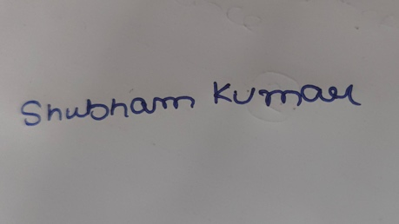 |  | 
Signature of Student | Signature of Supervisor | Signature of Additional Examiner
Name: Shubham Kumar | Name: Mrigank Sharma | Name: Madhu Khiani

