TextNova AI

Miss. Shital Waghmare Miss. Aishwarya Lad Miss. Snehal Patil
Dept. of Computer Science and Department of Computer Science and Department of Computer Science and
Engineering Engineering Engineering
Yashoda Technical Campus, Satara Yashoda Technical Campus, Satara Yashoda Technical Campus, Satara
Maharashtra, India Maharashtra, India Maharashtra, India
shitalwaghmare_engg@yes.edu.in 13_2024_cse@yes.edu.in 17_2024_cse@yes.edu.in

Miss. Anushka Dhumal Miss. Shraddha Borate Miss. Komal Valekar
Dept. of Computer Science and Dept. of Computer Science and Dept. of Computer Science and
Engineering Engineering Engineering
Yashoda Technical Campus, Satara Yashoda Technical Campus, Satara Yashoda Technical Campus, Satara
Maharashtra, India Maharashtra, India Maharashtra, India
14_2024_cse@yes.edu.in 18_2024_cse@yes.edu.in 10_2024_cse@yes.edu.in

ABSTRACT
This project proposes an AI-enabled web application for restoring degraded text in scanned or historical documents. Using a multi-agent architecture powered by LangGraph, the system integrates intelligent OCR, contextual search, and generative reconstruction. By leveraging sources like Wikipedia and ArXiv, alongside Google’s Gemini API, the solution intelligently fills gaps in damaged text. The application ensures reliability through user feedback, supporting academic, archival, and legal digitization efforts.

KEYWORDS :
Optical Character Recognition (OCR),Text Restoration / Document Restoration, LangGraph (multi-agent architecture), Google Gemini API, Flask, Image Enhancement, Historical Document Digitization
.

I. INTRODUCTION:

Digitization of historical and academic documents is critical for preservation and accessibility. However, many scanned materials suffer from faded ink, torn pages, or poor resolution, making them difficult to process with standard OCR tools. Incomplete digitization reduces their value for research and education. To address this, we propose an AI-driven system that not only extracts text but also reconstructs missing or unclear portions using contextual knowledge from trusted sources. This approach enhances document restoration, ensuring that valuable information remains accessible for future generations. Need of farmer equipment rental

1.1 Need for Document Restoration

Many scanned or historical documents suffer from faded ink, torn pages, or poor resolution.

Standard OCR tools often fail, leading to incomplete

digitization.

Researchers, students, and archivists struggle to access accurate text from degraded sources.

There is no single intelligent platform that combines OCR, restoration, and contextual reconstruction.

Manual restoration is time-consuming, error-prone, and not scalable.

Problem Statement

Many scanned or historical documents suffer from quality issues such as faded ink, torn pages, or low-resolution scans, making portions of the text difficult or impossible to read. Standard OCR (Optical Character Recognition) tools often struggle with such documents, either skipping unreadable sections or producing inaccurate results. This leads to incomplete digitization and reduces the value of these documents for research, education, and archival purposes. There is a growing need for an intelligent system that can go beyond basic text extraction. Such a solution should be capable of understanding the readable context and intelligently reconstructing missing or unclear text by referencing reliable external sources like Wikipedia. This would enable more accurate restoration of degraded content and help preserve important written materials for future use.

LITERATURE SURVEY

PreP-OCR: A Complete Pipeline for Document Image Restoration and Enhanced OCR Accuracy

Shuhao Guan, Moule Lin, Cheng Xu, Xinyi Liu, Jinman Zhao, Jiexin Fan, Qi Xu, Derek Green, 2025 (Conference) Two-stage pipeline: (1) deep learning–based image restoration using synthetic degraded data, (2) ByT5-based post-OCR correction model.

AI-driven Enhancement of Historical Documents

Zahra Ziran, Massimo Mecella, Simone Marinai, 2025 Uses AI-based image processing and deep learning techniques to enhance degraded manuscripts and reconstruct unclear regions.

DocRes: A Generalist Model Toward Unifying Document Image Restoration Tasks

Jiaxin Zhang, Dezhi Peng, Chongyu Liu, Peirong Zhang, Lianwen Jin, DocRes, 2024 CVPR (Conference, Open Access) Unified model with dynamic visual prompts handling multiple restoration tasks like dewarping, deblurring, deshadowing, and binarization.

Historical Text Image Enhancement Using Image Scaling and GANs

Sajid Ullah Khan, Imdad Ullah, Faheem Khan, Youngmoon Lee, Shahid Ullah 2023, Sensors (Journal) Wavelet-based upscaling followed by GAN-based fusion to enhance spatial and spectral features of images.

Practical System Alignment – Historical Document Text Restoration

VyaS-009 (GitHub project), Practical System Alignment
2024, Practical implementation (not formal journal) Combines Tesseract OCR with Gemini 1.5 for text refinement via a Gradio-based web interface.

Gap Identification

Existing document restoration systems mainly focus on image enhancement and text extraction separately, but they lack an intelligent and unified restoration approach. Many existing methods improve image quality visually but fail to reconstruct missing or unclear text accurately. Traditional systems also lack contextual understanding, which reduces the reliability of restored documents. In addition, most research platforms do not integrate trusted external knowledge sources for validating reconstructed content. User feedback and interactive correction mechanisms are also limited in current solutions. TextNova AI addresses these gaps by combining AI-based image enhancement, contextual text reconstruction using Gemini API, external knowledge validation, and user interaction into a single scalable platform for document restoration.

METHODOLOGY

3.1 Technologies Used
1. Gemini AI in Our Project

In the TextNova AI project, Google Gemini AI is used as the core generative intelligence component for contextual text reconstruction. After the uploaded document image is analyzed and processed, Gemini AI examines incomplete, faded, or unclear text regions and predicts the most meaningful content based on surrounding context. Instead of simply extracting visible text, the model intelligently understands sentence structure, semantics, and document flow to restore missing information accurately. Gemini AI also helps improve readability and coherence of reconstructed text by referencing contextual patterns and external knowledge sources. This enables the system to generate reliable, meaningful, and human-like restored text from degraded historical documents.

2. PIL (Image Processing) in Our Project

In the TextNova AI project, PIL (Python Imaging Library) is used for image preprocessing and enhancement before document analysis begins. Uploaded historical or damaged document images often contain noise, blur, faded text, low contrast, or uneven brightness, which affects restoration quality. PIL is used to perform operations such as image resizing, sharpening, contrast adjustment, filtering, cropping, and brightness enhancement. These preprocessing techniques improve the visual quality of document images and make the content clearer for further AI-based contextual analysis. By enhancing the input image quality, PIL helps the system achieve more accurate restoration and better reconstruction of degraded textual content.

3.2 Hardware Requirements

Quad-core Processor

16 GB RAM

500 GB Storage Capacity

3.3 Software Requirements

Operating System: Windows 10 / Linux / macOS

Python 3.10 or higher

Flask Framework

React.js Environment

Stable Internet Connection

Google Gemini API Access

Minimum 10 GB Free Disk Space

Workflow User uploads scanned document

OCR extracts available text

Restoration module enhances degraded portions

Generative reconstruction fills gaps using contextual knowledge

User validates and edits output

Final restored text is exported

BLOCK DIAGRAM

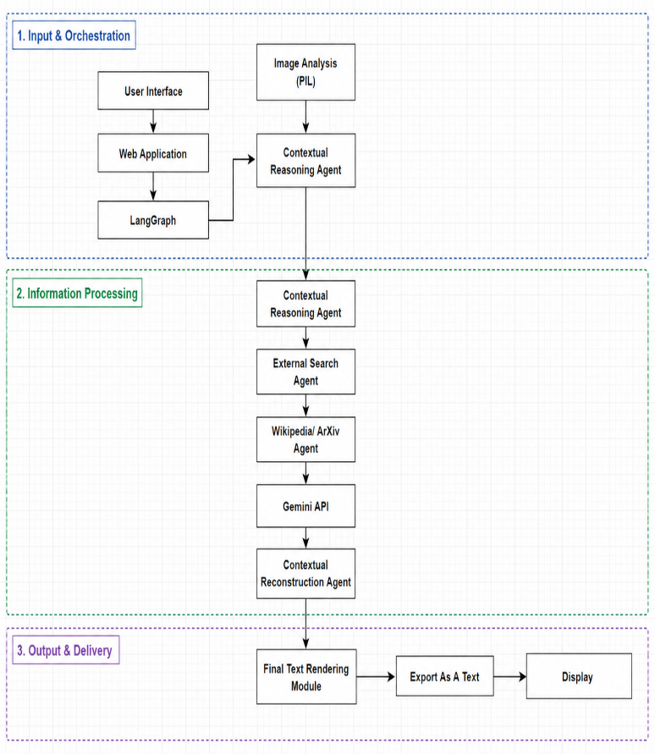

Fig 4.1 Block Diagram

The architecture of TextNova AI is divided into three major layers: Input & Orchestration, Information Processing, and Output & Delivery. In the first layer, the user uploads document images through the web application, while LangGraph manages workflow coordination. The image is analyzed using PIL, and a contextual reasoning agent interprets the document content. In the processing layer, external search agents retrieve relevant information from Wikipedia and ArXiv, while the Gemini API performs intelligent contextual reconstruction of missing or unclear text. Finally, the reconstructed text is rendered, exported as text, and displayed to the user through the output delivery module efficiently.

RESULT AND OUTPUT
Accurate restoration of degraded text.
Contextually relevant reconstructions verified against trusted sources.
Interactive interface for user validation.

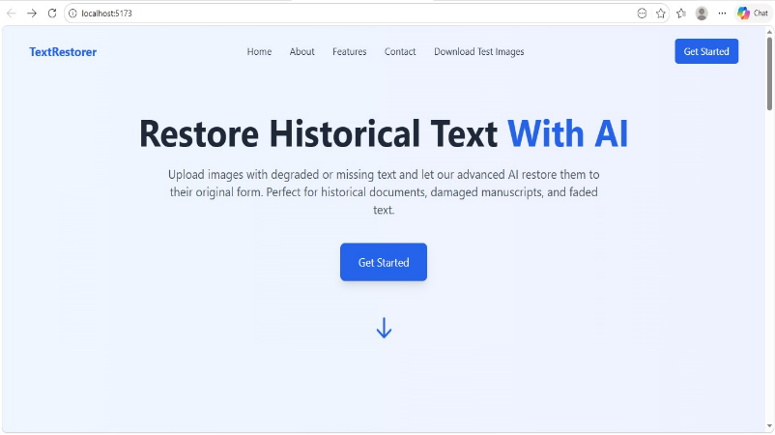

Fig 4.2 Front Page

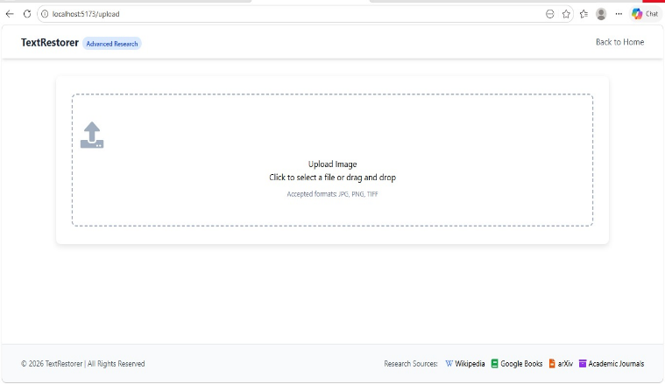

Fig 4.2 Upload Image

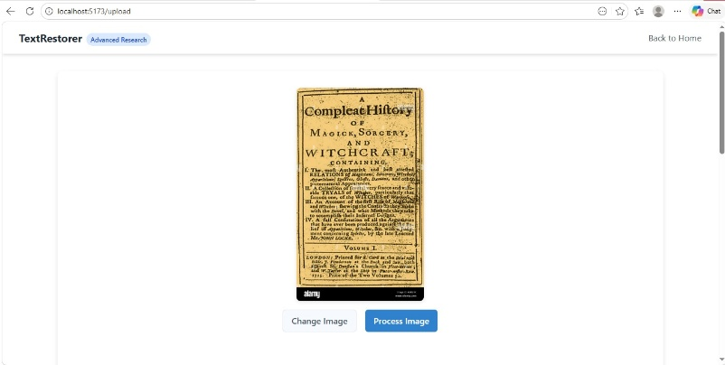

Fig 4.2 Processing Image

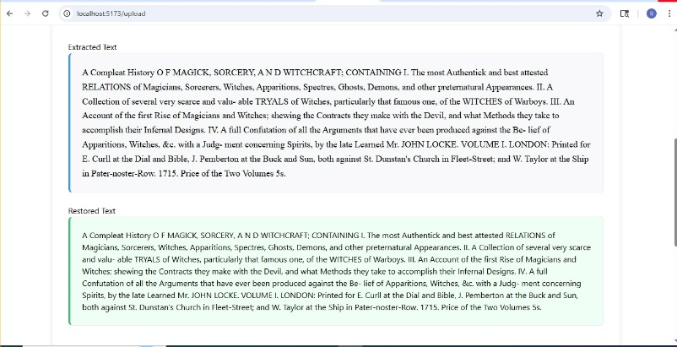

Fig 4.2 Text Restoration

FUTURE SCOPE

Cloud Collaboration Features

Enables multiple users to access, edit, and manage restored documents securely through cloud platforms.

Cross-Platform Availability

Supports seamless access and functionality across desktops, laptops, tablets, and mobile devices efficiently.

- Handwritten Text Recognition
Future improvements can include advanced models to process and reconstruct handwritten historical documents, which are currently challenging for standard OCR systems.

CONCLUSION

The proposed system addresses the limitations of traditional OCR by combining intelligent text extraction with generative reconstruction. By leveraging contextual knowledge from reliable sources, the solution ensures more complete and accurate digitization of degraded documents. Its modular architecture, powered by LangGraph and Gemini API, makes it scalable and adaptable across domains, ultimately contributing to the preservation of valuable written materials.

REFERENCE

1] Shuhao Guan, Moule Lin, Cheng Xu, Xinyi Liu, Jinman Zhao, Jiexin Fan, Qi Xu, Derek Green, PreP-OCR: A Complete Pipeline for Document Image Restoration and Enhanced OCR Accuracy, 2025, ACL 2025 (Conference),

2] P. Sri Charitha, P. Nithisha, P. Rahul, M. Ram Mohan, Haritha A., Improving Document Digitization with Machine Learning Based OCR, 2024, International Journal of Scientific and Advanced Technology (IJSAT),

3] Zahra Ziran, Massimo Mecella, Simone Marinai, AI Driven Enhancement of Historical Documents, 2025, International Journal on Digital Libraries (Springer Nature),

4] Tatiana But , AI in Historical Research: Trends & Insights, 2025, Historica Digital Humanities Review (survey article),

5] Ugonna Vivian Ailakhu, Digital Preservation Strategies for Historical Records in the Age of AI and the Metaverse, 2024, Library Hi Tech News (Emerald Publishing),

