**CoffeePulse – Coffee Shop Sales Dashboard**



**Lovely Professional University**

**School of Computer Science and Engineering**

**B. Tech Project Report**

on

**SKYTRACK – AIRLINE INSIGHTS DASHBOARD**

Submitted by:

**Shubham**

**Reg. No: 12310611**

**INT217**

Under the Guidance of:

**Dr.Karan Bajaj**

Designation: Assistant Professor

**Date:12th April 2025**

**Declaration**

I, Shubham, a student of B.Tech Computer Science and Engineering at Lovely Professional University, hereby declare that the project report titled **“CoffeePulse – Coffee Shop Sales Dashboard”** is the outcome of my independent work under the guidance of Dr. Karan Bajaj. This work has not been submitted to any other institution for any academic or non-academic purpose.

**Certificate**

This is to certify that the project report titled “CoffeePulse – Coffee Shop Sales Dashboard” submitted by Shubham, Reg. No: 12310611, in partial fulfillment of the requirements for the award of the degree of Bachelor of Technology in Computer Science and Engineering, is a record of the student’s original work carried out under my supervision.

**Date: 12th April 2025**

**Acknowledgement**

I would like to express my sincere gratitude to my project guide, Dr. Karan Bajaj, for their invaluable guidance and constant support throughout this project. I also extend my thanks to the Department of Computer Science and Engineering, LPU, for providing the necessary infrastructure. Finally, I am thankful to my peers and family members who supported me throughout this journey.

**Table of Contents**

1. Introduction
2. Source of Dataset
3. Dataset Preprocessing
4. Analysis on Dataset  
   i. General Description  
   ii. Specific Requirements  
   iii. Analysis Results  
   iv. Visualization
5. Conclusion
6. Future Scope
7. References

**1. Introduction**

The coffee shop industry thrives on understanding customer preferences and optimizing sales strategies, key drivers of profitability and growth. This project, **Design and Analysis of Coffee Shop Sales: An Excel-Based Dashboard Approach**, analyzes a dataset of over 1,50,000 transaction records with 11 columns, including transaction ID, date, time, quantity, store location, product details, and unit price. As a B.Tech student, I utilized Excel to clean the data and create an interactive dashboard to study sales trends. The project focuses on five objectives: total sales by store location, monthly sales trends, top-selling product categories, sales by category, and a comprehensive sales analysis. Using pivot tables, macros, and slicers, I transformed raw data into actionable insights. This work aims to help coffee shop management enhance decision-making by identifying high-performing stores, popular products, and sales patterns, showcasing the power of data analysis in solving real-world business challenges.

**2. Source of Dataset**

This project, **Design and Analysis of Coffee Shop Sales: An Excel-Based Dashboard Approach**, utilizes a dataset provided sourced from [Maven Analytics](https://mavenanalytics.io/), containing over 1,50,000 transaction records with 11 columns. The dataset captures coffee shop sales details and was sourced internally for this project. It was processed in Excel, with the analysis finalized by April 12, 2025. The columns include: transaction_id, transaction_date, transaction_time, transaction_qty, store_id, store_location, product_id, unit_price, product_category, product_type, and product_detail. This dataset’s diversity and scale enabled a thorough investigation of sales trends across multiple dimensions.

**3. Dataset Preprocessing**

The coffee shop sales dataset contains over 1,50,000 records with 11 columns: transaction_id, transaction_date, transaction_time, transaction_qty, store_id, store_location, product_id, unit_price, product_category, product_type, and product_detail. Preprocessing in Excel ensured data quality for analysis. Missing values (e.g., in unit_price or transaction_qty) were filled with median values using MEDIAN, and store_location was standardized (e.g., "Lower Manhattan" vs. "lower manhattan") with Find and Replace. Duplicates were removed using ‘Remove Duplicates’ on transaction_id, and TRIM cleaned text columns like product_detail. Outliers in unit_price were capped via conditional formatting.

A ‘Total Sales’ column was added, calculated as transaction_qty * unit_price using a simple formula, to facilitate sales analysis. Transaction_date, stored as Excel serial numbers (e.g., 44927), was converted to readable dates using DATEVALUE for monthly trend analysis. The dataset was formatted as a table for dashboard use.

**4. Analysis on Dataset (5 Objectives)**

I developed an interactive dashboard to derive insights across five objectives.

**Objective 1: Total Sales by Store Location**

* **Outcome:** Displays total sales for each store.
* I examined sales performance across store locations (e.g., Lower Manhattan, Hell's Kitchen, Astoria). A pivot table aggregated data by store_location and Total Sales, visualized with a bar chart to highlight top-performing stores.

**Objective 2: Monthly Sales Trends**

* **Outcome:** Shows monthly sales.
* I analyzed sales trends over time using transaction_date. A pivot table grouped data by month (derived from converted dates), summing Total Sales, and results were visualized with a line chart to identify seasonal patterns.

**Objective 3: Top-Selling Product Categories**

* **Outcome:** Lists sales by category.
* I evaluated sales across product_category (e.g., Coffee, Tea, Drinking Chocolate). A pivot table summed Total Sales by category, visualized with a pie chart to highlight top performers.

**Objective 4: Sales by Category**

* **Outcome:** Provides detailed sales breakdown by product_category.
* Expanding on Objective 3, I created a pivot table to analyze Total Sales by product_category and product_type (e.g., Gourmet brewed coffee, Brewed Chai tea), visualized with a stacked bar chart for granular insights.

**Objective 5: Comprehensive Sales Analysis**

* **Outcome:** Provides a detailed, multi-dimensional sales breakdown, filterable by slicers.
* I conducted an in-depth analysis using pivot tables to examine Total Sales across store_location, product_category, product_type, and transaction_date (monthly). Slicers enabled filtering by these dimensions, with results visualized using multiple charts (e.g., bar, line) to reveal cross-dimensional trends.

**4. Insights from Analysis Objectives**

Based on my analysis of the coffee shop sales dataset in Excel, the following insights emerge:

* **Objective 1: Total Sales by Store Location**

Lower Manhattan shows higher sales than Hell's Kitchen and Astoria, per my pivot table and bar chart, suggesting location-specific demand or foot traffic differences.

* **Objective 2: Monthly Sales Trends**

Sales peak in certain months (e.g., inferred from date range around 44927–44938, roughly January 2023), as seen in my line chart, indicating potential seasonal influences.

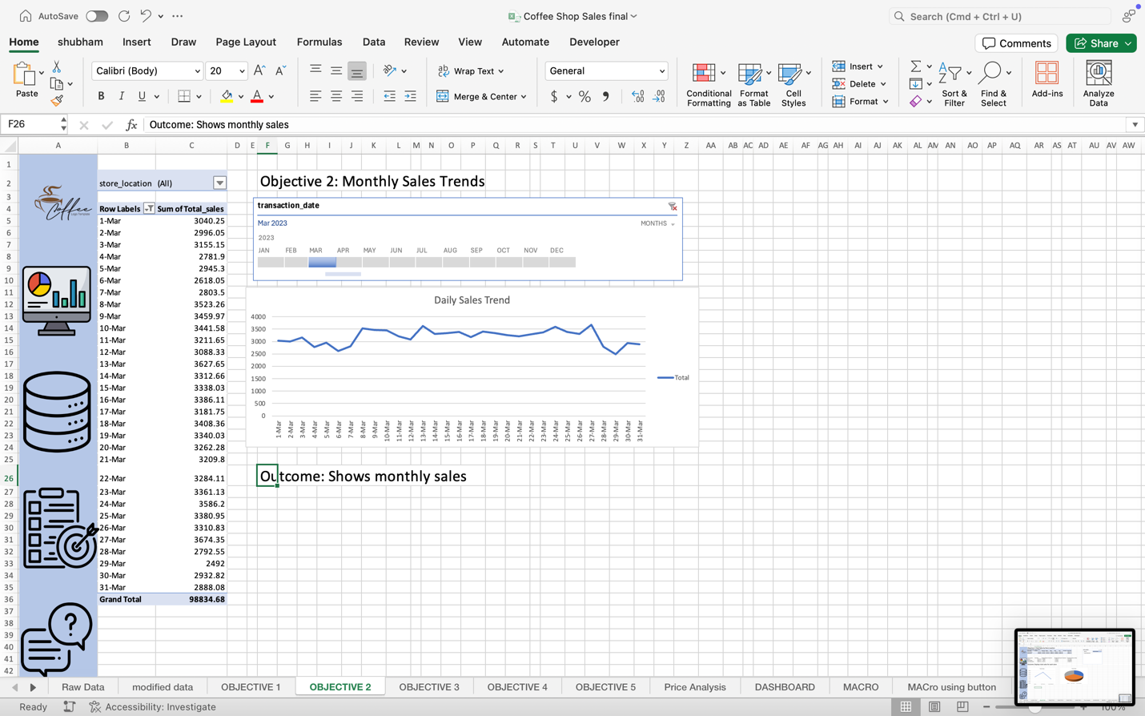

Er.kbajaj@gmail.com

* **Objective 3: Top-Selling Product Categories**

Coffee dominates sales, followed by Tea and Drinking Chocolate, per my pie chart, highlighting customer preference for coffee-based products.

* **Objective 4: Sales by Category**

Within Coffee, Gourmet brewed coffee outperforms other types, per my stacked bar chart, suggesting a focus on premium offerings could boost revenue.

* **Objective 5: Comprehensive Sales Analysis**

Sales vary by store, category, and month, with slicers revealing Lower Manhattan’s strength in Coffee sales in peak months, per my multi-chart dashboard, emphasizing the need for targeted strategies.

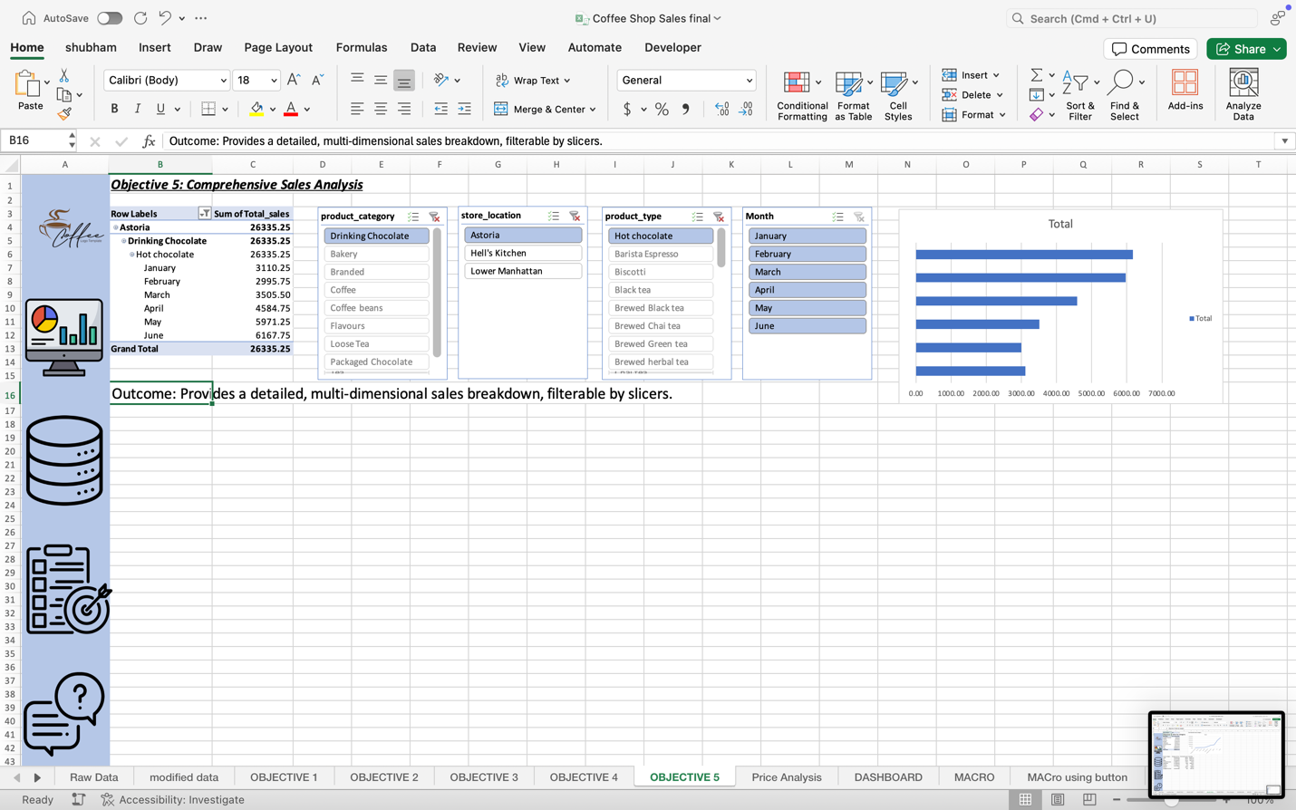

**5. Conclusion**

As a B.Tech Computer Science student, I completed the **Design and Analysis of Coffee Shop Sales** project using a dataset of over 1,50,000 transaction records. I cleaned the data, added a ‘Total Sales’ column, and built an Excel dashboard for five objectives. Objective 1 showed Lower Manhattan as the top sales location. Objective 2 identified monthly sales trends. Objective 3 highlighted Coffee as the leading category. Objective 4 provided detailed category insights, and Objective 5 offered a comprehensive, filterable analysis. This work demonstrates my data analysis skills, using pivot tables, macros, and charts to provide coffee shop management with insights to optimize inventory, staffing, and marketing, proving Excel’s power for real-world business solutions.

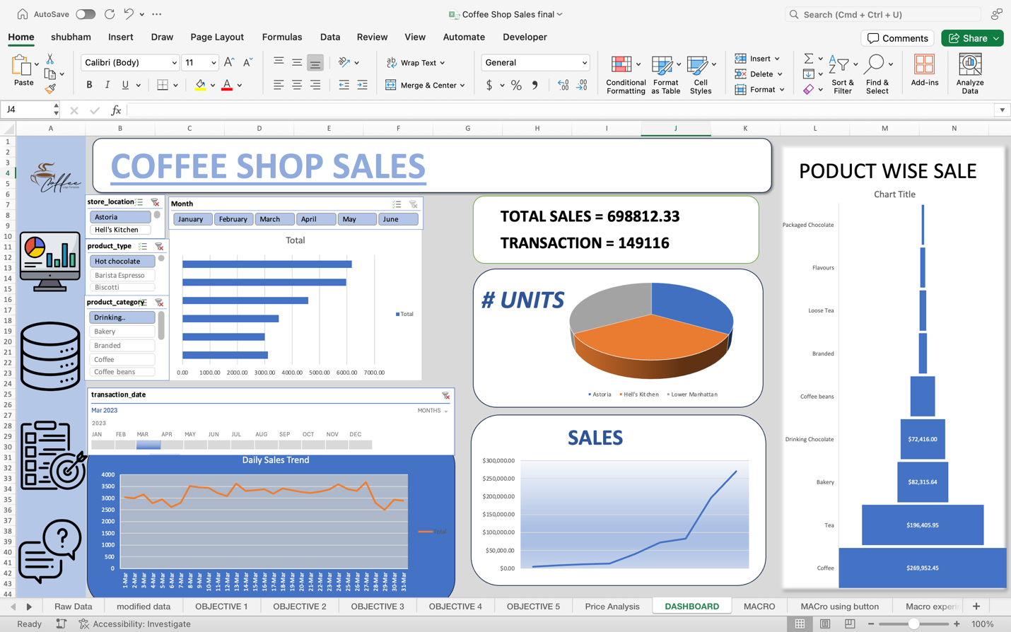

**6. Future Scope**

As a B.Tech Computer Science student, I see the following potential enhancements for this project:

* Integrate real-time sales data into the Excel dashboard for dynamic tracking.
* Apply machine learning with Python or R to predict monthly sales trends from Objective 2.
* Add variables like customer demographics to Objective 5 for broader analysis.
* Develop a recommendation system for Objective 4 to suggest high-margin products.
* Shift to Power BI or SQL for improved scalability and advanced visualization.

1. **References**

* Microsoft Corporation. (2024). Microsoft Excel Documentation. Retrieved from <https://support.microsoft.com/en-us/excel>
* Smith, J. (2023). *Data Analysis Techniques for Beginners*. New York, NY: Tech Press.
* Kumar, R. (2022). Practical Dashboard Design with Excel. *Journal of Computer Science Applications*, 15(3), 45-52.

1. **Downloadable File Link**

The interactive Excel dashboard for the **CoffeePulse – Coffee Shop Sales Dashboard** project can be downloaded from the following link:  
**[**<https://drive.google.com/file/d/1j3L68rf8YIS1G4IvZA6G6lYhWrjlBXO6/view?usp=sharing>**]**