CSY1018: Web Development

Assignment 1

Name: - Shubham Choudhary

UN ID Number: 15422589

BSc Computing

**Contents**

Getting Started .................................................................................................................................. 1

Designs .............................................................................................................................................. 1

Wireframes ......................................................................................................................................... 1

This is my wireframe for my homepage. ........................................................................................ 1

This is my wireframe for my about page. ....................................................................................... 2

This is my wireframe for my portfolio page. .................................................................................. 2

This is my wireframe for my contact page. .................................................................................... 3

This is my wireframe for my useful links page. .............................................................................. 3

Sketches ............................................................................................................................................. 3

Sketches Homepage ....................................................................................................................... 3

Sketches About ............................................................................................................................... 4

Sketches Portfolio .......................................................................................................................... 4

Sketches Useful Links ..................................................................................................................... 5

Sketches Contact ............................................................................................................................ 6

Prototypes .......................................................................................................................................... 7

Style Tile ............................................................................................................................................. 7

Images I have created ........................................................................................................................ 7

Evidence of how I have used Models of Good Practice .......................................................................7

Page Load Speed ................................................................................................................................ 7

Visual Appeal ......................................................................................................................................8

Navigation .......................................................................................................................................... 8

Progression of website over 12 weeks ............................................................................................... 9

Week 1 – 4 .......................................................................................................................................... 9

Week 4 – 8 ........................................................................................................................................ 10

Week 8-12 ........................................................................................................................................ 13

Peer Evaluations ...................................................................................... **Error! Bookmark not defined.**

First Review ......................................................................................... **Error! Bookmark not defined.**

**Getting Started**

To get an idea I went through lots of tutorial. I started my Portfolio after doing a lot of research. I noticed many were made through Bootstrap or HTML5. I started making my webpage using simple CSS fonts. Later I made it more attractive after getting familiar with it. But I felt a bit difficult while I was making my web pages responsive. This assessment is about developing an interactive web page design using HTML, CSS properties. The major purpose for this report is to assign all the details while developing my webpage using HTML5 and CSS properties and my experience while making my webpages and I have also included screenshots of my all web pages.

Before I actually got started on creating my portfolio, I went around and looked at other peoples

portfolios and got some ideas on how I could style and produce mine. I noticed a lot of them were

creating using a front end like Bootstrap or HTML5BoilerPlate. I decided to start building my website

using Bootstrap and I ended up using a theme, which over the length of the 12 weeks I would change

completely and make it my own creation. This made it easier for me and gave me a kind of platform

to be able to start to begin creating my own. The websites which I looked at to inspire me were:

• http://kellyedmunds.co.uk/

• http://joel.sh/

• http://ryanscherf.net/

• <http://www.rleonardi.com/interactive-resume/>

**Designs**

**Wireframes**

**This is my wireframe for my homepage.**

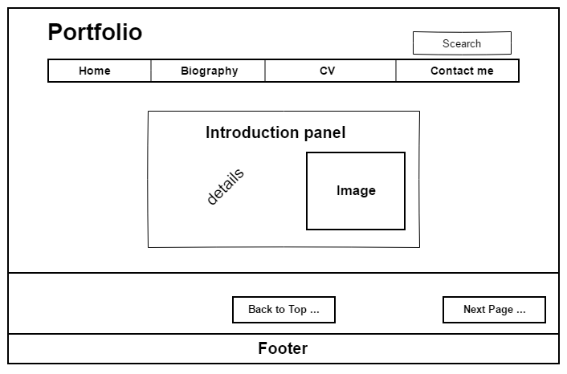

**This is my wireframe for my about page.**

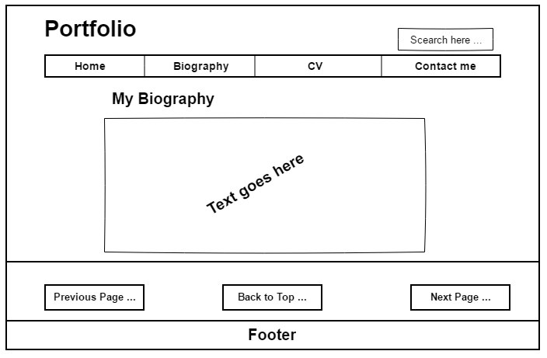

**This is my wireframe for my CV page.**

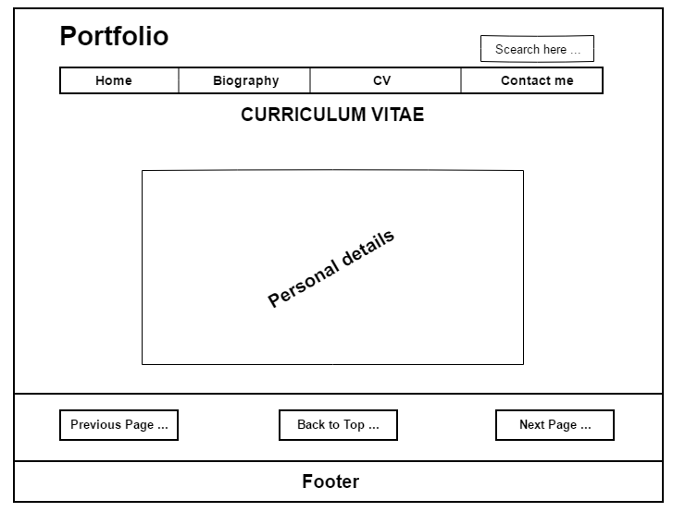

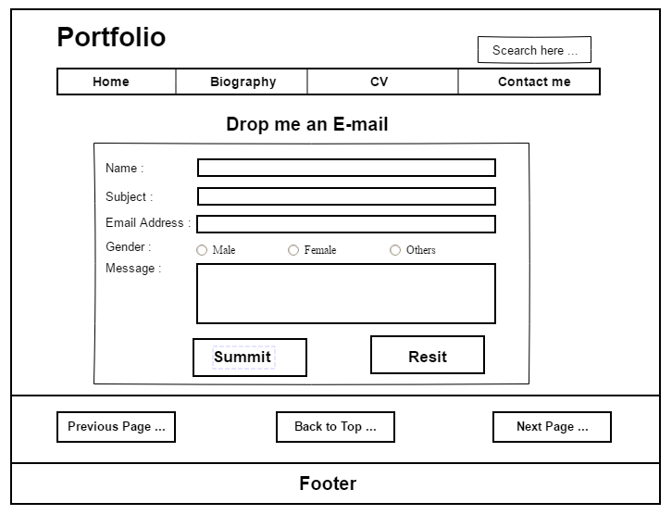**This is my wireframe for my contact page.**

Sketches Homepage

I want my homepage to be very simple and easy to help the user navigate across the whole website.

I will add a picture of myself in the middle which will spin on hover and then show another different

picture on the other side which will let the users click and take them to my portfolio page. I will have

footer at the bottom of each page and also the navigation bar will be across the whole of the top of

all the pages, this keeps my design consistent. The navigation bar will be a blue/purple colour and

when on hover it will change to black. There will also be a link so that people can download my CV

right from the homepage.

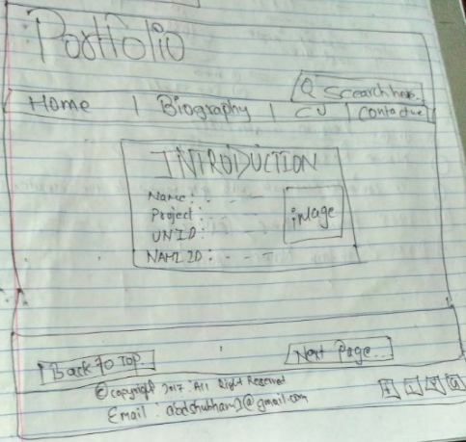

**Sketches About**

For my about page I have included the same navigation bar which I will be including on each page at

the top. I have then included a “Famous Quote” which will be centered into a div with curly font. I

have then got 2 DIVs next to each other which will include ‘About me’ and a ‘Inspirations’ section.

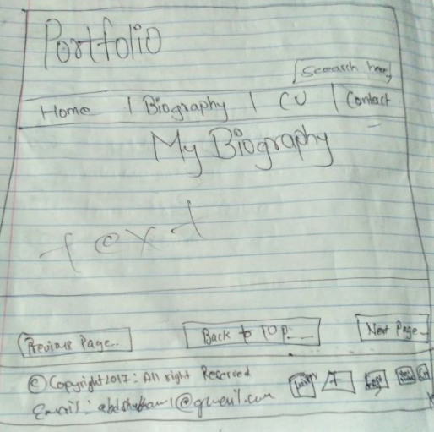

**Sketches CV**

My contact page will be more nice and simple. It will be centered with a contact us form which will

enable to visitor to send me an email from the form. The DIV that the contact form itself will be in I

want to be grey or a darker colour than everything out so that attention is straight towards it when

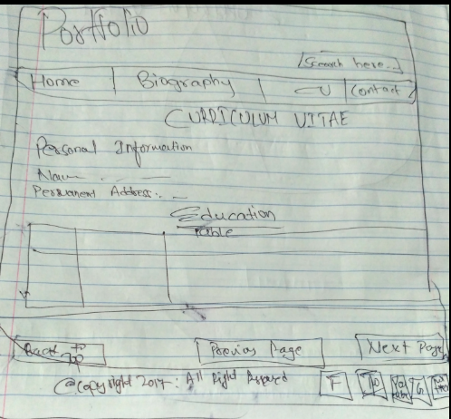the user goes on the page and it makes it stands out.

**Sketches Contact**

My contact page will be more nice and simple. It will be centered with a contact us form which will

enable to visitor to send me an email from the form. The DIV that the contact form itself will be in I

want to be grey or a darker colour than everything out so that attention is straight towards it when

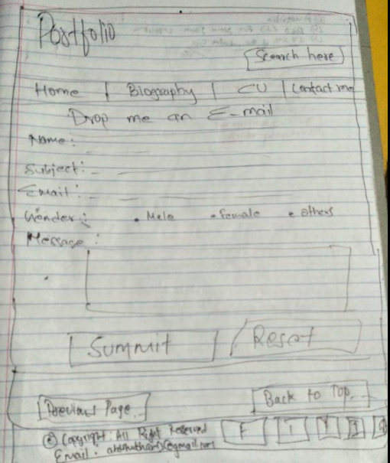the user goes on the page and it makes it stands out.

Wireframes Mobile Responsive

**Sketches Homepage**

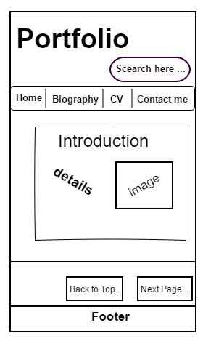

**Sketches Biography**

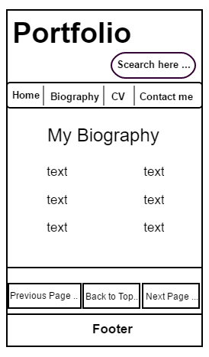

**Sketches CV**

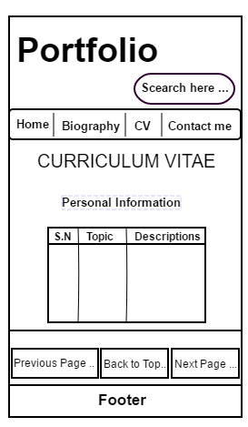

**Sketches Contact Me**

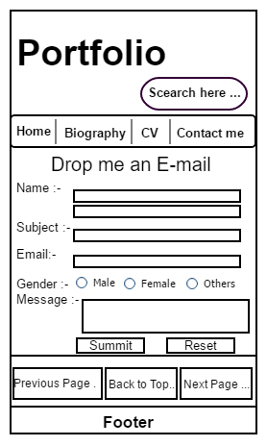

Screenshot of my Webpage Design

1. 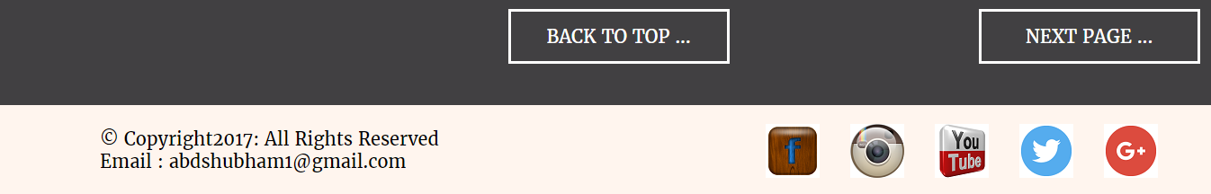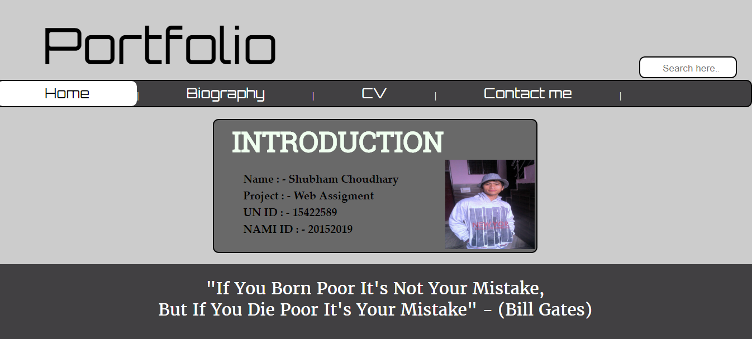Home Page
2. Biography Page

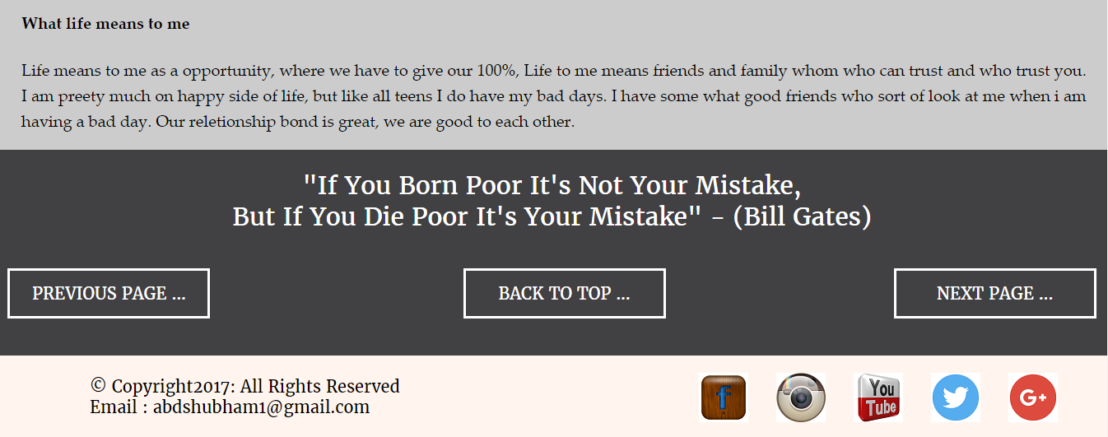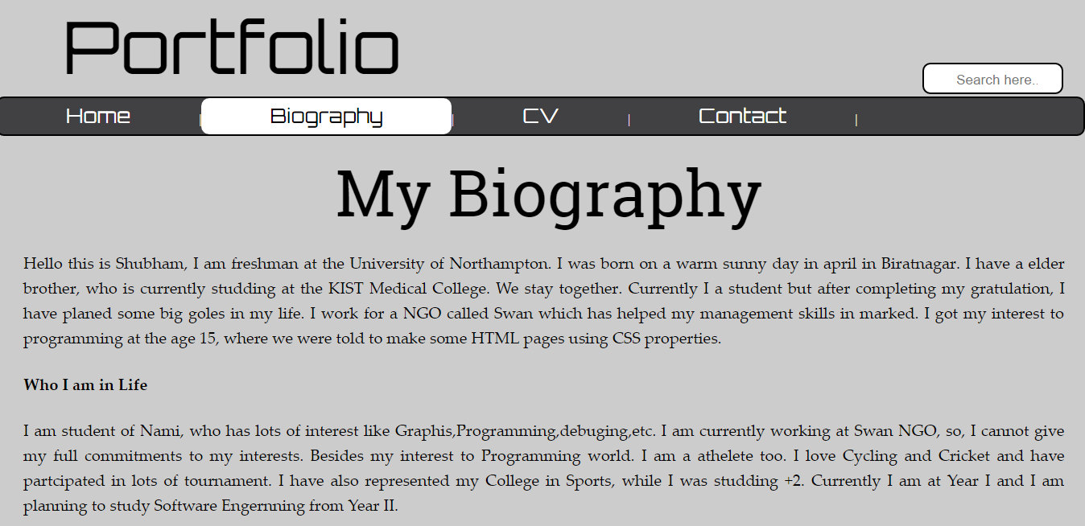

1. 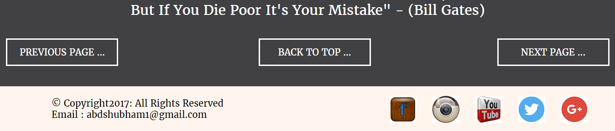Curriculum Vitae 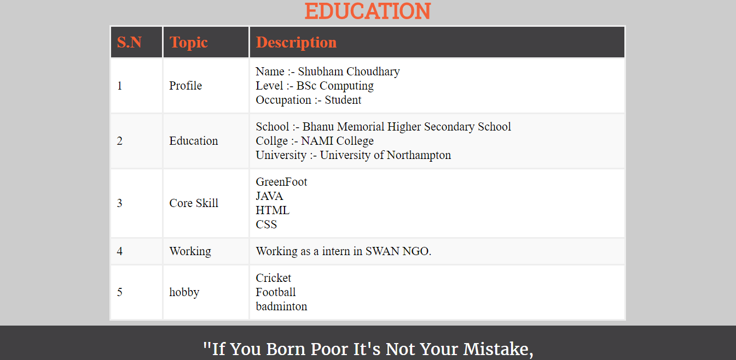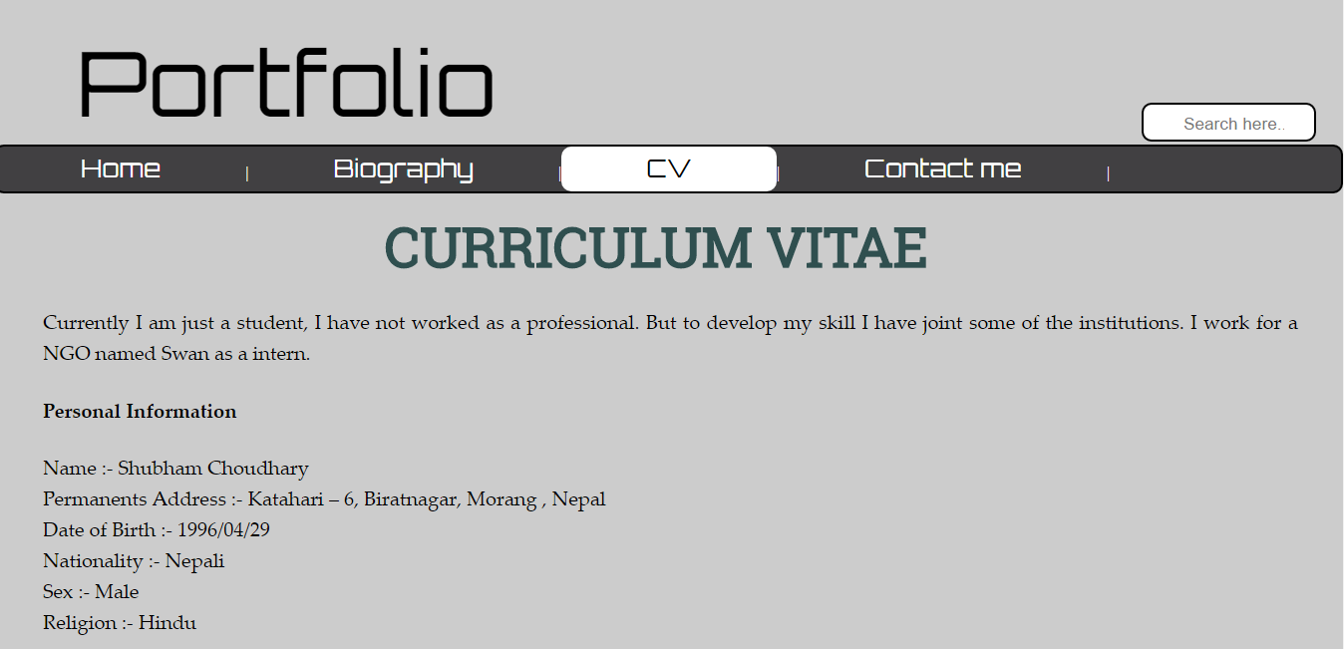
2. Contact Me

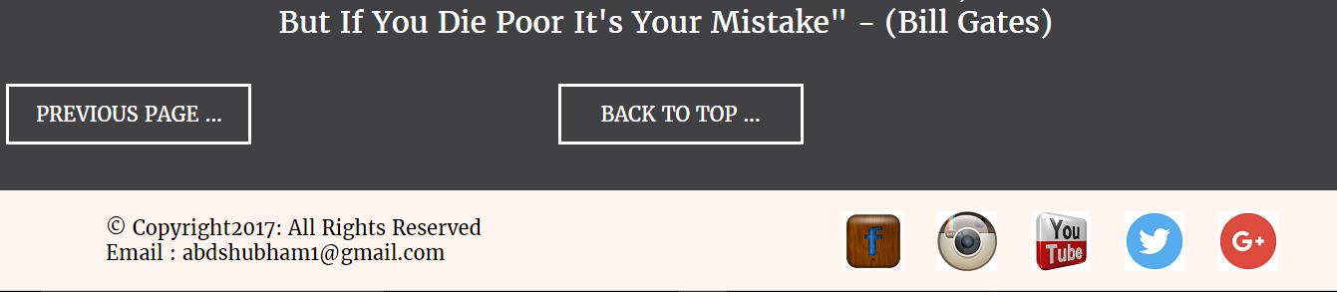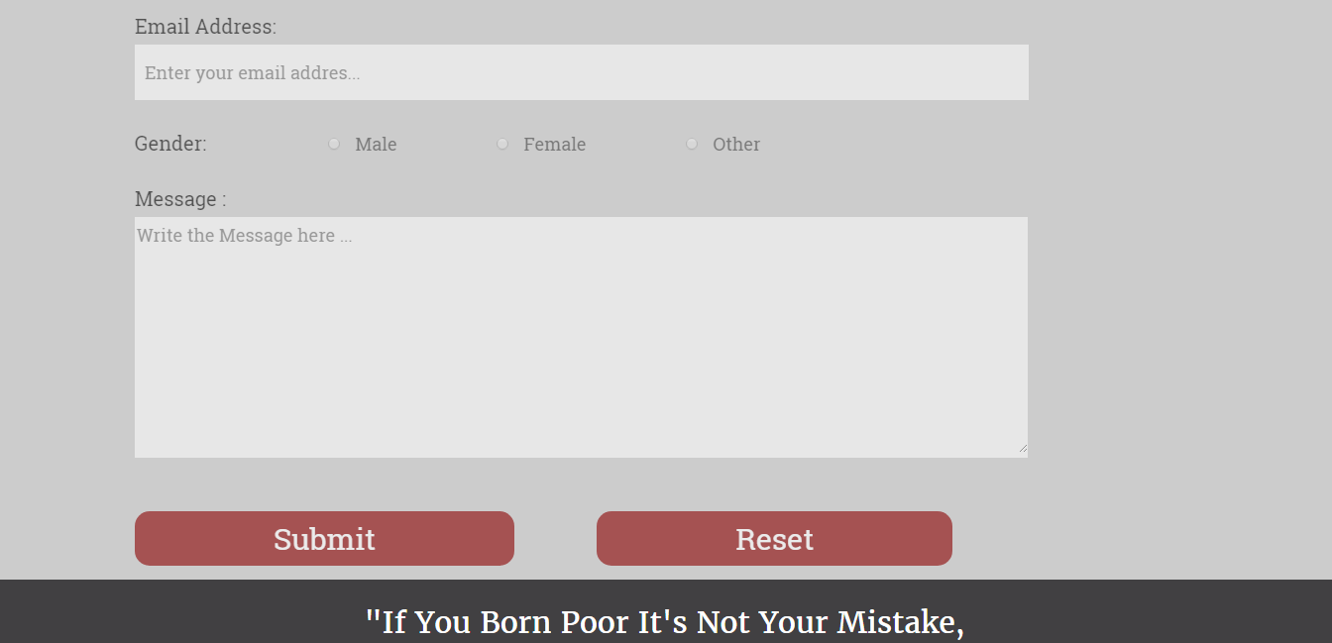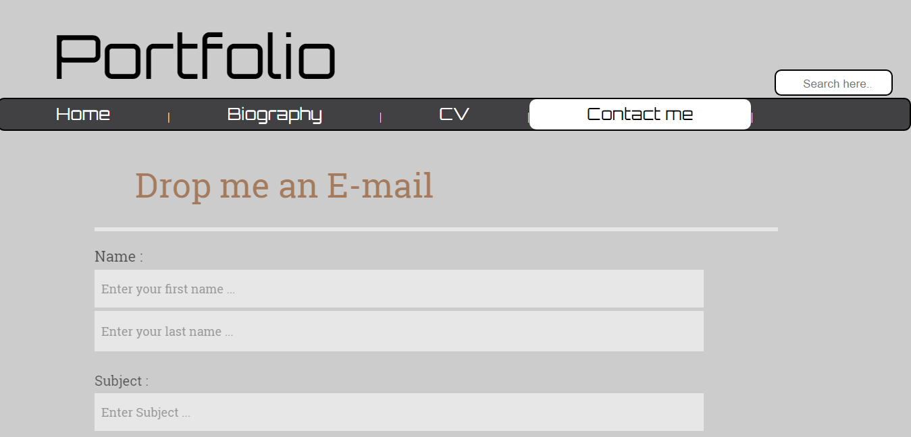

Screenshot of W3 Validator

