Disease Prediction Report

This is the report generated from the analysis of video captured by the drone

# Statistical analysis

The below graph shows the distribution of various disease as per our prediction. The prediction is done on the video captured from the drone

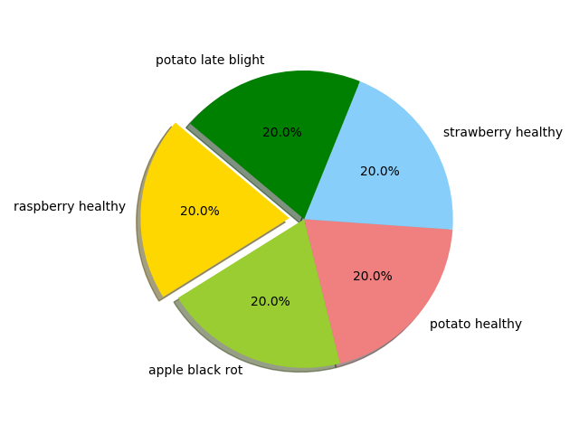

# Most Severe Disease

The two most severe diseases are:

1. raspberry healthy
2. apple black rot

# Cure Of Severe Diseases Found

The cure of disease are:

* raspberry healthy

# Detailed Analysis

Below is the indepth report

|  |  |  |
| --- | --- | --- |
| Name | Disease1 | Disease2 |
| 1111.JPG | corn maize cercospora leaf spot gray leaf spot | corn maize northern leaf blight |
| 11111.JPG | corn maize cercospora leaf spot gray leaf spot | corn maize northern leaf blight |
| 12.jpg | raspberry healthy | apple black rot |
| 123.jpg | raspberry healthy | apple black rot |
| 45545.JPG | potato early blight | grape leaf blight isariopsis leaf spot |
| image.jpg | raspberry healthy | apple black rot |