**SCILAB**

**NAME: SHUBHAM SHARMA**

**ROLL NO: 18i190002**

**MSC PHD (OR)**

**PART (1)**

We are getting avg no of customers in the system= 0.969

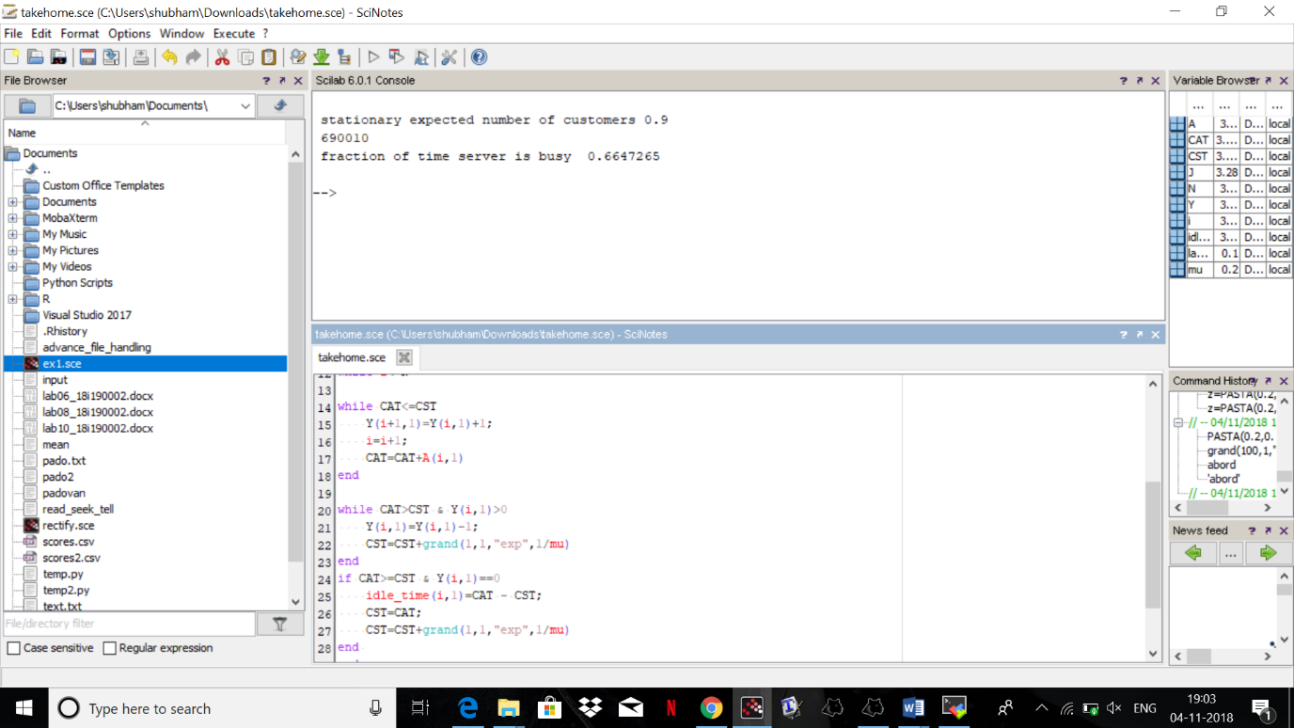

**PART (2)**

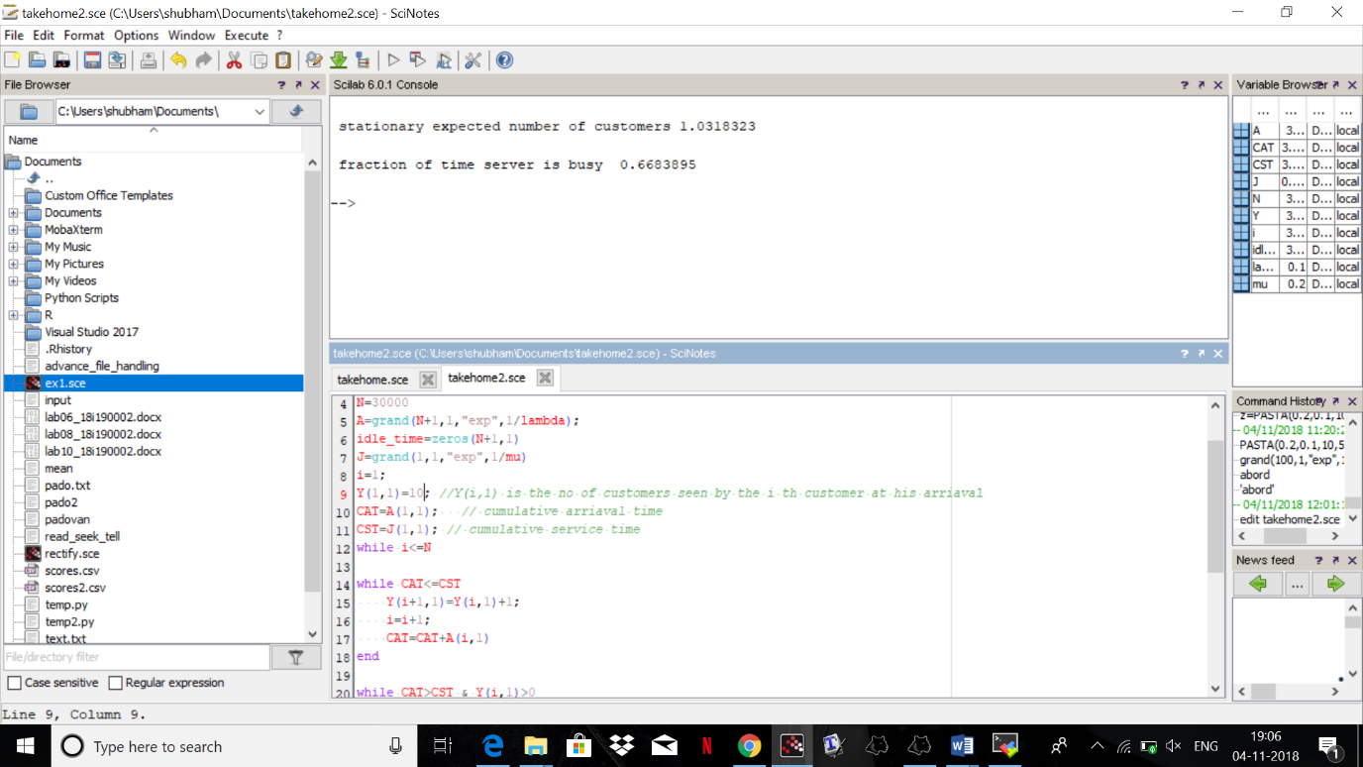

Stationary expected number of customers 1.0318323

**PART (2)**

Let N- Avg no of customers in the system

Let meu- Service Rate

Let lambda- Arrival Rate

then rho=lambda/meu, where rho represent the average proportion of time which the server is occupied. We need the utilization of the buffer and require rho<1 for the queue to be **stable**

N=rho/(1-rho)

N= 0.5/(1-0.5)

N=1

If we compare the solution we getting and the theoretical solution, then both of these are approximately equal.

**PART (3)**

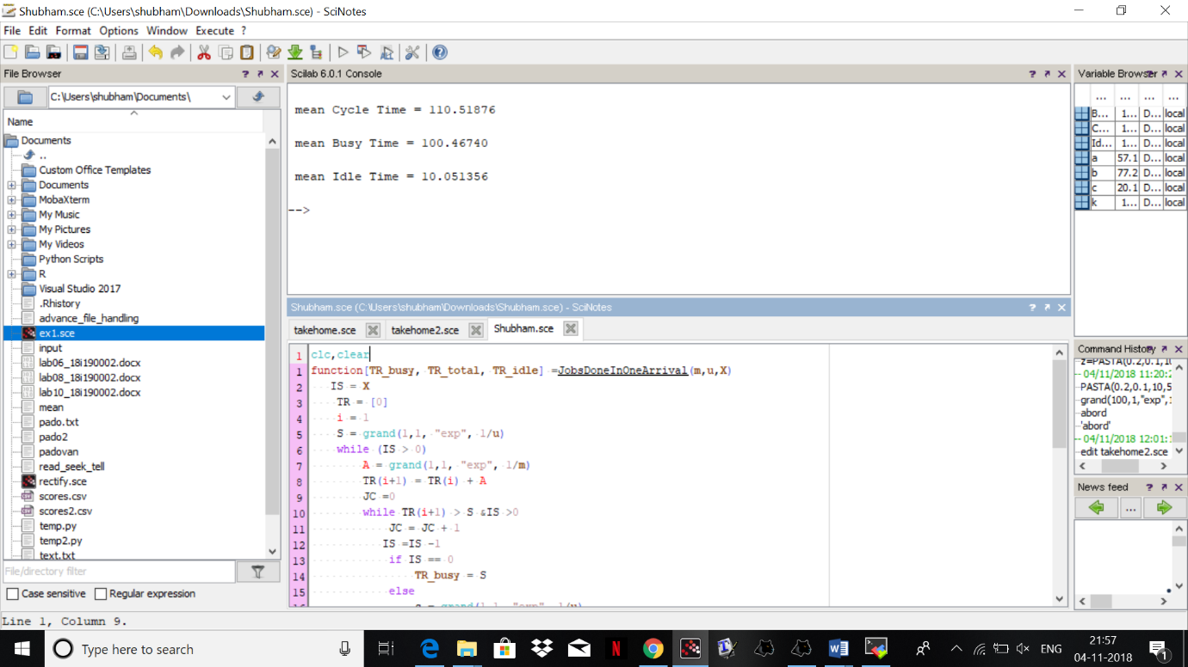

mean Cycle Time = 110.51876

mean Busy Time = 100.46740

mean Idle Time = 10.051356

To find the expected number of buzy period , the theoretical formula is 1/(mu*(1-r)).

If we solve with this formula we get value 10, which is approximately equal to mean of idle time.