1. **Solution to ex1:**

The lpp given in the question is :

minimize 3*x1 + 4*x2 + 5*y1;

subject to constraints:

6*x1 + 8*x2 + 10*y1 >= 200;

6*x2 + 5*y1 <= 8;

Where y1<=1000 and other variables belong to the set of real numbers

Solution: The following problem has been solved by AMPL

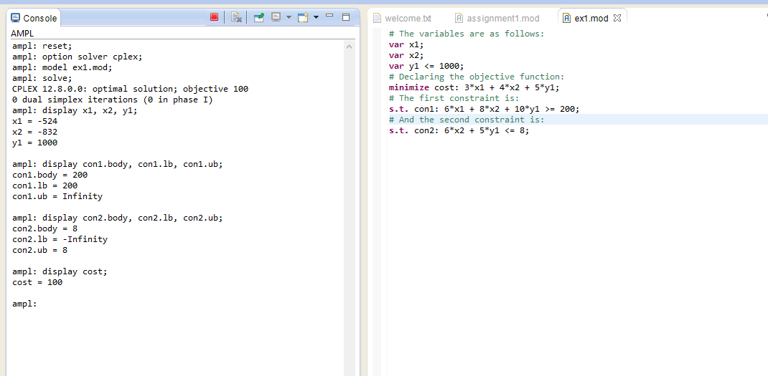 1) The optimal solution came out to be:100

2) The values are variables at optimal solution is:

X1=-524

X2=-832

Y1=1000

3)we have calculated the upper bound and lower bound of the given constraint 1 through AMPL:

Lower bound=200

Upper bound=infinity

Body of constraint 1=200

4)we have calculated the upper bound and lower bound of the given constraint 2 through AMPL:

Lower bound=-infinity

Upper bound=8

Body of constraint 2=8

5) The optimal solution by minimising the cost is 100

1. **Solution to ex2:**

The lpp given in the question is :

minimize 3*x1 + 4*x2 + 5*y1;

subject to constraints:

6*x1 + 8*x2 + 10*y1 >= 200;

6*x2 + 5*y1 <= 8;

Where 10<=y1<=1000 and other variables belong to the set of real numbers

Solution: The following problem has been solved by AMPL

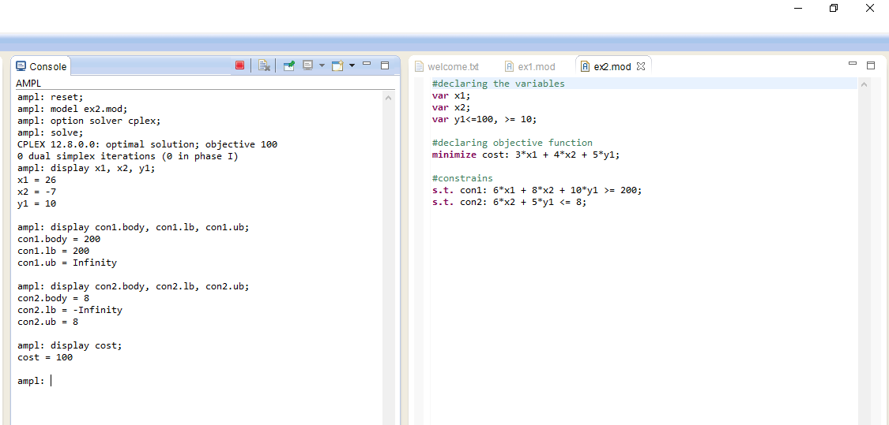 1) The optimal solution came out to be:100

2) The values are variables at optimal solution is:

X1=26

X2=-7

Y1=10

3)we have calculated the upper bound and lower bound of the given constraint 1 through AMPL:

Lower bound=200

Upper bound=infinity

Body of constraint 1=200

4)we have calculated the upper bound and lower bound of the given constraint 2 through AMPL:

Lower bound=-infinity

Upper bound=8

Body of constraint 2=8

5) The optimal solution by minimising the cost is 100

1. **Solution to ex3:**

Defining the variables:

Let xa1: Units shipped from warehouse A to customer 1

Let xb1: Units shipped from warehouse B to customer 1

Let xb2: Units shipped from warehouse B to customer 2

Let xa2: Units shipped from warehouse A to customer 2

(**these four variables will be converted into two by substitution method as per requirement of the question**)

We get the LPP as follows:

**Minimize** 50*xa1+60*xa2+40*xb1+55*xb2

Subject to constraints:

xa1+xa2<=80

xb1+xb2<=45

xa1+xb1=50

xa2+xb2=70

**substituting the values of xb1 and xb2 from the last two equation in the first two equations and the objective function we get the prob as follows:**

**Minimise 10*xa1+5*xa2+5850**

**Subject to:**

**xa1 + xa2>=75**

**xa1 + xa2<=80**

**where 0<=xa1<=50**

**& 0<=xa2<=70**

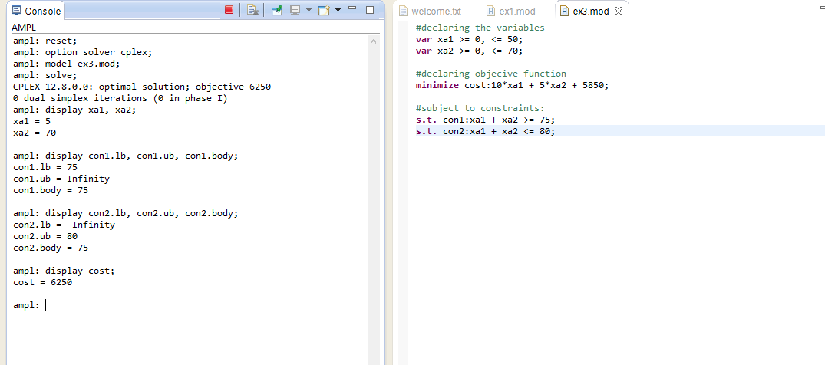

1) The optimal solution came out to be:6250

2) The values are variables at optimal solution is:

xa1=5

xa2=70

3)we have calculated the upper bound and lower bound of the given constraint 1 through AMPL:

Lower bound=75

Upper bound=Infinity

Body of constraint 1=75

4)we have calculated the upper bound and lower bound of the given constraint 2 through AMPL:

Lower bound=-infinity

Upper bound=80

Body of constraint 2=75

5) The optimal solution by minimising the cost is 6250