**NAME: SHUBHAM SHARMA**

**ROLL NO: 18i190002**

**MSC PHD (OR)**

**EX1:**

**part(a)(code file: ex1a.sce)**

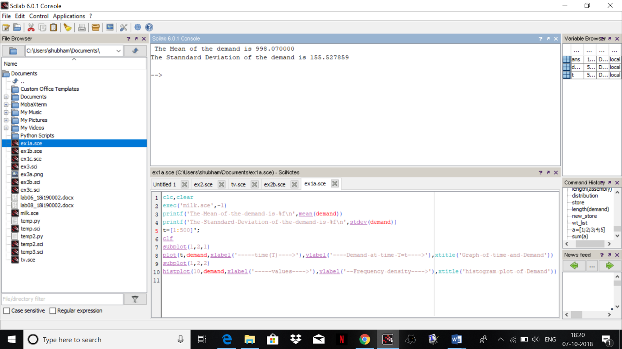

The Mean of the demand is 998.070000

The Standard Deviation of the demand is 155.527859

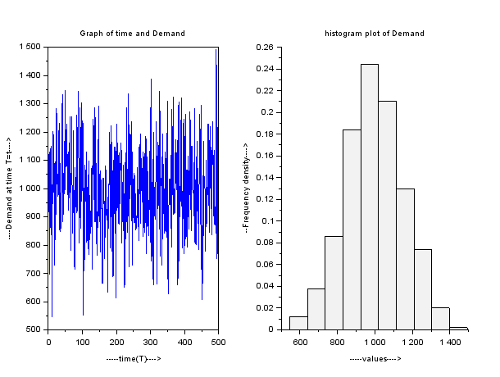

The distribution of the demand seems to be **Normal Distribution.**

**part(b)**

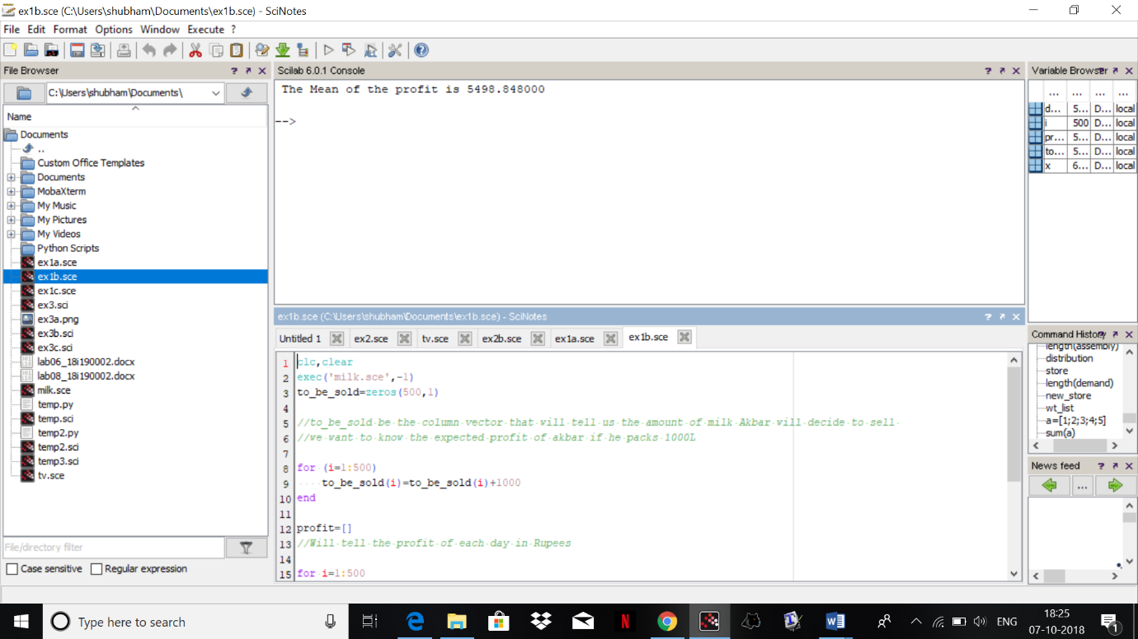

The Mean of the profit is **5498.848000.**

**part(c)** 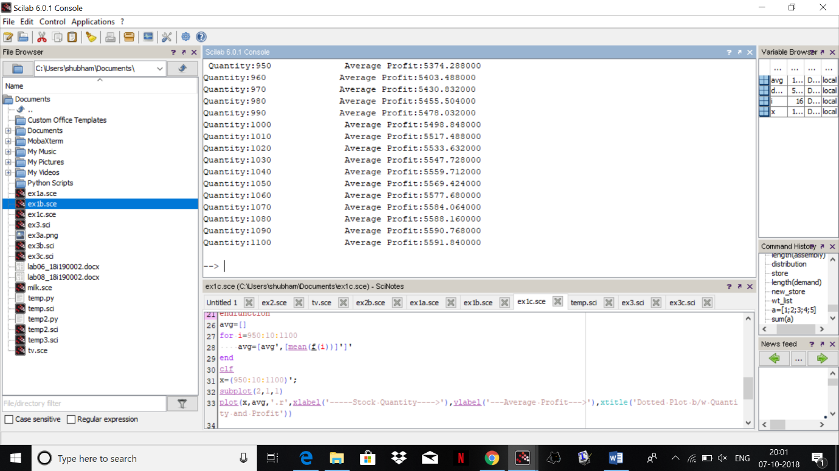

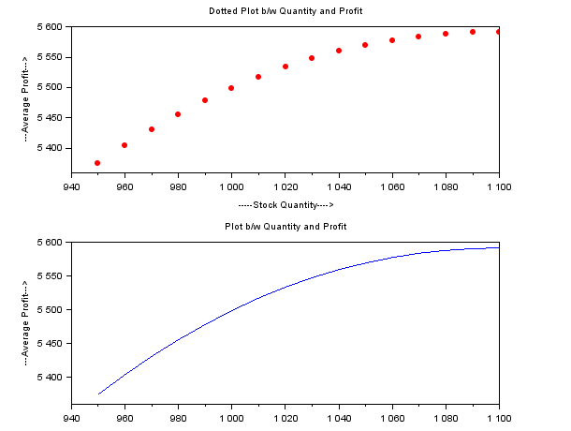

Quantity:950 Average Profit:5374.288000

Quantity:960 Average Profit:5403.488000

Quantity:970 Average Profit:5430.832000

Quantity:980 Average Profit:5455.504000

Quantity:990 Average Profit:5478.032000

Quantity:1000 Average Profit:5498.848000

Quantity:1010 Average Profit:5517.488000

Quantity:1020 Average Profit:5533.632000

Quantity:1030 Average Profit:5547.728000

Quantity:1040 Average Profit:5559.712000

Quantity:1050 Average Profit:5569.424000

Quantity:1060 Average Profit:5577.680000

Quantity:1070 Average Profit:5584.064000

Quantity:1080 Average Profit:5588.160000

Quantity:1090 Average Profit:5590.768000

Quantity:1100 Average Profit:5591.840000

**part(d)**

We are getting a concave curve if we take a plot of stock and average profit and the point on which we get the peak is the recommended stock level because we have maximum profit there

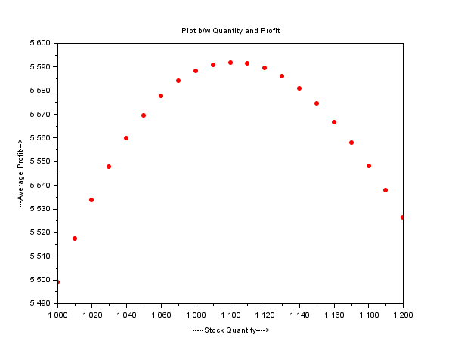 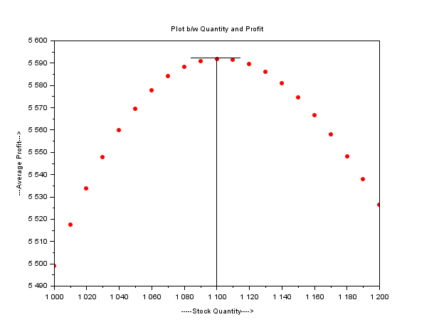

thus, stock level **1100** is the recommended stock level

**EX3:**

(Part c again with slight rectifications)

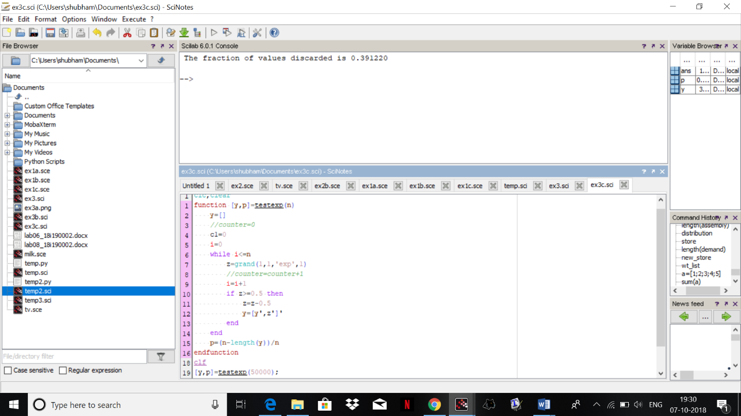

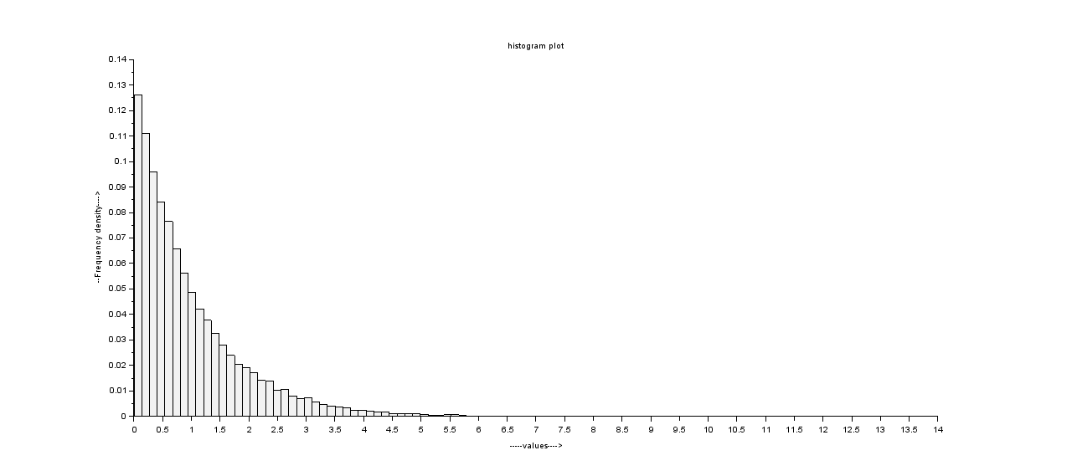

The fraction of values discarded is **0.391220**

the histplot is as follows , we see that we get less then half values which are less than 0.5 and we decrease the values to 0.5 so the graph will not consider higher values.

**EX3:**

**part(a)**

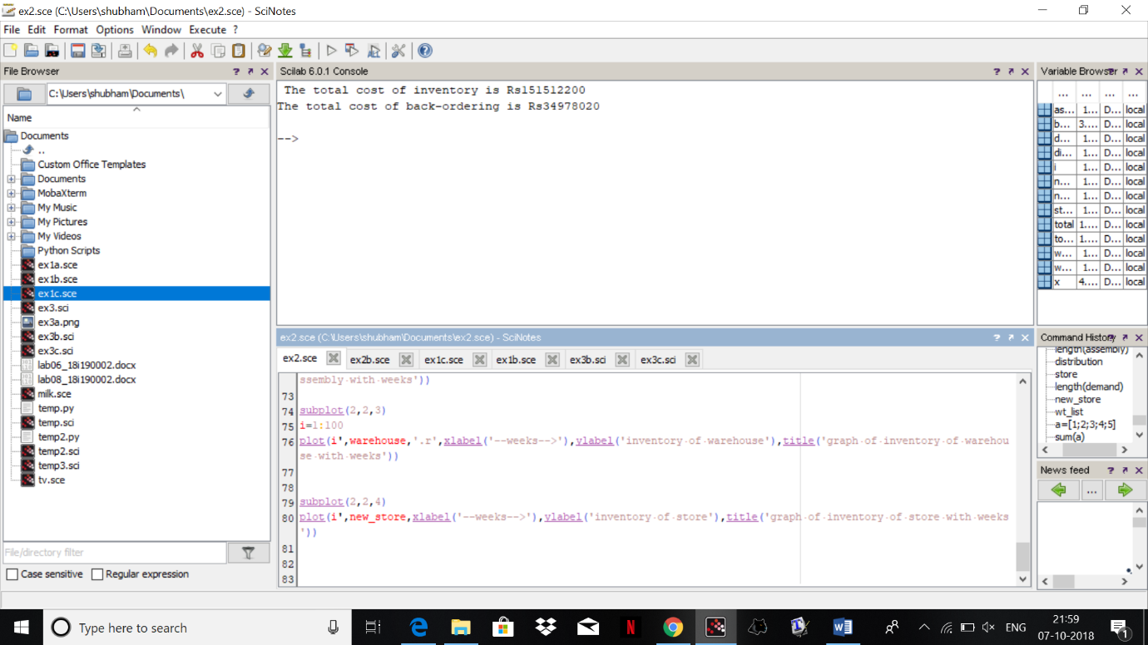

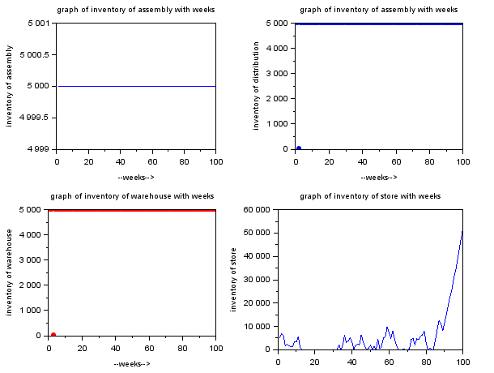

The total cost of inventory is Rs**151512200**

The total cost of back-ordering is Rs**34978020**

**part(b)**

The best fixed order quantity is : **6000** 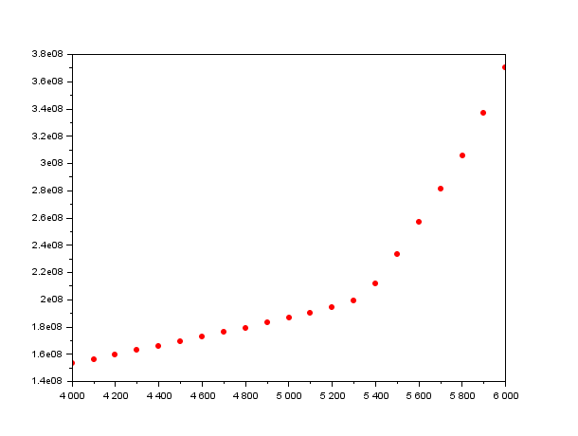

We can see from the graph that the best fixed order quantity is : **6000**

Quantity=4000 Total Cost=153115810

Quantity=4100 Total Cost=156312870

Quantity=4200 Total Cost=159500870

Quantity=4300 Total Cost=162710090

Quantity=4400 Total Cost=165920280

Quantity=4500 Total Cost=169135310

Quantity=4600 Total Cost=172432660

Quantity=4700 Total Cost=175872310

Quantity=4800 Total Cost=179299790

Quantity=4900 Total Cost=182808810

Quantity=5000 Total Cost=186490220

Quantity=5100 Total Cost=190407160

Quantity=5200 Total Cost=194487400

Quantity=5300 Total Cost=199288580

Quantity=5400 Total Cost=211838580

Quantity=5500 Total Cost=233205680

Quantity=5600 Total Cost=257063340

Quantity=5700 Total Cost=281413770

Quantity=5800 Total Cost=305815660

Quantity=5900 Total Cost=336950430

Quantity=6000 Total Cost=370202770

**part(c)**

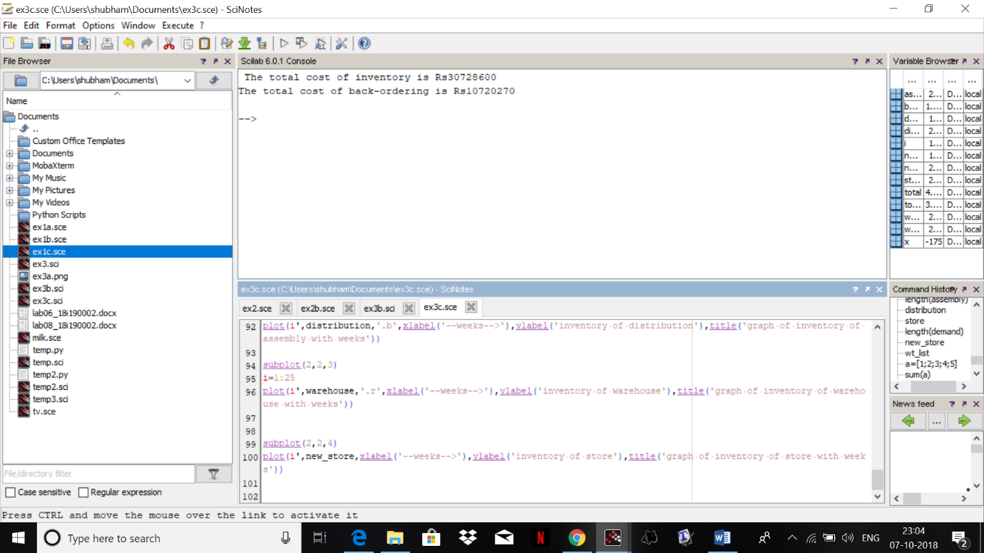

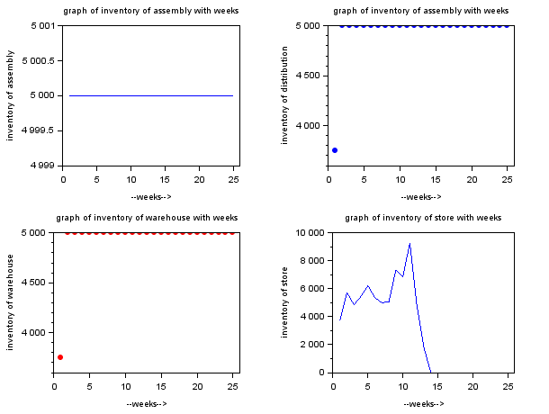

**part(d)**

The total cost of inventory is Rs553604300

The total cost of back-ordering is Rs0

This policy or ordering is an month is less reasonable as the cost is more

**what we can do is to take the average of demand each week and order that amount of stock that will minimize the cost**

**part(e)**

We can make the order in every two weeks and we get the following results

The total cost of inventory is Rs597524700

The total cost of back-ordering is Rs0

