**NAME: SHUBHAM SHARMA**

**ROLL NO: 18i190002**

**MSC PHD (OR)**

**EX3:**

**PART A**

Here is the Histplot when n=10, n=1000, n=1000000

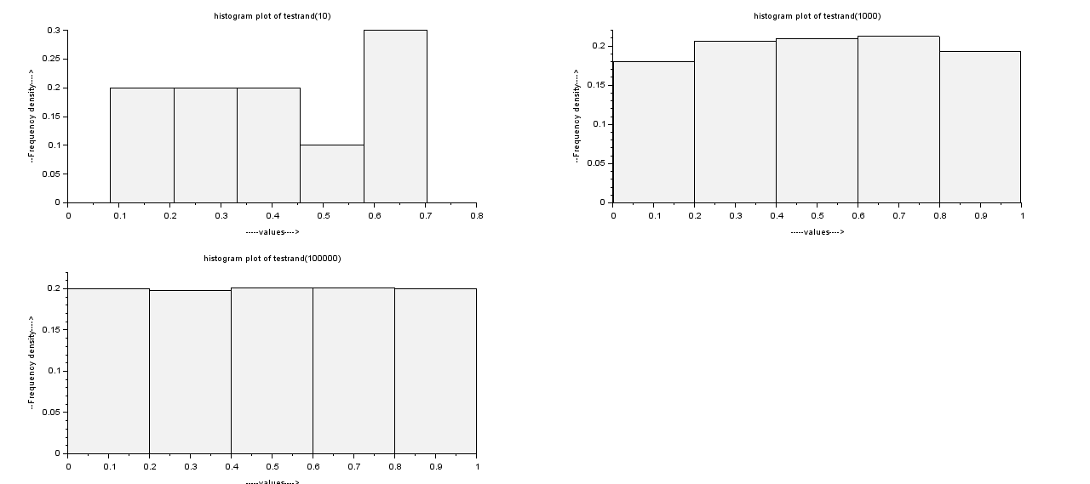

We are getting that hist plot as we expected as we are increasing the values of n , Larger the values of n we take , more precise and good results we’ll get. So in case of n=10 , there is a little variation , but in case of n=1000 and n=1000000 we are getting results as it should be in uniform distribution , so more the size of this sample , more it will behave like uniform distribution.

**PART B**

We have done the same using grand in scilab:

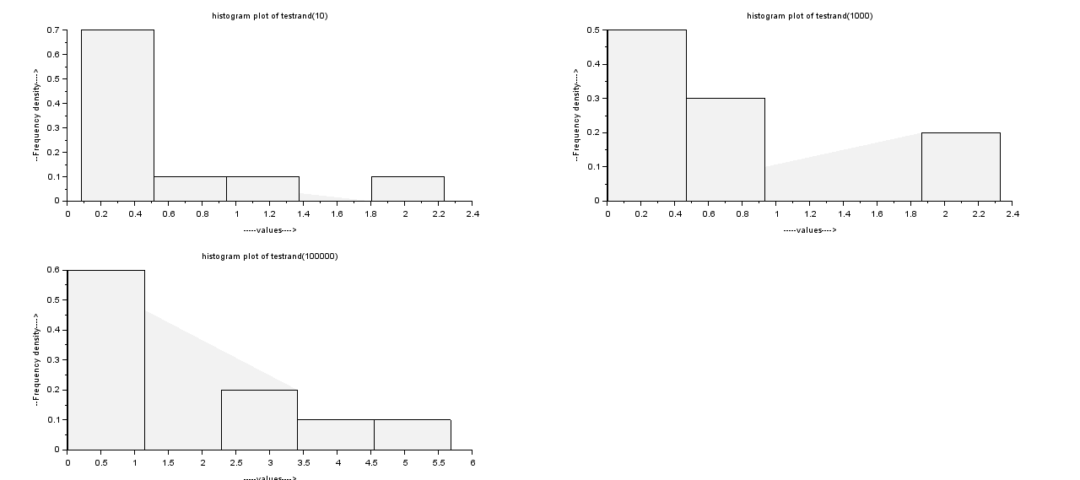

As we can see the histplot above , everytime it is coming exponentially as we expected but in case of uniform distribution , more was the size of sample , more precise the results were, but here we are getting results we expected in all the cases.

**PART C**

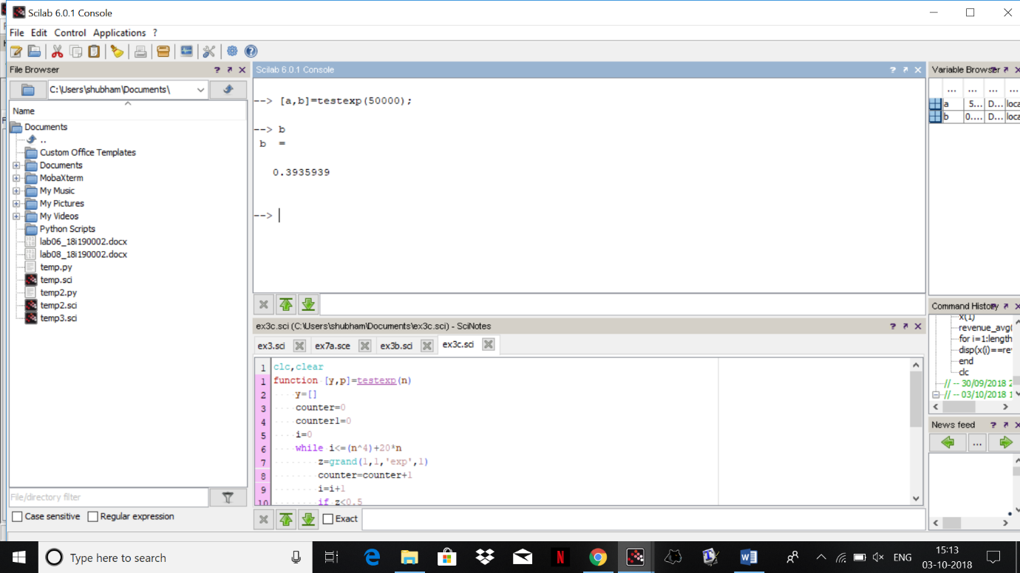

we are getting the ratio as asked : 0.3935939

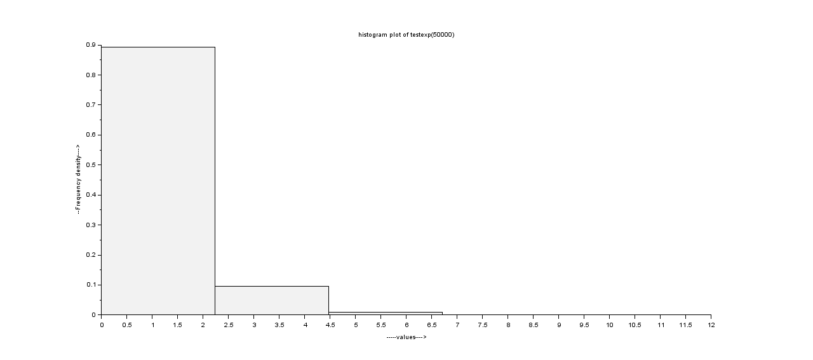

the hist plot is as follows , we see that we ger less then half values that were less than 0.5 and we decrease the values to 0.5 so the graph will not consider higher values.