**NAME: SHUBHAM SHARMA**

**ROLL NO: 18i190002**

**MSC PHD (OR)**

**Exercise 2):**

**PART (1) [R](code file is ex2a.sce)**

The 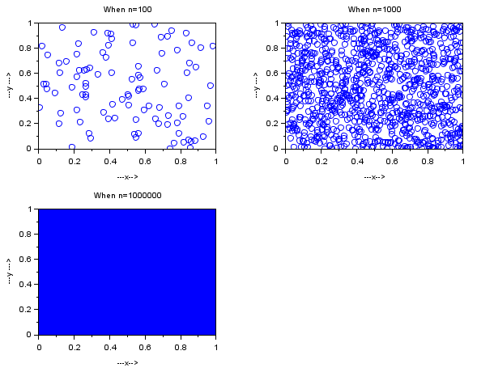

The plot is as above when n=100, n=1000 and n=1000000

When **n=100**  , We can see from the above graph that when n=100 the points are scattered over the whole area but it cannot actually be concluded whether the shape of the above graph is same as that of uniform distribution or not. Thus it cannot be said if it is uniform or not even when the points are scattered all over. So the data is not sufficient.

When **n=1000 ,** From the above graph we can see that the points are scattered all over uniformly and thus it is as we expected

When **n**=**1000000** , As we can see in the graph , the graph is fully occupied by the points which tells us that the points are uniformly distributed all over the graph and thus the result is as we expected.

**PART (2) [R](code file is ex2b.sce)**

We have made the scatter plot when each row of the given input2.sce is a point (x,y).

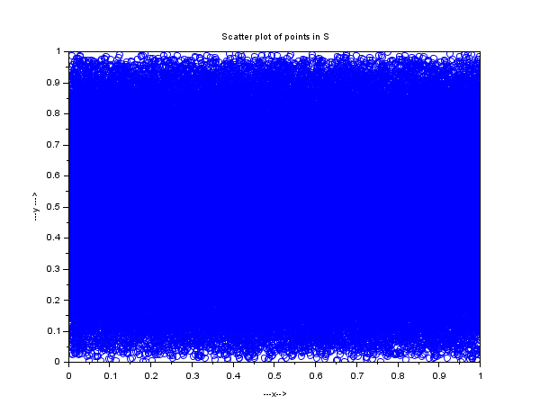

The points are uniformly scattered all over the graph so we can conclude as we expected from a graph of a uniform distribution.

**PART (3) [R](code file is ex2c.sce)** 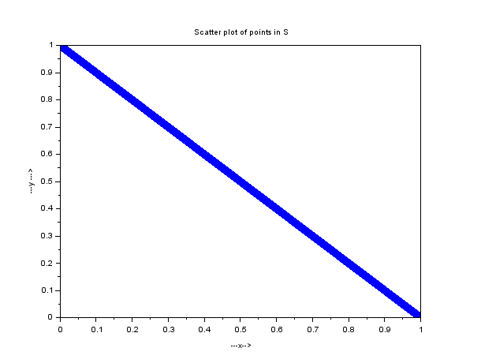

The above graph comes to be a straight line which is not as we expected. It is not even near to the graph of a uniform distribution, Thus , we can conclude that the values are not random , the values are following a particular sequence.

**Exercise 3):**

**PART (1) [R](code file is ex3.sce)**

The graph is constructed as it was mentioned in the question.

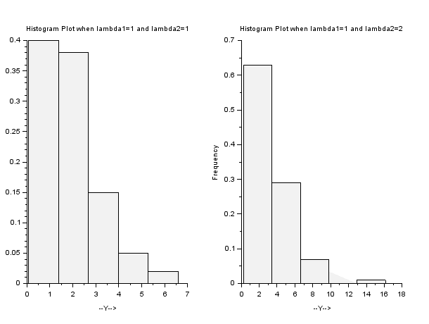

When **lambda1=lambda2=1,** We observe that when we add two exponential random variables , we are again getting an exponential random variable as we can see from the histogram plot of Y.

When **lambda1=lambda2=2,** We observe the same thing as we observed in the above case that when we add two exponential random variables , we are again getting an exponential random variable.

**PART (2) [R]**

As we can see , in both the cases , we have obtained an exponential plot , but as we can see that the slope of the histogram in the case 2 is more than that of the slope of the graph in case 1 and we are getting this change because of the changes in the parameter.

**Ex2(lab 09)**

**PART (a) [R]**

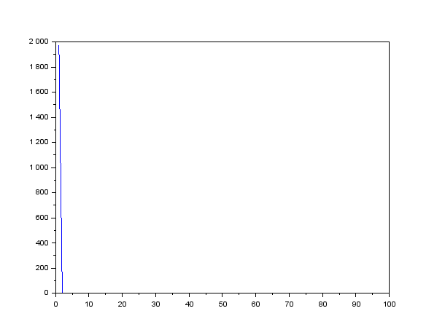

The inventory cost is 53947200.

The back ordering cost is : 1.758 *109

The total cost is : 1.812*109

**PART (b) [R]**

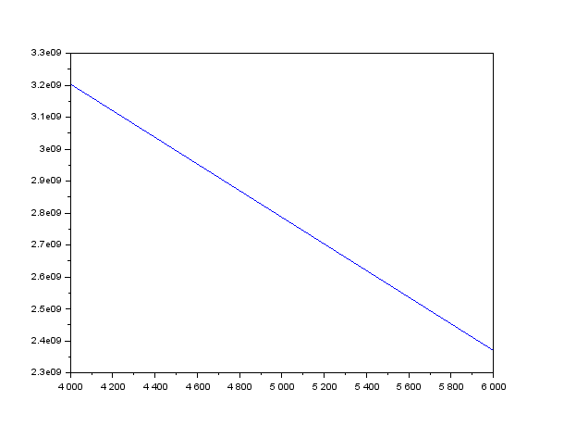

The best fixed order quantity is 6000.

**PART (c) [R]**

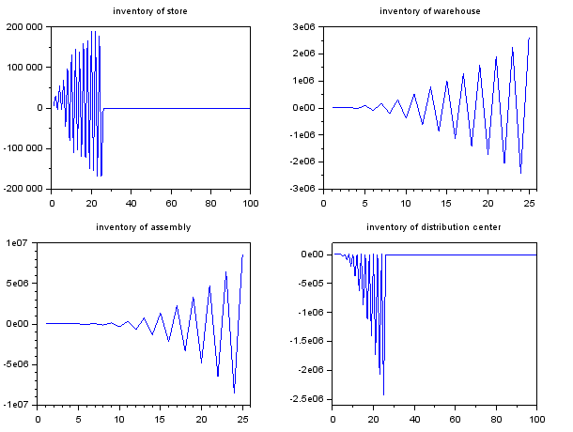

**PART (d) [R]**

No , we are getting more cost and more back logging , so the first policy was very better than this one. We can use the policy of the first part to get more better results.