NAME— ANIRBAN NASKAR

ROLL—18I190007

LAB—09

EX-1:-

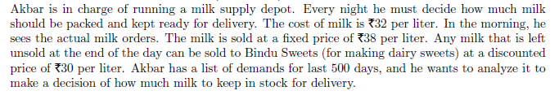

Answer:-

1. The cost of milk= Rs.38/per liter

The sold price of milk= Rs.32/per liter

If some milk are unsold then these are sold at Rs.30/per liter.

The list of demands of milk for 500 days are given in the file milk.sce

Then the mean of demand= 998.07

The standard deviation of demand= 115.528

The graph of ‘demand’ vs ‘time’:-

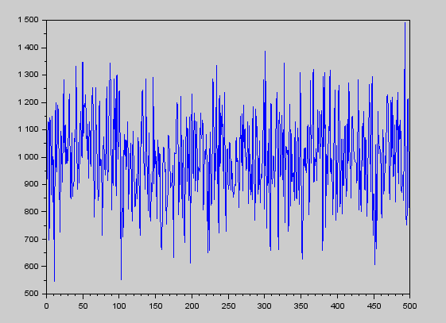

The histogram of demand:-

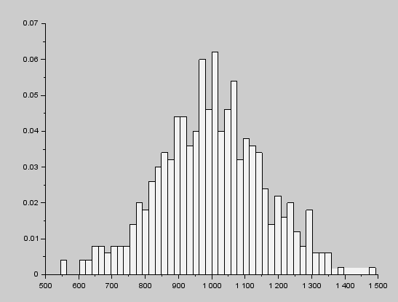

1. Now akbar wants to set his stock at a constant rate 1000 liter.

Then the average profit will be= Rs. 5498.

The graph for constant stock rate 1000 liter

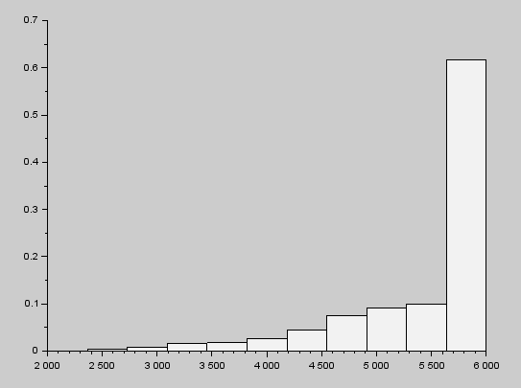

1. Now Akbar wants to know how his expected profit would change with the quantity of his stock. Find the profit for several different stock quantities in the range 950 : 10 : 1100.

The plot between the quantity and corresponding profits be:-

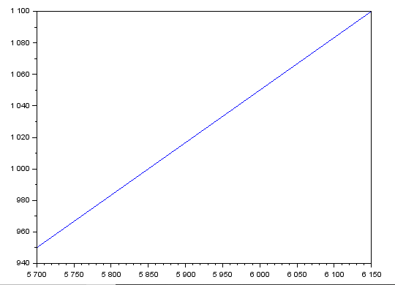

1. We get the maximum profit at stock 1100. So 1100 liter per day is the recommended stock level.