**NAME: SHUBHAM SHARMA**

**ROLL NO: 18i190002**

**MSC PHD (OR)**

**Exercise 1):**

**PART (1) [R]**

We have constructed the following LPP of the problem of sudoku

Defining a set N={1,2,3,4,5,6}

Defining the decision variables x{N,N,N}, such that for example x{1,2,3} will tell whether 3 will come in position {1,2},

x{i,j,k}={0, if k is not on the location I,j

1, if k is on the location I,j

defining an another decision variable z{N,N}, such that, sum{k in N} x[i,j,k]=1; for all i and j belongs to N.

we donot want any objective , we can put an objective function that will act as dummy , example **minimize 1**

subject to :-

# only one of each digit in each column

**subject** **to** Columns{j **in** N, k **in** N}:**sum**{i **in** N}(x[i,j,k])=1;

# only one of each digit in each row

**subject** **to** Rows{i **in** N, k **in** N}: **sum**{j **in** N}(x[i,j,k])=1;

# Only one of each digit will be each rectangle

**subject** **to** retangles{k **in** N, p **in** 1..3 ,q **in** 1..2}:**sum**{i **in** (2*p -1) ..(2*p),j **in** (3*q -2) ..(3*q) }x[i,j,k]=1;

#every row and column should have every digit

**subject** **to** all_filled{i **in** N, j **in** N}: **sum**{k **in** N}x[i,j,k]=1;

**subject** **to** known {(i,j,k) **in** DATA }:(x[i,j,k])=1;

**subject** **to** con1{i **in** N,j **in** N}:**sum**{k **in** N}k*x[i,j,k] = z[i,j];

The following above is the lpp of the problem given, where DATA will have all the values that are given in the question.

**PART (2) [R]**

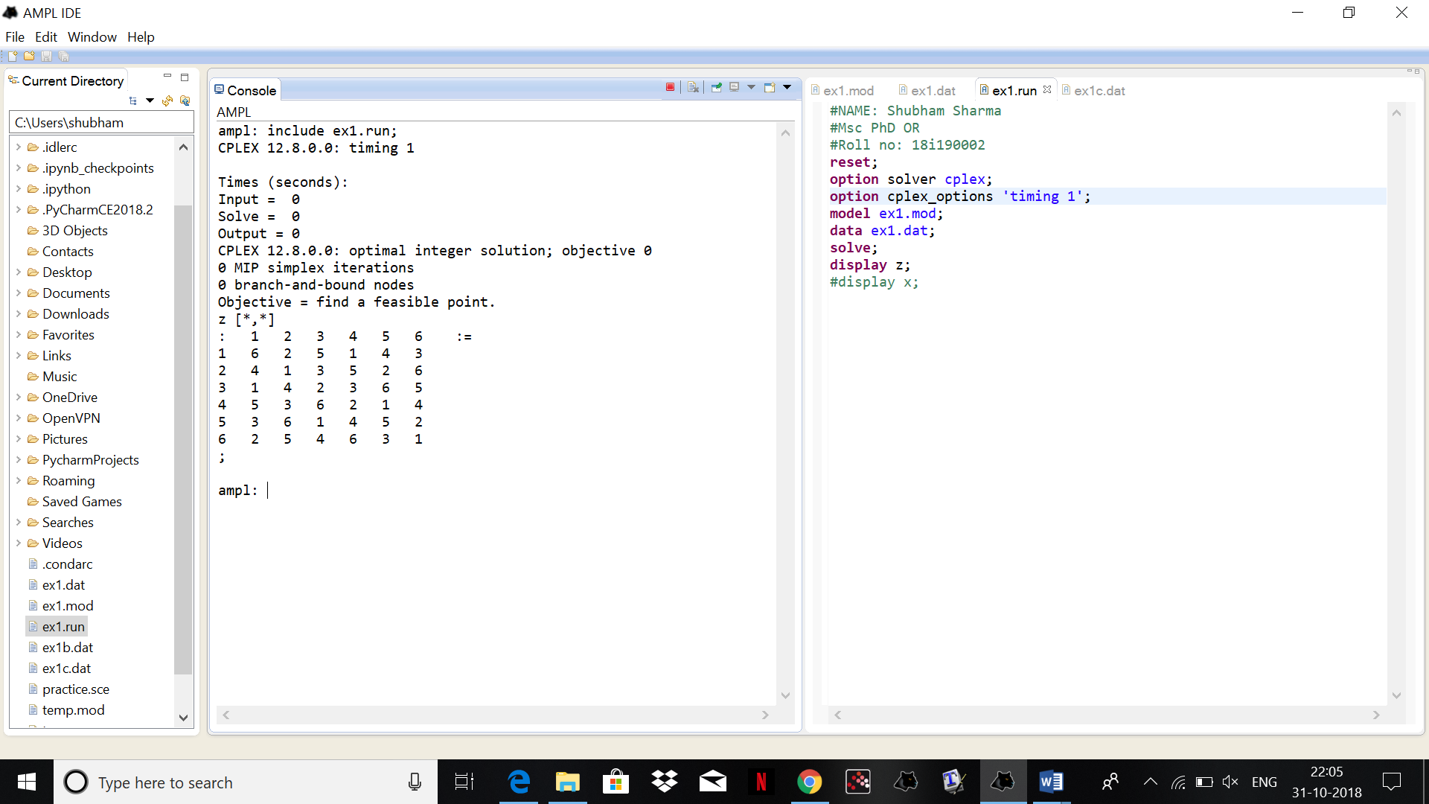

The solution obtained is correct as we can see it satisfy all the properties of the sudoku. The CPU time as shown is coming to be 0 seconds.

**PART (3) [R]**

**PART (4) [R]**

The model for figure 2 and figure 3 will have same model but we will just make some slight changes in the model file that will help us putting the input as per given in the question. The dat file we require is attached (for fig1-ex1b.dat) and (for fig2-ex1c.dat).

**PART (5) [R]**

For figure 1 we are getting the results:

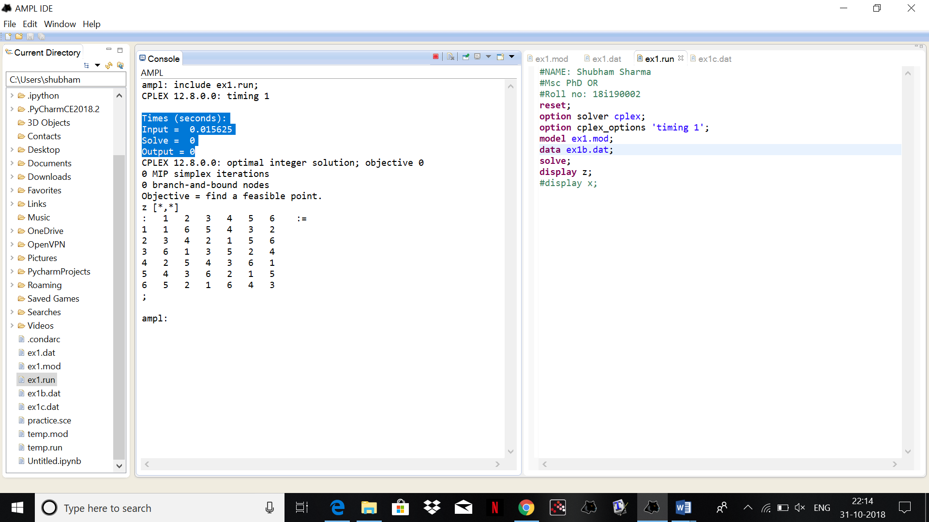

The timings are

Input = 0.015625

Solve = 0

Output = 0

For figure 3:

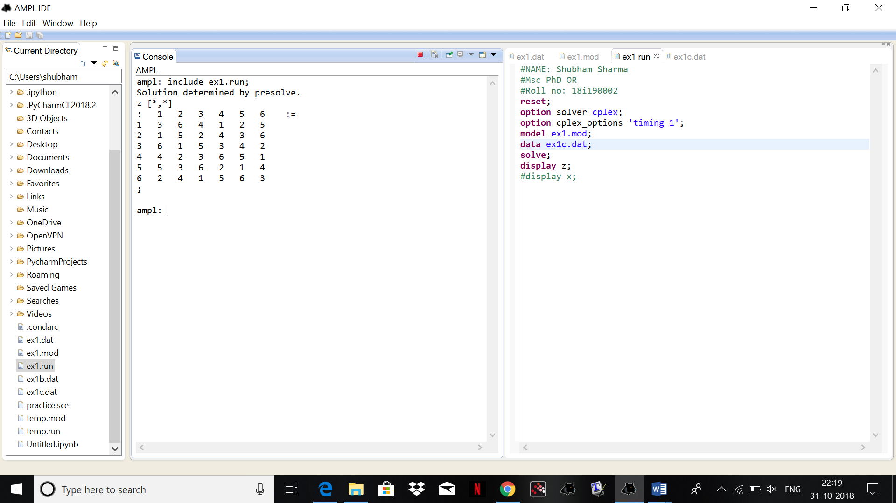

Answer is as soon in the figure. The time taken is 0 seconds

**PART (6) [R]**

The problems are easy. We cannot categorise the problems as per my laptop as each of the code is taking 0 seconds time in the ampl, but we can categorize on the basis of the data given **., as more the data of the sudoku given, more easy the problem is** .

**Exercise 2):**

**PART (1) [R]**

We have repeated the procedure 1000 times and displayed the value of tau.

**PART (2) [R]**

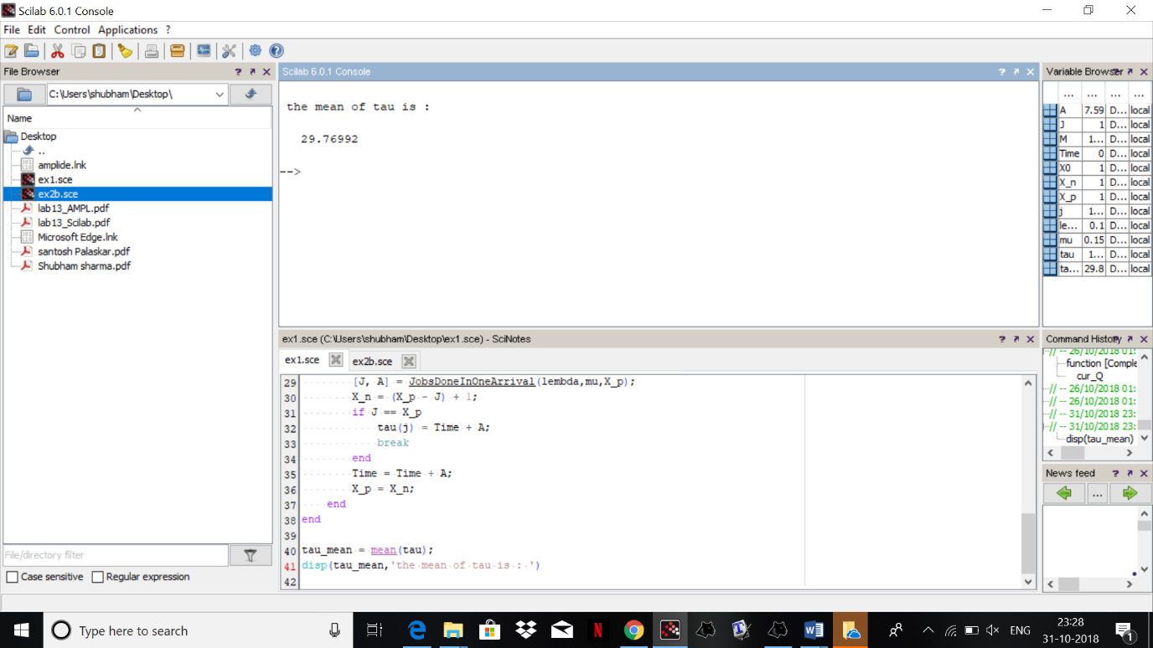

The mean of tau is : **29.76992**

**PART (3) [R]**

We can find the mean of the buzy period using PASTA. We can use the mean of idle times and mean of tau to estimate the mean of buzy period.